**OOM GUI ASSIGNMENT-1**

**Name: Aditya Aggarwal Roll Number: IIT2019210**

**Q1)** **Try out create an application which looks like the picture to**

**the right, without using the GUI Builder.**

**Solution:)**

**Code:**

package first;  
import javax.swing.*;  
import java.awt.*;  
  
public class AppF {  
 public static void main(String[] args) {  
 JFrame theFrame = new JFrame("Further Division of East and West Panels");  
 JPanel panel = new JPanel();  
 panel.setLayout( new BorderLayout() );  
 JPanel subPanel = new JPanel();  
 subPanel.add( new JButton( "RL" ));  
 subPanel.add( new JButton( "RR" ));  
  
 JPanel panel1 = new JPanel();  
 panel.setLayout( new BorderLayout() );  
 JPanel subPanel1 = new JPanel();  
 subPanel1.add( new JButton( "LL" ));  
 subPanel1.add( new JButton( "LR" ));  
  
 panel.add(subPanel, BorderLayout.*EAST*);  
 panel1.add(subPanel1, BorderLayout.*WEST*);  
  
 theFrame.add(new Button("Top"), BorderLayout.*NORTH*);  
 theFrame.add(new Button("Mid"), BorderLayout.*CENTER*);  
 theFrame.add(panel,BorderLayout.*EAST*);  
 theFrame.add(panel1,BorderLayout.*WEST*);  
 theFrame.setSize(400, 200);  
 theFrame.setVisible(true);  
  
 }  
}

**Output screenshot:**

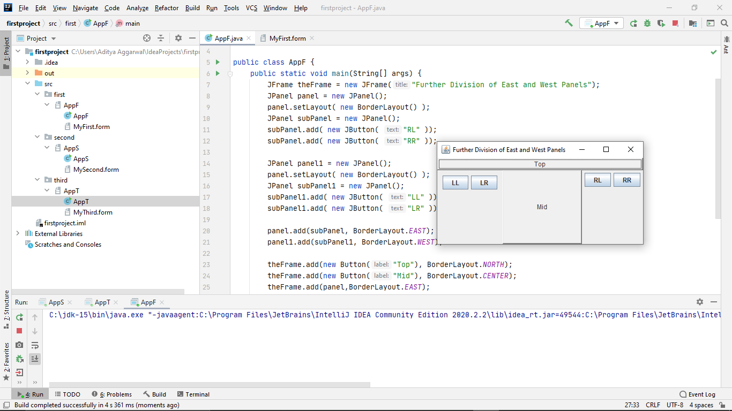

**Q2) Try out create an applica-tion which looks like the picture to the right, without using the GUI Builder.**

**Solution:**

**Code:**

package second;  
  
import javax.swing.*;  
import java.awt.*;  
  
public class AppS {  
 public static void main(String[] args) {  
 JFrame theFrame = new JFrame("Ice Cream Store");  
 JPanel thePanel1 = new JPanel();  
 JPanel thePanel2 = new JPanel();  
 JPanel thePanel3 = new JPanel();  
  
 JRadioButton Vanilla = new JRadioButton("Vanilla");  
 JRadioButton Strawberry = new JRadioButton("Strawberry");  
 JRadioButton Mixed = new JRadioButton("Mixed");  
  
 ButtonGroup theGroup1 = new ButtonGroup();  
 theGroup1.add(Vanilla);  
 theGroup1.add(Strawberry);  
 theGroup1.add(Mixed);  
  
 thePanel1.add(Vanilla);  
 thePanel1.add(Strawberry);  
 thePanel1.add(Mixed);  
  
 JLabel theLabel = new JLabel("BUY");  
 theLabel.setFont(new Font("Calibri (Body)", Font.*BOLD*, 40));  
 thePanel2.add(theLabel);  
  
  
 JCheckBox Chocolate = new JCheckBox("Chocolate sprinkle");  
 JCheckBox Cream = new JCheckBox("Cream");  
 JCheckBox Jam = new JCheckBox("Jam");  
  
 ButtonGroup theGroup2 = new ButtonGroup();  
 theGroup2.add(Chocolate);  
 theGroup2.add(Cream);  
 theGroup2.add(Jam);  
  
 thePanel3.add(Chocolate);  
 thePanel3.add(Cream);  
 thePanel3.add(Jam);  
  
 theFrame.add(thePanel1, BorderLayout.*NORTH*);  
 theFrame.add(thePanel2, BorderLayout.*CENTER*);  
 theFrame.add(thePanel3, BorderLayout.*SOUTH*);  
  
 theFrame.setSize(300, 180);  
 theFrame.setVisible(true);  
 }  
}

**Output Screenshot:**

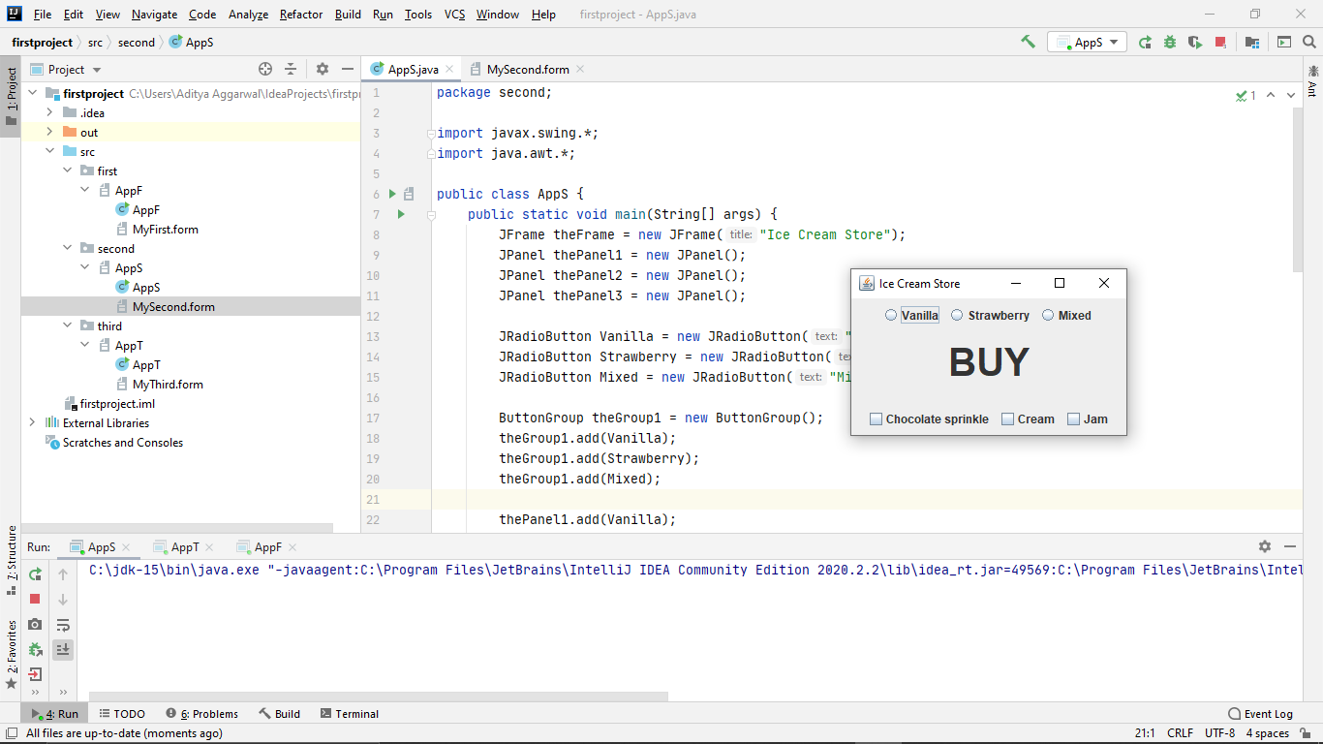

**Q3)** **Try out create an application which looks like the picture to**

**the right, without using the GUI Builder. Create event listeners for the buttons, that print the texts:**

* **”Brrr” for Arctic and Antarctic**
* **”Puhh” for America and Asia**
* **”Wet!” for Atlantic**

**Solution:**

**Code:**

package third;  
import javax.swing.*;  
import java.awt.*;  
import java.awt.event.*;  
  
public class AppT {  
  
 public static void main(String[] args){  
 JFrame theFrame = new JFrame("The A World...");  
  
 JPanel thePanel = new JPanel();  
 thePanel.setLayout(new BorderLayout());  
 final JTextField theText=new JTextField();  
 Button b1 = new Button("Arctic");  
 thePanel.add(b1,BorderLayout.*NORTH*);  
 b1.addActionListener(new ActionListener(){  
 public void actionPerformed(ActionEvent e){  
 System.*out*.println("Brrr");  
 }  
 });  
 Button b2 = new Button("Atlantic");  
 thePanel.add(b2,BorderLayout.*CENTER*);  
 b2.addActionListener(new ActionListener(){  
 public void actionPerformed(ActionEvent e){  
 System.*out*.println("Wet!");  
 }  
 });  
 Button b3 = new Button("Antarctic");  
 thePanel.add(b3,BorderLayout.*SOUTH*);  
 b3.addActionListener(new ActionListener(){  
 public void actionPerformed(ActionEvent e){  
 System.*out*.println("Brrr");  
 }  
 });  
 Button b4 = new Button("America");  
 thePanel.add(b4,BorderLayout.*WEST*);  
 b4.addActionListener(new ActionListener(){  
 public void actionPerformed(ActionEvent e){  
 System.*out*.println("Puhh");  
 }  
 });  
 Button b5 = new Button("Asia");  
 thePanel.add(b5,BorderLayout.*EAST*);  
 b5.addActionListener(new ActionListener(){  
 public void actionPerformed(ActionEvent e){  
 System.*out*.println("Puhh");  
 }  
 });  
  
 theFrame.add(thePanel);  
 theFrame.setSize(300,200);  
 theFrame.setVisible(true);  
 }  
}

**Output Screenshot:**

