LAB 2: C PROGRAMMING BASICS
Lab Report and Knowledge Check

I. INTRODUCTION
This lab focuses on basic C programming, GCC compilation, Linux commands, return values, exit status, and the four stages of C compilation. The practical work includes compiling and executing C programs, accepting user input, and observing the files produced during compilation.

II. PRACTICAL WORK AND FIGURE EVIDENCE
The following figures document the practical tasks completed during the lab.
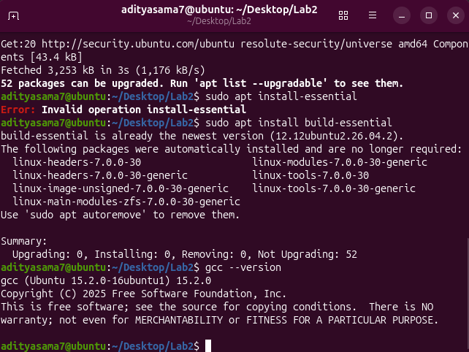
Figure 1: Installation and verification of GCC using the build-essential package and gcc --version.
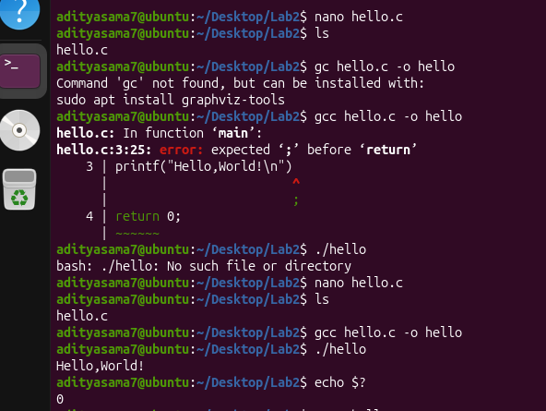
Figure 2: Creating and compiling hello.c, correcting a syntax error, and checking the program exit status.
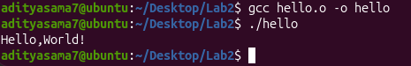
Figure 3: Successful execution of the Hello World C program.
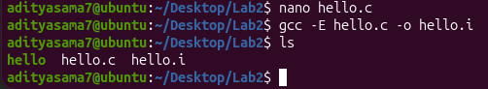
Figure 4: Preprocessing hello.c using gcc -E and generating the .i file.
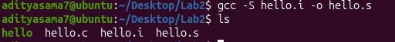
Figure 5: Generating assembly code using gcc -S and creating the .s file.
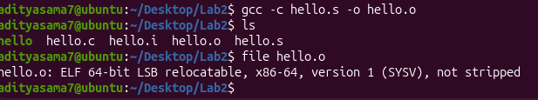
Figure 6: Creating the object file using gcc -c and checking the generated file.
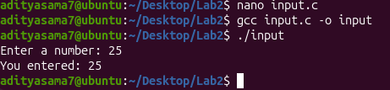
Figure 7: Compiling and executing a C program that accepts an integer from the user.
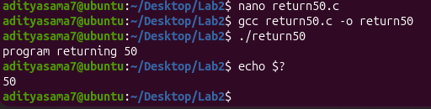
Figure 8: Program returning the value 50 and verifying the exit status with echo $?.
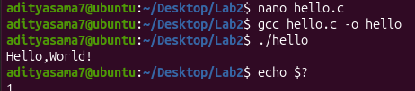
Figure 9: Program returning a non-zero value and verifying the exit status.

III. KNOWLEDGE CHECK QUESTIONS AND ANSWERS

Question 1
Q: What is the purpose of the #include directive in C programming? Provide an example of its usage.
Answer: The #include directive tells the C preprocessor to include the contents of a header file before the program is compiled. Header files provide declarations for functions and other definitions used by the program. For example, #include <stdio.h> includes the standard input/output functions such as printf() and scanf().

Question 2
Q: Explain the difference between the four stages of compilation. What file extension is produced at each stage?
Answer: The four stages are: (1) Preprocessing: expands header files and macros and produces a .i preprocessed file; (2) Compilation: converts the preprocessed C code into assembly language and produces a .s file; (3) Assembly: converts assembly instructions into machine-code object code and produces a .o object file; and (4) Linking: combines the object code with required libraries and produces the final executable file.

Question 3
Q: What does a return value of 0 from the main() function indicate to the operating system? What about a non-zero return value?
Answer: A return value of 0 normally indicates that the program completed successfully. A non-zero value is used to indicate that the program terminated with an error or another condition. The value can be checked in the Linux terminal using echo $?.

Question 4
Q: Write a C program that declares an integer variable, asks the user to input a value, and displays the entered value back to the user.
Answer: A simple program is:
#include <stdio.h>
int main() {
int number;
printf("Enter a number: ");
scanf("%d", &number);
printf("You entered: %d\n", number);
return 0;
}
The program declares an integer variable, reads a value using scanf(), and displays the same value using printf().

Question 5
Q: What GCC command would you use to: (1) only preprocess a file, (2) generate assembly code but not assemble it, and (3) create an object file without linking?
Answer: 1) Preprocess only: gcc -E hello.c -o hello.i
2) Generate assembly: gcc -S hello.i -o hello.s
3) Create an object file: gcc -c hello.s -o hello.o
These commands correspond to the preprocessing, compilation-to-assembly, and assembly stages respectively.

Question 6
Q: Explain why C is called a compiled language and how this differs from interpreted languages.
Answer: C is called a compiled language because its source code is translated into machine-level code by a compiler before the resulting program is executed. With GCC, the source code passes through preprocessing, compilation, assembly, and linking to produce an executable program. In an interpreted approach, source code is generally processed by an interpreter at execution time rather than first producing a standalone native executable in the same way.

IV. THEORY / KEY CONCEPTS
C Program Structure: A basic C program commonly contains preprocessor directives, the main() function, statements, and a return statement. The main() function is the starting point of execution.
GCC: GCC (GNU Compiler Collection) is used to compile C programs on Linux. The gcc --version command can be used to verify the installed compiler version.
Compilation Process: C source code is transformed through preprocessing, compilation, assembly, and linking. Each stage produces an intermediate or final output that moves the program closer to an executable form.
Return Values and Exit Status: The return value from main() becomes the program's exit status. In Linux, echo $? displays the exit status of the most recently executed command.
Standard Input and Output: The stdio.h header provides common input/output functions. printf() displays information and scanf() reads formatted input from the user.

V. LAB TASKS COMPLETED
- Compiled hello.c and verified the exit status using echo $?.
- Modified a program to return 1 and observed the non-zero exit status.
- Created and executed a program that accepts user input and displays it.
- Executed the four compilation stages separately and observed the generated files.
- Compiled and executed a program that returns the integer value 50.

VI. CONCLUSION
This lab provided practical understanding of C programming fundamentals, GCC commands, Linux compilation stages, user input, and program exit status. The figures provide evidence of the completed practical tasks, while the questions and theory summarize the main concepts covered in the lab.

VII. GITHUB REPOSITORY
Problem :