LABORATORY REPORT
Lab 4: A Practical Approach to Understanding
System Internals (Data Types and OS Memory Management)
Module: ST5003CMD
Operating Systems, Security, and Networks
Submitted By
Aditya Budhathoki
Student ID: 240594
Lecturer/Teacher
Rupak Rajbanshi
Academic Year: 2026

1. Introduction
This laboratory focuses on the relationship between C data types, memory allocation, and the way an operating system organizes a process in memory. A data type determines how many bytes are required and how those bytes are interpreted. When a variable is declared, memory must be made available for storing its value.
The laboratory also examines the main process memory segments: Text, Data, BSS, Heap, and Stack. By compiling and running C programs on Linux, the practical exercises show the sizes of common data types and the addresses of variables stored in different memory segments.
The purpose of the practical work is to connect the theoretical memory model with actual terminal output. The screenshots included in this report show the commands used during the practical work and the resulting program output.

2. Objectives
- To observe the memory size of common C data types using sizeof().
- To compare the observed sizes with the data type sizes given in the laboratory sheet.
- To understand the purpose of the Text, Data, BSS, Heap, and Stack segments.
- To observe variable addresses using the %p format specifier.
- To understand the difference between a pointer stored on the Stack and dynamically allocated data stored on the Heap.

3. Laboratory Exercise 1: Data Type Size Exploration
The first exercise uses sizeof() to determine how much memory is used by different data types on the Linux system used for the practical. The recorded output shows char = 1 byte, int = 4 bytes, float = 4 bytes, double = 8 bytes, long = 8 bytes, unsigned int = 4 bytes, and long long = 8 bytes.
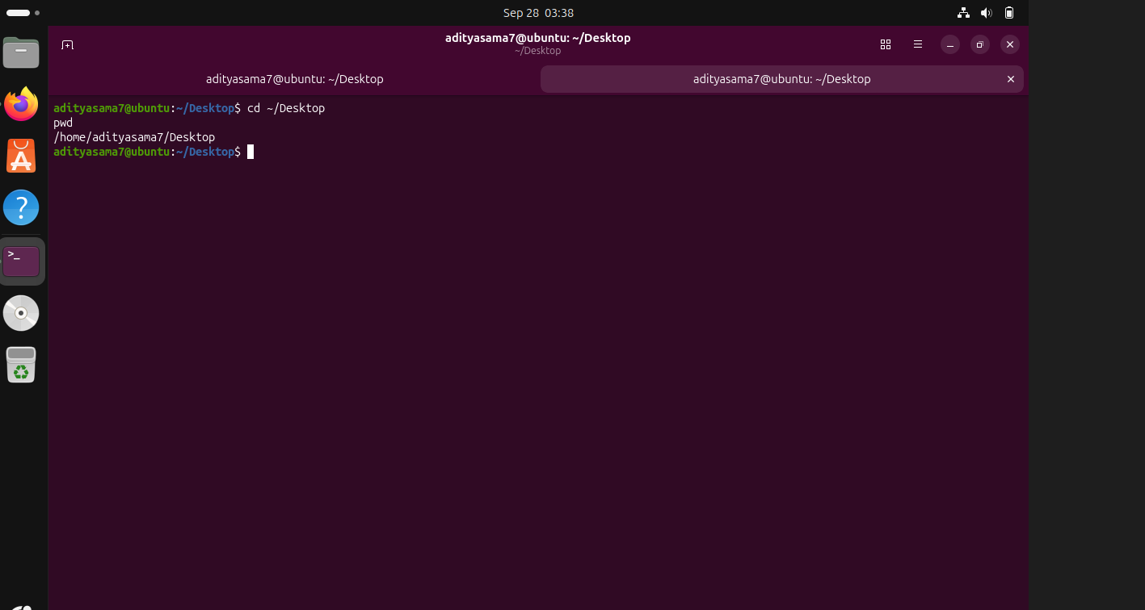
Figure 1: Creating and entering the Lab 4 working directory
Explanation: The terminal shows the Lab 4 directory being created and entered. This provides the working location where the C source files for the practical are stored.
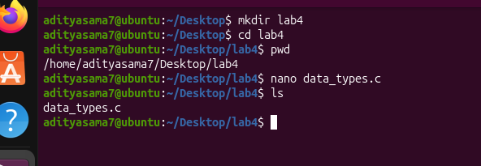
Figure 2: Creating the data_types.c source file
Explanation: The terminal shows the data_types.c file being created/edited using nano. This source file is used for the data type size experiment.
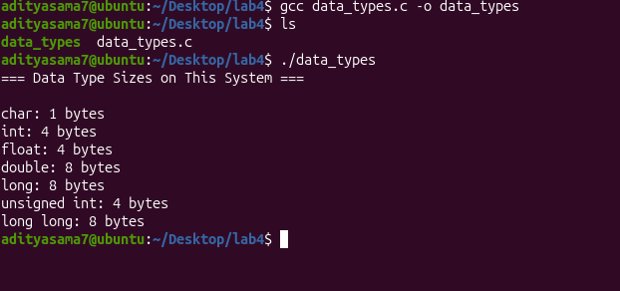
Figure 3: Compilation and output of the data type size program
Explanation: The program is compiled with GCC and executed successfully. The output records the number of bytes occupied by each tested data type on the system.

Answer: Why might sizeof(long) differ between 32-bit and 64-bit systems?
The size of long depends on the system architecture and its data model. A 32-bit system commonly uses 4 bytes for long, while many 64-bit Linux systems use 8 bytes. Therefore, the same C program can report a different sizeof(long) value on different architectures.

4. Laboratory Exercise 2: Memory Segment Address Mapping
The second exercise demonstrates where variables are placed in a process address space. The laboratory sheet identifies the Data segment for initialized global/static variables, the BSS segment for uninitialized global variables, the Stack for local variables and function-call information, and the Heap for dynamically allocated memory.
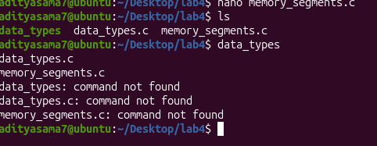
Figure 4: Attempt to execute the memory-segment program from the terminal
Explanation: The terminal shows an unsuccessful command attempt where file names were entered as commands. The shell reports 'command not found'. This is useful evidence of the command-line process before the correct compilation and execution commands were used.
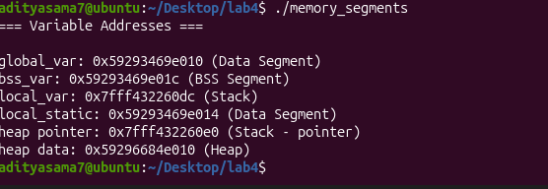
Figure 5: Observed variable addresses from the memory segment program
Explanation: The output labels each variable according to its memory segment. The initialized global variable is shown in the Data segment, the uninitialized global variable in BSS, the local variable and pointer variable on the Stack, and the dynamically allocated value on the Heap. The output also illustrates that stack addresses are higher than the shown heap/data addresses.
Figure 6: Successful compilation of memory_segments.c
Explanation: The terminal shows gcc compiling memory_segments.c into the executable memory_segments. This confirms that the source program was successfully compiled before it was executed.

Observation
From the recorded addresses, the Stack variables have the highest addresses among the displayed regions, while the Data/BSS addresses are lower and the Heap address lies in the middle range. This agrees with the general process memory layout described in the laboratory sheet.

5. Answers to the Knowledge Check Questions
1) What is a data type in the context of programming and operating systems?
A data type specifies how much memory is required for a value and how the stored bytes should be interpreted. It also determines which operations are valid for that value.
2) Name the five main memory segments in a process memory layout.
The five main segments are Text, Data, BSS, Heap, and Stack.
3) What is the difference between the Data segment and the BSS segment?
The Data segment stores initialized global and static variables, while the BSS segment stores uninitialized global and static variables. Both are used for variables whose lifetime extends across the program execution.
4) Why does the OS place the stack at high virtual addresses and the text segment at low addresses?
This arrangement is part of the conventional process virtual-memory layout. It keeps different regions separated and allows the Stack and Heap to have room to grow toward each other while code and static data remain in their own regions. The exact virtual address layout can vary between systems and configurations.
5) What happens to stack memory when a function returns? Who reclaims it?
The stack space used by the function's local variables and call information becomes available again when the function returns. Stack management is automatic, handled by the program's execution environment and compiler-generated instructions rather than by manually calling free().
6) How does the OS know which memory belongs to which process?
Each process has its own virtual address space. The operating system and hardware memory management mechanisms maintain mappings and protection information so that a process's virtual addresses refer to memory assigned to that process and are protected from unauthorized access by other processes.

6. Answers to the Laboratory Exercise Deliverables
Lab 1 – Data Type Size Exploration
- The program was compiled and executed using GCC on the Linux system.
- The observed output was: char 1 byte, int 4 bytes, float 4 bytes, double 8 bytes, long 8 bytes, unsigned int 4 bytes, and long long 8 bytes.
- The result is consistent with a typical 64-bit Linux data model for these types.
Lab 2 – Memory Segment Address Mapping
- The program declares variables representing Data, BSS, Stack, and Heap memory.
- The addresses are printed using %p and are labelled according to their memory segment.
- In the recorded output, the Stack addresses are the highest among the displayed regions, while Data/BSS are lower and the Heap lies between them.
- The exact addresses can change between executions because modern systems commonly use address-space randomization.

7. Conclusion
This laboratory provided a practical understanding of how data types and process memory are related. The data type experiment showed that the amount of memory used by a variable depends on its type and system architecture. The memory-segment experiment then connected C variables with the operating system's process memory layout.
The practical output also demonstrated an important difference between Stack and Heap memory. A pointer variable can be stored on the Stack while the memory it points to is allocated on the Heap. Overall, the exercises help explain how the operating system organizes, protects, and manages the virtual address space of a running process.

