LAB REPORT
Lab 3: Investigating Process Lifecycles
and OS Interaction
Operating Systems, Security, and Networks

Submitted By | Aditya Budhathoki
Student ID | 240594
Subject | Operating Systems, Security, and Networks
Lecturer / Teacher | Rupak Rajbanshi
Lab | Lab 3 – Investigating Process Lifecycles and OS Interaction

1. Introduction
This lab was carried out to understand how a C program behaves as a process under Linux. The practical work connects simple C programs with process management concepts such as process IDs, parent processes, execution time, exit status, standard input/output, and conditional termination.
The lab sheet explains that the operating system manages processes and resources, and that these programs interact with the Linux kernel through functions such as getpid(), getppid(), and sleep(). The work also demonstrates how the shell can inspect a running process and read the status returned by a program.
Write C program → Compile with gcc → Run program → Observe OS behaviour → Verify with terminal → Record result

2. Task 1 – The Long-Running Process
The purpose of Task 1 is to create a process that remains active for about 30 seconds. The program uses a loop and sleep(1), so the process stays alive long enough to be monitored from another terminal.

Theory / Key idea
- sleep(1) pauses the process for approximately one second.
- The loop repeats 30 times, so the program takes roughly 30 seconds to complete.
- Using & starts the program in the background and returns control to the shell.
- The ps command can be used to inspect processes that are currently running.

Commands used
gcc task1_alive.c -o task1
./task1 &
ps aux | grep task1
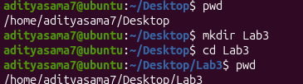
Figure 1. Creating the Lab 3 working directory
The terminal shows the Lab3 directory being created and opened before the practical work begins.
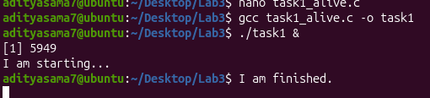
Figure 2. Compiling and running Task 1 in the background
The task1_alive.c program is compiled and started with &, and the program prints its starting message.
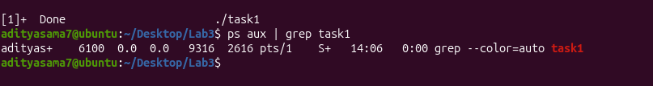
Figure 3. Checking the Task 1 process with ps
The ps aux | grep task1 command is used to look for the task1 process in the terminal.
Result: Task 1 demonstrates that a running C program is an active OS process that can be started in the background and inspected from the shell.

3. Task 2 – Process Identity (PID and PPID)
Task 2 focuses on process identity. Every Linux process has a Process ID (PID), while PPID identifies the process that created it. The program obtains these values using getpid() and getppid().

Theory / Key idea
- PID identifies the currently running process.
- PPID identifies the parent process that created it.
- getpid() returns the current process ID.
- getppid() returns the parent process ID.
- The process sleeps for 20 seconds so that it can be checked from the shell.

Commands used
gcc task2_identity.c -o task2
./task2 &
ps -p <PID> -o pid,ppid,cmd
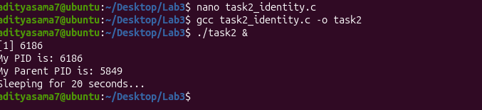
Figure 4. Displaying the PID and PPID
The program prints its current PID and its parent PID, then waits for 20 seconds.
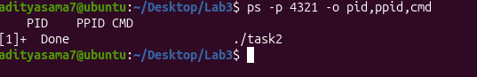
Figure 5. Attempting to verify the Task 2 process with ps
The ps command is used to inspect a process by PID.
Note: The PID entered in this screenshot is 4321, while Figure 4 shows the program PID as 6186. For a correct verification, the PID printed by the program (6186 in Figure 4) should be used.
Result: The program successfully obtains and displays its PID and PPID. The terminal verification should use the same PID printed by the program so that ps checks the correct process.

4. Task 3 – Exit Codes and OS Feedback
Task 3 shows how a program communicates its final status back to the operating system. A return value of 0 represents successful completion, while a non-zero value represents an error or failure. The shell stores the most recent exit status in $?.

Theory / Key idea
- return 0 tells the OS that the program completed successfully.
- return 1 tells the OS that the program ended with a failure/unsuccessful condition.
- echo $? displays the exit status of the most recently completed command.
- Positive input follows the success branch; negative input follows the failure branch.

Commands and expected results
gcc task3_exit.c -o task3
# Positive input
./task3
# Enter: 5
echo $?
# Result: 0
# Negative input
./task3
# Enter: -5
echo $?
# Result: 1
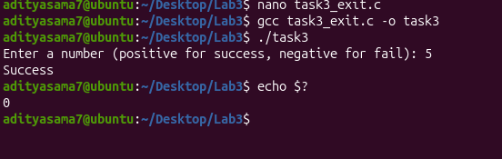
Figure 6. Task 3 with positive input
The program receives 5, prints Success, and echo $? returns 0.
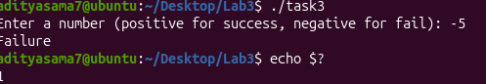
Figure 7. Task 3 with negative input
The program receives -5 and prints Failure. The shell command echo $? is then used to check the exit status.
Note: The lab sheet specifies that the negative-input case should return 1. The numeric result is not clearly visible in the supplied screenshot, so the documented lab result is used for the expected answer.
Result: Task 3 demonstrates the difference between program output and an exit status returned to the operating system.

5. Task 4 – Standard I/O Streams
Task 4 demonstrates standard input and standard output. scanf() reads the user's input from stdin, while printf() sends output to stdout.

Theory / Key idea
- stdin is the standard input stream, normally connected to the keyboard.
- stdout is the standard output stream, normally connected to the terminal.
- scanf() reads the name entered by the user.
- printf() displays the greeting on the terminal.

Commands used
gcc task4_input.c -o task4
./task4
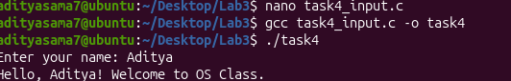
Figure 8. Reading input through stdin and displaying output through stdout
The user enters the name Aditya and the program displays a personalised welcome message.
Result: Task 4 successfully demonstrates basic standard I/O: input is taken from the terminal and the result is displayed back through standard output.

6. Task 5 – Conditional Execution and Termination
Task 5 combines process identification, user input, conditional execution, sleep(), and exit status. The program prints its PID, asks whether the user wants to continue, and returns a different status depending on the selected option.

Theory / Key idea
- getpid() displays the PID of the current process.
- Input 1 follows the continue branch, waits for 5 seconds, and returns 0.
- Input 0 follows the exit branch and returns 1.
- The final exit code can be checked with echo $?.

Commands and expected results
gcc task5_control.c -o task5
./task5
# Choose 1
echo $?
# Result: 0
./task5
# Choose 0
echo $?
# Result: 1
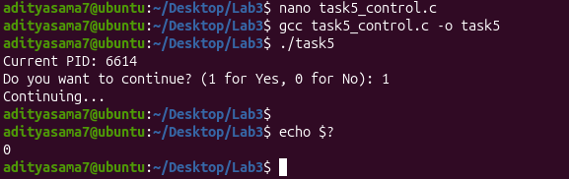
Figure 9. Task 5 – Continue option
The program prints its PID, the user selects 1, the program continues, and the shell reports exit status 0.
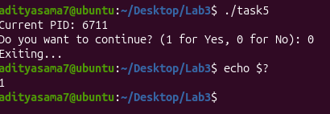
Figure 10. Task 5 – Exit option
The user selects 0, the program exits, and the shell reports exit status 1.
Result: Task 5 shows how a program can make a decision from user input and communicate the final result back to the OS.

7. GitHub Submission / Push Issue
The lab submission checklist requires the five C source files to be properly named, the work to be documented, and the code to be pushed to a personal GitHub repository with a README.md.
Figure 11. Checking the Lab3 files before Git submission
The terminal lists the five task source files and their compiled programs in the Lab3 directory.
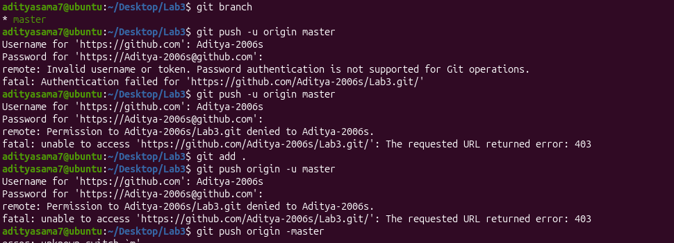
Figure 12. GitHub push attempt and authorization error
The terminal shows attempts to push the Lab3 repository to GitHub. The push is rejected and the server returns HTTP 403.

8. Overall Conclusion
This lab helped connect C programming with real operating-system behaviour. Instead of treating a program as only a piece of code, the practical work showed that it becomes a process managed by the Linux kernel.
Across the five tasks, I observed how a process can stay alive long enough to be monitored, how a process gets a PID and a parent PID, how a program reports success or failure through an exit code, how standard input and output work, and how user decisions can control the way a process terminates.
The practical screenshots also made the verification steps easier to understand because the commands were tested directly in the Linux terminal. The GitHub section identified a separate submission issue: the code push was rejected with a 403 authorization error and therefore needs to be fixed before the repository submission is considered complete.

