JAVA PROGRAM:

1.Print integer entered by user.

import java.util.Scanner;

class Main{

public static void main (String[]args)

{

Scanner sc=new Scanner(System.in);

System.out.println("Enter an integer:");

int n=sc.nextInt();

System.out.println("The integer is:"+n);

}

}

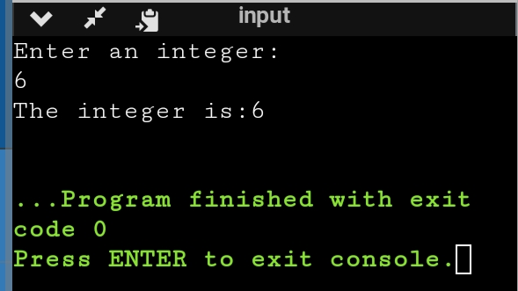

2.Usage of primitive data type

import java.util.Scanner;

public class Main

{

public static void main(String[] args) {

Scanner sc=new Scanner(System.in);

System.out.println("Enter an integer:");

int n=sc.nextInt();

System.out.println("The integer is"+n);

System.out.println("Enter float value :");

float m=sc.nextFloat();

System.out.println("Floating value is:"+m);

System.out.println("Enter the Boolean value:");

boolean t=sc.nextBoolean();

System.out.println("The boolean value is "+t);

}

}

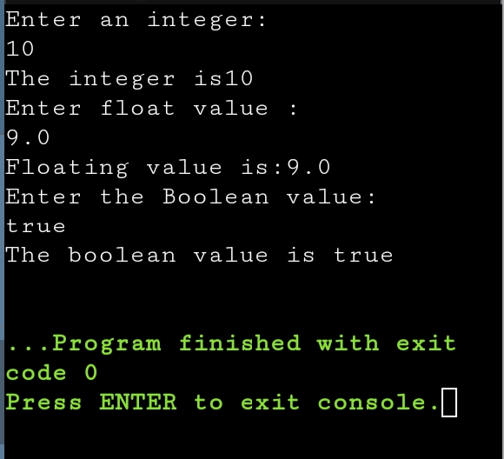

3.Swap two numbers using temporary variable

import java.util.Scanner;

public class Main

{

public static void main(String[] args) {

Scanner sc=new Scanner(System.in);

System.out.println("Enter first number:");

int a=sc.nextInt();

System.out.println("Enter second number:");

int b=sc.nextInt();

int c;

c=a;

a=b;

b=c;

System.out.println("After Swapping :");

System.out.println("First no. is-"+a);

System.out.println("Second no. is-"+b);

}

}

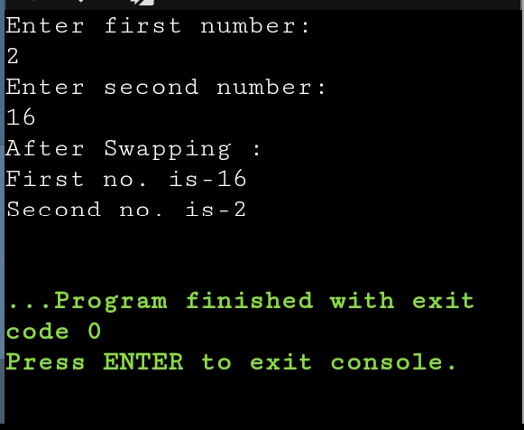

4.Check whether a number is odd or not using if else statement

import java.util.Scanner;

public class Main

{

public static void main(String[] args) {

Scanner sc=new Scanner(System.in);

System.out.println("Enter a number:");

int a=sc.nextInt();

if(a%2==0)

System.out.println("Even Number");

else

System.out.println("Odd Number");

}

}

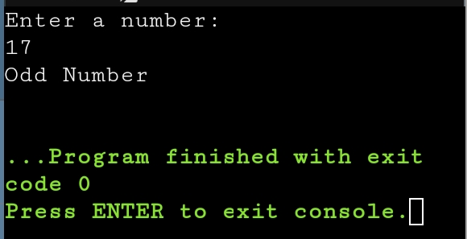

5.Vowel or consonant

import java.util.Scanner;

public class Main

{

public static void main(String[] args) {

Scanner sc=new Scanner(System.in);

System.out.println("Enter a character:");

char ch;

ch=sc.next().charAt(0);

if(ch=='a'||ch=='e'||ch=='i'||ch=='o'||ch=='u'||ch=='A'||ch=='E'||ch=='I'||

ch=='O'||ch=='U')

System.out.println("Vowel");

else

System.out.println("Consonant");

}

}

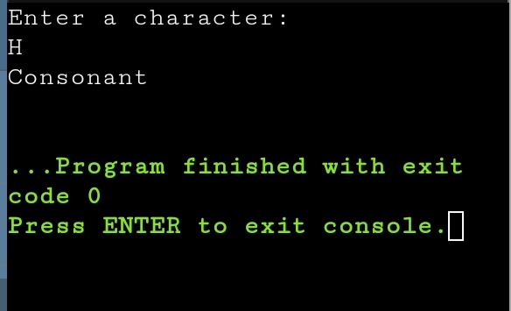

6.Check whether number is positive or negative

import java.util.Scanner;

public class Main

{

public static void main(String[] args) {

Scanner sc=new Scanner(System.in);

System.out.println("Enter a number:");

int n=sc.nextInt();

if(n>=1)

System.out.println("Positive");

else if(n==0)

System.out.println("Neither positive nor negative ");

else

System.out.println("Negative");

}

}

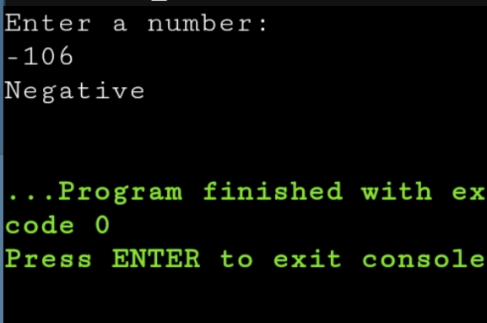

7.Sum of natural number using for loop

import java.util.Scanner;

public class Main

{

public static void main(String[] args) {

Scanner sc=new Scanner(System.in);

System.out.println("Enter no of terms:");

int n=sc.nextInt();

int sum=0;

for(int i=1;i<=n;i++)

{

sum+=i;

}

System.out.println("Sum of n natural number"+sum);

}

}

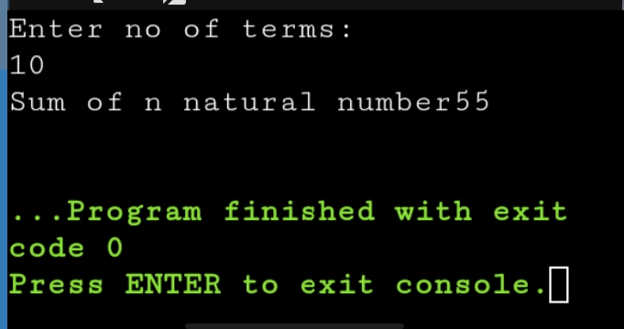

8.Factorial of a number using for loop.

import java.util.Scanner;

public class Main

{

public static void main(String[] args) {

Scanner sc=new Scanner(System.in);

System.out.println("Enter a number:");

int n=sc.nextInt();

int fact=1;

for(int i=1;i<=n;i++)

{

fact\*=i;

}

System.out.println("Factorial of number is"+fact);

}

}

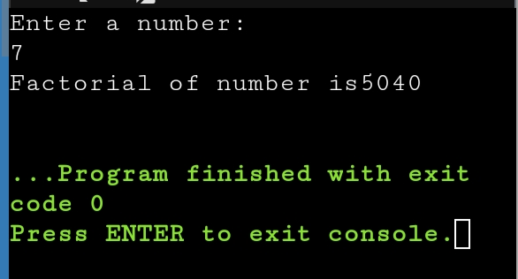

9.Multiplication Table

import java.util.Scanner;

public class Multiplication{

public static void main(String[] args){

Scanner sc=newScanner(System.in);

System.out.println("Enter a number");

int n=sc.nextInt();

for(int i=1;i<=10;i++)

{

System.out.println(n+"x"+i+"="+n\*i);

}

}

}

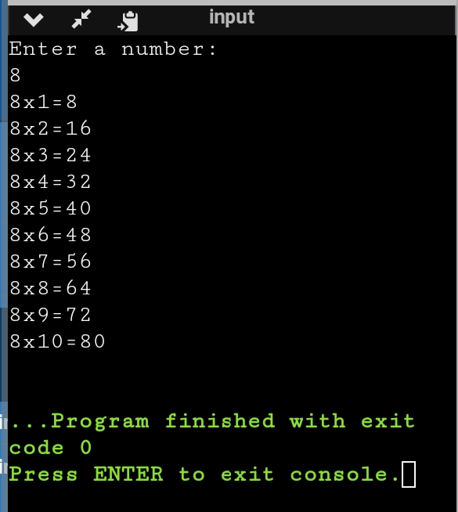

10.Display uppercase alphabet from A to Z using for loop

import java.util.Scanner;

public class Main

{

public static void main(String[] args) {

Scanner sc=new Scanner(System.in);

System.out.println("Upper-case alphabet from A to Z are:");

char ch;

for(ch='A';ch<='Z';ch++)

{

System.out.print(ch+" ");

}

}

}

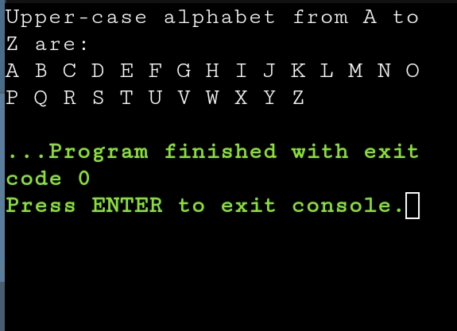

11.Find gcd of two numbers using for loop and if statement

import java.util.Scanner;

public class Main

{

public static void main(String[] args) {

Scanner sc=new Scanner(System.in);

System.out.println("Enter first number:");

int a=sc.nextInt();

System.out.println("Enter second number:");

int b=sc.nextInt();

int GCD=1;

for(int i=1;i<=a&&i<=b;i++)

{

if(a%i==0&&b%i==0)

GCD=i;

}

System.out.println("GCD of two entered number is:"+ GCD);

}

}

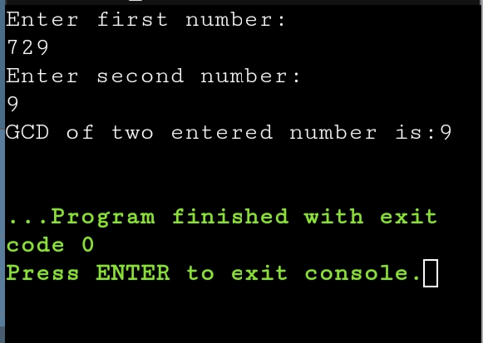

12.Reverse the number

import java.util.Scanner;

public class Main

{

public static void main(String[] args) {

Scanner sc=new Scanner(System.in);

System.out.println("Enter a number:");

int a=sc.nextInt();

int rev=0,q;

while(a!=0)

{

q=a%10;

rev=(rev\*10)+q;

a=a/10;

}

System.out.println("Reverse of number is:"+ rev);

}

}

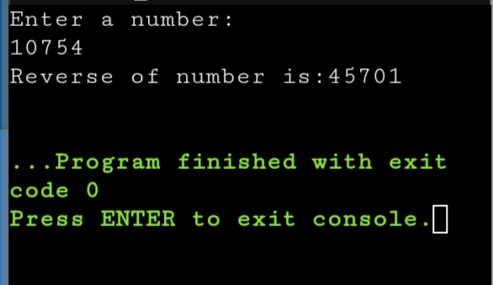

13.Demonstrate creating class and instance (object).

class Student{

int id;

String name;

public static void main(String[] args)

{

Student s1=new Student();

System.out.println(s1.id);

System.out.println(s1.name);

}

}

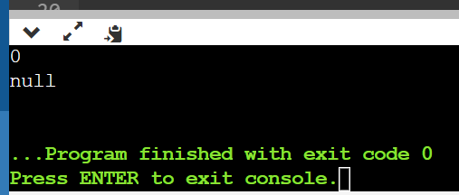

14.Demonstrate using instance/class variable in a java program by creating a simple public class.

public class Studentsrecords

{

/\* declaration of instance variables\*/

public String name; //public instance

public Studentsrecords(String sname)

{

name = sname;

}

public void printstud()

{

System.out.println("Student Name: " + name );

}

public static void main(String args[])

{

Studentsrecords s = new Studentsrecords("Monica");

s.printstud();

}

}

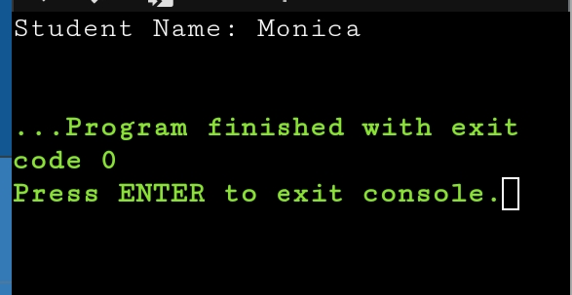

15.Demonstrate the java class using getter setter method for accessing private data member .

class Student{

private String name;

private int rollno;

public void setName(String n) {

name=n;

}

public String getName() {

return name;

}

public void setRollno(int r) {

rollno=r;

}

public int getRollno() {

return rollno;

}

}

public class Main{

public static void main(String[] args){

Student s1=new Student();

s1.setName("ABC");

s1.setRollno(36);

System.out.println(s1.getName());

System.out.println(s1.getRollno());

}

}

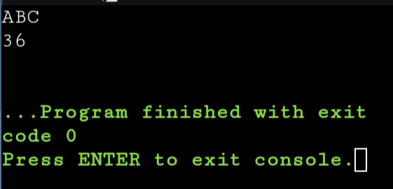

16.Demonstrate the use of static variable

class VariableDemo

{

static int count=0;

public void increment()

{

count++;

}

public static void main(String args[])

{

VariableDemo obj1=new VariableDemo();

VariableDemo obj2=new VariableDemo();

obj1.increment();

obj2.increment();

System.out.println("Obj1: count is="+obj1.count);

System.out.println("Obj2: count is="+obj2.count);

}

}

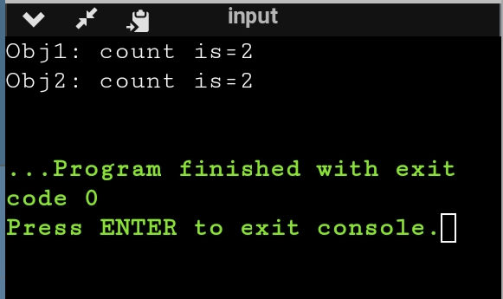

17.Demonstrate the use of static method.

class StaticTest {

// static method

static int add(int a, int b){

return a + b;

}

}

public class Main {

public static void main( String[] args ) {

StaticTest st = new StaticTest();

System.out.println(" 2 + 3 = " + StaticTest.add(2,3));

}

}

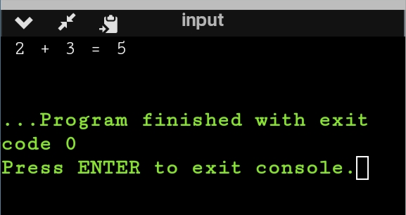

18.Demonstrate the use of Scanner class for taking input/output from user.

import java.util.Scanner;

public class A{

public static void main(String[] args){

Scanner sc=new Scanner(System.in);

System.out.println("Enter any number:");

int n=sc.nextInt();

System.out.println("The number is"+n);

}

}

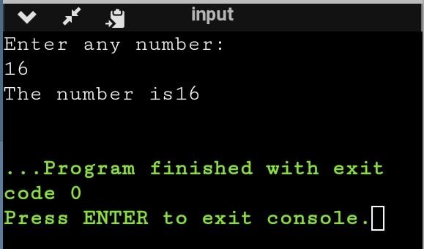

19.Light Program

import java.util.Scanner;

public class Light{

boolean isOn;

void switchOn(){

isOn=true;

System.out.println(isOn);

}

void switchOff(){

isOn=false;

System.out.println(isOn);

}

public static void main(String[] args){

Light led =new Light();

Light halogen=new Light();

led.switchOn();

halogen.switchOff();

System.out.println(led.isOn);

}

}

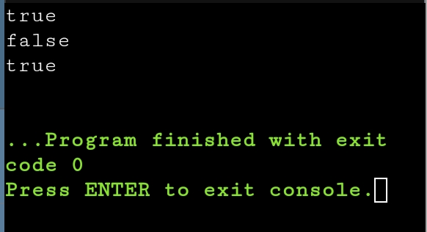

20.Create a class Box

public class Box{

private int height;

private int length;

private int breadth;

Box(){

height=0;

length=0;

breadth=0;

}

Box(int height,int length,int breadth){

this.height=height;

this.length=length;

this.breadth=breadth;

}

public int Volume(){

return(length\*breadth\*height);

}

public static void main(String[] args){

Box cuboid1=new Box();

System.out.println("The area of cuboid is"+cuboid1.Volume());

Box cuboid2=new Box(10,15,30);

System.out.println("The area of cuboid is"+cuboid2.Volume());

}

}

