

**A PROJECT REPORT ON**

**Floor Cleaning Robot**

SUBMITTED BY

**Vinayak Nitin Renukdas**

**Aditya Avinash Bodhi**

**Ghananshu Gajendra Desale**

UNDER THE GUIDANCE OF

**Prof. Sagar Joshi:**



**Department of Robotics & Mechatronics**

**INSTITUTE FOR DESIGN OF ELECTRICAL**

**MEASURING INSTRUMENTS**

SWATANTRAVEER TATYA TOPE MARG, CHUNABHATTI,

SION, MUMBAI-400022



**CERTIFICATE**

This to certify that

**Vinayak Nitin Renukdas**

**Aditya Avinash Bodhi**

**Ghananshu Gajendra Desale**

have undertaken this project **“Floor Cleaning Robot”** under our guidance as prescribed by the IDEMI, as the curriculum for the Diploma in Robotics & Mechatronics for the academic year 2024-2025

**Project Guide HOD**

**Prof. Sagar Joshi Diploma in Robotics Mechatronics**

**Examiner**



**Date -___________**

**DECLARATION**

We declare that this written submission represents our ideas in our own words and where others’ ideas and words have been included. We have adequately cited and referenced the original sources. We also declare that we adhered to all principles of academic honesty and integrity and have not misinterpreted or fabricated or falsified any idea/data/fact/source in our submission. We understand that any violation of the above will be cause for disciplinary action by the institute and can also evoke penal action from then sources which have thus not been properly cited or from whom proper permission has not been taken when required.

**Vinayak Renukdas Aditya Bodhi Ghananshu Desale**



**Acknowledgement**

It is our privilege to express our sincerest regard to our project guide **Prof. SAGAR JOSHI** who gave us the golden opportunity to do this wonder project on the topic **Floor Cleaning Robot** for his valuable inputs, guidance and encouragement, whole-hearted cooperation and constructive criticism throughout the duration of our project. We deeply express our sincere thanks to our HOD of Diploma in Robotics & Mechatronics for encouraging and allowing our department premises for the partial fulfilment of the requirements. We also extend our deepest gratitude to all the esteemed faculty members and dedicated workers who credited their invaluable expertise and support to this project. Last but not least we express our sincere thanks to all our friends and our parents who have patiently extended all sorts of help for accomplishing this undertaking.



Project Details

**Project Name: Floor Cleaning Robot**

**Group Members:**

|  |  |  |
| --- | --- | --- |
| Sr. no | Name | Enrolment no. |
| 1 | Vinayak Renukdas | 2111011 |
| 2 | Aditya Bodhi | 2211011 |
| 3 | Ghananshu Desale | 2212025 |

**Branch: Robotics & Mechatronics**

**Year: Third (Final)**

**Semester: Fifth**

**College Name: Institute for Design of Electrical Measurement Instruments**

**Assigned Faculties: Prof. Sagar Joshi**

**Project Duration: August 2024 – December 2024**



**Table of content**

Table of content………………………………………………………………6

Bill of material……………………………………………………………….7

Aim of the project……………………………………………………………8

Key factors of consideration…………………………………………………9

Process of making…………………………………………………………..10

Block diagram………………………………………………………………11

Electronic components……………………………...………………………13

Arduino nano……………………………………………………………….13

L298N motor driver………………………………………………………...16

HC-05 bluetooth module……………………………………………………18

HCSR-04 ultrasonic sensor…………………………………………………20

Relay module……………………………………………………………….22

Submersible pump………………………………………………………….24

Circuit diagram……………………………………………………………..26

Program……………………………………………………………………..27

Project snapshots……………………………………………………………33

Working……………………………………………………………………..34

Conclusion………………………………………………………………….35

References…………………………………………………………………..36



**Bill of material**

|  |  |  |  |
| --- | --- | --- | --- |
| **Sr. no.** | **Component** | **Quantity** | **Price (₹)** |
| 1 | Arduino Nano | 1 | 200 |
| 2 | L298N Motor Driver | 1 | 143 |
| 3 | HC-05 Bluetooth Module | 1 | 218 |
| 4 | HCSR-04 Ultrasonic Sensor | 1 | 55 |
| 5 | Relay Module | 1 | 33 |
| 6 | Dual Shaft DC Motors | 4 | 236 |
| 7 | Submersible Pump | 1 | 40 |
| 8 | Switch | 1 | 25 |
| 9 | 3.7V Li-ion Cells | 4 | 160 |
| 10 | 18650 Cell Holder | 1 | 40 |
| 11 | Zero PCB | 1 | 38 |
| 12 | Female Header Pins | 2 | 40 |
| 13 | Rubber Wheels | 4 | 140 |
| 14 | A4 Size Acrylic sheet | 1 | 240 |
| 15 | Rubber tube | 1 | 50 |
| **Total**  **Price** |  |  | **1658** |



**Aim of the Project**

Our project’s primary goal was to advance our technical skills and knowledge while contributing to societal welfare. This project is budget friendly as well as beginner friendly from the perspective of someone who wants to learn about robotics and mechatronics. The emphasis was on expanding our knowledge and skills in mechanical, electronic and software engineering aspects

**Initiation of the Idea**

The idea for this project was conceived with the intent to develop a practical yet innovative solution to simplify daily cleaning tasks. Observing the increasing demand for automation and efficiency in routine chores, we aimed to design a versatile cleaning robot that integrates basic robotics and mechatronics principles. The concept evolved from the desire to create a functional prototype that not only showcases technical feasibility but also serves as an educational tool for aspiring engineers. The focus was on using readily available and budget-friendly components to ensure accessibility and replicability for beginners in the field.



**Key Factors of Consideration**

**Control System:** A robust control system was implemented to manage the operation of sensors and actuators. It ensured precise coordination and smooth functionality.

**Programming:** The robot was programmed with logical algorithms for movement control, obstacle detection, and mode switching. The code was designed to be efficient, modular, and easy to debug.

**Power Supply Management**: Efficient power management was prioritized to maintain consistent performance and ensure that all components operated reliably within their power limits.

**Sensors & Feedback**: Sensors were integrated for obstacle detection, enabling the robot to navigate its environment effectively and avoid collisions.

**Communication Interface:** A wireless communication interface was included to allow remote operation of the robot, providing a user-friendly control method.

**Mechanical Design:** The robot's mechanical design was optimized for cleaning efficiency and manoeuvrability, with careful placement of motors, sponges, and structural components.

**Modular Integration**: The system was built with modularity, enabling easy replacement or upgrading of individual components without affecting overall functionality.



**Process of Making**

**Conceptualization:** The project began with brainstorming ideas for the floor cleaning robot, focusing on its dual functionality as both a remote-controlled and autonomous mobile system. The aim was to design a robot that could navigate independently, detect obstacles, and perform cleaning tasks efficiently.

**Design:** In the design phase, we created a detailed block diagram of the robot's control system. This diagram helped in understanding how each component would interact with others, providing a clear roadmap for the system’s functionality. Based on the design, we could visualize the necessary features and functions, which guided the selection of specific components.

**Component Selection:** Once the control system was mapped out, we moved to selecting the appropriate components. We carefully chose motors, sensors, the microcontroller, and other electronic components based on their compatibility and functionality. The goal was to ensure seamless communication between all parts, balancing performance with budget.

**Assembly:** With all the components ready, we began assembling the robot. This step involved attaching motors to the robot’s frame, ensuring a stable foundation for movement. We also soldered header pins onto the PCB and connected the components using wires as per the circuit diagram. Careful attention was given to the wiring to avoid loose connections or interference.

**Programming**: After the assembly, we moved on to the programming phase. We first wrote and tested individual programs for each component, such as motor control and sensor integration. Once we were confident in the performance of each component, we integrated all the individual programs into one program for the robot and uploaded it using the IDE.



**Testing & Troubleshooting:** With the robot assembled and programmed, we conducted extensive testing. Each component was tested separately to ensure functionality, and then the entire robot was tested as a whole. We observed how the components interacted, verifying that the robot behaved as expected. Any issues, such as design flaws, loose connections, or programming errors, were promptly identified and resolved through troubleshooting.

**Documentation:** Throughout the process, we maintained thorough documentation. This included detailed notes on the design, assembly steps, component selection, wiring diagrams, and programming. Additionally, a comprehensive user manual was created to guide future users in building, using, and maintaining the robot.



**Block Diagram**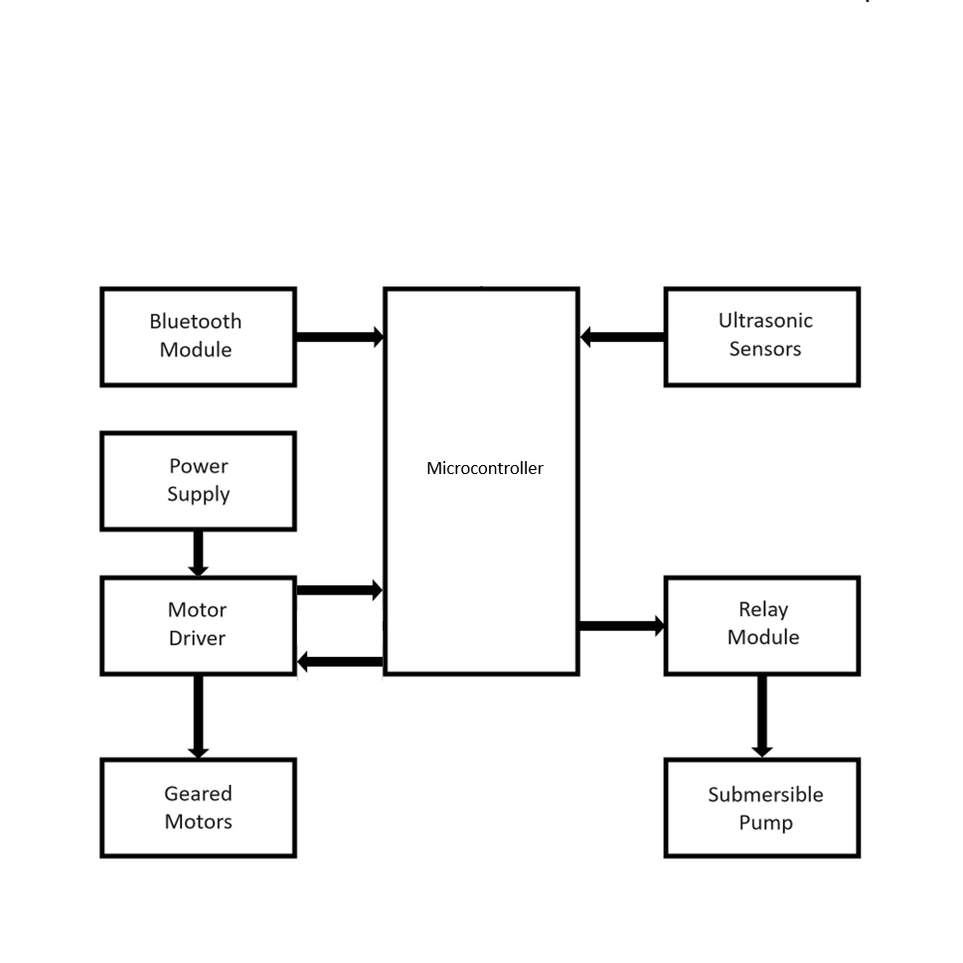



**Electronic Components**

**Arduino Nano**

Arduino Nano is an intelligent development board designed for building faster prototypes with the smallest dimension. Arduino Nano being the oldest member of the Nano family, provides enough interfaces for your breadboard-friendly applications. At the heart of the board is ATmega328 microcontroller clocked at a frequency of 16 MHz featuring more or less the same functionalities as the Arduino UNO**. (1)**

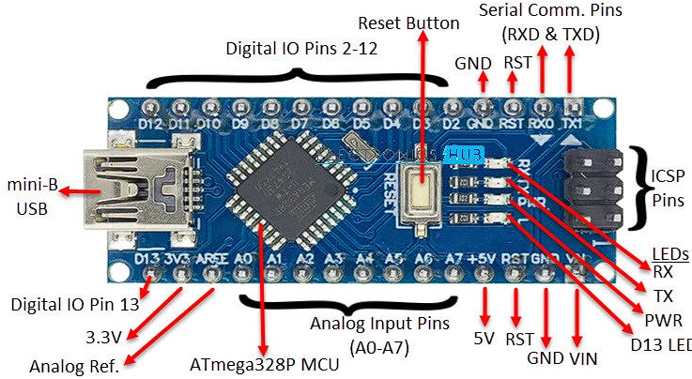



**Specifications**

ATmega328 Microcontroller

High-performance low-power 8-bit processor

Achieve up to 16 MIPS for 16 MHz clock frequency

32 kB of which 2 KB used by bootloader

2 kB internal SRAM 1 kB

EEPROM

32 x 8 General Purpose Working Registers

Real Time Counter with Separate Oscillator

Six PWM Channels

Programmable Serial USART

Master/Slave SPI Serial Interface

**Power**

Mini-B USB connection

7-15V unregulated external power supply (pin 30)

5V regulated external power supply (pin 27)



**Sleep Modes**

Idle

ADC Noise Reduction

Power-save

Power-down

Standby

Extended Standby

**I/O**

20 Digital

8 Analog

6 PWM Output



**L298N Motor Driver**

This dual bidirectional motor driver, is based on the very popular L298 Dual H-Bridge Motor Driver Integrated Circuit. The circuit will allow you to easily and independently control two motors of up to 2A each in both directions. It is ideal for robotic applications and well suited for connection to a microcontroller requiring just a couple of control lines per motor. It can also be interfaced with simple manual switches, TTL logic gates, relays, etc. This board equipped with power LED indicators, on-board +5V regulator and protection diodes. **(2)**

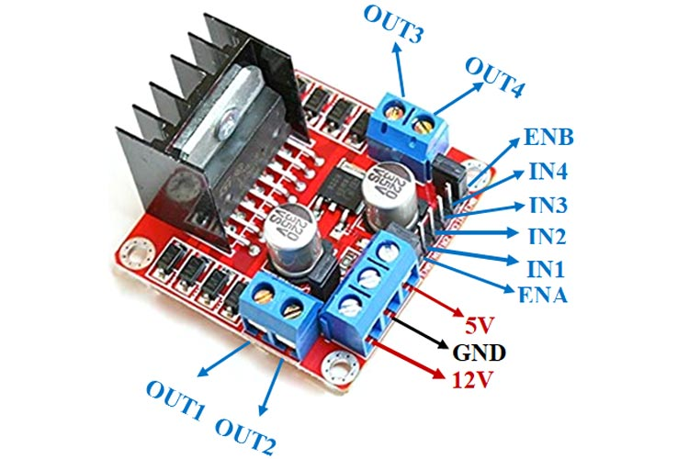



**Specifications**

**Input voltage:** 3.2V – 40V DC

**Driver:** L298N Dual H Bridge DC Motor Driver

**Peak current:** 2A

**Operating current range:** 0 - 36mA

**Control signal input voltage range:**

**Low:** -0.3V ≤ Vin ≤ 1.5V.

**High:** 2.3V ≤ Vin ≤ Vss.

**Enable signal input voltage range:**

**Low:** -0.3 ≤ Vin ≤ 1.5V (control signal is invalid)

**High:** 2.3V ≤ Vin ≤ Vss (control signal active)

**Maximum power consumption:** 20W (when the temperature T = 75 ℃) **Storage temperature:** -25 ℃ ~ +130 ℃



**HC-05 Bluetooth Module**

HC-05 module is an easy-to-use Bluetooth SPP (Serial Port Protocol) module, designed for transparent wireless serial connection setup. Serial port Bluetooth module is fully qualified Bluetooth V2.0+EDR (Enhanced Data Rate) 3Mbps Modulation with complete 2.4GHz radio transceiver and baseband. It uses CSR Bluecore 04-External single chip Bluetooth system with CMOS technology and with AFH (Adaptive Frequency Hopping Feature). It has the footprint as small as 12.7mmx27mm. Hope it will simplify your overall design/development cycle. **(3)**

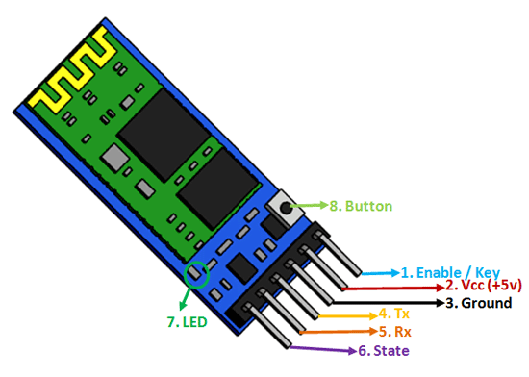



**Hardware features**

Typical -80dBm sensitivity

Up to +4dBm RF transmit power

Low Power 1.8V Operation ,1.8 to 3.6V I/O

PIO control

UART interface with programmable baud rate

With integrated antenna

With edge connector

**Software features**

Default Baud rate: 38400, Data bits:8, Stop bit:1, Parity: No parity, Data control: has. Supported baud rate: 9600,19200,38400,57600,115200,230400,460800

Given a rising pulse in PIO0, device will be disconnected

Status instruction port PIO1: low-disconnected, high-connected

PIO10 and PIO11 can be connected to red and blue led separately. When master and slave are paired, red and blue led blinks 1time/2s in interval, while disconnected only blue led blinks 2times/s.

Auto-connect to the last device on power as default

Permit pairing device to connect as default

Auto-pairing PINCODE:”0000” or “1234” as default

Auto-reconnect in 30 min when disconnected as a result of beyond the range of connection



**HC-SR04 Ultrasonic Sensor**

Ultrasonic ranging module HC - SR04 provides 2cm - 400cm non-contact measurement function, the ranging accuracy can reach to 3mm. The modules include ultrasonic transmitters, receiver and control circuit. **(4)**

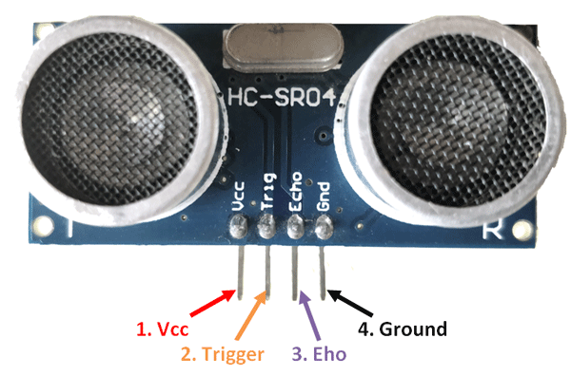



**Specifications**

**Working Voltage:** DC 5 V

**Working Current:** 15mA

**Working Frequency:** 40Hz

**Max Range:** 4000 mm

**Min Range**: 20 mm

**Measuring Angle:** 15 degrees

**Trigger Input Signal:** 10uS TTL pulse

**Echo Output Signal Input:** TTL lever signal and the range in proportion



**Relay Module**

Relay is an electromechanical device that uses an electric current to open or close the contacts of a switch. The single-channel relay module is much more than just a plain relay, it comprises of components that make switching and connection easier and act as indicators to show if the module is powered and if the relay is active or not. **(5)**

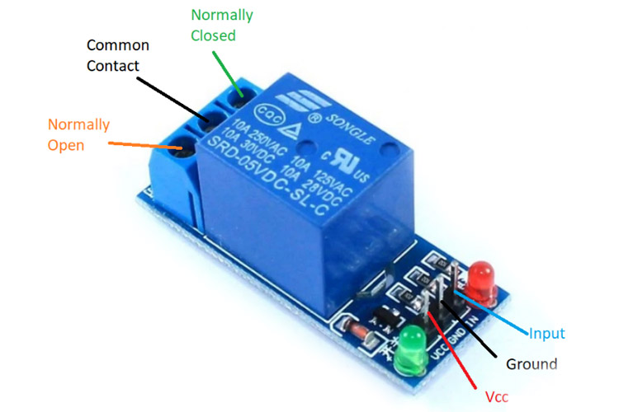



**Specifications**

**Supply voltage:** 3.75V to 6V

**Quiescent current:** 2mA

**Current when the relay is active:** 70mA

**Relay maximum contact voltage:** 250VAC or 30VDC

**Relay maximum current:** 10A



**Submersible Pump**

The submersible pump used in the project is a compact, DC-powered device designed for low-pressure liquid dispensing applications. It operates autonomously, controlled by the relay module, to dispense cleaning liquid for a particular time interval. Its small size and lightweight design make it ideal for integration into robotics and automation systems. **(6)**

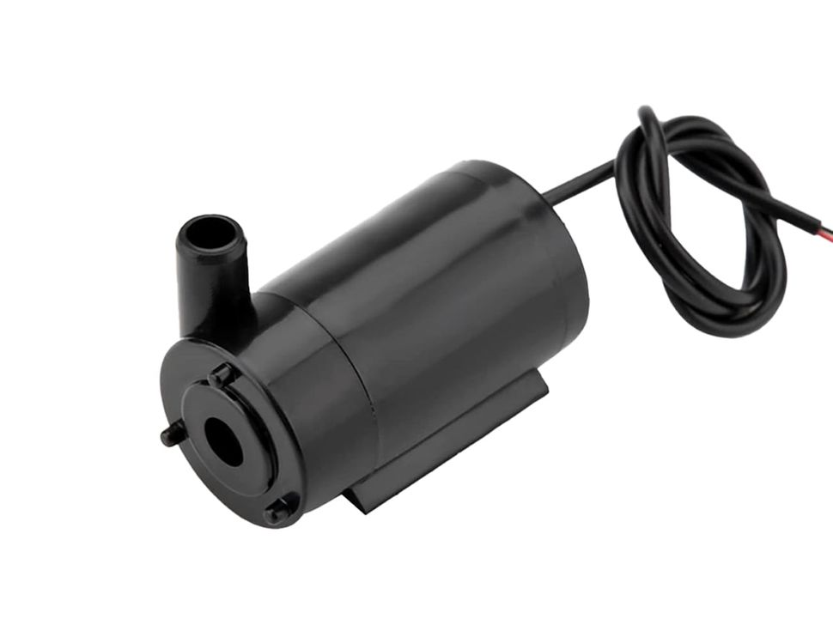



**Specifications**

**Voltage rating:** 2.5 – 6V

**Flow rate:** 80 – 120 L/Hr

**Maximum lift:** 400 – 1100 mm



**Circuit Diagram**

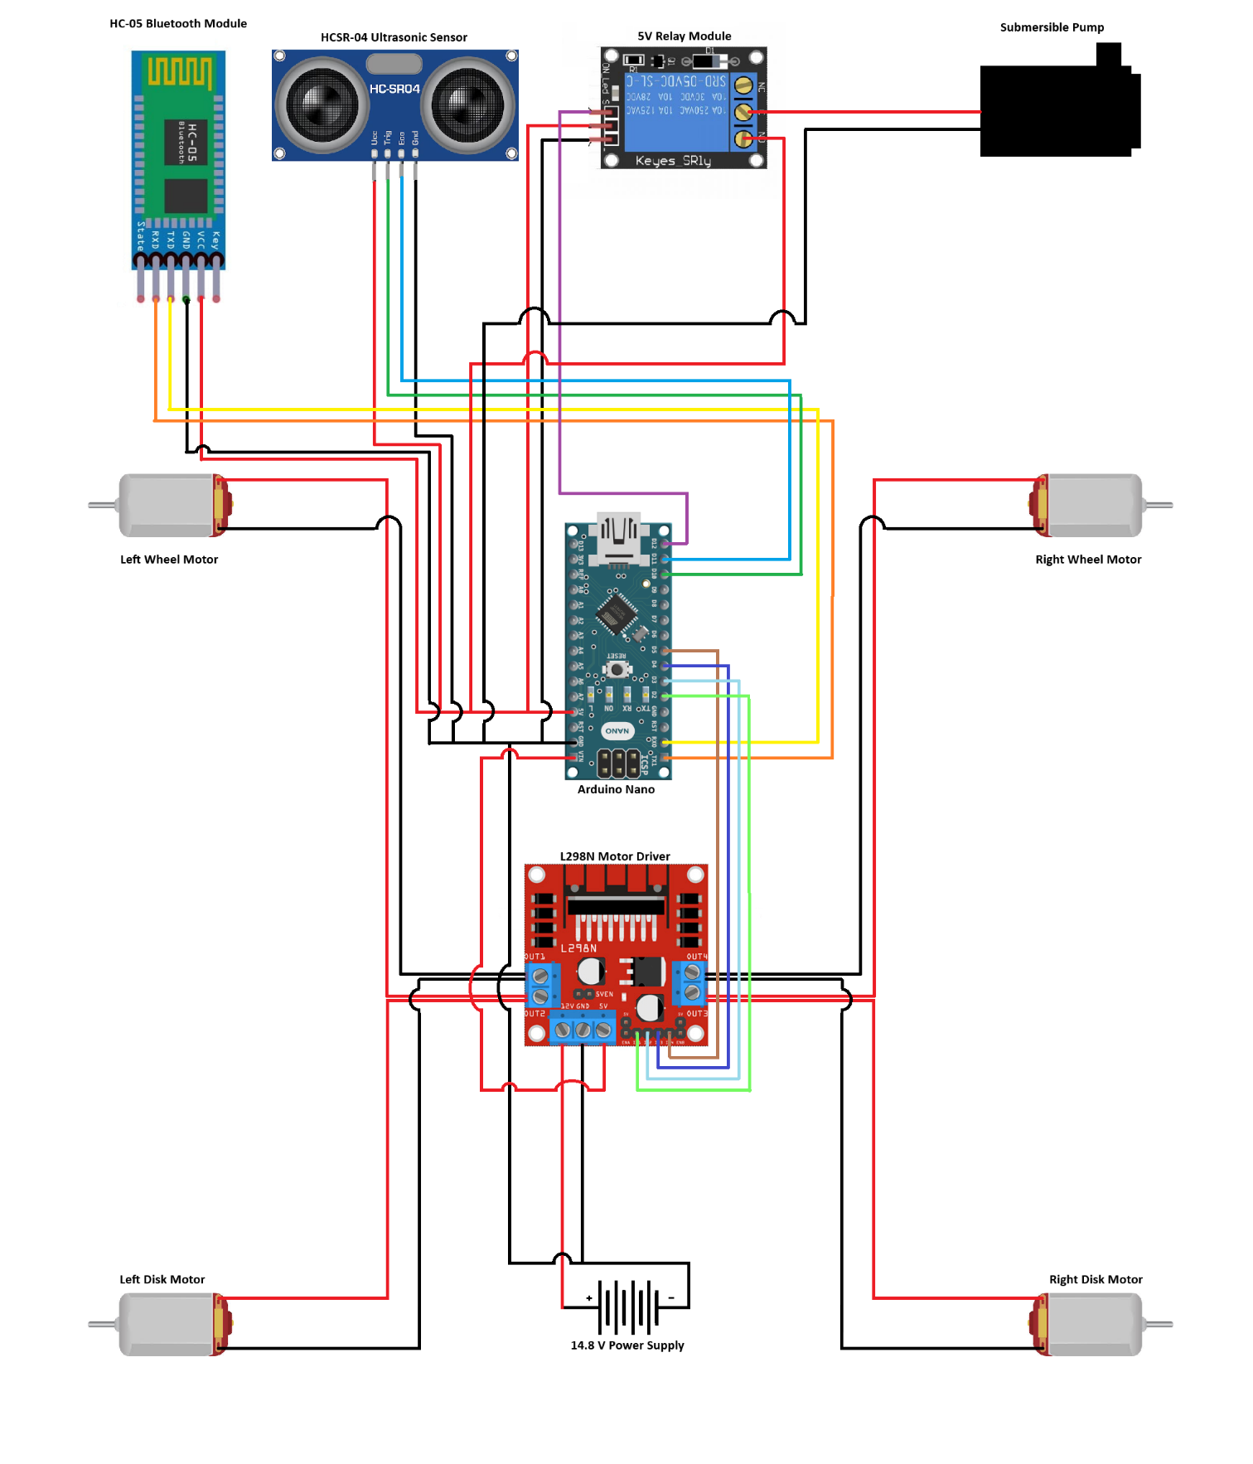



**Program**

// Motor control pins

#define IN1 2

#define IN2 3

#define IN3 4

#define IN4 5

// Ultrasonic sensor pins

#define TRIG_PIN 10

#define ECHO_PIN 11

// Relay control pin

#define RELAY_PIN 12

// Mode control variables

bool bluetoothMode = true; // Start in Bluetooth mode

// Timer variables for relay control

unsigned long previousMillis = 0; // Stores last time the relay was updated

const long relayOnTime = 2000; // Relay on for 2 seconds

const long relayOffTime = 30000; // Relay off for 30 seconds

bool pumpState = false; // Track the state of the pump (on/off)

void setup() {

  // Motor driver pins

  pinMode(IN1, OUTPUT);

  pinMode(IN2, OUTPUT);

  pinMode(IN3, OUTPUT);

  pinMode(IN4, OUTPUT);

  // Ultrasonic sensor pins

  pinMode(TRIG_PIN, OUTPUT);



 pinMode(ECHO_PIN, INPUT);

  // Relay pin

  pinMode(RELAY_PIN, OUTPUT);

  digitalWrite(RELAY_PIN, LOW); // Ensure pump is off at start

  // Bluetooth communication

  Serial.begin(9600);

}

void loop() {

  // Automated pump control

  unsigned long currentMillis = millis(); // Get current time

  // Check if it's time to change pump state

  if (pumpState) {

    if (currentMillis - previousMillis >= relayOnTime) {

      digitalWrite(RELAY_PIN, LOW); // Turn pump off

      pumpState = false;

      previousMillis = currentMillis; // Reset timer

    }

  } else {

    if (currentMillis - previousMillis >= relayOffTime) {

      digitalWrite(RELAY_PIN, HIGH); // Turn pump on

      pumpState = true;

      previousMillis = currentMillis; // Reset timer

    }

  }

  if (bluetoothMode) {

    // Bluetooth control mode

    if (Serial.available()) {

      char command = Serial.read();



executeBluetoothCommand(command);

    }

  } else {

    // Autonomous mode

    autonomousMode();

  }

}

// Function to execute Bluetooth commands

void executeBluetoothCommand(char command) {

  stopMotors(); // Stop motors before processing command

  switch (command) {

    case 'F': // Move forward

      moveForward();

      break;

    case 'B': // Move backward

      moveBackward();

      break;

    case 'L': // Turn left

      turnLeft();

      break;

    case 'R': // Turn right

      turnRight();

      break;

    case 'S': // Switch to autonomous mode

      bluetoothMode = false;

      break;

    case 'C': // Switch back to Bluetooth mode

      bluetoothMode = true;

      stopMotors();

      break;

    default:



stopMotors();

      break;

  }

}

// Function for autonomous obstacle avoidance

void autonomousMode() {

  while (!bluetoothMode) { // Stay in autonomous mode until 'C' is received

    long distance = measureDistance();

    if (distance < 30) {

      stopMotors();

      delay(500);

      turnLeft();

      delay(1000); // Adjust delay for turning

      stopMotors();

      delay(500);

    } else {

      moveForward();

    }

    // Check if 'C' is received to exit autonomous mode

    if (Serial.available() && Serial.read() == 'C') {

      bluetoothMode = true;

      stopMotors();

      break;

    }

  }

}

// Function to measure distance with ultrasonic sensor

long measureDistance() {

  digitalWrite(TRIG_PIN, LOW);

  delayMicroseconds(2);



digitalWrite(TRIG_PIN, HIGH);

  delayMicroseconds(10);

  digitalWrite(TRIG_PIN, LOW);

  long duration = pulseIn(ECHO_PIN, HIGH);

  long distance = duration * 0.034 / 2; // Convert to cm

  return distance;

}

// Motor control functions

void moveForward() {

  digitalWrite(IN1, HIGH);

  digitalWrite(IN2, LOW);

  digitalWrite(IN3, HIGH);

  digitalWrite(IN4, LOW);

}

void moveBackward() {

  digitalWrite(IN1, LOW);

  digitalWrite(IN2, HIGH);

  digitalWrite(IN3, LOW);

  digitalWrite(IN4, HIGH);

}

void turnLeft() {

  digitalWrite(IN1, LOW);

  digitalWrite(IN2, HIGH);

  digitalWrite(IN3, HIGH);

  digitalWrite(IN4, LOW);

}

void turnRight() {

  digitalWrite(IN1, HIGH);



 digitalWrite(IN2, LOW);

  digitalWrite(IN3, LOW);

  digitalWrite(IN4, HIGH);

}

void stopMotors() {

  digitalWrite(IN1, LOW);

  digitalWrite(IN2, LOW);

  digitalWrite(IN3, LOW);

  digitalWrite(IN4, LOW);

}



**Project Snapshots**

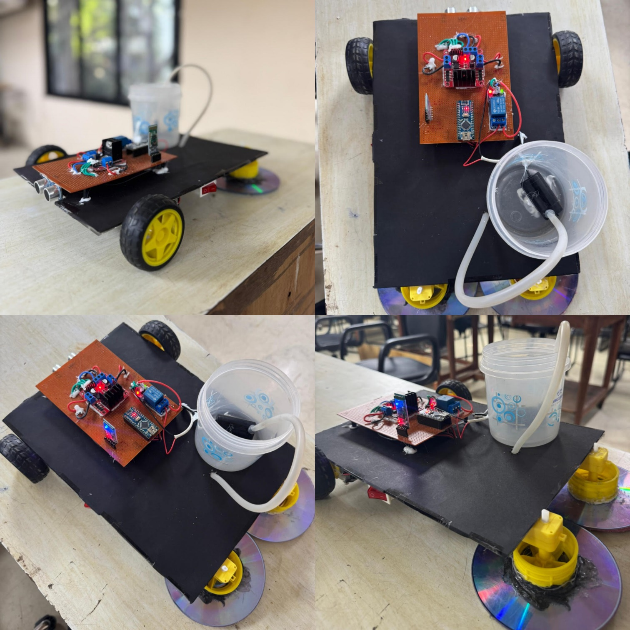



**Working**

Once the power supply is switched on, all the components of the robot activate, and it starts in Bluetooth mode by default. The user must pair their smartphone with the HC-05 Bluetooth module and connect using the Arduino Bluetooth Controller mobile app. When the connection is successful, the Bluetooth module's LED will blink, signalling readiness.

In Bluetooth mode, the user can control the robot's movement using the arrow buttons in the app. Pressing the 'S' button switches the robot to autonomous mode, where it navigates on its own. In autonomous mode, the ultrasonic sensors continuously monitor the surroundings for obstacles. When an obstacle is detected by the front sensor, the robot halts to avoid collision and adjusts its path by turning until it finds a clear route. The user can return to Bluetooth control by pressing the 'C' button in the app.

The cleaning system operates autonomously and does not require manual intervention. The relay module is programmed to activate for two seconds, dispensing cleaning liquid through a tube onto the floor. Afterward, the relay switches off for thirty seconds before repeating the process.

The robot's movement is powered by two front DC motors with wheels, enabling smooth mobility, while two rear DC motors equipped with sponge discs efficiently wipe the floor. This dual cleaning and mobility mechanism ensures effective operation, whether in autonomous or manual mode.



**Conclusion**

This project successfully integrates robotics, automation, and manual control into a single functional cleaning robot. By combining Bluetooth-controlled mobility with autonomous navigation and an automated cleaning mechanism, this robot demonstrates versatility and efficiency. The system can clean floors effectively with minimal human intervention, making it a valuable prototype for household or industrial cleaning applications. The project highlights the practical application of mechatronics and Arduino programming, paving the way for further innovation in robotics and automation.



**References**

1. **Arduino Nano:**

[**https://docs.arduino.cc/resources/datasheets/A000005-datasheet.pdf**](https://docs.arduino.cc/resources/datasheets/A000005-datasheet.pdf)

1. **L298N Motor Driver:** [**https://www.handsontec.com/dataspecs/L298N%20Motor%20Driver.pdf**](https://www.handsontec.com/dataspecs/L298N%20Motor%20Driver.pdf)
2. **HC-05 Bluetooth Module:** [**https://components101.com/sites/default/files/component_datasheet/HC-05%20Datasheet.pdf**](https://components101.com/sites/default/files/component_datasheet/HC-05%20Datasheet.pdf)
3. **HCSR-04 Ultrasonic Sensor:** [**https://cdn.sparkfun.com/datasheets/Sensors/Proximity/HCSR04.pdf**](https://cdn.sparkfun.com/datasheets/Sensors/Proximity/HCSR04.pdf)
4. **5V Relay Module:**

[**https://handsontec.com/dataspecs/relay/1Ch-relay.pdf**](https://handsontec.com/dataspecs/relay/1Ch-relay.pdf)

1. **Submersible Pump:**

**https://techiesms.com/product/submersible-mini-dc-water-pump/**