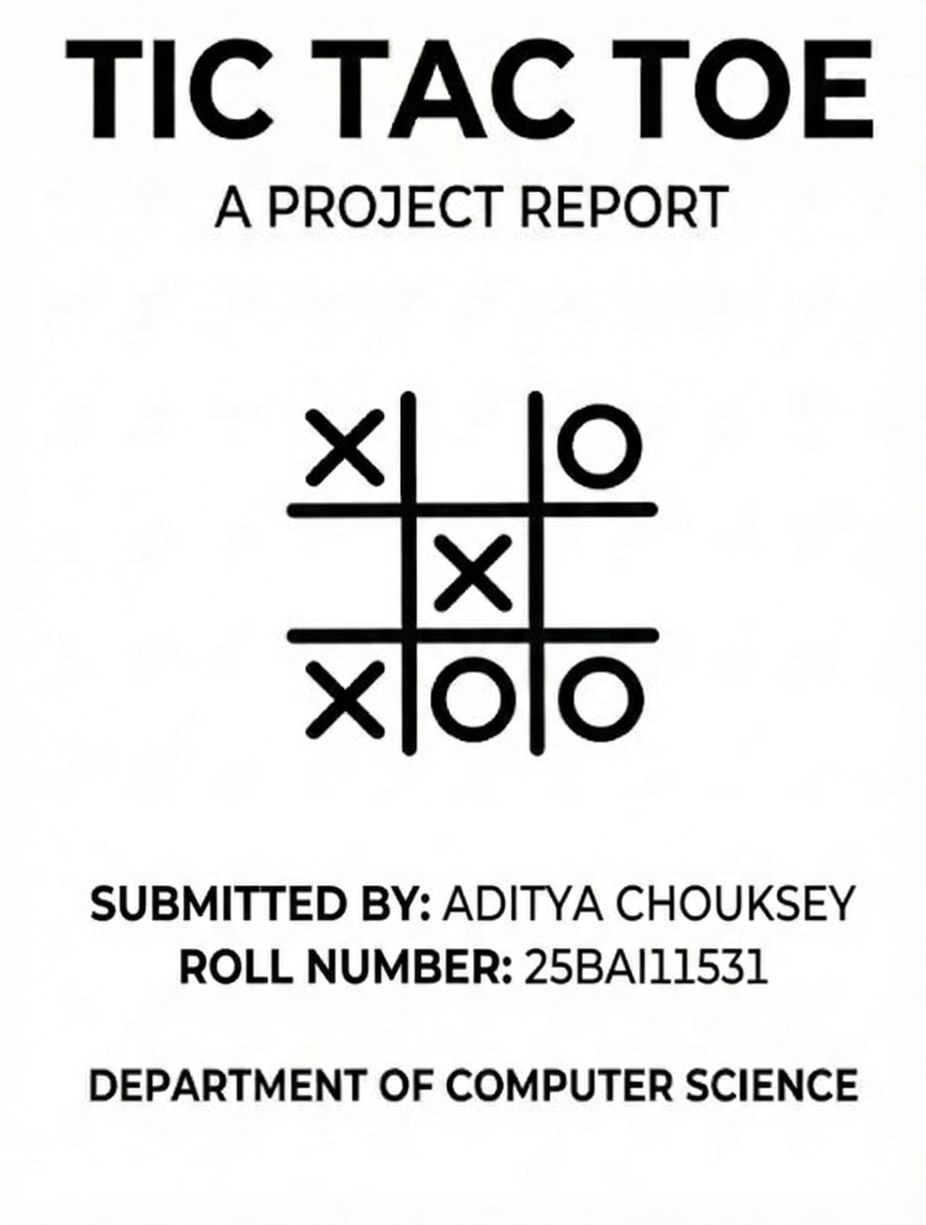

Introduction

The game of Tic-Tac-Toe is an example of a simple task which can be programmed in Python by a beginner.

Atypical Loops, Functions, Conditional statements and Lists are the main features of Python language that are illustrated in the project to have a working game.

Problem Statement

Design and develop a functional Python program that allows two human players to play Tic-Tac-Toe on a 3×3 grid. The system verifies the moves, updates the board, detects the winner, and determines if the match ends in a draw.

Project Overview

Tic-Tac-Toe is a classic game played on a 3×3 grid between two players.
Player X and Player O take turns

We first prompt the users to select the grid positions on 3×3 by entering numbers between 1 and 9. The cell is then put in

The board is updated after every input, and the program verifies a player's win.

Functional Requirements

FR1 – Player Input Module
- Accepts moves (1–9) from Player X and Player O.

- Validates if the position is empty.

FR2 – Board Management Module
- Stores and updates the 3×3 grid using a list.

- Displays board after each turn.

FR3 – Winner/Draw Evaluation Module
- Checks 8 winning combinations (3 rows, 3 columns, 2 diagonals)
TicTacToe_Project_Report

- Declares winner or draw

Non-Functional Requirements

- Usability:
The game must be easy to understand, with clear prompts.

- Reliability:
Should correctly identify all winning patterns and avoid invalid moves.

- Performance:
The program should respond instantly as it is lightweight.

- Maintainability:
Code is modular with separate functions for board display and winner checking.

- Error-Handling:
Prevents invalid inputs (non-numbers / already occupied cells).

System Architecture

Architecture Description
The system follows a simple linear structure:
Player Input → Validation → Update Board → Check Winner → Repeat
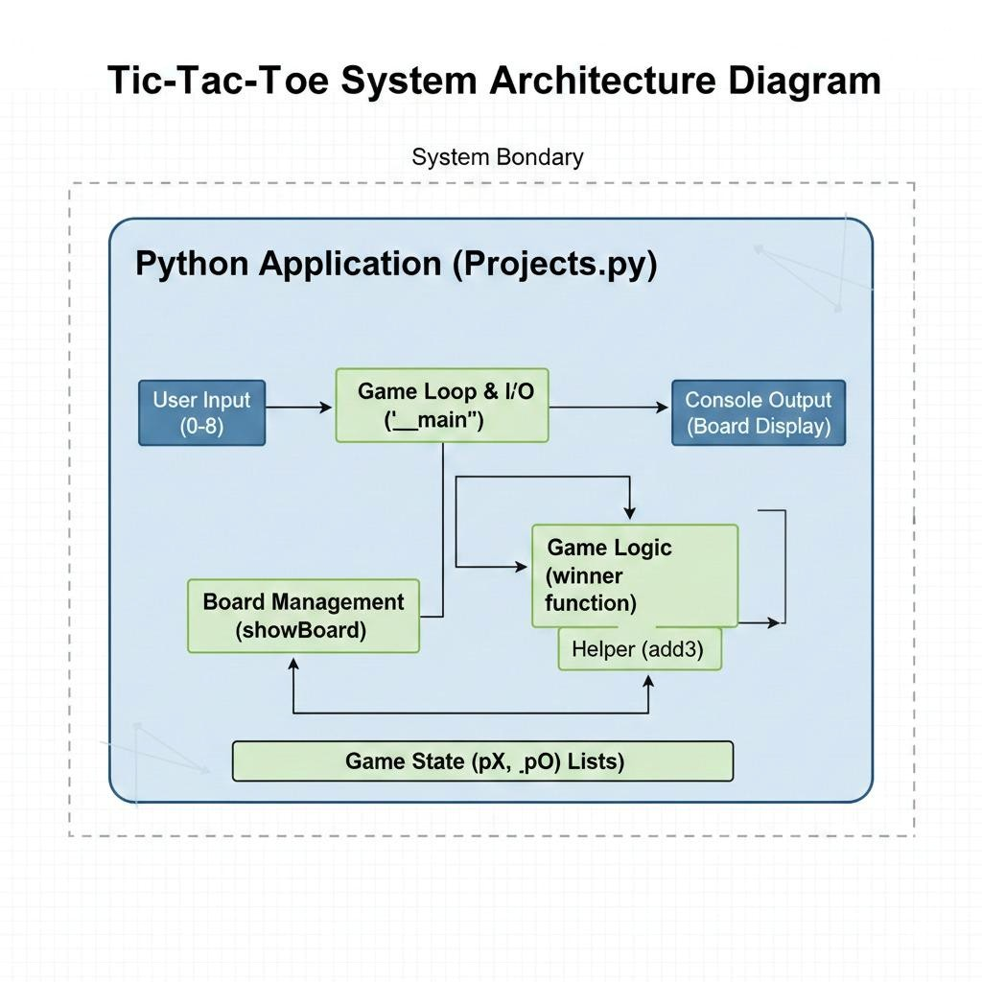

Design Diagram

1. Use Case Diagram

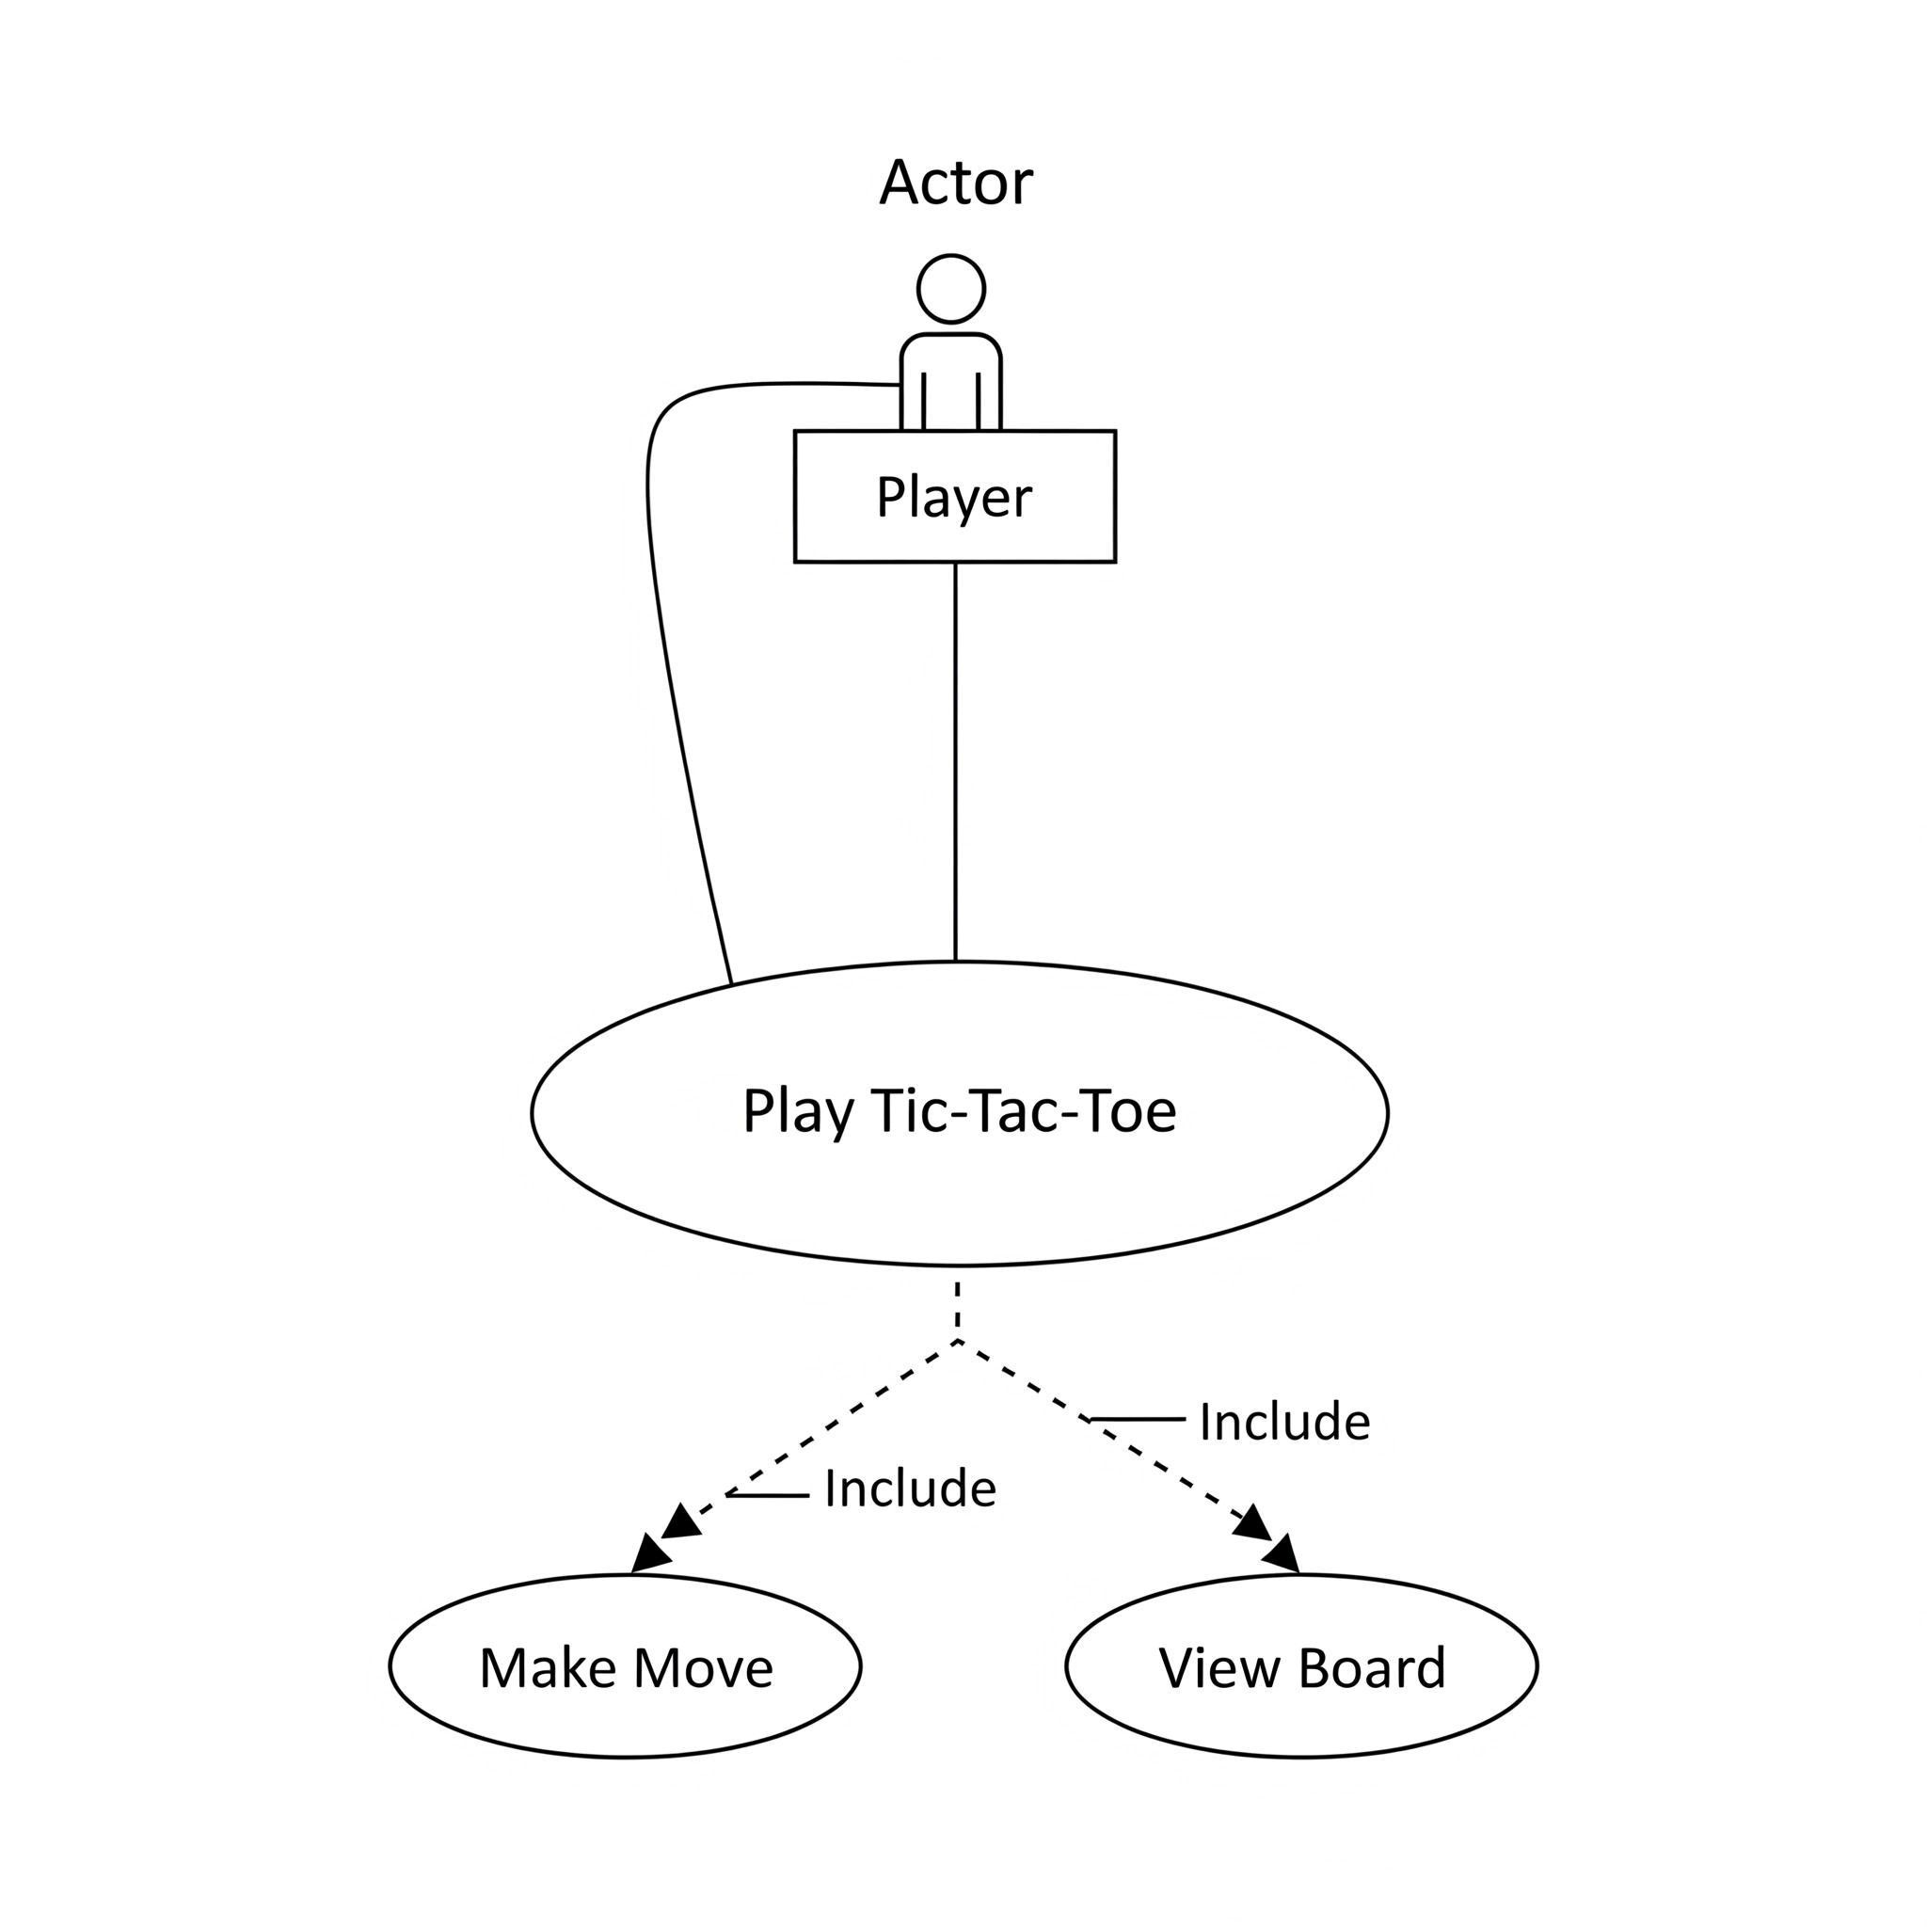

2. Work Flow Diagram
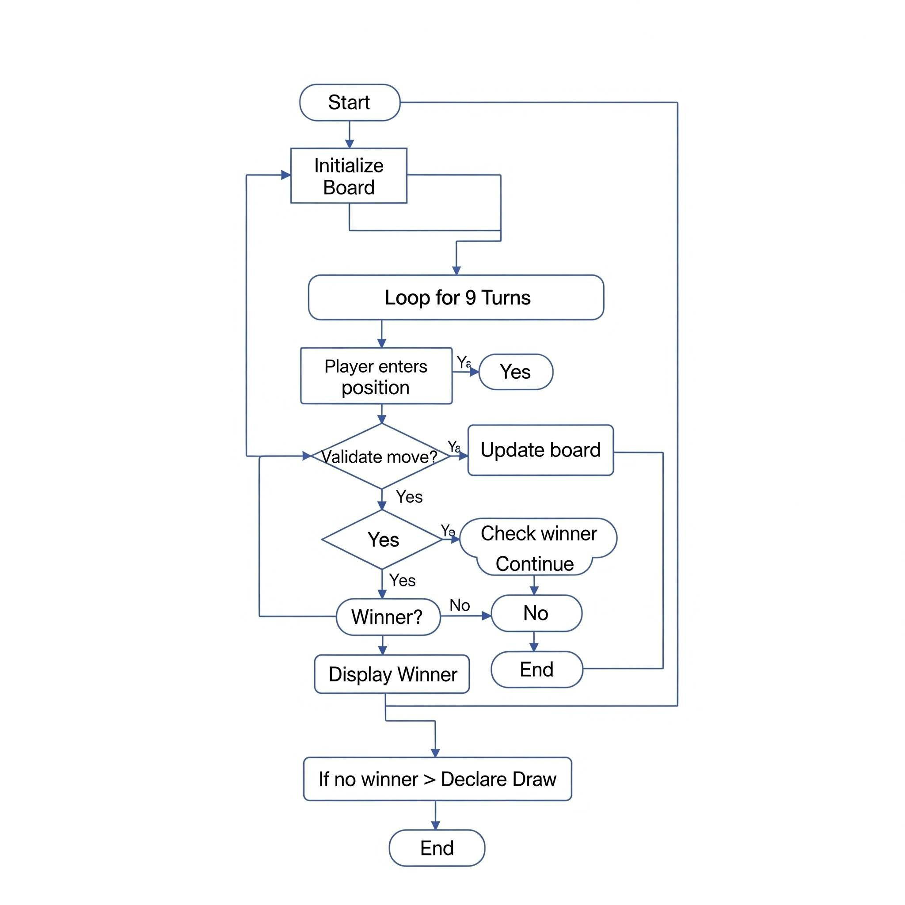

3. Sequence Diagram
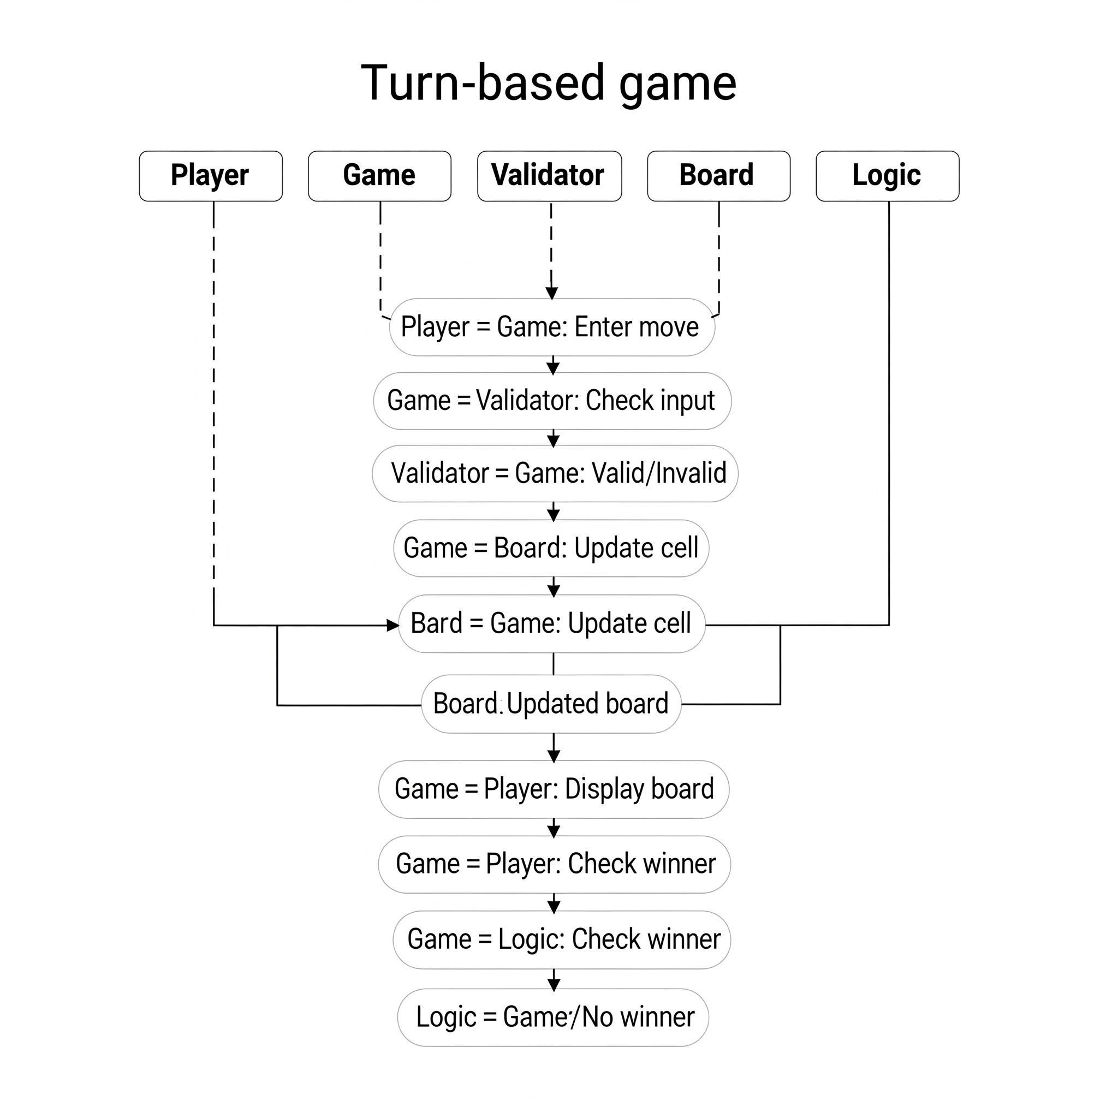

4. Class / Component Diagram

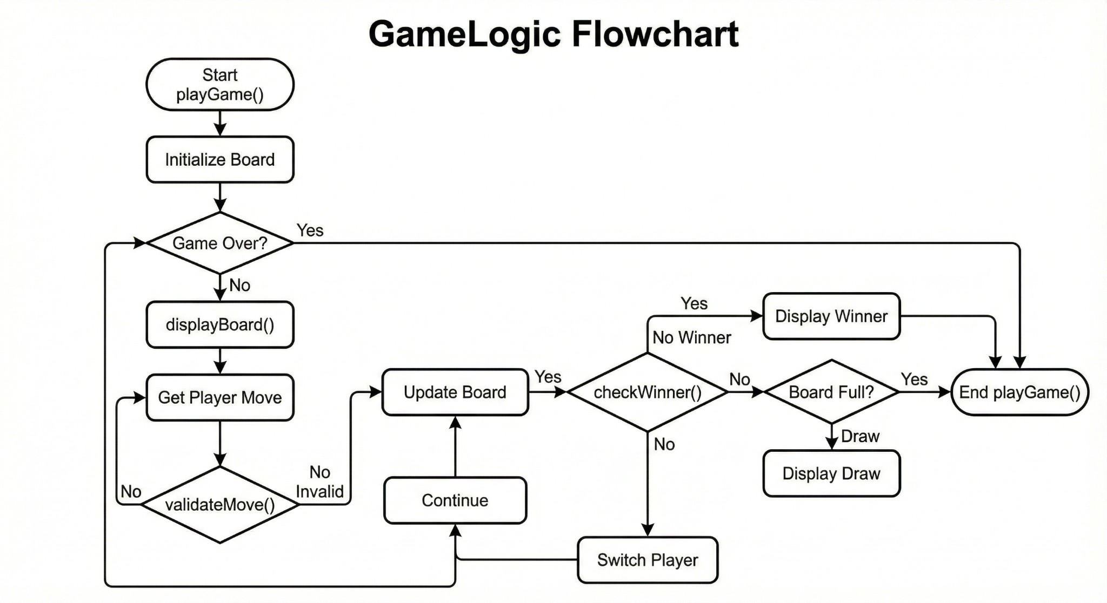

Design Decisions & Rationale

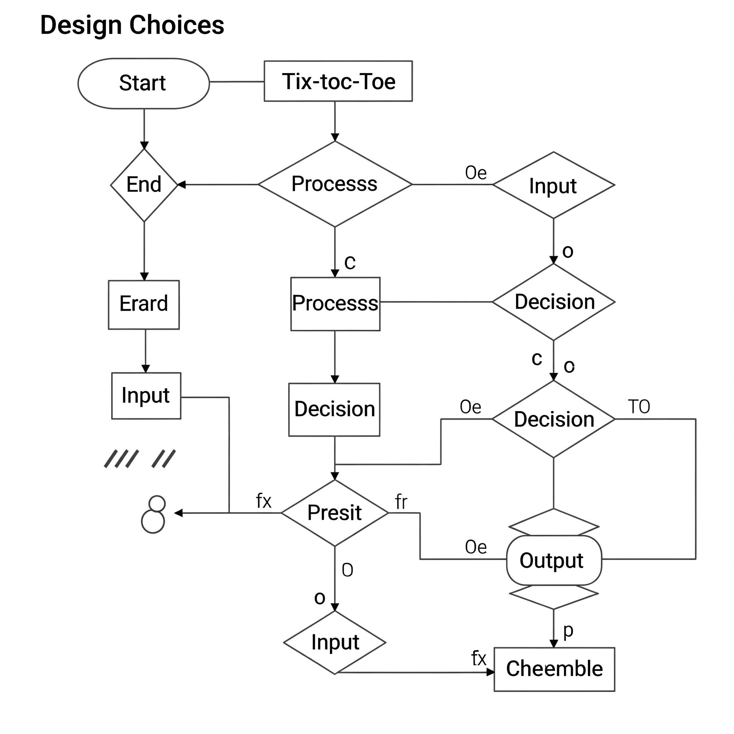

Implementation Details

- Lists: The 3×3 board is a list of 9 elements.

- Functions: Employ to show the board and find the winners.

- Conditionals: Ensure that moves are legit, identify winners, and take care of games that end in a draw.

- Loops: There can be a maximum of 9 turns, thus the game may loop 9 times. Someone may also win before that.

- After the game is initialized, the board is empty. The players decide which numbered position is going to be their move.

- The Program assures the move is legal, and hence the board is updated. It checks all possible winning combinations.

- If none of the combinations satisfy the winning condition and the board is full, the result is a draw.

ScreenShots And Results

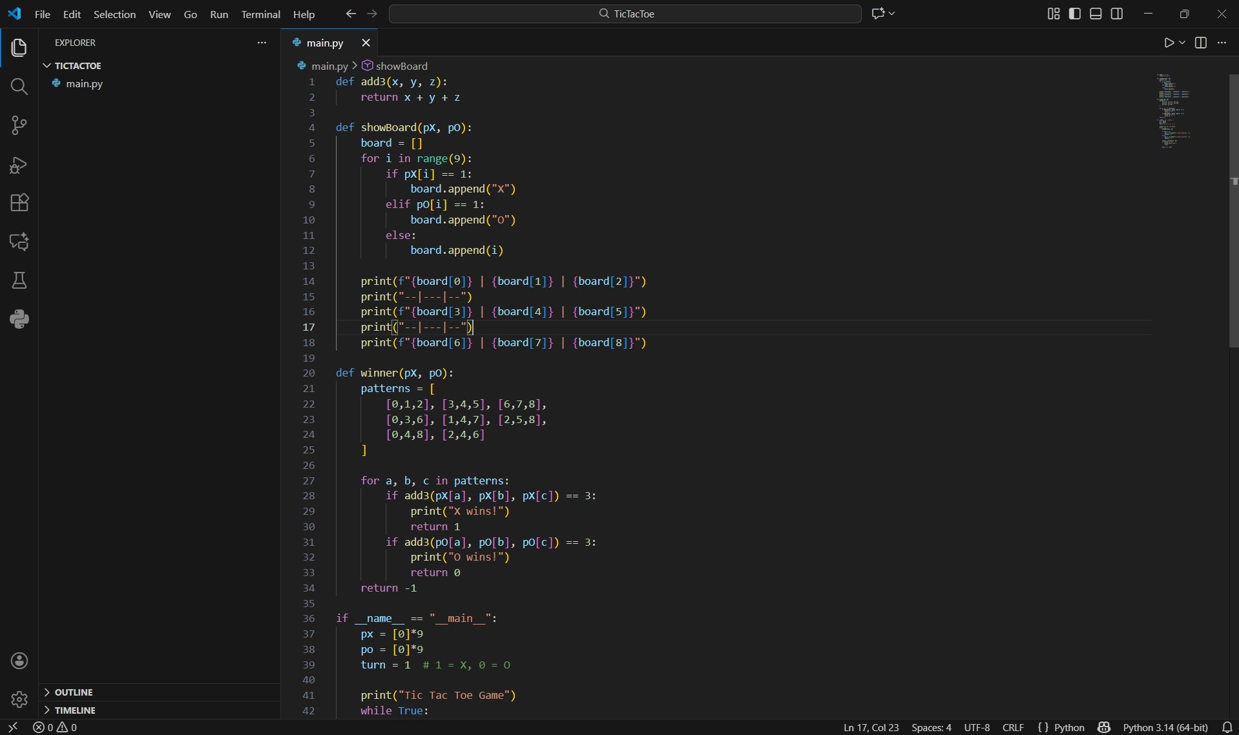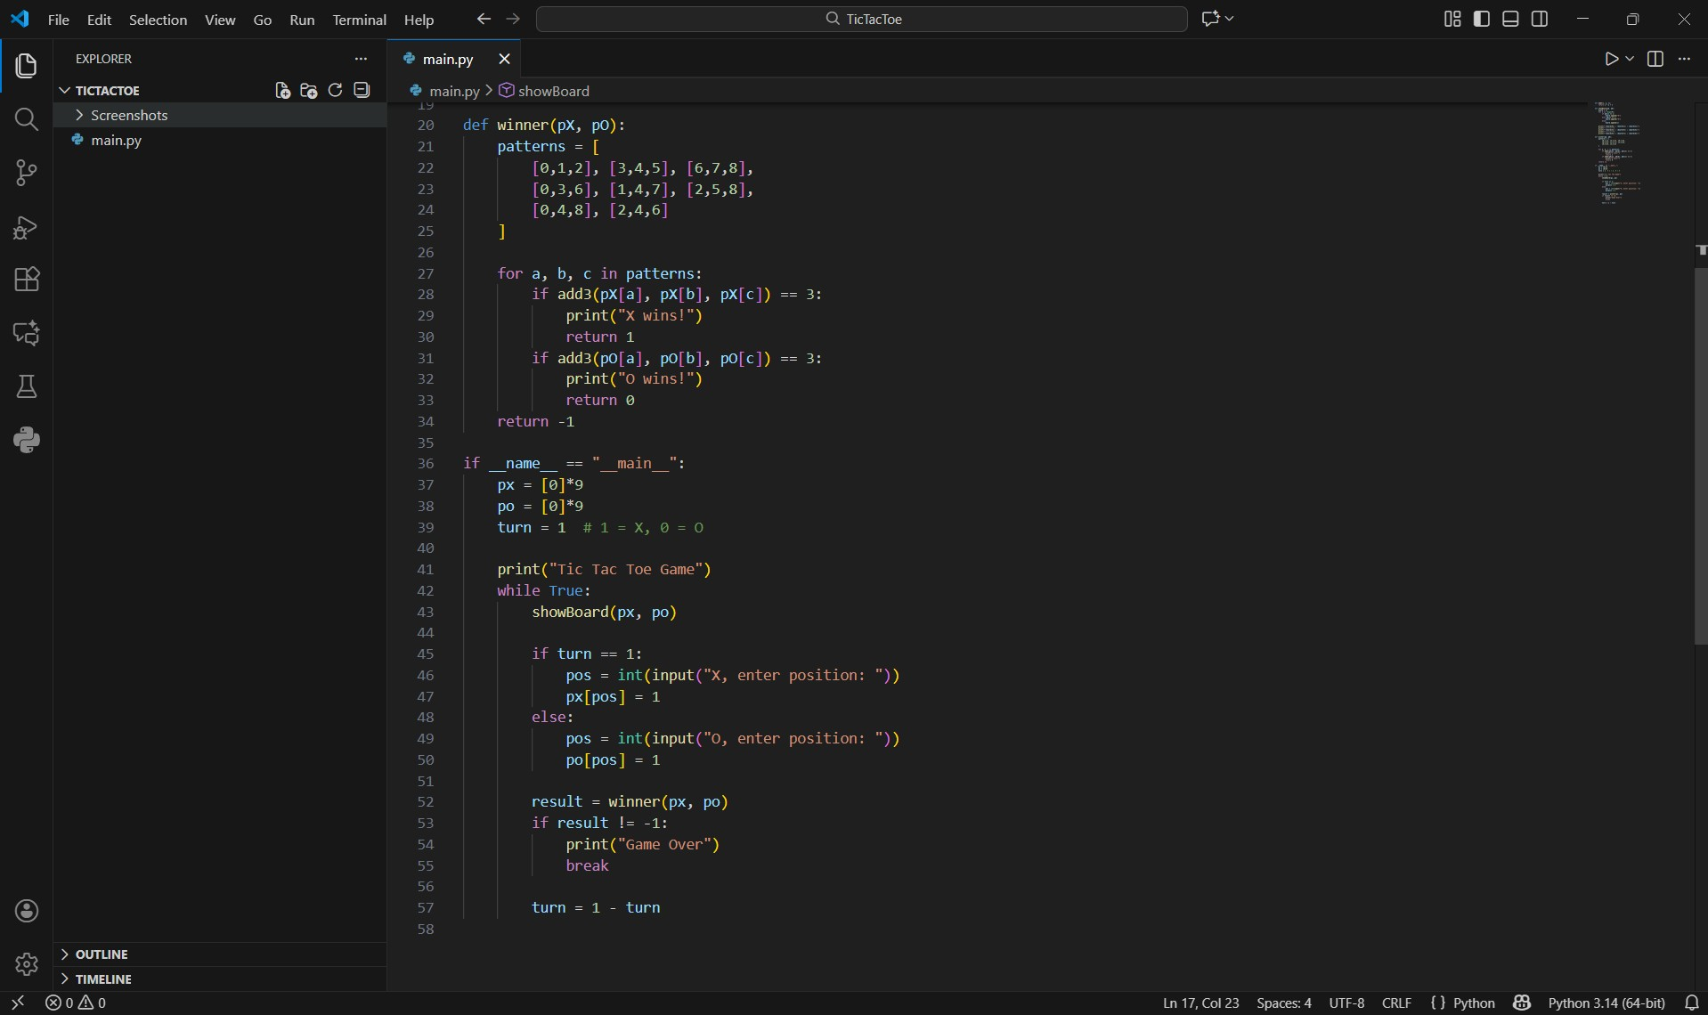

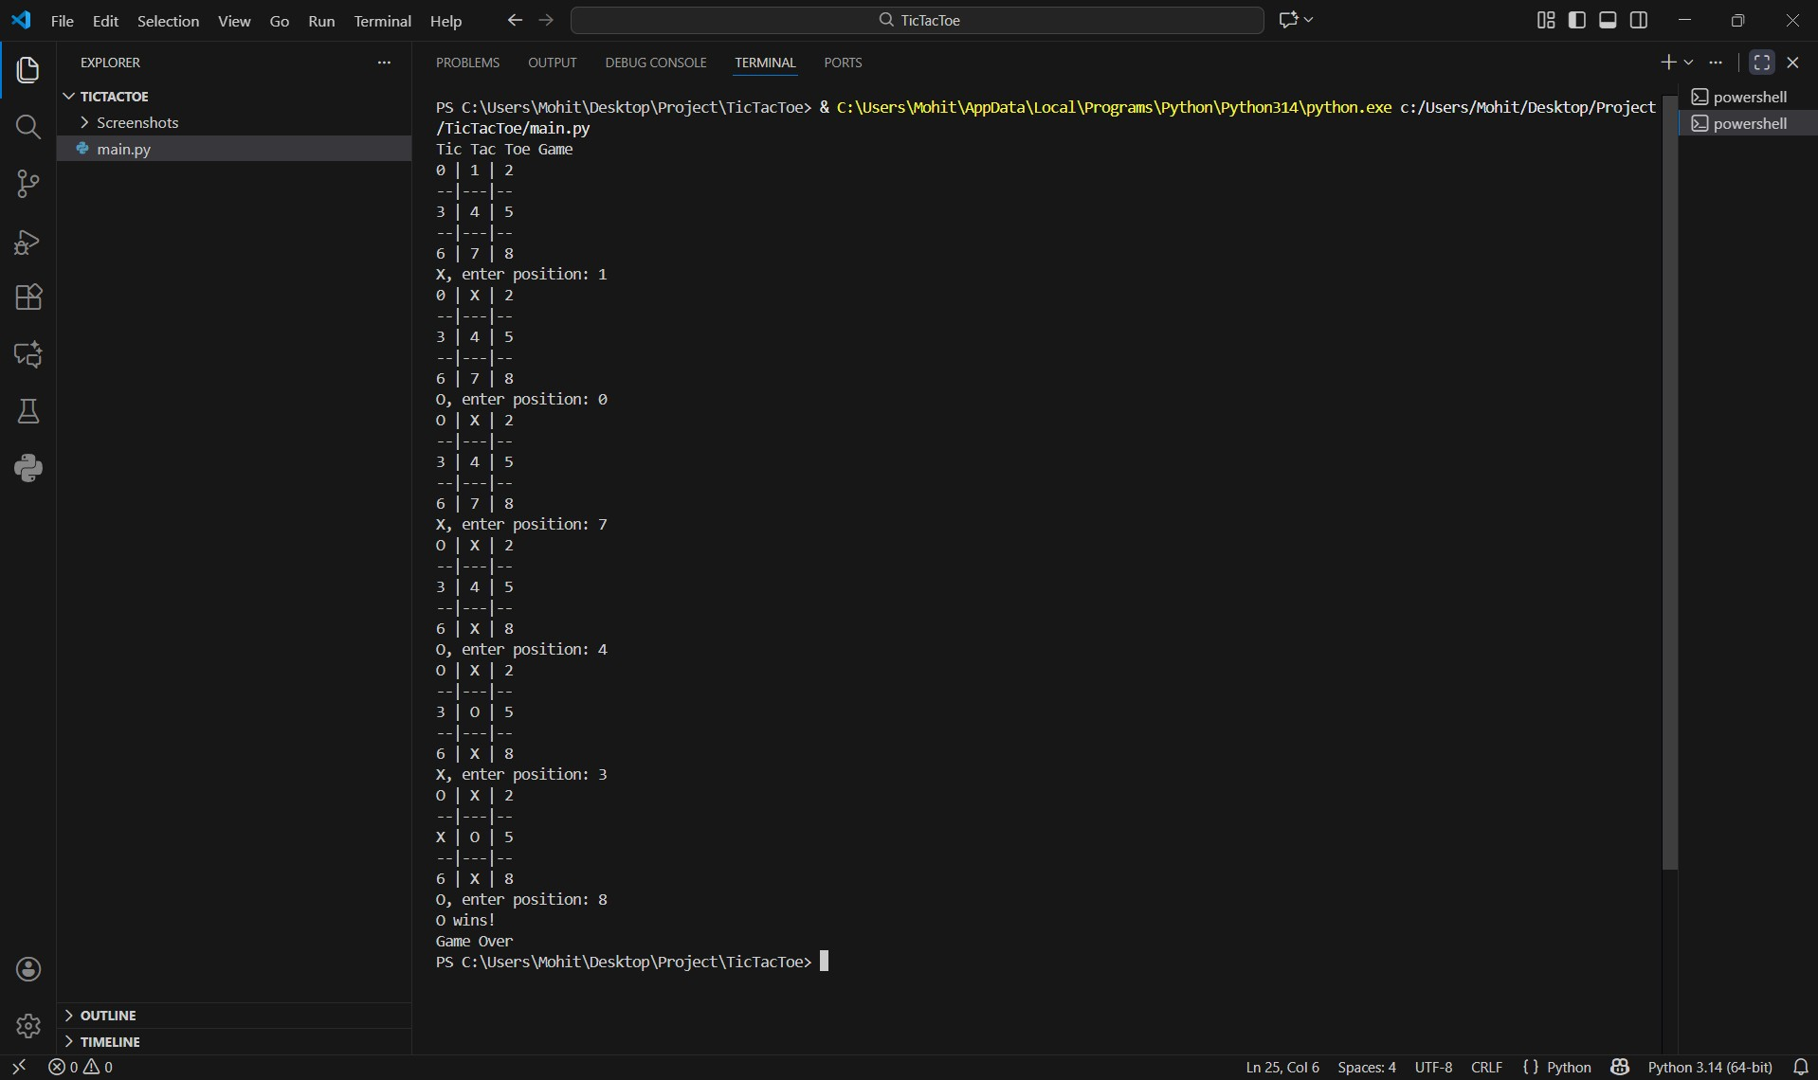

Testing And Approach
- Test valid moves

- Test invalid moves

- Test winning rows/columns/diagonals

- Test draw condition

- Test early termination when winner found

Challenges Faced

- Checking all winning combinations correctly

- Ensuring the program rejects illegal moves

- Making the board display clean and readable

Learnings & Key Takeaways

- Understanding of functions and modular programming

- Improved debugging skills

- Realizing how simple logic builds complete systems

- Experience with conditional branching and loops

Future Enhancements

- Add computer AI opponent

- Add scoring system

- Add GUI using Tkinter

- Add multiplayer over network

Reference

1. Vityarthi
2.
3. GitHub Open Source 4.
5. Youtube

Logic to Win

The program checks eight different sequences of cells that might bring victory:

- Three rows

- Three columns

- Two diagonals

- i.e., any three cells which contain the same symbol, X or O, are sufficient to declare that player the winner.

Conclusion

This Tic Tac Toe project is a demonstration of how simple concepts can be used to create a

working game which solves the problem. It is a good pool of exercises for programming novices and may be developed further

by adding features like AI player, GUI, scoreboard, etc.

