📘 ELECTION GUIDE ASSISTANT
AI-Powered Interactive Election Process Navigator
ABSTRACT
Elections are a cornerstone of democracy, yet many citizens face challenges in understanding the electoral process, timelines, and required actions. This project proposes the development of an AI-powered Election Guide Assistant that simplifies the election journey through personalized guidance, interactive timelines, and intelligent decision-making.
The system leverages artificial intelligence, rule-based logic, and official data sources such as the Election Commission of India to provide accurate, real-time, and easy-to-understand information.
The assistant introduces unique features such as:
- Election Journey Visualization
- Smart Timeline Generator
- Simulation Mode
- AI Decision Engine
- Multilingual Interaction
The system is designed with a focus on usability, accessibility, transparency, and trust, ensuring users receive reliable and actionable information.
TABLE OF CONTENTS
- Introduction
- Problem Statement
- Objectives
- Literature Review
- Proposed System
- System Architecture
- Unique Features
- Functional Requirements
- Non-Functional Requirements
- Technology Stack
- Google Services Integration
- AI System Design
- UI/UX Design
- Data Flow & Algorithms
- Security Design
- Testing Strategy
- Accessibility Design
- Deployment Strategy
- Performance Optimization
- Future Enhancements
- Conclusion
1. INTRODUCTION
Elections are complex multi-step processes involving eligibility verification, voter registration, electoral roll management, polling, and result declaration. Despite the availability of official resources, users often struggle due to fragmented information.
This project introduces an AI assistant that:
- Simplifies election procedures
- Provides personalized guidance
- Tracks election progress
- Ensures trust via official sources
2. PROBLEM STATEMENT
Current issues:
- Lack of centralized guidance
- Confusing timelines
- Poor accessibility
- No personalization
- Fear among first-time voters
3. OBJECTIVES
- Provide step-by-step election guidance
- Improve voter awareness
- Offer personalized recommendations
- Enhance accessibility
- Ensure trust and neutrality
4. LITERATURE REVIEW
Election systems are traditionally supported by:
- Static government websites
- FAQs
- PDF manuals
Limitations:
- Not interactive
- Not personalized
- Hard to understand
5. PROPOSED SYSTEM
The Election Guide Assistant is an AI-based system that:
- Tracks user journey
- Provides actionable steps
- Displays election timelines
- Offers simulation for learning
6. SYSTEM ARCHITECTURE
Components:
- Frontend (React)
- Backend (FastAPI)
- Database (Firestore)
- AI Engine (Google api key + Rule Engine)
- APIs (Election Data) (later phase)
7. UNIQUE FEATURES (CORE SECTION)
7.1 Where Am I in the Election Journey Mode
Shows progress like:
- Eligibility ✔
- Registration ⏳
- Verification ❌
- Voting ⏳
👉 Converts complexity into clarity.
7.2 Personalized Next-Step Cards
Instead of overload:
- “Check voter list”
- “Find polling booth”
- “Carry ID”
7.3 Smart Election Timeline Generator
Auto generates:
- Notification date
- Nomination deadline
- Poll date
- Result date
- 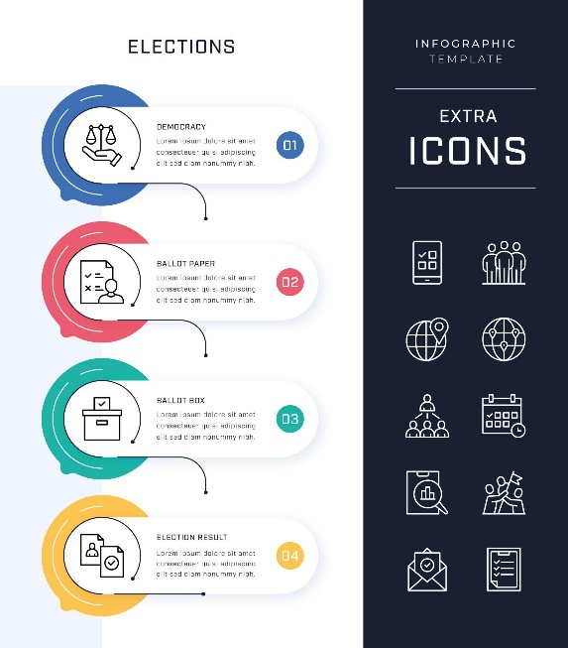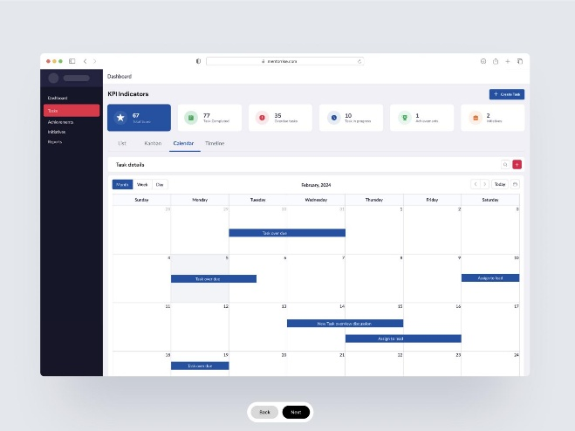
7.4 Ask in Any Style
User can ask:
- Explain like I am 12
- Give summary
- What should I do today
7.5 Myth vs Fact Engine
Example:
Myth: You can vote anywhere
Fact: Only assigned booth allowed
7.6 Multilingual Support
Languages:
- English
- Hindi
7.7 Official Source Citation(for later phase)
Every answer shows:
👉 “Source: ECI”
7.8 Election Journey Visualization (Gamified UX)
User sees:
👉 Step progress bar
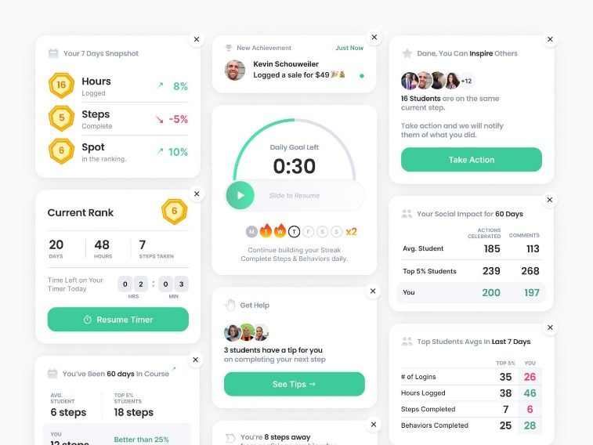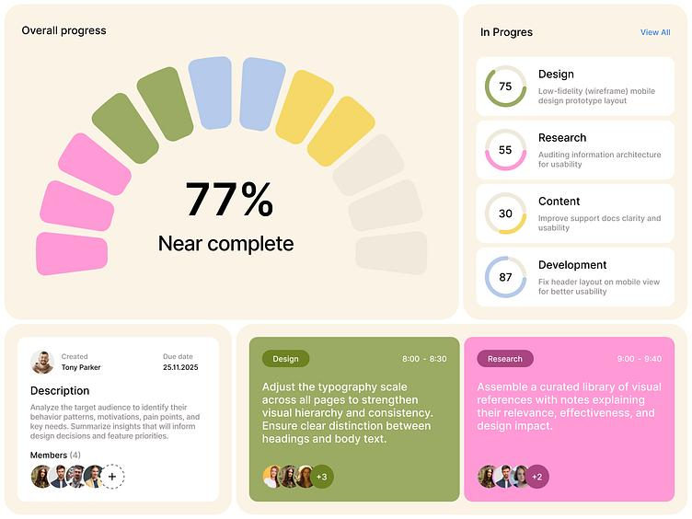
7.9 AI Decision Engine
Logic:
IF age ≥ 18
AND not registered
THEN recommend registration
7.10 Hyper-Personalized Checklists
First-time voter:
- Register
- Verify name
- Carry ID
Returning voter:
- Check booth
- Download slip
7.11 Simulation Mode
Practice voting:
- EVM usage
- VVPAT
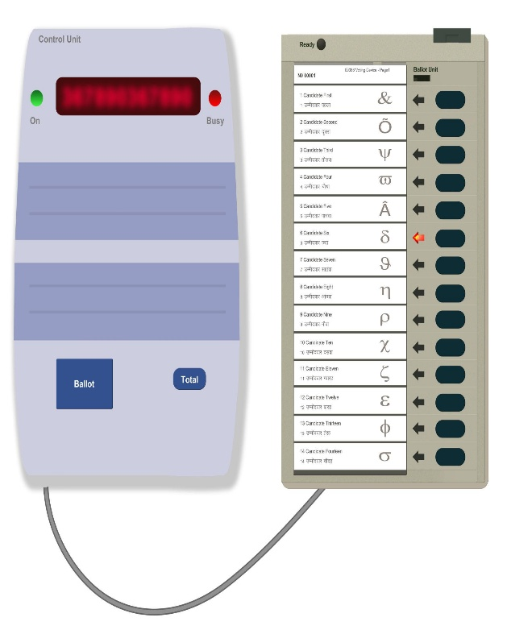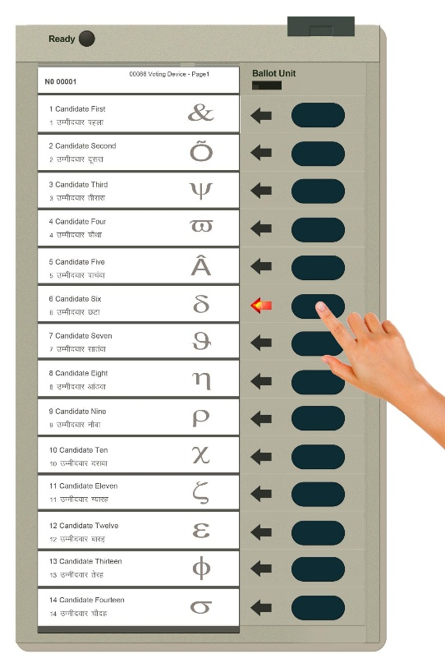
7.12 Smart Polling Booth Locator
Features:
- Map
- Distance
- Travel time
8. FUNCTIONAL REQUIREMENTS
- Chat interaction
- Timeline display
- Notification system
- Simulation module
9. NON-FUNCTIONAL REQUIREMENTS
- High availability
- Low latency
- Secure data
- Scalable
10. TECHNOLOGY STACK
Frontend:
- React
- Tailwind CSS
Backend:
- FastAPI
Database:
- Firestore
AI:
- OpenAI / Gemini api key
11. GOOGLE SERVICES INTEGRATION
- Google Cloud Run (deployment)
- Google Maps API (location)
- Firebase (notifications)
- Antigravity (AI workflow development)
12. AI SYSTEM DESIGN
Hybrid Approach:
Rule Engine
- Eligibility logic
LLM
- Natural conversation
RAG
- Official data retrieval
13. UI/UX DESIGN
- Chat interface
- Timeline view
- Dashboard
- Cards layout
14. DATA FLOW & ALGORITHMS
Flow:
User → Backend → AI → Response
Algorithm Example:
IF age >= 18:
IF registered == False:
Suggest registration
ELSE:
Suggest booth verification
15. SECURITY DESIGN
- HTTPS encryption
- Secure API access
- Input validation
- Data privacy
16. TESTING STRATEGY
- Unit testing
- Integration testing
- UI testing
- Load testing
17. ACCESSIBILITY DESIGN
- Voice support
- Simple UI
- Multilingual
18. DEPLOYMENT STRATEGY
- Backend and Frotend→ Cloud Run
19. PERFORMANCE OPTIMIZATION
- Caching
- API optimization
- Lazy loading
20. FUTURE ENHANCEMENTS
- Global election support
- Mobile app
- AI voice assistant
21. CONCLUSION
The Election Guide Assistant transforms a complex civic process into a simple, personalized journey. By combining AI, official data, and user-centric design, it improves accessibility, awareness, and participation in democratic processes.
🎯 FINAL PROJECT SUMMARY
An AI-powered election assistant that guides users through the electoral process using personalized timelines, intelligent recommendations, and interactive learning tools.

