FlowSync Arena
AI-Powered Crowd Flow and Event Experience Optimization System
Premium Project Documentation
(Web-Based • Google Cloud Run Deployment • No IoT Dependency)

Document Purpose
This report is written as a polished technical project document for a web-based system that improves safety, mobility, and overall experience in large sporting venues. It focuses on crowd movement, waiting time reduction, real-time coordination, and emergency-aware venue operations.

Project Type | Final Year / Advanced Product Documentation
Core Platform | Web application deployed on Google Cloud Run
Primary Constraint | No IoT sensors or hardware devices
Focus | Crowd safety, routing, queue prediction, and venue coordination

Prepared for academic, portfolio, and presentation use

Table of Contents
- Abstract
- Problem Background and Motivation
- Objectives
- Scope, Assumptions, and Constraints
- User Personas and Key Use Cases
- Functional and Non-Functional Requirements
- System Architecture
- Dashboards and Information Design
- Module Breakdown
- Algorithms and Decision Logic
- Database Design
- Suggested Tech Stack
- Technical Implementation on Google Cloud Run
- Deployment and DevOps Plan
- Unique Features and Innovation Layer
- Safety, Ethics, and Privacy Considerations
- Testing and Evaluation Strategy
- Future Scope
- Conclusion
- References

1. Abstract
FlowSync Arena is a web-based crowd orchestration platform designed to improve the physical event experience at large sporting venues without relying on IoT sensors or dedicated hardware devices. The system combines ticket-aware planning, live web-based crowd telemetry, predictive queue estimation, adaptive route guidance, and organizer dashboards to reduce bottlenecks before they become dangerous. Instead of treating crowd safety as a last-minute operational task, the platform turns it into a continuous decision loop that helps fans, staff, and venue administrators act on the same operational picture.
The system is shaped around a very practical reality: in high-energy celebratory events, even a small delay in communication or routing can create a large and risky crowd surge. FlowSync Arena addresses this by using software-only inputs such as ticket scans, user check-ins, manual staff updates, event schedules, and historical movement patterns. The platform then converts those signals into real-time guidance, queue estimates, and zone risk levels. The result is a smoother experience for attendees, better situational awareness for organizers, and a safer operational model for stadiums and fan zones.
Core Idea
Treat the stadium like a live, adaptive network. The system predicts where pressure will build, then gently redistributes movement through web, dashboard, and notification layers before the venue becomes congested.

2. Problem Background and Motivation
Large-scale sporting celebrations bring together excitement, unpredictability, and dense human movement. The same energy that makes a victory parade memorable can also create severe operational danger when people converge too quickly at a single entrance, exit, or public space. Guidance from event-safety authorities emphasizes the need for crowd controls, clear responsibilities, route planning, and continuous monitoring of how people arrive, enter, move, and disperse. In India, NDMA crowd-management guidance similarly stresses planning, control, and the importance of documenting who does what and when. This project is motivated by that safety-first view of crowd operations rather than by simple convenience features.
A modern sporting venue is therefore not just a place to watch a game; it is a temporary city with changing flows, waiting points, service areas, and emergency pathways. When software can reduce uncertainty in that city, the experience improves for everyone: attendees reach their seat faster, vendors can serve more people, security teams can react earlier, and event organizers gain the ability to intervene before a bottleneck becomes a crisis.
Why this matters
Crowd safety is not just about reacting during an incident. It is about designing the whole experience so that pressure never gets concentrated in a dangerous way.

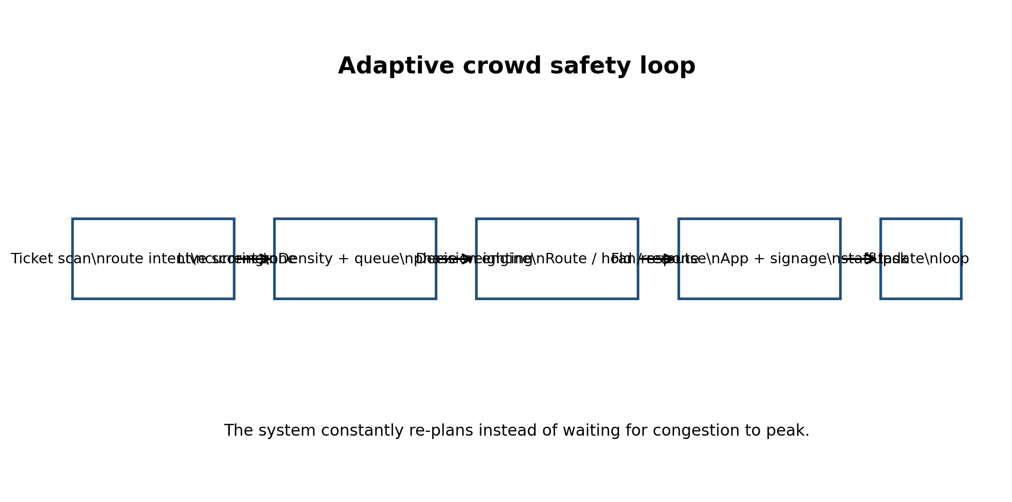
Figure 1: Adaptive crowd safety loop used by FlowSync Arena.

3. Objectives
The project has both operational and experiential goals. The primary aim is to make crowd movement more predictable and less stressful. The secondary aim is to present a modern, polished matchday experience that still remains easy to use when the venue is busy.
Objective Area | What It Solves | Measured By
Safety | Reduce congestion in gates, corridors, stairs, toilets, and exits. | Risk score reduction, fewer bottlenecks
Efficiency | Minimize queue time and route confusion. | Entry wait time, route completion time
Coordination | Unify organizer, staff, and fan actions. | Alert response time, task completion
Experience | Make the event feel easier and more premium. | Satisfaction feedback, app engagement

4. Scope, Assumptions, and Constraints
The platform is intentionally designed as a software-only system. It does not require CCTV analytics, Bluetooth beacons, RFID gateways, floor sensors, turnstile hardware integration, or other IoT devices to function at the prototype stage. This constraint makes the solution easier to deploy, cheaper to maintain, and more realistic for a student project or hackathon prototype. It also means the system must rely on data that is available from web and operational inputs.
In Scope | Web app, admin dashboard, queue prediction, route guidance, alerting, analytics.
Out of Scope | Physical hardware installation, computer vision pipelines, biometric identity tracking.
Assumption | Venue staff can update zone states or incident flags from the admin console.
Constraint | Deployment should stay lightweight enough for Cloud Run scaling and fast cold starts.

5. User Personas and Key Use Cases
The system supports multiple user types because large sporting events are collaborative by nature. Fans need navigation, staff need task clarity, and organizers need control.
Persona | Needs | System Response
Attendee / Fan | Fast entry, seat guidance, low wait times, emergency-safe directions. | Mobile web route recommendations and live queue views.
Staff Member | Clear instructions, zone assignment, escalations. | Task queue with assigned actions and urgency levels.
Organizer / Security Lead | Live operational picture, control of crowd pressure, auditable decisions. | Heatmaps, alerts, and override controls in dashboard.
Vendor / Service Operator | Visibility of demand spikes and service bottlenecks. | Queue forecasts and dynamic service recommendations.

6. Functional and Non-Functional Requirements
The requirements below keep the project practical while still leaving room for innovation.
Functional Requirements | Non-Functional Requirements
Display zone occupancy and risk levels. | Fast response under peak traffic.
Suggest least-crowded routes from current location to target zone. | Scalable deployment on Cloud Run.
Predict queue wait time for gates, toilets, and concessions. | Mobile-friendly responsive UI.
Send alerts when thresholds are crossed. | Simple role-based access control.
Allow staff to mark a zone as blocked, slow, or normal. | Low cognitive load during emergencies.
Record movement and alert history for post-event analytics. | Auditable event logs and secure authentication.

7. System Architecture
The architecture is layered so each concern can scale independently. The presentation layer is a responsive web interface. The application layer handles authentication, routing logic, and live event coordination. The data layer stores user, zone, queue, and alert state. In a production deployment, Cloud Run hosts the containerized services and scales them according to demand. According to Google Cloud documentation, Cloud Run automatically scales container instances based on demand, supports configurable concurrency, and charges for consumed CPU, memory, and networking during request processing.
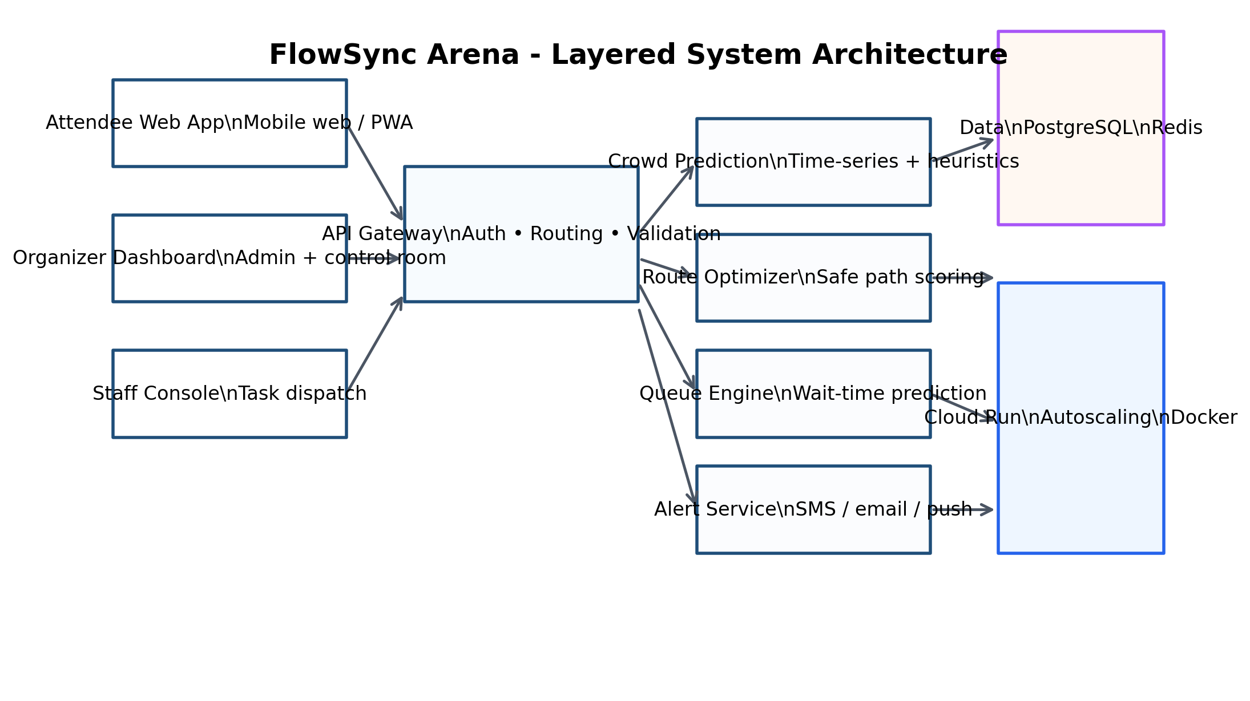
Figure 2: High-level system architecture for the web-based deployment.
This architecture is deliberately modular. If the venue later wants to add SMS gateways, QR check-in services, or advanced forecasting models, those capabilities can be added as independent services without changing the whole application.

8. Dashboards and Information Design
Dashboards are the visible face of the system. They must be minimal enough to be understood instantly, but rich enough to support fast decisions. FlowSync Arena therefore includes separate views for fans, staff, and control-room operators.
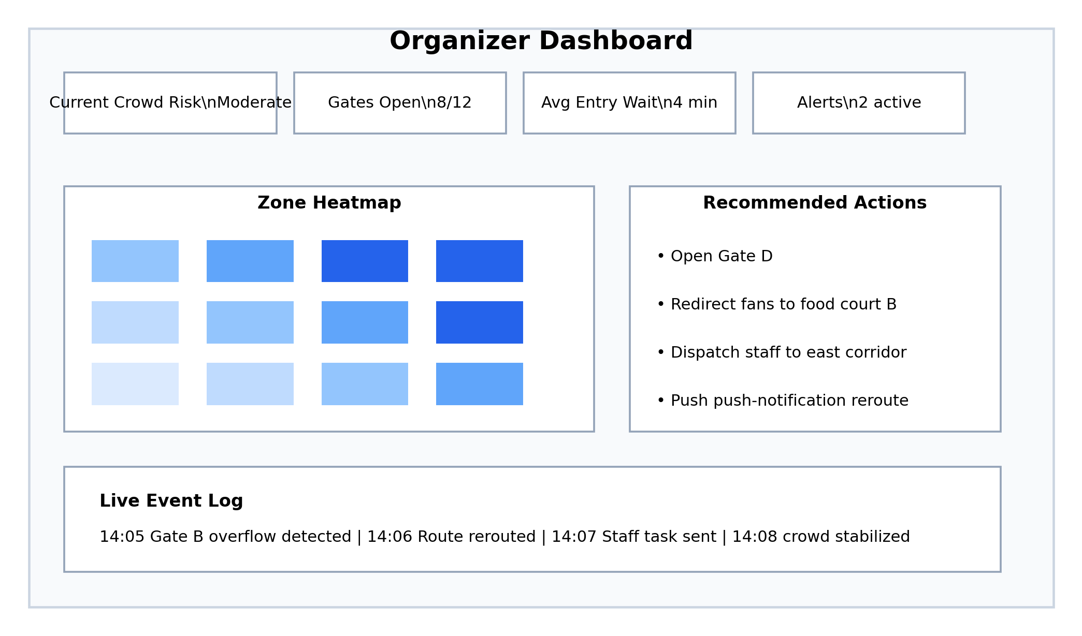
Figure 3: Organizer dashboard concept with risk summary, heatmap, and live actions.
Dashboard | Primary User | Main Widgets | Decision Support
Fan Dashboard | Attendees | Route, queue, gates, alerts | Where should I go right now?
Staff Console | Ground staff | Tasks, zone status, escalation | What should I do next?
Control Room | Organizers | Heatmap, risk, overrides | Where is pressure building?
Post-Event Analytics | Management | Trends, SLA, learnings | What should change next time?

9. Module Breakdown
- Authentication and Role Management: Handles fan, staff, organizer, and super-admin access using secure login flows and role-based permissions.
- Zone Registry: Stores venue layout data such as gates, stairs, blocks, exits, concessions, and service areas.
- Crowd Estimation Engine: Produces zone density estimates using operational signals, check-ins, and time-based movement patterns.
- Queue Prediction Engine: Forecasts waiting time and overload risk using historic patterns and current event state.
- Route Guidance Engine: Calculates the safest practical route rather than only the shortest route.
- Alert and Notification Service: Pushes warnings to dashboards, staff tasks, and attendee screens.
- Analytics and Reports: Captures event-time and post-event metrics for review.
- Admin Overrides: Lets operators mark zones as closed, slow, or rerouted in real time.
- Digital Twin Simulation: Runs what-if scenarios to test how crowd pressure shifts when routes change.
- Unique Experience Layer: Adds calmer routing, low-stimulation mode, and context-aware simplification of the UI.

Unique module worth highlighting
The digital twin simulation and the crowd thermostat logic make the project feel noticeably more advanced than a typical queue tracker.

10. Algorithms and Decision Logic
The project does not need only one AI model. It needs a stack of simple, explainable decision layers that behave well under pressure. That is often better than a single opaque model in a safety-critical environment.
Problem | Algorithm / Rule | Input | Output
Crowd density estimate | Zone occupancy formula | Check-ins, exits, manual flags | Density score
Safe routing | Weighted shortest path | Distance, density, queue, closure | Route recommendation
Queue time | Regression / time-series forecast | Historical waits, phase, demand | Predicted wait
Risk detection | Threshold + trend logic | Density slope, dwell time, crowd phase | Alert level
Action selection | Rule engine | Severity and zone status | Open, hold, reroute, evacuate

10.1 Crowd Density Estimation
A practical density estimate can be computed with a simple formula that is easy to explain to stakeholders:
Density(zone) = (active users + new entries - exits) / zone area.
The formula is not meant to be perfect; it is meant to be stable, understandable, and useful. When operational confidence improves, the estimate can be refined with learning-based correction terms.

10.2 Safe Route Scoring
The route engine should minimize a combined cost rather than pure distance. A corridor that is shorter but crowded may be more dangerous than a longer but safer alternative. The cost function can therefore be expressed as:
Cost = distance + alpha × crowd density + beta × queue time + gamma × closure penalty.
This makes the routing logic easier to reason about than a black-box model and also allows organizers to tune policy values during live events.

10.3 Alert Prioritization
Alerts must not overwhelm users. They should be prioritized into levels: informational, caution, serious, and critical. Critical alerts should interrupt the normal interface and only appear for genuinely dangerous conditions. This avoids notification fatigue and helps users trust the system when it really matters.


11. Database Design
PostgreSQL is the main persistent store because it is reliable, easy to query, and well-suited to structured operational data. Redis can be used as a short-lived cache for live density, active sessions, and real-time alert state.
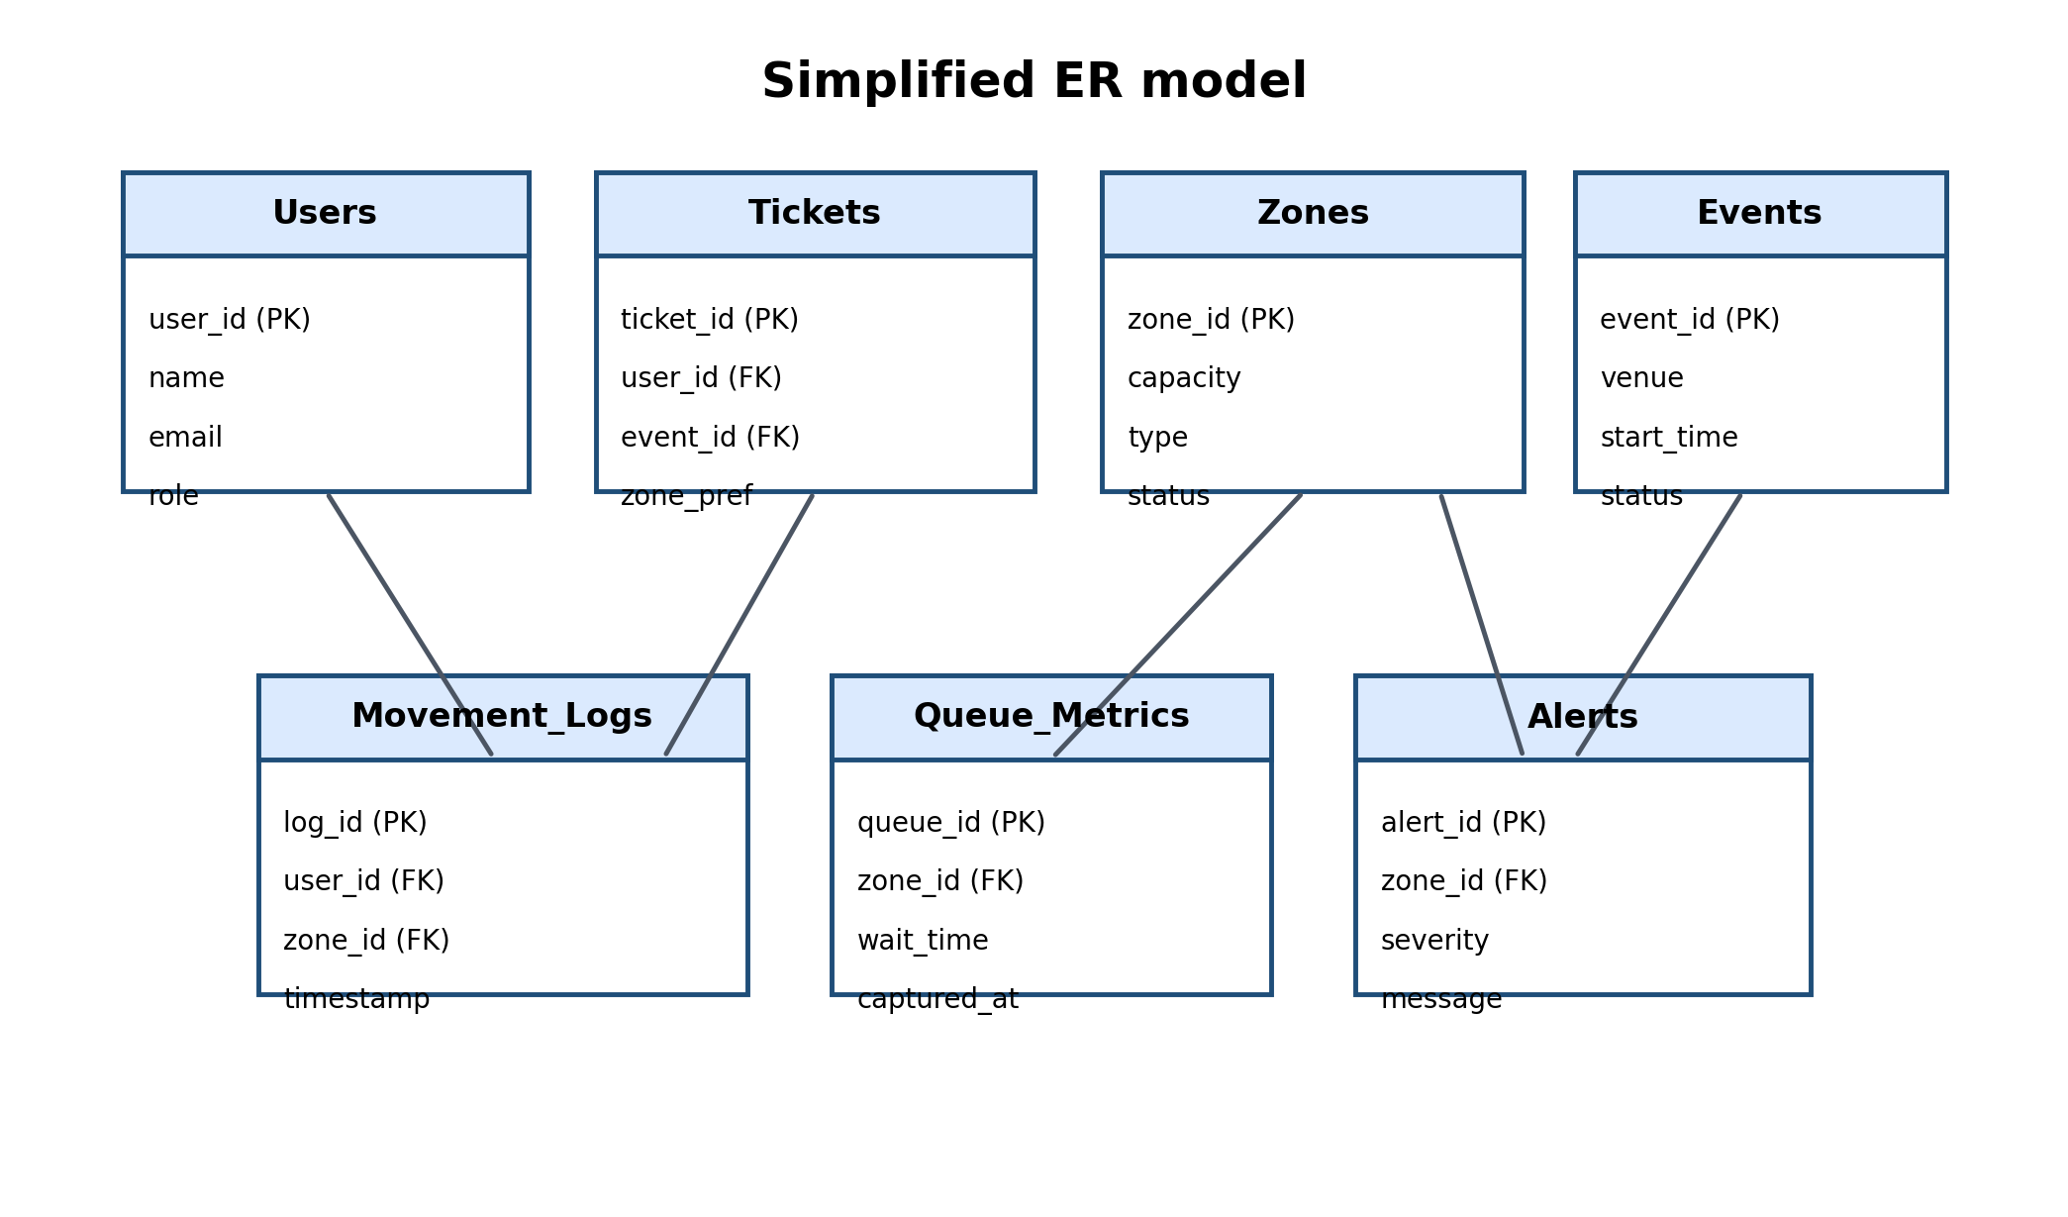
Figure 4: Simplified ER model for the core data layer.
- Users: Stores authentication identity, role, and contact preferences.
- Events: Stores event metadata, venue, date, and operational status.
- Zones: Represents gates, stands, corridors, exits, toilets, and service points.
- Tickets: Maps a user to an event and preferred zone or entry group.
- Movement Logs: Captures event-time zone transitions for analytics and prediction.
- Queue Metrics: Stores predicted and actual wait times across zones.
- Alerts: Keeps the audit trail for warnings, escalations, and emergency states.
- Staff Tasks: Tracks operational instructions assigned to staff members.

12. Suggested Tech Stack
The stack below is chosen for maintainability, deployment simplicity, and compatibility with Google Cloud Run.
Layer | Recommended Stack | Why This Choice Works
Frontend | React or Next.js with Tailwind CSS | Fast UI development and mobile-friendly responsive screens.
Backend | FastAPI or Node.js Express | Container-friendly APIs with clean deployment on Cloud Run.
Database | PostgreSQL on Cloud SQL | Structured operational records and audit history.
Cache / Realtime | Redis | Live state and low-latency session data.
Auth | Firebase Auth / JWT | Simple and secure role-based access.
Maps | Mapbox / Leaflet | Route display and venue navigation.
Notifications | FCM / email / SMS gateway | Multi-channel alert delivery.
CI/CD | GitHub Actions + Artifact Registry | Automated build and deploy.
Hosting | Google Cloud Run | Autoscaling serverless containers.

Cloud Run fit
Cloud Run is a strong deployment target because it is fully managed, scales automatically with demand, and supports configurable concurrency. That is useful when event traffic spikes suddenly during an important match or celebration.

13. Technical Implementation on Google Cloud Run
The implementation should be container-first from day one. Each service is packaged as a Docker image, published to Artifact Registry, and deployed to Cloud Run as a revisioned service. The API layer can be split into a main web service and one or more background services if needed. This keeps the platform practical for demos while remaining close to a real production pattern.
- 1. Build frontend - Create responsive screens for fans, staff, and organizers, including a shared navigation shell and live status badges.
- 2. Build APIs - Expose endpoints for density, routes, queues, alerts, user actions, and staff overrides.
- 3. Add data models - Implement PostgreSQL schemas and migrations with clear foreign keys and status history.
- 4. Add caching - Use Redis for live risk levels, current zone summaries, and short-lived session tokens.
- 5. Package with Docker - Create a compact runtime image with environment-based configuration.
- 6. Deploy to Cloud Run - Deploy with min/max instances, concurrency tuning, and request timeout settings.
- 7. Observe and improve - Use logs, metrics, and traces to monitor latency and error spikes during load tests.
A sensible API layout could include /api/auth/login, /api/zones, /api/route, /api/queue, /api/alerts, /api/admin/override, and /api/analytics. Each endpoint should validate inputs carefully because an event system should fail safely, not creatively.

13.1 Cloud Run Configuration Strategy
Recommended Cloud Run configuration: start with moderate concurrency, a small minimum instance count for critical services, and sensible request timeouts. For highly interactive endpoints, latency matters more than raw throughput, so a narrower concurrency setting can feel better than a huge one. Google Cloud's documentation notes that Cloud Run instances can serve multiple requests concurrently up to a configurable maximum, with a default of 80 in many cases.

13.2 Environment Variables
Variable | Purpose
DATABASE_URL | Connection string for PostgreSQL.
REDIS_URL | Cache/session connection.
JWT_SECRET | Token signing key.
MAPBOX_TOKEN | Map rendering service.
NOTIFICATION_PROVIDER_KEY | Messaging and alert delivery.
APP_ENV | Development, staging, or production.

14. Deployment and DevOps Plan
The deployment pipeline should be simple enough for continuous iteration but robust enough for a public-facing event. A GitHub push triggers tests, builds a container, pushes the artifact, and deploys a new Cloud Run revision. Staging and production should be separate services or separate environments so feature testing never breaks the live venue view.
- Lint and run unit tests on every commit.
- Run integration tests for critical APIs.
- Build Docker image and scan dependencies.
- Push image to Artifact Registry.
- Deploy to Cloud Run with environment variables injected securely.
- Run smoke tests against the new revision.
- Promote staging to production after verification.

15. Unique Features and Innovation Layer
- Crowd Thermostat: A live control concept that continuously measures pressure and nudges people toward safer spaces before congestion peaks.
- Invisible Concierge: A context-aware assistant that gives the right direction at the right moment without forcing users to dig through menus.
- Shared Spatial Brain: One operational map powers fan guidance, staff tasks, and admin analytics at the same time.
- Calm Route Mode: A route option designed for people who want fewer turns, simpler screens, and lower notification intensity.
- What-If Simulator: A digital twin-style planning tool that tests how the venue behaves if a gate closes or a surge arrives.
- Micro-Zone Control: The venue is split into very small operational zones so rerouting becomes precise rather than generic.
Why this stands out
Most projects stop at showing a map. This one actively manages pressure, guides behavior, and supports staff decisions in the same workflow.

16. Safety, Ethics, and Privacy Considerations
A crowd-management system should not become a surveillance-heavy system by accident. Because this version is web-based and does not depend on sensors, it naturally stays lighter on privacy risk. Still, the design should use role-based access, data minimization, clear audit logs, and short-lived operational records where possible. If location or movement history is stored, it should be kept only for the purpose of safety and post-event learning.
Risk | Mitigation | Design Principle
Notification overload | Use severity filtering and alert cooldowns. | Only send actionable alerts.
Wrong rerouting | Use route fallback and operator override. | Fail safe, not silent.
Data misuse | Limit access and log admin actions. | Least privilege.
Operational confusion | Keep one canonical source of truth. | Single shared control plane.

17. Testing and Evaluation Strategy
Testing should cover both software correctness and real-world usability. Since the project is about crowd safety, the most important question is not merely whether the software runs, but whether it behaves calmly and predictably when many users arrive at once.
- Unit tests for route scoring, queue prediction, and alert thresholds.
- Integration tests for APIs, authentication, and database writes.
- Load testing to simulate match-day spikes and Cloud Run auto-scaling behavior.
- Usability testing on mobile screens under low attention conditions.
- Failure testing for database lag, API timeouts, and partial service outages.
- Scenario testing for blocked exits, sudden gate closure, and emergency reroutes.
Evaluation metrics
A strong result is not just a fast response time. It is a measurable drop in queue duration, fewer congestion warnings, quicker staff action, and higher user confidence.

18. Future Scope
The current web-only solution is already useful, but it can grow in several directions. Future versions may add deeper personalization, multi-venue support, richer simulation, and optional computer vision modules if a venue later chooses to invest in hardware. Another direction is multi-lingual assistance for international matches, since smoother communication is often the difference between confusion and calm movement. Over time, the platform could also integrate with city traffic, transit schedules, and parking systems to provide an end-to-end matchday journey rather than only an inside-the-stadium experience.
A more ambitious research direction is reinforcement-learning-based crowd steering, where the system learns which interventions actually reduce risk in different venues. Another is predictive emergency modeling, where organizers simulate how a crowd might react to weather, a delayed start, a celebrity appearance, or a sudden celebration surge. Those are natural extensions once the core system is stable.
Next Phase | Capability | Benefit
Phase 2 | Multilingual fan assistant | Better accessibility for diverse crowds
Phase 3 | Integration with transport feeds | Reduced arrival pressure
Phase 4 | What-if simulation sandbox | More accurate planning
Phase 5 | Advanced ML learning loop | Adaptive crowd response

19. Conclusion
FlowSync Arena is designed to solve a very real problem: crowd movement becomes dangerous when planning is too static for the scale and emotion of a live sports celebration. By using only web-based inputs, Cloud Run deployment, predictive logic, and clear operational dashboards, the platform offers a realistic and deployable solution that balances safety with a premium fan experience. It is intentionally practical, yet still innovative enough to stand out in a project portfolio.

20. References
- [1] Google Cloud Run documentation: automatic scaling, concurrency, and deployment behavior. Official Cloud docs.
- [2] Google Cloud Run quickstart and deployment guides. Official Cloud docs.
- [3] HSE event safety guidance: managing crowds safely and assessing crowd safety risks.
- [4] NDMA crowd management guide for events and mass gatherings.
- [5] WHO mass gathering preparedness guidance.

Appendix A. Sample API Specification
This appendix is included to make the document feel implementation-ready. The API list below is concise enough for a student project but structured enough to scale.
Endpoint | Method | Purpose | Response
/api/auth/login | POST | Authenticate users | JWT + role
/api/zones | GET | List venue zones | Zone state list
/api/route | POST | Return safe path | Route steps
/api/queue | GET | Fetch queue forecast | Wait time
/api/alerts | GET | Get active alerts | Alert list
/api/admin/override | POST | Change zone status | Updated status

Appendix B. Sample Event Scenario
Scenario: A major victory celebration begins and attendees start moving toward the main entrance. The system detects that the east gate is filling faster than expected while a nearby service corridor remains underused. It immediately updates the fan dashboard, suggests the less busy corridor, posts a staff task to open another assistance point, and marks the original entry line as cautionary. If pressure keeps rising, the organizer dashboard shifts the affected zone from yellow to red and triggers a stronger alert. The user experience remains calm because the system explains the change rather than simply blocking access.

Appendix C. Suggested Presentation Points
- Problem: crowd surges in large sports celebrations can become dangerous within minutes.
- Solution: predictive, web-based crowd orchestration without IoT dependency.
- Innovation: shared spatial brain, calm routing, and digital twin planning.
- Deployment: containerized, scalable, and easy to host on Google Cloud Run.

Appendix D. Detailed Operational Playbook
This playbook explains how the venue team should use the system from the first public announcement until the last attendee leaves.

D.1 Pre-event readiness
Before the event begins, the organizer should load the venue map, confirm all zone capacities, set the expected attendance, and mark any maintenance areas as restricted. The admin console should also confirm the communication channels that will be used for alerts, such as in-app prompts, SMS, or public display boards. A short dry run should verify that staff can log in, view their assigned zones, and receive tasks instantly.

D.2 Arrival management
During arrival, the fan dashboard should prioritize the fastest entry route and avoid pushing everybody toward the same gate. If a gate reaches a caution threshold, the route engine should spread arrivals across alternate gates. Staff in the affected zones should receive an automatic task to open auxiliary support or guide people manually.

D.3 In-event operations
Once the match is underway, the focus shifts from entry flow to service flow. Concession and restroom queues usually become the dominant friction points. The system should therefore update route recommendations after halftime, because the best path during entrance is not necessarily the best path during intermission.

D.4 Exit orchestration
Exiting a venue can be just as dangerous as entering it. The platform should prioritize broad exits, avoid narrow corridors, and stagger guidance so people are not funneled into a single route. If parking lots or transit stops are busy, the app can recommend a slower but safer exit window.
Operational principle
The system should always prefer a slightly slower movement pattern over a crowded one. Safety comes first; convenience comes second.
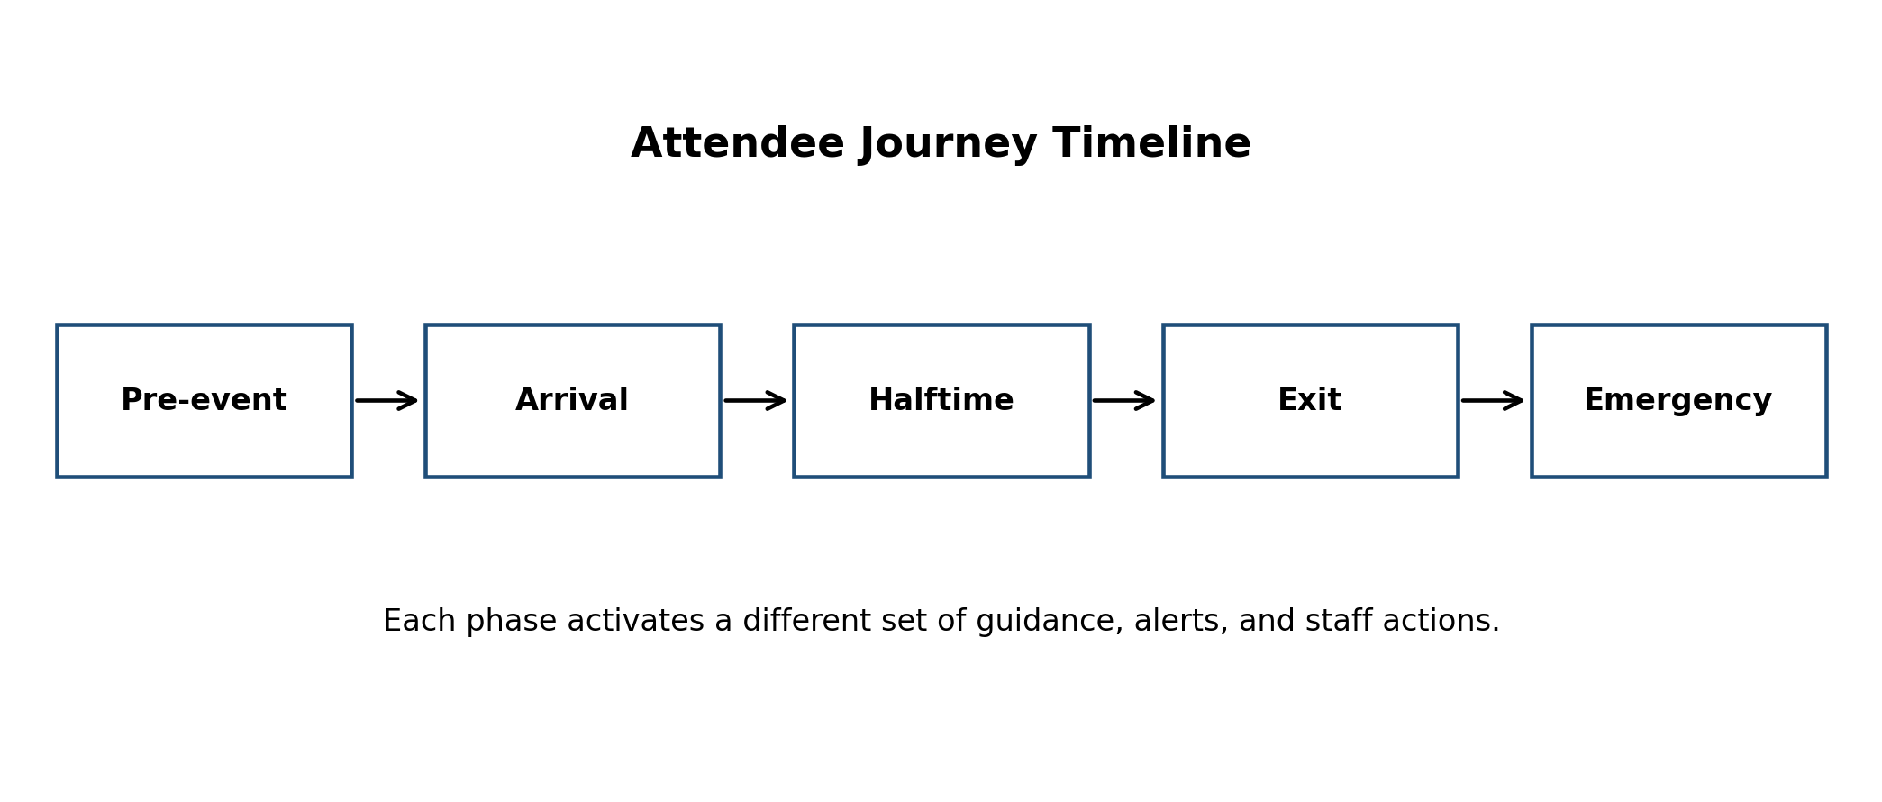
Figure 5: Crowd-control emphasis shifts across the attendee journey.

Appendix E. Screen-by-Screen UI Specification
This section describes the likely screens that the final web application would present to different users.
Screen | Description
Login Screen | Role-aware login with clear access entry points for fans, staff, and organizers.
Fan Home Screen | A large route card, active queue estimates, and a simple safety banner.
Zone Detail Screen | Density, wait time, available alternatives, and route selection.
Staff Tasks Screen | Priority task list, zone status, and a confirm-complete action.
Organizer Dashboard | Heatmap, risk timeline, alert history, and zone overrides.
Analytics Screen | Event summary, bottlenecks, peak congestion periods, and recommended improvements.
A premium interface should avoid clutter. The most important data should appear first, and the system should avoid forcing users to read dense paragraphs when they are already moving in a crowded environment. That is why fan screens should feel calm, while organizer screens should feel dense and operational.
The design language can use one accent color for normal operations, amber for caution, and red for critical states. These colors should be used sparingly so that they retain meaning even during long events.

Appendix F. Pseudocode for Core Algorithms
The pseudocode below is intentionally simple so that it is easy to explain in a viva or presentation.

Queue prediction
Input: zone history, current event phase, current check-in rate
Output: wait time estimate
1. Read recent queue observations
2. Compute trend over last few intervals
3. Add event-phase multiplier
4. Blend historical average and current demand
5. Return predicted waiting time

Safe route selection
Input: current location, target zone, live density, route graph
Output: safest practical route
1. Mark blocked zones as unavailable
2. Assign a cost to every edge
3. Increase cost for high density or long queue time
4. Run weighted shortest path
5. Return route with lowest safety cost

Alert triggering
Input: density score, slope, dwell time, staff override
Output: alert level
1. Compare score with threshold
2. Check whether score is rising fast
3. Escalate level if the same zone remains saturated
4. Cool down repeated messages
5. Record the alert for audit

Appendix G. Field Dictionary for the Main Database Tables
The field dictionary below helps make the schema implementation-ready.
Table | Field | Type | Meaning
Users | user_id | UUID | Primary identifier
Users | role | Enum | Fan, staff, organizer, admin
Events | event_id | UUID | Event primary key
Zones | capacity | Integer | Maximum safe occupancy
Zones | status | Enum | Open, slow, closed, blocked
Movement_Logs | timestamp | Timestamp | Movement event time
Queue_Metrics | wait_time | Integer | Predicted wait in minutes
Alerts | severity | Enum | Info, caution, serious, critical
Staff_Tasks | assigned_to | UUID | Staff member responsible
Staff_Tasks | status | Enum | Pending, active, done
This schema is intentionally normalized around zone and event identity. That makes it easier to query by zone, compare events, and build post-event analytics without duplicating too much data.

Appendix H. API Contract Samples
A short contract sample is included so the project feels like a real software system rather than a conceptual idea.
Endpoint / Sample | Meaning
POST /api/route  { "from":"gate_a", "to":"stand_12" } | Returns a JSON route with steps, risk score, and suggested travel time.
GET /api/zones | Returns a live list of all venue zones with density and status.
POST /api/admin/override  { "zone_id":"east_corridor", "status":"closed" } | Allows an authorized operator to close or reopen a zone.
GET /api/alerts | Returns all active alerts sorted by severity and timestamp.
The project should standardize error responses as well. A user-facing issue should say what happened in plain language, and a developer-facing log should preserve detailed trace information.

Appendix I. Load Testing and Stress Testing Plan
Since the platform is designed for peak traffic moments, load testing deserves explicit attention.
- Simulate hundreds of concurrent fans opening the route page at the same time.
- Simulate repeated dashboard refreshes during halftime.
- Verify that queue calculations remain fast under load.
- Check whether Cloud Run scales out quickly enough for sudden spikes.
- Measure how the system behaves if Redis is temporarily unavailable.
- Verify that critical alerts still reach the control room when noncritical screens are busy.
Test success criteria
The application should remain responsive, degrade gracefully, and never show stale or misleading safety information.

Appendix J. Google Cloud Run Runbook
This runbook is a practical checklist for deployment day.
- Confirm that the container starts locally with production environment variables.
- Verify that health checks return success.
- Deploy to a staging Cloud Run service first.
- Run smoke tests for login, route lookup, and alert retrieval.
- Check logs and latency after the first few requests.
- Set min instances if the app must stay warm during the event.
- Keep rollback instructions ready in case a bad revision appears.
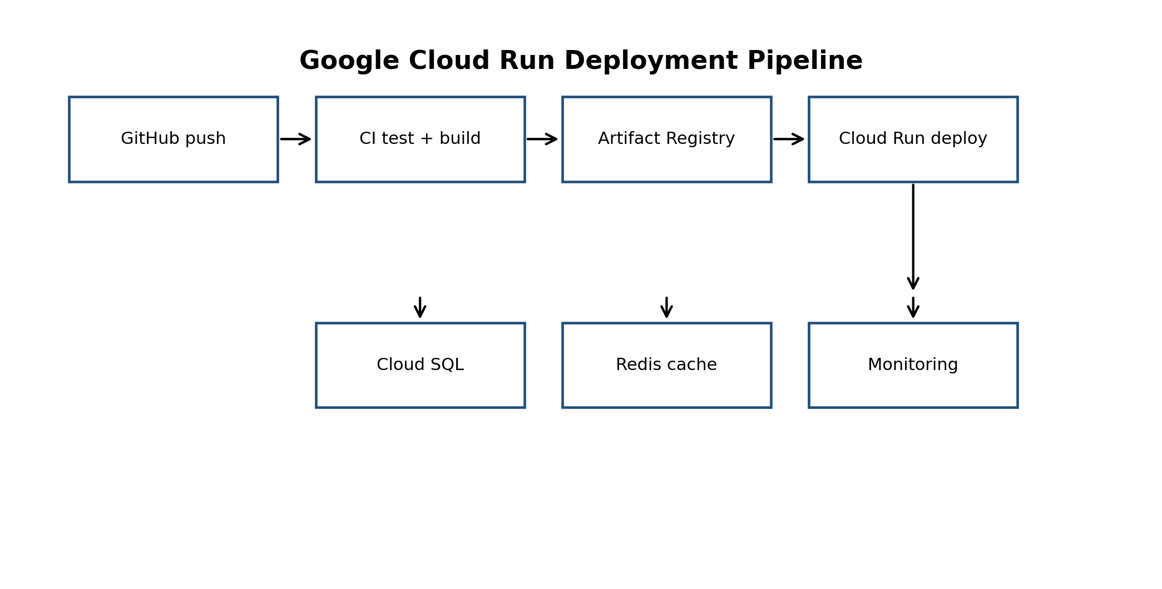
Figure 6: Deployment pipeline for the Cloud Run version of the system.

Appendix K. Extended Design Notes and Justification
The reason this document intentionally avoids hardware dependence is strategic. Hardware adds cost, delays deployment, creates integration risk, and can break the prototype if one component fails. A software-first approach lets the project demonstrate value using data the venue already has. That makes the idea more portable across stadiums, fan parks, university auditoriums, and public celebration spaces.
Another important choice is to prefer explainable logic for critical routing decisions. In a crowd-safety context, explainability is a feature, not a nice-to-have. An organizer should be able to answer why the system rerouted people, why a zone became red, and why a task was escalated. Clear logic makes the system easier to trust during stressful moments.
Finally, the design deliberately separates experience features from control features. The attendee sees calm guidance and simple status cards. The organizer sees density, queues, and zone pressure. The staff sees tasks. Everyone gets the same underlying truth, but in a form suited to their job.
This split is important because the wrong interface can increase stress. A fan does not need the full operational picture. A control-room manager does. By giving each role only the relevant information, the system stays readable under pressure.

Appendix L. Presentation and Viva Notes
- Start with the real-world problem: crowd surges can become dangerous very quickly.
- Explain why a web-only solution is practical and low-cost.
- Show the shared spatial brain idea as the innovation center.
- Mention Cloud Run as the deployment target because it scales automatically.
- Walk through one sample journey from arrival to exit.
- End with safety, privacy, and future scope.

Appendix M. Command Center Standard Operating Procedure
This section turns the system into an operational process. A good dashboard is only useful if the people using it know exactly what to do when a signal changes. The SOP below is intentionally written as a simple sequence so that it can be understood in an exam, demo, or live venue context.

M.1 Before gates open
The command center should verify event timing, zone status, staffing assignments, communication channels, and escalation contacts. The operator should confirm that the heatmap loads correctly, that all active zones are visible, and that the alert thresholds match the expected crowd size.

M.2 Thirty minutes before peak arrival
Operators should watch entry-related metrics closely. If a gate starts to diverge from its expected rate, the system should push a caution signal. The staff lead should either open another lane or push people to an alternate gate before the line becomes rigid.

M.3 Halftime or intermission
The system should switch its emphasis from entry to service movement. The operator should watch toilets, concessions, and circulation corridors, because those areas often become the new pressure points. The organizer dashboard should re-rank zones by urgency.

M.4 Post-match exit
The command center should favor broad exit corridors, direct people to less crowded transit options, and watch the speed at which each zone drains. If one route remains saturated, the operator should keep the alternate path active longer rather than allowing a rebound pileup.
SOP principle
Every operational step should have a visible owner: the system suggests, the staff executes, and the organizer approves exceptions.

Appendix N. Failure Modes and Risk Register
Crowd systems fail in more than one way. They can fail technically, operationally, or cognitively. A premium project document should show that those failures were considered in advance.
Failure Mode | How It Appears | Impact | Mitigation
Wrong route suggestion | User is guided into a busy corridor. | Delay and confusion. | Keep route fallback logic and operator override active.
Alert fatigue | Users ignore messages. | Reduced trust. | Rate-limit alerts and show only actionable changes.
API slowdown | Screens feel stale. | Low usability. | Cache current state and separate critical reads from heavy reports.
Database lag | Analytics updates late. | Inaccurate trends. | Use queued writes for noncritical logging.
Staff non-response | Tasks remain open too long. | Operational gap. | Escalate unresolved tasks automatically.
Partial connectivity loss | Some screens stop updating. | Inconsistent information. | Use local stale-state indicators and recovery banners.

The key idea is that the system should never silently pretend things are normal. If the data becomes stale, the interface should say so clearly. That is much safer than showing false precision during a live event.
High-value mitigation
Staleness indicators matter. A live crowd dashboard that is slightly delayed is still useful; a delayed dashboard that looks real can be dangerous.

Appendix O. Security, Privacy, and Access Control Model
Security should be proportionate to the system’s role. Fans need quick access, staff need operational access, and organizers need override access. The system should enforce the principle of least privilege so that each user can only see the data required for their role.
Layer | Protection | Reason
Authentication | JWT or managed auth provider | Keeps login flows clear and secure.
Transport | HTTPS everywhere | Protects data in transit.
Role access | RBAC with server-side checks | Prevents unauthorized actions.
Data storage | Encrypted database and secrets | Protects sensitive operational records.
Audit trail | Immutable event logs | Supports accountability.

- Do not expose all zone data to all users.
- Do not store sensitive data longer than necessary.
- Do not allow front-end code to make trust decisions alone.
- Do not let alert thresholds be modified without audit logging.
Because the system is web-based and avoids sensor-based tracking, it can stay privacy-light while still being operationally useful. That is a major practical advantage when deploying a prototype for a real venue team.

Appendix P. Metrics, KPIs, and Dashboard Definitions
This section defines the numbers that make the dashboards meaningful. Without precise definitions, the same chart can be interpreted in multiple ways.
Metric | Definition | Why It Matters
Entry wait time | Time from joining entry line to zone entry. | Measures access efficiency.
Zone density | Attendees per square meter or zone occupancy ratio. | Measures congestion.
Alert response time | Time from alert creation to staff acknowledgment. | Measures responsiveness.
Route completion time | Time for a fan to follow the recommended path. | Measures route quality.
Stale-state rate | How often a screen shows delayed live data. | Measures trustworthiness.
Task closure rate | Percentage of staff tasks completed on time. | Measures operational discipline.

A strong dashboard tells a simple story: how crowded things are, how fast the crowd is moving, and what the team should do next. If a chart cannot support a decision, it should probably not be on the main screen.

Appendix Q. Detailed Database Design Notes
The database should support two modes: live operations and post-event review. Live operations need quick reads and current state. Post-event review needs historical records, comparisons, and trend analysis. The schema should therefore preserve event identity, zone identity, and timestamped state transitions.

Q.1 User and role tables
These tables should keep account information minimal and role-driven. A person may be both a staff member and an organizer in testing, so role assignment should be explicit rather than inferred.

Q.2 Zone state history
Do not overwrite zone status too aggressively. Store change history so the team can reconstruct how and when a zone moved from normal to caution to blocked.

Q.3 Event snapshots
Important live states should be captured periodically. This makes post-event analytics more reliable and allows the team to replay the event at a coarse level.

Q.4 Audit logging
Every override, alert, and manual change should be logged with time, actor, and reason. That protects accountability and helps debugging.
Database rule
Prefer append-only history for critical operational events. Deleting the past can delete the lesson.

Appendix R. Detailed Milestones and Build Plan
A clear build plan helps the project feel executable. The table below can be used as a semester roadmap or sprint roadmap.
Phase | Focus | Output | Proof of completion
Phase 1 | UI and routing prototype | Basic web app | Screens open and navigate
Phase 2 | Data model and APIs | CRUD + auth | Database records created
Phase 3 | Queue and route logic | Decision engine | Route results generated
Phase 4 | Organizer dashboard | Live control view | Heatmap and alerts visible
Phase 5 | Cloud Run deployment | Hosted container | App accessible via URL
Phase 6 | Testing and polish | Final release candidate | Load tests pass

This phased approach is useful because it lets the project be demonstrated at every stage. Even if the queue model is not finished, the interface and deployment pipeline can still be shown. That reduces project risk and makes it easier to present progress honestly.

Appendix S. Reporting and Post-Event Review Format
After the event, the system should produce a short review report. The report does not need to be fancy, but it should be structured enough to help teams improve the next event.
- Peak entry points and times.
- Top three congested zones.
- Average queue time by service type.
- Alerts raised and how quickly they were handled.
- Routes that worked best and routes that should be avoided next time.
- Recommended layout or staffing changes.
This closes the loop between event operations and learning. A project becomes much more credible when it shows how the next event will be better because of the last one.

Appendix T. Stakeholder Communication Matrix
The system only works if the right message reaches the right person at the right time. This matrix defines who receives which type of information, how often it should be sent, and what style it should use.
Stakeholder | Information Need | Channel | Tone
Fan | Route, queue, safety notices | Mobile web / push | Simple and calm
Staff | Task, zone status, escalation | Staff console / push | Direct and action-oriented
Organizer | Heatmap, alert summary, overrides | Control dashboard | Operational and concise
Security | Critical incidents, blocked paths | Dashboard / SMS | Urgent and precise
Vendor | Demand spikes and nearby queues | Vendor view | Practical and short
A communication matrix helps reduce confusion because each audience receives only the details that matter most. The fan does not need a full incident log, and the control room does not need casual UI hints. This separation keeps the experience efficient and safer.
Messaging rule
Say the minimum needed to achieve the safe action. In a crowd event, clarity matters more than decoration.

Appendix U. Sample JSON Payloads and Error Responses
The following payload examples make the API layer concrete and easy to implement.
Sample | Meaning
{ "zone_id": "gate_b", "density": 0.82, "status": "caution" } | Zone state response for dashboards.
{ "from": "parking_1", "to": "stand_5", "mode": "safe" } | Route request from one point to another.
{ "event_id": "evt_102", "phase": "halftime", "predicted_wait": 7 } | Queue forecast payload.
{ "alert_id": "a11", "severity": "critical", "message": "East corridor blocked" } | Critical alert response.
{ "error": { "code": "STALE_DATA", "message": "Live state unavailable" } } | Safe fallback error response.
Error handling is especially important in this project. When a route is not available, the system should not hide the issue. It should explain the failure and suggest the next best safe option. A crowd application should degrade visibly rather than silently.
- Prefer structured JSON over free-form strings.
- Use a stable error code for each failure type.
- Return a human-readable message and a machine-readable code together.

Appendix V. Glossary of Important Terms
A short glossary makes the document easier to read and also gives you simple viva answers.
Term | Meaning
Crowd density | How tightly people are packed in a zone.
Queue forecast | Predicted waiting time for a gate or service point.
Digital twin | A software model that simulates the venue.
Zone | A small controllable area inside or around the venue.
Override | Manual action that changes a system decision.
Stale data | Information that is delayed and may no longer reflect reality.
Heatmap | A visual representation of pressure across zones.
Routing cost | A score used to choose the safest route.
Using a consistent glossary is more than a writing trick. It keeps the whole project aligned. If the same concept is called by three different names, users and evaluators get confused. A stable vocabulary makes the system feel intentional.

Appendix W. Viva-Ready Summary Points
- Problem: Large celebrations can turn into dangerous crowd surges very quickly.
- Constraint: The system must work without IoT sensors or hardware devices.
- Solution: Use a web platform with route guidance, queue prediction, and live dashboards.
- Deployment: Use Docker and Google Cloud Run for scalable hosting.
- Innovation: Add a crowd thermostat, calm routing, and digital twin thinking.
- Outcome: Safer movement, shorter waits, better coordination, and a stronger attendee experience.
If you need to present the project in class, this is the shortest honest pitch: FlowSync Arena uses software, not hardware, to guide crowds away from pressure points before they become dangerous. It helps fans move smoothly, helps staff act faster, and helps organizers stay in control.
Final pitch
It is not just a map. It is a live operating system for crowds.

Appendix X. Detailed Wireframe Descriptions
This appendix describes the layout philosophy for each screen. Even without a coded prototype image in the document, the verbal wireframe helps explain how the system should feel.

X.1 Fan home screen
The top of the page should show the safest recommended route, the next action, and the most important warning if one exists. The center of the screen should keep a strong visual hierarchy so that the eye goes to the action card first. Secondary details such as alternative routes and queue estimates should sit below it.

X.2 Staff task screen
The staff screen should be denser than the fan screen. It needs a task list, zone state chips, and a button to confirm completion. Each task must include location, urgency, and one-line instructions so a staff member can act quickly while walking.

X.3 Organizer dashboard
The organizer view should be split into a left-side summary and a right-side heatmap or zone table. The summary should show current risk, critical alerts, and response status. The heatmap should support click-through into zone detail.

X.4 Analytics view
The analytics screen is for learning after the event. It should show peak pressure moments, route performance, alert history, and recommended layout changes. This screen can afford to be richer because it is used after the event, not during a rush.
The wireframe design should keep spacing generous enough that screens do not feel cramped on a phone. During a live event, the user is often distracted, moving, or carrying something; the interface should therefore act like a calm guide rather than a dense control panel.
UI design principle
On the attendee screen, one action should dominate. On the admin screen, one state should dominate. In both cases, the user should know immediately what matters most.

Appendix Y. Frequently Asked Technical Questions
Question | Suggested Answer
Why no IoT sensors? | Because the goal is a deployable, affordable web solution that can work with data already available to the venue and its staff.
Why Google Cloud Run? | Because it automatically scales containerized services, which is useful when traffic spikes suddenly during a sporting event.
Why PostgreSQL? | Because the data is structured, relational, and audit-heavy, which suits zone, event, task, and alert records.
Why a digital twin? | Because it helps test what would happen if the venue layout or gate status changes.
Why separate dashboards? | Because fans, staff, and organizers need different levels of detail and different actions.

- The system is explainable.
- The system is mobile-friendly.
- The system scales with demand.
- The system is designed for safety first.
These FAQs are useful because they let you defend the project design quickly. In a viva, the interviewer often asks about trade-offs. Having a short, confident answer for each trade-off makes the project sound well thought out.
Answering strategy
When asked why a feature exists, link it to safety, usability, cost, or scalability. Those four reasons cover most design decisions in the project.

