INDUSTRY WHITEPAPER
Global Vitamin C Market

How a $2.24 billion industry will reshape itself by 2035
An analyst's guide to market sizing, segmentation, regional balance of power, competitive landscape, regulation, consumer demand, and what we believe will happen next

PUBLICATION DATE | May 2026
CLASSIFICATION | Investment Grade - Proprietary Analysis
PAGES | Approximately 20
FORECAST HORIZON | 2025 through 2035

Table of Contents
- Executive Summary
- Global Vitamin C Market Size Outlook (2025–2035)
- Market Dynamics- Drivers & Challenges
- Industry Attractiveness Assessment – Porter’s Five Forces
- Market Segmentation by Grade and Product Form
- End-Use Industry Analysis
- High-Growth Sub-Segment Opportunities
- Derivatives and Pricing Structure Analysis
- Regional Market Dynamics and Outlook
- Competitive Landscape and Market Share Analysis
- Regulation and Compliance Overview
- End-User Behavior Outlook
- Strategic Investment Priorities
- Scenario Analysis and Future Outlook
- Investment Thesis and Strategic Conclusions
SECTION 1
EXECUTIVE SUMMARY
DATA CONFIDENCE - ACCURATE
Cross-validated across multiple independent sources. Low estimation variance.

The global Vitamin C market remains a stable and resilient segment within nutraceuticals and specialty chemicals, driven by consistent demand across food, supplements, pharmaceuticals, and personal care. We estimate the market at USD 2.24 billion in 2025, projected to reach USD 3.44 billion by 2035, creating USD 1.20 billion in incremental opportunity.
Long-term growth is expected to be driven by rising health awareness, premium wellness adoption, expanding cosmeceutical applications, and increasing demand for advanced delivery formats such as liposomal and encapsulated Vitamin C. At the same time, supply concentration in China and evolving regulatory standards will remain key factors shaping pricing, margins, and competitive dynamics across the industry.
Nearly 80% of global ascorbic acid production comes from just four provinces in China, making supply concentration the single most important factor shaping the Vitamin C market.
Three Key Findings Shaping Our Market View
China continues to dominate global supply
Nearly 80% of global ascorbic acid production is concentrated in four Chinese provinces, making the market highly vulnerable to regulatory and environmental disruptions. Recent factory shutdowns triggered sharp price spikes, highlighting the structural supply risk embedded across the value chain.
Cosmetics is emerging as the fastest-growth segment
Demand for advanced ascorbyl derivatives in premium skincare continues to accelerate, particularly across Asian beauty markets. Strong innovation activity from Korean and Japanese formulators is driving above-market growth in cosmeceuticals.
Supplement demand has structurally strengthened post-COVID
Vitamin C supplement consumption remains significantly above pre-pandemic levels, especially in North America. Immune health has shifted from a temporary trend to a long-term consumer priority, creating a higher and more stable demand baseline.

SECTION 2
Global Vitamin C Market Size Outlook (2025)

DATA CONFIDENCE - MODERATE (variance up to ±20%)
Subject to currency fluctuation, differences across published definitions, and the inclusion or exclusion of intra-group transfer pricing.

We estimate the global Vitamin C market at USD 2.24 billion in 2025, adjusted slightly below published averages to account for intra-group transfer pricing and subsidized Chinese exports. The market expanded from USD 1.72 billion in 2020 to USD 2.12 billion in 2024, reflecting steady post-pandemic growth. After temporary pricing pressure during 2021–2023, the market rebounded strongly in 2024, driven by rising demand from functional beverages and improving Chinese spot prices.
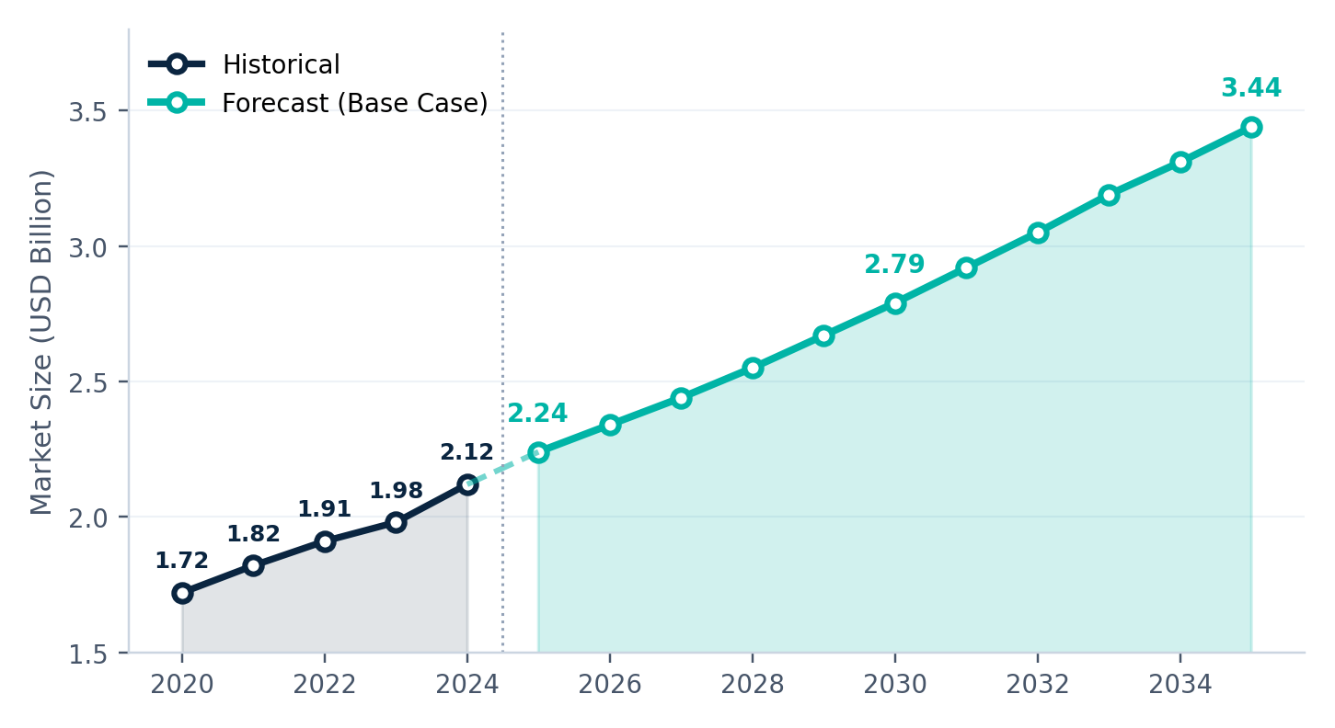
Figure 1.1 - Global Vitamin C market: historical 2020 to 2024 and base-case forecast 2025 to 2035, in USD billion.
Long-Term Growth Outlook
The global Vitamin C market is projected to reach USD 3.44 billion by 2035, growing at a CAGR of 4.4%. Most incremental value creation will come from higher-margin downstream applications, particularly across supplements, cosmeceuticals, and functional wellness products, rather than bulk ingredient sales.
This is not a market driven by hype cycles — long-term value comes from steady compounded growth and strong positioning across the value chain.

SECTION 3
Market Dynamics- Drivers & Challenges

DATA CONFIDENCE - ACCURATE
Cross-validated across multiple independent sources. Low estimation variance.

The market’s growth fundamentals remain strongly positive. We estimate that long-term growth drivers contribute nearly 289 basis points to the market CAGR, while structural restraints reduce growth by only around 58 basis points. The overall balance remains favorable, supporting our projected 4.4% long-term growth outlook.
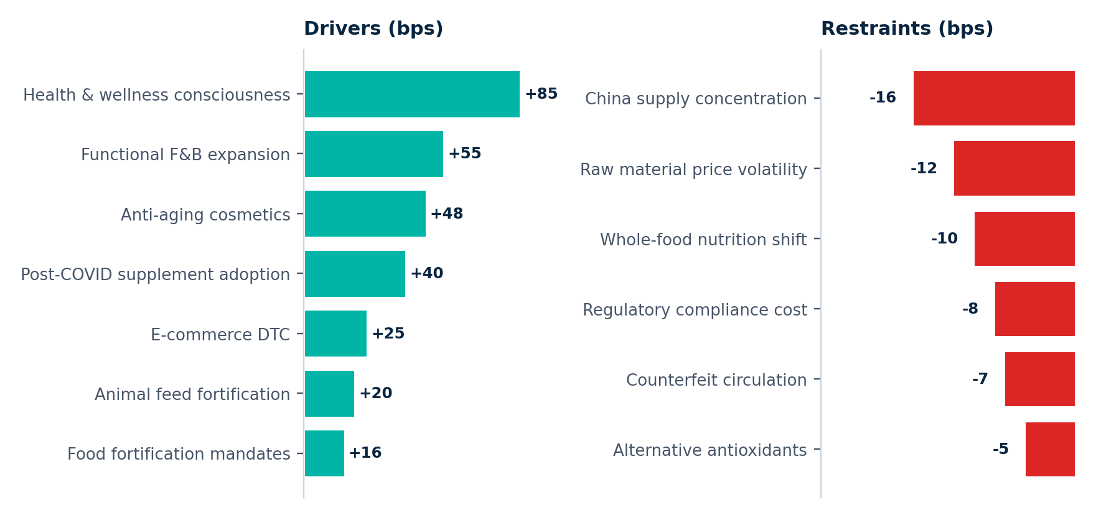
Figure 2.1 - What pushes growth up, and what pulls it down, in basis points of annual CAGR.
What Is Driving Market Growth
Consumer focus on immunity and preventive health remains the market’s strongest growth driver, contributing nearly 85 basis points to annual growth. Functional foods and beverages are another major catalyst, growing 8.2% annually during 2023–2024. Premium skincare demand, post-COVID supplement adoption, expanding e-commerce channels, and government-backed food fortification programs continue to strengthen long-term demand.
What Continues to Challenge Growth
China’s supply concentration remains the market’s largest structural risk, contributing nearly 16 basis points of annual growth drag and driving significant price volatility. Spot prices ranged from USD 2,425 to over USD 7,000 per metric ton during recent disruptions, creating margin pressure for downstream players. Regulatory costs, counterfeit products, and gradual consumer preference toward food-based nutrition remain additional long-term headwinds.
SECTION 4
Industry Attractiveness Assessment – Porter’s Five Forces
DATA CONFIDENCE - ACCURATE
Cross-validated across multiple independent sources. Low estimation variance.

Based on Porter’s Five Forces analysis, the global Vitamin C market demonstrates moderate industry attractiveness, with an overall score of 3 out of 5. Supplier power and competitive rivalry remain the most intense forces due to China’s supply concentration and pricing pressure. In contrast, the threat of substitutes and new entrants remains relatively limited, while buyer bargaining power continues to remain moderate across most end-use segments.
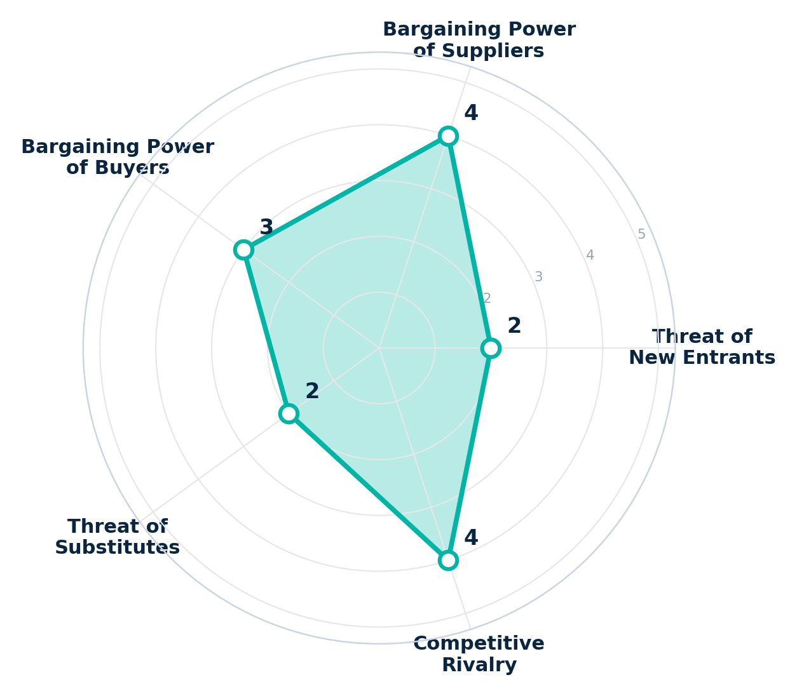
Figure 3.1 - Porter's Five Forces for the global Vitamin C industry, scored 1 to 5.
How Attractive Is the Vitamin C Industry
- Supplier Power – High (4/5): Market heavily dependent on a limited number of Chinese producers controlling ~80% of global supply.
- Competitive Rivalry – Medium-High (4/5): Strong pricing competition in bulk Vitamin C; premium players compete through quality and formulation capabilities.
- Buyer Power – Medium (3/5): Large formulators have purchasing leverage, while smaller buyers remain price-sensitive.
- Threat of New Entrants – Low (2/5): High capital requirements and regulatory barriers limit new competition.
- Threat of Substitutes – Low (2/5): Alternative antioxidants offer limited replacement potential for Vitamin C applications.

SECTION 5
Understanding Demand Across Grades and Forms

DATA CONFIDENCE - MODERATE (variance up to ±20%)
Triangulated from partial datasets or analogous segments. Read as directional, not precise.

How Different Grades Shape Market Demand
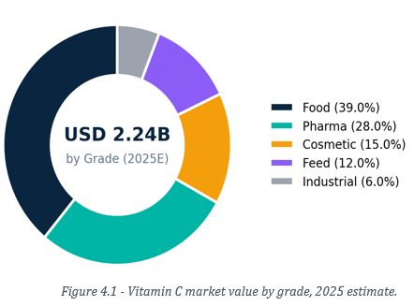
The Vitamin C market is segmented across food, pharmaceutical, cosmetic, animal feed, and industrial grades, each defined by distinct purity standards, regulatory requirements, and pricing dynamics. Food grade remains the largest segment, accounting for 39.0% of the 2025 market value (USD 874.1 million), followed by pharmaceutical grade at 28.0% (USD 627.8 million). While cosmetic grade represents a smaller share at 15.0%, it is emerging as the fastest-growing segment, driven by rising demand for premium skincare and cosmeceutical formulations.
Understanding Demand Across Forms
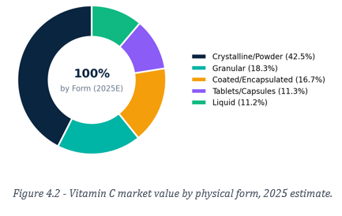
The physical form of Vitamin C plays an important role in determining application suitability, product stability, and pricing dynamics. Crystalline and powder formats dominate the market, accounting for 42.5% of total value, supported by widespread use in food fortification and pharmaceutical applications. Coated and encapsulated formats are emerging as the fastest-growing segment, expanding at 7.2% annually due to increasing demand for extended-release supplements and stability-focused functional foods. Granular forms represent 18.3% of the market, mainly serving supplement premix applications, while liquid (11.2%) and tablet/capsule (11.3%) formats remain concentrated in consumer-facing products such as beverages, intravenous therapies, and over-the-counter supplements.

SECTION 6
Demand Distribution Across Key Industries

DATA CONFIDENCE - MODERATE (variance up to ±20%)
Triangulated from partial datasets or analogous segments. Read as directional, not precise.
Growth Is Shifting Toward Higher-Value Applications
Food & beverages remain the largest Vitamin C application segment, accounting for 38.5% of market value, followed by dietary supplements (26.0%) and pharmaceuticals (18.0%). Cosmetics and personal care continue to gain momentum, while animal feed remains a smaller but stable application area within the overall demand landscape.
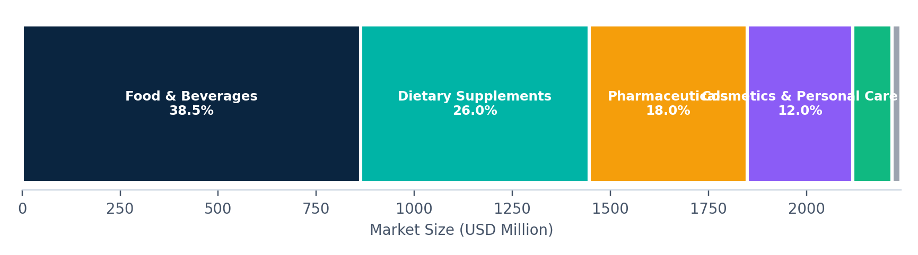
Figure 5.1 - End-use application share, 2025 estimate.
Cosmetics and personal care remains the fastest-growing Vitamin C application, expanding at 7.8% annually — well above the overall market CAGR of 4.4%. While food, pharmaceuticals, and supplements deliver stable growth, the strongest value creation and margin expansion opportunities continue to sit within premium cosmetic-grade Vitamin C derivatives.
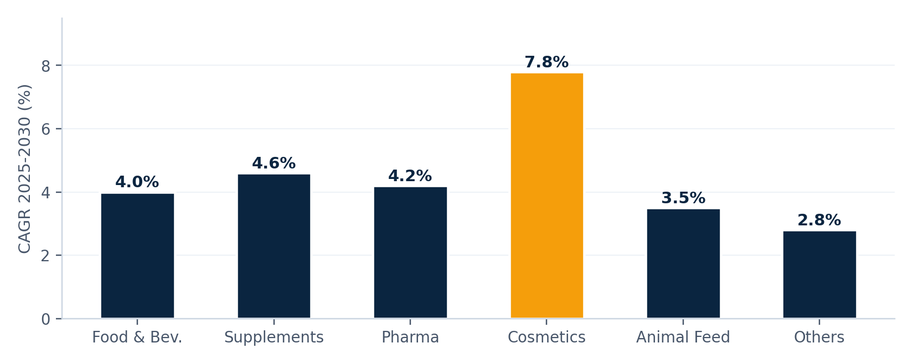
Figure 5.2 - Compound annual growth rates by end-use application, 2025 to 2030.

SECTION 7
High-Growth Sub-Segments Reshaping the Market
DATA CONFIDENCE - MODERATE (variance up to ±20%)
Triangulated from partial datasets or analogous segments. Read as directional, not precise.

Overall market averages do not fully capture where growth is truly concentrated. Within each major application segment, select high-growth niches are expanding well above the market average, offering stronger pricing power, faster demand acceleration, and more attractive long-term investment opportunities.
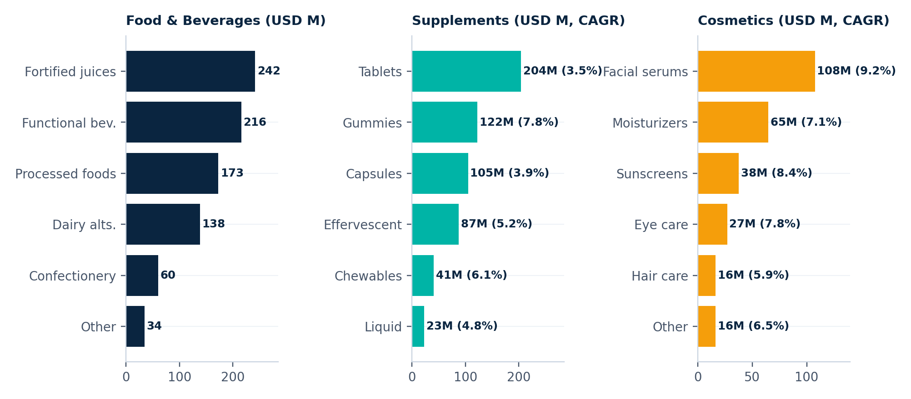
Figure 6.1 - Sub-segment sizes and growth rates within food and beverages, dietary supplements, and cosmetics.
High-Growth Sub-Segments Driving Future Market Expansion
- Food & Beverages: Functional and immunity beverages are growing at 7.1% annually — nearly double the rate of fortified juices and processed foods — driven by wellness-focused beverage brands and digital-first entrants.
- Dietary Supplements: Gummy supplements are expanding at 7.8% annually, significantly outperforming traditional tablets (3.5%) as consumers increasingly prefer convenient and better-tasting formats.
- Cosmetics & Personal Care: Facial serums (9.2%) and Vitamin C-based sunscreens (8.4%) remain the fastest-growing cosmetic applications, supported by premium skincare demand and strong K-beauty influence.
SECTION 8
Derivatives & Value Across the Pricing Structure

DATA CONFIDENCE - MODERATE (variance up to ±20%)
Triangulated from partial datasets or analogous segments. Read as directional, not precise.

The Vitamin C market highlights significant value expansion across the formulation chain. Bulk food-grade ascorbic acid may sell at ~USD 2,400 per metric ton, while premium formats such as liposomal serums can exceed USD 150,000 per metric ton.
Pure L-ascorbic acid accounts for USD 1.21 billion or 53.9% of derivative value, while higher-growth derivatives such as sodium ascorbate, ascorbyl glucoside, and ascorbyl palmitate continue gaining traction across beverages, skincare, and wellness applications.
The same Vitamin C molecule can generate 40–80x higher value simply through premium formulation, delivery format, and brand positioning.
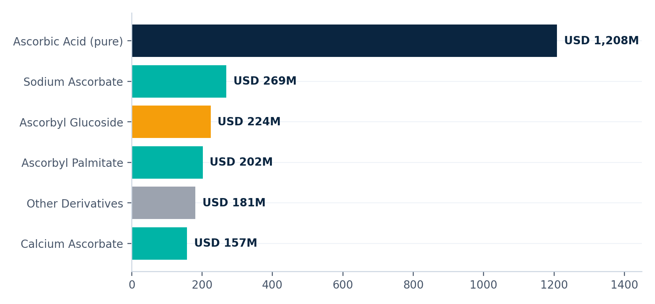
Figure 7.1 - Derivative product market sizes, 2025 estimate.
The Multi-Tier Pricing Structure
Vitamin C pricing varies significantly across grades and applications, reflecting differences in purity, formulation complexity, certification standards, and end-use positioning. While bulk grades compete on cost, premium pharmaceutical, cosmetic, and natural-source variants command significantly higher pricing due to value-added formulations and clean-label demand.
Tier | Price (USD/MT) | Grade | Principal buyers
Commodity bulk | 2,200-3,500 | Food/Feed | Large food manufacturers, feed companies
Standard pharma | 3,500-5,500 | USP | Generic drug manufacturers
Premium pharma | 5,500-8,000 | EP/USP | Branded pharma, injectables
Cosmetic grade | 6,000-12,000 | Derivatives | Premium cosmeceutical brands
Natural source | 15,000-60,000+ | Organic | Clean-label brands, premium DTC
SECTION 9
Regional Outlook & Dynamics

DATA CONFIDENCE - ACCURATE
Cross-validated across multiple independent sources. Low estimation variance.

Asia produces. The West consumes. Africa fortifies.

The global Vitamin C market reflects a clear regional divide across production, consumption, and nutritional demand patterns. Asia-Pacific remains the industry’s manufacturing and supply hub, accounting for USD 963.7 million or 43.0% of global market value. North America (26.8%) and Europe (21.0%) continue to represent the largest consumption markets, driven by supplements, functional foods, and premium wellness products. Meanwhile, Latin America and the Middle East & Africa are increasingly supported by food fortification and public health nutrition initiatives.
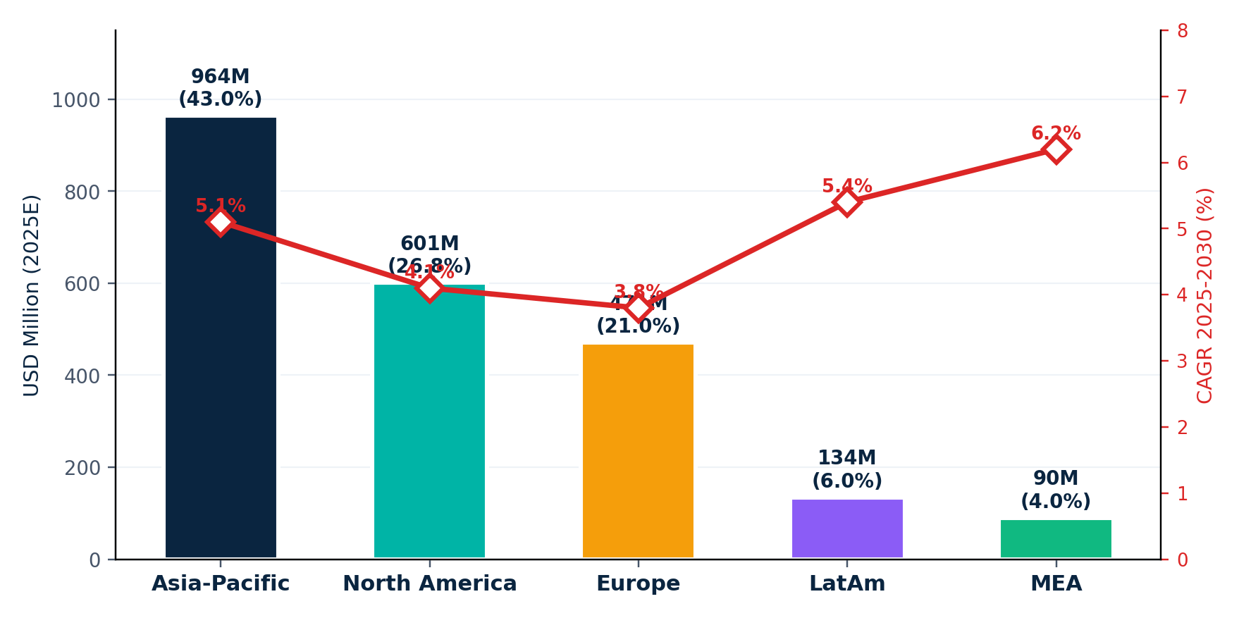
Figure 8.1 - Regional market size 2025 and projected CAGR through 2030.
North America – A Mature Consumption-Driven Market
North America represents the second-largest Vitamin C market, valued at USD 600.6 million in 2025, with the United States contributing nearly 90% of regional demand. Supported by strong supplement and functional wellness consumption, the region is projected to grow at a steady 4.1% CAGR, reaching USD 732.4 million by 2030.

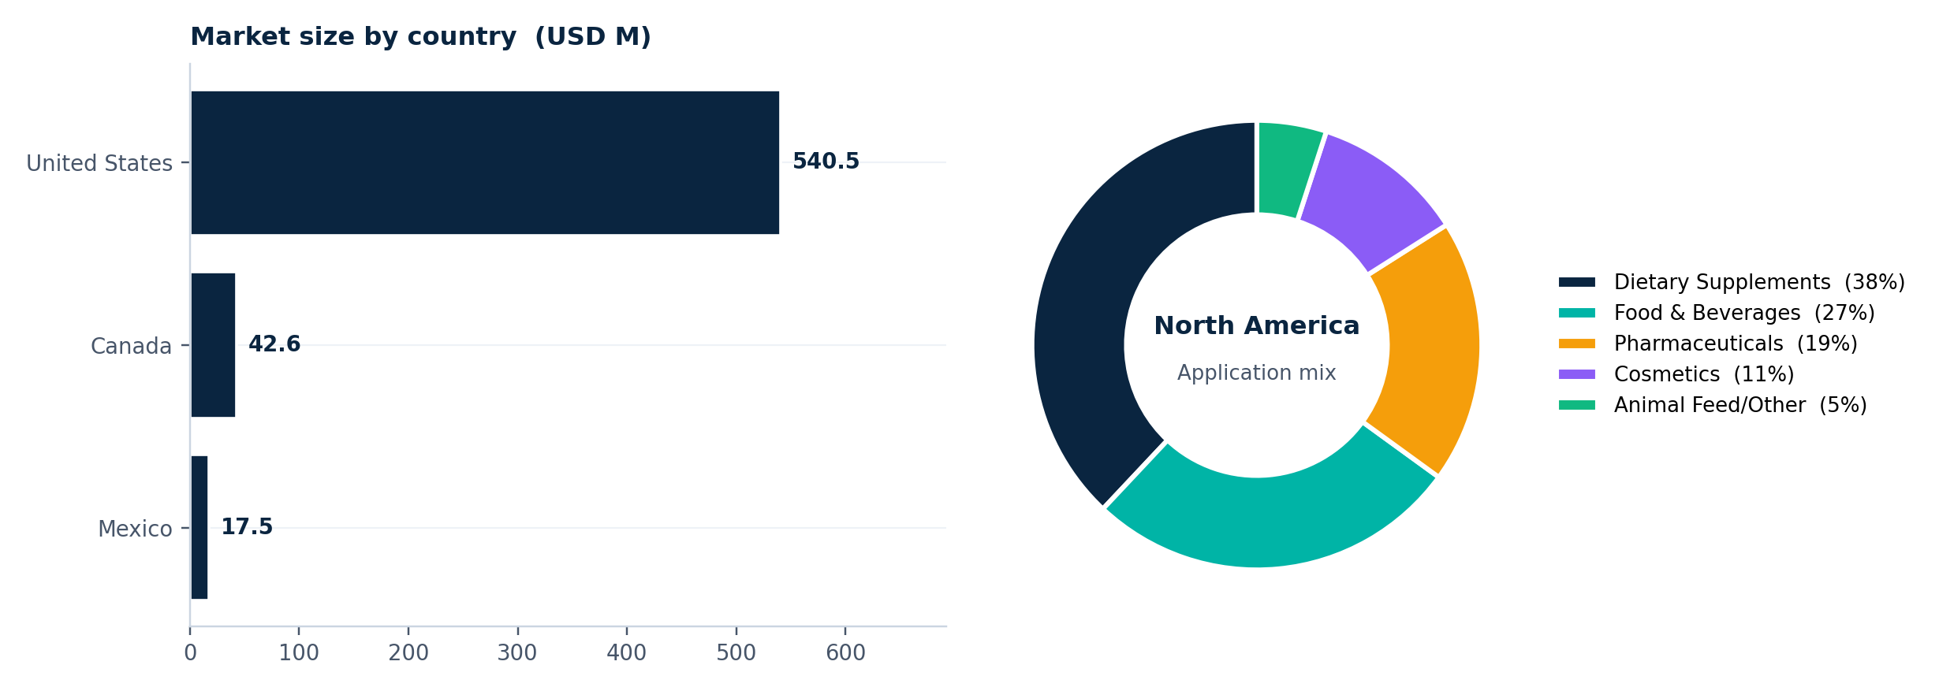
Figure 9.1 - North America: country market sizes and application mix, 2025 estimate.
Key Market Dynamics – North America
- Dietary supplements account for nearly 38% of regional Vitamin C demand, supported by a mature wellness and retail ecosystem.
- Post-COVID supplement demand remains structurally elevated, sustaining consumption levels above the 2019 baseline.
- The market operates under strict FDA, DSHEA, and FTC regulatory oversight, with separate compliance pathways in Canada.
- Supply-chain diversification beyond China remains a key strategic priority for manufacturers and formulators.
Europe – A Regulation-Driven Pharmaceutical Market
Europe represents a USD 470.6 million Vitamin C market in 2025, accounting for 21.0% of global demand. The region is projected to grow at 3.8% annually, reaching USD 567.0 million by 2030. Germany, France, and the UK remain the largest consumption markets, supported by strong pharmaceutical demand, strict regulatory standards, and growing clean-label wellness trends.
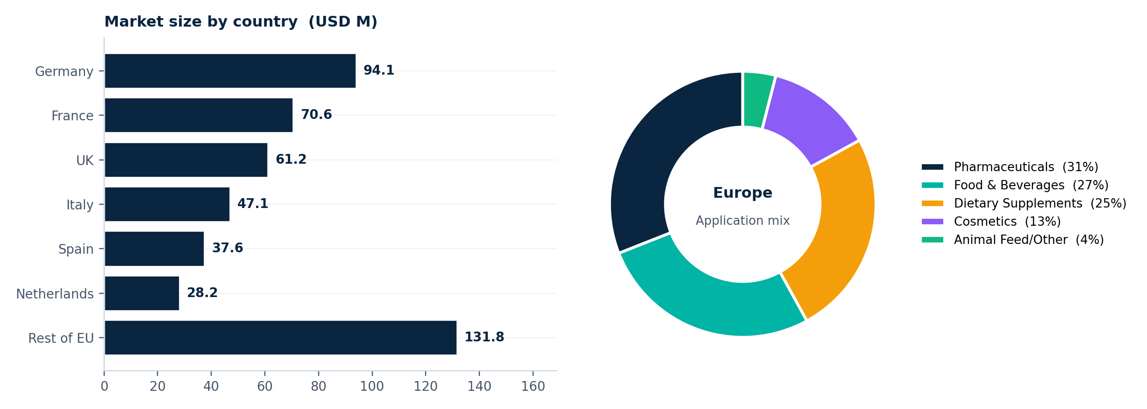
Figure 10.1 - Europe: country market sizes and application mix, 2025 estimate.
Key Market Dynamics – Europe
- Europe remains one of the most regulation-intensive Vitamin C markets, with stricter compliance standards across supplements, food fortification, and cosmetics.
- EFSA-approved health claims create a significantly higher evidence threshold compared to the U.S. market.
- Pharmaceutical-grade and certified high-purity Vitamin C products continue to command premium pricing across the region.

Asia-Pacific – The Global Production and Demand Center
Asia-Pacific remains the largest and most strategically important Vitamin C market, serving as both the global manufacturing hub and the largest consumption region. Valued at USD 963.7 million in 2025 (43.0% of global market value), the region is projected to grow at 5.1% annually, reaching USD 1,233.4 million by 2030, supported by strong production capacity, rising supplement demand, and expanding functional food and skincare markets.
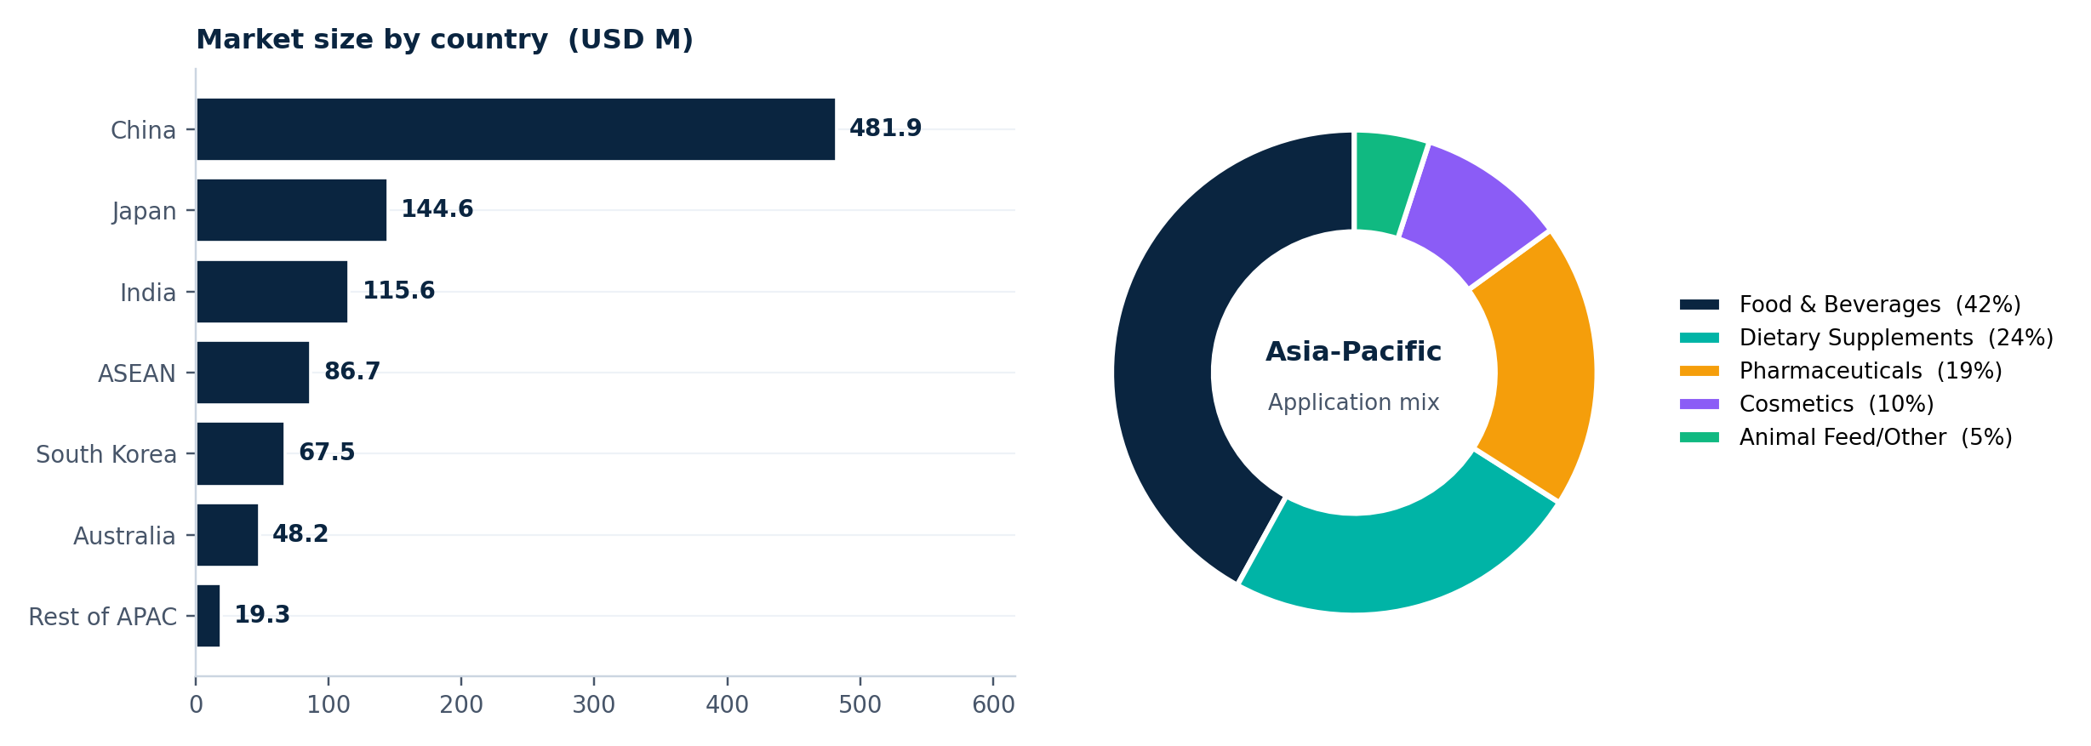Figure 11.1 - Asia-Pacific: country market sizes and application mix, 2025 estimate.
Key Market Dynamics – Asia-Pacific
- China continues to dominate the global Vitamin C supply chain, producing nearly 80–90 thousand metric tons annually across four major provinces and accounting for ~80% of global supply. Pricing volatility remains closely tied to environmental compliance cycles and production controls.
- India is emerging as the fastest-growing market in the region, projected to expand at 7.8% annually, supported by food fortification initiatives, expanding pharmaceutical manufacturing capacity, and rising middle-class supplement consumption.
Latin America – An Import-Dependent Growth Market
Latin America represents a USD 134.5 million Vitamin C market in 2025, accounting for 6.0% of global demand, and is projected to grow at 5.4% annually. Brazil and Mexico together contribute nearly 65% of regional consumption, supported by rising supplement adoption, expanding functional food demand, and increasing dependence on imported Vitamin C supply.

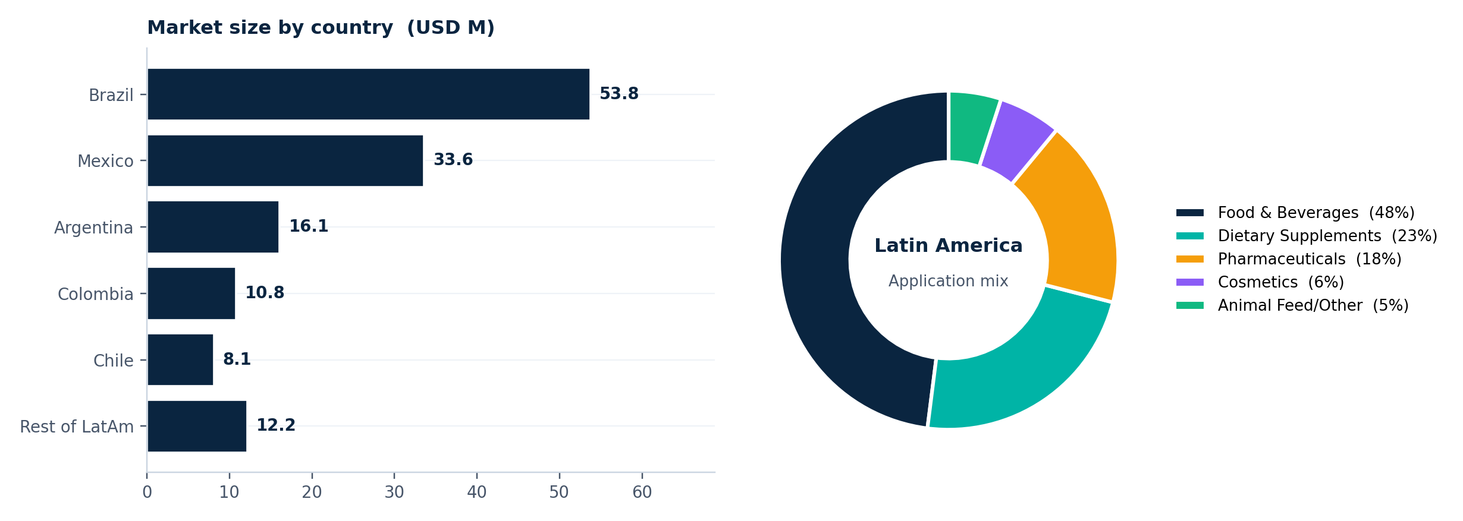
Figure 12.1 - Latin America: country market sizes and application mix, 2025 estimate.
Key Market Dynamics – Latin America
- Government-led food fortification initiatives in Brazil continue to support long-term demand growth across staple food categories.
- Mexico’s evolving supplement regulations are expanding over-the-counter wellness opportunities and improving market accessibility.
Middle East & Africa – A Small but High-Growth Opportunity
The Middle East & Africa represents the smallest regional Vitamin C market at USD 89.7 million in 2025, accounting for 4.0% of global value. However, the region is projected to grow at the fastest pace globally, with a CAGR of 6.2%, driven by rising health awareness, food fortification initiatives, and expanding supplement demand across GCC and African markets.
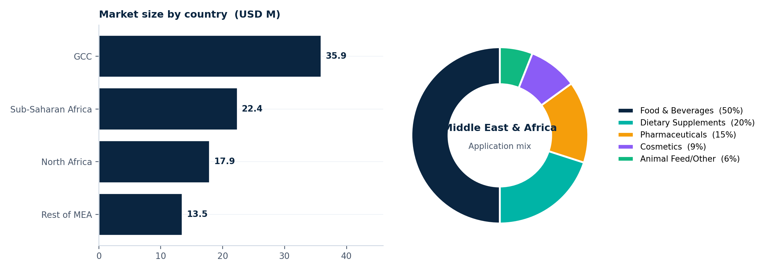Figure 13.1 - MEA: sub-region market sizes and application mix, 2025 estimate.
Key Market Dynamics – Middle East & Africa
- The GCC market is driven by premium wellness consumption, with strong demand for Halal-certified supplements, clinical Vitamin C therapies, and premium healthcare products. In contrast, Sub-Saharan Africa is primarily fortification-led and remains the fastest-growing sub-region at 7.8% annually.
- The regulatory landscape remains fragmented across the region, with country-specific frameworks gradually aligning toward international Codex Alimentarius standards.

SECTION 10
Competitive Landscape

DATA CONFIDENCE - MODERATE (variance up to ±20%)
Triangulated from partial datasets or analogous segments. Read as directional, not precise.

The global Vitamin C market remains highly concentrated, with the top ten players controlling nearly 81.5% of total market value. Industry leadership is dominated by DSM-Firmenich, CSPC Pharmaceutical Group, and Northeast Pharmaceutical Group, which together account for approximately 44% of global revenue, reflecting strong scale advantages across production, supply chains, and formulation capabilities.
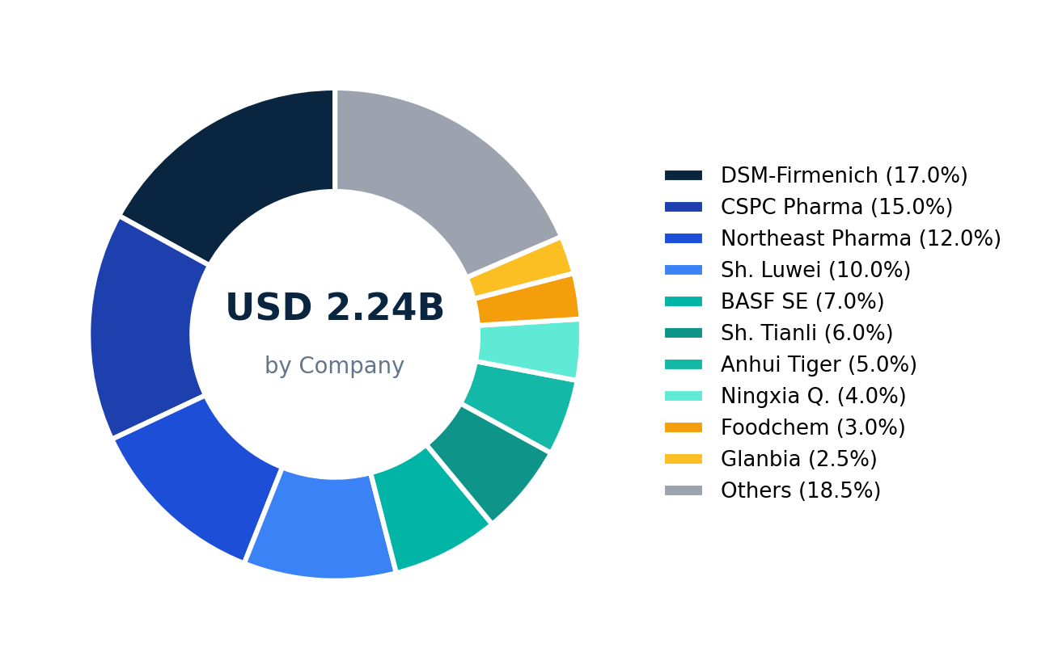
Figure 14.1 - Estimated market share by company, 2025.
Market Leaders and Competitive Positioning
- DSM-Firmenich (~17% share): Global market leader with strong pricing power in premium pharmaceutical-grade Vitamin C through its widely recognized Quali-C portfolio and high-purity formulations.
- CSPC Pharmaceutical Group (~15% share): Largest Chinese producer with significant manufacturing scale, increasingly expanding from commodity bulk supply into higher-margin pharmaceutical-grade applications.
- BASF: A leading premium-market participant focused on advanced nutrition, pharmaceutical-grade quality, and encapsulation technologies across Europe and North America.
Premium-focused players such as DSM-Firmenich and BASF operate at significantly higher gross margins (30–38%) compared to Chinese volume-driven producers (17–28%). The difference highlights the stronger pricing power of pharmaceutical-grade, cosmetic-focused, and branded specialty Vitamin C formulations over commodity bulk production.
SECTION 11
Regulation and Compliance Overview
DATA CONFIDENCE - MODERATE (variance up to ±20%)
Triangulated from partial datasets or analogous segments. Read as directional, not precise.

Regulation acts as a built-in cost layer across the Vitamin C industry, directly influencing margins, pricing, and market entry dynamics. We estimate regulatory compliance expenses account for roughly 4–9% of industry cost of goods sold, depending on product grade, certification requirements, and regional regulatory standards.
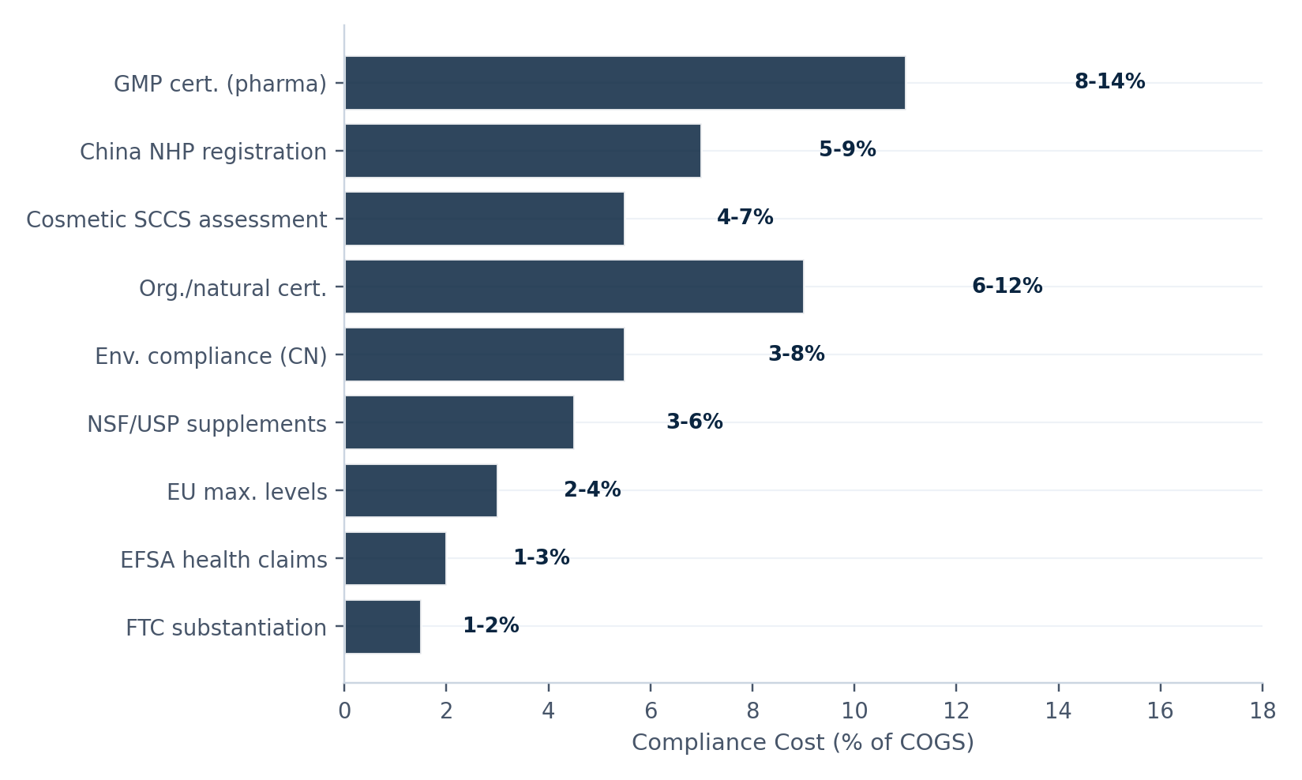
Figure 15.1 - Compliance cost burden by regulatory area, as a percentage of cost of goods sold.
Regulatory Complexity and Cost Burden Across Markets
- Pharmaceutical-grade compliance is the costliest pathway, with GMP certification adding an estimated 8–14% to COGS due to strict facility, testing, and audit requirements.
- China’s NHP Blue Cap system remains highly time-intensive, with approval timelines often extending 2–3 years for new products.
- Supplement and cosmetic certifications carry comparatively lower costs, though third-party verification and EU safety compliance still add meaningful operational overhead.
- Regulatory frameworks differ significantly by region: the U.S. follows a post-market oversight model, while the EU and China enforce stricter pre-market approvals.
- The long-term regulatory direction is tightening, particularly around synthetic nutrient labeling and supplement marketing claims in Europe and parts of North America.

SECTION 12
End User Behavior Outlook
DATA CONFIDENCE - ACCURATE
Cross-validated across multiple independent sources. Low estimation variance.

Consumer behavior in the Vitamin C market has shifted from short-term immunity-driven purchasing to longer-term wellness and lifestyle adoption, particularly among Millennial and Gen Z consumers. At the same time, ingredient-aware “skintellectual” consumers are driving stronger demand for transparent, science-backed skincare and premium Vitamin C formulations.
Consumer Spending Patterns Are Becoming Increasingly Segmented
Willingness to pay for Vitamin C products varies significantly across consumer profiles. While price-sensitive buyers remain focused on low-cost generic tablets, premium wellness consumers are increasingly paying higher prices for branded, buffered, extended-release, and liposomal formulations positioned around efficacy, convenience, and superior absorption.
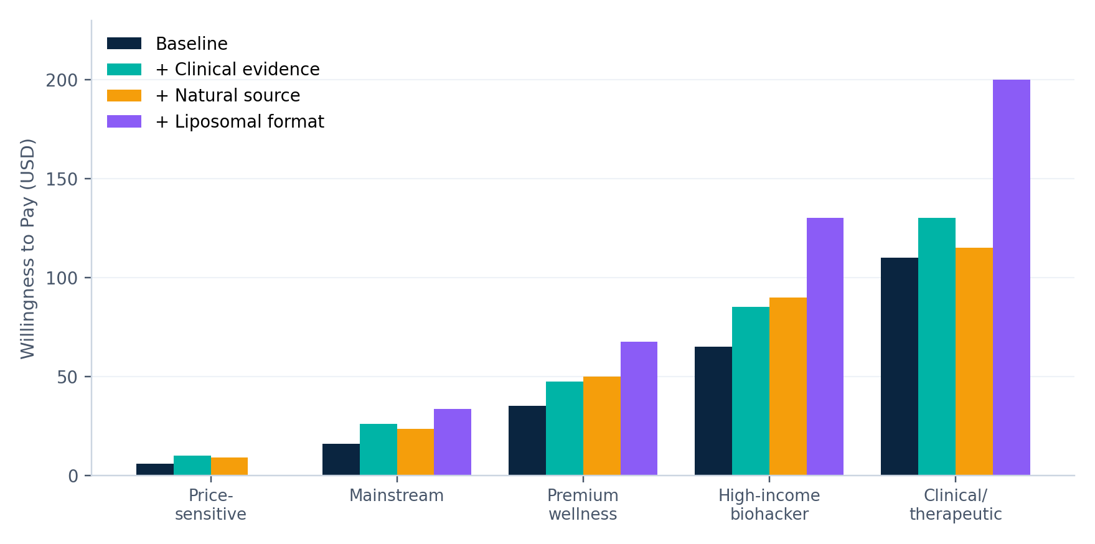
Figure 16.1 - Willingness to pay by consumer profile and product attribute, in USD per thirty-day supply.
Consumer Behavior, Pricing Power, and Innovation Trends
- Consumer spending is becoming increasingly segmented, ranging from USD 4–8 for generic tablets to over USD 130 for premium liposomal Vitamin C products, reflecting rising demand for efficacy-focused wellness solutions.
- Pricing power remains strongest in premium supplements and cosmeceuticals, where lower price sensitivity supports higher margins and sustained premium positioning compared to commodity bulk applications.
- Consumer pain points are accelerating formulation innovation, driving adoption of stabilized derivatives, buffered formats, liposomal delivery systems, and traceability-focused supply chains across premium product categories.

SECTION 13
Strategic Investment Priorities
DATA CONFIDENCE - MODERATE (variance up to ±20%)
Triangulated from partial datasets or analogous segments. Read as directional, not precise.

The Vitamin C market offers multiple investment pathways, but returns vary significantly depending on where participants operate within the value chain. The most attractive opportunities over the next five years are expected to come from premium formulations, cosmetic derivatives, advanced delivery systems, and downstream wellness applications, where pricing power and margin expansion remain structurally stronger than bulk commodity production.
Opportunity | Target segment | Time | ROI | Investment
Premium liposomal supplement | Wellness millennials, biohackers | 12-18 mo | HIGH (45-70%) | Medium
Cosmetic Vitamin C serum line | Skintellectual beauty consumers | 12-24 mo | HIGH (40-65%) | Med-High
Functional immunity beverage | Health-conscious adults | 6-12 mo | MED (22-35%) | Medium
Pharma-grade API supply | Generic drug manufacturers | 24-36 mo | MED (20-28%) | High (CapEx)
Food fortification ingredients | Large food manufacturers | 6-18 mo | MEDIUM | Low-Med
India API localisation | Indian pharma manufacturers | 36-48 mo | MED-HIGH | High
SSA fortification (PPP) | Governments, NGOs | 12-24 mo | LOW-MED | Low

Table 17.1 - Go-to-market strategy matrix, ranked by expected ROI and time-to-market.
Highest-Potential Investment Opportunities
- Premium downstream products offer the highest returns, with liposomal Vitamin C supplements projected to generate 45–70% five-year ROI, while cosmetic serum lines deliver 40–65% returns with gross margins reaching 55–72%.
- Pharmaceutical API expansion and Indian localization strategies require higher capital investment but offer long-term strategic value through supply diversification away from China and government-backed manufacturing incentives.
- Sub-Saharan African food fortification programs represent a lower-return but high-growth opportunity, supported by WHO- and UNICEF-backed partnerships focused on maternal and child nutrition initiatives.

SECTION 14
Scenario Analysis: Three Possible Market Futures
DATA CONFIDENCE - ACCURATE
Cross-validated across multiple independent sources. Low estimation variance.

Our base-case forecast projects the global Vitamin C market to grow at a 4.4% CAGR, reaching USD 3.44 billion by 2035. However, long-term market outcomes remain sensitive to regulatory shifts, supply-chain disruptions, consumer wellness trends, and geopolitical developments. To reflect this uncertainty, we model three realistic market scenarios spanning bullish, base-case, and downside growth trajectories.
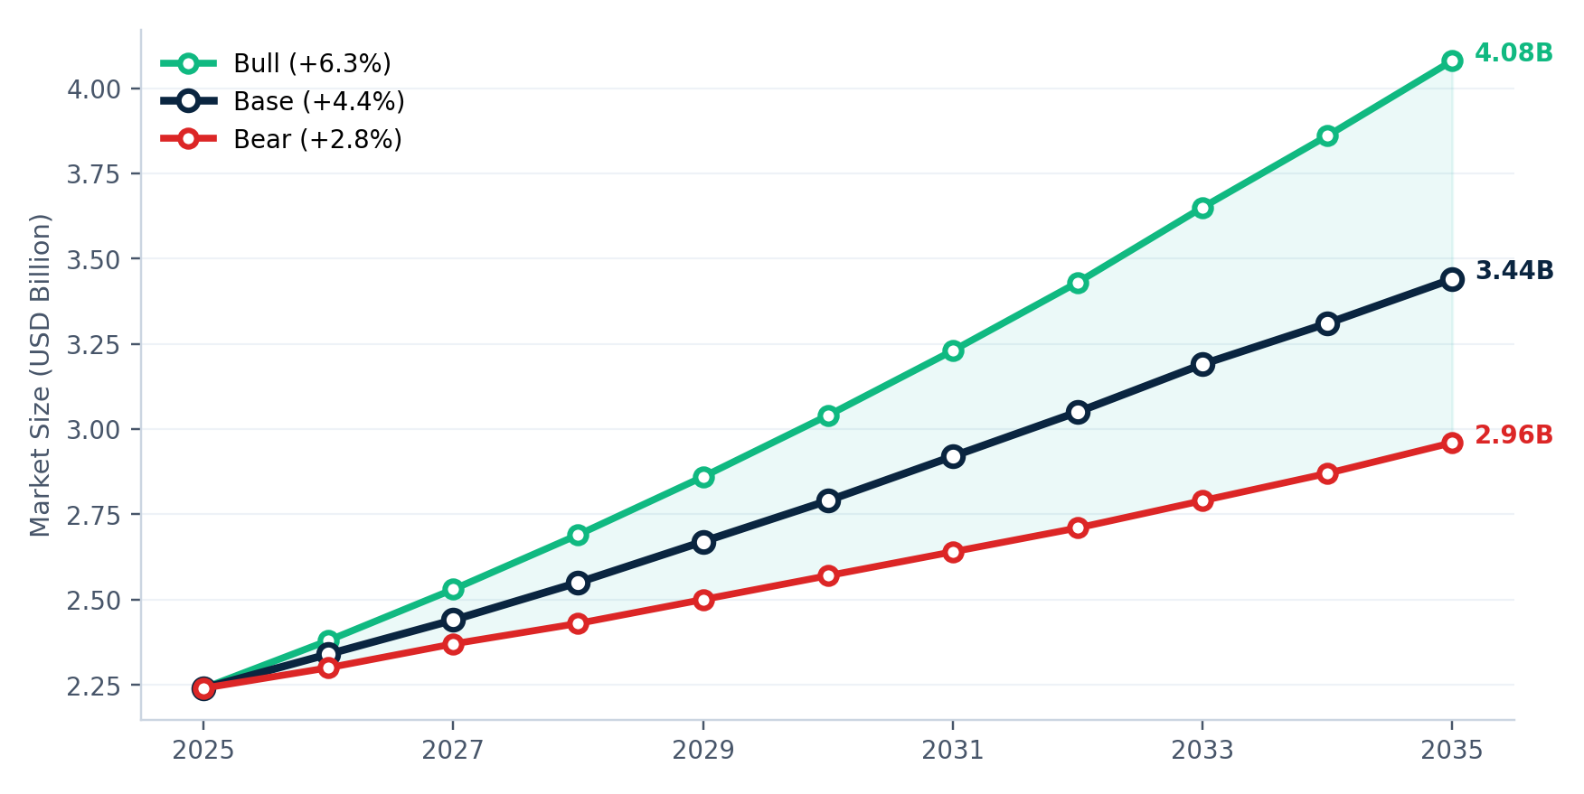
Figure 18.1 - Bear, base, and bull case forecasts, 2025 to 2035.
Scenario Outlook: Bear, Base, and Bull Case Futures
- Bear Case – USD 2.96 Billion by 2035 (2.8% CAGR): Prolonged China supply disruptions, escalating trade tensions, tighter supplement regulations, and weakening consumer demand could significantly slow market growth, particularly across premium wellness categories.
- Base Case – USD 3.44 Billion by 2035 (4.4% CAGR): Moderate regulatory tightening, stable health-conscious consumption, and gradual supply diversification support steady long-term market expansion and balanced industry growth.
- Bull Case – USD 4.08 Billion by 2035 (6.3% CAGR): Faster wellness adoption, supply diversification into India and Europe, lower production costs, and accelerating cosmeceutical demand could materially strengthen market growth, with premium skincare segments potentially expanding at 10–12% annually

SECTION 15
Investment Thesis: Where Long-Term Value Creation Will Come From
DATA CONFIDENCE - ACCURATE
Cross-validated across multiple independent sources. Low estimation variance.

The Vitamin C market presents a structurally attractive long-term opportunity driven by stable demand fundamentals, expanding wellness adoption, and growing premiumization across end-use applications. Over the next decade, value creation is expected to increasingly shift toward higher-margin downstream formulations, branded wellness products, and differentiated delivery formats.
- Steady Structural Growth: The global Vitamin C market is projected to grow at a stable 4.4% CAGR through 2035, creating nearly USD 1.20 billion in incremental market opportunity, supported by resilient wellness, supplement, food, and cosmetic demand.
- Premiumization Will Drive Outsized Returns: High-growth segments such as cosmeceuticals (7.8% CAGR) and liposomal supplements (15–20% CAGR) continue to outperform bulk commodity applications, creating stronger pricing power and margin expansion opportunities.
- Supply Diversification Is Becoming Strategic: With nearly 80% of global production concentrated in China, downstream operators are increasingly prioritizing Indian, European, and alternative sourcing strategies to reduce supply-chain and geopolitical risk exposure.
- Margins Continue to Shift Downstream: Premium consumer brands and advanced formulations are expected to generate materially higher returns than bulk ingredient manufacturing, reinforcing the importance of branding, formulation innovation, and direct-to-consumer channel strategies.
Concluding View
The Vitamin C market remains a structurally attractive long-term opportunity, combining stable demand fundamentals with premiumization-led value creation. Companies positioned in high-margin downstream applications and diversified supply-chain models are expected to capture disproportionate growth and profitability over the next decade.
IMPORTANT NOTICE
Disclaimer

This document has been prepared for informational and strategic planning purposes only.
All market sizes, growth rates, forecasts, and segment estimates presented in this paper are analyst-derived. They are constructed through cross-validation of multiple independent data sources and with the methodological adjustments documented earlier in the paper. While we have applied reasonable care in compiling and reviewing the underlying data, actual market outcomes may vary materially from the projections presented here.
Factors that may cause actual outcomes to differ from forecasts include - but are not limited to - macroeconomic conditions, currency movements, regulatory and policy changes, geopolitical developments, supply-chain disruptions, technological breakthroughs, and shifts in consumer behaviour. These factors are partially addressed in our scenario analysis but cannot be fully anticipated.
This document does not constitute investment advice, a recommendation to buy or sell any security, or an offer or solicitation in any jurisdiction. Readers should perform their own due diligence and consult appropriate professional advisors before making any commercial, financial, or strategic decision based on the contents of this paper.
All trademarks, company names, and product names referenced in this document remain the property of their respective owners. Mention of specific companies, products, or services is for analytical context and does not constitute endorsement.
This paper is the proprietary work product of its authors. Redistribution, reproduction, or commercial use of any portion of this document without prior written permission is prohibited.

