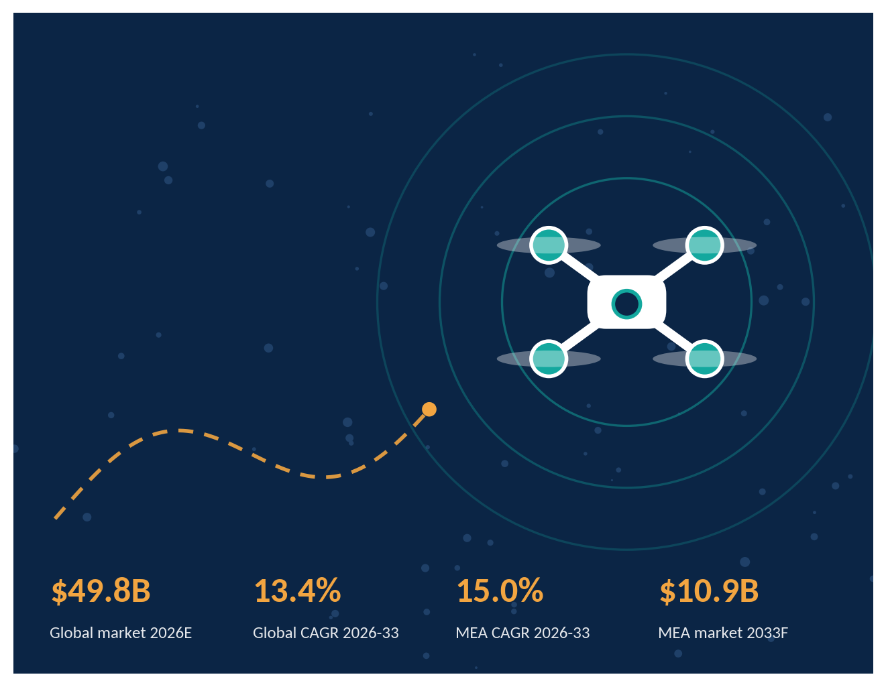
WHITEPAPER | OCTOBER 2026
Drone Market Outlook 2026-2033
Global trends and the Middle East & Africa opportunity: market sizing, segment and country dollar opportunities, regulation, vendor intelligence and strategic recommendations
Prepared by
Coherent Market Insights (CMI)
Aerospace, Defense & Emerging Technology Practice

Contents
1 Executive Summary: Global vs Middle East & Africa 3
2 Current Market Trends, Growth Factors, Restraints and Impact 5
3 Global Drone Market Size: Scenario Analysis by Segments, Region & Top Countries 7
4 Middle East Drone Market Size: Opportunity Analysis by Segments & Country 9
5 Africa Drone Market Size: Opportunity Analysis by Segments & Country 12
6 Regulatory & Policy Outlook 15
7 Vendor Intelligence 17
8 Strategic Recommendations & Way Forward 19
9 Research Methodology 20
10 About CMI 22

About this whitepaper
This whitepaper sizes the global drone (UAS) market and goes deep on the Middle East and Africa, the two regions where defense localisation, giga-project construction, energy-sector autonomy and new BVLOS regulation are creating the largest absolute dollar opportunities outside Asia Pacific.
Market values are in USD billion at constant 2025 prices unless stated. 2025 is the base year, 2026E is the estimate year and 2027F-2033F are forecasts. Market scope covers hardware, software and services for civil, commercial and defense unmanned aerial systems, and excludes counter-UAS unless explicitly noted.

Data status
Figures are CMI triangulated estimates built from public regulator, company and third-party research data (see Chapter 9). This document is a publication template: refresh all values from CMI's proprietary database before external release.

01 Executive Summary
The global drone market is moving from a gadget-and-pilot-project phase into an infrastructure-and-security phase. CMI estimates the market at $44.0B in 2025, rising to $49.8B in 2026 and $120.3B by 2033, a 13.4% CAGR. Published third-party estimates for 2025 range from about $32B to $84B depending on scope, so CMI uses a triangulated base (Chapter 9).
Figure 1: Headline market metrics: Global vs Middle East & Africa
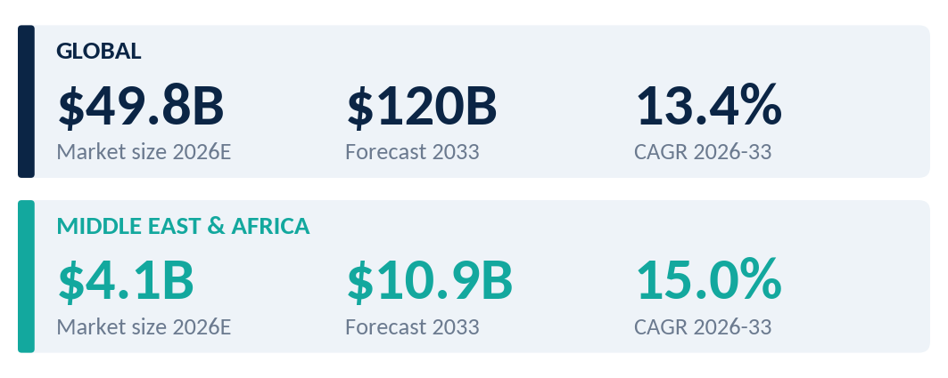
Source: CMI analysis. 2026E = estimate, 2033F = forecast.

1.1 Global snapshot
- North America leads with about 34.0% of 2026 value ($16.9B), anchored by US defense and enterprise inspection programs.
- Asia Pacific is the growth engine, adding $26.0B of incremental revenue to 2033 at a 15.5% CAGR on manufacturing scale and maritime security demand.
- Defense and civil are converging. Low-cost attritable systems, AI autonomy and counter-UAS are reshaping procurement, while civil use cases such as inspection, mapping and agriculture are scaling through drone-as-a-service.

1.2 Middle East & Africa snapshot
- MEA is a $4.10B market in 2026E (8.2% of global) forecast to reach $10.9B by 2033F, growing at 15.0% CAGR, about 1.5 pp faster than the world.
- Middle East ($3.48B in 2026E) is led by Saudi Arabia and the UAE. Together they hold about 47.4% of the sub-region and are funding local OEM capacity, giga-project construction monitoring and layered air defense.
- Africa ($0.62B in 2026E) is smaller but compounding at 15.1%, with South Africa the most mature market and Nigeria, Morocco and the Rest of Africa growing fastest on agriculture, mining, security and medical-delivery use cases.
Figure 2: MEA outgrows the global market and gains share through 2033
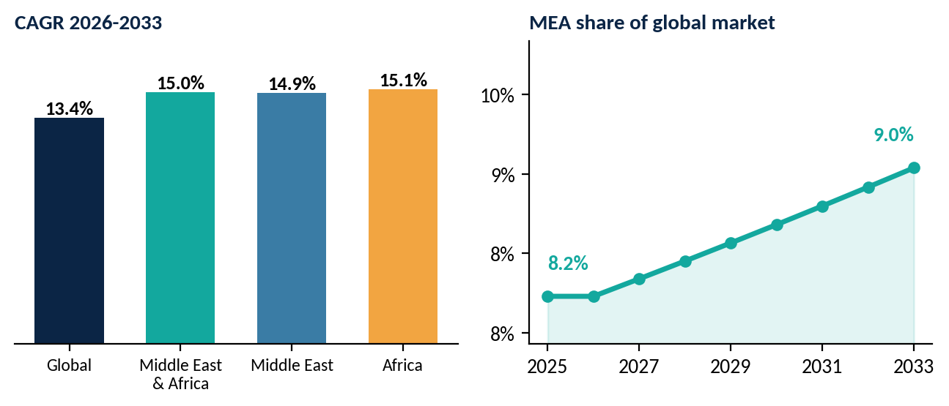
Source: CMI analysis

1.3 Global vs Middle East & Africa at a glance
Table 1: Global vs MEA scorecard
Dimension | Global | Middle East & Africa
Market size 2025 | $44.0B | $3.62B
Market size 2026E | $49.8B | $4.10B
Market size 2033F | $120.3B | $10.9B
CAGR 2026-2033 | 13.4% | 15.0%
Incremental revenue 2026-33 | $70.5B | $6.78B
Largest demand pool | Commercial inspection, agriculture and defense ISR | Defense & homeland security (Middle East); agriculture and mining (Africa)
Fastest-growing type | Hybrid / VTOL and long-endurance fixed-wing | Hybrid / VTOL (Middle East 21%, Africa 23% CAGR)
Primary growth catalyst | AI autonomy, defense scale-up, BVLOS | Sovereign defense programs, giga-projects, energy inspection
Primary constraint | Fragmented regulation, supply-chain security | Airspace-security incidents, restrictive import and permit regimes
Source: CMI analysis
Key conclusions
1. The Middle East will add roughly $5.74B of annual revenue by 2033, with Saudi Arabia ($1.78B) and the Rest of Middle East ($1.97B) the largest absolute pools.
2. Africa is a volume and services story: sub-$0.5B in 2033 per country, but the Rest of Africa and Nigeria compound at 17-18%.
3. Winners will combine hardware + local presence + services + compliance. Pure hardware exporters face rising localisation and sourcing barriers.

02 Market Trends, Drivers & Restraints
Six structural trends are reshaping demand. Together they explain why MEA's growth premium over the global market persists even after a volatile 2026 for regional airspace.
Figure 3: Six trends shaping the drone market
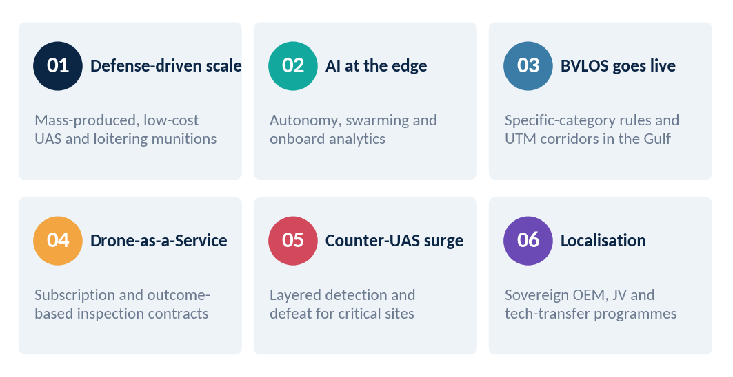
Source: CMI analysis

2.1 Current market trends
Defense-driven scale. Wartime lessons have pulled mass-produced, low-cost UAS and loitering munitions into mainstream procurement. Public-source estimates place the global military drone market at roughly $24-27B in 2025-26, growing at about 11.5-13.6% a year.
Counter-UAS surge. Counter-drone systems are the fastest-growing adjacent category. The global counter-UAS market is projected to rise from about $6.6B in 2025 to $20.3B by 2030 (25.1% CAGR), and Middle East & Africa counter-drone demand is forecast to grow near 27.7% annually through 2030 (Cognitive Market Research).
BVLOS and UTM. Regulators in the Gulf are moving from case-by-case waivers to defined risk-based categories. Saudi Arabia's GACA Part 107 V5 introduces standard scenarios (STS-01, STS-02) for populated-area VLOS and industrial BVLOS work, with Remote ID obligations from January 2026.

2.2 Growth factors and restraints
The MEA drone market is being supported by several structural growth factors, particularly defense modernisation, localization initiatives, smart-city investments, and increasing use of drones for energy and infrastructure inspection. These drivers are expected to contribute positively to market CAGR over the forecast period. The figure presents CMI’s assessment of the relative contribution of these factors to MEA market growth, with the estimated impact expressed in percentage points of CAGR.

Figure 4: Impact of growth factors and restraints on MEA CAGR (percentage points)
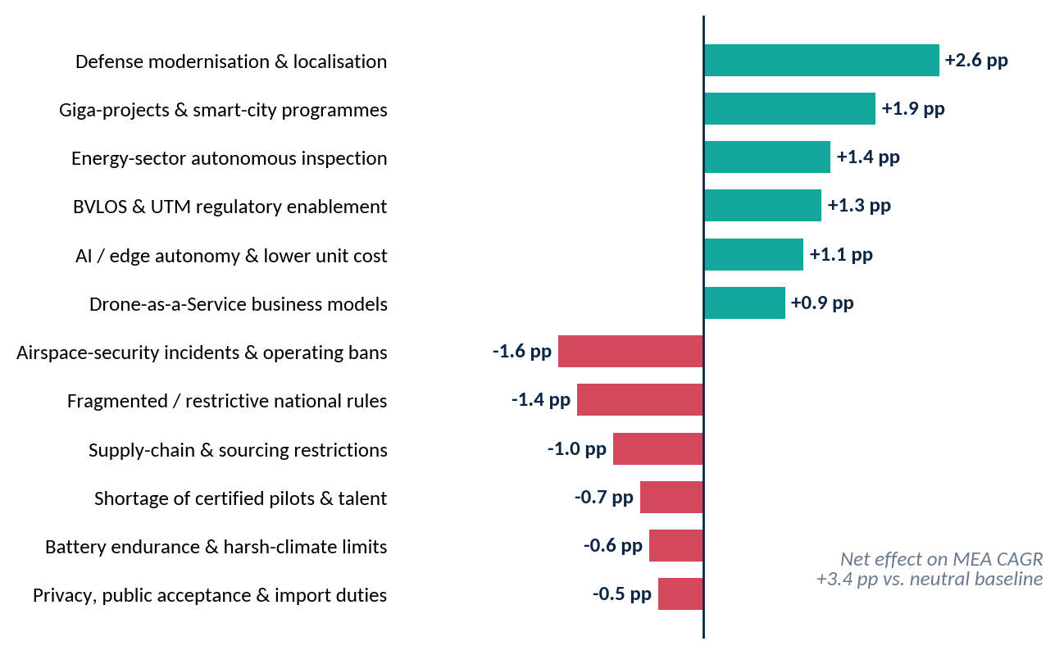
Source: CMI analysis; weights reflect CMI expert-panel scoring

2.3 Impact assessment matrix
This matrix summarizes the relative impact, timing, and geographic exposure of key market factors shaping the Middle East & Africa drone market. Defense localization, smart-city investments, and autonomous inspection are expected to support market growth, while airspace restrictions, regulatory fragmentation, sourcing constraints, and operational limitations may moderate adoption.
Table 2: Impact assessment of market factors
Factor | Type | Impact | Timeframe | Most exposed
Defense modernisation & localisation | Driver | High | Short-Long | KSA, UAE, Egypt
Giga-projects & smart-city programs | Driver | High | Short-Mid | KSA, UAE, Qatar
Energy-sector autonomous inspection | Driver | Medium | Short-Mid | Gulf, Algeria, Nigeria
BVLOS & UTM enablement | Driver | Medium | Mid | KSA, UAE, South Africa
Airspace-security incidents & bans | Restraint | High | Short | UAE, Qatar, Kuwait
Fragmented / restrictive rules | Restraint | Medium | Short-Mid | Morocco, Algeria, Nigeria
Supply-chain & sourcing restrictions | Restraint | Medium | Mid | All importers
Talent and endurance limits | Restraint | Low | Mid-Long | Africa, Gulf field ops
Source: CMI analysis

03 Global Drone Market Size: Scenario Analysis
CMI's base case values the global drone market at $49.8B in 2026E, reaching $120.3B in 2033F. Because published estimates diverge on scope and definitions, CMI frames the outlook as three scenarios rather than a single point estimate.
Figure 6: Global drone market by region, 2025-2033 (USD billion)
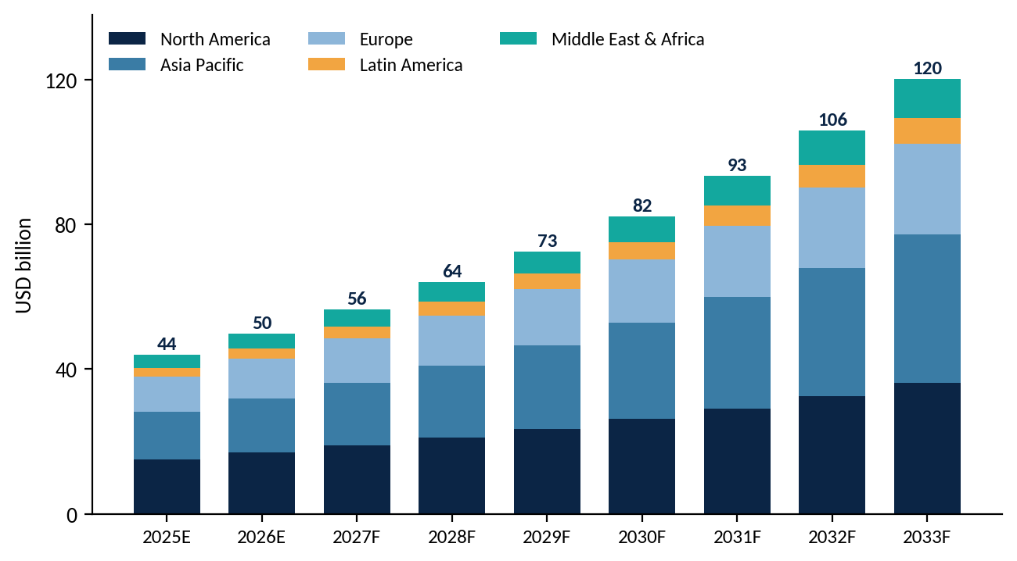
Source: CMI analysis

3.1 Scenario analysis
Figure 7: Global Drone market scenarios: conservative, base and optimistic
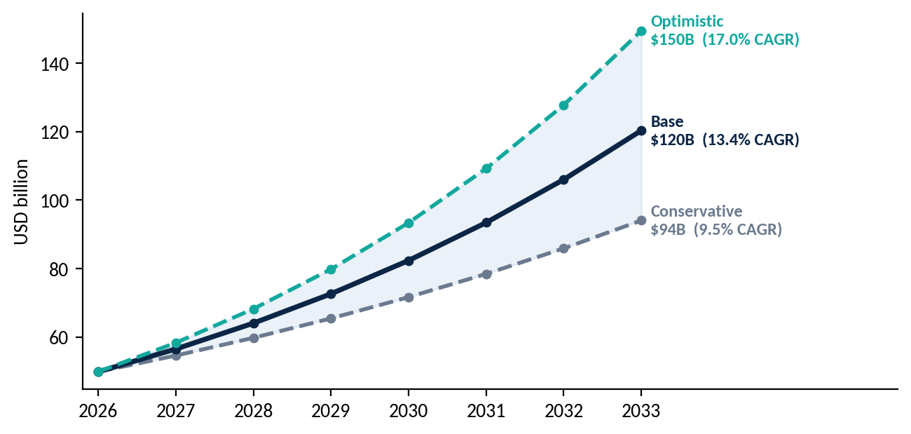
Source: CMI analysis
Table 3: Scenario definitions
Scenario | CAGR 2026-33 | 2033 value | What has to be true
Conservative | 9.5% | $94.0B | Slower regulatory harmonisation, persistent trade restrictions on key components, and defense procurement normalising after current conflicts.
Base | 13.4% | $120.3B | BVLOS rules in major markets mature by 2028, drone-as-a-service scales, and sovereign defense programs continue.
Optimistic | 17.0% | $149.5B | Rapid UTM roll-out, autonomous delivery reaches mass scale and AI-native platforms cut operating costs sharply.
Source: CMI analysis

3.2 Global Drone Market size by Segments

Global Opportunity By Drone Type
Figure 12: Global market by drone type, 2026E vs 2033F
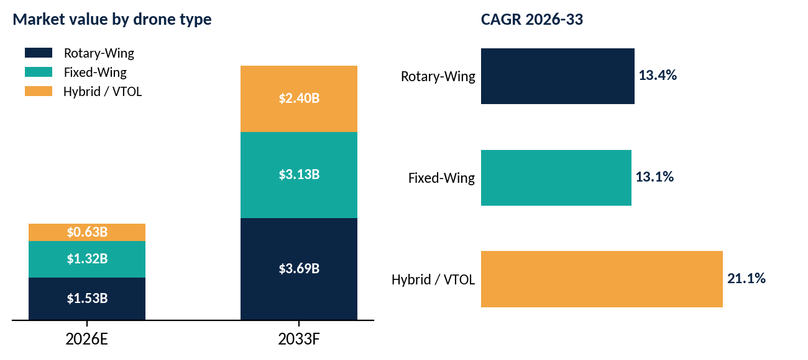
Source: CMI analysis
Rotary-wing remains the largest type through 2033F ($3.69B), but Hybrid / VTOL grows from $0.63B to $2.40B at 21.1% CAGR as operators want long-range BVLOS inspection without runways. Fixed-wing demand is driven by medium- and long-endurance ISR.

Global Opportunity By End User
Figure 13: Global market by end user, 2026E vs 2033F (USD billion)
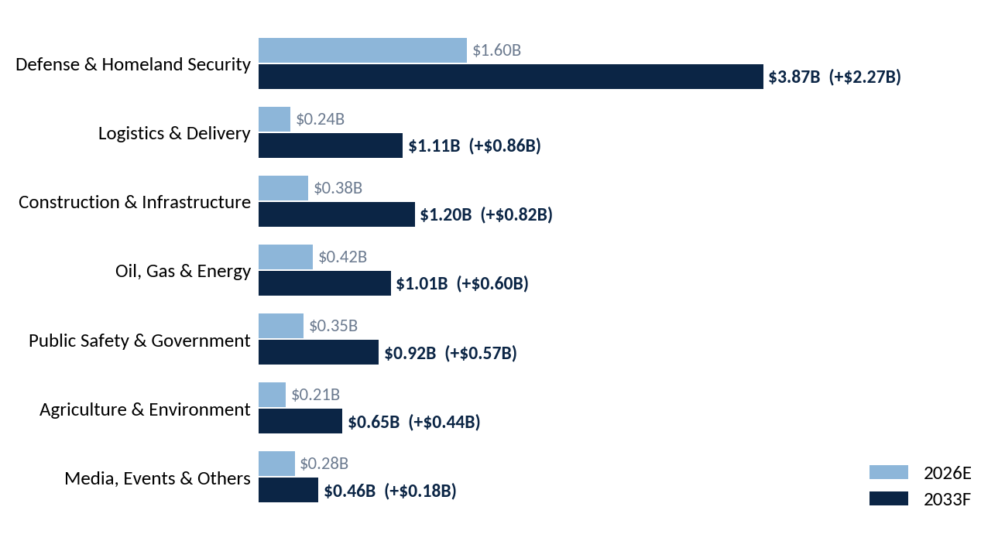
Source: CMI analysis
Defense & Homeland Security is the biggest absolute opportunity (+$2.27B), followed by Logistics & Delivery (+$0.86B), the fastest-growing civil end user, and Construction & Infrastructure (+$0.82B).

3.3 Global Drone Market Size By Region
Figure 8: Regional share of the global market, 2026E vs 2033F

The figure compares the regional distribution of the global drone market in 2026 and 2033, highlighting how market shares are expected to evolve over the forecast period. Changes reflect varying adoption rates, investment levels, regulatory developments, and demand across key regions.
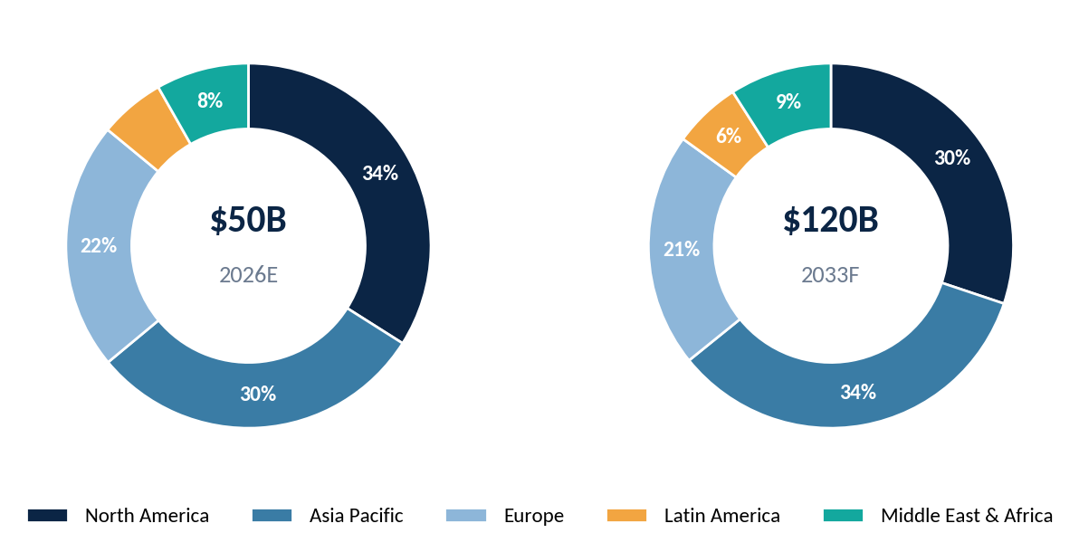
Source: CMI analysis
Global: Absolute dollar opportunity by region, 2026-2033

The absolute dollar opportunity analysis highlights the incremental revenue potential across major global regions between 2026 and 2033. The comparison reflects differences in market size, adoption rates, investment intensity, and the pace of drone deployment across commercial, defense, infrastructure, and industrial applications. Regions with stronger technology adoption, defense spending, regulatory enablement, and large-scale infrastructure programs are expected to account for a substantial share of the incremental opportunity. The figure provides a regional perspective on where future market expansion could generate the greatest revenue pool during the forecast period.
Figure 9: Global: Absolute dollar opportunity by region, 2026-2033
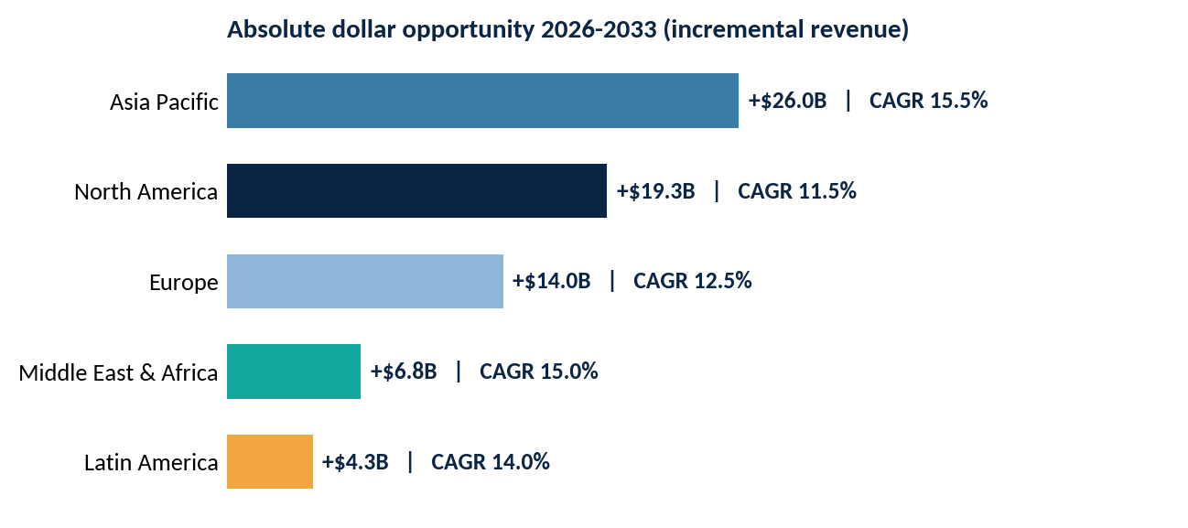
Source: CMI analysis

3.4 Regional highlights
North America. Largest region at $16.9B in 2026E. The US Department of Defense's attritable-systems push, FAA BVLOS rulemaking and enterprise drone-in-a-box deployments sustain an 11.5% CAGR.
Europe. $11.0B in 2026E. EASA's open/specific/certified categories and U-space implementation support commercial scale, while rearmament is lifting defense UAS spending. CAGR 12.5%.
Asia Pacific. $14.9B in 2026E and the fastest-growing major region (15.5% CAGR). China's manufacturing base, India's production-linked incentives and maritime-security demand in Southeast Asia and Australia drive growth.
Latin America. $2.89B in 2026E. Precision agriculture in Brazil and Argentina, mining in Chile and Peru, and public-security deployments in Mexico and Colombia support a 14.0% CAGR.
Middle East & Africa. $4.10B in 2026E, rising to $10.9B in 2033F (15.0% CAGR). Gulf sovereign spending and a nascent but fast-growing African commercial base push MEA to 9.0% of global value by 2033. Chapters 4 and 5 break this down by country and segment.
The regional analysis is extended below to a country-level geographic framework. Each regional view follows a common structure covering 2026E market size, 2033F forecast value, CAGR and incremental dollar opportunity. Country-level values for North America, Latin America, Europe and Asia Pacific should be refreshed from the CMI proprietary database before external publication; Middle East and Africa values are carried forward from the detailed country analysis in Chapters 4 and 5.

3.5 Regional Analysis, By Key Countries

North America Drone Market by Country
The North America country view separates the United States and Canada, with a residual Rest of North America category to ensure reconciliation with the regional total. The United States is expected to remain the dominant demand pool, supported by defense procurement, enterprise inspection, public safety and evolving BVLOS deployment.

North America Country market sizing and opportunity analysis
Country | 2026E | 2033F | CAGR | Incremental $
US | $0.85B | $2.63B | 17.5% | +$1.78B
Canada | $0.80B | $2.13B | 15.0% | +$1.33B
Source: CMI analysis

Latin America Drone Market by Country
The Latin America country framework focuses on the region’s principal drone demand centers across agriculture, mining, infrastructure inspection and public safety. Brazil and Mexico represent the largest addressable pools, while Argentina, Chile, Colombia and Peru provide additional sector-specific opportunities.

Latin America Country market sizing and opportunity analysis
Country | 2026E | 2033F | CAGR | Incremental $
Brazil | $0.85B | $2.63B | 17.5% | +$1.78B
Mexico | $0.80B | $2.13B | 15.0% | +$1.33B
Argentina | $0.24B | $0.70B | 16.5% | +$0.46B
Chile | $0.13B | $0.33B | 14.0% | +$0.20B
Colombia | $1.46B | $3.43B | 13.0% | +$1.97B
Rest of Latin America | $3.48B | $9.22B | 14.9% | +$5.74B
Source: CMI analysis

Europe Drone Market by Country
The Europe country view captures major commercial and defense drone markets under the broader EASA/U-space ecosystem, while retaining country-level differences in defense spending, industrial adoption and regulatory maturity.

Europe Country market sizing and opportunity analysis
Country | 2026E | 2033F | CAGR | Incremental $
Germany | $0.85B | $2.63B | 17.5% | +$1.78B
United Kingdom | $0.80B | $2.13B | 15.0% | +$1.33B
France | $0.24B | $0.70B | 16.5% | +$0.46B
Italy | $0.13B | $0.33B | 14.0% | +$0.20B
Russia | $1.46B | $3.43B | 13.0% | +$1.97B
Rest of Europe | $3.48B | $9.22B | 14.9% | +$5.74B
Source: CMI analysis

Asia Pacific Drone Market by Country
Asia Pacific is the fastest-growing major regional market in the current global outlook. The country framework separates the major manufacturing, defense and commercial adoption centers to show where regional growth and incremental revenue are concentrated.

Asia Pacific Country market sizing and opportunity analysis
Country | 2026E | 2033F | CAGR | Incremental $
China | $0.85B | $2.63B | 17.5% | +$1.78B
Japan | $0.80B | $2.13B | 15.0% | +$1.33B
India | $0.24B | $0.70B | 16.5% | +$0.46B
South Korea | $0.13B | $0.33B | 14.0% | +$0.20B
Australia | $1.46B | $3.43B | 13.0% | +$1.97B
Rest of Asia Pacific | $3.48B | $9.22B | 14.9% | +$5.74B
Source: CMI analysis

Middle East Drone Market by Country
Saudi Arabia and the UAE are the leading named markets, while Qatar and Kuwait provide smaller but strategically important opportunities. The remaining countries are retained within Rest of Middle East so that the table reconciles directly with the existing regional estimate.

Middle East Country market sizing and opportunity analysis
Country | 2026E | 2033F | CAGR | Incremental $
Saudi Arabia | $0.85B | $2.63B | 17.5% | +$1.78B
UAE | $0.80B | $2.13B | 15.0% | +$1.33B
Qatar | $0.24B | $0.70B | 16.5% | +$0.46B
Kuwait | $0.13B | $0.33B | 14.0% | +$0.20B
Rest of Middle East | $1.46B | $3.43B | 13.0% | +$1.97B
Source: CMI analysis

Africa Drone Market by Country
South Africa is the largest established market, while Nigeria, Morocco and the Rest of Africa show stronger growth profiles across agriculture, logistics, mining, security and infrastructure applications.

Africa Country market sizing and opportunity analysis
Country | 2026E | 2033F | CAGR | Incremental $
South Africa | $190M | $420M | 12.0% | +$230M
Egypt | $100M | $266M | 15.0% | +$166M
Nigeria | $70M | $210M | 17.0% | +$140M
Algeria | $60M | $150M | 14.0% | +$90M
Morocco | $60M | $170M | 16.0% | +$110M
Rest of Africa | $140M | $446M | 18.0% | +$306M
Source: CMI analysis

04 Middle East Drone Market: Opportunity Landscape
The Middle East drone market is estimated at $3.48B in 2026E and is forecast to reach $9.22B by 2033F (14.9% CAGR), an absolute opportunity of +$5.74B. For reference, Mordor Intelligence sizes the six-state GCC market at $2.32B in 2026, with Saudi Arabia holding a 34.1% share in 2025 and Qatar showing the highest forecast CAGR (13.7% to 2031).
Figure 10: Middle East drone market by country, 2025-2033 (USD billion)
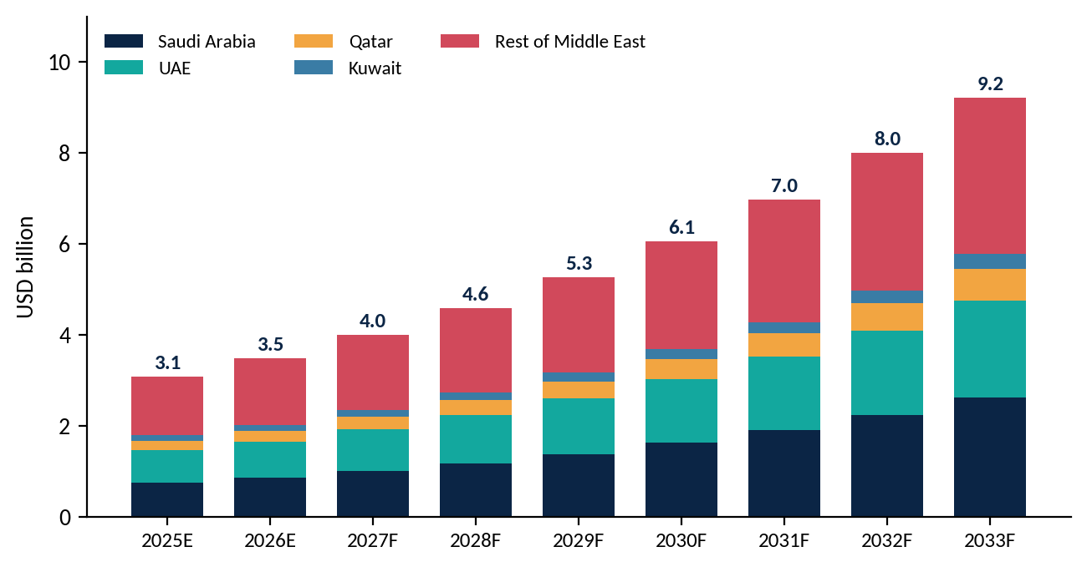
Source: CMI analysis

4.1 Middle East: Absolute dollar opportunity by country
Table 5: Middle East market by country (USD)
Country | 2026E | 2033F | CAGR | Incremental $
Saudi Arabia | $0.85B | $2.63B | 17.5% | +$1.78B
UAE | $0.80B | $2.13B | 15.0% | +$1.33B
Qatar | $0.24B | $0.70B | 16.5% | +$0.46B
Kuwait | $0.13B | $0.33B | 14.0% | +$0.20B
Rest of Middle East | $1.46B | $3.43B | 13.0% | +$1.97B
Middle East total | $3.48B | $9.22B | 14.9% | +$5.74B
Source: CMI analysis
Figure 11: Country attractiveness: growth vs absolute opportunity
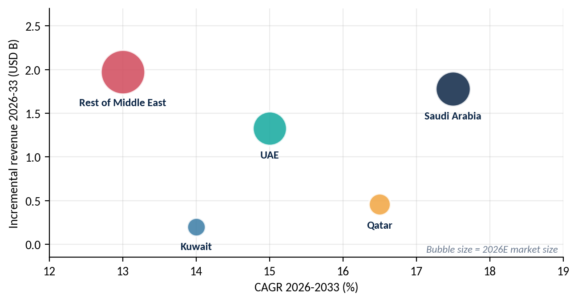
Source: CMI analysis

4.2 Middle East Opportunity by drone type
Figure 16: Middle East market by drone type, 2026E vs 2033F
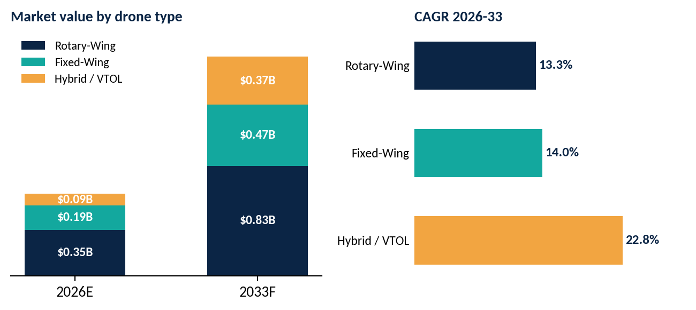
Source: CMI analysis
Rotary-wing multi-rotors dominate ($0.83B in 2033F) given low cost and ease of training, while Hybrid / VTOL compounds at 22.8% as long-range delivery and survey missions across poor road networks make runway-independent airframes attractive.

4.3 Middle East Opportunity by end user
Figure 17: Middle East market by end user, 2026E vs 2033F (USD billion)
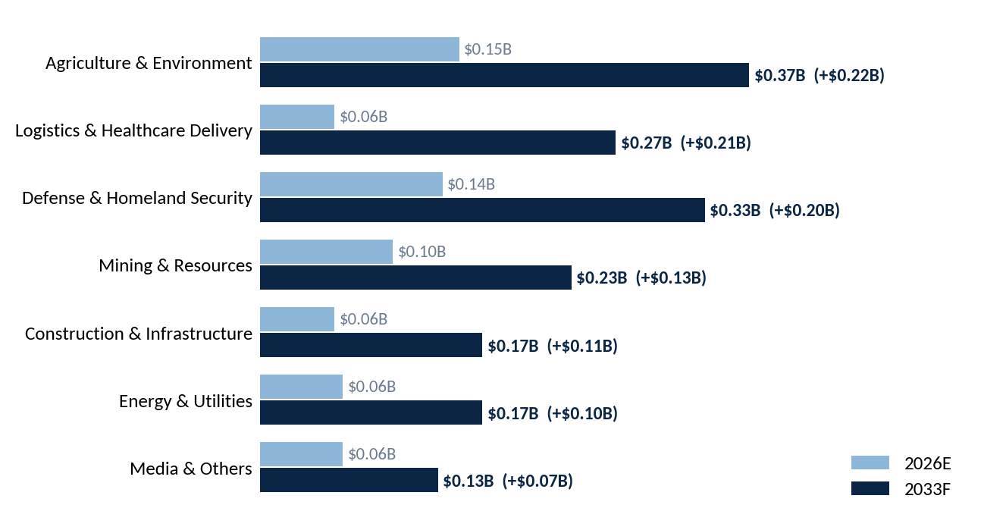
Source: CMI analysis
Agriculture is the largest absolute opportunity (+$0.22B), but Logistics & Healthcare Delivery is the fastest-growing end user, rising from $0.06B to $0.27B (25.0% CAGR) as national health agencies contract blood, vaccine and medicine delivery.

4.4 Middle East Drone Market: Country landscape

Saudi Arabia
Fastest-growing large market. Vision 2030 giga-projects (NEOM, Red Sea, Qiddiya, ROSHN), oil-field inspection and the SAMI-Baykar localisation program anchor demand, while GACA's Part 107 V5 framework and the first medicine-delivery drone permit for the Hajj season show a regulator actively enabling civil use cases. Priority use cases: construction monitoring, pipeline and flare inspection, border surveillance, pilgrim-season logistics.

Saudi Arabia Opportunity by drone type
Figure 12: Saudi Arabia market by drone type, 2026E vs 2033F
Source: CMI analysis
Rotary-wing remains the largest type through 2033F ($3.69B), but Hybrid / VTOL grows from $0.63B to $2.40B at 21.1% CAGR as operators want long-range BVLOS inspection without runways. Fixed-wing demand is driven by medium- and long-endurance ISR.

Saudi Arabia Opportunity by end user
Figure 13: Saudi Arabia market by end user, 2026E vs 2033F (USD billion)
Source: CMI analysis
Defense & Homeland Security is the biggest absolute opportunity (+$2.27B), followed by Logistics & Delivery (+$0.86B), the fastest-growing civil end user, and Construction & Infrastructure (+$0.82B).

United Arab Emirates
The most advanced procurement and regulatory ecosystem, with EDGE Group entities (ANAVIA, ADASI) as national champions. At UMEX 2026 the UAE announced AED1.396B (about $380M) for 92 ANAVIA HT-750 aircraft. 2026 also showed the regulatory flip side: a federal suspension of drone operations from 28 February was lifted on 30 June. Priority use cases: defense ISR and counter-UAS, urban air mobility, smart-city logistics.

United Arab Emirates Opportunity by drone type
Figure 12: United Arab Emirates market by drone type, 2026E vs 2033F
Source: CMI analysis
Rotary-wing remains the largest type through 2033F ($3.69B), but Hybrid / VTOL grows from $0.63B to $2.40B at 21.1% CAGR as operators want long-range BVLOS inspection without runways. Fixed-wing demand is driven by medium- and long-endurance ISR.

United Arab Emirates Opportunity by end user
Figure 13: United Arab Emirates market by end user, 2026E vs 2033F (USD billion)
Source: CMI analysis
Defense & Homeland Security is the biggest absolute opportunity (+$2.27B), followed by Logistics & Delivery (+$0.86B), the fastest-growing civil end user, and Construction & Infrastructure (+$0.82B).

Qatar
Qatar pairs World Cup-era infrastructure assets with a new drone law and the highest GCC forecast growth rate. Kuwait is a smaller, defense- and oil-led market that has issued a new decree-law.

Qatar Opportunity by drone type
Figure 12: Qatar market by drone type, 2026E vs 2033F
Source: CMI analysis
Rotary-wing remains the largest type through 2033F ($3.69B), but Hybrid / VTOL grows from $0.63B to $2.40B at 21.1% CAGR as operators want long-range BVLOS inspection without runways. Fixed-wing demand is driven by medium- and long-endurance ISR.

Qatar Opportunity by end user
Figure 13: Qatar market by end user, 2026E vs 2033F (USD billion)
Source: CMI analysis
Defense & Homeland Security is the biggest absolute opportunity (+$2.27B), followed by Logistics & Delivery (+$0.86B), the fastest-growing civil end user, and Construction & Infrastructure (+$0.82B).

Rest of Middle East
The Rest of Middle East, including Israel (about 32% of regional UAV revenue), Turkey, Oman, Bahrain, Iraq and Jordan, is the largest pool because of established defense drone industries and export programs.

Rest of Middle East Opportunity by drone type
Figure 12: Rest of Middle East market by drone type, 2026E vs 2033F
Source: CMI analysis
Rotary-wing remains the largest type through 2033F ($3.69B), but Hybrid / VTOL grows from $0.63B to $2.40B at 21.1% CAGR as operators want long-range BVLOS inspection without runways. Fixed-wing demand is driven by medium- and long-endurance ISR.

Rest of Middle East Opportunity by end user
Figure 13: Rest of Middle East market by end user, 2026E vs 2033F (USD billion)
Source: CMI analysis
Defense & Homeland Security is the biggest absolute opportunity (+$2.27B), followed by Logistics & Delivery (+$0.86B), the fastest-growing civil end user, and Construction & Infrastructure (+$0.82B).

4.5 Middle East Drone Market: Use-case opportunity heat map
Table 6: Use-case attractiveness by country (CMI assessment)
Use case | UAE | KSA | Qatar | Kuwait | Rest of ME
Border & perimeter ISR | High | High | Medium | Medium | High
Oil & gas inspection | High | High | High | High | Medium
Construction & smart city | High | High | Medium | Low | Medium
Medical & parcel logistics | High | Medium | Medium | Low | Low
Public safety & civil defense | High | High | Medium | Medium | Medium
Counter-UAS | High | High | High | Medium | Medium
Agriculture & environment | Low | Medium | Low | Low | Medium
Source: CMI analysis
Where to play in the Middle East
Largest absolute pool: Defense & Homeland Security in Saudi Arabia and the UAE, where localisation requirements favour partners with in-country assembly and sovereign data hosting.
Fastest-growing civil pool: Logistics & Delivery and Construction & Infrastructure, anchored by giga-project operators and health and municipal authorities.
Adjacent upside: counter-UAS is growing at roughly 28% a year in the GCC and is typically bought alongside, or ahead of, offensive and ISR platforms.

05 Africa Drone Market: Opportunity Landscape
Africa is the smallest region in the study but one of the fastest-growing: CMI estimates $0.62B in 2026E, reaching $1.66B by 2033F (15.1% CAGR). Africa's commercial drone fleet is expected to grow from roughly 12,000-18,000 units in 2026 to 50,000-80,000 by 2035 (IndexBox), led by agriculture, infrastructure inspection and logistics. Third-party estimates for South Africa alone range from $138M (IMARC, 2024, narrower scope) to $504M (Grand View Horizon, 2024, hardware, software and services).
Figure 14: Africa drone market by country, 2025-2033 (USD billion)
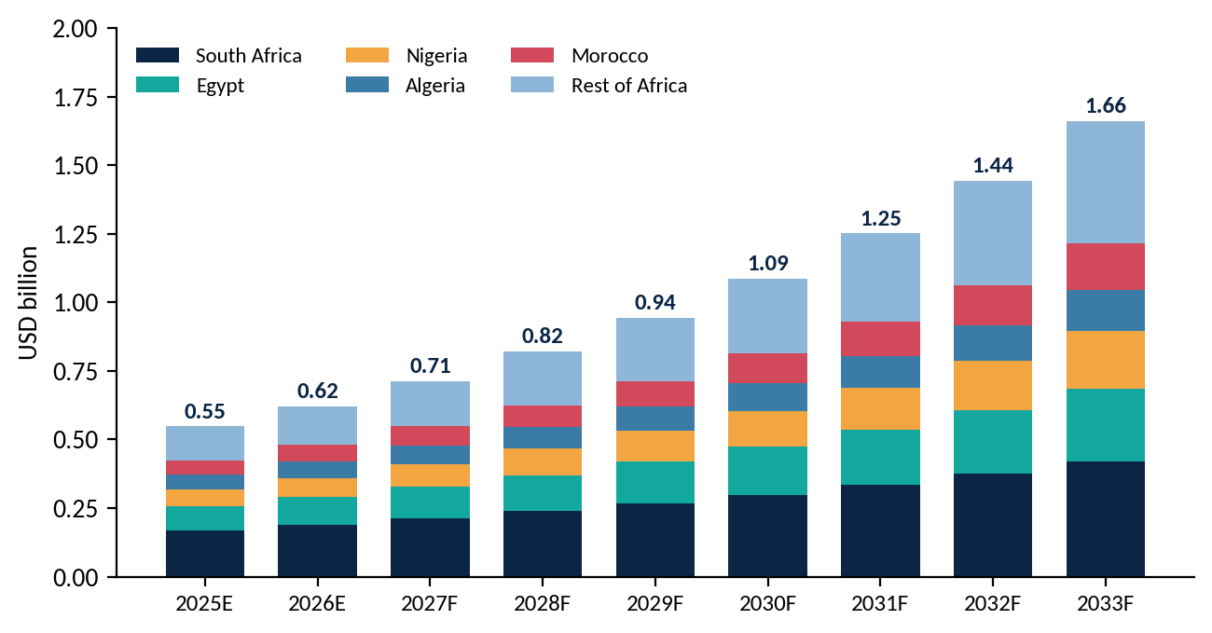
Source: CMI analysis

5.1 Africa: Absolute dollar opportunity by country
Table 7: Africa Drone market by country (USD million)
Country | 2026E | 2033F | CAGR | Incremental $
South Africa | $190M | $420M | 12.0% | +$230M
Egypt | $100M | $266M | 15.0% | +$166M
Nigeria | $70M | $210M | 17.0% | +$140M
Algeria | $60M | $150M | 14.0% | +$90M
Morocco | $60M | $170M | 16.0% | +$110M
Rest of Africa | $140M | $446M | 18.0% | +$306M
Africa total | $620M | $1,662M | 15.1% | +$1,042M
Source: CMI analysis
Figure 15: Country attractiveness: growth vs absolute opportunity
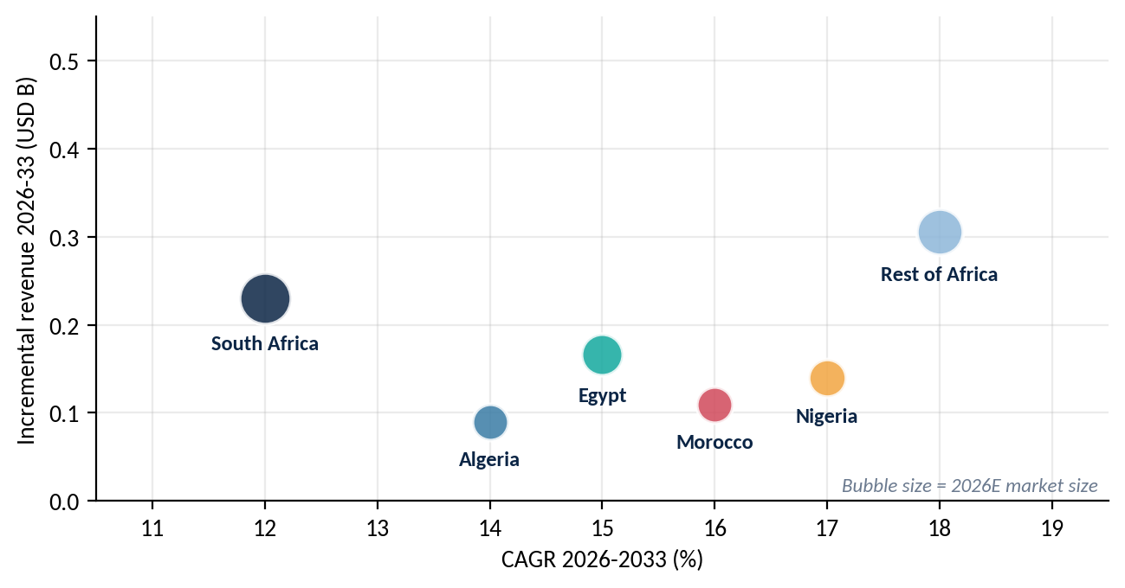
Source: CMI analysis

5.2 Africa Opportunity by drone type
Figure 16: Africa market by drone type, 2026E vs 2033F
Source: CMI analysis
Rotary-wing multi-rotors dominate ($0.83B in 2033F) given low cost and ease of training, while Hybrid / VTOL compounds at 22.8% as long-range delivery and survey missions across poor road networks make runway-independent airframes attractive.

5.3 Africa Opportunity by end user
Figure 17: Africa market by end user, 2026E vs 2033F (USD billion)
Source: CMI analysis
Agriculture is the largest absolute opportunity (+$0.22B), but Logistics & Healthcare Delivery is the fastest-growing end user, rising from $0.06B to $0.27B (25.0% CAGR) as national health agencies contract blood, vaccine and medicine delivery.

5.4 Africa Drone Market: Country landscape

South Africa
The most mature ecosystem, with a local OEM and agritech base (for example Aerobotics), strong mining demand and a clear SACAA framework. Largest absolute market but slowest growth of the focus countries as it matures.

South Africa Opportunity by drone type
Figure 16: South Africa market by drone type, 2026E vs 2033F
Source: CMI analysis
Rotary-wing multi-rotors dominate ($0.83B in 2033F) given low cost and ease of training, while Hybrid / VTOL compounds at 22.8% as long-range delivery and survey missions across poor road networks make runway-independent airframes attractive.

South Africa Opportunity by end user
Figure 17: South Africa market by end user, 2026E vs 2033F (USD billion)
Source: CMI analysis
Agriculture is the largest absolute opportunity (+$0.22B), but Logistics & Healthcare Delivery is the fastest-growing end user, rising from $0.06B to $0.27B (25.0% CAGR) as national health agencies contract blood, vaccine and medicine delivery.

Egypt
Egypt combines state-led construction (the New Administrative Capital, megacity Cairo at roughly 23 million people), border security and Suez-corridor monitoring.

Egypt Opportunity by drone type
Figure 16: Egypt market by drone type, 2026E vs 2033F
Source: CMI analysis
Rotary-wing multi-rotors dominate ($0.83B in 2033F) given low cost and ease of training, while Hybrid / VTOL compounds at 22.8% as long-range delivery and survey missions across poor road networks make runway-independent airframes attractive.

Egypt Opportunity by end user
Figure 17: Egypt market by end user, 2026E vs 2033F (USD billion)
Source: CMI analysis
Agriculture is the largest absolute opportunity (+$0.22B), but Logistics & Healthcare Delivery is the fastest-growing end user, rising from $0.06B to $0.27B (25.0% CAGR) as national health agencies contract blood, vaccine and medicine delivery.

Nigeria
Nigeria (Lagos at roughly 22 million people) is the continent's fastest-growing large market on security, pipeline inspection and agriculture, but NCAA permitting is costly and complex. It restricts import and use, so demand is channelled through government, OCP-style industrial operators and licensed integrators.

Nigeria Opportunity by drone type
Figure 16: Nigeria market by drone type, 2026E vs 2033F
Source: CMI analysis
Rotary-wing multi-rotors dominate ($0.83B in 2033F) given low cost and ease of training, while Hybrid / VTOL compounds at 22.8% as long-range delivery and survey missions across poor road networks make runway-independent airframes attractive.

Nigeria Opportunity by end user
Figure 17: Nigeria market by end user, 2026E vs 2033F (USD billion)
Source: CMI analysis
Agriculture is the largest absolute opportunity (+$0.22B), but Logistics & Healthcare Delivery is the fastest-growing end user, rising from $0.06B to $0.27B (25.0% CAGR) as national health agencies contract blood, vaccine and medicine delivery.
Rest of Africa
The Rest of Africa (Kenya, Rwanda, Ghana, Ethiopia, Tanzania and others) leads growth through medical-delivery and agri-service pioneers.

Rest of Africa Opportunity by drone type
Figure 16: Rest of Africa market by drone type, 2026E vs 2033F
Source: CMI analysis
Rotary-wing multi-rotors dominate ($0.83B in 2033F) given low cost and ease of training, while Hybrid / VTOL compounds at 22.8% as long-range delivery and survey missions across poor road networks make runway-independent airframes attractive.

Rest of Africa Opportunity by end user
Figure 17: Rest of Africa market by end user, 2026E vs 2033F (USD billion)
Source: CMI analysis
Agriculture is the largest absolute opportunity (+$0.22B), but Logistics & Healthcare Delivery is the fastest-growing end user, rising from $0.06B to $0.27B (25.0% CAGR) as national health agencies contract blood, vaccine and medicine delivery.

5.5 Africa Drone Market: Use-case opportunity heat map
Table 8: Use-case attractiveness by country (CMI assessment)
Use case | S. Africa | Egypt | Nigeria | Algeria | Morocco
Precision agriculture | High | Medium | High | Low | Medium
Mining & quarry survey | High | Medium | Low | Medium | Medium
Border & security | Medium | High | High | High | High
Medical & parcel delivery | Medium | Low | High | Low | Low
Energy & utilities inspection | High | High | High | High | Medium
Infrastructure & land mapping | Medium | High | Medium | Low | Medium
Source: CMI analysis
Where to play in Africa
Anchor market: South Africa for certified operations, mining and agri-analytics; use it as the regional service and compliance hub.
Growth markets: Nigeria, Egypt and the Rest of Africa for security, energy inspection and medical delivery, typically via government or donor-funded programs.
Business model: services and outcome-based contracts outperform hardware sales, as import costs, duties and limited pilot talent raise the barrier for end users to own fleets.

06 Regulatory & Policy Outlook
Regulation is both the largest enabler and the largest swing factor in MEA. The Gulf is shifting from permit-by-permit control to risk-based categories with digital identification, while North Africa remains restrictive. 2026 has been defining: the UAE suspended operations nationwide and then reopened, Saudi Arabia expanded civil authorisations, and Qatar and Kuwait introduced new legislation.
Figure 18: 2026 regulatory milestones in the Gulf
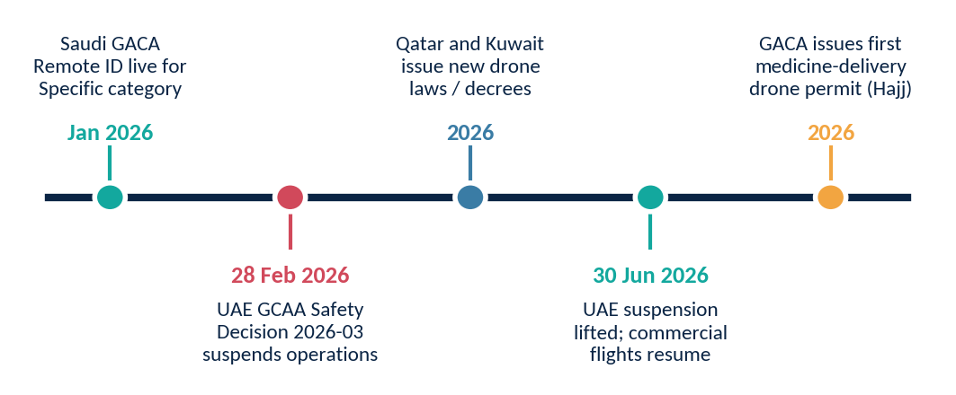
Source: GCAA, GACA and public regulatory notices; CMI analysis
Figure 19: Regulatory enablement scorecard by country
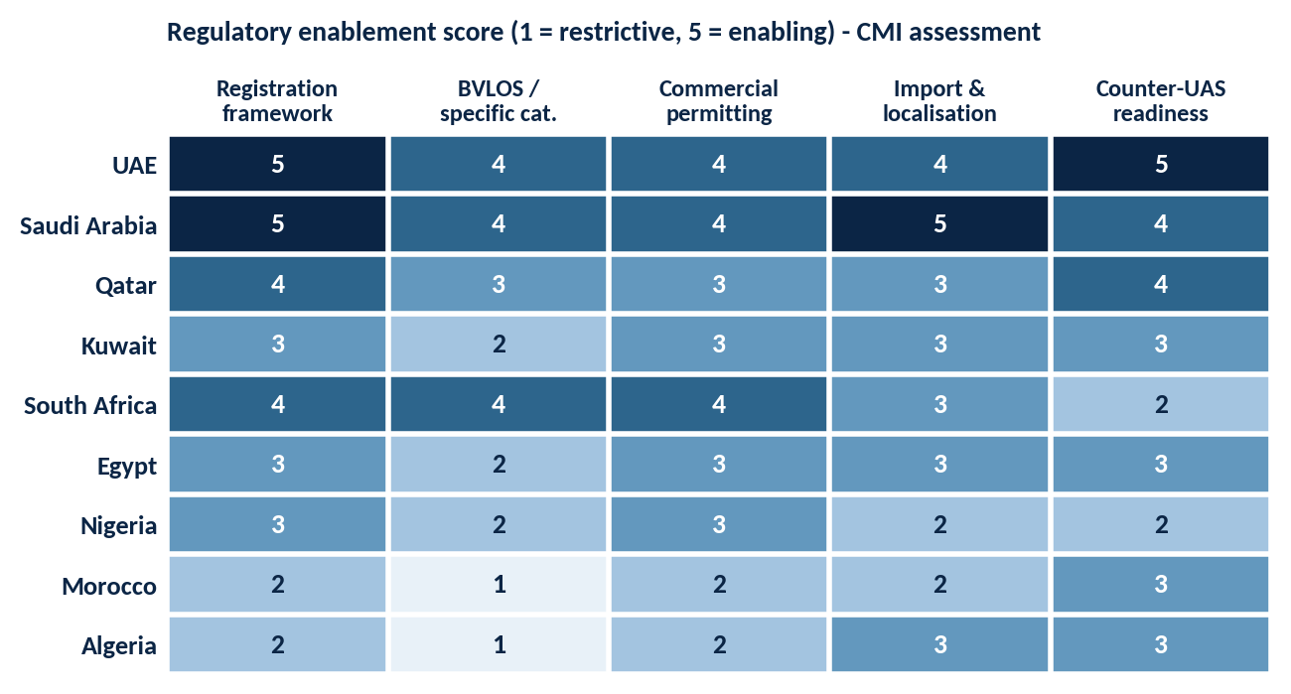
Source: CMI assessment

6.1 Regulator and rules snapshot
Table 9: Regulatory snapshot
Country | Regulator | Key requirements and 2026 developments
UAE | GCAA; DCAA (Dubai) | All drones registered regardless of weight; permits and NOTAMs for commercial work. Nationwide suspension 28 Feb 2026, lifted 30 Jun 2026.
Saudi Arabia | GACA | Part 107 V5 aligned to EASA concepts; STS-01 (VLOS in populated zones) and STS-02 (industrial BVLOS); Remote ID mandatory in Specific category from January 2026; Remote Pilot Certificate for commercial use.
Qatar | QCAA | New drone law with criminal penalties; tighter registration and operator approval.
Kuwait | DGCA | New decree-law governing import, registration and operation.
South Africa | SACAA | RPAS regime with operator certificates and registration for most commercial operations; most enabling framework in Africa.
Nigeria | NCAA | Permit mandatory and costly; import duties and complex approvals raise entry barriers.
Morocco | DGAC | Import and use require prior authorisation; effectively restricted for non-government users.
Egypt / Algeria | ECAA / civil aviation authority | Tightly controlled import and use; government-led demand.
Source: CMI analysis

6.2 Policy outlook to 2030
- Remote ID and UTM become table stakes across the Gulf by 2028, creating demand for compliance software and certified hardware.
- Localisation mandates will tie procurement to in-country assembly and technology transfer, particularly in Saudi Arabia (SAMI-Baykar) and the UAE (EDGE).
- Counter-UAS regulation will formalise who may detect and defeat drones at critical sites after the 2026 incidents.
- African harmonisation is slow: expect South Africa, Rwanda, Ghana and Kenya to lead, with North Africa lagging until at least 2028.

6.3 Regulatory watchlist 2026-2028
Table 10: Regulatory watchlist
Theme | What to watch | Market implication
Remote ID & UTM | Enforcement of Saudi Remote ID; UAE national UTM and My Drone Hub registration roll-out | Compliance modules and certified hardware become a pre-condition for commercial contracts
Operating suspensions | Criteria and notice periods for any future nationwide restrictions | Contract clauses for force majeure; demand for resilient, multi-site service models
Medical & parcel delivery | GACA permits following the first Hajj medicine-delivery authorisation | First commercial corridors for logistics operators in KSA
Qatar & Kuwait laws | Implementing rules under the new law and decree-law | Licensing lead times and local-partner requirements
Import & duties | Morocco, Nigeria and Algeria import authorisation and duty reforms | Channel structures and local assembly become decisive
Source: CMI analysis
Implication for market entry
Treat regulatory readiness as a product feature: vendors that arrive with type approvals, Remote ID compliance and local operating partners shorten sales cycles materially. Build regulatory scenarios, including a temporary civil suspension, into 2027 planning.

07 Vendor Intelligence
The drone ecosystem has three vendor tiers: global platform leaders (DJI, Chinese and US primes), regional champions (EDGE Group, Baykar, Elbit, IAI) and specialist service and software players (Terra Drone, Zipline, Aerobotics and local integrators).

7.1 Value chain analysis
Figure 20: Drone value chain and share of value pool
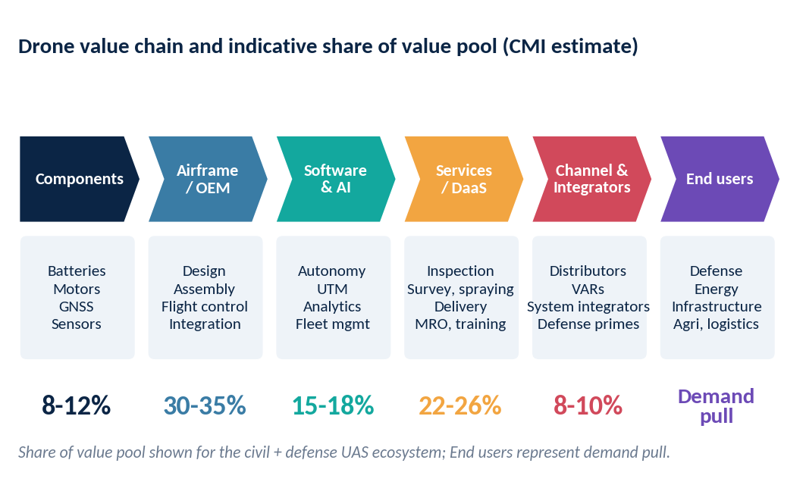
Source: CMI analysis
Services and DaaS capture the second-largest slice of the value pool and are growing fastest, while airframe OEMs still capture the largest share. Localisation programs push value from imported airframes toward in-country integration, payloads and maintenance.

7.2 Vendor market share (Global)
Figure 21: Vendor share of Global drone market value, 2025E
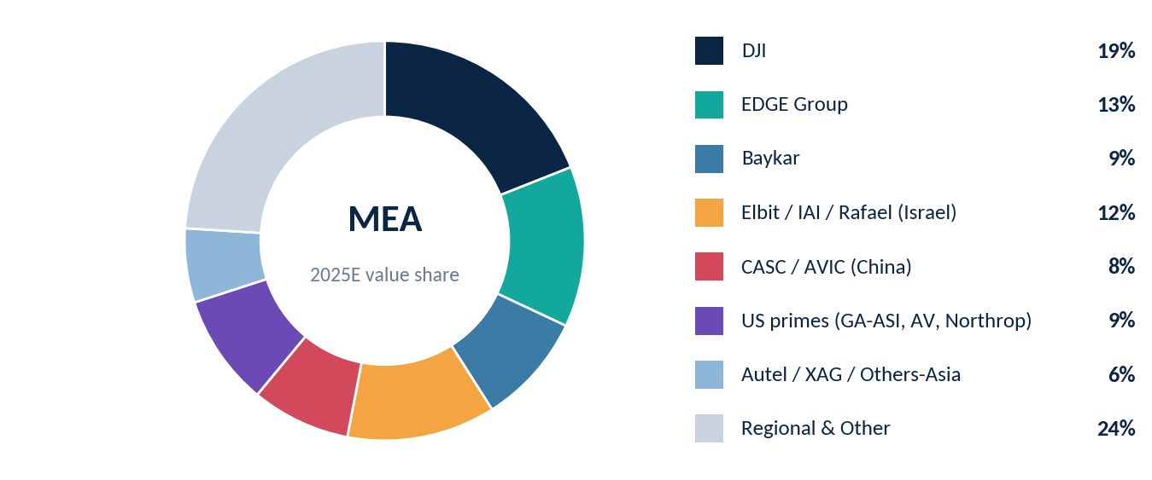
Source: CMI estimate (indicative)
DJI leads the civil segment, while defense is split between national champions (EDGE, Baykar), Israeli suppliers and Chinese and US primes. A long tail of regional and local integrators holds almost a quarter of value.

7.3 Vendor market share (MEA)
Figure 21: Vendor share of MEA drone market value, 2025E
Source: CMI estimate (indicative)
DJI leads the civil segment, while defense is split between national champions (EDGE, Baykar), Israeli suppliers and Chinese and US primes. A long tail of regional and local integrators holds almost a quarter of value.

7.4 Vendor capability mapping (MEA)
Figure 22: Capability heat map of leading vendors in MEA
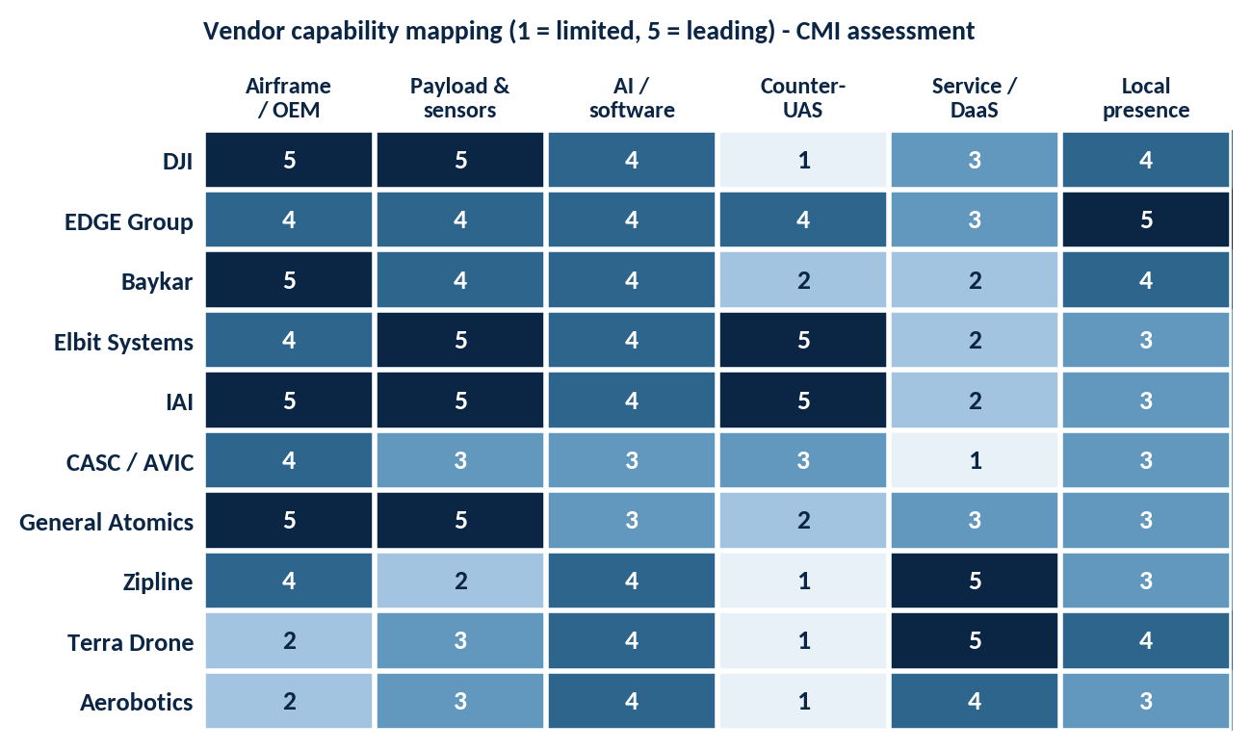
Source: CMI assessment

7.5 Vendor dashboard (MEA)
Table 11: Vendor dashboard
Vendor | HQ | Core strength | MEA footprint and recent moves
DJI | China | Commercial multirotor, payloads, enterprise ecosystem | Largest civil installed base; exposure to sourcing restrictions in some markets
EDGE Group | UAE | Sovereign defense UAS, loitering munitions, counter-UAS | 92 ANAVIA HT-750 aircraft (AED1.396B) announced at UMEX 2026
Baykar | Turkey | Combat-proven tactical and MALE UAS | Saudi localisation program with SAMI
Elbit / IAI | Israel | ISR, loitering munitions and counter-UAS | Established regional portfolios; Israel is about 32% of regional UAV revenue
CASC / AVIC | China | Medium-altitude armed UAS (Wing Loong, CH series) | Exports to Gulf and North Africa
General Atomics | USA | Long-endurance MALE UAS (Reaper family) | Foreign Military Sales channel
Zipline | USA | Medical and parcel delivery | National health-delivery networks in several African countries
Terra Drone / Aerobotics | Japan / South Africa | Inspection services; agritech analytics | Terra Drone Arabia in Saudi; Aerobotics in Southern Africa
Source: CMI analysis
Competitive implications
1. Sovereign champions (EDGE, Baykar via SAMI) will take a rising share of defense spend as localisation requirements tighten; foreign OEMs need JV or technology-transfer structures to stay relevant.
2. In civil, hardware is commoditising; differentiation shifts to software, compliance and service density. Service specialists such as Terra Drone and Aerobotics are the natural acquisition or partnership targets for OEMs.
3. Counter-UAS and detection are the fastest-growing adjacent offers and a gateway to larger platform sales.

08 Strategic Recommendations
The recommendations below translate the market outlook into actions by stakeholder. A common theme: localise, bundle and comply. Success in MEA depends less on airframe specifications than on in-country presence, regulatory fluency and recurring-revenue offers.
Figure 23: Three-phase way forward for MEA entry and scale-up
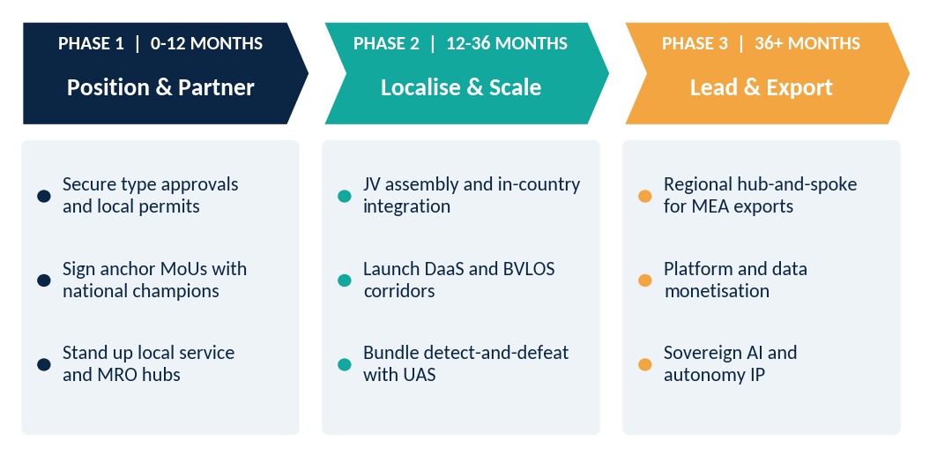
Source: CMI analysis

8.1 Recommendations by stakeholder
Table 12: Strategic recommendations by stakeholder
Stakeholder | Priority moves | Success KPIs
Drone manufacturers | Form JVs with national champions (SAMI, EDGE, local primes); design variants for 50C heat, dust and BVLOS; certify early under GACA and GCAA categories; pair airframes with mission-ready payloads. | In-country content %; type approvals; backlog from sovereign buyers
Technology providers (AI, UTM, comms, counter-UAS) | Embed Remote ID and UTM compliance in products; offer sovereign-hosted analytics; bundle detect-and-defeat; build Arabic/local-language and API integrations for giga-project operators. | Platform ARR; # integrated fleets; compliance certifications
Service providers (DaaS, inspection, MRO) | Sign multi-year inspection contracts with energy and utility majors; invest in BVLOS-qualified pilots; target agriculture and mining in Africa with outcome-based pricing. | Contract backlog; utilisation; revenue per drone
Channel partners and integrators | Specialise by vertical; secure authorised-distributor status with leading OEMs; add training, insurance and compliance services to lift margin beyond hardware resale. | Attach rate of services; gross margin; certified-pilot pipeline
End users (energy, construction, agriculture, health) | Move from pilots to enterprise frameworks; standardise data formats; write performance-based contracts. | Cost per inspection; incident rate; data re-use
Investors and development partners | Back local assemblers, DaaS platforms and training academies; use blended finance for African medical-delivery and agri-drone networks. | Portfolio revenue growth; local jobs; regulatory milestones
Source: CMI analysis
Five priority actions for 2026-27
1. Apply for or upgrade authorisations under the new Saudi and UAE frameworks before the next procurement cycle.
2. Sign a localisation MoU with at least one national champion in KSA or the UAE.
3. Build a counter-UAS or detection offer, as demand is outpacing drone sales.
4. Launch a DaaS pilot in energy inspection and an agri-service pilot in Africa.
5. Create a regulatory-watch function covering all focus countries.

09 Research Methodology
CMI's market estimates combine top-down sizing from regional and national totals with bottom-up build-ups by drone type, end user and country. Every number passes through at least two independent reconciliations before publication.
Figure 24: CMI five-step research process
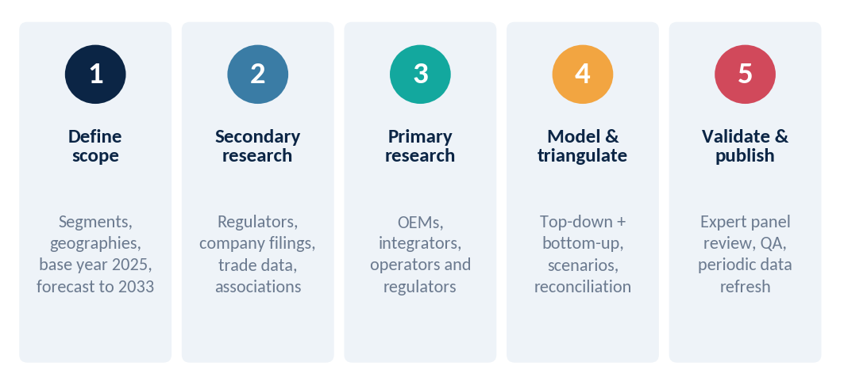
Source: CMI

9.1 Data triangulation
Published estimates for the 2025 global drone market range from $32.2B to $83.8B because of different scope definitions (consumer vs commercial vs defense, hardware only vs hardware + software + services). CMI sets its base at $44.0B by scoping civil, commercial and defense UAS across hardware, software and services, and excluding counter-UAS.
Figure 25: Published 2025 global drone market estimates vs CMI base
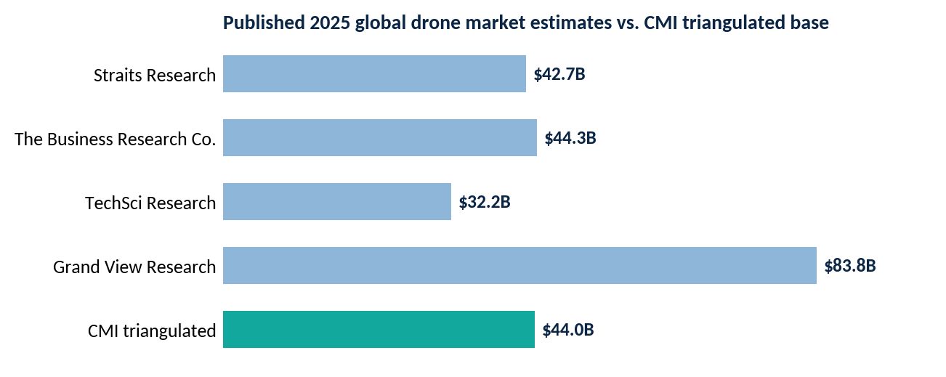
Source: Straits Research, The Business Research Company, TechSci Research, Grand View Research; CMI analysis

9.2 Regional and country reference points
Table 13: Third-party data used for calibration
Reference estimate | Scope | Published value
Grand View Horizon: MEA drone market | Hardware, software, services | $3.04B (2024) to $7.08B (2030), 15.1% CAGR
Mordor Intelligence: GCC drones | Six GCC states | $2.07B (2025) to $4.12B (2031), 12.1% CAGR
MarketsandMarkets: Middle East UAV | UAV by type, platform, country | $1.70B (2025) to $3.31B (2030), 14.2% CAGR
MarketsandMarkets: Saudi Arabia UAV | UAV | $242M (2025) to $700M (2030), 23.7% CAGR
MarketsandMarkets: UAE UAV | UAV | $160M (2025) to $394M (2030), 19.7% CAGR
IMARC: South Africa drones | Hardware-centric | $138M (2024) to $336M (2033), 10.4% CAGR
Grand View Horizon: South Africa | Hardware, software, services | $504M (2024) to $1.22B (2030), 15.8% CAGR
Source: CMI analysis

9.3 Market definition and segmentation
Table 14: Scope of the study
Dimension | Segments covered
Drone type | Rotary-wing; Fixed-wing; Hybrid / VTOL
End user | Defense & homeland security; oil, gas & energy; construction & infrastructure; logistics & delivery; public safety & government; agriculture & environment; mining; media & others
Offering | Hardware (airframe, payload, propulsion); software and analytics; services (DaaS, MRO, training)
Geography | North America, Europe, Asia Pacific, Latin America, Middle East (UAE, KSA, Qatar, Kuwait, Rest of Middle East), Africa (South Africa, Egypt, Nigeria, Algeria, Morocco, Rest of Africa)
Years | Base 2025; estimate 2026; forecast 2027-2033
Source: CMI analysis

9.4 Assumptions and limitations
- Values are nominal-USD revenue at manufacturer or service-provider level; classified defense procurement is estimated from budget notices, export licences and company disclosures and carries wider error bands (+/- 15-20%).
- Country forecasts assume no repeat of the 2026 nationwide operating suspension in the UAE; a repeat would lower 2027 civil revenue in the affected country.
- Vendor shares, regulatory scores and capability scores are CMI expert assessments and are indicative.
- This template should be refreshed with CMI's proprietary database and validated through primary interviews before publication.

10 About CMI
Coherent Market Insights (CMI) is a global market research and consulting organisation that helps clients make confident decisions in fast-moving industries. We combine syndicated research, custom consulting and advisory engagements to deliver data-driven market intelligence across aerospace and defense, technology, healthcare, energy, chemicals and consumer sectors.

What we do
- Syndicated research: market size, share and forecast reports with segment and country detail.
- Custom consulting: market entry, go-to-market, competitor benchmarking and partner screening.
- Advisory and data services: opportunity assessments, due diligence support and on-demand analyst access.

How we work
Our analysts blend primary interviews with industry participants, secondary research and proprietary models to build forecasts that withstand scrutiny. Each report undergoes multi-stage validation, including expert panel review.

Contact
Channel | Details
Website | www.coherentmarketinsights.com
Email | [insert sales / research contact email]
Phone | [insert regional phone numbers]
Offices | [insert office locations]
Source: CMI analysis
Disclaimer
This document is provided for information purposes only. Estimates are forward-looking and subject to change. CMI accepts no liability for decisions made on the basis of this document. Third-party names and trademarks belong to their respective owners.

