TASK 4
Version-Controlled DevOps Project with Git
Git • GitHub • Branching • Pull Requests • Tags
Project: Git-Devops-Task4
Repository: Aditya-Cyb/Git-Devops-Task4
Workflow: main → dev → feature → PR → dev → PR → main → v1.0.0

1. Objective
The objective of this task is to manage a DevOps project using Git and GitHub best practices. The implementation demonstrates repository initialization, meaningful commits, branch-based development, Pull Requests, merging, .gitignore usage, Git tagging, and final version verification.

2. Tools and Technologies Used
Technology | Purpose | Implementation
Git | Version control | Local repository and branch management
GitHub | Remote repository | Branches, Pull Requests, merges and tag
Git Bash | Command-line environment | Git commands on Windows
Markdown | Documentation | README.md

3. Overall Git Workflow
main
↑
│ Pull Request
dev
↑
│ Pull Request
feature/project-update
│
└── Feature development + commit
The feature branch was first merged into dev through a Pull Request. The updated dev branch was then merged into main through a second Pull Request. Finally, version v1.0.0 was created and pushed to GitHub.

4. Project Setup
git --version
cd ~/Desktop
mkdir Git-Devops-Task4
cd Git-Devops-Task4
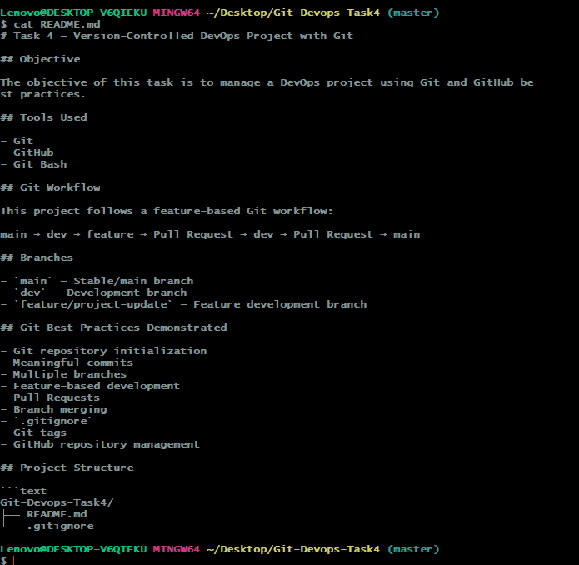
Figure 1. Git version verification and Task 4 project directory creation.
git init
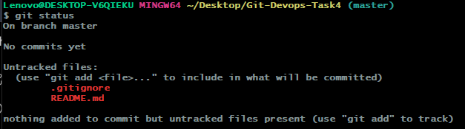
Figure 2. Initial Git repository status.

5. Project Files and .gitignore
The project contains README.md and .gitignore. The .gitignore file was configured with:
.DS_Store
The README documents the task objective, tools, workflow, branches, and Git best practices.
Figure 3. Project files staged for the initial commit.

6. Initial Git Commit
git add .
git status
git commit -m "Initial project setup"
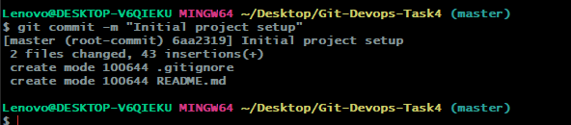
Figure 4. Successful initial Git commit.

7. GitHub Repository Configuration
git branch -M main
git remote add origin https://github.com/Aditya-Cyb/Git-Devops-Task4.git
git remote -v
git push -u origin main
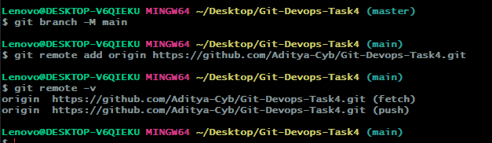
Figure 5. GitHub remote configuration.
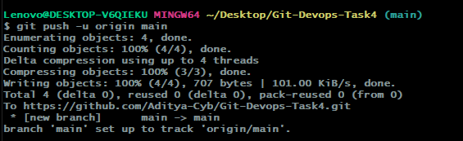
Figure 6. Initial main branch pushed to GitHub.

8. Development Branch
git checkout -b dev
git push -u origin dev
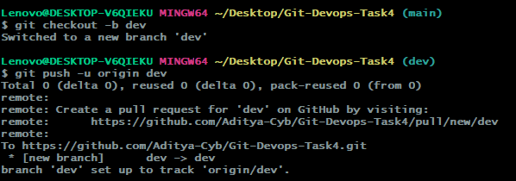
Figure 7. dev branch creation and push.

9. Feature Branch Development
git checkout -b feature/project-update
git push -u origin feature/project-update
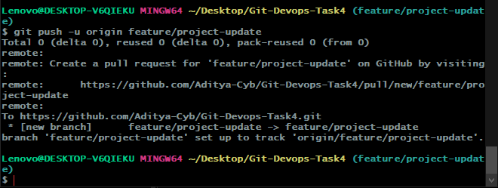
Figure 8. feature/project-update branch creation and push.
## Feature Update
This update was developed on the feature branch.
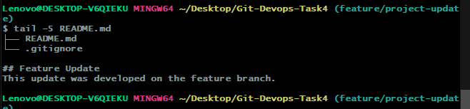
Figure 9. Feature update created on the feature branch.
git add README.md
git commit -m "Add feature branch update"
git push origin feature/project-update
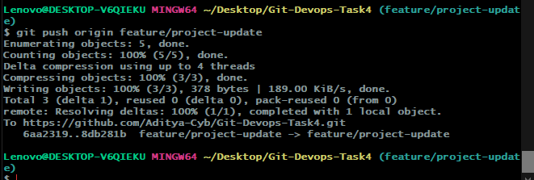
Figure 10. Feature branch changes pushed.

10. Pull Request: Feature → Dev
The feature branch was submitted to dev through a Pull Request. The corrected PR used dev as the base branch.
base: dev
compare: feature/project-update
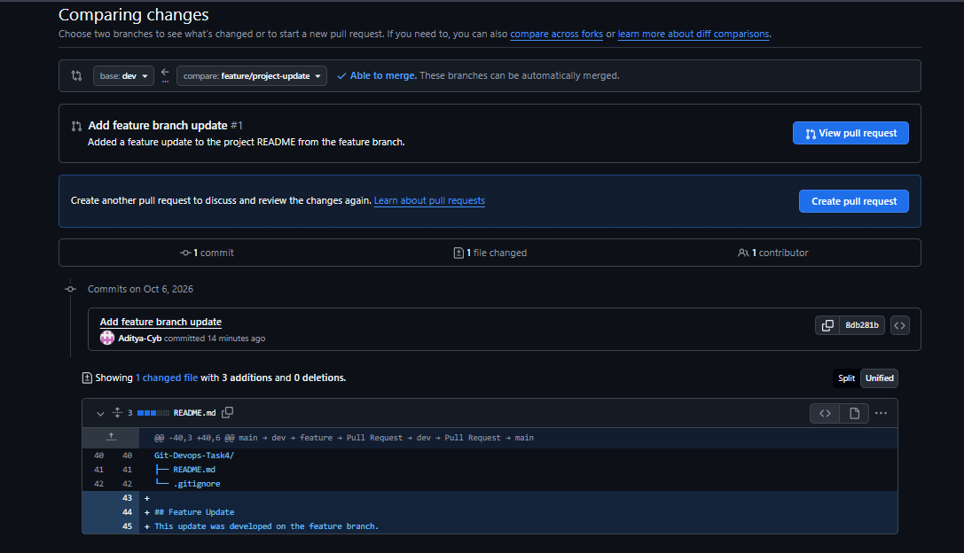
Figure 11. Correct feature/project-update → dev comparison.
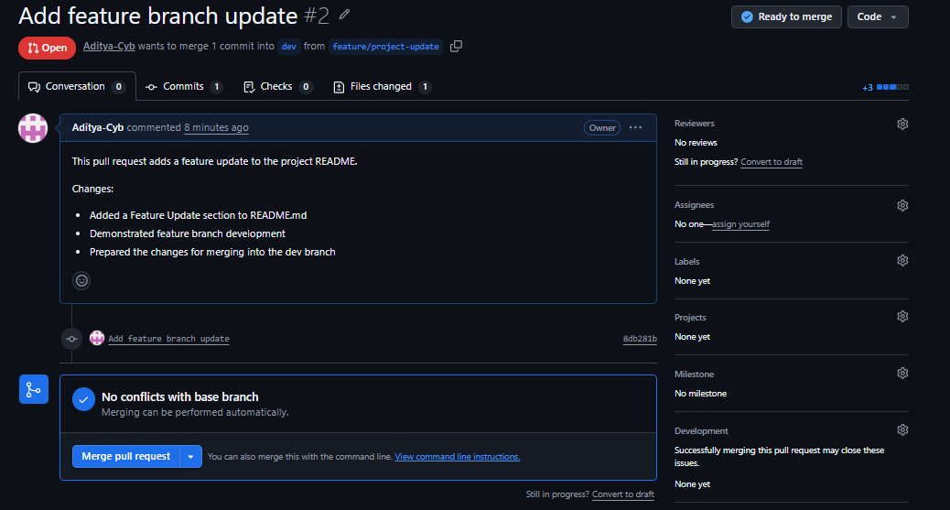
Figure 12. Feature → Dev Pull Request ready to merge.
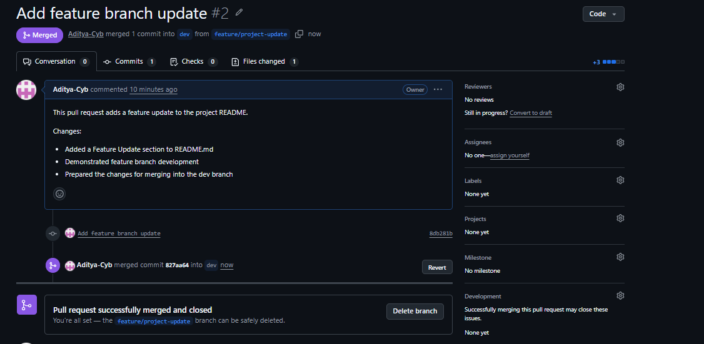
Figure 13. Feature → Dev Pull Request successfully merged and closed.

11. Synchronizing the Dev Branch
git checkout dev
git pull origin dev
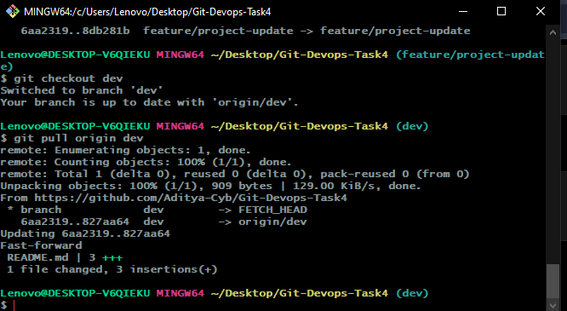
Figure 14. Local dev branch synchronized with origin/dev.

12. Pull Request: Dev → Main
base: main
compare: dev
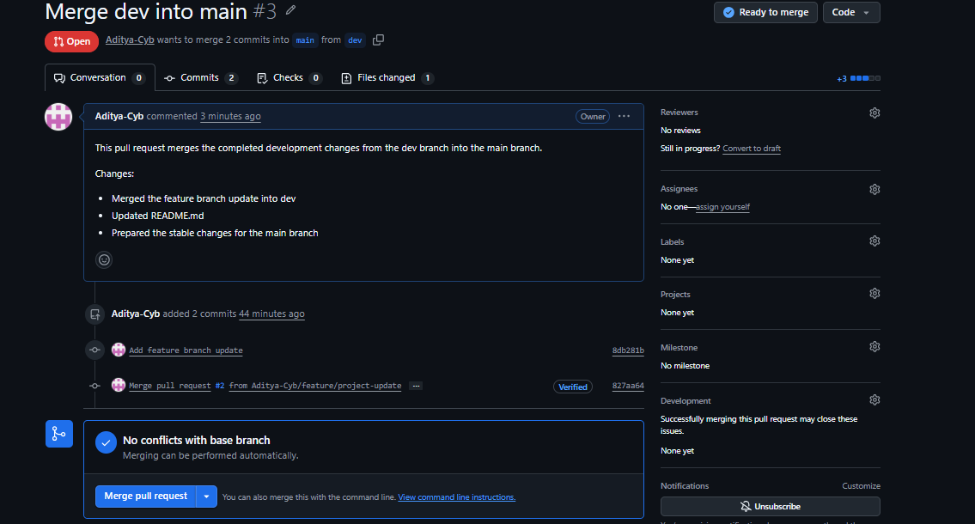
Figure 15. Dev → Main Pull Request ready to merge.
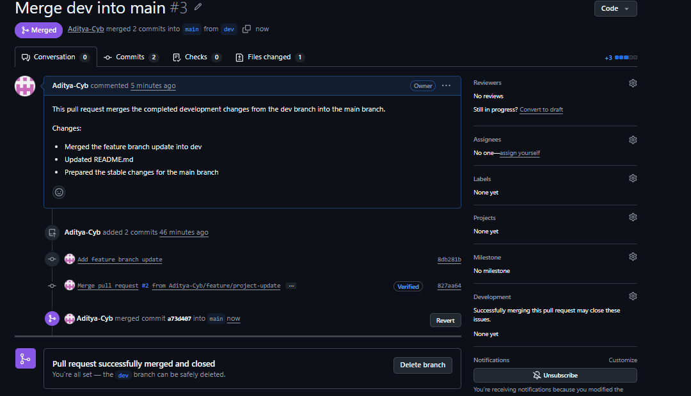
Figure 16. Dev → Main Pull Request successfully merged and closed.

13. Version Tagging
git checkout main
git pull origin main
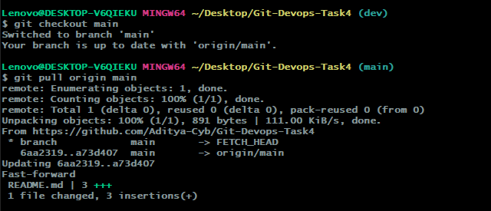
Figure 17. Main branch synchronized with origin/main.
git tag -a v1.0.0 -m "Task 4 version 1.0.0"
git tag
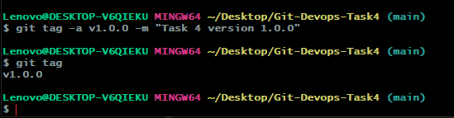
Figure 18. v1.0.0 tag created locally.
git push origin v1.0.0
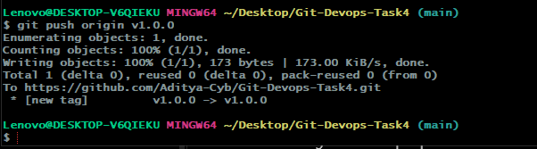
Figure 19. v1.0.0 successfully pushed to GitHub.

14. Final Branch and Tag Verification
git branch -a
git tag
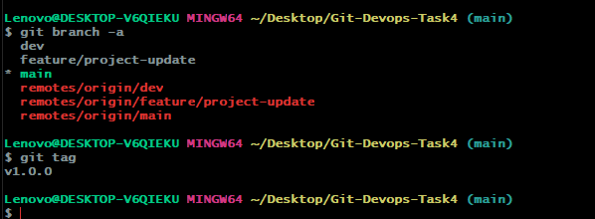
Figure 20. Final branch and tag verification.
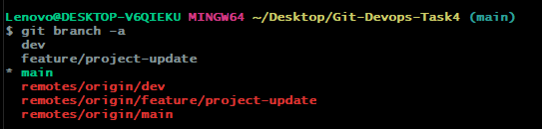
Figure 21. Final local and remote branch verification.

15. Submission Evidence
No. | Evidence | Result
1 | Repository initialization | git init completed successfully.
2 | Initial commit | README.md and .gitignore committed.
3 | GitHub setup | main branch pushed to GitHub.
4 | Branching | dev and feature/project-update created and pushed.
5 | Feature development | README feature update committed.
6 | Feature → Dev PR | Pull Request merged successfully.
7 | Dev → Main PR | Pull Request merged successfully.
8 | Version tagging | v1.0.0 created and pushed.
9 | Final verification | Branches and tag verified.

16. Result
The Git-based DevOps workflow was successfully implemented. The project was initialized locally, committed to GitHub, developed through dedicated branches, reviewed through Pull Requests, merged into the stable main branch, and versioned using the v1.0.0 Git tag.
- Local Git repository initialized successfully.
- README.md and .gitignore created and committed.
- main, dev and feature/project-update branches created.
- Feature changes developed and committed separately.
- Feature → Dev Pull Request completed.
- Dev → Main Pull Request completed.
- v1.0.0 version tag created and pushed to GitHub.
- Final branch and tag state verified.

17. Key Achievements
- Applied a structured branch-based Git workflow.
- Used meaningful commit messages.
- Demonstrated isolated feature development.
- Used Pull Requests for controlled branch integration.
- Maintained a stable main branch.
- Used .gitignore for repository hygiene.
- Applied version tagging with v1.0.0.
- Maintained the project in a dedicated GitHub repository.

18. Implementation Note
This task focuses on Git and GitHub workflow practices rather than application deployment. The project demonstrates branch management, Pull Requests, merging, remote synchronization, and version tagging.

19. Conclusion
Task 4 successfully demonstrates a practical version-controlled DevOps workflow using Git and GitHub. The complete process from local repository initialization to feature development, Pull Request based integration, main branch stabilization, and v1.0.0 version tagging was completed successfully.

20. Final Submission Checklist
- ☐ Dedicated GitHub repository created.
- ☐ README.md included.
- ☐ .gitignore included.
- ☐ Initial Git commit completed.
- ☐ main branch pushed to GitHub.
- ☐ dev branch created and pushed.
- ☐ feature/project-update branch created and pushed.
- ☐ Feature update committed.
- ☐ Feature → Dev Pull Request merged.
- ☐ Dev → Main Pull Request merged.
- ☐ v1.0.0 tag created.
- ☐ v1.0.0 tag pushed to GitHub.
- ☐ Final branches and tag verified.
- ☐ Documentation and execution screenshots included.

