TASK 5: HOST A STATIC WEBSITE WITH GITHUB PAGES
DevOps Internship – Practical Documentation

1. Objective
To create a simple static website using HTML and CSS, store the source code in a GitHub repository, and publish the website online using GitHub Pages.

2. Tools and Technologies Used
- GitHub repository for source-code version control
- HTML5 for website structure
- CSS for styling and layout
- GitHub Pages for static website hosting
- Web browser for deployment verification

3. Repository Details
Repository name | GitHub-Pages-Task5
Repository URL | https://github.com/Aditya-Cyb/GitHub-Pages-Task5
Branch | main
Publishing source | Deploy from a branch
Publishing folder | / (root)
Website URL | https://aditya-cyb.github.io/GitHub-Pages-Task5/
Main file | index.html

4. Problem Statement
A static website needs to be accessible on the internet without purchasing hosting. This task uses GitHub Pages to publish a website directly from a public GitHub repository.

5. Methodology
- Created a public GitHub repository named GitHub-Pages-Task5.
- Added an index.html file containing the website structure and embedded CSS styling.
- Committed the website file to the main branch.
- Opened repository Settings and selected Pages.
- Configured GitHub Pages to deploy from the main branch and root folder (/).
- Waited for publishing to complete and opened the generated website URL in a browser.
- Updated README.md with the project objective, technologies, features, repository link, and live website link.

6. Implementation Details
The index.html file contains a page header, a personal introduction card, a link to the developer’s GitHub profile, and a footer. CSS controls typography, background colors, spacing, rounded corners, and the card shadow. The viewport setting supports display on different screen sizes.
GitHub Pages was configured with main as the publishing branch and /(root) as the folder. The index.html file in the repository root acts as the website entry page.

7. Deployment Configuration
The repository Pages settings were configured as follows:
- Source: Deploy from a branch
- Branch: main
- Folder: / (root)
- Enforce HTTPS: enabled
The first attempt returned a 404 error while the site was not yet available. After checking the correct project URL and allowing the publishing process to complete, the website loaded successfully.

8. Screenshots / Project Evidence
Figure 1. GitHub Pages configuration showing deployment from the main branch and root folder.
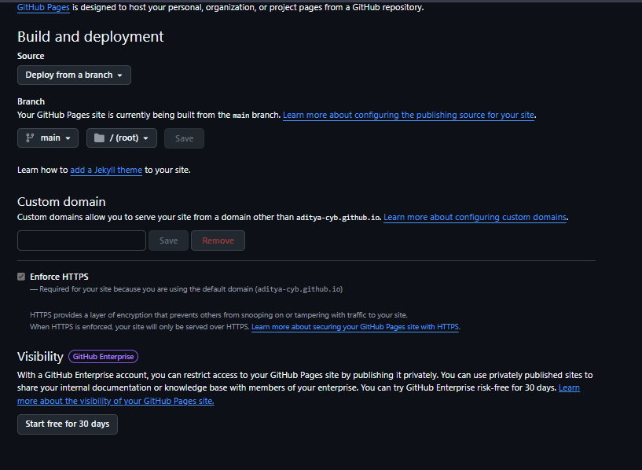
Figure 2. Live website successfully opened in the browser.
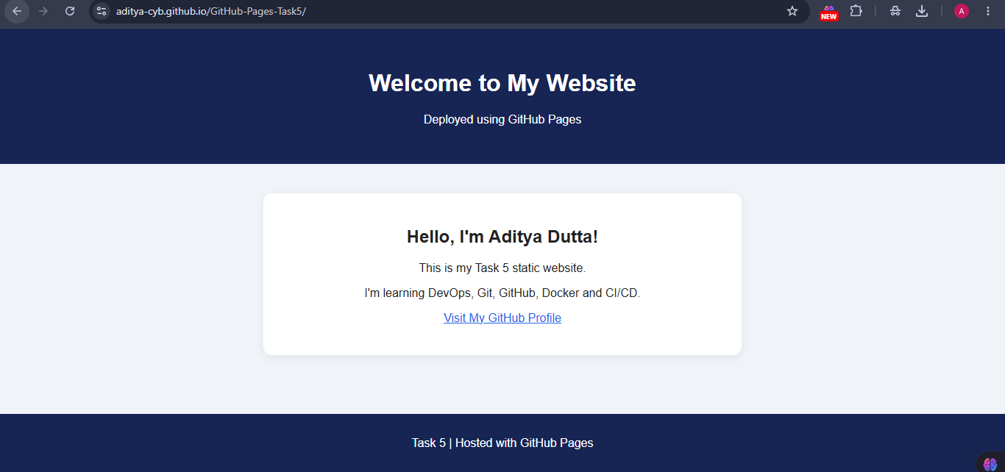
Figure 3. GitHub repository showing index.html and the updated README.md.
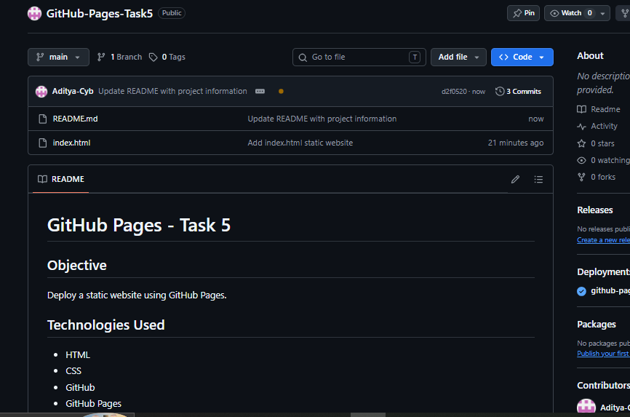

9. Results and Outcomes
- The static website was successfully published using GitHub Pages.
- The live URL was verified in a browser and displayed the expected page content.
- The repository contains index.html and README.md with project information.
- The deployment was completed without paid hosting.

10. Challenges Faced and Solutions
Challenge: The website initially displayed a 404 error. Solution: The exact project URL was checked and the GitHub Pages publishing process was allowed to finish. The website then loaded successfully.
Challenge: Identifying the correct publishing configuration. Solution: The repository was configured to deploy from main and /(root), where index.html is located.

11. Interview Questions and Answers
What is GitHub Pages?
GitHub Pages is a hosting service that publishes static websites directly from a GitHub repository.
Can you host dynamic apps here?
GitHub Pages serves static content. It does not run server-side application code such as Node.js or Python directly.
What are the limits of GitHub Pages?
It is intended for static websites and has usage/build limits. It is not a replacement for a backend server or database host.
How do you update the website?
Edit the files, commit and push changes to the configured publishing branch, and wait for GitHub Pages to redeploy.
What happens when you delete the repo?
The website hosted from that repository will no longer be available at that repository’s GitHub Pages URL.
What is the default file that loads?
index.html is typically served as the default entry page for the site root.
Can you use a custom domain?
Yes. A custom domain can be configured in Pages settings with the required DNS records.

12. Conclusion
This task provided practical experience in creating a static website, managing files in GitHub, configuring GitHub Pages, and verifying a live deployment. The website is publicly accessible, and the repository README documents the project and its links.

13. Deliverables
GitHub repository: https://github.com/Aditya-Cyb/GitHub-Pages-Task5
Live website: https://aditya-cyb.github.io/GitHub-Pages-Task5/

