TASK 2
Create a Simple Jenkins Pipeline for CI/CD
Node.js Application • Jenkins • Docker • GitHub

Project: Jenkins-CICD-Task2
Repository: Aditya-Cyb/Jenkins-CICD-Task2
Pipeline: Build → Test → Deploy
Documentation: DevOps Internship

1. Objective
The objective of this task is to create a basic Jenkins CI/CD pipeline that automates the build, testing, and deployment of a Node.js application using Docker. The pipeline is integrated with a GitHub repository and is configured to trigger automatically when code is pushed to the main branch.

2. Tools and Technologies Used
Technology | Purpose | Implementation
Node.js + Express | Web application runtime and HTTP server | app.js
Git / GitHub | Source-code management and remote repository | main branch
Jenkins | CI/CD pipeline automation | Jenkinsfile
Docker | Containerization and deployment | Dockerfile
ngrok | Temporary public access to local Jenkins | GitHub webhook endpoint

3. Overall CI/CD Architecture
The implemented workflow connects GitHub, Jenkins, Docker, and a local Node.js application. A push to the main branch generates a GitHub webhook request. ngrok forwards the request to the local Jenkins server, which starts the Jenkinsfile pipeline. The pipeline builds a Docker image, runs a health check, and deploys the tested image as a Docker container.
Developer / Local Project
|
v
GitHub Repository
|
| push to main
v
GitHub Webhook
|
v
ngrok
|
v
Jenkins
|
+--> Build Docker Image
|
+--> Test Container
| |
| +--> /health check
|
+--> Deploy Container
|
v
Node.js Application
localhost:3001
Figure 1. Task 2 CI/CD architecture: GitHub push to automated Jenkins Build–Test–Deploy.

4. Project Setup

4.1 Project Structure
Jenkins-CICD-Task2/
├── .gitignore
├── Dockerfile
├── Jenkinsfile
├── app.js
├── jenkins-docker/
│ └── Dockerfile
├── package.json
├── package-lock.json
└── README.md

4.2 Initialize Node.js Project
The Node.js project was initialized using npm and Express was installed as the web framework.
npm init -y
npm install express

4.3 Node.js Application
const express = require("express");
const app = express();
const PORT = 3000;
app.get("/", (req, res) => {
res.send("Hello! Jenkins CI/CD Pipeline is Working 🚀");
});
app.get("/health", (req, res) => {
res.status(200).send("Application is healthy");
});
app.listen(PORT, () => {
console.log(`Server running on port ${PORT}`);
});
The root route provides the application response, while the /health endpoint is used by the Jenkins Test stage to verify that the containerized application is responding correctly.

5. Dockerization
A Dockerfile was created to package the Node.js application and its dependencies into a portable Docker image.
FROM node:20-alpine
WORKDIR /app
COPY package*.json ./
RUN npm install
COPY . .
EXPOSE 3000
CMD ["node", "app.js"]

5.1 Local Docker Build
docker build -t jenkins-cicd-task2:latest .

5.2 Local Container Test
docker run -d -p 3001:3000 \
--name jenkins-cicd-task2-container \
jenkins-cicd-task2:latest
The container was verified locally through http://localhost:3001. The host port is 3001, while the Node.js application listens on port 3000 inside the container.

6. GitHub Repository
The project was uploaded to the public GitHub repository:
https://github.com/Aditya-Cyb/Jenkins-CICD-Task2

6.1 Git Commands Used
git init
echo "node_modules/" > .gitignore
git add .
git status
git commit -m "Add Jenkins CI/CD pipeline"
git remote add origin https://github.com/Aditya-Cyb/Jenkins-CICD-Task2.git
git remote -v
git branch -M main
git pull --rebase origin main
git push -u origin main
The repository uses the main branch for the Jenkins CI/CD trigger.

7. Jenkins Configuration
Jenkins was run in Docker using a custom Jenkins image containing Docker CLI. The Jenkins container was also given access to the host Docker daemon through the Docker socket.

7.1 Custom Jenkins Dockerfile
FROM jenkins/jenkins:lts
USER root
RUN apt-get update \
&& apt-get install -y docker.io \
&& apt-get clean \
&& rm -rf /var/lib/apt/lists/*
USER jenkins

7.2 Jenkins Container
MSYS_NO_PATHCONV=1 docker run -d \
--name jenkins \
-p 8080:8080 \
-p 50000:50000 \
-v jenkins_home:/var/jenkins_home \
-v /var/run/docker.sock:/var/run/docker.sock \
--user root \
jenkins-docker

7.3 Pipeline Job Configuration
Setting | Value
Job Name | Jenkins-CICD-Task2
Definition | Pipeline script from SCM
SCM | Git
Repository URL | https://github.com/Aditya-Cyb/Jenkins-CICD-Task2.git
Branch Specifier | */main
Script Path | Jenkinsfile
Trigger | GitHub hook trigger for GITScm polling
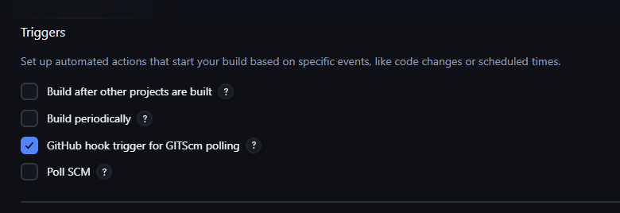
Figure 2. Jenkins Build Trigger configuration with GitHub hook trigger enabled.

8. Jenkinsfile — CI/CD Pipeline
The Jenkinsfile defines the declarative pipeline and contains three main stages: Build, Test, and Deploy.

8.1 Environment Variables
environment {
IMAGE_NAME = "jenkins-cicd-task2"
CONTAINER_NAME = "jenkins-cicd-task2-container"
DEPLOY_PORT = "3001"
}

8.2 Build Stage
stage('Build') {
steps {
echo 'Building Docker image...'
sh 'docker build -t ${IMAGE_NAME}:latest .'
}
}
Purpose: Build the Docker image from the application Dockerfile.

8.3 Test Stage
docker run -d --name ${CONTAINER_NAME}-test ${IMAGE_NAME}:latest
sleep 5
# Check /health endpoint
docker rm -f ${CONTAINER_NAME}-test
Purpose: Run a temporary container and verify the /health endpoint returns HTTP 200.

8.4 Deploy Stage
docker rm -f ${CONTAINER_NAME} 2>/dev/null || true
docker run -d \
-p ${DEPLOY_PORT}:3000 \
--name ${CONTAINER_NAME} \
${IMAGE_NAME}:latest
Purpose: Deploy the tested image as the application container on host port 3001.

9. GitHub Webhook Integration
A GitHub webhook was configured so that a push to the main branch sends a POST request to the Jenkins GitHub webhook endpoint. Because Jenkins is running locally, ngrok provides the temporary public endpoint required by GitHub.

9.1 ngrok
ngrok http 8080
The current ngrok public endpoint used during testing was:
https://proven-unreeling-raisin.ngrok-free.dev/github-webhook/
Note: This is a temporary ngrok address and may change when a new ngrok session is started.

9.2 Webhook Configuration
Setting | Value
Payload URL | https://proven-unreeling-raisin.ngrok-free.dev/github-webhook/
Content type | application/json
Events | Just the push event
Secret | Not configured
Active | Enabled
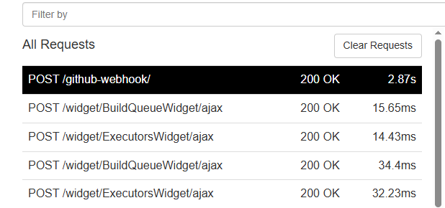
Figure 3. ngrok Inspector showing POST /github-webhook/ with HTTP 200 OK.

10. Automatic CI/CD Execution
A harmless README change was committed and pushed to the main branch to test the complete GitHub-to-Jenkins automation.
echo "Webhook test" >> README.md
git add README.md
git commit -m "Test Github push webhook"
git push origin main

10.1 Jenkins Webhook Processing
Received PushEvent for
https://github.com/Aditya-Cyb/Jenkins-CICD-Task2
SCM changes detected in Jenkins-CICD-Task2.
Triggering #2
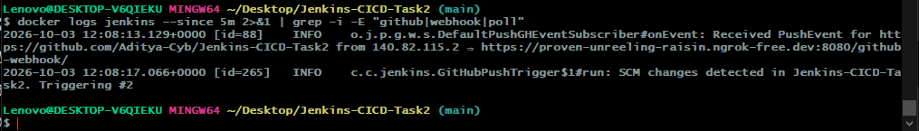
Figure 4. Jenkins log confirming that the GitHub push triggered Build #2 automatically.

10.2 Build #2 Verification
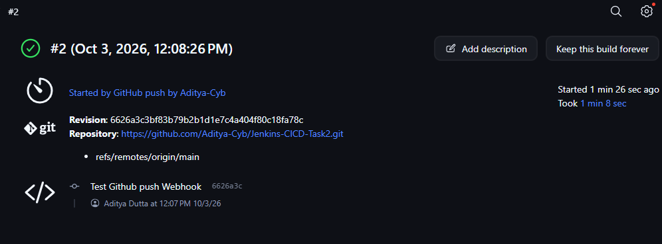
Figure 5. Jenkins Build #2 showing 'Started by GitHub push by Aditya-Cyb' and successful completion.

11. Pipeline Execution Result
The automatically triggered Jenkins Build #2 completed all required stages successfully.
Stage | Evidence | Result
Checkout | Obtained Jenkinsfile from GitHub | SUCCESS
Build | docker build -t jenkins-cicd-task2:latest . | SUCCESS
Test | Health check passed | SUCCESS
Deploy | Application deployed on port 3001 | SUCCESS
Post Actions | Jenkins CI/CD Pipeline completed successfully! | SUCCESS

11.1 Console Output Summary
Started by GitHub push by Aditya-Cyb
Obtained Jenkinsfile from git
Building Docker image...
Testing Docker container...
Health check passed
Deploying application...
Application deployed on port 3001
Jenkins CI/CD Pipeline completed successfully!
Finished: SUCCESS

12. Jenkins Security Restoration
After the CI/CD pipeline was verified, Jenkins security was restored. An administrator account was created and login access was successfully verified. The existing Jenkins jobs were preserved.
Verification | Result
Admin login | Successful
Jenkins-CICD-Task2 job | Preserved
Existing express-ci-cd job | Preserved
Existing flask-ci-cd job | Preserved
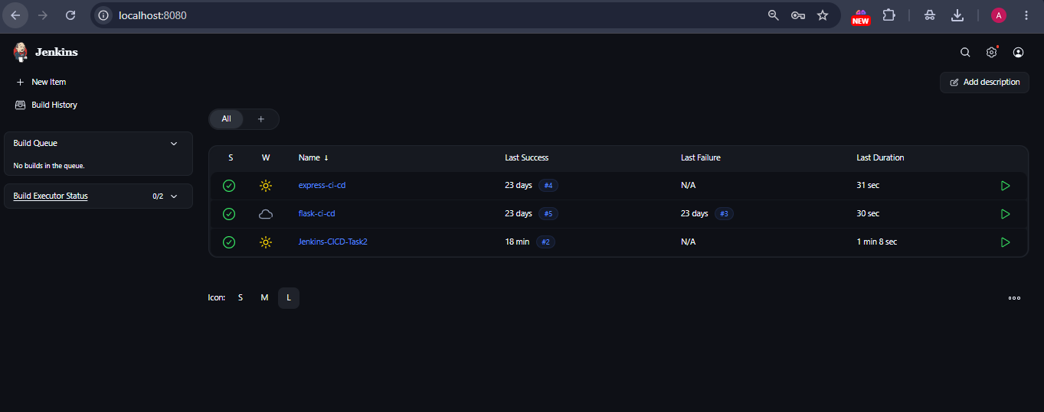
Figure 6. Jenkins dashboard after security restoration with existing jobs preserved.

13. Submission Evidence / Screenshots
The following evidence should be included in the final submission in the order below. Screenshots already captured during implementation are included where available.
No. | Evidence | Caption / Purpose
1 | GitHub repository | Shows Jenkins-CICD-Task2 repository and project files.
2 | Jenkins pipeline configuration | Shows Pipeline from SCM, repository URL, */main, and Jenkinsfile.
3 | GitHub webhook / ngrok | Shows POST /github-webhook/ with HTTP 200 OK.
4 | Automatic Jenkins trigger | Shows GitHub PushEvent and Build #2 being triggered.
5 | Jenkins Build #2 | Shows build started by GitHub push and successful completion.
6 | Console output | Shows Build, Test, Deploy, Health check passed, and Finished: SUCCESS.
7 | Running application | Shows the deployed Node.js application at http://localhost:3001.
8 | Jenkins secured dashboard | Shows login/security restored and existing jobs preserved.

14. Result
The Node.js application was successfully integrated with a Jenkins CI/CD pipeline. A GitHub push automatically triggered Jenkins through a GitHub webhook forwarded by ngrok. Jenkins then checked out the repository, built the Docker image, tested the container through the /health endpoint, and deployed the tested image as a Docker container on port 3001. The automated Build #2 completed with 'Finished: SUCCESS'.

15. Key Achievements
- Node.js web application created and tested locally.
- Application containerized using Docker.
- Project hosted on the GitHub main branch.
- Jenkins pipeline configured from SCM using Jenkinsfile.
- Build, Test, and Deploy stages implemented.
- GitHub webhook configured for push-triggered automation.
- ngrok used to expose the local Jenkins webhook endpoint during testing.
- Automatic Jenkins Build #2 successfully triggered by a GitHub push.
- Docker health check successfully passed during the Test stage.
- Application successfully deployed through the Jenkins pipeline.
- Jenkins security restored and administrator login verified.

16. Implementation Note
This implementation uses a local Jenkins instance and a Docker deployment on the same host. ngrok was used only to make the local Jenkins webhook endpoint reachable from GitHub during testing. The deployment target is the local Docker host at port 3001; no external cloud deployment is claimed.

17. Conclusion
Task 2 successfully demonstrates a practical Jenkins-based CI/CD workflow for a Node.js application. GitHub is used for source control, GitHub Webhooks initiate the automation, Jenkins provides pipeline orchestration, and Docker provides containerization and deployment. The final Build–Test–Deploy workflow was automatically triggered by a GitHub push and completed successfully.

18. Final Submission Checklist
☐ GitHub repository URL added to the submission.
☐ Jenkinsfile included in the repository.
☐ Dockerfile included in the repository.
☐ Jenkins pipeline configuration screenshot included.
☐ GitHub webhook / ngrok verification screenshot included.
☐ Automatic Jenkins Build #2 screenshot included.
☐ Console output showing Build → Test → Deploy success included.
☐ Running application screenshot included.
☐ Jenkins security/login verification screenshot included.
☐ Final documentation reviewed for correct project name and repository URL.

