TASK 3
Infrastructure as Code (IaC) with Terraform
Terraform • Docker • Nginx • GitHub
Project: Terraform-Docker-Task3
Repository: Aditya-Cyb/Terraform-Docker-Task3
Workflow: Init → Plan → Apply → Verify → State → Destroy
Documentation: DevOps Internship

1. Objective
The objective of this task is to provision a local Docker container using Terraform and understand the basic Infrastructure as Code (IaC) workflow. Terraform is used to declare the Docker image and container, generate an execution plan, provision the resources, inspect Terraform state, and destroy the infrastructure after verification.

2. Tools and Technologies Used
Technology | Purpose | Implementation
Terraform v1.16.1 | Infrastructure as Code | main.tf
Docker v28.3.3 | Container runtime | Local Docker Engine
Docker Provider v4.6.0 | Terraform-to-Docker integration | kreuzwerker/docker
Nginx | Web server / container image | nginx:latest
Git / GitHub | Source control and submission | main branch
Git Bash | Command-line environment | Windows

3. Overall IaC Architecture
The implemented workflow connects Terraform with the local Docker Engine. Terraform reads the declarative configuration in main.tf, uses the Docker provider to manage resources, and provisions an Nginx container exposed on localhost:8080.
Developer / Local Project
|
v
main.tf
|
v
Terraform CLI
|
v
Docker Provider
|
+--> nginx:latest
|
v
terraform-nginx
|
v
localhost:8080
|
v
Nginx Welcome Page
Figure 1. Task 3 IaC architecture: Terraform provisions and manages a local Docker Nginx container.

4. Project Setup

4.1 Project Structure
Terraform-Docker-Task3/
├── .gitignore
├── .terraform.lock.hcl
├── main.tf
└── README.md

4.2 Initialize Terraform Project
The project directory was created and the Terraform configuration file was prepared in Git Bash.
cd ~/Desktop
mkdir Terraform-Docker-Task3
cd Terraform-Docker-Task3
touch main.tf

5. Terraform Configuration
The main.tf file uses the Docker provider to pull the Nginx image and create a Docker container.
terraform {
required_providers {
docker = {
source = "kreuzwerker/docker"
version = "4.6.0"
}
}
}
provider "docker" {
}
resource "docker_image" "nginx" {
name = "nginx:latest"
}
resource "docker_container" "nginx" {
name = "terraform-nginx"
image = docker_image.nginx.image_id
ports {
internal = 80
external = 8080
}
}
The container listens on port 80 internally and is published on host port 8080. The resulting service is accessed at http://localhost:8080.

6. Terraform Initialization
Terraform was initialized using:
terraform init
Terraform successfully installed the kreuzwerker/docker provider version 4.6.0 and generated .terraform.lock.hcl to record the provider selection.
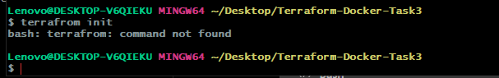
Figure 2. Terraform initialization showing successful Docker provider installation.

7. Terraform Plan
The infrastructure plan was generated before applying any changes:
terraform plan
Terraform identified two resources to create:
- docker_image.nginx — nginx:latest
- docker_container.nginx — terraform-nginx with host port 8080 mapped to container port 80
Plan: 2 to add, 0 to change, 0 to destroy.
The plan operation was used as a preview and did not modify the Docker infrastructure.

8. Terraform Apply and Provisioning
The planned infrastructure was provisioned using:
terraform apply
Terraform successfully created the Nginx image and the terraform-nginx container.
Apply complete! Resources: 2 added, 0 changed, 0 destroyed.
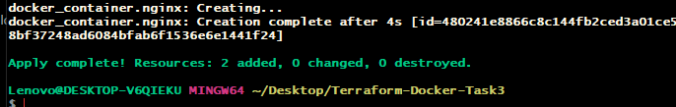
Figure 3. Successful terraform apply showing two resources created.

9. Docker and Application Verification

9.1 Docker Container Verification
The running Docker containers were checked with:
docker ps
The Terraform-managed terraform-nginx container was running with port mapping 8080:80.
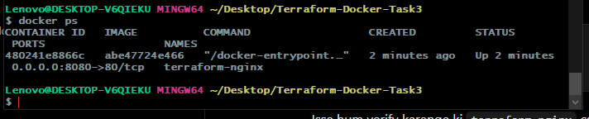
Figure 4. docker ps output showing terraform-nginx running on 0.0.0.0:8080→80/tcp.

9.2 Browser Verification
The Nginx web server was verified in a browser using:
http://localhost:8080
The Nginx Welcome page was displayed successfully, confirming that the provisioned container was serving HTTP traffic.
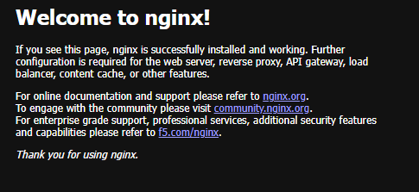
Figure 5. Nginx Welcome page successfully accessed through localhost:8080.

10. Terraform State Verification
Terraform state was inspected using:
terraform state list
The following managed resources were listed:
docker_container.nginx
docker_image.nginx
This confirmed that Terraform was tracking both the Docker container and Docker image in its state.

11. Destroying the Infrastructure
After successful verification, the provisioned infrastructure was removed using:
terraform destroy
Terraform successfully destroyed both managed resources.
Destroy complete! Resources: 2 destroyed.
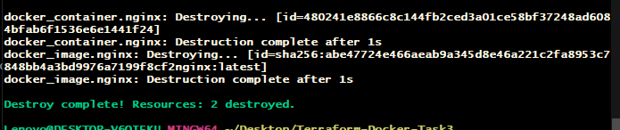
Figure 6. Successful terraform destroy showing two resources destroyed.

12. GitHub Repository
A dedicated GitHub repository was created for Task 3:
https://github.com/Aditya-Cyb/Terraform-Docker-Task3
The repository contains the Terraform configuration, provider lock file, .gitignore, and README.md.

12.1 Git Commands Used
git init
echo ".terraform/" >> .gitignore
echo "*.tfstate*" >> .gitignore
git add .
git status
git branch -M main
git commit -m "Add Terraform Docker infrastructure"
git remote add origin https://github.com/Aditya-Cyb/Terraform-Docker-Task3.git
git remote -v
git pull --rebase origin main
git push -u origin main
Terraform state files and the local .terraform directory were excluded from version control using .gitignore. The repository uses the main branch.
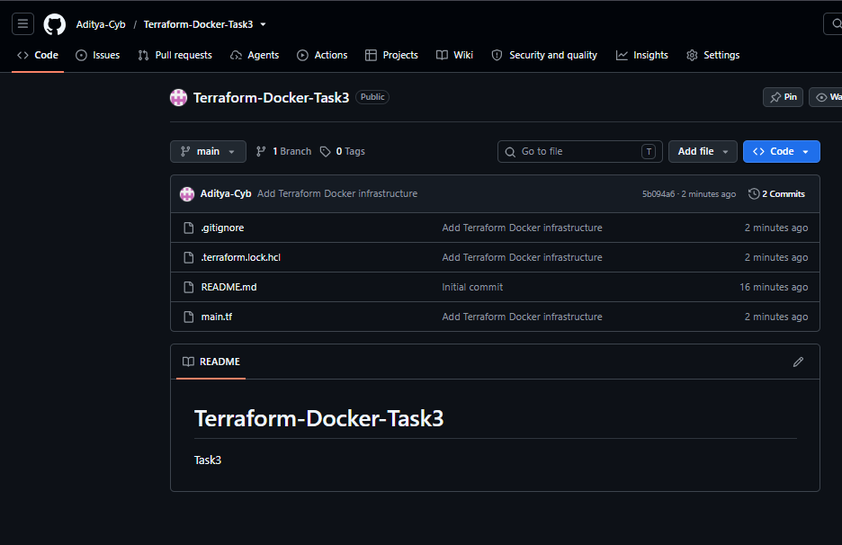
Figure 7. GitHub repository showing main.tf, .gitignore, .terraform.lock.hcl, and README.md.

13. README Documentation
The repository README was updated to document the objective, tools, Terraform workflow, resources, verification steps, state management, destroy operation, results, and learning outcomes.
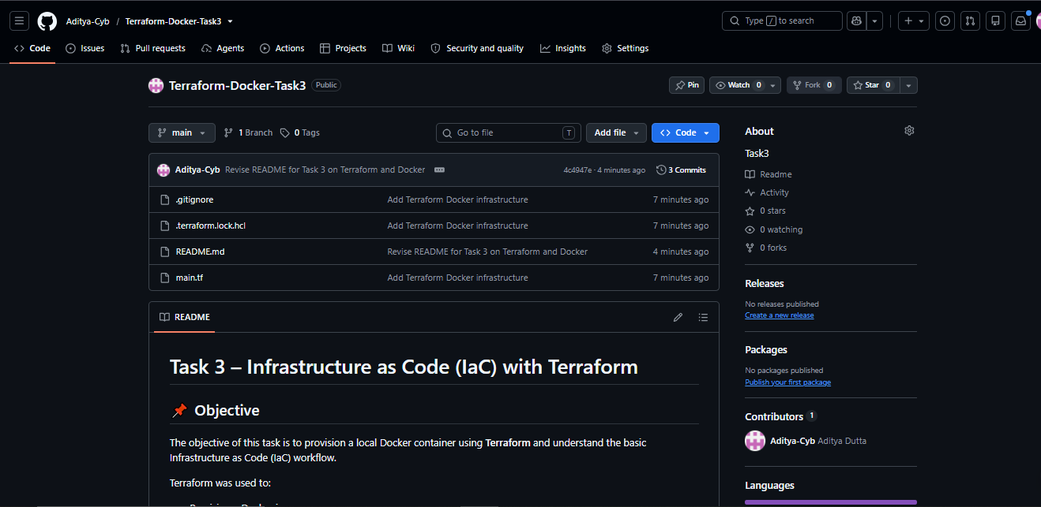
Figure 8. GitHub README showing the completed Task 3 documentation.

14. Submission Evidence / Screenshots
The following evidence was captured during implementation and is included in this documentation where available.
No. | Evidence | Caption / Purpose
1 | Terraform initialization | Shows Docker provider installation and successful terraform init.
2 | Terraform plan | Shows the planned creation of two Terraform resources.
3 | Terraform apply | Shows two resources successfully created.
4 | Docker verification | Shows terraform-nginx running with port 8080:80.
5 | Running application | Shows the Nginx Welcome page at localhost:8080.
6 | Terraform state | Shows docker_container.nginx and docker_image.nginx in state.
7 | Terraform destroy | Shows two resources successfully destroyed.
8 | GitHub repository | Shows Task 3 source files and README.
9 | README documentation | Shows the documented Task 3 workflow.

15. Result
The Terraform-Docker infrastructure was successfully provisioned and managed locally. Terraform initialized the Docker provider, generated a plan for two resources, created the Nginx image and container, verified the application through Docker and a browser, tracked the resources in Terraform state, and finally destroyed both resources.
Operation | Evidence | Result
Initialization | Docker provider v4.6.0 installed | SUCCESS
Plan | 2 to add, 0 to change, 0 to destroy | SUCCESS
Apply | 2 resources added | SUCCESS
Docker verification | terraform-nginx running | SUCCESS
Browser verification | Nginx Welcome page | SUCCESS
State | 2 managed resources listed | SUCCESS
Destroy | 2 resources destroyed | SUCCESS

16. Key Achievements
- Terraform configuration created for local Docker infrastructure.
- Docker provider successfully initialized and installed.
- Nginx image and container successfully provisioned using Terraform.
- Terraform plan used before provisioning to preview changes.
- Docker container verified through docker ps.
- Application verified through the Nginx Welcome page at localhost:8080.
- Terraform state successfully inspected using terraform state list.
- Terraform-managed resources successfully destroyed using terraform destroy.
- Task 3 project uploaded to a dedicated GitHub repository.
- README documentation completed and committed to GitHub.

17. Implementation Note
This implementation uses Terraform with the local Docker Engine. The deployment target is the local Docker host, and the Nginx service was verified through localhost:8080. No external cloud deployment is claimed. The Terraform state and .terraform directory were intentionally excluded from Git version control through .gitignore.

18. Conclusion
Task 3 successfully demonstrates a practical Infrastructure as Code workflow using Terraform and Docker. The complete lifecycle—configuration, initialization, planning, provisioning, verification, state inspection, and destruction—was executed successfully. Terraform was used to declaratively manage an Nginx Docker image and container, while GitHub was used to store the project configuration and documentation.

19. Final Submission Checklist
☐ GitHub repository URL added to the submission.
☐ main.tf included in the repository.
☐ .terraform.lock.hcl included in the repository.
☐ .gitignore configured for Terraform state/local files.
☐ README.md included and reviewed.
☐ terraform init execution evidence included.
☐ terraform plan execution result documented.
☐ terraform apply execution evidence included.
☐ Docker container verification screenshot included.
☐ Nginx browser verification screenshot included.
☐ terraform state verification completed.
☐ terraform destroy execution evidence included.
☐ Final documentation reviewed for correct project name and repository URL.

