TASK 1
Automate Code Deployment Using CI/CD Pipeline
(GitHub Actions)
Node.js Application • Docker • Docker Hub • Render
Project: nodejs-demo-app
Repository: Aditya-Cyb/nodejs-demo-app
Documentation

1. Objective
The objective of this task is to implement a CI/CD pipeline for a Node.js web application using GitHub Actions. The pipeline automates source-code checkout, dependency installation, testing, Docker image creation, authentication with Docker Hub, and publishing of the Docker image. The resulting container image is then used for cloud deployment on Render.

2. Tools and Technologies Used
Technology | Purpose | Implementation
Node.js + Express | Web application runtime and HTTP server | app.js
Git / GitHub | Source-code management and remote repository | main branch
GitHub Actions | CI automation | .github/workflows/main.yml
Docker | Containerization | Dockerfile
Docker Hub | Container image registry | adityadev02/nodejs-demo-app
Render | Cloud deployment and public access | Web Service using existing image

3. Overall CI/CD Architecture
The implemented workflow follows the sequence below. GitHub Actions performs the continuous integration portion, while the Docker image produced by the pipeline is used for the cloud deployment.
Developer / Local Project
|
v
GitHub Repository
|
| push to main
v
GitHub Actions
|
+--> Checkout Code
+--> Setup Node.js
+--> npm install
+--> npm test
+--> docker build
+--> Docker Hub login
+--> docker push
|
v
Docker Hub
|
| existing image
v
Render
|
v
Public Web Application
Note: The initial Render service deployment was configured manually using the existing Docker Hub image. The current GitHub Actions workflow automatically builds and pushes the image to Docker Hub; it does not currently contain a Render deploy hook/API step.
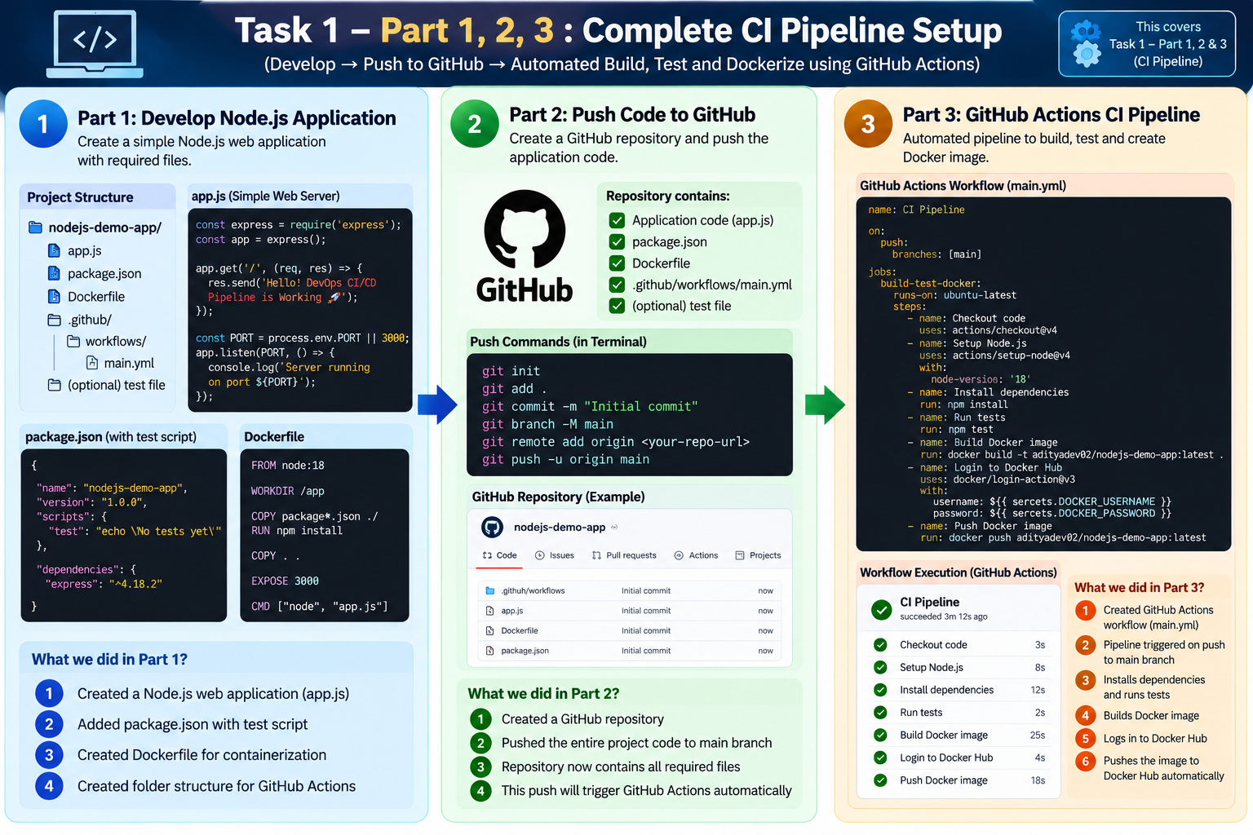
Figure 1. Task 1 Parts 1–3: Application development, GitHub repository, and GitHub Actions CI pipeline.

4. Project Setup

4.1 Project Structure
nodejs-demo-app/
├── app.js
├── package.json
├── package-lock.json
├── Dockerfile
├── .gitignore
└── .github/
└── workflows/
└── main.yml

4.2 Initialize Node.js Project
The project was initialized using npm and Express was installed as the web framework.
npm init -y
npm install express
The resulting package.json contains the project metadata, Express dependency, and a test script.

4.3 Node.js Application
const express = require("express");
const app = express();
const PORT = process.env.PORT || 3000;
app.get("/", (req, res) => {
res.send("Hello! DevOps CI/CD Pipeline is Working 🚀");
});
app.listen(PORT, "0.0.0.0", () => {
console.log(`Server running on port ${PORT}`);
});

4.4 Test Script
A simple automated test command was configured so that the GitHub Actions pipeline can validate the project.
"scripts": {
"test": "node -e \"console.log('Tests passed')\""
}
The command was also executed locally using:
npm test

5. Dockerization
A Dockerfile was created to package the Node.js application and its dependencies into a portable container image.
FROM node:20
WORKDIR /app
COPY package*.json ./
RUN npm install
COPY . .
EXPOSE 3000
CMD ["node", "app.js"]

5.1 Local Docker Build
docker build -t nodejs-demo-app .

5.2 Local Container Test
docker run -d -p 3000:3000 --name nodejs-demo-container nodejs-demo-app
The container was verified locally through http://localhost:3000 and displayed the expected application message.

6. GitHub Repository
The project was uploaded to the public GitHub repository:
https://github.com/Aditya-Cyb/nodejs-demo-app

6.1 Git Commands Used
git init
git add .
git commit -m "Initial commit"
git branch -M main
git remote add origin <repository-url>
git push -u origin main
The repository uses the main branch for the CI/CD trigger.

7. GitHub Actions CI/CD Workflow
The workflow file is located at .github/workflows/main.yml. It is triggered whenever code is pushed to the main branch.
name: Node.js CI/CD Pipeline
on:
push:
branches:
- main
jobs:
build-and-deploy:
runs-on: ubuntu-latest
steps:
- name: Checkout Code
uses: actions/checkout@v4
- name: Setup Node.js
uses: actions/setup-node@v4
with:
node-version: 20
- name: Install Dependencies
run: npm install
- name: Run Tests
run: npm test
- name: Build Docker Image
run: docker build -t nodejs-demo-app .
- name: Login to Docker Hub
uses: docker/login-action@v3
with:
username: ${{ secrets.DOCKERHUB_USERNAME }}
password: ${{ secrets.DOCKERHUB_TOKEN }}
- name: Push Docker Image
run: |
docker tag nodejs-demo-app ${{ secrets.DOCKERHUB_USERNAME }}/nodejs-demo-app:latest
docker push ${{ secrets.DOCKERHUB_USERNAME }}/nodejs-demo-app:latest

7.1 Pipeline Stages
Pipeline Stage | Description
Checkout Code | Downloads the source code from GitHub.
Setup Node.js | Configures Node.js 20 on the GitHub Actions runner.
Install Dependencies | Runs npm install to install Express and project dependencies.
Run Tests | Runs npm test and verifies the test step.
Build Docker Image | Builds the application container from the Dockerfile.
Login to Docker Hub | Authenticates using GitHub repository secrets.
Push Docker Image | Tags and pushes the latest image to Docker Hub.

7.2 GitHub Secrets
The following repository secrets were configured for Docker Hub authentication:
- DOCKERHUB_USERNAME — Docker Hub username: adityadev02
- DOCKERHUB_TOKEN — Docker Hub access token (stored securely as a GitHub secret)
The Docker Hub token value is not included in this documentation for security reasons.

8. Docker Hub Image Publishing
After successful testing and Docker image creation, GitHub Actions publishes the image to Docker Hub.
Repository:
adityadev02/nodejs-demo-app
Tag:
latest
Image:
docker.io/adityadev02/nodejs-demo-app:latest
The Docker Hub repository was verified and the latest tag was visible after the successful GitHub Actions run.

9. Cloud Deployment on Render
The Docker Hub image was deployed to Render as a Web Service using the Existing Image option.

9.1 Render Configuration
Setting | Value
Service type | Web Service
Source | Existing Image
Docker image | docker.io/adityadev02/nodejs-demo-app:latest
Plan | Free
Region | Oregon (US West)
Environment variables | None manually added; Render provides PORT at runtime

9.2 Deployment Verification
Render reported a successful deployment and the container started on the port supplied by the platform. The public service URL was then opened in a browser.
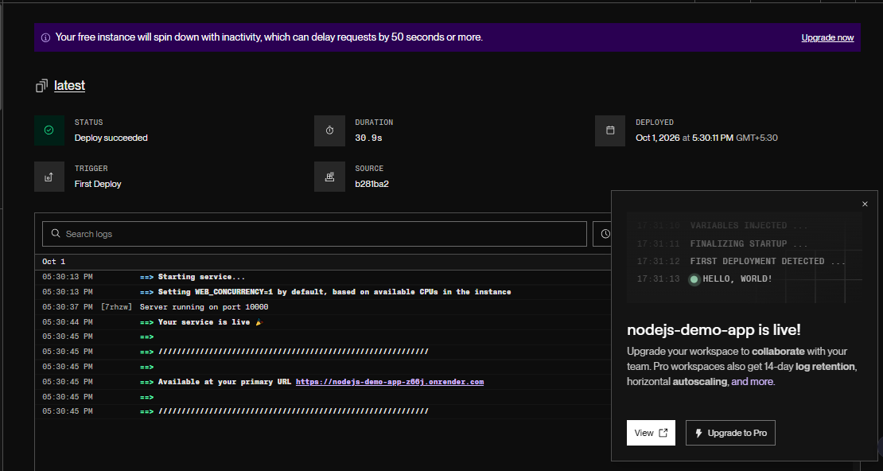
Figure 2. Render deployment status showing 'Deploy succeeded' and the public service URL.

9.3 Live Application Result
Hello! DevOps CI/CD Pipeline is Working 🚀
The application was successfully accessible through the public Render URL. This confirms that the Docker image could be run successfully as a cloud-hosted web service.

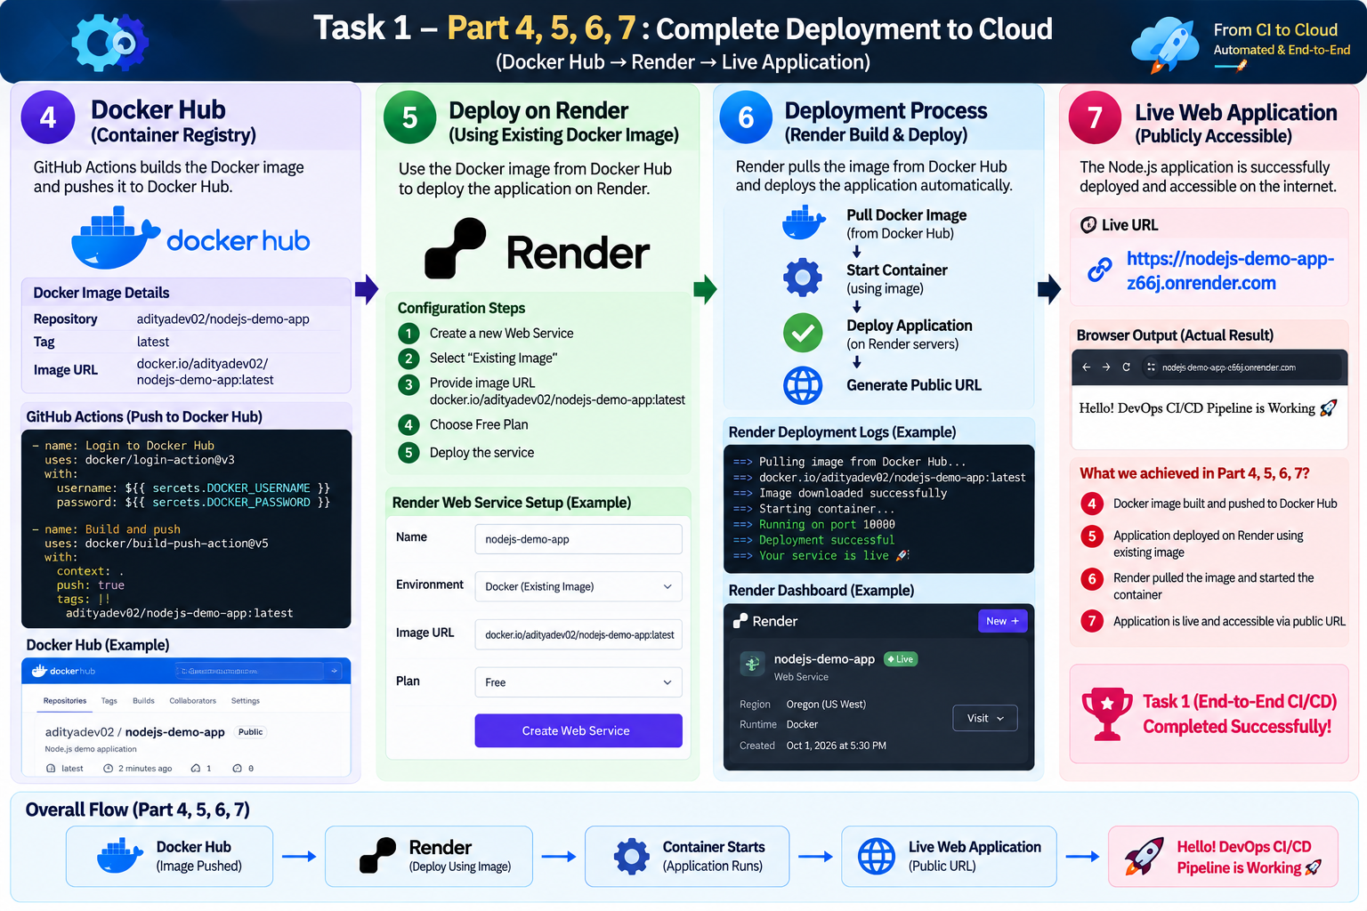
Figure 4. Task 1 Parts 4–7: Docker Hub, Render deployment, deployment verification, and live application.

10. Submission Evidence / Screenshots
The following screenshots should be included in the final submission in the order below:
No. | Evidence | Caption / Purpose
1 | GitHub repository | Shows nodejs-demo-app repository and project files.
2 | GitHub Actions workflow | Shows successful execution with all required steps green.
3 | Docker Hub repository | Shows adityadev02/nodejs-demo-app and the latest image tag.
4 | Render deployment | Shows Deploy succeeded and the service is live.
5 | Live application | Shows the public URL and application output in the browser.

11. Result
The Node.js application was successfully integrated with a GitHub Actions CI pipeline. The workflow automatically checks out the source code, installs dependencies, executes the test command, builds a Docker image, authenticates with Docker Hub, and pushes the latest image to the configured repository. The resulting Docker image was successfully deployed to Render and verified through a public web URL.

12. Key Achievements
- Node.js web application created and tested locally.
- Application containerized using Docker.
- Source code hosted on GitHub main branch.
- GitHub Actions workflow configured for push-triggered CI.
- Automated dependency installation and testing implemented.
- Docker image automatically built and pushed to Docker Hub.
- Docker Hub image successfully deployed to Render.
- Public web application successfully verified in a browser.

13. Implementation Note
The current GitHub Actions workflow ends after publishing the Docker image to Docker Hub. The initial Render deployment was configured using Render's Existing Image option. Therefore, this documentation does not claim that every subsequent GitHub push automatically triggers a Render redeployment. A Render Deploy Hook or API call can be added in a future enhancement if fully automatic post-push cloud redeployment is required.

14. Conclusion
Task 1 successfully demonstrates a practical CI/CD workflow for a Node.js application. GitHub is used for source control, GitHub Actions provides automation, Docker provides containerization, Docker Hub acts as the container registry, and Render provides cloud hosting. The final application was successfully deployed and accessed through a public URL, completing the implemented build, test, containerization, publishing, and cloud deployment workflow.

15. Final Submission Checklist
- ☐ GitHub repository URL added to the submission.
- ☐ main.yml workflow included in the repository.
- ☐ GitHub Actions successful-run screenshot included.
- ☐ Docker Hub image screenshot included.
- ☐ Render deployment-success screenshot included.
- ☐ Live application screenshot included.
- ☐ Task 1 flowchart/poster included.
- ☐ Final documentation reviewed for correct project name and URLs.

