 E-Asset Management

Abstract

The E-Asset Management system is a cutting-edge web-based application designed to revolutionize asset management within organizations. In an era where efficient resource allocation is paramount, this system offers a comprehensive solution for tracking and maintaining a wide range of assets, including laptops, books, mobile devices, and more. With user-friendly interfaces for both administrators and employees, it seamlessly facilitates processes such as asset borrowing, returns, and late-return penalty enforcement. The system's extensible architecture accommodates future asset categories and operations, ensuring adaptability to evolving organizational needs. Through unique user profiles, dynamic asset categories, and detailed reporting, the E-Asset Management system enhances visibility, accountability, and resource optimization, making it an indispensable tool for businesses seeking to streamline their asset management practices.

Introduction

# In today's fast-paced and dynamic business environment, efficient management of company assets is critical for ensuring operational smoothness and maximizing productivity. The need to keep track of assets, their availability, their condition, and their usage is paramount. To address these challenges, we present the "E-Asset Management" system, a web-based application designed to streamline asset management within your organization.

# The E-Asset Management system is a comprehensive solution that caters to the diverse needs of administrators and employees. It offers a seamless way to keep track of a wide range of assets, such as laptops, books, mobile devices, and more. Furthermore, the system is designed to be highly extensible, allowing for the integration of additional asset categories and operations as your organization evolves.

The E-Asset Management system is designed to enhance asset visibility, optimize asset utilization, and streamline administrative tasks. It ensures that your organization's assets are efficiently managed, reducing downtime and improving resource allocation.

**Implementation**

**Front-End**

There is a user home page with two types of users

* Admin
* Borrower

1. Design the User Interface:

- Create a user-friendly interface for your home page.

- Include a "Register" and a "Login" button for users to choose from.

2. Database Setup:

- Set up a database to store user information. Create two tables: one for Admins and one for Borrowers. These tables should include fields such as username and password.

3. User Registration:

- When a user clicks on the "Register" button, they should be taken to a registration form.

- The registration form should collect necessary information, such as username, password, email, and other relevant details.

- Validate user input and make sure the username is unique.

- Hash and securely store the password in the database.

4. User Login:

- When a user clicks on the "Login" button, they should be taken to a login form.

- The login form should collect the email ID and password.

- Authenticate the user by checking the entered credentials against the database records.

- If the credentials are correct, grant access to the respective user's page. If not, display an error message and prompt the user to try again.

5. Admin and Borrower Pages:

- Create separate pages for Admins and Borrowers.

- Implement access control by checking the user type (Admin or Borrower) during the login process.

- Redirect the user to their respective page after successful login.

6. Logout Functionality:

- Provide a "Logout" option on each user's page to allow them to securely log out and end their session.

7. User Experience:

- Ensure a good user experience with clear error messages, user-friendly forms, and responsive design.

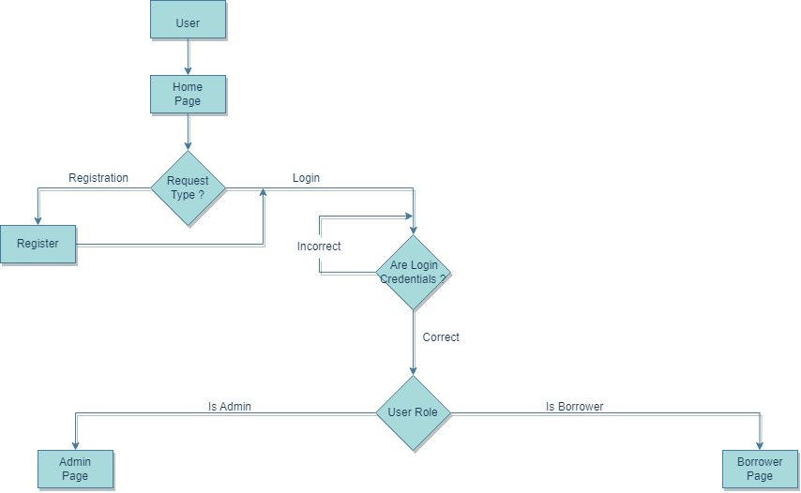

**In Admin’s Home Page:**

Functionalities:

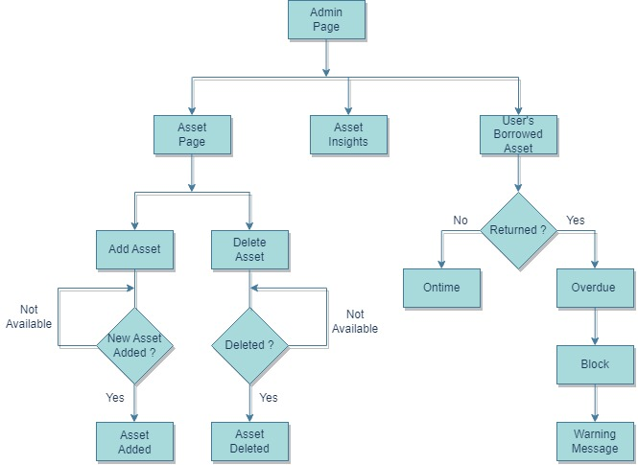

1. Add Asset:

- Users with the appropriate permissions can add new assets to the system. This functionality involves uploading the asset (e.g., Laptops, Mobile devices, Books, Cable, Headphones)

- Ensure that the asset is properly categorized, described and tagged for easy retrieval in the future.

2. Edit Asset:

- Admin with the necessary privileges can edit the description and metadata associated with an existing asset. This allows for keeping asset information up-to-date and accurate.

3. Delete Asset:

- Admin can delete assets from the system, but this should typically be reserved for assets that are no longer needed or in use.

4. Checking Borrowed Assets:

- Admin can check the status of assets users have borrowed. This could include information such as the due date for returning the asset.

- Implement a notification system to remind users for returning asset.

5. Late Fee and Banning:

- If a user exceeds the allotted time for borrowing an asset, late fee will be charged.

Define a clear late fee policy, including the amount and how it is calculated.

- Implement a mechanism for tracking late returns and calculating late fees.

- Consider temporarily banning users who repeatedly fail to return assets on time.

Define the ban duration based on your organization's policies.

- Implement a notification system to inform users about their late fees and bans.

**In User’s Home Page:**

Functionalities:

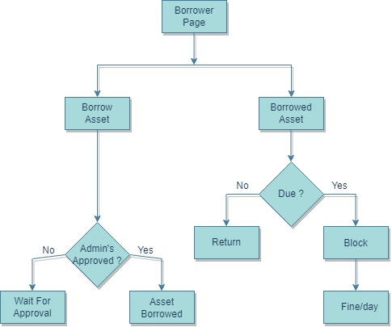

1. Borrow Asset with Admin Approval:

- When a user logs in to their home page, provide them with an option to request the borrowing of assets that require admin approval.

- Users can browse the available assets in the system and select the one they want to borrow.

- Once the user selects an asset, they initiate a borrowing request.

- The request is then sent to the admin for approval.

2. Pay for Late Fees:

- Users have the option to view their outstanding late fees on their home page.

- Display a clear list of late fees, indicating the asset, due date, and the total amount owed.

- Provide various payment options, such as credit card, PayPal, or other preferred payment methods.

It's essential to ensure that the user interface for these functionalities is intuitive and user-friendly. Users should be able to track their borrowing requests, view late fees, and make payments with ease. Additionally, administrators should have a clear workflow for reviewing and approving borrowing requests. Clear communication through notifications and reminders will help streamline the process and enhance user experience.

**Back-End**

In Back-End, we used Java and MySQL.

**ER Diagram:**

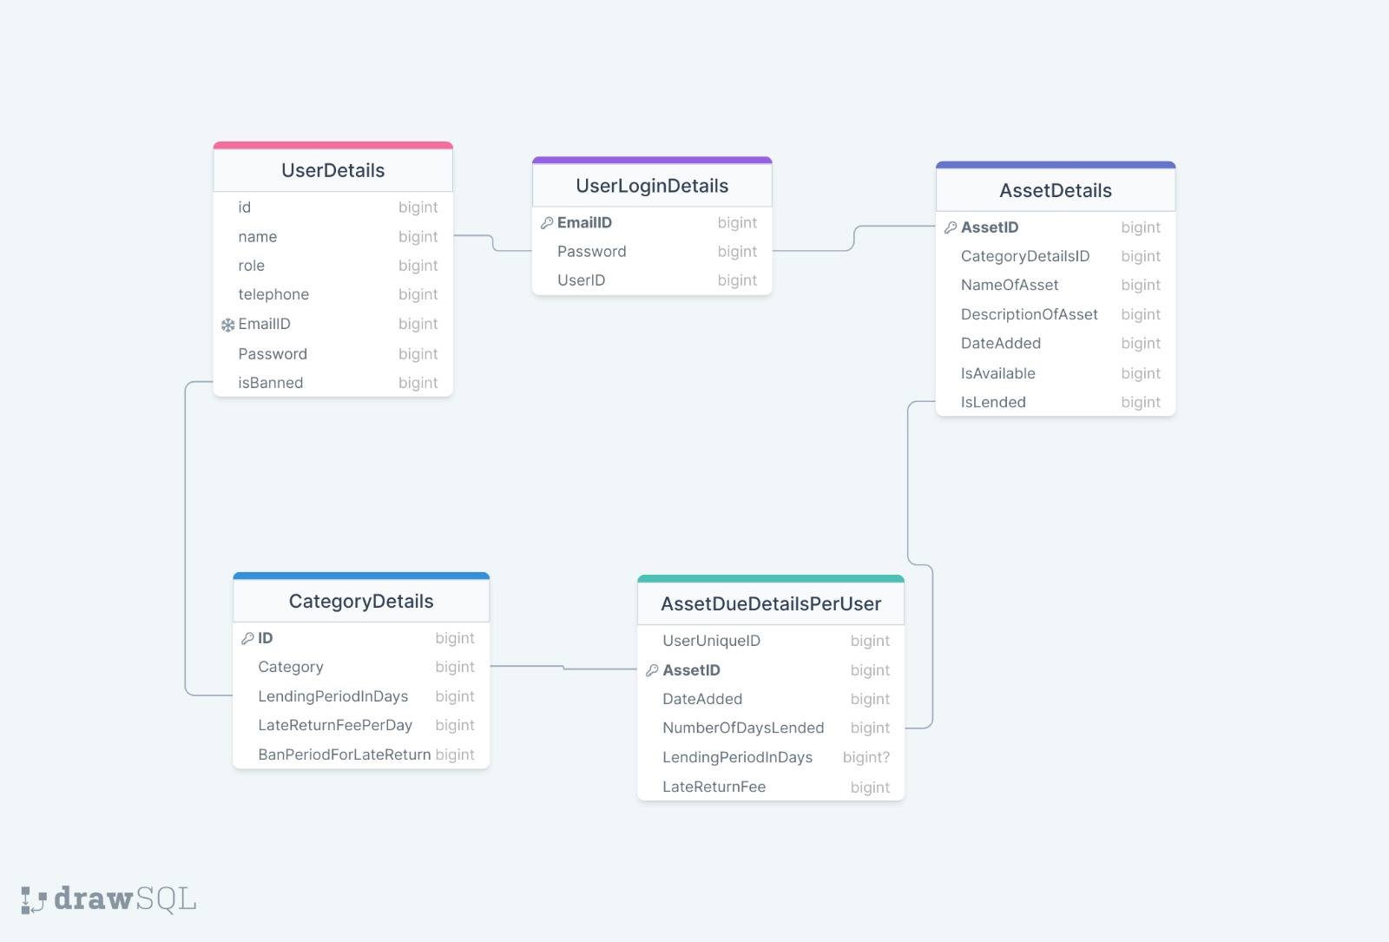

**Use Case Diagram:**

