DOCUVISION
A complete beginner's guide and teacher demonstration

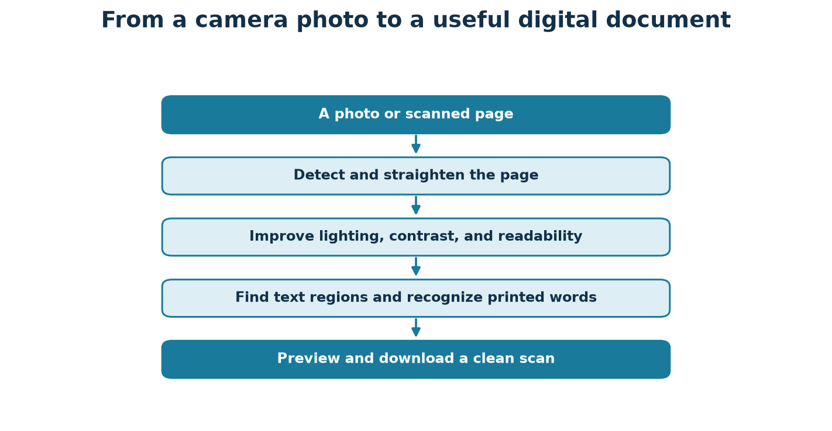
Plain-language explanation • code walkthrough • libraries • demo plan
Project files: app.py and src/docuvision/
Open the deployed DocuVision app

How to use this guide
This document is written for someone who is new to image processing and Python projects. Read the first sections to understand the idea, then use the code walkthrough to connect the idea to the actual files. The last sections give you a practical demonstration order and simple answers to likely teacher questions.
In one sentence: DocuVision takes a photograph or image of a paper page, improves and straightens it, can recognize its printed words, and also demonstrates the image-processing methods used along the way.

Contents at a glance
- The project idea and beginner vocabulary
- The complete scan pipeline and its purpose
- What each processing module and app tab does
- How the code runs from the browser to the algorithms
- Libraries and tools used
- How to run it locally and on Streamlit Cloud
- A ready-to-follow teacher demonstration
- Limitations, tests, results, and glossary

1. What problem does the project solve?
A phone photograph of a page is not automatically a good digital document. The page may be tilted, photographed from an angle, shaded on one side, noisy, blurred, or low in contrast. A person can still read it, but the computer sees only colored pixel values. DocuVision demonstrates how classical image-processing operations can make that pixel grid easier to view, store, and read.
The main practical path is: provide a page image, run the scan pipeline, inspect each processing stage, read the OCR result if the OCR engine is available, then download the processed image, recognized text, or PDF. The other tabs expose individual algorithms so a student can learn what each method changes.

What DocuVision is — and is not
It is | It is not
A classical image-processing teaching and document-scanning app. | A learned AI model that has been trained on a private dataset.
A set of visible processing stages with reusable Python functions. | A guarantee that every blurry or damaged page can be recovered.
A browser interface plus an optional desktop webcam demo. | A physical scanner; it receives images from a camera, upload, or file.
An OCR client that calls the separate Tesseract program. | OCR by itself; cleaning an image and recognizing text are different jobs.

The most important beginner distinction
Image processing vs OCR: Image processing changes the picture (for example, brightens it or makes text black and paper white). OCR means Optical Character Recognition: software tries to turn visible letters in that picture into editable text. A clear scan does not automatically mean perfectly recognized text.

2. Basic ideas you need before reading the code
Term | Simple meaning | How it appears here
Pixel | One tiny square of color in a digital picture. | An image is a grid of pixels.
Grayscale | One brightness number per pixel, from 0 (black) to 255 (white). | Used by thresholding, filters, and OCR.
BGR / RGB | Three color numbers per pixel; OpenCV commonly stores Blue, Green, Red. | Uploaded color photos are decoded as BGR.
uint8 | An 8-bit whole number; it can store 0 through 255. | Most images in the project use this format.
Noise | Unwanted random variation, like speckles in a photo. | Median and Gaussian filters can reduce some noise.
Threshold | A brightness cutoff that separates lighter and darker pixels. | Often converts a grayscale page to black text on white paper.
Kernel / window | A small neighborhood used to inspect or change nearby pixels. | Used for blurring, edges, morphology, and local thresholds.
Transform | A mathematical change of coordinates or representation. | Perspective correction and Fourier/Walsh transforms.
Label / mask | A map that marks which pixels belong to a region or object. | Used for text regions, components, and watershed.

A grayscale image can be thought of as a table of numbers. A filter looks at a small neighborhood around each number and calculates a new value. A threshold compares each brightness value with a cutoff. A geometric transform moves pixel coordinates so a slanted page can be viewed face-on.
pixel brightness: 0 = black | 128 = middle gray | 255 = white

A few equations behind the pictures
You do not need to memorize these to use the app. They show the basic idea behind important methods, using symbols only after the plain-language explanation.
Idea | Simple equation | Meaning
Grayscale from BGR | Y ≈ 0.114B + 0.587G + 0.299R | Combine blue, green, and red into one brightness value. The human eye is more sensitive to green.
Global threshold | B(x,y) = 255 if I(x,y) > T, else 0 | Compare each pixel with cutoff T; output white or black.
Contrast stretch | I' = 255 × (I − Imin) / (Imax − Imin) | Map the observed darkest/lightest values across the available brightness range.
MSE and PSNR | MSE = average((A−B)²); PSNR = 10 log10(255²/MSE) | Measure pixel error; larger PSNR means smaller average error. Identical images give infinite PSNR.
Harris corner response | R = det(M) − k × trace(M)² | A large corner response suggests intensity changes strongly in two directions.
Optical flow brightness rule | Ix·u + Iy·v + It ≈ 0 | A tracked point is assumed to keep similar brightness as it moves by (u,v).
Compression ratio | original byte count / encoded byte count | A ratio above 1 means the encoded file is smaller than the raw pixel array.

Remember: Equations describe assumptions. If those assumptions are wrong (for example, strong glare changes the page brightness), the algorithm may not produce the desired result.

3. Overall design: how the pieces fit together
The project keeps the user interface separate from the image algorithms. The browser screens live in app.py and src/docuvision/ui/. Reusable image operations live in src/docuvision/. This makes it possible to test algorithms without starting Streamlit.
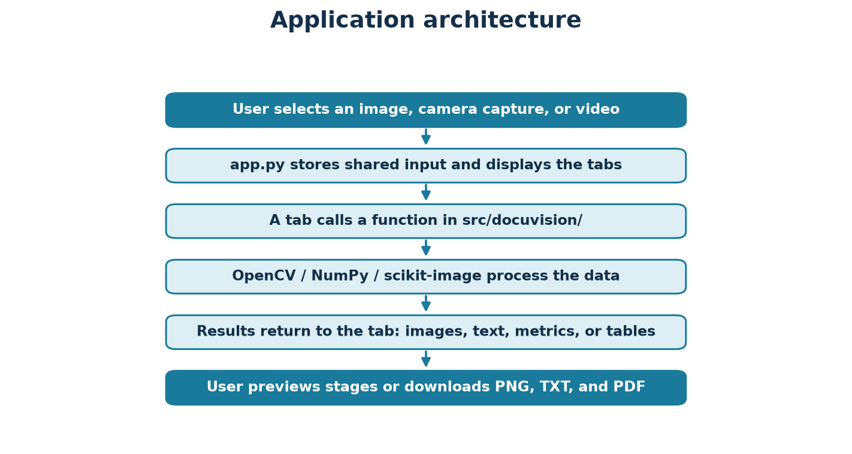

Where the main work happens
Location | Responsibility
app.py | Builds the Streamlit page, sidebar, input selection, and eight tabs.
src/docuvision/ui/tab_*.py | Shows controls and presents outputs for one learning area.
src/docuvision/pipeline.py | Connects the scan stages in a defined order and records each result.
src/docuvision/*.py | Contains algorithms such as enhancement, segmentation, features, and compression.
src/docuvision/evaluation/ | Creates test data, computes metrics, and writes CSVs/charts/summary.
tests/ | Uses small synthetic images to check expected behavior.

4. The complete document-scan pipeline
The Scan tab calls run_pipeline() in src/docuvision/pipeline.py. The function is a sequence of steps. It records each step as a Stage object (name, image, method, parameters, elapsed time, and whether it was skipped). This is why the interface can show a slider for intermediate outputs rather than only one final result.
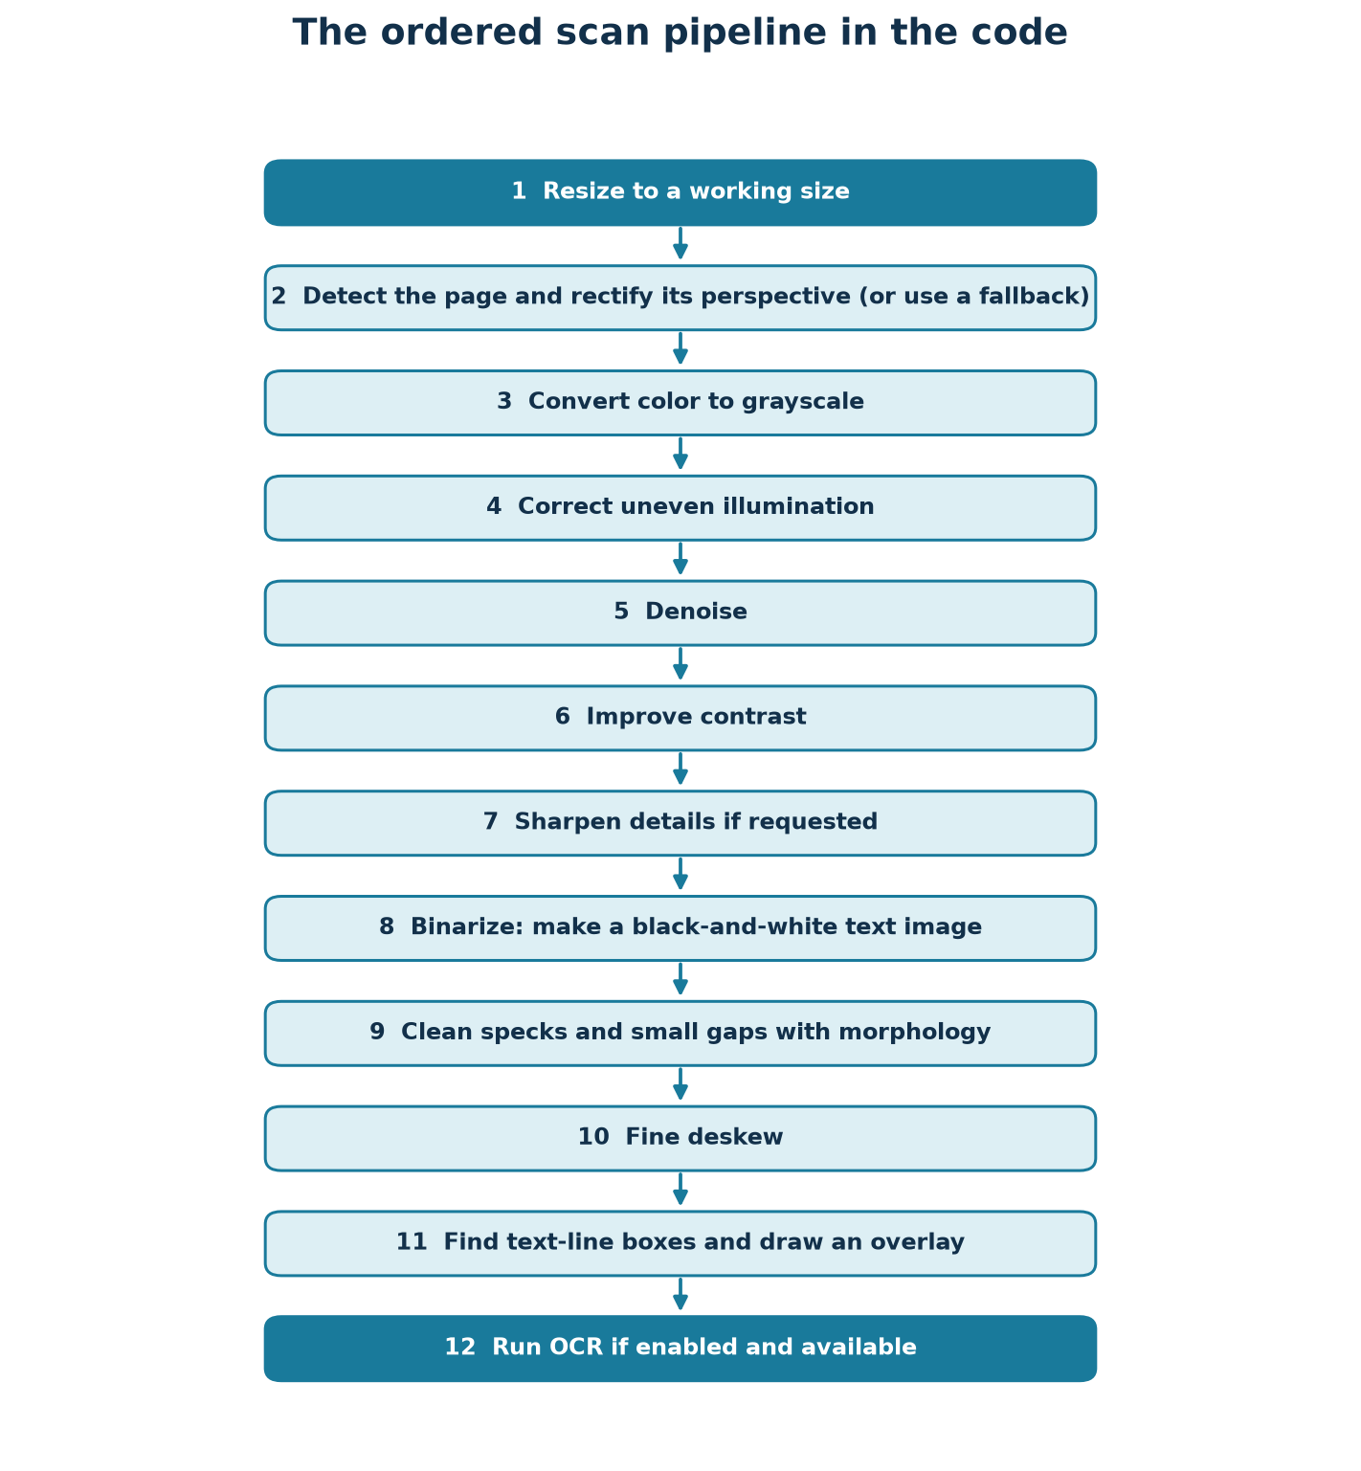
Step | What it does in plain language | Why it helps
Resize | Reduces an oversized image while keeping its proportions. | Controls memory and processing time.
Page detection / rectification | Looks for a page quadrilateral, then warps it to a front-facing rectangle. | Removes perspective tilt when page corners are visible.
Fallback | If corners are missed, tries SIFT template alignment when a template exists; otherwise processes the full image. | Avoids failing outright when automatic page detection misses.
Grayscale | Converts color to one brightness value per pixel. | Most scan algorithms need brightness, not color.
Illumination correction | Estimates and compensates for uneven lighting using homomorphic filtering or background division. | Can make shaded paper more uniform.
Denoise | Reduces small random pixel changes, using median or Gaussian filtering. | Can reduce specks while retaining text edges.
Contrast | Spreads or locally adjusts brightness values, such as CLAHE. | Makes faint print easier to distinguish.
Sharpen | Emphasizes edges with unsharp masking or high-boost filtering. | Can make soft text boundaries clearer; too much can add halos.
Binarize | Creates a two-tone black/white image with Otsu, adaptive, or Sauvola thresholding. | Separates foreground text from background paper.
Morphology | Removes specks and closes tiny breaks with small structuring elements. | Cleans the binary result; large kernels can damage letters.
Deskew | Estimates text/page angle and rotates the grayscale and binary results. | Aligns rows and columns for reading.
Layout | Finds text-line boxes and draws them on an image. | Shows where the system thinks text is located.
OCR | Asks Tesseract to recognize the chosen image stage. | Produces text and word-level boxes/confidences.

Perspective fallback explained
- First, detect four page corners and use a perspective transform.
- If corners cannot be detected and a template is provided, try feature matching and homography alignment.
- If both attempts fail, keep the entire working image and continue the pipeline rather than crashing.

Why the pipeline has both gray and binary outputs
The enhanced grayscale output keeps shades and anti-aliased edges, which can be useful for OCR. The binary output has only black and white pixels and is useful for displaying text segmentation, morphology, and thresholding. They serve related but different purposes.

5. The processing methods, one area at a time

Unit 1 — image enhancement
src/docuvision/enhancement.py contains point operations and neighborhood filters. A point operation changes each pixel mostly from its own value; a neighborhood filter uses nearby pixels too. The Enhancement tab lets a user compare these operations.
Method family | Examples in the code | Easy explanation
Intensity transforms | digital_negative, contrast_stretch_minmax, log_transform, power_law, bit_plane_slice | Change brightness values to reveal or emphasize details.
Histograms | compute_histogram_scratch, equalize_scratch, equalize_cv, clahe, histogram_match_scratch | Count brightness values; redistribute them to improve contrast.
Sampling / quantization | downsample, reduce_gray_levels | Use fewer pixels or fewer brightness levels to demonstrate information loss.
Smoothing filters | mean_filter, median_filter, gaussian_filter, order_statistic_filter | Reduce noise; each uses a different rule for combining a neighborhood.
Sharpening | laplacian_sharpen, unsharp_mask, high_boost | Emphasize local changes and edges.
Arithmetic / logic | add, subtract, multiply, divide, absdiff, weighted_blend, bitwise operations | Combine images or compare their pixels.
Illumination | background_division, frequency.homomorphic_filter | Reduce smooth background shading while retaining local detail.

Unit 2 — segmentation and edges
Segmentation means dividing an image into meaningful groups, such as foreground and background or individual connected objects. src/docuvision/segmentation.py includes both low-level edge/threshold operations and region-level methods.
- Connected components label groups of touching foreground pixels; 4-connectivity checks only up/down/left/right, while 8-connectivity also includes diagonals.
- Point and line detectors apply small textbook masks; Sobel, Prewitt, and Roberts estimate image gradients and reveal edges.
- Laplacian and LoG methods look for rapid changes; Canny and DoG offer additional edge methods.
- Otsu selects a global threshold from a histogram; adaptive and Sauvola methods choose thresholds locally, which is useful under uneven illumination.
- Region growing starts at seed pixels and adds nearby pixels that meet a similarity rule.
- Split-and-merge recursively divides areas and merges similar neighbors; it is intentionally limited to small images.
- Distance transforms and watershed can separate touching objects; Felzenszwalb provides graph-based segmentation.
- segment_text_blocks returns text-region rectangles in reading order for the page layout display.

Unit 3 — frequency processing and morphology
Spatial filtering changes pixels by looking at their neighbors. Frequency filtering first describes an image in terms of slowly changing and rapidly changing patterns. In a document, slow changes often correspond to broad illumination; fast changes often include text edges and fine detail.
- frequency.py contains scratch 1-D/2-D DFTs, FFT spectrum visualization, inverse reconstruction, and centered ideal/Butterworth/Gaussian low-pass and high-pass masks.
- A notch-reject mask can suppress repeating periodic interference. apply_frequency_filter pads before transforming and crops afterward to reduce circular wrap-around artifacts.
- Homomorphic filtering logs the image, emphasizes selected frequencies, inverts the transform, exponentiates, and normalizes. It models an image as illumination multiplied by reflectance: smooth illumination can be reduced while local detail is emphasized.
- Ringing demo compares the oscillations an ideal sharp cutoff can create against smoother Butterworth and Gaussian transitions.
- morphology.py builds rectangular, elliptical, and cross structuring elements; erosion shrinks foreground, dilation grows it, and opening/closing combine those operations.
- Morphological gradient, top-hat, and black-hat operations highlight boundaries or small bright/dark structures. Text helpers remove specks, join strokes, extract lines, and combine words into text-line masks.

What does a frequency filter actually do?
The Fourier transform rewrites the image as a combination of spatial patterns with different rates of change. A low-pass filter keeps the slowly varying patterns and attenuates fast changes; a high-pass filter does the reverse. A smooth Gaussian mask changes gradually, while an ideal mask changes abruptly and can create ringing near sharp edges. Homomorphic filtering starts with a simple model: observed image = illumination × reflectance. Taking a logarithm turns multiplication into addition, so a low-frequency illumination component can be reduced while finer reflectance detail is retained or emphasized.

Unit 4 — why corners and descriptors help
A corner is a location where image brightness changes in two directions, so moving it usually changes the local image patch in a distinctive way. A descriptor stores a summary of that patch. Matching descriptors between two images gives point pairs; RANSAC searches for a homography supported by a consistent subset of those pairs. That mapping can align a photographed form with a reference template.

Unit 5 — how Lucas–Kanade tracking works
The brightness rule gives one equation but two unknown motion components, so one pixel alone cannot determine full 2-D motion. Lucas–Kanade gathers equations from a small window and solves a least-squares system. A corner provides brightness variation in two directions and usually constrains both components better than a straight edge. Pyramid tracking first looks at smaller versions of the frame, where a large movement appears smaller, then refines the estimate at higher resolution.

Unit 6 — how actual-byte compression is compared
An encoder returns bytes, not just a count of theoretical symbols. A decoder reads those bytes back. If the codec is declared lossless, the test compares every decoded pixel with the original and expects exact equality. For a lossy transform codec, coefficients are removed or quantized before being Huffman-coded; fewer retained details usually mean smaller files but lower reconstruction quality.

Unit 4 — geometry and visual features
Geometry changes where pixels are located; feature methods find distinctive points or patterns. geometry.py provides affine transforms and document-corner detection. features.py contains corner/blob detectors, pyramids, SIFT/ORB matching, and HOG.
- Harris and Shi–Tomasi identify corner-like pixels; corners are useful because image intensity changes in two directions, making them easier to track.
- Hessian blob detection finds round or blob-like structures at different scales.
- Gaussian and Laplacian pyramids represent the image at multiple sizes; the Laplacian pyramid can be reconstructed.
- Scale space and Difference of Gaussians (DoG) search for features across position and scale; DoG approximates a Laplacian-of-Gaussian response.
- SIFT produces distinctive keypoints/descriptors; ORB is a faster alternative. Brute-force matching plus Lowe's ratio test filters ambiguous matches.
- RANSAC estimates a homography while rejecting mismatched point pairs; align_to_template uses this for registration.
- HOG summarizes local edge directions as a descriptor and can also return a visualization.

Unit 5 — motion and capture stability
The motion module compares frames from a video. It contains frame differencing, background estimation, Lucas–Kanade optical flow, Horn–Schunck flow, and a document capture state machine.
- Lucas–Kanade estimates movement for selected points. Its aperture problem means a straight edge alone does not reveal motion along the edge; corners provide changes in two directions.
- The OpenCV pyramidal LK implementation tracks across image scales so larger motion can be handled; forward-backward checking discards unreliable tracks.
- Horn–Schunck estimates a dense smooth flow field; flow_to_color visualizes direction and magnitude, and draw_flow_arrows overlays vectors.
- DocumentTracker detects page corners, selects Shi–Tomasi points inside the page, tracks them, estimates a homography, and periodically re-detects.
- StabilityDetector moves through IDLE, MOVING, STABLE, CAPTURED, and PAGE_CHANGED states. It waits for consecutive low-motion frames and keeps the sharpest candidate based on Laplacian variance.
- process_video returns frame progress and ends with events, captures, and a timeline table. make_demo_video creates a deterministic video without an external input file.

Unit 6 — compression
Compression reduces the number of bytes needed to store an image. Lossless methods recover the original pixels exactly. Lossy methods deliberately discard detail to reduce the file size. compression.py uses real encoded byte streams, so its size measurements include headers rather than estimating a theoretical bit count.
Codec / idea | What happens
RLE | Stores repeated values as runs; useful when long repeated stretches occur, especially in binary scans.
Huffman | Assigns shorter prefix-free codes to frequent symbols; code lengths are canonicalized and bits are packed.
LZW | Builds a dictionary of repeated byte sequences and emits dictionary codes.
IGS quantization | Reduces gray levels while distributing quantization error to reduce visible false contours.
WHT / DCT block transform | Transforms each small block, keeps selected coefficients or quantizes them, then entropy-codes the coefficients.
PNG / JPEG comparison | OpenCV encodes and decodes real PNG/JPEG files as familiar lossless/lossy baselines.

The compression table measures original bytes, encoded bytes, compression ratio, bits per pixel, actual round-trip equality for lossless codecs, and encoding time. The rate-distortion curve compares compression ratio with PSNR/SSIM as the quality parameters change.

Unit 7 — evaluation and reproducibility
Evaluation uses generated pages with known text and known geometry. A fixed random seed makes the generated degradation repeatable. SET_A changes lighting/noise/blur while remaining pixel-aligned to the clean page, so PSNR and SSIM comparisons are meaningful. SET_B also changes geometry and stores true page corners for geometric error measurement.
Metric | What it tells us
PSNR | Pixel reconstruction error expressed in decibels; higher usually means closer pixel values.
SSIM | Compares local structure, contrast, and brightness; closer to 1 is more structurally similar.
CER / WER | Character/word edit-distance error against known transcription; lower is better.
Corner error | Average geometric distance between predicted and known page corners, in pixels.
Sharpness | Variance of the Laplacian; a simple focus/detail indicator, not a complete quality measure.
RMS contrast | Spread of image intensity values as a contrast estimate.

Unit 9 — OCR
ocr.py is an adapter around pytesseract, which calls the separate Tesseract executable. run_ocr returns recognized text and a pandas table of word boxes/confidences. tesseract_available checks the executable before use. When it is absent, the app returns a clear status instead of crashing. CER and WER normalize text and use Levenshtein edit distance.
In the Scan tab, OCR can be retried using enhanced grayscale, black-and-white, or original grayscale, with layout choices such as “Block of text” and “Sparse text / poster.” For a decorative cover, try black-and-white plus Sparse text / poster. The stage selector opens on the last pipeline stage. These options can help, but artistic lettering may still not be recognized exactly. The optional crop controls let you select a smaller rectangle and preview it before retrying, which can reduce interference from nearby artwork.

6. How the code works from click to result

A. The Streamlit entry point
- app.py calls st.set_page_config() to choose the browser title and wide layout.
- _sidebar_settings() selects a PipelineConfig preset and displays the syllabus map.
- _sidebar_image() reads an uploaded picture, a browser camera photo, or a file in data/samples/ and stores the decoded BGR image in st.session_state.
- main() displays a Tesseract availability warning when needed and creates the tabs.
- Each tab calls render() in its own UI module; the UI module calls library functions and displays their output.

B. What happens when Run document pipeline is clicked
- src/docuvision/ui/tab_scan.py checks for the source image.
- It serializes the settings and calls _cached_pipeline(). Streamlit's cache avoids repeating identical expensive processing for the same bytes and settings.
- _cached_pipeline() rebuilds PipelineConfig and calls run_pipeline(image, config).
- run_pipeline() validates the image, applies steps in order, and appends a Stage record for each operation. Disabled stages are still recorded with skipped=True.
- The scan tab shows source and enhanced output, lets the user choose a stage, then displays OCR text and download buttons.
- scan_to_pdf() converts the final grayscale image to a one-page PDF. PNG, TXT, and PDF downloads are made in the browser.
User click -> tab_scan.render() -> _cached_pipeline() -> pipeline.run_pipeline() -> Stage images + OCR -> preview/download

C. Stage configuration
config.py defines a frozen PipelineConfig. A preset is a ready-made combination of settings: fast favors speed, balanced is the default compromise, max_quality uses a larger working image and stronger processing, and the two baseline presets provide simple threshold-only comparisons. A disabled_steps tuple lets evaluation and the UI skip named steps while keeping them visible in the ordered output.

D. Errors and data conventions
- Most core functions expect a nonempty uint8 grayscale or BGR image and validate that input.
- Functions generally return a new image rather than modifying the user's input array.
- Tesseract absence becomes an explicit status; OCR engine errors become an explicit OCR-failed status.
- Invalid method names or invalid array shapes raise clear ValueError exceptions rather than silently producing a fake success.
- Streamlit caches results in session memory; it does not permanently save a user's uploaded image as a repository file.

7. The eight tabs in the deployed app
Tab | What a student can do | Main code
Scan | Run end-to-end cleaning, inspect stage images/timing, view OCR and download PNG/TXT/PDF. | ui/tab_scan.py, pipeline.py, ocr.py
Unit 1 · Enhancement | Try intensity changes, histograms, filters, noise, sharpening, arithmetic, and sampling. | ui/tab_enhancement.py, enhancement.py
Unit 2 · Segmentation | Compare edges, thresholding, regions, connected components, and watershed. | ui/tab_segmentation.py, segmentation.py
Unit 3 · Frequency & Morphology | View spectra and filters, ringing, WHT bases, and morphological operations. | ui/tab_frequency.py, frequency.py, morphology.py
Unit 4 · Geometry & Features | Explore transforms, corners, keypoints, matching, pyramids, and HOG. | ui/tab_features.py, geometry.py, features.py
Unit 5 · Motion | Generate or upload video, inspect motion/stability timeline, flow, captures, and segmentation demos. | ui/tab_motion.py, motion.py
Unit 6 · Compression | Compare actual codec byte sizes and lossless checks; inspect WHT/DCT rate-distortion. | ui/tab_compression.py, compression.py
Evaluation | Read generated tables/charts and run a small browser evaluation. | ui/tab_evaluation.py, evaluation/run_eval.py

For a first run: Choose Sample in the sidebar, select document_sample.png, open Scan, and press Run document pipeline. This avoids needing to find a suitable image before learning the app.

8. Libraries and tools used
Library / tool | Why it is used in DocuVision
Python | Main programming language; standard library modules also handle paths, JSON, timing, queues, and byte packing.
OpenCV (opencv-python-headless) | Image decoding, color conversion, transforms, morphology, edge operators, feature detection/matching, optical flow, video processing, and PNG/JPEG encoding. The headless package avoids GUI system libraries on cloud servers.
NumPy | Stores images as arrays and implements matrix operations, transforms, masks, and image arithmetic.
SciPy | Scientific routines and filters used by classical image-processing implementations.
scikit-image | Provides Sauvola thresholding, SIFT-related blob/HOG utilities, Felzenszwalb segmentation, and structural similarity.
Pandas | Stores OCR word boxes, motion timelines, evaluation tables, and codec comparison results.
Pillow | Renders synthetic document pages and writes one-page PDF output from the grayscale scan.
Matplotlib | Creates evaluation charts and visual demonstrations.
Streamlit | Builds the browser UI, tabs, widgets, cached processing, and interactive downloads.
pytesseract + Tesseract OCR | pytesseract is the Python bridge; the separately installed Tesseract executable performs OCR.
RapidFuzz | Computes fast Levenshtein edit distances for character and word error rates.
fpdf2 | Declared PDF-generation dependency; the current scan export uses Pillow's PDF writer.
pytest | Runs the deterministic automated test suite.
Ruff | Checks Python imports and selected lint rules.
setuptools / wheel | Build/install the src-layout Python package.

Why headless OpenCV? The hosted app does not open native desktop windows. opencv-python-headless provides the image-processing APIs without requiring server GUI libraries such as libGL.

9. How to run and use the project

Run locally on macOS or Linux
cd docuvision
python3 -m venv .venv
source .venv/bin/activate
python -m pip install -r requirements.txt
streamlit run app.py
Keep the terminal running. Streamlit prints a local address, usually http://localhost:8501. Open it in a browser.

Run locally on Windows PowerShell
cd docuvision
py -3 -m venv .venv
.\.venv\Scripts\Activate.ps1
python -m pip install -r requirements.txt
streamlit run app.py

First scan: click-by-click
- Open the app and select Sample in the left sidebar.
- Choose 01_clean_print_page.jpg for the first, easy scan and OCR demonstration.
- Select 02_shadowed_tilted_page.jpg for the second demonstration: page-corner detection and perspective correction on a gently shadowed photograph.
- Optional: open the matching .txt file beside each sample image and paste its contents into the Scan tab ground-truth field to display CER.
- Open the Scan tab.
- Leave the balanced preset selected for a first attempt.
- Click Run document pipeline and wait for processing.
- Use the Stage slider to inspect each operation; read the technique, unit, and time caption.
- Read the OCR text area if Tesseract is available. If not, the app gives a clear notice; the cleaned scan still works.
- Download PNG for the image, TXT for OCR output, or PDF for a printable page.

OCR setup on a personal computer
Tesseract is a separate system program, not just a Python package. On macOS install with brew install tesseract; on Debian/Ubuntu use sudo apt-get install tesseract-ocr; on Windows use the installer described in README.md. If it is not on PATH, set TESSERACT_CMD to the full executable path. The deployed Streamlit app declares Tesseract and English language data in the root-level packages.txt; after a deploy rebuild, the availability banner should reflect the server's actual installation.

Streamlit Cloud deployment
- The GitHub repository is Aditya-Deshwal23/IPCV-mini-Project on branch main.
- In Streamlit Community Cloud, select that repository and branch, with app.py as the main file.
- requirements.txt installs Python packages; packages.txt installs system packages including Tesseract and English data.
- Wait for the app build to finish, then open the deployed app. If dependencies change, trigger a rebuild/reboot.
Deployed app: https://ipcv-mini-project-eycbr3cmbbyzikdmudnqrv.streamlit.app/
A browser camera capture is a single photo supplied to the web app. The separate live_demo.py uses a camera attached to the local computer or a supplied video file; a cloud server cannot use your laptop's connected webcam as its own camera.

10. Teacher demonstration plan (about 8 minutes)
The goal is to show one complete result first, then briefly connect that result to the algorithms. Keep the deployed app or local app open and use the bundled sample if you do not have a page photograph ready.
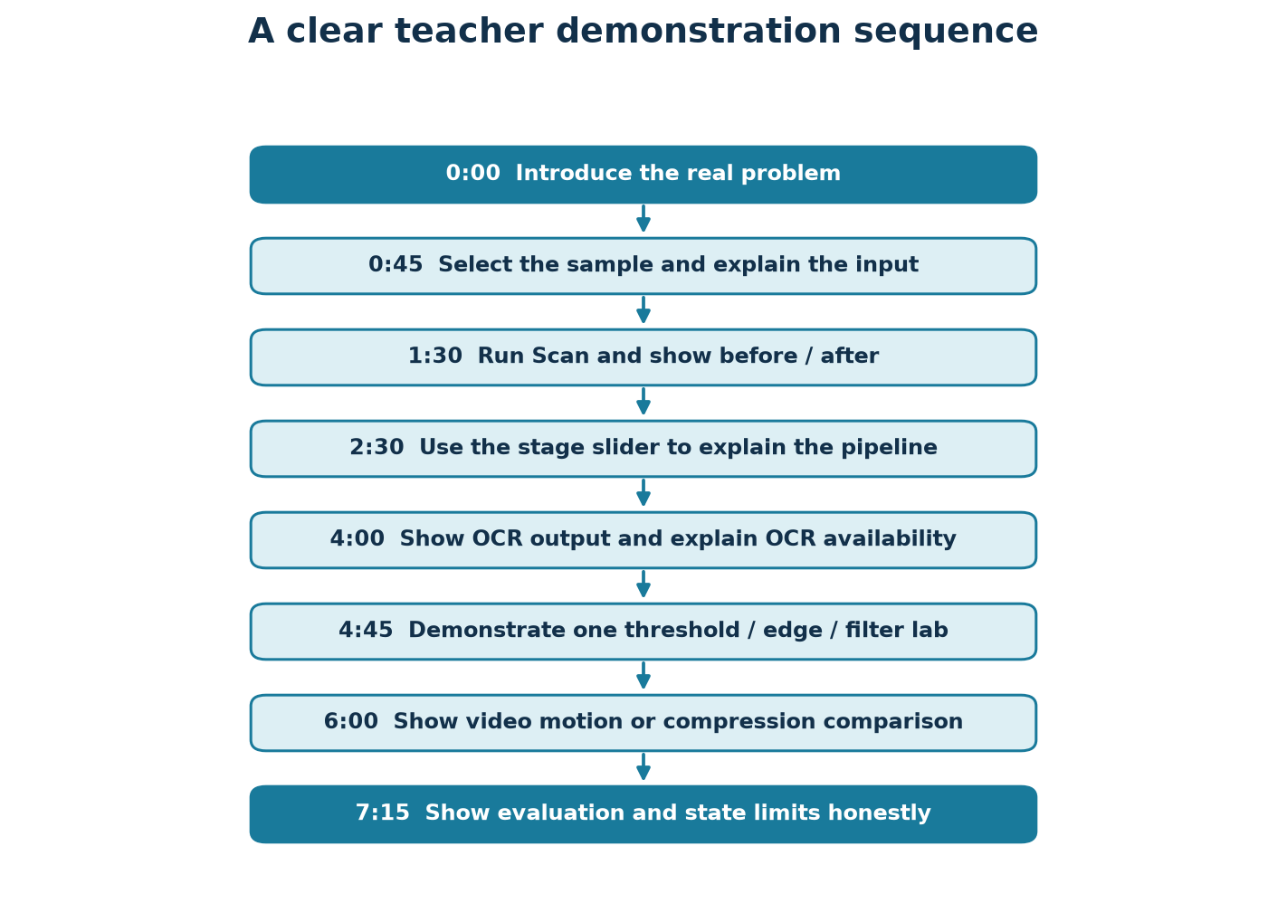
Time | Action | What to say
0:00–0:45 | Introduce DocuVision. | “This project improves document images using classical image-processing methods and can then recognize the printed text.”
0:45–1:30 | Select Sample → document_sample.png. | “The input is an image represented as a grid of pixel values; I can also upload a photo or take one in the browser.”
1:30–2:30 | Open Scan and click Run document pipeline. | “The stages are ordered and individually visible, so I can explain what changed instead of hiding the processing in one black box.”
2:30–4:00 | Move the Stage slider through resize, rectify, illumination, denoise, contrast, threshold, layout. | “Each stage records its method and time. The grayscale result keeps detail, while the binary result simplifies text to black and white.”
4:00–4:45 | Show OCR status/text and downloads. | “OCR is a separate step: Tesseract reads the processed pixels and returns text plus word boxes. A missing executable is reported clearly.”
4:45–6:00 | Show a threshold/edge operation in Unit 2 or filters in Unit 1. | “A threshold compares brightness against a cutoff. Otsu chooses a global cutoff; local threshold methods adapt to shading.”
6:00–7:15 | Show a generated motion demo or compare compression codecs. | “Motion uses tracked points and stability; compression compares actual encoded byte streams and verifies lossless round trips.”
7:15–8:00 | Open Evaluation and finish with limitations. | “The evaluation uses generated images and fixed seeds. It is useful for repeatable tests but not a substitute for a large real-world dataset.”

Short opening and closing script
Opening: “A photograph of a document can have shadows, tilt, and noise. DocuVision demonstrates how image processing can improve the page and how OCR can turn printed letters into text.”

Closing: “The important point is that each processing step is inspectable and testable. The system can help with ordinary images, but glare, poor focus, missing page boundaries, and OCR quality still limit the result.”

11. Likely teacher questions and simple answers
Question | Beginner-friendly answer
What is the goal of the project? | To improve photographed document images, show the processing steps, and optionally recognize the printed text.
What does OCR stand for? | Optical Character Recognition. It converts visible text in an image into machine-readable characters.
Why convert to grayscale? | Most page cleanup depends on brightness; one value per pixel is simpler than three color channels.
Why can Otsu fail under a shadow? | Otsu chooses one threshold for the whole image. A dark shadow can make one cutoff unsuitable for both bright and shaded areas.
Why use Sauvola or adaptive thresholding? | They calculate local cutoffs, so different parts of a page can handle different lighting.
What is morphology used for? | Small-shape operations clean isolated dots or reconnect tiny gaps after thresholding.
Why do corners track well? | Corners change in two image directions; a plain edge does not reveal movement along the edge. This is the optical-flow aperture problem.
What is a homography? | A 3-by-3 projective mapping used to relate points on a tilted page to points on a flat rectangular view.
What is a lossless codec? | One whose decoder reconstructs exactly the original image array; the tests check array equality.
Why does Huffman compression work? | Frequent symbols get shorter prefix codes and rare symbols get longer ones, reducing the average bits per symbol.
Why is the report cautious about results? | The committed result summary is a small N=2 smoke evaluation, so it checks the workflow but is not enough to claim broad accuracy.
What happens when Tesseract is unavailable? | The app reports its status clearly and continues to offer image processing; OCR itself cannot return recognized words until the executable is available.

12. Tests, results, and what they mean
The tests create small synthetic images and videos so they do not need a camera, downloaded model, or external dataset. They test exact or measurable behavior such as round-trip equality, reconstruction error, threshold correctness, image geometry, and pipeline output format.
- The tested areas include configuration, enhancement, segmentation, frequency, morphology, features, geometry, motion, compression, evaluation, IO, and the pipeline.
- Compression tests verify real byte round trips for lossless encoders and compare the declared ratios using actual stream lengths.
- Motion and pipeline tests use synthetic imagery/video rather than relying on a physical camera.
- The current repository's generated evaluation summary records Pages per set: 2 and Tesseract available: False. This is a smoke-run snapshot; regenerate with --n 30 for the planned larger synthetic evaluation.
- The full project test suite passed 90 tests in the recent local verification. Test success establishes the tested behaviors, not perfection on every real photograph.
How to run checks: Activate the project's virtual environment, then run pytest -q and ruff check . from the repository root.

13. Limitations and responsible claims
- A white page on a white surface may not have enough contrast for reliable corner detection.
- Strong glare, clipped highlights, severe motion blur, folds, occlusion, or very low resolution can destroy information; classical processing cannot recreate detail that was never captured.
- Thresholds and filters need suitable parameters for the page and image. Over-processing may remove thin strokes or create artifacts.
- OCR depends on image quality, language data, font, layout, and Tesseract installation; its result may contain recognition mistakes.
- Optical flow and feature matching can fail on flat, repeated, blurry, or fast-moving scenes.
- The documented evaluation is synthetic and the committed result snapshot uses two pages per set; do not present it as a statistically representative real-world benchmark.
- The desktop OpenCV live demo needs a local camera or video. Streamlit's camera widget captures a still image in the browser.
- SURF is not implemented; standard OpenCV SIFT and ORB are used instead.

14. Small glossary
Word | Meaning
Binarization | Turning a gray image into two classes, normally black foreground and white background.
Connected component | A group of foreground pixels connected under a selected neighbor rule.
Descriptor | A compact numerical summary of a local image patch for comparison/matching.
Homography | A projective transformation that maps points between two planar views.
Illumination | The light falling on the page; it can vary across the image.
Kernel | A small matrix/window used to compute a local image operation.
RANSAC | A robust fitting method that repeatedly finds a model supported by many consistent matches.
Sequency | The number of sign changes in a Walsh basis row.
Threshold | A cutoff used to divide brightness values into groups.
Variance of Laplacian | A simple focus/sharpness measure based on how strongly image brightness changes around edges.

15. Main source files to remember
File | Remember it as
app.py | The front door: shared inputs and tabs.
src/docuvision/config.py | The set of adjustable pipeline settings and presets.
src/docuvision/pipeline.py | The ordered scan recipe and intermediate Stage records.
src/docuvision/enhancement.py | Brightness, contrast, filtering, sharpening, and arithmetic.
src/docuvision/segmentation.py | Edges, thresholding, regions, connected components, and text boxes.
src/docuvision/frequency.py / morphology.py | Frequency transforms/filters and shape-based cleanup.
src/docuvision/geometry.py / features.py | Page geometry, corners, descriptors, feature matching, and HOG.
src/docuvision/motion.py | Optical flow, tracking, stability, and video processing.
src/docuvision/compression.py | Actual-byte codecs and transform compression.
src/docuvision/ocr.py | Tesseract connection, word boxes, CER, and WER.
src/docuvision/evaluation/ | Synthetic data, metrics, reproducible runs, and generated reports.
src/docuvision/ui/ | One Streamlit display module per learning tab.
tests/ | Automated checks using synthetic inputs.
requirements.txt / packages.txt | Python packages / system packages for deployment.

References and further reading
The project report discusses these classical sources. This guide paraphrases the ideas for learning and does not reproduce article text.
- N. Otsu, “A Threshold Selection Method from Gray-Level Histograms,” 1979.
- B. D. Lucas and T. Kanade, “An Iterative Image Registration Technique with an Application to Stereo Vision,” 1981.
- B. K. P. Horn and B. G. Schunck, “Determining Optical Flow,” 1981.
- D. G. Lowe, “Distinctive Image Features from Scale-Invariant Keypoints,” 2004.
- J. Sauvola and M. Pietikäinen, “Adaptive Document Image Binarization,” 2000.
- R. C. Gonzalez and R. E. Woods, Digital Image Processing.
Prepared from the DocuVision source code, project README, report, and test suite. Document generated 2026-10-26.

