HOSPITAL PERFORMANCE ANALYTICS DASHBOARD
End-to-End Data Analytics Project Report
Built with Microsoft Excel | Power Pivot | Pivot Tables | Interactive Dashboard

1. Project Overview
This project demonstrates a complete, end-to-end data analytics workflow applied to a real-world hospital dataset. The objective was to transform raw, multi-table hospital records into an interactive, insight-driven performance dashboard using Microsoft Excel's advanced analytical capabilities.
The dashboard enables hospital administrators to monitor patient demographics, analyze hospital utilization patterns, and assess operational efficiency — all through a single, interactive interface.

2. Dataset Overview
The project utilized a multi-table relational hospital dataset containing over 27,000+ encounter records linked to patient records. The two primary tables used were:
- Patients Table — Demographic data including gender, date of birth, marital status, race, ethnicity, and birthplace.
- Encounters Table — Hospital visit records including admission/discharge timestamps, encounter class, payer, organization, and reason descriptions.
Dataset Size: 20,000+ records across tables, with 27,891 total encounters and 974 unique patients — reflecting a realistic, large-scale healthcare dataset.

3. Data Relationship Modeling
Before any transformation, the schema and relationships between tables were analyzed:
- Each patient holds a unique identifier (patients.Id)
- Each encounter references a patient via the PATIENT foreign key (encounters.PATIENT)
- One patient can have multiple encounters — establishing a one-to-many relationship
Using Microsoft Excel's Power Pivot Data Model, a formal relationship was created between patients.Id and encounters.PATIENT. This enabled cross-table analysis — querying patient demographics against encounter data — without the need for VLOOKUP or data duplication.
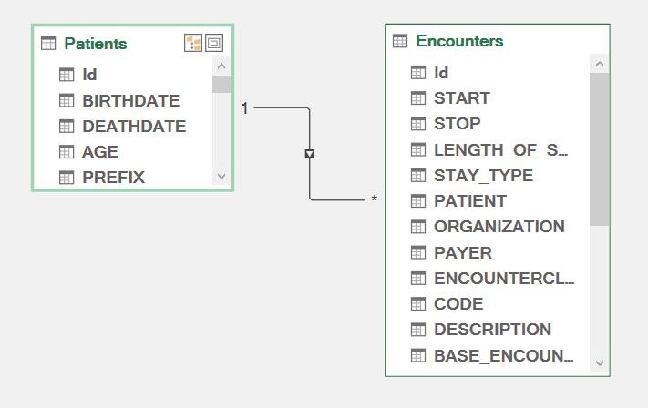

4. Data Cleaning & Transformation

4.1 Categorical Standardization
Raw categorical codes were converted into human-readable labels for better analytical clarity:
- Gender: 'M' → Male | 'F' → Female
- Marital Status: 'M' → Married | 'S' → Single | Blank → Unknown
Implemented using Excel's IF/IFS functions to ensure consistency across 20,000+ records.

4.2 Handling Missing Values
A strategic approach was used — missing values were handled contextually rather than deleted:
- DEATHDATE — Left as blank (used in conditional age calculation logic)
- ZIP codes — Blanks replaced with 'Unknown' for regional grouping
- REASONDESCRIPTION — Blanks converted to 'Not Specified' for consistent categorization

4.3 Feature Engineering
Multiple derived columns were engineered to unlock deeper analytical dimensions:
- Age Calculation — Dynamic age computed from BIRTHDATE; if deceased, age calculated to DEATHDATE; otherwise to today's date
- Age Group Segmentation — Child (0-18) | Adult (19-40) | Middle Age (41-60) | Senior (60+)
- Length of Stay (LOS) — Calculated as (STOP - START) in days; same-day visits standardized to 1 day per real-world reporting norms
- Stay Type — Short Stay (1-2 days) | Medium Stay (3-7 days) | Long Stay (8+ days)

5. KPI Summary

KPI | Value | Business Interpretation
Total Visits | 27,891 | Total hospital encounters recorded
Total Patients | 974 | Unique patients in the dataset
Avg Length of Stay | 1.24 days | Average hospitalization duration
Average Age | 72 years | Population health profile

6. Multi-Dimensional Analysis
Pivot tables were constructed to answer key business questions across multiple dimensions:
- Demographic Analysis — Visits by age group; gender distribution across patient population
- Utilization Analysis — Stay type distribution by age and gender; total visits per demographic segment
- Operational Efficiency — Average Length of Stay by age group; identification of high-LOS segments
- Temporal Trends — Year-wise and month-wise patient visit trends to identify seasonal patterns
- Cross-Dimensional Analysis — Age Group vs Stay Type; Gender vs Visit Volume for intersection insightS.

7. Key Insights

Insight | Finding
Senior Dominance | 21,632 of 27,891 visits (77%) are by senior patients (60+), indicating high geriatric care demand.
Short Stay Majority | 99.84% of all encounters are short-stay (1-2 days), showing strong throughput and outpatient efficiency.
LOS by Age Group | Adults average 2.31 days LOS vs Seniors at 1.07 days — seniors have quicker turnaround despite higher volume.
Gender Distribution | Near-equal split: 51% Male, 49% Female — no gender-based utilization bias observed.
Monthly Patterns | Visit volume peaks in March (205) and December (198); lowest in January (116) — seasonal demand fluctuations exist.
Long Stay Rarity | Long stays (8+ days) represent only 0.11% of cases, mostly concentrated in the senior age bracket.

8. Dashboard Design & Interactivity
A dedicated Dashboard sheet was built with a structured, professional layout:

KPI Cards (Top Row)
Four key metrics displayed prominently — Total Visits (27,891), Total Patients (974), Average LOS (1.24 days), Average Age (72) — providing an at-a-glance summary for stakeholders.

Visualization Suite
- Bar Chart — Visits by Age Group (highlights senior dominance)
- Pie Chart — Gender Distribution (51% Male, 49% Female)
- Column Chart — Stay Type Distribution broken down by gender
- Bar Chart — Average LOS by Age Group
- Line Chart — Monthly Patient Visit Trends
- Line Chart — Genderwise Hospital Visit comparison by age group

Interactive Slicers
Four slicers were connected to all pivot charts simultaneously, enabling dynamic cross-filtering: Year | Gender | Age Group | Stay Type. Any selection instantly updates all six charts, creating a fully interactive analytical experience.

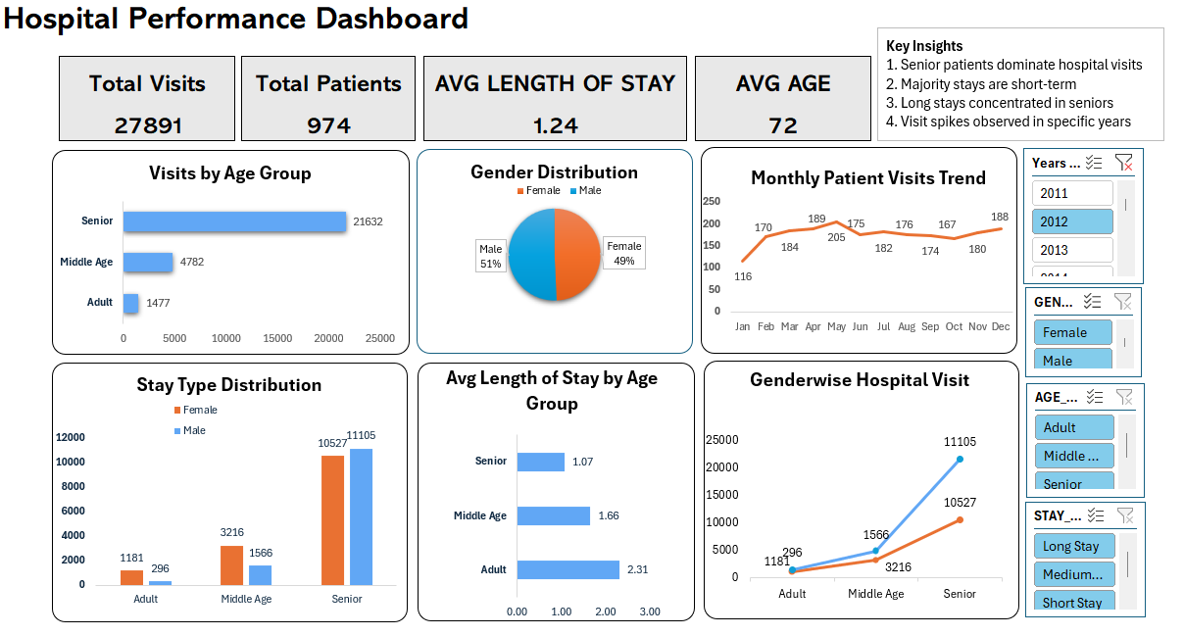

9. Excel Skills & Techniques Applied

Skill Area | Tools / Techniques Applied
Data Modeling | Power Pivot, One-to-Many Relationships
Data Cleaning | IF/IFS Functions, XLOOKUP, Null Handling
Feature Engineering | Age Calculation, Age Groups, LOS, Stay Type
Analysis | Pivot Tables, Cross-Dimensional Analysis
Visualization | Bar, Pie, Line, Column Charts
Interactivity | Slicers (Year, Age, Gender, Stay Type)
Dashboard Design | KPI Cards, Layout, Color Theming, Formatting

10. Conclusion
This project demonstrates a complete data analyst skillset applied to a real-world healthcare scenario. It covers the full analytics pipeline — from raw data ingestion and relationship modeling, through data cleaning and feature engineering, to multi-dimensional analysis and interactive dashboard delivery.
The result is a production-ready Excel dashboard that provides actionable insights on hospital performance, patient demographics, and operational efficiency — built entirely within Microsoft Excel without any external tools or coding languages.
Key Takeaways:
- End-to-end analytics workflow demonstrated with real-world data
- Power Pivot Data Model used for relational cross-table analysis
- Business logic applied consistently throughout data transformations
- Interactive dashboard suitable for executive and operational stakeholders
- Insights directly actionable for hospital administration decisions

