# MINOR PROJECT-1

**SYNOPSIS**

**ON**

## Bagh Chal (A 2D Board Game)



|  |  |  |
| --- | --- | --- |
|  | **Submitted By** |  |
| Aditya Goyat | Aryan Saxena Shaswat Bisoyi | Hardik Basera |
| R214220086 | R214220274 R2142201072    ***Under the guidance of***  **Mr. Pankaj Badoni**  Assistant Professor- SG  Department of Cybernetics | R214220478 |

**Department of Cybernetics**

**School of Computer Science**

# UNIVERSITY OF PETROLEUM AND ENERGY STUDIES

**Dehradun-248007**

**Aug-Nov, 2022**

# Index

**Contents Page Number**

**Chapter 1: Abstract** 3

**Chapter 2: Introduction**  4

**Chapter 3: Problem Statement**  5

**Chapter 4: Literature** 6

**Chapter 5: Objectives**  8

**Chapter 6: Methodology**  9

**Chapter 7: System Requirement**   11

**Chapter 8: PERT Chart** 12

**Chapter 9: References**  13

# Chapter 1: Abstract

India has been a pioneer in giving the world various board games that not only entertain the player but demand a high strategic mind-set. Chess being the most popular example which is celebrated worldwide. This project aims to bring out another board game of Indian origin to the world, namely ‘Goats and Tigers’ or ‘Baghchal’. Baghchal is a strategic, player-vs-player traditional board game that demands the tigers to eat 5 goats and the goats to trap all tigers. Baghchal will be digitized in using Modern OpenGL and Socket Programming in C++. Along with extensive game development, game design will play a big role in deciding the flow of the game and creating reward systems.

Keywords: Board games, Indian origin, Baghchal, Modern OpenGL, Game Design.

# 

# Chapter 2: Introduction

Starting from an early age we are exposed to board games but every game we play is an influenced from the west. The Western culture introduced us to board games such as Monopoly, Ludo, Scrabble etc. While these games have been very popular, we are overlooking the Indian heritage and the Indian knowledge system which have created some very mathematically fascinating as well as fun board games. One of those games is Bagh Chal (Goats and Tigers) which is a strategy-based game requiring problem solving as well as some level of prediction for the optimal moves to take. Recreating this game would allow developing basic problem solving and strategizing ability in a fun way with essence of our culture in it.

# Chapter 3: Problem Statement

Over the decades, as we get increasingly influenced by the Western culture, we forget our own heritage and history. Our goal is to bring back our fun and entertaining board games that originated in our sub-continent and get our youth more interested and excited about the Indian culture. We also intent to give an idea to our users about the origins of gaming in India and how it developed over the years.

# Chapter 4: Literature

1. **Game Engine with 3D Graphics:**A game engine is a tool for game development. It provides general functionality for game development like 2D and 3D Graphics, physics simulations, audio, lighting, camera etc. This paper helps us understand how we can use OpenGL to understand the functionalities required to create a game engine. Concepts like Rasterization, Shaders, Viewport, NDC, Game Loop etc. are explained in this paper.[1]
2. **Game Design Patterns for CPU Performance Gain in Games**Games require heavy computation power as each pixel on the screen has to be calculated. Lighting and game mechanics need to be optimized for best performance. This paper gives an overview of various Design Patters that can be applied to program games with high performance. Patterns like Component, Object Pool, Spatial Partitioning and Flyweight are discussed. [2]
3. **Developing Simple Games with OpenGL:**This book by Osama Hosam is a comprehensive discussion about all the important aspects of creating a simple game in OpenGL. Coloring, 3D Environments, Texturing, Path Finding, Game Interface are some of the topics discussed. We are provided by a framework to create games by the help of examples like Tetris. [3]
4. **Theory of Fun for Game Design:**  
   Games are fun but just because something is a game doesn’t mean it’ll be fun. This book serves as a guide to game design, helping understand the psychology behind ‘fun’. Starting from what is the definition of a “Game” to understanding the design of Chinese game ‘Go’ this book is our base for understanding game design. [4]
5. **Chores Are Fun: Understanding Social Play in Board Games for Digital Tabletop Game Design:**Five categories of interactions in a gameplay are discussed in this book.Namely ‘Chores’, ‘Reflection on Gameplay’, ‘Out-of-game’, ‘Strategies’ and ‘Game itself’. *‘Puerto Rico’, ‘Heroscape’,* *‘Fluxx’, ‘Ingenious’* are the titles with extensive research. Stating ‘Chores’ are critical to form mutual focus of attention and synchronizing emotions. [5]
6. **C++ Network Programming:**  
   Socket Programming is a solution to achieve networking in C++. The Adaptive Communication Environment is an open-source framework that runs across various hardware and operating systems. Problems like data loss, the wrong le used in API call, Operator precedence errors, and many more issues are discussed.[6]
7. **Indian Board Games, Pavements & Labyrinths:**Chess, probably the most successful board games of all time hold an Indian origin. In this paper the legacy of several other board games with Indian origin is discussed. ‘Shatranj’ the forerunner of chess, ‘Pachisi’ the forerunner of Ludo, Thayyam, Ashte-Kashte etc. are discussed. Chaturanga games dates back to 326 BCE. [7]
8. **Analyzing Thousand Years Old Game Tigers and Goats Is Still Alive:**‘Tigers and Goats’ or ‘Bagh-Bakri or ‘Bagh-Chaal’ or ‘Aadu Puli Attam’ a game with several names is what we landed upon. This paper discusses the legacy of ‘Aadu Puli Attam’ and for Game Refined Theory is applied to quantify entertainment. The mathematical aspects of the game link bipersonal, finite, dynamic, sequential, non-cooperative zero-sum, complete and perfect information game. [8]

# Chapter 5: Objective

Our objectives are:

1. To bring back the lost games that originated in the Indian sub-continent.
2. To get our youth more excited about our history and heritage.
3. To give a glimpse of the history and origin of gaming in India to the users.
4. To promote OpenGL programming and highlight its power and vast usage.

# Chapter 6: Methodology

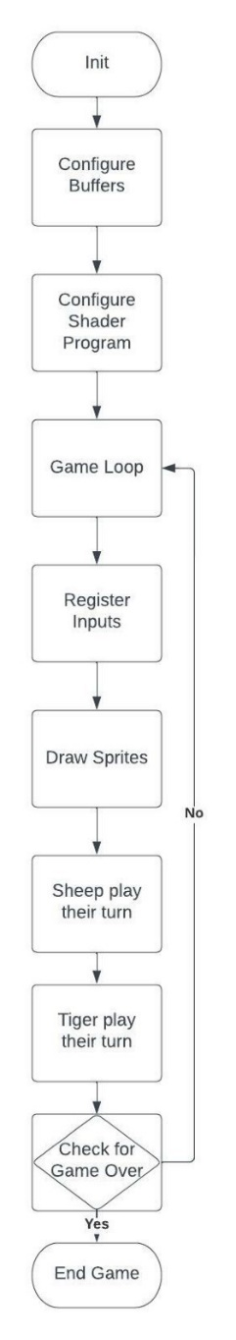We are going to use the waterfall model of software development for this project. First, we need to research the distinct types of game programming designs and choose the one most suited to our needs and project. Simultaneously we will think about the game design and flow of the gameplay as well. Then we are going to brush up on our modern OpenGL knowledge and learn about the new concepts that we will be using in the project via books and websites online. We then are going to design algorithms for every major feature of the project on paper and review it ourselves to find the most optimal solution. The algorithms will include dynamic programming, backtracking and other similar algorithms. After all the pre-requisites, we will start developing the application on Visual Studio 2022 using OpenGL 3.3 and GLSL. We then will review and test the code and fix it as well. This testing will be both black box testing by giving several types of inputs and analyzing the output and white box testing by going back into the code and checking for errors and bugs. After reviewing and making sure that the application works as we intend it to, we are going to export it for use.

**Basics units of the game**: 3 tigers and 15 goats

**Objective of the game**: Tigers have to kill 5 goats or the goats of the trap the tigers

**Working**: Every unit can only move to adjacent intersection. The Tiger can skip over goat to kill it. If all the 3 tigers are stuck the goats win.

Until all 15 goats are placed none of them can be re arranged or moved.

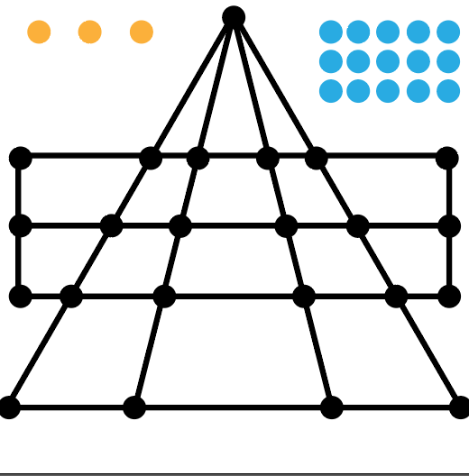

[9]

**Game Ending:** Once 5 goats are killed it is mathematically impossible for the goats to win. Hence the winning condition for tigers is killing 5 goats by skipping over them.

As it requires deciding the optimal paths for the units to be moved there could be an implementation system which predicts these moves or two users can play giving their inputs.

# Chapter 7: System Requirement

## 1. Software Requirements

Operating System : Windows 10/8/7 (32-bit or 64-bit)/ Linux

Software : Visual Studio 2022

Compiler : Microsoft C++ Compiler

## 2. Hardware Requirements

Processor : Dual Core 2.7 GHz or better

RAM : 512 MB or higher

Disk Space : 512 MB

# Chapter 8: PERT Chart

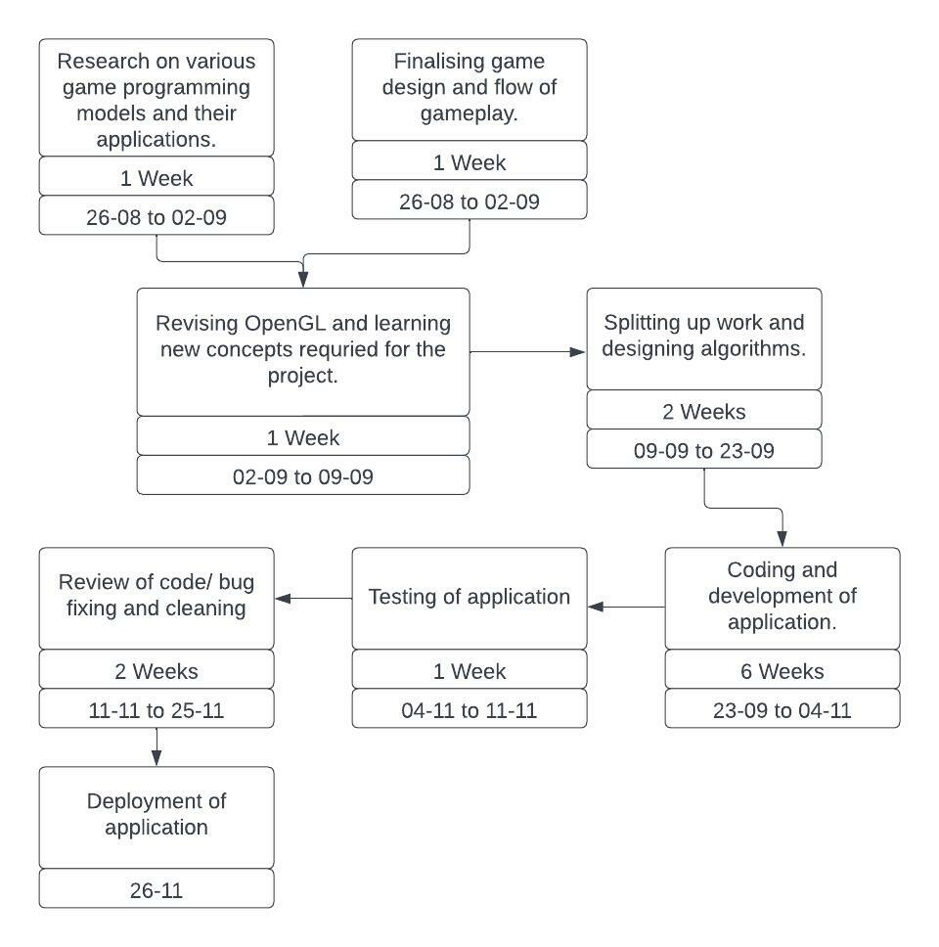

# Chapter 9: References

1. Cauê Viegas Oliveira, Felipe Santos Oliveira, Helio Pedrini, 2016, “Game Engine with 3D Graphics”, Instituto De Comoutacao: <https://www.ic.unicamp.br/~reltech/PFG/2016/PFG-16-13.pdf>
2. Xi Wang, 2016, “Game Design Patterns for CPU Performance Gain in Games”, TU Wien:   
   <https://www.cg.tuwien.ac.at/research/publications/2016/Wang-2016-BAC/Wang-2016-BAC-thesis.pdf>
3. Osama Hosam, 2015,“Developing Simple Games with OpenGL”, researchgate.net:   
   <https://www.researchgate.net/profile/Osama-Hosam/publication/283255927_Developing_Simple_Games_with_OpenGL/links/562f26d908ae04c2aeb612bb/Developing-Simple-Games-with-OpenGL.pdf>
4. Raph Koster, 2013,“Theory of Fun for Game Design”, O’Reilly Media : <https://www.google.co.in/books/edition/_/3TAKAgAAQBAJ?hl=en&gbpv=0>
5. Yan Xu, Evan Barba, Iulian Radu, Maribeth Gandy, Blair MacIntyre, 2011, “Chores Are Fun: Understanding Social Play in Board Games for Digital Tabletop Game Design”, Georgia Institute of Technology: <http://www.digra.org/wp-content/uploads/digital-library/11307.16031.pdf>
6. Douglas C Schmidt, Stephen D Huston, 2002, “C++ Network Programming Volume 1”, Addison-Wesley: <https://www.google.co.in/books/edition/C++_Network_Programming_Volume_I/V43ubgzakIAC?hl=en&gbpv=1&dq=c%2B%2B+socket+programming&pg=PR5&printsec=frontcover>
7. Nigel, 1987, “Indian Board Games, Pavements & Labyrinths”, Caerdroia 21 Pennick:<https://www.labyrinthos.net/C21%20Games%20Pavements%20Labyrinths.pdf>
8. Sakshi Agarwal, Hiroyuki Iida, 2018, “Analyzing Thousand Years Old Game Tigers And Goats Is Still Alive”, Asia-Pacific Journal of Information Technology and Multimedia:  
   Link: <https://www.ukm.my/apjitm/public/assets/article/2018/0702/01.pdf>
9. Saman Saeedi, 2013, “Tigers and Goats: An Interesting AI Game in Javascript and HTML5, CodeProject.com  
   Link: <https://www.codeproject.com/Articles/692277/Tigers-and-Goats-An-Interesting-AI-Game-in-Javascr>