

SCHOOL OF MECHANICAL ENGINEERING

MEE2008- Product Design for Manufacturing

Professor Name: Dr. Darius Gnanaraj S

DFMA Analysis of a Pedestal Fan

Submitted by,

NAME: Aditya Jai Warrier REG NO: 18BME0865

Table of Contents

Introduction…………………………………………………………………………………………………………….1
Summary of Review 1…….…………………………………………………..…….……………………………2
Summary of Review 2…….…………………………………………………..…….……………………………3
Assembly Information…………………………………………..…….………………………………………….4
Part information...…………….………………………………………………..…….……………………………5
DFMA analysis…….…………….………………………………………………..…….………………………….11
Time and Cost analysis….…………………………………………………..…….………..………………….15
Results and Conclusion……….……………………………………………………………..………………….19
References…………………………………………………………………………………………….……………...20

INTRODUCTION

In this project, the product chosen for performing DFMA analysis is a Pedestal Fan. DFMA is a design approach that focuses on ease of manufacture and efficiency of assembly. By simplifying the design of a product, it is possible to manufacture and assemble it more efficiently, in the minimum time and at a lower cost. This project starts with a summary of previous knowledge gained in the first and second review. Next, the parts of the assembly were identified along with a short description of its function along with the material used to make it. To identify the parts which could be replaced or combined, a DFA worksheet was used. After this, principles of DFM were used to reduce the number of parts of manufacturing. Changes were made in order to reduce the assembly time. For this purpose, the theoretical part count efficiency (DFA index) was calculated for both the existing assembly design and the optimum assembly design. Finally, a cost analysis was carried out to find the total cost saved by using DFMA analysis.

1

Summary of Review 1

In Review 1, we familiarized concepts such as DFM, DFA and DFMA by using an example for each. The features of a DFMA software was discussed in detail. The advantages of this tool and its importance to a product designer were realized.

Design for Manufacturing (DFM) is the practice of designing in such a way that the parts of the product are easy to manufacture. It’s a widely used concept that exists in all engineering principles. However, its implementation may vary according to the manufacturing technology.

Design for Assembly (DFA) is the process by which the products are designed with ease of assembly in mind. The general idea is that fewer the parts in a product, lesser the time it takes to assemble it, thereby reducing assembly costs.

Design for Manufacturing and Assembly (DFMA) is the combination of the above two methodologies. By simplifying the design of a product, it is possible to manufacture and assemble it more efficiently, in the minimum time and at a lower cost.

2

Summary of Review 2

In Review 2, a presentation was prepared based on a journal written on the topic ‘New Product Development by DFMA and Rapid Prototyping’. In this paper, the authors focus on re-designing a fluid flow control valve and optimize its design to ensure the reduced number of parts, safety, reliability, time to market and customer satisfaction. For this purpose, they have adopted a DFMA analysis.

By using DFMA techniques and Theoretical Part Count Efficiency method the number of parts has been reduced and the DFA index, which is way of determines the assembly time efficiency, was increased from 10.34% to 62.06%. The total number of parts were reduced to six. Rapid Prototyping was finally used to validate the design and testing purposes.

Combination of the above two techniques has proven itself to be a worthwhile investment with significant observations of ensuring optimal quality, reduced number of parts, reliability, time to-market, lifecycle, safety and customer satisfaction.

3

Assembly information

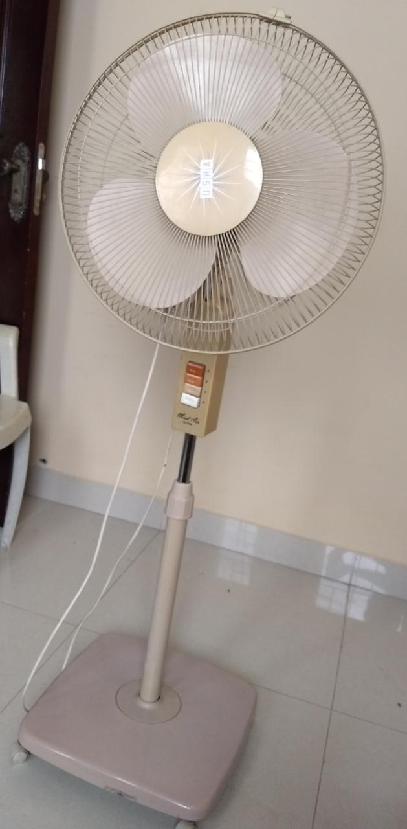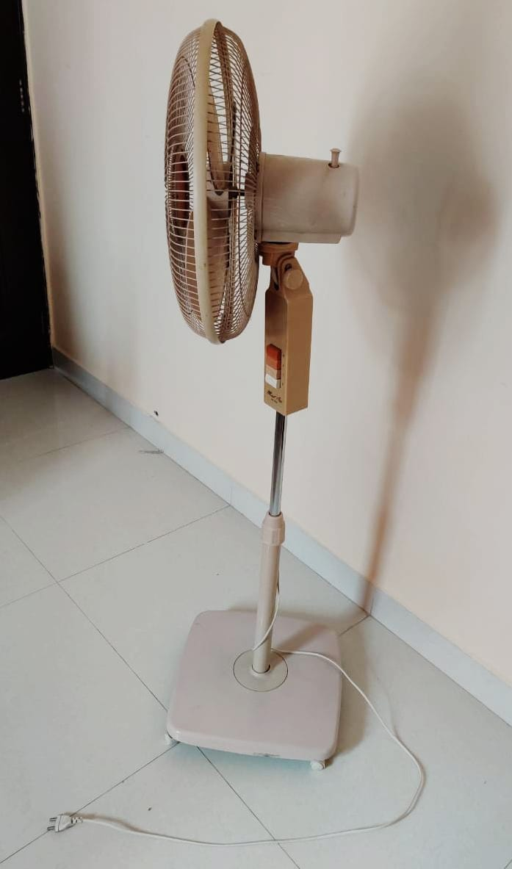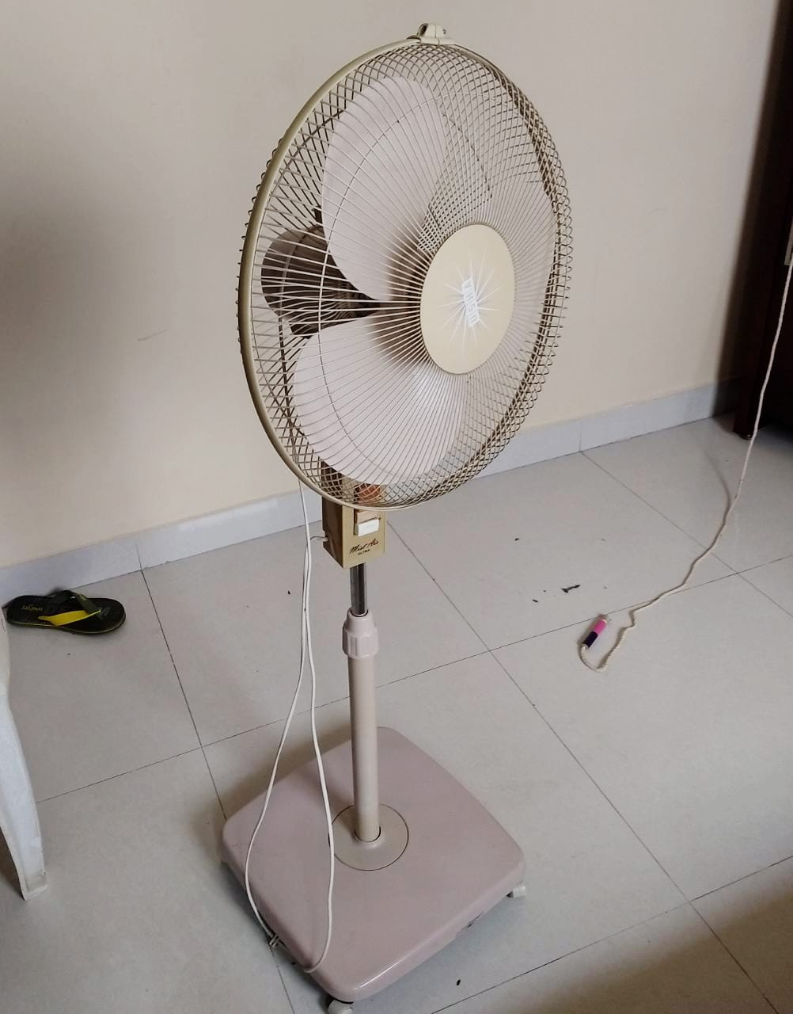

A pedestal fan is an electric, oscillating fan supported by an adjustable, detachable stand. They are electrically-powered devices that are used to circulate a cool breeze around your home. It can be moved around easily as it has roller supports on its base. It is portable and can be used anywhere as long as a socket nearby.

4

Part information

S.no | Picture of part | Part name and Material | Description
1 | 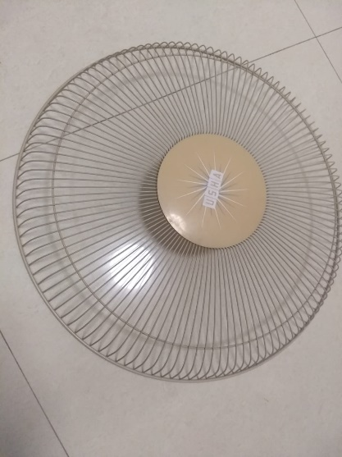 | Front Blade Guard  Made of metal wires | Corrosion Resistant grills  Fan guards are used to provide a physical barrier around spinning fan blades to prevent accidental contact with fingers or other objects
2 | 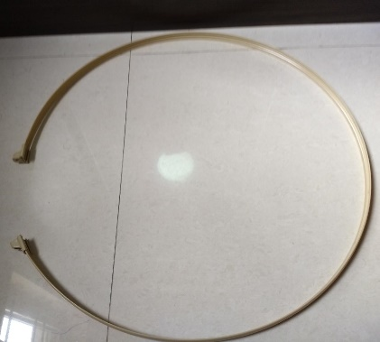 | Circlip  Made of Plastic | Holds the front and rear guards together  Has a cavity to place the screw and nut which closes the loop.
3 | 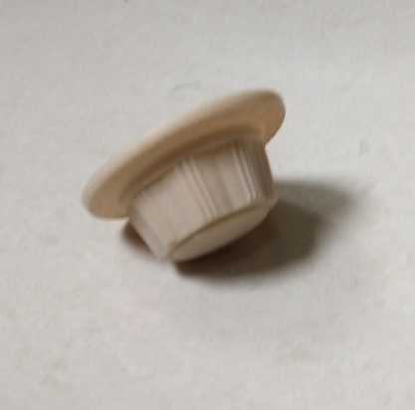 | Blade Cap  Made of Plastic | Holds the fan blade in position.  Restricts any linear motion
4 | 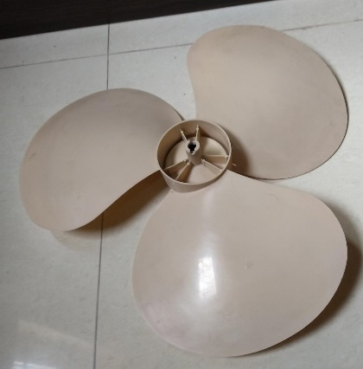 | Fan blade  Made of Plastic | Rotation causing pressure difference which in turns causes wind to flow from behind the fan to the front.

5

Part information

S.no | Picture of part | Part name and Material | Description
5 | 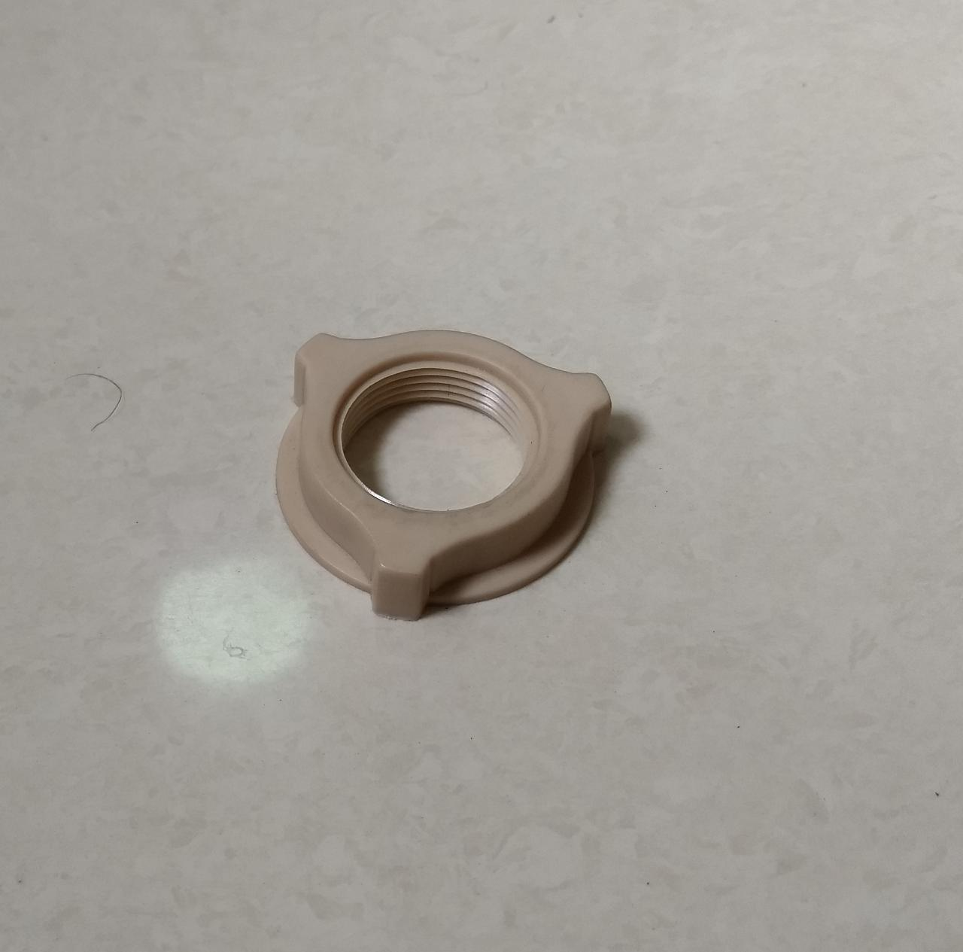 | Rear guard nut  Made of Plastic | Used to hold the rear guard in position.
6 | 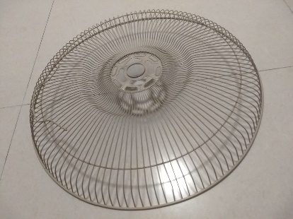 | Rear Blade guard  Made of metal wires | Corrosion Resistant grills  Fan guards are used to provide a physical barrier around spinning fan blades to prevent accidental contact with fingers or other objects
7 | 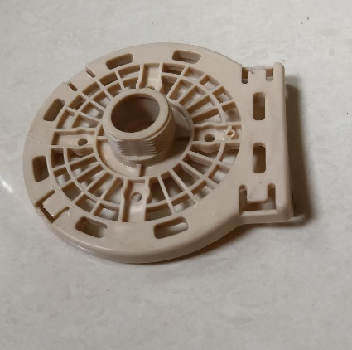 | Motor Front cover  Made of Plastic | Covers the face of the motor.
8 | 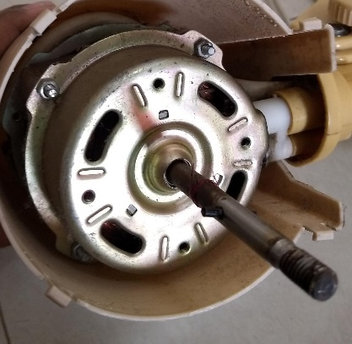 | Motor  Made of Silicon steels  Shaft- Mild steel | Rotates the fan blades  Swings the head of the fan from one side to another and vice-versa

6

Part information

S.no | Picture of part | Part name and Material | Description
9 | 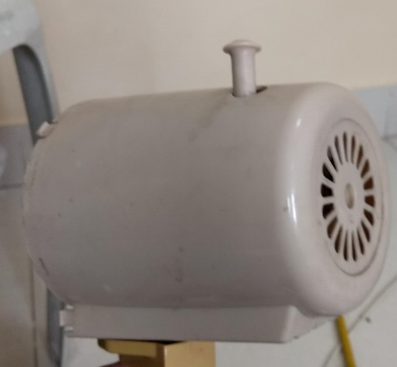 | Motor housing and clutch knob  Made of Plastic | Hides and protects the motor.  A clutch knob is connected to the motor which enables the head of the fan to oscillate or to stay in a single position.
10 | 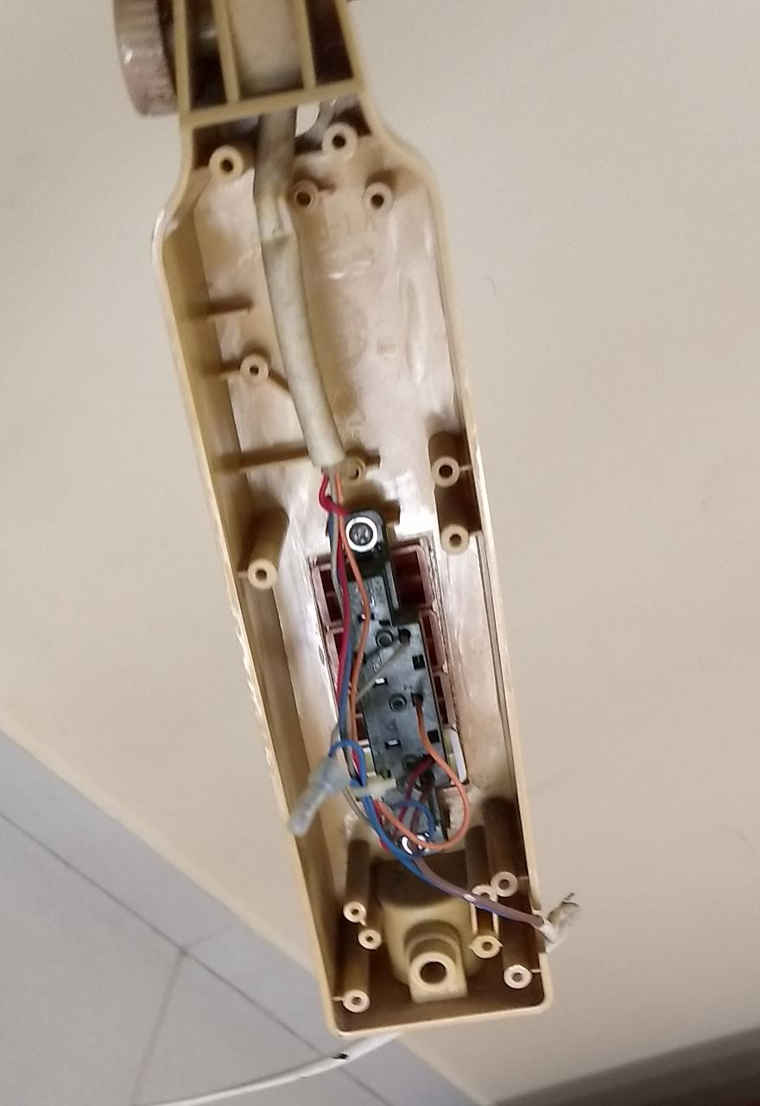 | Control box with Switch panel circuit  Made of Plastic  Wires are made of Copper wrapped with plastic insulator | Contains the switch panel which regulates the speed with which the fan rotates.  4 modes- 0,1,2,3 are provided.
11 | 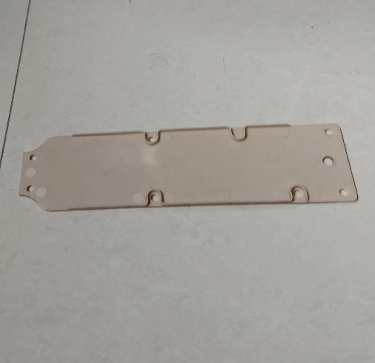 | Control box cover  Made of Plastic | Hides and protects the switch panel circuit
12 | 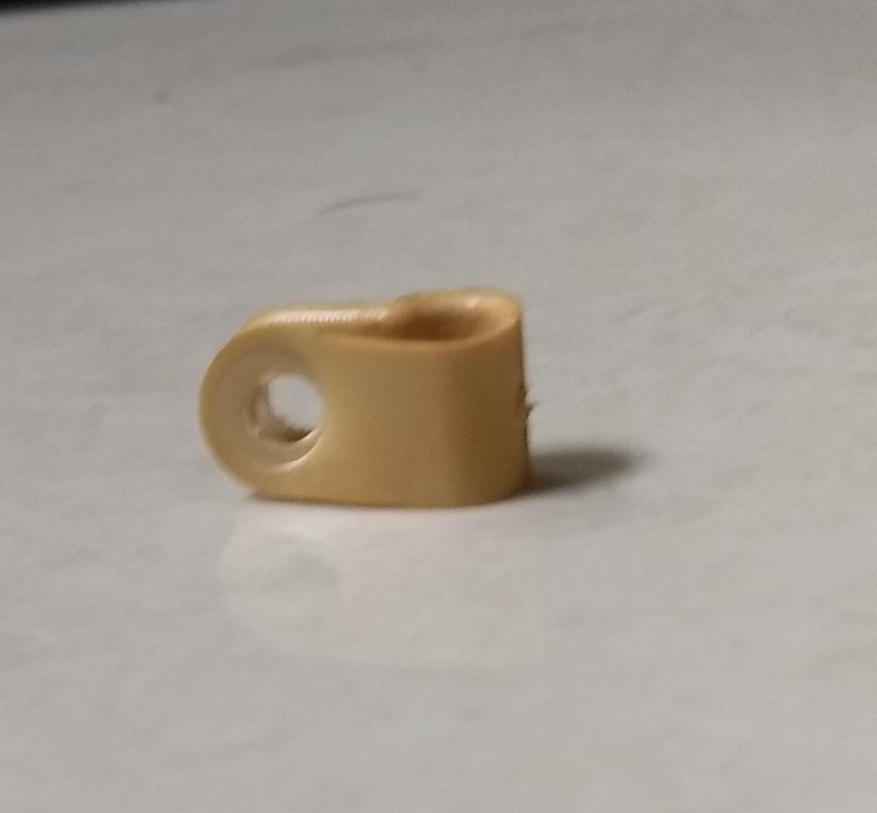 | Wire holder  Made of Plastic | Holds the wire in a fixed position.

7

Part information

S.no | Picture of part | Part name and Material | Description
13 | 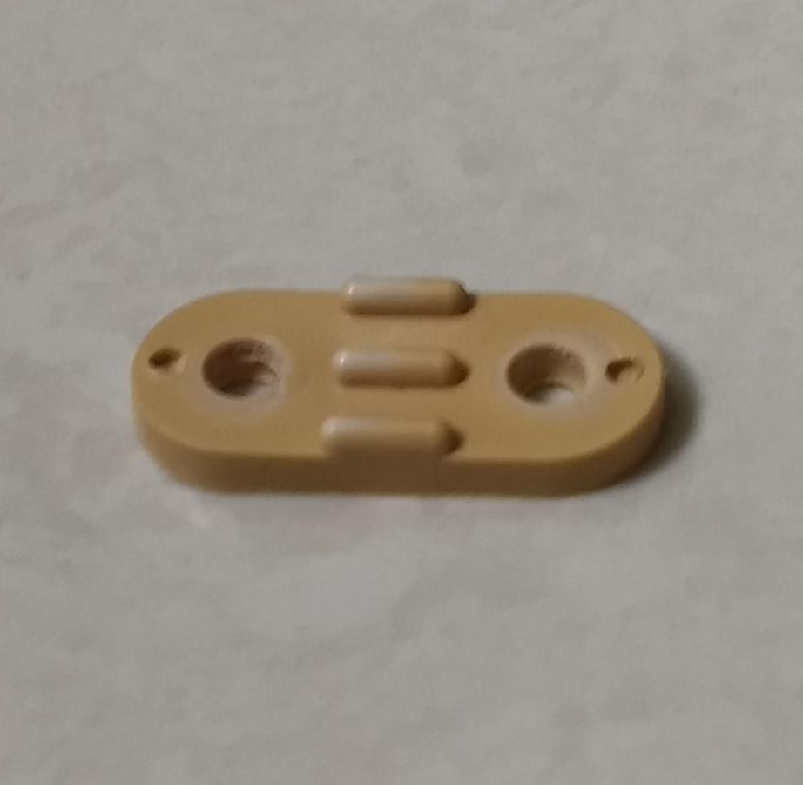 | Wire positioner  Made of Plastic | Used to prevent the wire from slipping away from the control box.  Fastens the wire against the wall of the control box
14 | 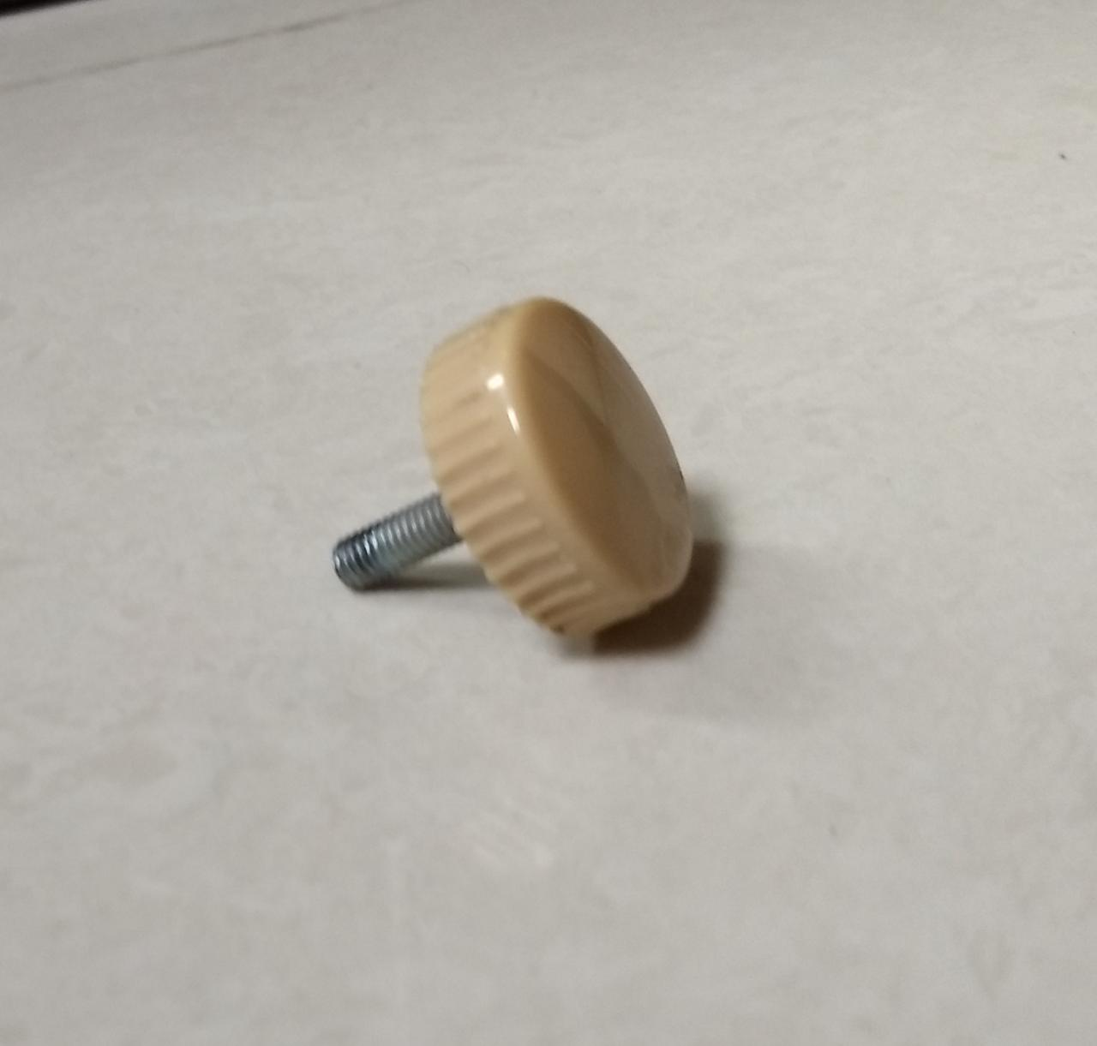 | Knob  Made of Plastic | Used for tightening the head of the fan above the control box
15 | 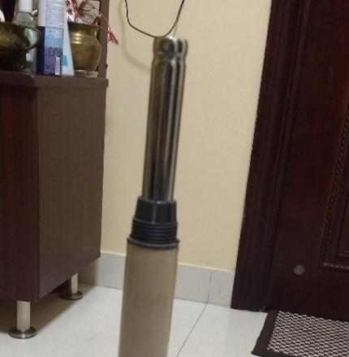 | Extension pole  Made of Stainless steel | Adjusts the height of the fan.
16 | 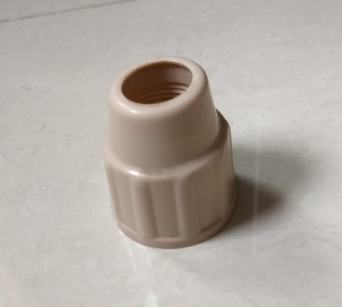 | Height adjustment ring  Made of Plastic | Used to adjust the length of the extension pole.

8

Part information

S.no | Picture of part | Part name and Material | Description
17 | 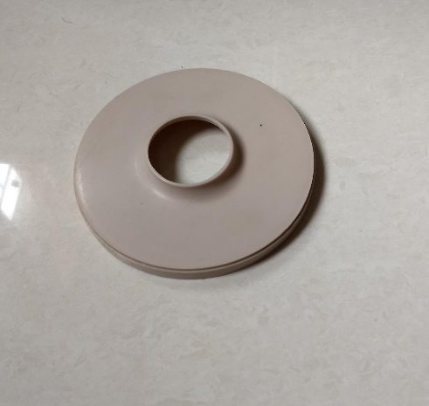 | Stand cover  Made of Plastic | Covers the joining of the extension pole and the base of the pedestal fan.
18 | 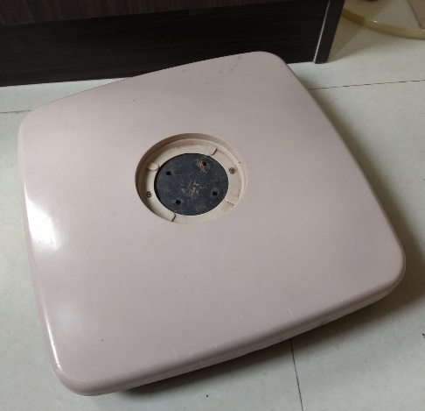 | Base of the pedestal fan  Made of Plastic and hardener resin | Connects the fan to the wheels of the fan. Supports the weight of the body.  The wheels are attached to the base by a hardener resin.
19 | 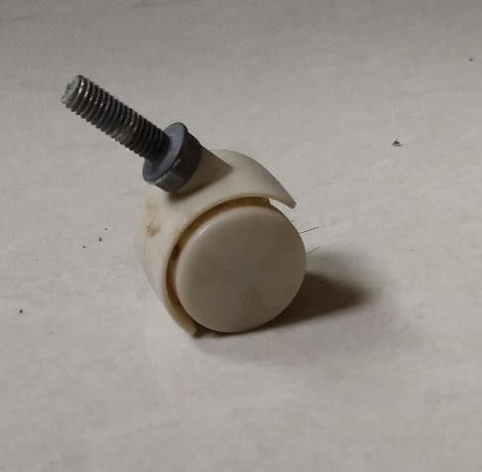 | Wheel  Made of Plastic | Makes it easier to move the fan around.  There are 4 wheels placed at each corner of the base and are free to rotate independently of each other.
20 |  | Wire  Has a plastic coating with copper wires inside | Used to connect to the nearest power supply to input current to the motor.

9

Part information- Fasteners

S.no | Picture of part | Part name and Material | Description
21 | 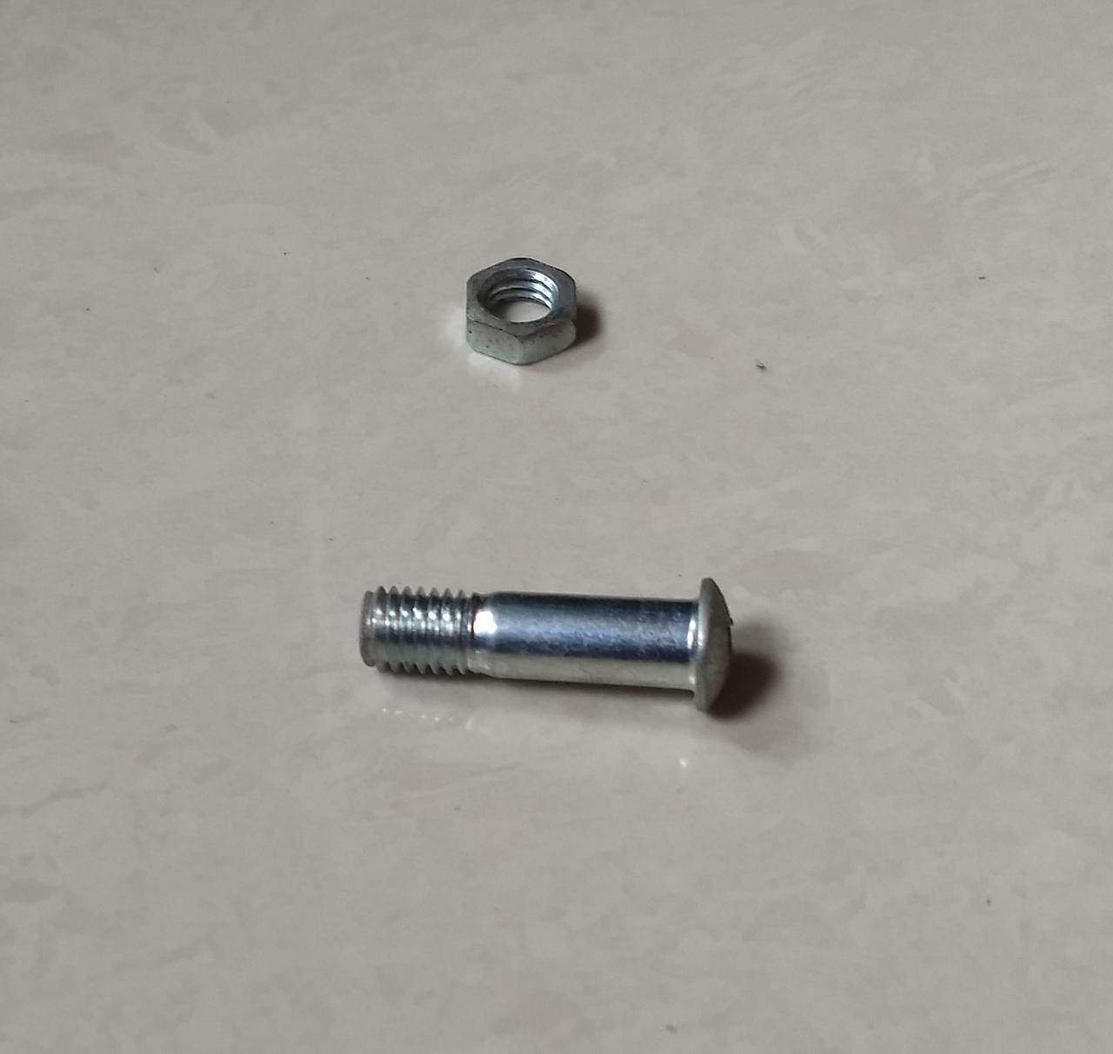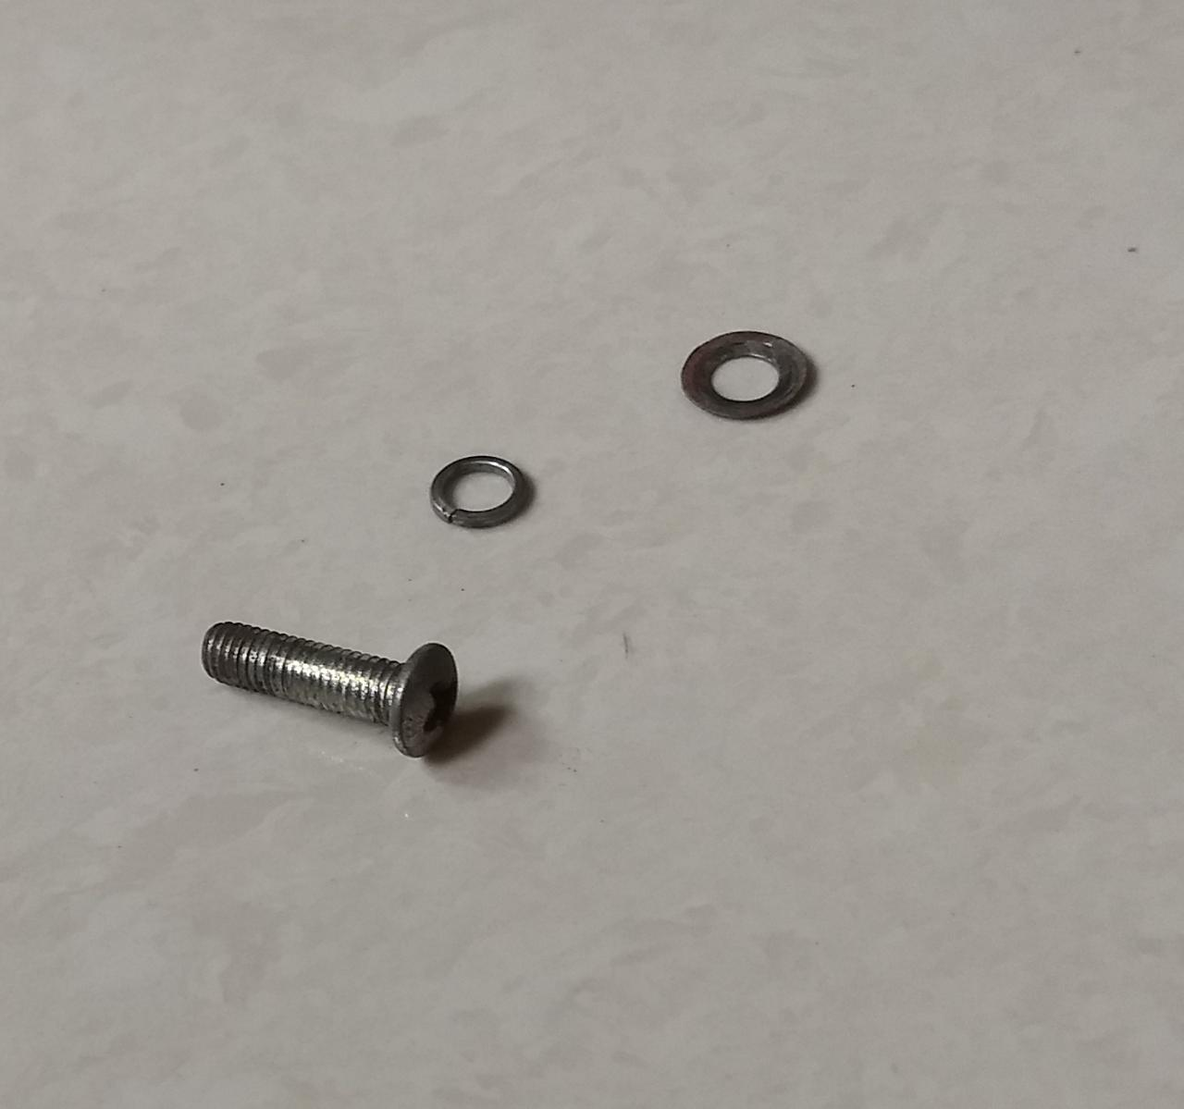  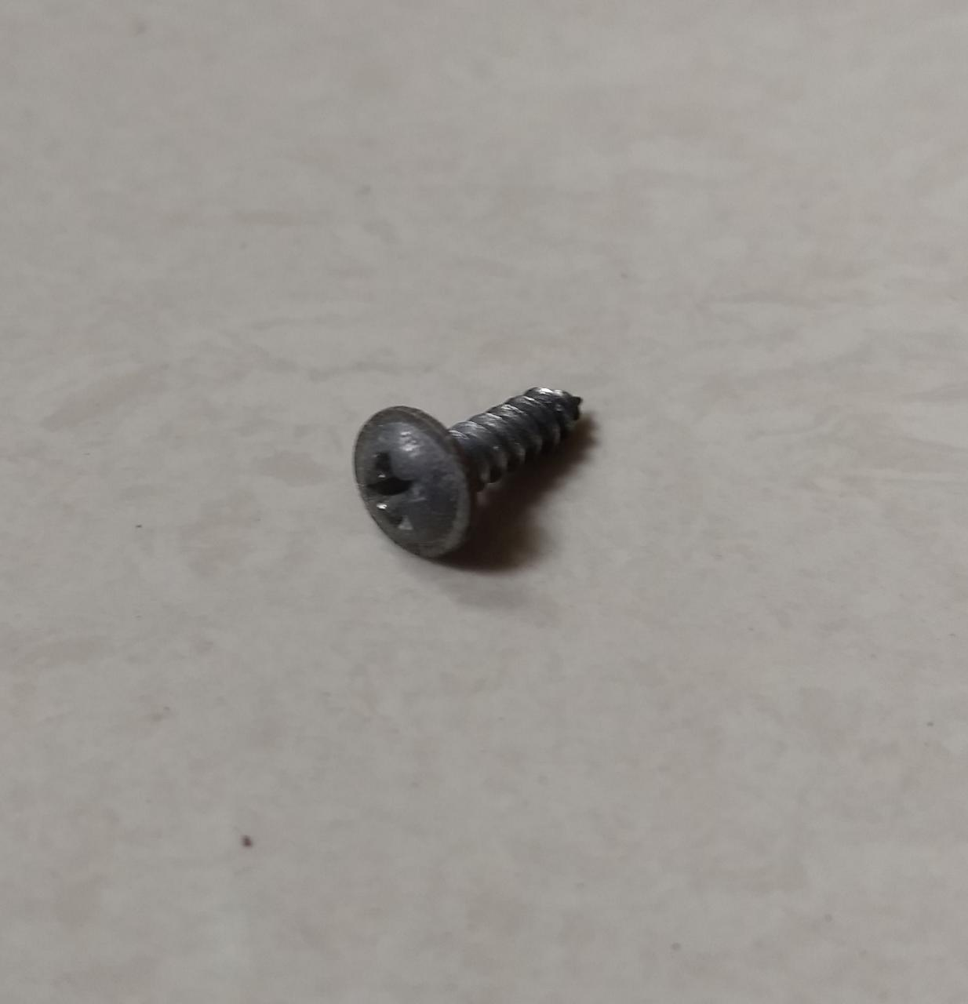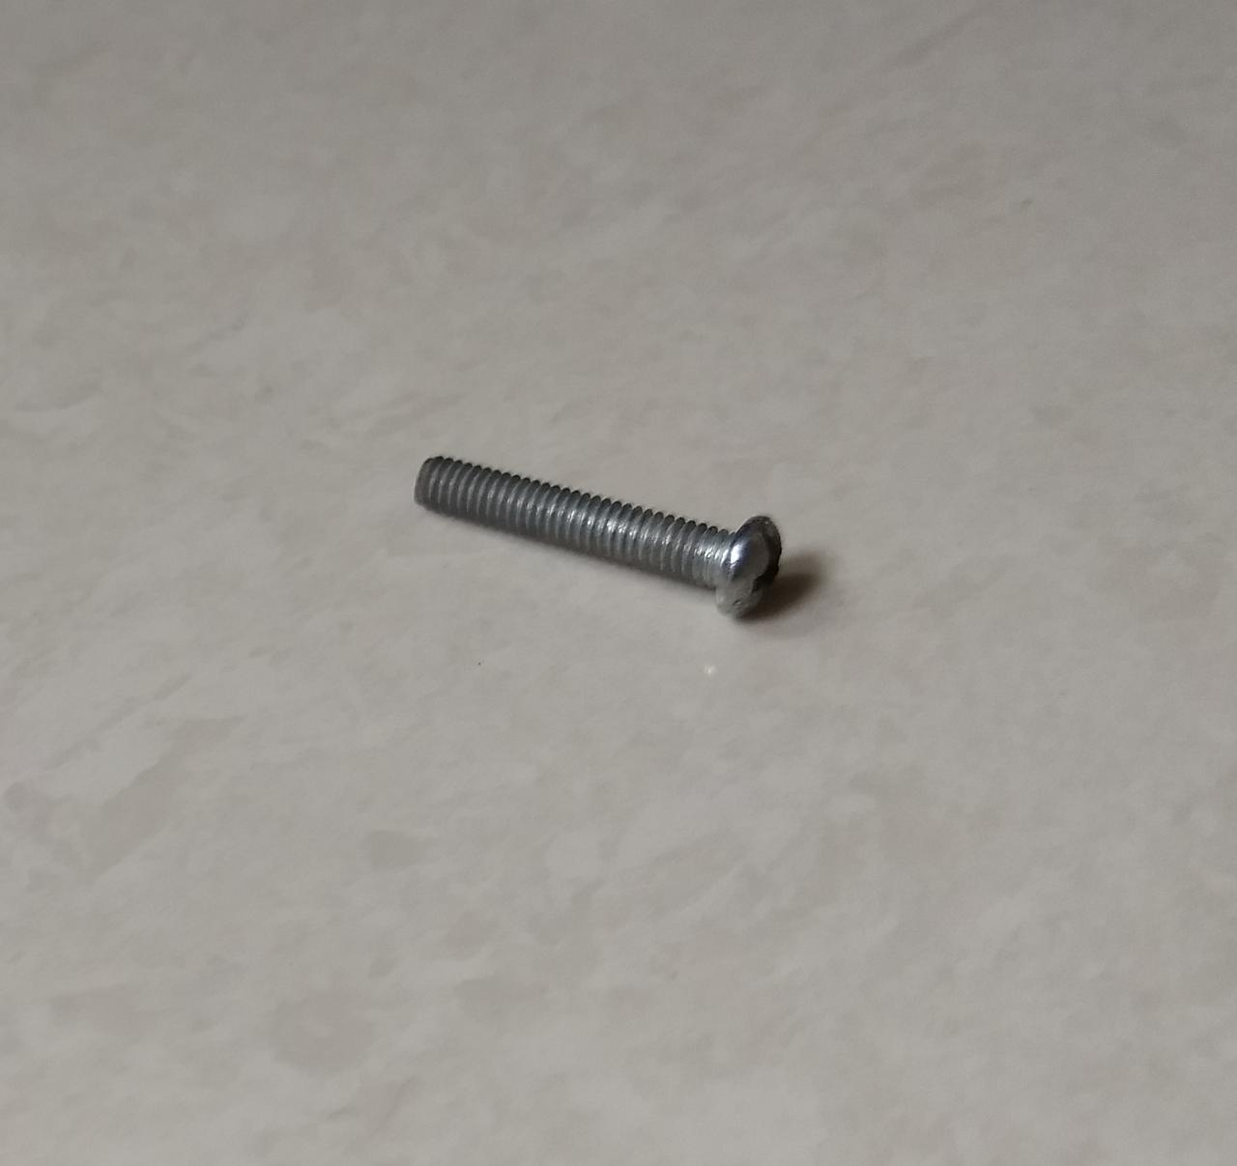 | Screw  Screw-Rivet  Screw made of stainless steel  Rivet made of zinc plated steel | Used in many places to fix parts to one other.  Different sizes and heads were used at different parts.
22 | 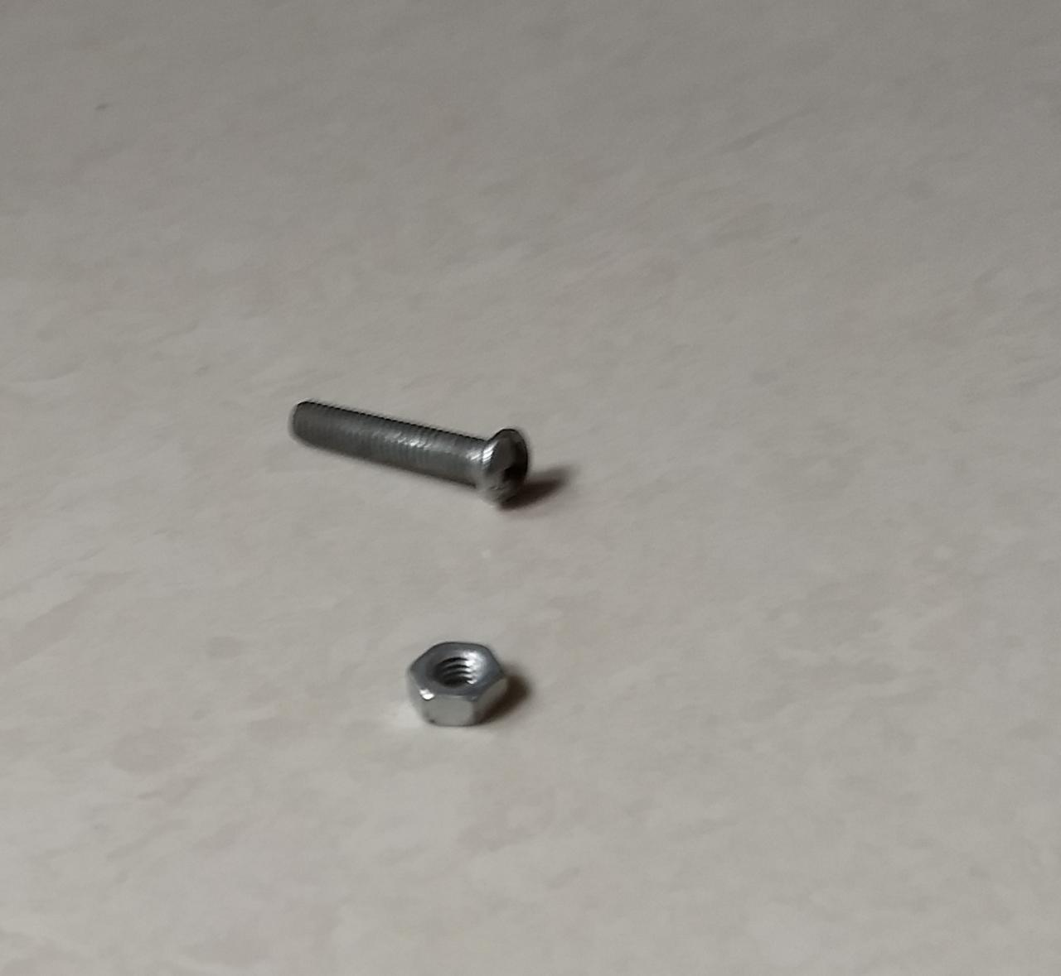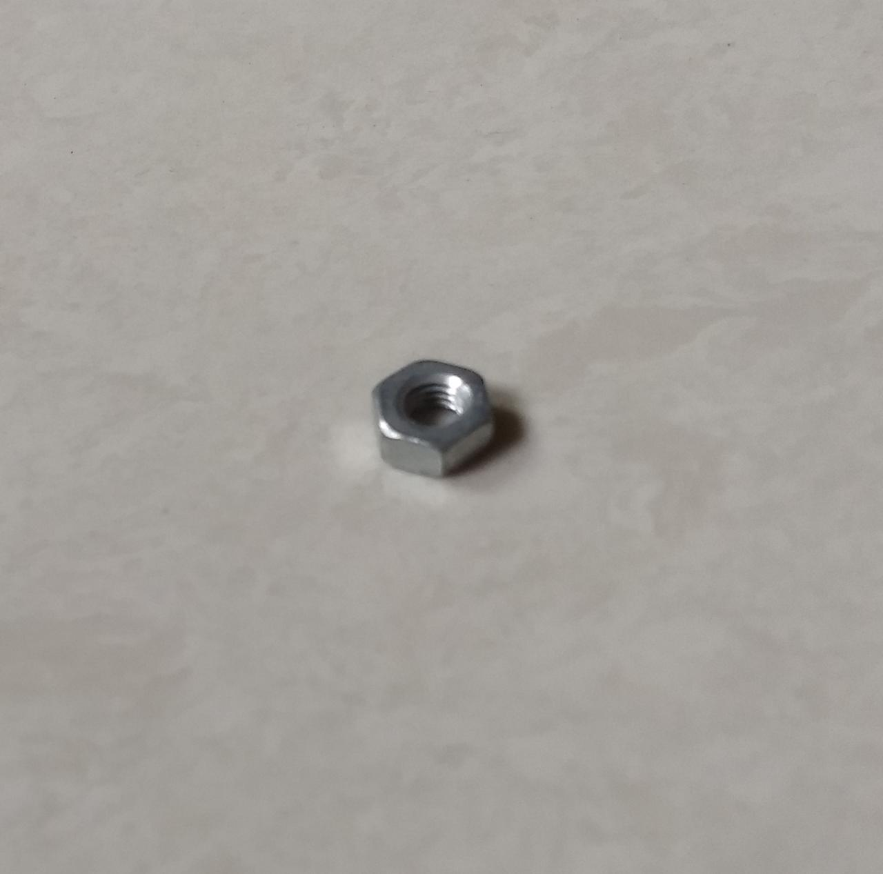 | Nut | Used to fasten multiple parts together.  Different sizes were used.
23 |  | Conical washer  Helical washer | Prevents the motion of the fastener.  In some cases, it protects the fastener. Extends life.

10

Analysis carried out

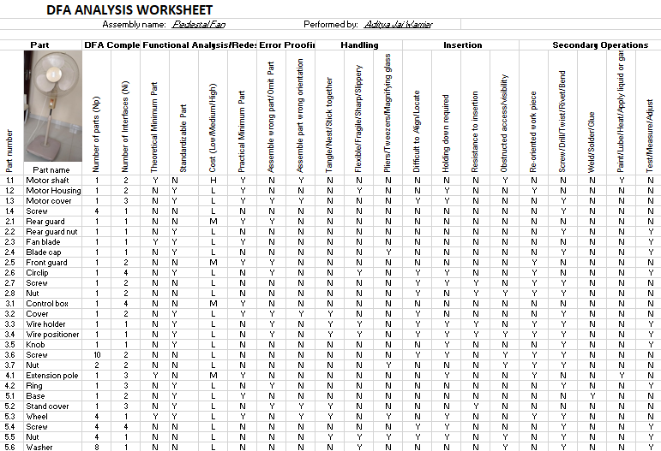

This gives a clear idea of the changes that can be made in order to reduce assembly costs and time.

11

Ideas adopted

The following general DFM design principles were adopted to reduce assembly cost and manufacturing costs:

- Snap fit design- Guards

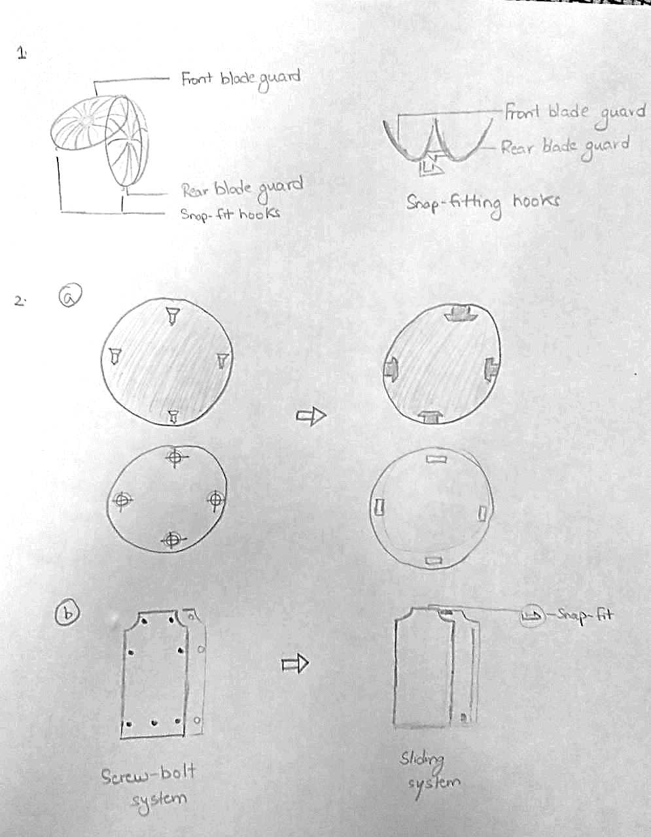
By using this in the blade guards, the need for circlip, screw and a nut are eliminated. Assembly time has decreased and manufacturing cost has been reduced.

12

- Self-fastening parts- Motor cover, Control box cover

The screws are removed by using a snap fit mechanism for attaching the motor cover to the motor.
For the control box cover, a sliding mechanism has been adopted (similar to the one used in TV, AC remotes). This eliminates the need for screwing.
Hence, assembly time and manufacturing costs have been reduced.

13

- Symmetry- Stand base
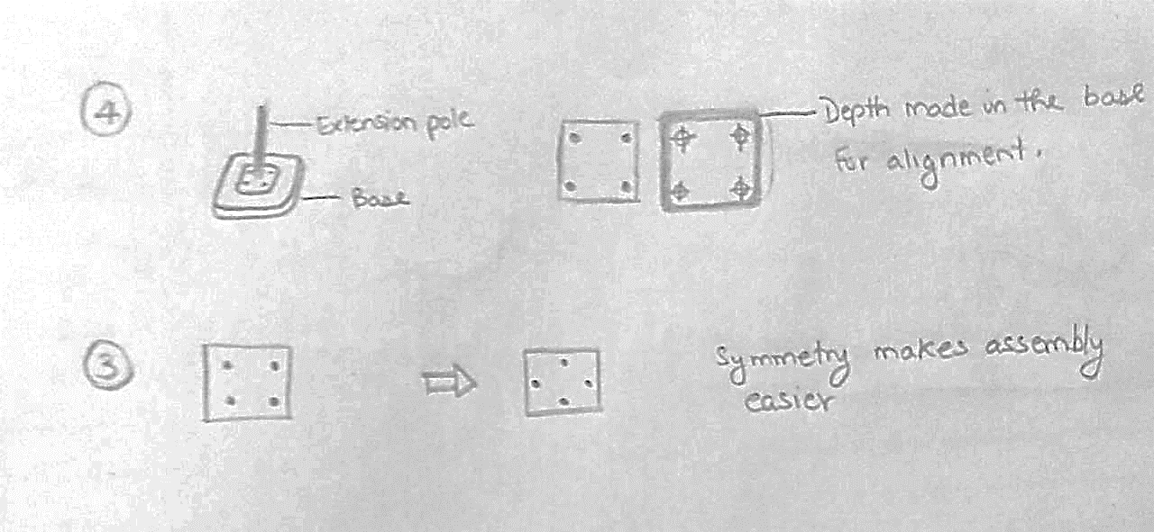
By using symmetry in the stand base, the need for re-orientation is eliminated. This reduces the assembly time.

- Self-aligning parts- Stand base

Self-aligning makes it easier for assembling the stand to the base of the pedestal fan.

This reduces the assembly time by reducing error in assembly.

14

Analysis carried out

For the existing design, the details of parts and assembly time are given below-

S.no | Part name | Number | Theoretical Part Count | Assembly time,  (in sec)
1 | Front Blade Guard | 1 | 0 | 3
2 | Circlip | 1 | 0 | 3
3 | Blade Cap | 1 | 0 | 3
4 | Fan blade | 1 | 1 | 3
5 | Rear guard nut | 1 | 0 | 3
6 | Rear Blade guard | 1 | 0 | 3
7 | Motor Front cover | 1 | 0 | 3
8 | Motor | 1 | 1 | 3
9 | Motor housing and clutch knob | 1 | 0 | 3
10 | Control box | 1 | 1 | 3
11 | Control box cover | 1 | 0 | 3
12 | Wire holder | 1 | 0 | 3
13 | Wire positioner | 1 | 0 | 3
14 | Knob | 1 | 0 | 3
15 | Extension pole | 1 | 1 | 3
16 | Height adjustment ring | 1 | 0 | 3
17 | Stand cover | 1 | 0 | 3
18 | Pedestal Fan Base | 1 | 1 | 3
19 | Wheel | 4 | 1 | 12
20 | Wire | 1 | 1 | 3
21 | Screw | 19 | 0 | 57
22 | Nut | 7 | 0 | 21
23 | Washer | 8 | 0 | 24
TOTAL |  | 57 | 7 | 171

DFA index = 7 x 3 / 171 = 12.28%

15

Analysis carried out

For the optimum design, the details of parts and assembly time are given below-

S.no | Part name | Number | Theoretical Part Count | Assembly time,  (in sec)
1 | Blade Guard | 1 | 1 | 3
2 | Blade Cap | 1 | 1 | 3
3 | Fan blade | 1 | 1 | 3
4 | Rear guard nut | 1 | 1 | 3
5 | Motor Front cover | 1 | 1 | 3
6 | Motor | 1 | 1 | 3
7 | Motor housing and clutch knob | 1 | 1 | 3
8 | Control box | 1 | 1 | 3
9 | Control box cover | 1 | 1 | 3
10 | Knob | 1 | 1 | 3
11 | Extension pole | 1 | 1 | 3
12 | Pedestal Fan Base with wheels | 1 | 1 | 3
13 | Wire | 1 | 1 | 3
14 | Screw | 4 | 1 | 12
15 | Nut | 4 | 1 | 12
16 | Washer | 4 | 1 | 12
TOTAL |  | 29 | 16 | 75

DFA index = 16 x 3 / 75 = 64%
The DFA index has been increased by 51.72% by using DFMA.
The assembly time has reduced from 171 sec to 75 seconds.
Time saved = $\frac{171-75}{171}$ * 100= 56.140%
A reduction of 56.14% in the assembly time has been observed.

16

Cost Analysis-

For the existing design, the details of the cost of parts are given below-

S.no | Part name | Number | Cost  (in Rupees) | Total cost of part  (in Rupees)
1 | Front Blade Guard | 1 | 250 | 250
2 | Circlip | 1 | 250 | 250
3 | Blade Cap | 1 | 20 | 20
4 | Fan blade | 1 | 200 | 200
5 | Rear guard nut | 1 | 20 | 20
6 | Rear Blade guard | 1 | 250 | 250
7 | Motor Front cover | 1 | 10 | 10
8 | Motor | 1 | 450 | 450
9 | Motor housing and clutch knob | 1 | 250 | 250
10 | Control box | 1 | 200 | 200
11 | Control box cover | 1 | 10 | 10
12 | Wire holder | 1 | 2 | 2
13 | Wire positioner | 1 | 2 | 2
14 | Knob | 1 | 5 | 5
15 | Extension pole | 1 | 35 | 35
16 | Height adjustment ring | 1 | 20 | 20
17 | Stand cover | 1 | 10 | 10
18 | Pedestal Fan Base | 1 | 65 | 65
19 | Wheel | 4 | 15 | 60
20 | Wire | 1 | 24 | 24
21 | Screw | 19 | 3 | 57
22 | Nut | 7 | 2 | 14
23 | Washer | 8 | 0.5 | 4
TOTAL |  | 57 |  | 2208

Cost of manufacturing existing design is Rs 2,208.
(Cost of product in market is Rs 2,499)

17

Cost Analysis-

For the optimum design, the details of the cost of parts are given below-

S.no | Part name | Number | Cost  (in Rupees) | Total cost of part  (in Rupees)
1 | Blade Guard | 2 | 500 | 500
2 | Blade Cap | 1 | 20 | 20
3 | Fan blade | 1 | 200 | 200
4 | Rear guard nut | 1 | 20 | 20
5 | Motor Front cover | 1 | 10 | 10
6 | Motor | 1 | 450 | 450
7 | Motor housing and clutch knob | 1 | 250 | 250
8 | Control box | 1 | 200 | 200
9 | Control box cover | 1 | 10 | 10
10 | Knob | 1 | 5 | 5
11 | Extension pole with ring | 1 | 40 | 40
12 | Pedestal Fan Base with wheels | 1 | 100 | 100
13 | Wire | 1 | 24 | 24
14 | Screw | 4 | 3 | 12
15 | Nut | 4 | 2 | 8
16 | Washer | 4 | 0.5 | 2
TOTAL |  | 29 |  | 1851

Cost of manufacturing design after DFMA is Rs 1,851.
Cost saved = $\frac{2,208-1,851}{2,208}$ x 100 = 16.168%

A reduction of 16.17% in the manufacturing costs has been observed.

18

Results-

By using DFMA techniques and Theoretical Part Count Efficiency method the number of parts has been reduced. The existing design had 23 main components. This was reduced to 16. The DFA index was increased by 51.72% for the modified design. The assembly time was reduced by 56.14% and the manufacturing costs were reduced by 16.17%.

Conclusion-

Product was re-designed by DFMA technique. A pedestal fan was taken as a case study to optimize the product in terms of cost and assembly time. The DFMA analysis has proven to be a worthwhile investment with significant observations of ensuring optimal quality, reduced number of parts, reliability, time-to-market and reduced manufacturing costs. It has been shown that early consideration of manufacturing issues also shortens product development time, minimizes cost, and ensures a smooth transition into production for quick time to market. Also, by implementing these concepts in product development good designs can be produced.

19

References-

www.indiamart.com for cost of individual parts

‘NEW PRODUCT DEVELOPMENT BY DFMA AND RAPID PROTOTYPING’- Dr Wankhade Nitesh
Prakash, Dr V. G. Sridhar and Dr K. Annamalai

Slides uploaded by Dr S Darius Gnanaraj

20

