TOPOLOGY OPTIMIZATION
OF
A MULTI-TOOL

A project report submitted for Design Process Planning and Management
G1

Bachelor of Technology in Mechanical
Engineering

by
Aditya Jai Warrier – 18BME0865
Anirudh Bharath – 18BME0750
Avinash Nambiar – 18BME0495

SCHOOL OF MECHANICAL ENGINEERING


May, 2021

TABLE OF CONTENTS

CHAPTER  NO. | TITLE |  |  | PAGE NO.
 | EXECUTIVE SUMMARY / ABSTRACT |  |  | 1
 | LIST OF TABLES |  |  | 2
 | LIST OF FIGURES |  |  | 3
1 | INTRODUCTION AND SIGNIFICANCE |  |  | 4
 | 1.1 |  | INTRODUCTION | 4
 | 1.2 |  | PROBLEM DEFINITION | 4
 | 1.3 |  | SIGNIFICANCE OF THE WORK | 4
2 | METHODOLOGY AND EXPERIMENTAL WORK |  |  | 5
 | 2.1 | METHODOLOGY |  | 5
 | 2.2 | MODELLING/ ANALYSIS |  | 6
 | 2.3 | FINAL DESIGN |  | 10
3 | MANUFACTURING |  |  | 11
 | 3.1 | DETAILS |  | 11
 | 3.2 | PROCESS & G-CODE |  | 12
4 | CONCLUSION |  |  | 15

ABSTRACT

A multitool is an equipment that is portable and can be carried around easily. It consists of various different mini tools that can be of various uses. It is commonly used in trips where carrying each individual tool becomes difficult and a multitool is easier to yield.

These days multitools are heavy and the there is scope for improvement in both the design and weight reduction. In addition to this multitools have a fixed set of mini tools which cannot be swapped out. This decreases the usability & functionality of the tool.

Throughout project we wish to develop both a multitool casing as well as the various mini tools which can be swapped out from the casing. This adds portability & further extends its uses in various scenarios. The customer can swap the tools out as per his/her use and desire. This feature of removing the mini tools, also helps in decreasing the weight of the overall multitool as there won't be unnecessary mini tools.

We have further worked on this by optimising the design of the tool so as to minimise the weight of each individual tool thereby decreasing the weight of the multitool as a whole. This optimised design was the manufactured using computer aided manufacturing and implemented into the casing.

LIST OF TABLES

Figure No. | Title | Page No.
3.1 (a) | Details of Manufacturing- 1 | 11
3.1 (a) | Details of Manufacturing- 2 | 12

LIST OF FIGURES

Figure No. | Title | Page No.
2.1 (a) | Bell & Howell multi-tool | 5
2.2 (a) | CAD model of multi-tool | 6
2.2 (b) | Knife optimization | 7
2.2 (c) | Saw knife optimization | 8
2.2 (d) | Serrated knife optimization | 9
2.3 (a) | Topology optimized multi-tool | 10
2.4 (a) | CAM processing of knife | 12
2.4 (b) | CAM processing of serrated knife | 13
2.4 (c) | CAM processing of saw knife | 14

INTRODUCTION AND SIGNIFICANCE

1.1 INTRODUCTION
A multi-tool (or multitool) is a hand tool that combines several individual functions in a single unit. It mostly consists of a hammer, plier, blade, wire cutter, can opener, scissors, saw, nail file etc. It is commonly used by cyclists to allow adjustment of bicycle fasteners during a ride, or for repairing a broken chain. For sport fishermen, a specialized multitool may combine common functions such as cutting fishing line, crimping weights, removing hooks or opening split rings. The advantage of a multitool is saving weight and space over a set of individual tools to perform the same functions.

1.2 PROBLEM DEFINITION
The functionality of the multi-tool lies in the number of tools it contains. However, on adding more tools the weight becomes significantly larger and this can be an issue. Light weightiness is an important characteristic of a multitool. In order, to keep the weight of the multitool low, we have performed a topology optimization on the individual tools. By reducing the weight of individual tools, we can reduce the weight of the entire multitool without removing any tools.

1.3 SIGNIFICANCE OF WORK
Topology optimization (TO) is a mathematical method that optimizes material layout within a given design space, for a given set of loads, boundary conditions and constraints with the goal of maximizing the performance of the system. It is widely used in the aerospace industry to design aviation vehicles as weight reduction is an important factor when it comes to efficiency. Lower weights reduce fuel consumption thereby increasing efficiency.
The benefits of implementing Topology optimization to a multitool design are-
- Light weight
- Low material cost
- More tools
- Ergonomically appealing
Computer Aided Manufacturing (CAM) is the use of software and computer-controlled machinery to automate a manufacturing process. We have used CAM to obtain G codes for the manufacturing of some tools like knife, saw and serrated knife. CAM can help in improving the productivity of CNC machines. It also helps in reduction of material waste, hence saving material costs.
DESIGN METHODOLOGY
2.1 METHODOLOGY
The methodology adopted was to model a pre-existing multi-tool using Fusion 360 and then optimize the tools using Shape optimization to make more space for more tools and make the whole product lighter. The multi-tool taken for CAD modelling is shown below-
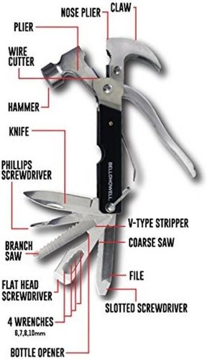

The tools taken for topology optimization were the knife, saw and serrated knife. After carrying out the shape optimization on Fusion 360, the tools were re-assembled and the final weight of the product was recalculated.

2.2 MODELLING/ ANALYSIS
The multi-tool shown above is designed on Fusion 360 and is shown below-

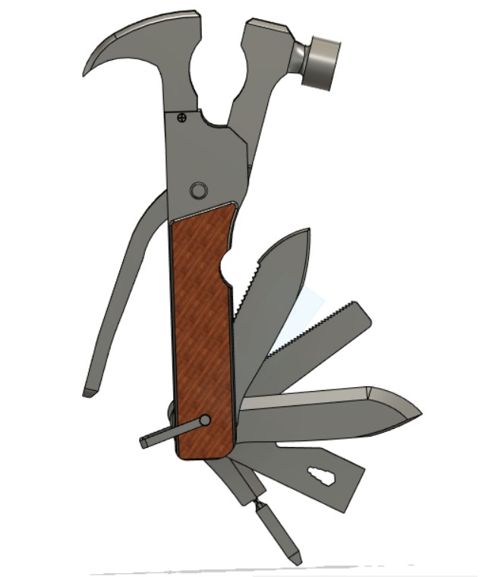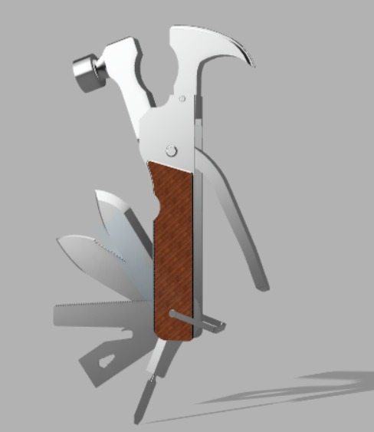

The aim of the analysis is to reduce as much mass as possible without compromising on its strength or stiffness. The analysis was carried out on Fusion 360 in the simulation section. The tools which were initially designed were taken as the input. The hole section in the tools were given a fixed constraint as a boundary condition. The load taken into account was 10 Pa which is the usual range of application. This was applied to the tool according to its use. The handle region was preserved in order to make sure that no material is removed from it. The materials used for the tools were assigned appropriately. The results of the analysis are shown as follows-

The initial mass of the knife was 89.91g and after an optimization of 25.2697%, the mass was reduced to 67.19g (approx.)
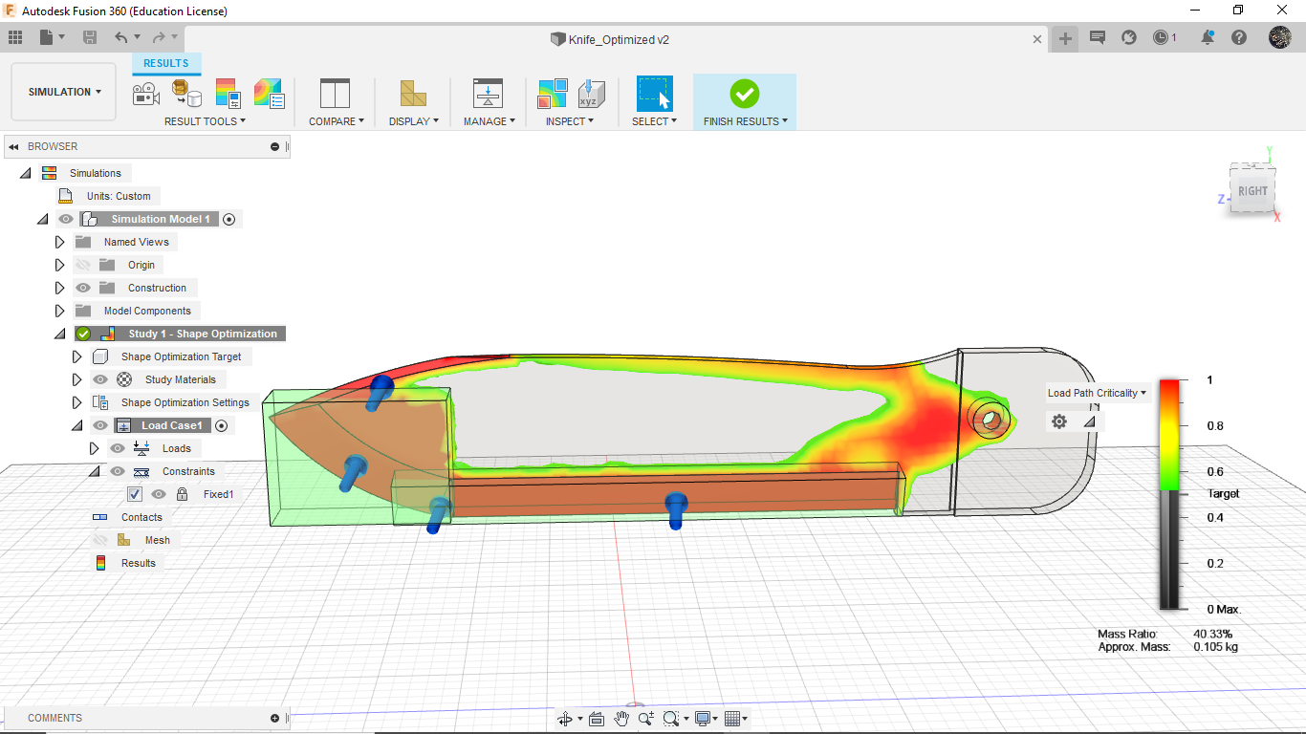
The optimized knife looks like-
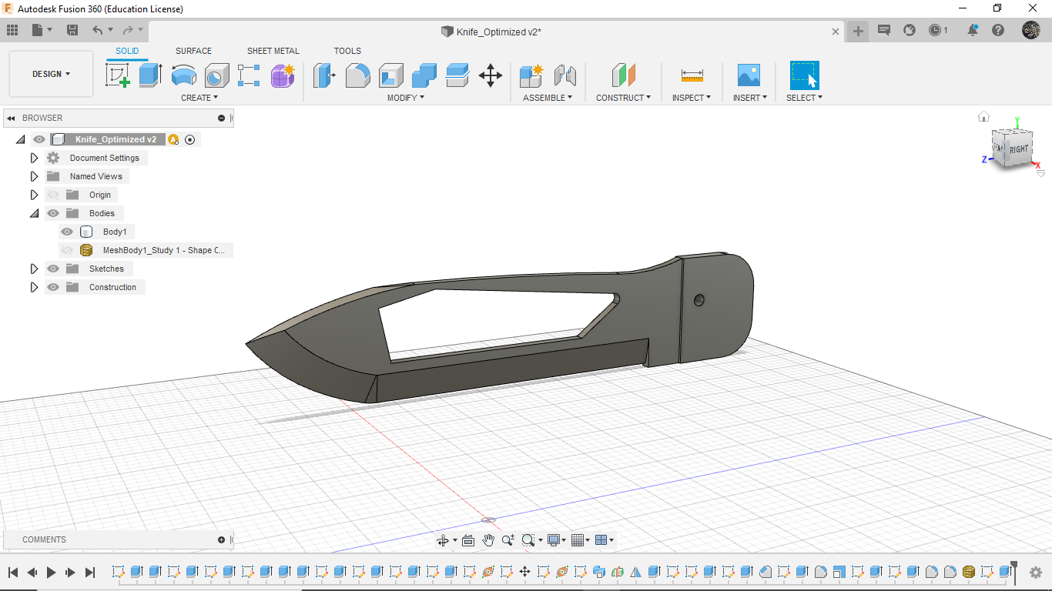
The initial mass of the saw knife was 80.18g and after an optimization of 64.143%, the mass was reduced to 28.75g (approx.).
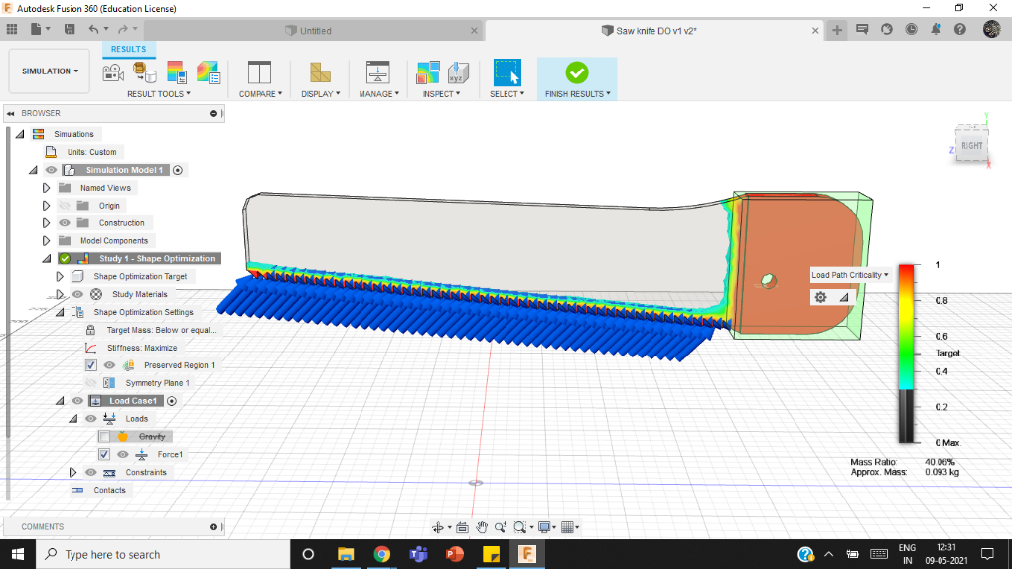

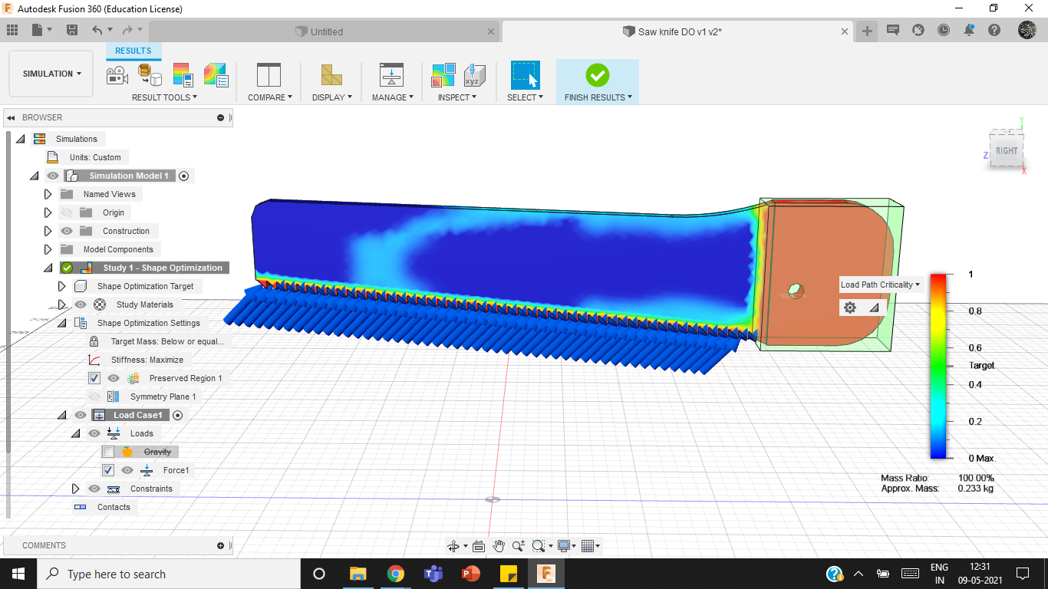

The optimized saw looks like-
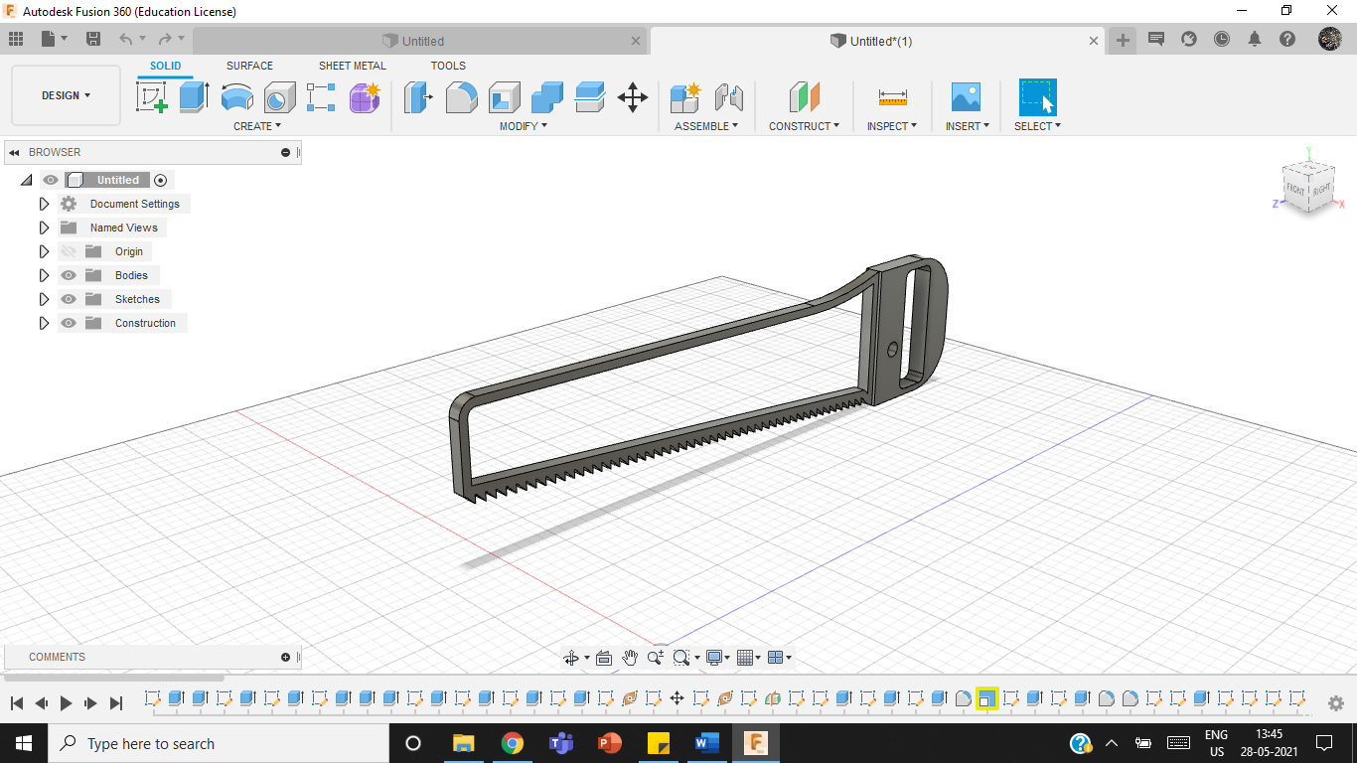

The initial mass of the serrated knife was 96.81 g and after an optimization of 45.54%, the mass was reduced to 52.72g (approx.).
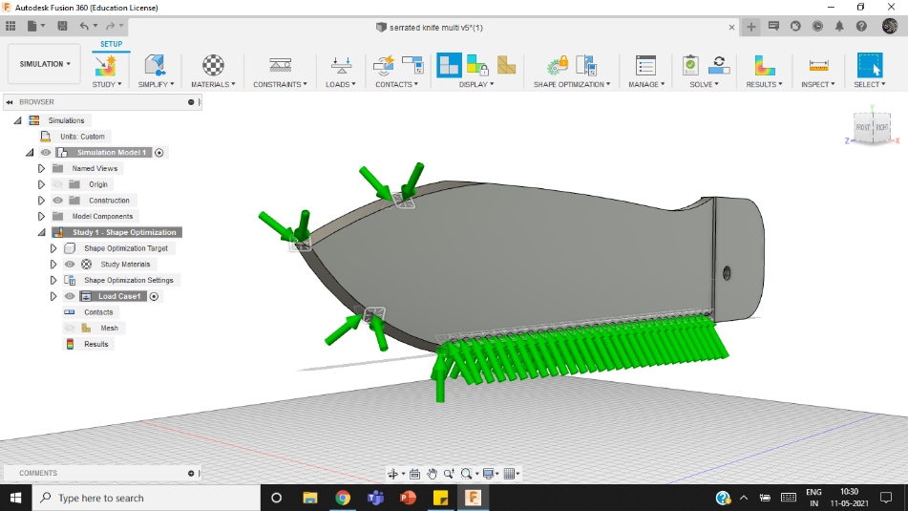
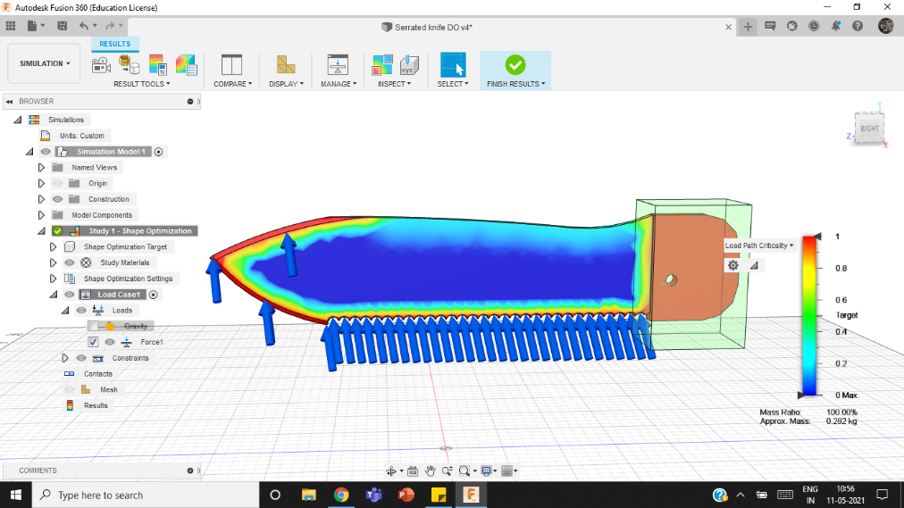

The optimized serrated knife looks like-
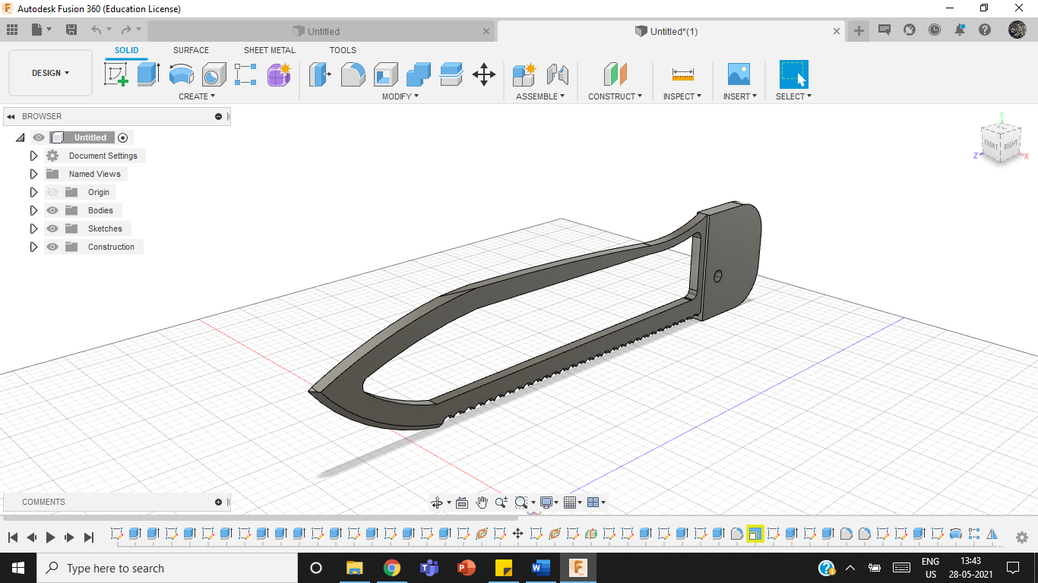

2.3 FINAL DESIGN
After Topologically optimizing the tools, the final design looks like-
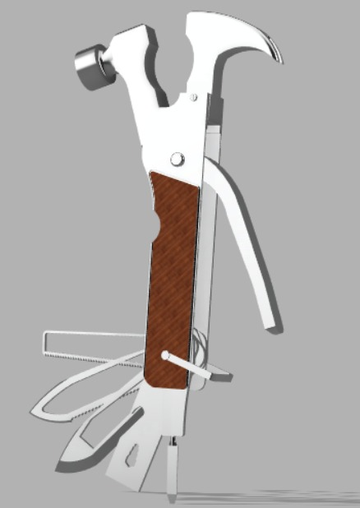
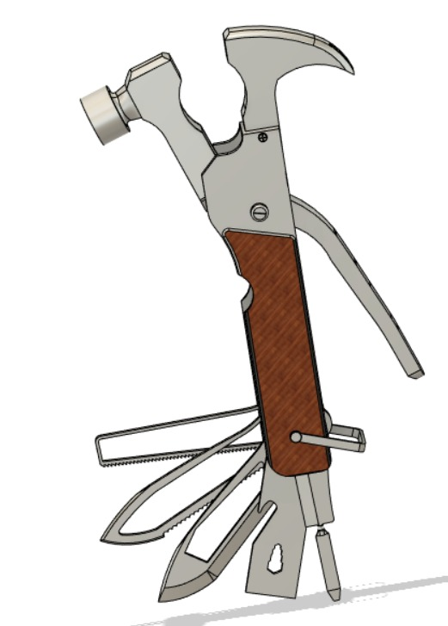
The weight of the entire multi-tool is 1563.63g. The design looks more aesthetically pleasing compared to the previous design.

MANUFACTURING
3.1 DETAILS
S.No | Details | Knife | Serrated Knife | Saw Knife
1 | Processes involved in manufacturing | Facing: is the process of removing metal from the end of a workpiece to produce a flat surface. It is done to provide a true, flat surface, square with the axis of the workpieces.  2D Pocketing: is the process of providing a clear & sharp boundary removing the excess material from the sides.  Boring : is the process of making a whole and removing the material.  Adaptive clearing: is a process that is used to remove a large amount of material. It guarantees maximum load on the tool during the entirety of the machining process. It also decreases the breakage of the tool thus making it efficient. It can be used for achieving very fine details which may not be possible otherwise.  For Aluminium, it is recommended that the depth of cut is about 1.5-2 times the diameter of the tool. | Facing: is the process of removing metal from the end of a workpiece to produce a flat surface. It is carried out to provide a true, flat surface, square with the axis of the workpieces.  2D Pocketing: is the process of providing a clear & sharp boundary removing the excess material from the sides.  Boring : is the process of making a whole and removing the material.  Adaptive clearing: is a process that is used to remove a large amount of material. It guarantees maximum load on the tool during the entirety of the machining process. It also decreases the breakage of the tool thus making it efficient. It can be used for achieving very fine details which may not be possible otherwise.  For Aluminium, it is recommended that the depth of cut is about 1.5-2 times the diameter of the tool. | Facing: is the process of removing metal from the end of a workpiece to produce a flat surface. It is done to provide a true, flat surface, square with the axis of the workpieces.  2D Pocketing: is the process of providing a clear & sharp boundary removing the excess material from the sides.  Boring : is the process of making a whole and removing the material.  Adaptive clearing: is a process that is used to remove a large amount of material. It guarantees maximum load on the tool during the entirety of the machining process. It also decreases the breakage of the tool thus making it efficient. It can be used for achieving very fine details which may not be possible otherwise.  For Aluminium, it is recommended that the depth of cut is about 1.5-2 times the diameter of the tool.
2 | Materials used (Components) | Stainless Steel | Aluminium | Aluminium
3 | Materials used (Tool) | Aluminium (Flat end mill 4mm dia) | Aluminium (Flat end mill 10mm dia) | Aluminium (Flat end mill 4mm dia)
4 | Time Required for Manufacturing | 24 minutes 04 seconds | 17 minutes 15 seconds | 30 minutes 37 seconds
5 | Tools used | Facing: 50mm dia face mill  2D Pocketing: Flat end mill 4mm dia  Boring: Flat end mill 4mm dia  Adaptive Clearing: Flat end mill 4mm dia | Facing: 50mm dia face mill  2D Pocketing: Flat end mill 4mm dia  Boring: Flat end mill 4mm dia  Adaptive Clearing: Flat end mill 10mm dia | Facing: 50mm dia face mill  2D Pocketing: Flat end mill 10mm dia  Boring: Flat end mill 4mm dia  Adaptive Clearing: Flat end mill 4mm dia
6 | Machine Used | General Mill Turn Lathe | General Mill Turn Lathe | General Mill Turn Lathe
3.2 PROCESSES AND G-CODE
The setup for the optimized Knife looks like-
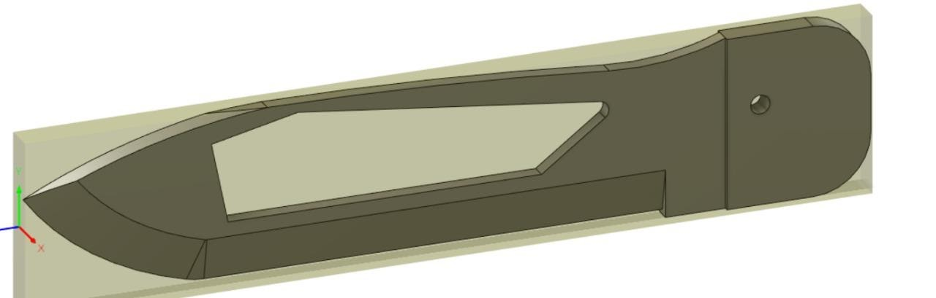

The part after the manufacturing processes looks like-
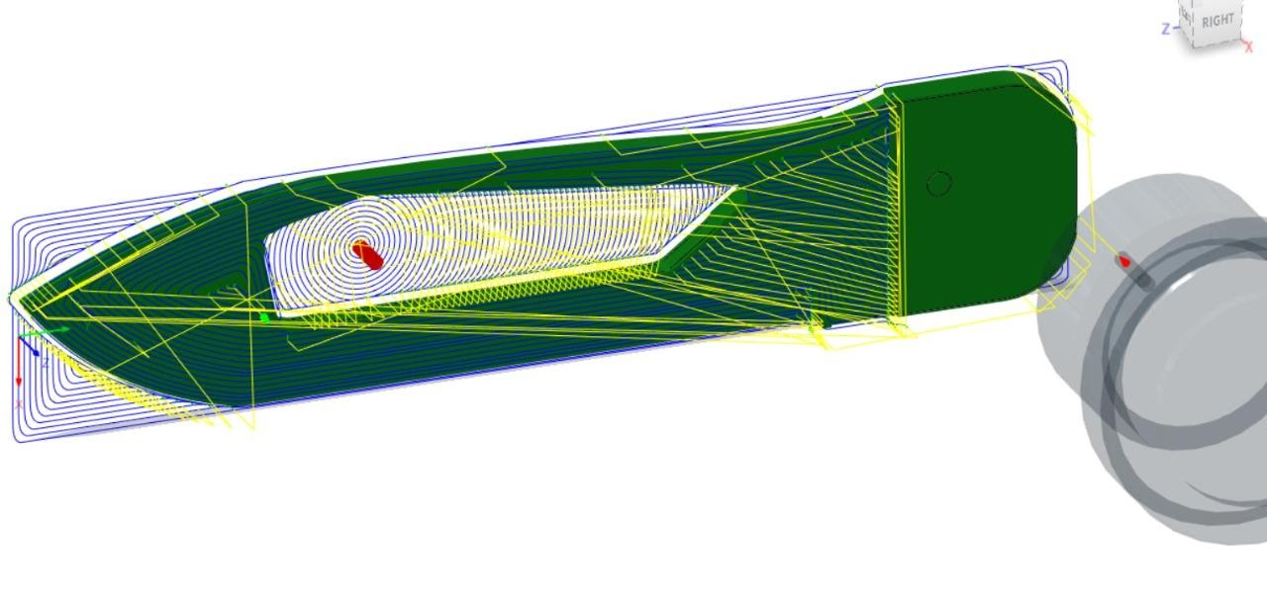
The setup for the optimized Serrated Knife looks like-
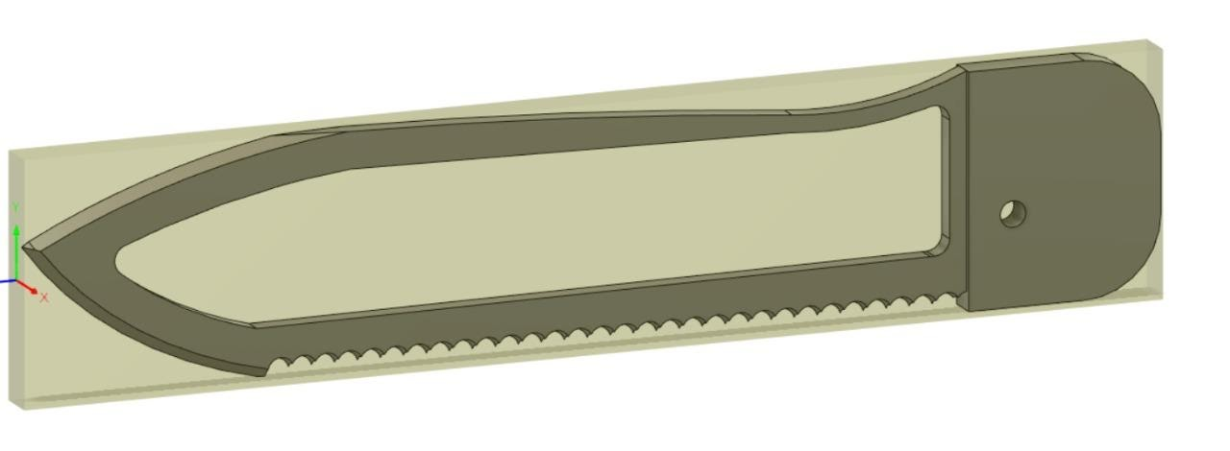

The part after the manufacturing processes looks like-
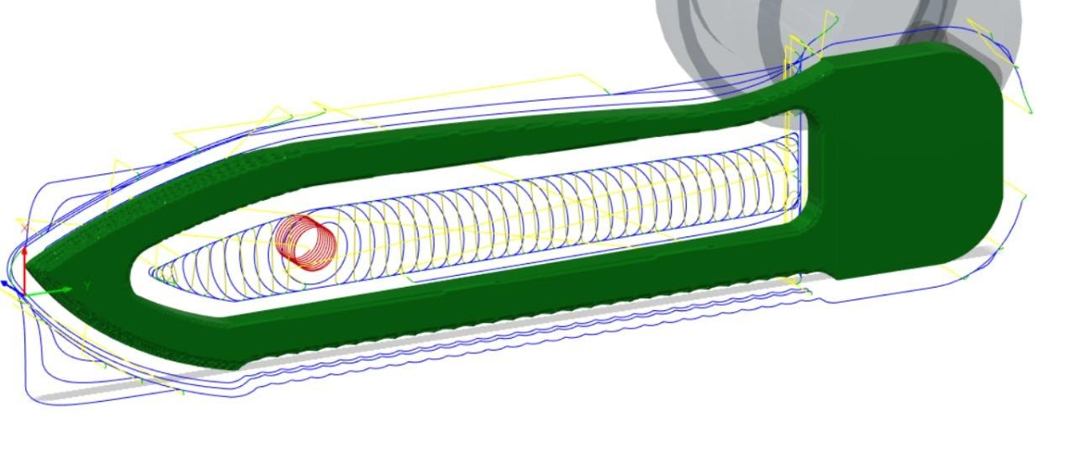

The setup for the optimized Saw Knife looks like-
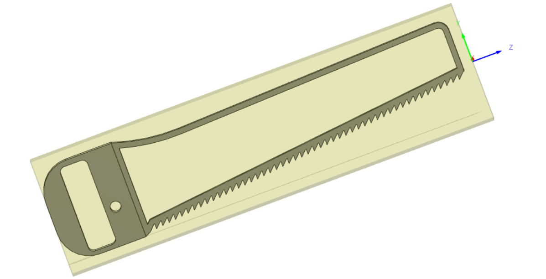
The part after the manufacturing processes looks like-
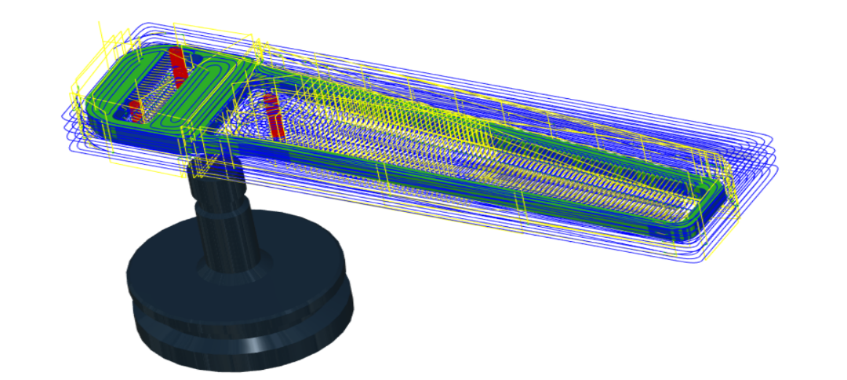

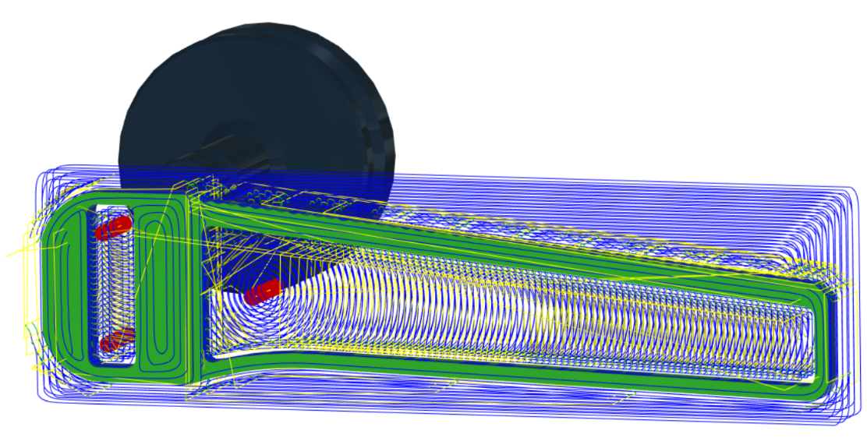
The following Google drive link contains the G codes of the three components-
https://drive.google.com/drive/folders/133MXWJp0mIL-2F_luPqE3wnZ93kstt86?usp=sharing

CONCLUSION
The multi-tool was modelled on Fusion 360 including tools like hammer, plier, nose plier, wire cutter, claw, bottle opener, knife, saw knife, serrated knife and a slot for attaching any type of screw head. The weight before the analysis was around 1681.87 g. A topology optimization was carried on 3 tools- knife, saw, and serrated knife. A weight reduction of 40.33%, 40.06% and 41.98% was achieved respectively. The tools were re-designed according to the analysis and the final product was assembled. Each of these tools were then manufactured using CAM processes and the G codes were generated accordingly. The final weight was around 1563.63 g. The total weight reduction was around 7% or 118.24g. This has made a space for at least 3 more tools and can be increased by carrying out topology optimization for more tools.

