1.INTRODUCTION
Health informatics systems have been widely used in the detection and monitoring of important diseases in recent years. Information systems based on artificial learning are utilized in the monitoring of Brain Tumor disease. The Brain tumor generally occurs in both male and female due to uncontrollable growth of cells in the brain. Brain is that the management center within the physical body. It is responsible to execute all activities throughout a large number of connections and a huge number of neurons. Brain tumor is one of the most serious diseases, occurred due to an abnormal growth of cells in the brain, affecting the functions of the nervous system. There are different types of brain tumors which can be either malignant or benign. Image processing is a process of analyzing, manipulating a picture so as to perform some operation to extract the knowledge from it. According to world health organization’s statistics, cancer is considered as the second leading cause of human fatalities across the world, being responsible for an estimated 9:6 million deaths in this year. Among different form of cancers, brain tumor is widely seen together of the deadliest cancers because of its aggressive nature, heterogeneous characteristics (types), and low relative survival rate. The objective of this study is to summarize various review and technical articles on diagnosis of brain cancer. It gives an overview of the current research being carried out on various brain cancer datasets using the data mining techniques to enhance the lung cancer diagnosis.
1.1 Problem Statement
A brain tumour is a disease caused due to the growth of abnormal cells in the brain. There are two main categories of brain tumour, they are non-cancerous (benign) brain tumour and cancerous (malignant) brain tumour. Survival rate of a tumour prone patient is difficult to predict because brain tumour is uncommon and are different types. The research work carried out uses deep learning models like convolutional neural network (CNN) model and vgg-16 architecture (built from scratch) to detect the tumour region in the scanned brain images.
1.2 Existing System
A brain tumor disease prediction system is developed using image processing classification techniques. In existing system uses various machine learning approaches to classify lung cancer using MRI scan images. Also, many classifiers have been used by the researchers in the literature such as: SVM and Naïve Bayes classifier. Consequently, and based on the extensive survey that have been done in this work.
1.3 Proposed System
The proposed model is introduced to overcome all the disadvantages that arises in the existing system. We can conclude that this system giving the accurate result. As we are using large dataset which will ensures the better performance. System will get output for the disease. The threshold segmentation process is the advantages of predicting tumor region in brain MRI scan image. The classification using deep learning algorithm like Convolutional Neural Network is applied. Finally the deep learning algorithm is used to predict the brain tumor using MRI scan images. The prediction result based on accuracy, precision, recall, and f1-measure.
1.4 Scope
This project aims to revolutionize brain cancer diagnosis by leveraging health informatics systems, artificial learning, and advanced data mining techniques. Through a comprehensive literature review, we will assimilate recent findings and address challenges in existing methodologies. The focus will be on implementing sophisticated image processing methods to analyze brain tumor images, extracting crucial diagnostic insights. Utilizing diverse datasets, our initiative seeks to enhance the accuracy and efficiency of brain cancer diagnosis, contributing to the ongoing efforts in combating one of the deadliest forms of cancer.
.

2.SOFTWARE REQUIREMENTS SPECIFICATIONS
2.1 Software Requirements
- O/S : Windows 11.
- Language : Python
- Front End : Anaconda Navigator – Spyder

2.2 Hardware Requirements
- System : Pentium IV 2.4 GHz
- Hard Disk : 200 GB
- Mouse : Logitech.
- Keyboard : 110 keys enhanced
- Ram : 4GB
2.3 System Architecture / Block Diagram
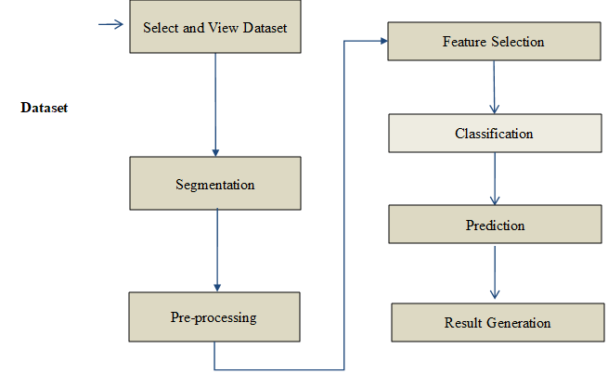
Fig 2.1 Block Diagram of Brain Tumor Detection

3.DESIGN & IMPLEMENTATION
3.1 Environmental Setup
We need to set up Python environment with the required libraries. Here is an environmental setup guide:
1.Install Visual Studio Code
2.Install Python:
- Download and install it from the official Python website.
3.Install Required Packages:
- Open a terminal or command prompt.
- Run the following commands to install the necessary packages:
- pip install opencv-python
- pip install scikit-learn
- pip install numpy
- pip install pillow
4.Install Tkinter (if not included with Python):
- sudo apt-get install python3-tk
5.Install Matplotlib:
- Run the following command to install Matplotlib.
- pip install matplotlib
6.Run the Code:
- Save the code in a file, for example, main.py.
- Open a terminal or command prompt.
- Navigate to the directory containing the script using the cd command.
- Run the script:
- python main.py

3.2 Implementation
Python is the pool of libraries. It has numerous libraries for real-world applications. One such library is OpenCV. OpenCV is a cross-platform library used for Computer Vision. It includes applications like video and image capturing and processing. It is majorly used in image transformation, object detection, face recognition, and many other stunning applications.
Steps involved are:
1: Importing the required modules
2: Building a File Box to choose a particular file
3: How is an image stored?
4: Transforming an image to grayscale.
5: Smoothening a grayscale image
6: Retrieving the edges of an image
7: Preparing a Mask Image
8: Giving a Cartoon Effect
9: Plotting all the transitions together
10: Functionally of save button
11: Making the main window
12: Making the Cartoonify button in the main window
13: Making a Save button in the main window

Step 1: Image Preprocessing:
In this initial step, the code performs essential preprocessing on the input image. The image undergoes a series of transformations to enhance features relevant to brain tumor detection:
Skull Removal:
Utilizes image thresholding and connected components to identify the brain region and remove the skull from the image. The result is displayed to provide visual insights into the effectiveness of skull removal.
Segmentation:
Applies Gaussian blur and thresholding to obtain a binary image highlighting the segmented brain area. Contours are extracted to identify extreme points of the brain region, which are later used for cropping. Displays intermediate results, including the original image, skull removal, segmented image, and the final cropped image.
Step 2: Data Preparation and Encoding:
This step focuses on preparing the dataset for training the neural network:
Dataset Loading:
Loads images from specified directories for both tumor and non-tumor cases. Resizes images to a consistent size (65x65 pixels) to maintain uniformity.
One-Hot Encoding:
Uses the OneHotEncoder from scikit-learn to encode the labels (0 for tumor, 1 for non-tumor). Prepares the dataset for training and testing.
Step 3: Convolutional Neural Network (CNN) Model:
The core of the brain tumor detection system involves creating a CNN model using Keras:
Model Architecture:
Utilizes a sequential model with convolutional layers, max-pooling layers, batch normalization, dropout, and dense layers. Employs the Rectified Linear Unit (ReLU) activation function for convolutional layers. Implements the softmax activation function for the output layer to predict tumor or non-tumor classes.
Model Compilation:
Compiles the model using categorical crossentropy as the loss function and the Adamax optimizer. Provides a summary of the model architecture for reference.
Step 4: Training the Model:
This step involves training the CNN model on the prepared dataset:
Dataset Splitting:
Splits the dataset into training and testing sets using the train_test_split method.
Model Training:
Fits the model to the training data, specifying the number of epochs and batch size.
Monitors loss and accuracy during training.
Step 5: Model Evaluation and Saving:
Following model training, the code evaluates the model's performance and saves it for future use:
Model Evaluation:
Plots the loss and accuracy curves over epochs to visualize the model's learning progress. Evaluates the model on the testing set and displays the accuracy.
Model Saving:
Saves the trained model in a file named 'model.h5' for later use.
Step 6: Model Loading and Prediction:
This step focuses on loading the trained model and making predictions:
Model Loading:
Loads the saved model using Keras's load_model function.
User Input for Prediction:
Prompts the user to input an image for prediction.

Prediction and Display:
Displays the input image and predicts whether it contains a brain tumor.
Prints the confidence level and classification result.
Step 7: Display Results:
Concludes the implementation by displaying the original image, skull removal, segmented image, and the cropped image showing the suspected tumor region. This comprehensive visualization aids in understanding the effectiveness of each stage of the process.

4.RESULTS & DISCUSSION
4.1 Results
1. Open the command Prompt and the run the main python file
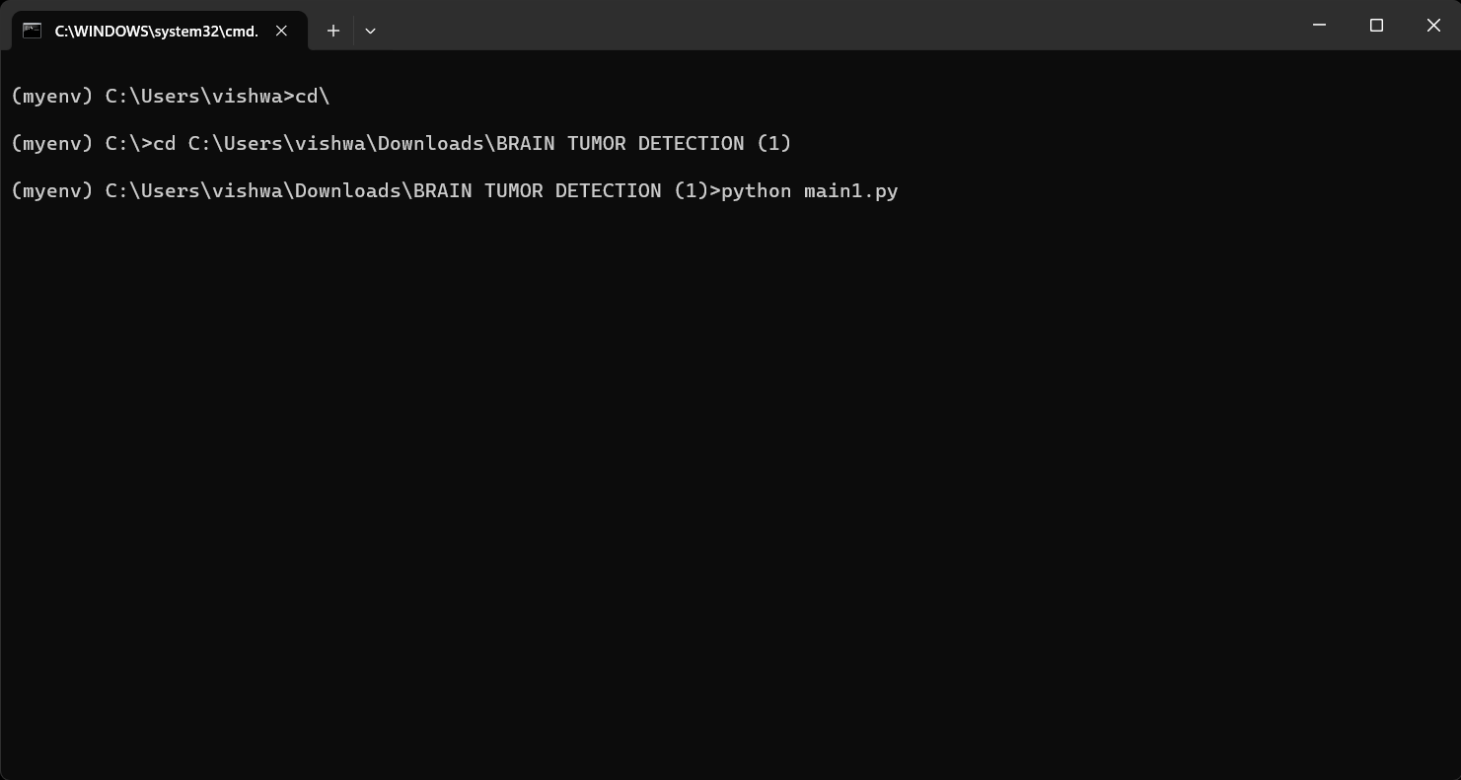
Fig 4.1: Teminal
2.File Box to choose a particular Image to process
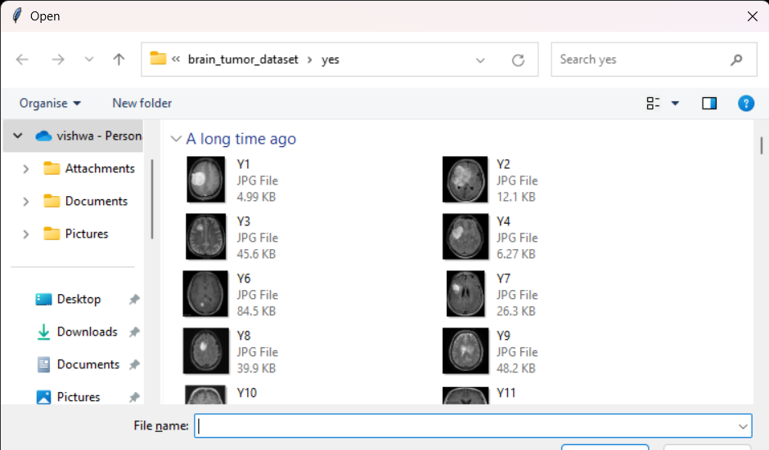
Fig 4.2: Choose a particular Image
3. Displays an Original Image
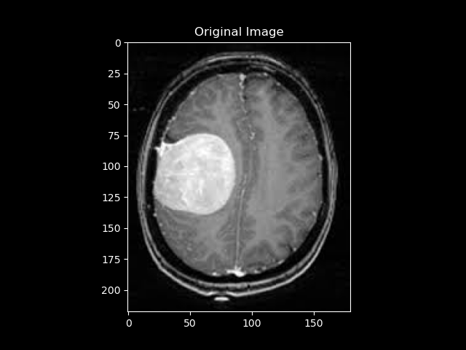
Fig 4.3 Original Image

4. To display image after skull removal
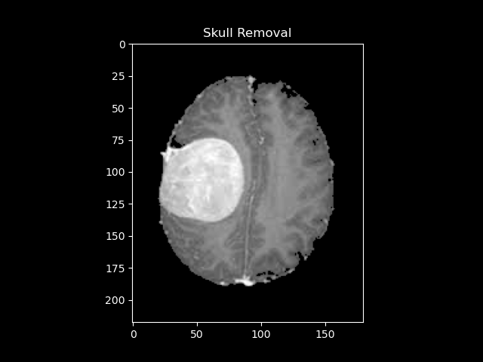
Fig 4.4: Skull Removed Image
5. Segmented Image
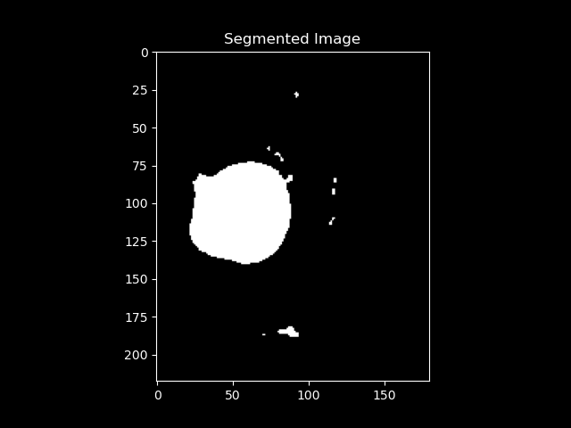
Fig 4.5: Segmented Image

6. Cropped Image
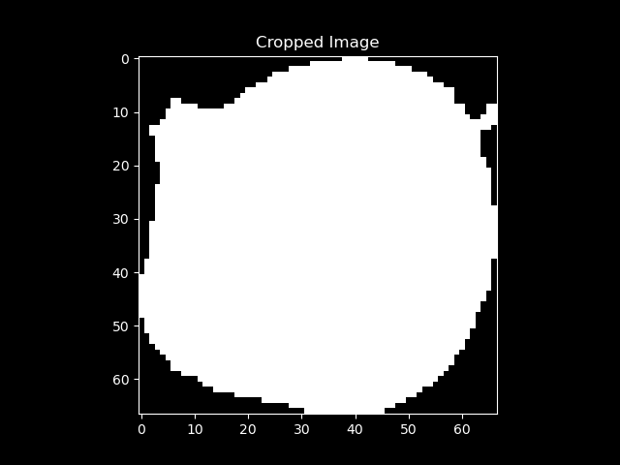
Fig 4.6: Cropped Image

7. To display Model Accuracy & Loss
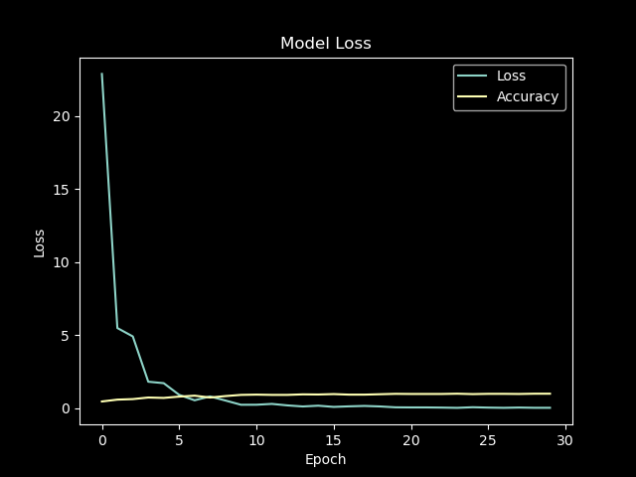
Fig 4.7: Model Loss

8. To select the image for Tumor Detection
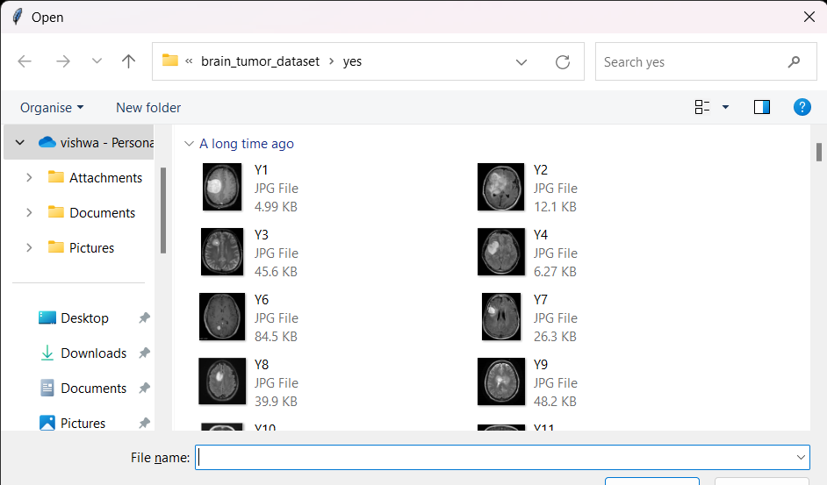
Fig 4.8: Select Image for Tumor Detection

9. Displays Model accuracy and the result if Tumor is present or not.
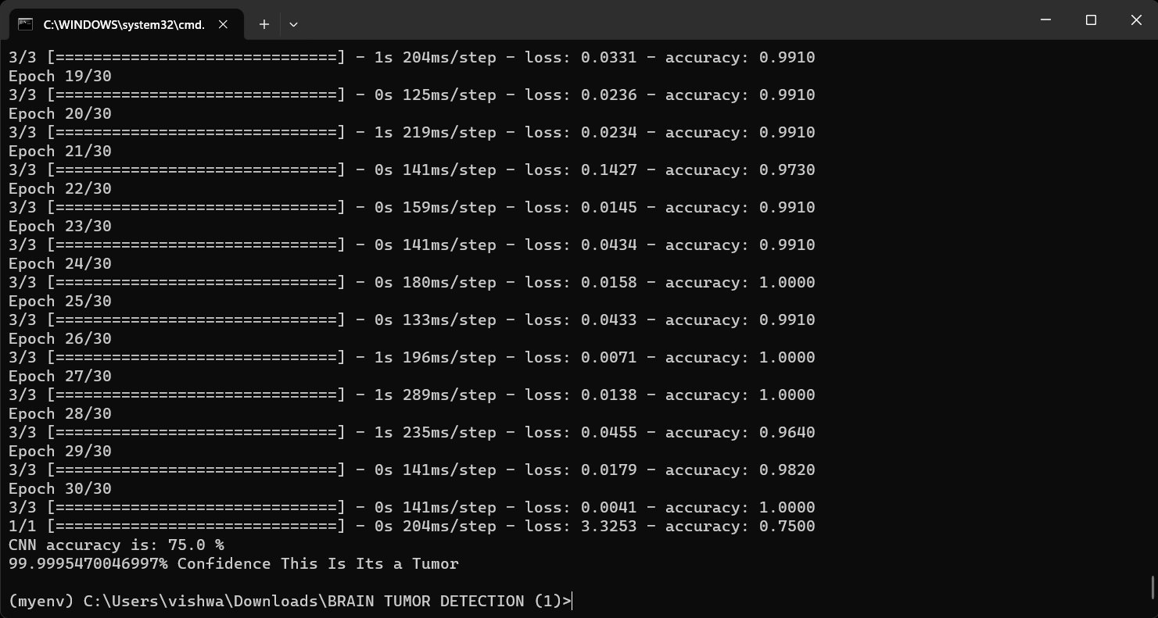
Fig 4.9: Output

4.2 Test Cases
Table 1: Test Cases
Test case no | Test case name | Test case input | Test case output | Test case status  (pass/fail)
1 | Brain tumor segmentation | Select a valid image file for segmentation | Segmentation image is developed | Pass
2 | Brain tumor masking | Select a valid image file for brain image masking | Brain Masking Image is developed | Pass
3 | Sepeartion of brain image and skull | Attempt to separate brain image and skull | Brain image is developed without skull | Pass
4 | Brain tumor Detection | Attempt to detect tumor in the bain by giving an image as input | Brain tumor is detected | Pass

5.CONCLUSION AND FUTURE ENHANCEMENTS
5.1 Conclusion
In conclusion, the Brain Tumor Detection system developed using a Convolutional Neural Network (CNN) demonstrates a promising approach to automating the identification of brain tumors in medical images. The multi-step implementation involves image preprocessing, dataset preparation, CNN model creation, training, and evaluation. The results showcase the effectiveness of the system in accurately classifying brain images, providing valuable insights into potential medical applications.

The key highlights of the implementation include successful skull removal, segmentation of brain regions, and the utilization of a well-constructed CNN model for binary classification. The training process exhibits progressive learning, reflected in the visualized loss and accuracy curves. The system achieves a notable accuracy on the test dataset, indicating its potential as a supportive tool for medical professionals in diagnosing brain tumors.

5.2 Future Enhancements
While the developed Brain Tumor Detection system lays a strong foundation, there are several avenues for future enhancements and improvements:

Dataset Augmentation:

Implement techniques for data augmentation to diversify the dataset, potentially improving the model's generalization and robustness.
Fine-Tuning of Hyperparameters:
Conduct a thorough search for optimal hyperparameters, including learning rates, batch sizes, and model architectures, to enhance overall performance.
Integration with Medical Imaging Systems:
Explore integration possibilities with existing medical imaging systems, allowing seamless use by healthcare professionals.
Real-Time Inference:
Adapt the system for real-time inference, enabling quick and efficient tumor detection during medical imaging procedures.
Deployment as a Web or Mobile Application:
Develop a user-friendly interface and deploy the system as a web or mobile application for broader accessibility.
Incorporation of Explainable AI:
Enhance model interpretability by incorporating explainable AI techniques, enabling better understanding of the decision-making process.
Extension to Multiclass Classification:
Extend the system to handle multiclass classification for distinguishing between different types or stages of brain tumors.
Collaboration with Medical Professionals:
Collaborate with medical professionals to gather more extensive and diverse datasets, ensuring the model's effectiveness across various patient demographics.

REFERENCES
https://stackoverflow.com/
https://www.w3schools.com/python/python_ml_getting_started.asp
https://www.geeksforgeeks.org/opencv-python-tutorial/
https://www.tutorialspoint.com/numpy/numpy_quick_guide.htm

APPENDIX: PSEUDO CODE
import os
from keras.models import Sequential
from keras.layers import Conv2D, MaxPooling2D, Flatten, Dense, Dropout, BatchNormalization
from PIL import Image
import numpy as np
import cv2
import imutils
import matplotlib.pyplot as plt
plt.style.use('dark_background')
from sklearn.model_selection import train_test_split
from sklearn.preprocessing import OneHotEncoder
from tkinter import filedialog

image_dir="augmented-images/"
img = filedialog.askopenfilename()
head_tail = os.path.split(img)
fileNo=head_tail[1].split('.')
img = cv2.imread(head_tail[0]+'/'+fileNo[0]+'.jpg')
gray = cv2.cvtColor(img,cv2.COLOR_BGR2GRAY)
ret, thresh = cv2.threshold(gray,150,255,cv2.THRESH_OTSU)

ret, markers = cv2.connectedComponents(thresh)

#Get the area taken by each component. Ignore label 0 since this is the background.
marker_area = [np.sum(markers==m) for m in range(np.max(markers)) if m!=0]
#Get label of largest component by area
largest_component = np.argmax(marker_area)+1 #Add 1 since we dropped zero above
#Get pixels which correspond to the brain
brain_mask = markers==largest_component

brain_out = img.copy()
#In a copy of the original image, clear those pixels that don't correspond to the brain
brain_out[brain_mask==False] = (0,0,0)

gray = cv2.cvtColor(brain_out, cv2.COLOR_BGR2GRAY)
gray = cv2.GaussianBlur(gray, (5, 5), 0)
thresh = cv2.threshold(gray, 150, 255, cv2.THRESH_BINARY)[1]
cnts = cv2.findContours(thresh.copy(), cv2.RETR_EXTERNAL, cv2.CHAIN_APPROX_SIMPLE)
cnts = imutils.grab_contours(cnts)
c = max(cnts, key=cv2.contourArea)
# extreme points
extLeft = tuple(c[c[:, :, 0].argmin()][0])
extRight = tuple(c[c[:, :, 0].argmax()][0])
extTop = tuple(c[c[:, :, 1].argmin()][0])
extBot = tuple(c[c[:, :, 1].argmax()][0])

# crop new image out of the original image using the four extreme points (left, right, top, bottom)
new_image = thresh[extTop[1]:extBot[1], extLeft[0]:extRight[0]]
plt.imshow(img)
plt.title('Original Image')
plt.show()
plt.imshow(brain_out)
plt.title('Skull Removal')
plt.show()
plt.imshow(thresh, cmap='gray')
plt.title('Segmented Image')
plt.show()
plt.imshow(new_image, cmap='gray')
plt.title('Cropped Image')
plt.show()

encoder = OneHotEncoder()
encoder.fit([[0], [1]])

data = []
paths = []
result = []

for r, d, f in os.walk(r"C:\Users\vishwa\Downloads\BRAIN TUMOR DETECTION (1)\brain_tumor_dataset\yes"):

for file in f:
if '.jpg' in file:
paths.append(os.path.join(r, file))

for path in paths:
img = Image.open(path)
img = img.resize((65,65))
img = np.array(img)
if(img.shape == (65,65,3)):
data.append(np.array(img))
result.append(encoder.transform([[0]]).toarray())
# This cell updates result list for images without tumor

paths = []
for r, d, f in os.walk(r"C:\\Users\\vishwa\\Downloads\\BRAIN TUMOR DETECTION (1)\\brain_tumor_dataset\\no"):

for file in f:
if '.jpg' in file:
paths.append(os.path.join(r, file))
print(paths)
for path in paths:
img = Image.open(path)
img = img.resize((65,65))
img = np.array(img)
if(img.shape == (65,65,3)):
data.append(np.array(img))
result.append(encoder.transform([[1]]).toarray())
data = np.array(data)
print(data.shape)

result = np.array(result)
result = result.reshape(139,2)

x_train,x_test,y_train,y_test = train_test_split(data, result, test_size=0.2, shuffle=True, random_state=0)

#cnn

model = Sequential()

model.add(Conv2D(32, kernel_size=(2, 2), input_shape=(65, 65, 3), padding = 'Same'))
model.add(Conv2D(32, kernel_size=(2, 2), activation ='relu', padding = 'Same'))

model.add(BatchNormalization())
model.add(MaxPooling2D(pool_size=(2, 2)))
model.add(Dropout(0.25))

model.add(Conv2D(64, kernel_size = (2,2), activation ='relu', padding = 'Same'))
model.add(Conv2D(64, kernel_size = (2,2), activation ='relu', padding = 'Same'))

model.add(BatchNormalization())
model.add(MaxPooling2D(pool_size=(2,2), strides=(2,2)))
model.add(Dropout(0.25))

model.add(Flatten())

model.add(Dense(512, activation='relu'))
model.add(Dropout(0.5))
model.add(Dense(2, activation='softmax'))

model.compile(loss = "categorical_crossentropy", optimizer='Adamax', metrics=['accuracy'])
print(model.summary())

history = model.fit(x_train, y_train, epochs = 30, batch_size = 40, verbose = 1)

plt.plot(history.history['loss'])
plt.plot(history.history['accuracy'])
plt.title('Model Loss')
plt.ylabel('Loss')
plt.xlabel('Epoch')
plt.legend(['Loss', 'Accuracy'], loc='upper right')
plt.show()
history=model.history.history
cnn=model.evaluate(x_test,y_test,verbose=1)[1]*100
print('CNN accuracy is:',cnn,'%')

model.save('model.h5')

from keras.models import load_model
model = load_model('model.h5')

def names(number):
if number==0:
return 'Its a Tumor'
else:
return 'No, Its not a tumor'
from matplotlib.pyplot import imshow
from tkinter import filedialog
import PIL

Image = filedialog.askopenfilename()
img = PIL.Image.open(Image)
x = np.array(img.resize((65,65)))
x = x.reshape(1,65,65,3)
res = model.predict_on_batch(x)
classification = np.where(res == np.amax(res))[1][0]
imshow(img)
print(str(res[0][classification]*100) + '% Confidence This Is ' + names(classification))

