FraudGuard
A Credit Card Transaction and Fraud Monitoring Database
Final Project Proposal
COP5711: Parallel and Distributed Database Systems | Summer 2026

1. Project Title and Team Members
Project title: FraudGuard, a credit card transaction and fraud monitoring database.
Course: COP5711, Parallel and Distributed Database Systems, Summer 2026.
Team members and planned responsibilities:
Team Member | Responsibility
Aditya Khadye | Schema design, ETL, and data loading
[Team Member 2] | [Role]
[Team Member 3] | [Role]
[Team Member 4] | [Role]
Note: replace the bracketed placeholders with your teammates' names, and add or remove rows to match your group size.

2. Application Domain and Objectives
Our application domain is finance and banking, specifically credit card transaction processing and fraud monitoring. The database stores customers, the cards they hold, the merchants they pay, and every transaction between them. On top of this, it supports fraud monitoring and customer behavior analytics: each transaction carries a fraud label, so analysts can study where, when, and how fraudulent activity occurs.

Primary users
- Fraud and risk analysts reviewing flagged transactions
- Compliance and audit teams tracing account and card activity
- Data and BI analysts producing spending and fraud trend reports
- An automated screening process that reads new transactions and raises alerts

System outputs
- Per customer and per card transaction histories
- Spending and behavior summaries by customer, merchant, and category
- Fraud rate breakdowns by region, merchant category, and time period
- Flagged transaction alerts queued for analyst review

Scope
- In scope: a normalized relational schema, transactional inserts and lookups, analytical aggregations over large transaction volumes, and reporting on the provided fraud label.
- Out of scope: real time streaming ingestion, building a machine learning fraud model from scratch (we use the dataset's existing fraud label), and integration with live payment networks.

Data source
We will use the IBM synthetic Credit Card Transactions dataset (Erik Altman, available on Kaggle). It provides millions of labeled transactions spanning customers, cards, and merchants, with geographic attributes such as merchant city and state. Because the data is synthetic, it carries no real personal information, which makes it well suited for a course project.

3. ER Diagram and Schema Draft
The draft model centers on the TRANSACTION entity, which links a CARD (owned by a CUSTOMER) to a MERCHANT (classified by a merchant category code). Transactions flagged as fraudulent can raise a FRAUD_ALERT for analyst review. The raw dataset embeds merchant and category fields inside each transaction record; we split these into separate MERCHANT and MERCHANT_CATEGORY entities to reduce redundancy and move toward third normal form.
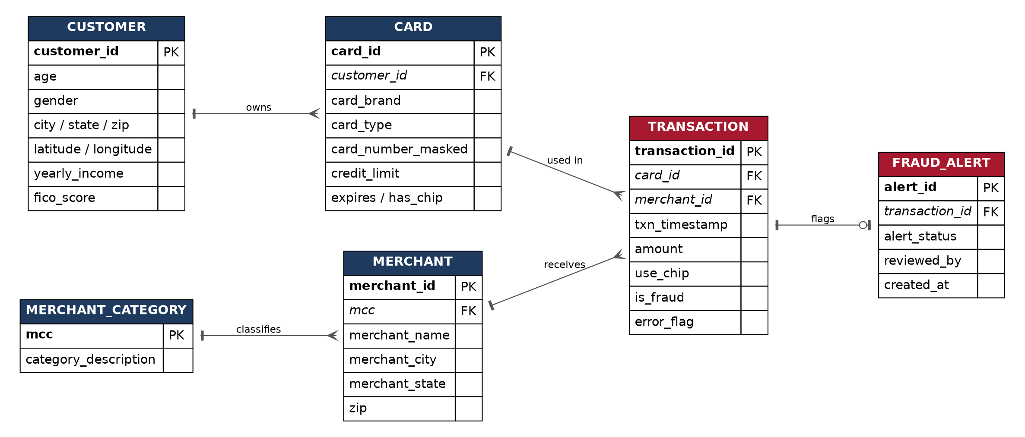
Figure 1. Draft ER diagram (crow's foot notation). PK = primary key, FK = foreign key.

Key entities
- CUSTOMER: a cardholder, with demographic and location attributes (city, state, coordinates, income, FICO score).
- CARD: a payment card belonging to one customer, with brand, type, credit limit, and expiry.
- MERCHANT: a business that accepts payments, with name, location, and a category code.
- MERCHANT_CATEGORY: a lookup of merchant category codes (MCC) to readable descriptions.
- TRANSACTION: a single card payment, with timestamp, amount, entry method, and a fraud flag.
- FRAUD_ALERT: an optional review record raised for a flagged transaction.

Relationships
- A CUSTOMER owns one or many CARDs (1:N)
- A CARD is used in one or many TRANSACTIONs (1:N)
- A MERCHANT receives one or many TRANSACTIONs (1:N)
- A MERCHANT_CATEGORY classifies one or many MERCHANTs (1:N)
- A TRANSACTION may raise zero or one FRAUD_ALERT (1:0..1)

4. Future Scaling Considerations
The TRANSACTION table is the part of this system that grows without bound. The full dataset is already in the tens of millions of rows, and a production version would keep accumulating, so a single node would eventually struggle on both storage and query speed. We are starting to think about a few directions to revisit as the course covers distributed and parallel topics:
- Partitioning: split the TRANSACTION table, for example by time (range on the transaction timestamp) or by region (list or hash on merchant state), so that queries scan only the relevant partitions instead of the whole table.
- Geographic distribution: place or replicate data across regions for locality and availability, accepting the consistency tradeoffs that come with it.
- Query load: add read replicas and precomputed or materialized summaries to absorb heavy analytical queries such as fraud rate dashboards.
- Distributed transactions: cross region operations, such as analyzing transfers between accounts in different locations, may eventually need distributed transaction handling and protocols like two phase commit.

5. Tools and Technologies
Primary database system: PostgreSQL. The course allows PostgreSQL, MySQL, or SQLite, and we chose PostgreSQL for these reasons:
- Native declarative partitioning (range, list, and hash) maps directly to the scaling ideas above
- A mature query planner and strong indexing support for large analytical queries
- A clear path to a distributed extension (Citus) if we choose to extend the project later
Supporting tools:
- Python: pandas with psycopg2 or SQLAlchemy for ETL and loading the dataset into PostgreSQL.
- SQL: schema definition, constraints, indexes, and the analytical queries.
- Optional app layer: a thin Streamlit or Flask dashboard for a simple fraud monitoring view.
- Modeling and collaboration: draw.io or Graphviz for the ER diagram, and Git with GitHub for version control.

6. Challenges and Next Steps

Known challenges
- Data volume: the full dataset is tens of millions of rows, so we will load a representative subsample and use bulk COPY for fast loading.
- Normalization: merchant and category fields are embedded in the transaction records and must be extracted and deduplicated into their own tables.
- Fraud class imbalance: fraudulent transactions are a small fraction of the data, which we need to account for in any analysis we present.
- Partition key choice: selecting keys that balance fast transactional lookups against regional analytics.
- Sensitive fields: even though the data is synthetic, we will mask card numbers and treat the data as if it were real.

Next steps
- Finalize the full schema with primary and foreign keys, data types, and indexes.
- Write and test ETL scripts to load a subsample into PostgreSQL.
- Implement core queries: customer and card history, fraud rate by region and category, and a sample distributed transaction scenario.
- Incorporate instructor feedback and refine the schema and scope.

