
"Agentic AI and RAG-Based Framework for Digital Forensics"

A
MID-SEMESTER PROJECT REPORT
submitted in partial fulfillment of the
requirements for the award of the degree of
BACHELOR OF TECHNOLOGY
in
COMPUTER SCIENCE & ENGINEERING
with specialization in Artificial Intelligence & Machine Learning
by

Name | Roll No.
Aditya Khatri | R2142230710
Abhay Kumar Kashyap | R2142230733
Devansh Singh Rawat | R2142230767
Vanshika Trikha | R2142231145

under the guidance of
Dr. Anish Kumar Vishwakarma
Assistant Professor, School of Computer Science
School of Computer Science
University of Petroleum & Energy Studies
Bidholi, Via Prem Nagar, Dehradun, Uttarakhand
October 2026
CANDIDATE'S DECLARATION

We certify that the project titled “Agentic AI and RAG-Based Framework for Digital Forensics” is being carried out in partial fulfilment of the requirements for the degree of Bachelor of Technology in Computer Science and Engineering (specialisation in Artificial Intelligence and Machine Learning) at the School of Computer Science, University of Petroleum and Energy Studies, Dehradun, under the guidance of Dr. Anish Kumar Vishwakarma.
This report covers the project up to its mid-semester stage: the design as it was built, how it was implemented, and the results measured so far. The work described is our own. Wherever ideas, datasets or methods from published work have been used, the sources are acknowledged. Results are reported as measured, including those that were weaker than expected.
This work has not been submitted to any other university or institution for the award of a degree or diploma.
Aditya Khatri (R2142230710)
Abhay Kumar Kashyap (R2142230733)
Devansh Singh Rawat (R2142230767)
Vanshika Trikha (R2142231145)
Project Guide: Dr. Anish Kumar Vishwakarma

ACKNOWLEDGEMENT

Our thanks go to our guide, Dr. Anish Kumar Vishwakarma of the School of Computer Science, UPES Dehradun, whose direction and questions helped us settle the scope of this project.
The School of Computer Science, UPES, gave us the academic setting and the computing time needed for training and testing. We also credit the authors and maintainers of the public datasets, benchmarks and open-source libraries on which this work is built.
We also thank our classmates and families for their support during the project.
AI-based assistants were used while developing the code and while drafting parts of this report. All experiments were run on the project's own data, and every number, table and figure in the report is produced from result files saved in the project repository.

ABSTRACT
Generative models now make it hard to tell authentic content from synthetic. Machine-written text can be paraphrased to slip past detectors, and manipulated images may carry only faint artefacts. A forensic examiner therefore needs more than a score: they need to know what was checked, how far the result can be trusted and why a conclusion was reached.
The project builds a digital-forensics framework around an agentic controller and retrieval-augmented generation (RAG), and applies it to text and images. Several independent tools score each input: a DeBERTa-v3 classifier and a Binoculars statistical probe for text, an EfficientNet-B4 network with Grad-CAM and CLIP-based probes for images, and optional language-model judges. A LangGraph orchestrator routes each case, a scope guard decides which image tools apply, a ChromaDB knowledge base supplies cited reference material, and a verifier combines calibrated scores, detects disagreement and refers uncertain cases to a human. Every case is stored as an audit record with a SHA-256 hash of the input. The system runs behind a FastAPI service with a purpose-built web interface, and is covered by 81 automated tests and a continuous-integration pipeline.
At the mid-semester stage the framework works end to end on local models. On five held-out text sets the system reaches AUROC 0.957 to 0.998. On face-swap images it reaches 0.976 to 0.999 on datasets represented in training, but only 0.794 on manipulation methods it has never seen, which remains the main open weakness. Testing on held-out generators, attacks and datasets exposed generalisation gaps that in-domain scores hid (text AUROC 0.66 and image AUROC 0.52 before the fixes described here). The language-model judges are implemented and tested but have not yet been benchmarked; this and a judge ablation are planned for the end-semester stage.

TABLE OF CONTENTS
S.No. | Contents | Page No.
1 | 1. Introduction | 6
2 | 1.1 Technical Background | 6
3 | 1.2 Motivation | 6
4 | 1.3 Problem Statement | 6
5 | 1.4 Area of Application | 6
6 | 1.5 Datasets and Input Format | 7
7 | 1.6 Objectives and Status | 7
8 | 2. Literature Review | 9
9 | 2.1 Related Work | 9
10 | 2.2 Inference from Literature and Research Gap | 10
11 | 2.3 SWOT Analysis | 10
12 | 3. System Design & Methodology | 11
13 | 3.1 System Architecture as Built | 11
14 | 3.2 Text Forensics Agent | 12
15 | 3.3 Image Forensics Agent | 12
16 | 3.4 Agentic Orchestration | 12
17 | 3.5 RAG and Verification Layer | 13
18 | 3.6 Methodology and Timeline | 13
19 | 4. Implementation & Working Model | 15
20 | 4.1 Engineering Structure | 15
21 | 4.2 Training and Evaluation Method | 15
22 | 4.3 Working Modules and Attained Deliverables | 15
23 | 4.4 Service, Interface and Security | 16
24 | 5. Results & Evaluation | 18
25 | 5.1 Text Detection Results | 18
26 | 5.2 Image Detection Results | 18
27 | 5.3 Robustness to Re-uploaded Images | 19
28 | 5.4 Findings Against the Research Questions | 20
29 | 5.5 Problems Found and Fixed | 20
30 | 5.6 Limitations | 21
31 | 6. Conclusion & Future Scope | 22
32 | 6.1 Conclusion | 22
33 | 6.2 Plan for the End-Semester Stage | 22
34 | 6.3 Future Scope | 22
35 | References | 23

INTRODUCTION

1.1 Technical Background
Evidence handled in investigations now includes material that no camera or person produced. Language models write fluent essays, and image generators and face-swapping tools produce portraits that pass casual inspection. For an examiner this removes a basic assumption: how a document or picture looks no longer says where it came from.
Most published detectors are a single trained classifier. They score well on data that resembles their training set and then weaken when the text generator, the writing domain, the compression level or the manipulation method changes. We saw this in our own early models (Section 2.2), and benchmarks such as RAID for text [1] and FaceForensics++ for faces [4] exist because such drops are common.
We therefore treat the task as an examination, not a single prediction. Independent tools each give a reading, a controller decides how the readings are gathered and combined, retrieved reference notes give the result something citable to rest on, and a verifier asks whether the readings agree well enough to report.
The framework combines four ideas. Ensemble of specialist tools: each detector looks at a different kind of evidence. Calibration: raw model outputs are converted to probabilities on a held-out calibration split, so that scores from different tools can be compared and combined. Retrieval-augmented generation: reports cite retrieved forensic notes instead of relying on a model's memory. Verification and Reflexion: a verifier checks whether the tools agree and, when they do not, a language-model judge may re-examine the case once with the other tools' outputs in view.

1.2 Motivation
- Generated content is cheap to produce and often cannot be recognised by eye.
- A detector trained on one source can fail without warning on another generator, domain or compression level.
- An investigator needs the evidence and the reliability of a result, not only a real-or-fake probability.
- Text and images fail in different ways, so separate specialist tools suit the problem better than one model for everything.
- A control layer can choose tools, repeat a doubtful check and pass unresolved cases to a person.

1.3 Problem Statement
The aim is a complete forensic workflow for text and images. It should run several different detection methods on the same material, merge their outputs under explicit rules, retrieve supporting reference knowledge, and return a verdict with a confidence value and an explanation. No single model is to be treated as final authority, and cases the tools cannot settle must be identified for a human examiner.

1.4 Area of Application
- Screening of digital evidence in cybercrime cases.
- Checking suspicious text and images in newsrooms and fact-checking desks.
- Identity-fraud and KYC cases where a face may have been swapped or synthesised.
- Media verification and provenance checks inside organisations.
- Detection of machine-written text in academic and publishing workflows.
- Later extension to video and to watermark-based provenance.

1.5 Datasets and Input Format
Datasets are split between model development and robustness testing so that reported scores reflect generalisation rather than memorisation. Text is split by source document or question, images by source video, and whole generators and attack types are held out of training.
Modality | Dataset | Role | Input | Evaluation focus
Text | HC3, MAGE, RAID | Training mix (136k rows), calibration, held-out tests | Raw UTF-8 text, 20 to 20,000 words | Cross-generator, cross-domain, paraphrase, synonym and homoglyph attacks
Image (face swap) | WildDeepfake, FaceForensics++ (C32), Celeb-DF v2 | Training mix, calibration, held-out tests | JPEG, PNG or WebP face images and crops | Seen and unseen manipulation methods
Image (synthetic faces) | GRAVEX-200K, DeepDetect-2025 | CLIP face probe | RGB face images | AI-generated portraits
Image (art and scenes) | DeepDetect-2025, real-versus-AI art set | General AI-image probe | RGB images without a face | Non-face synthetic images

RAID is very large (over six million machine-generated texts) and varies the generator (11), the domain (8), the adversarial attack (11) and the decoding strategy (4) [1]. WildDeepfake supplies internet-collected deepfakes and FaceForensics++ supplies controlled manipulations [4], [5]. The face-swap sets were converted to face crops with MTCNN so that all sources share one preprocessing; FaceForensics++ is the C32 compression level, not C23. Face2Face and FaceShifter were never used in training and form the zero-shot test.

1.6 Objectives and Status
Main Objective
To build a framework that uses an agentic controller and retrieval-augmented generation to judge whether text or images are machine-generated or manipulated. Several complementary detection techniques are combined, and every report must be explainable, backed by retrieved evidence and honest about its confidence.
No. | Sub-objective (from the synopsis) | Status | What was built
1 | Multi-signal text detector | Done, modified | DeBERTa-v3-base classifier, Binoculars probe (Qwen2.5), LLM judge. The XGBoost stylometric model was dropped after the plan was revised (Section 3.2).
2 | Image forensics pipeline | Done, modified | EfficientNet-B4 with Grad-CAM, CLIP face probe, general AI-image probe, scope guard, vision judge. Frequency and residual tools are not built.
3 | LangGraph orchestrator | Done | Typed state, modality routing, verifier loop with one Reflexion pass, report and persistence nodes.
4 | Shared RAG knowledge base | Done | ChromaDB with literature notes, generator profiles and case memory; cited reports.
5 | Verifier / critic stage | Done | Calibrated fusion, disagreement rule, uncertain band, human referral.
6 | Evaluation with ablations | Partly done | Nine held-out sets with confidence intervals for the local tools. Judge ablation rows are pending.
7 | Prototype and deployment | Done, modified | FastAPI with a custom web interface (not React), Docker images, CI, SHA-256 evidence store.

LITERATURE REVIEW

2.1 Related Work
We read widely in three connected areas: detection of machine-written text, image and deepfake forensics, and retrieval- and agent-based reasoning. The goal was to see where methods supplement each other, not to pick one best detector.
Year | Work | Area | Contribution | Finding relied on | Limitation
2019 | Rössler et al. [4] | Image | Large benchmark of facial manipulations at several compression levels | Detectors can be compared under controlled, repeatable conditions | Results depend on the manipulation methods and compression included
2020 | Zi et al. [5] | Image | Deepfakes collected from the internet, with baseline detectors | A harder, uncontrolled test than lab-made data | Measures detection only; the verdict is not explained
2020 | Lewis et al. [6] | RAG | Generation conditioned on passages retrieved from an external index | Sources can be named and updated without retraining | Output is only as good as the passages retrieved
2023 | Mitchell et al. [2] | Text | DetectGPT: machine text sits near a local maximum of model likelihood | Works without training a detector | Needs many model evaluations per text; tied to specific model behaviour
2024 | Hans et al. [3] | Text | Binoculars: ratio of perplexity to cross-perplexity from two models | Competitive zero-shot detection across document types | Accuracy varies by generator and domain; two models must be loaded
2024 | Dugan et al. [1] | Text | RAID: very large test set varying model, domain, attack and decoding | Shows how quickly detectors fail off their training distribution | Reports the failures but proposes no remedy
2026 | Zhang et al. [7] | Agentic image | ForenAgent: a multimodal model calls low-level forensic tools in a loop | Adaptive tool use helps on hard forgeries | Latency and reliability of the loop are unresolved
2026 | Wang et al. [8] | Image reasoning | LaP-Forensics: RGB plus reconstruction residuals for reasoning | Residuals help across unseen generators | Whether free-text explanations are faithful is open

The following works were added during implementation and are used directly in the system.
Year | Work | Used in this project for
2017 | Selvaraju et al. [9] | Grad-CAM heat maps that show which image regions influenced the EfficientNet decision
2019 | Tan and Le [10] | EfficientNet-B4 backbone for face-manipulation detection
2020 | Li et al. [11] | Celeb-DF v2 dataset and official test split
2021 | He et al. [12] | DeBERTa architecture for the text classifier
2021 | Radford et al. [13] | CLIP ViT-L/14 features for the face probe, the general probe and the scope guard
2023 | Shinn et al. [14] | Reflexion: one self-correction pass by the judge when tools disagree
2024 | Li et al. [15] | MAGE benchmark for in-the-wild machine-generated text
2024 | Yan et al. [16] | Corrective retrieval ideas behind the similarity cut-off and query rewrite in the RAG layer

2.2 Inference from Literature and Research Gap
Three points follow from the literature. Accuracy depends on the data: RAID shows detectors weakening under paraphrasing, unfamiliar sampling settings and generators they never saw [1], and the step from FaceForensics++ to WildDeepfake shows the same for faces [4], [5].
The signals complement each other. For text, style statistics, model likelihoods and learned representations fail in different places; for images, pixel artefacts, frequency patterns and semantic oddities do the same. ForenAgent combines high-level reasoning with low-level tools [7], and LaP-Forensics adds reconstruction residuals to RGB evidence [8].
An explanation is only useful when it points to evidence. Retrieval lets a system cite an external, updatable source instead of relying on what a model memorised [6], but citations alone do not show how sure the system is, so the individual tool readings and the uncertainty must be shown as well.
Our own experiments agree with this reading. A text classifier trained only on HC3 scored 1.000 in-domain but 0.658 on MAGE, and an image model trained only on WildDeepfake scored 0.52 on FaceForensics++ frames, which is chance level. In both cases a high in-domain score hid a failure on data from a different source.
Research gap. Prior work mostly addresses one detector, one modality or one reasoning method. What is missing is a single text-and-image workflow in which a controller chooses the tools, interpretations are tied to retrieved knowledge, and disagreement is checked before anything is reported. The contribution sought here is that integrated, measured workflow, not a new base classifier for each modality.

2.3 SWOT Analysis
Strengths  Several independent signals; tools can be swapped; reports show their evidence; uncertainty is explicit. | Weaknesses  More models mean more latency; confidence is hard to calibrate; retrieval is only as good as the notes.
Opportunities  Video analysis; watermark and provenance services; learning from human-verified cases; use in organisational forensic workflows. | Threats  Fast-moving generators; deliberate evasion; tampered retrieval content; privacy and legal requirements on evidence.

SYSTEM DESIGN & METHODOLOGY

3.1 System Architecture as Built
The system is split into layers so that model inference, agent decisions, retrieval and the user-facing service can change independently. A request first reaches the API, which checks the input by content (file type, size, dimensions, length) and applies an optional access key and rate limit. The orchestrator then determines the modality and opens a shared investigation state, to which each specialist tool adds a structured observation of score, confidence and explanation. Reference material is retrieved, the verifier reconciles the observations, and the report generator writes the result; a case whose tools conflict or stay unsure is flagged for a human examiner.
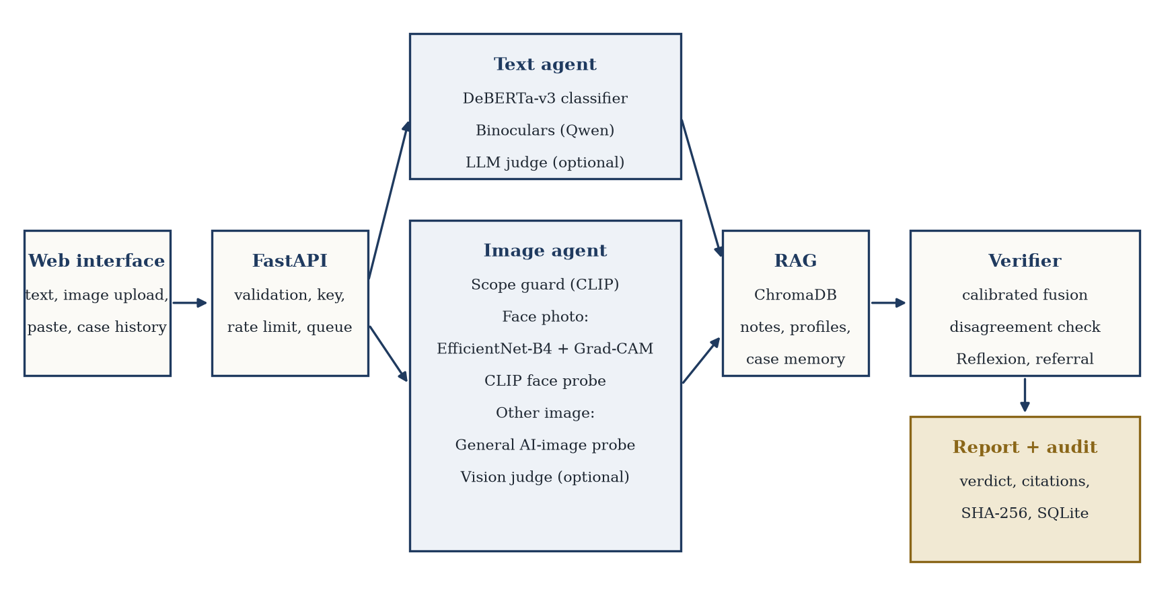
Figure 3.1: System architecture as built. The LangGraph orchestrator routes by modality; the verifier may trigger one Reflexion pass.
Several parts of the synopsis plan changed during implementation. Each change was recorded in the project decision log with its reason.
Synopsis plan | As built | Reason
XGBoost on stylometric features | Removed | The mixed-corpus transformer was far stronger, and handcrafted features added little over it.
RoBERTa-base classifier | DeBERTa-v3-base on a 136k-row HC3 + MAGE + RAID mix | A small model trained on HC3 alone memorised HC3 style and fell to AUROC 0.66 on MAGE.
Frequency and residual image tools | CLIP-based probes and a scope guard | Self-blended images, extra manipulation types and CLIP were tested for unseen-method transfer; only CLIP fusion helped. Frequency tools remain future work.
Xception baseline | EfficientNet-B4 only | One strong backbone kept the comparison clean on a single GPU.
React front end | Custom HTML, CSS and JavaScript served by FastAPI | No build step or second container; full control over the report layout.
Qdrant for production | ChromaDB only | Sufficient at the current scale; a persistent volume covers the demo and Docker use.

3.2 Text Forensics Agent
The text agent runs three tools and records each result in the shared state.
- Neural classifier. DeBERTa-v3-base fine-tuned on a mix of HC3, MAGE and RAID (136,000 training rows). Long texts are scored in sliding windows. Input is normalised first (zero-width characters removed, NFKC applied, look-alike Cyrillic and Greek letters mapped to ASCII when the text is mostly Latin); this alone raised AUROC on the homoglyph attack from 0.72 to 0.99 without retraining.
- Binoculars probe. The ratio of log-perplexity to cross-perplexity between Qwen2.5-0.5B and Qwen2.5-0.5B-Instruct [3], mapped to a probability by a logistic fit on the calibration split. It needs at least 50 words. Its fusion weight is capped at 0.10 because it did not improve the fused score (Section 5.4).
- Language-model judge. A prompted judge (Gemini or Claude, switchable) that treats the document strictly as data. It is optional and its output is parsed defensively; failures become error verdicts and never stop the pipeline.
Tools that cannot work on a given input are excluded from fusion and recorded as unavailable. Short passages down-weight the tools that are unreliable on them.

3.3 Image Forensics Agent
The deepfake detectors were trained on face photographs, so a zero-shot CLIP scope guard first estimates whether the image is a face photo. This addition followed a live test in which an AI-generated illustration was labelled authentic, because no tool had been trained on non-face images.
- Face photos: an EfficientNet-B4 network trained on a three-dataset mix (WildDeepfake, FaceForensics++, Celeb-DF) with strong augmentation, producing a Grad-CAM heat map [9], and a unified CLIP ViT-L/14 logistic probe trained on face swaps and AI-synthesised faces [13].
- Other images: a general CLIP probe trained on real-versus-AI images. The face tools return an explanatory “not used” verdict instead of a misleading score.
- Vision-language judge: an optional prompted judge for semantic plausibility, such as lighting, anatomy and garbled text.

3.4 Agentic Orchestration
The base classifiers remain ordinary tools. The agentic layer is the LangGraph graph that decides what happens to a case. The implemented flow is:
1. Validate the evidence and create a job record.
2. Route by modality; for images, run the scope guard and select the applicable tools.
3. Run the tools; a crashing or unavailable tool becomes an error verdict instead of stopping the case.
4. Retrieve reference material and cited case-memory neighbours.
5. Fuse calibrated scores, measure disagreement among the tools that carry real weight, and decide on the verdict.
6. If those tools disagree and a judge is available, re-run the judge once with the other tools' outputs and the retrieved notes (Reflexion).
7. Write the report and persist the audit record; refer the case to a human when it remains uncertain or conflicted.

3.5 RAG and Verification Layer
Knowledge base. ChromaDB holds three layers: literature notes written in our own words, generator-fingerprint notes, and case memory (every analysed job, storing the verdict and tool explanations but never the analysed content). Retrieval uses cosine similarity with a cut-off of 0.5; if nothing passes, the query is rewritten once from the strongest tool's features, and if still nothing passes the report says that no supporting evidence was found. Retrieved material never changes a score. Case-memory entries produced by the system itself are marked unverified; only a human correction makes an entry verified.
Fusion. Each usable tool contributes weight = base weight × length factor × confidence. Base weights come from validation AUROC, and scores are temperature-scaled on a calibration split that is never used for early stopping or testing. The verdict is synthetic above an upper threshold, authentic below a lower threshold and uncertain between them; both thresholds are fixed on calibration data before any test set is touched.
Verification. Disagreement is measured as the spread of scores among tools whose weight is at least 0.3; low-weight tools are advisory and only mentioned in the notes. This rule came from an observation during evaluation: the weak Binoculars probe disagreed with the classifier so often that 75 percent of MAGE cases were being referred to a human. A case is referred when fewer than two tools are usable, the verdict is uncertain, the weighted tools still disagree, or a human-verified earlier case contradicts the verdict.

3.6 Methodology and Timeline
Phase | Task | Output / deliverable | Timeline | Status
A | Literature review and architecture | Gap analysis, state schema | W1-2 | Done
B | Text models | DeBERTa-v3 classifier, Binoculars probe, LLM judge, input normalisation | W3-5 | Done
C | Image models | EfficientNet-B4, CLIP probes, scope guard, Grad-CAM | W6-8 | Done (frequency tools not built)
D | Agentic orchestration | Routing, fusion, state control, Reflexion | W9-10 | Done
E | RAG and verifier | Vector knowledge base, cited reports, case memory | W11-12 | Done
F | Frontend and evidence store | Web interface, SQLite audit records, hashing, Docker, CI | W13-14 | Done
G | Evaluation and documentation | Ablations, cross-domain tests, final report | W15-16 | In progress: local-tool results done; judge ablation pending

IMPLEMENTATION & WORKING MODEL

4.1 Engineering Structure
The code base is a single repository (github.com/Aditya-Khatri-7/Major-Project-) with strict separation between HTTP handling, forensic logic, retrieval, model artefacts and the interface.
forensics-agent/
api/ endpoints, validation, security (key, rate limit, retention)
agents/ orchestrator, verifier, fusion, calibration, text and image agents
rag/ ingestion, retrieval, case memory, knowledge_base/
evidence_store/ SQLAlchemy audit records and input hashing
training/ classifier training and calibration
eval/ score cache, benchmarks, robustness test, plots
web/ web interface (HTML, CSS, JavaScript)
tests/ 81 unit and integration tests
Configuration is read from environment variables through one settings class, and secrets are never stored in the repository. The test suite needs neither models nor API keys. A GitHub Actions pipeline runs the linter and tests, and builds both Docker images and imports the application inside the API image, so the container build is verified on every push.

4.2 Training and Evaluation Method
- Splits. Text by source document or question; images by source video. Whole generators (Cohere) and attack types (paraphrase, synonym, homoglyph) were held out of training.
- Training. Transfer learning throughout. Early stopping on validation AUROC, bf16 or fp32 weights (fp16 caused NaN losses), class weights where the data were imbalanced, and strong augmentation for images (random downscale, JPEG compression, blur, erasing).
- Calibration. Temperature scaling, fusion weights and decision thresholds are fitted on a separate calibration split and frozen before testing.
- Metrics. AUROC with 95 percent bootstrap intervals, TPR at 1 percent false positives, expected calibration error, escalation rate, and accuracy on the cases the system decides.

4.3 Working Modules and Attained Deliverables
Area | Attained | Remaining
Core engineering | Typed state schema, settings class, structured JSON logs, 81 tests, CI with Docker build | Distributed tracing (future scope)
Text agent | Classifier, Binoculars probe, judge adapter, input normalisation, calibration, five held-out benchmarks | Judge calibration and ablation (needs API quota)
Image agent | Scope guard, EfficientNet-B4, CLIP probes, Grad-CAM, four benchmarks, re-upload robustness test | Better transfer to unseen manipulation methods
Orchestration | LangGraph routing, fusion, disagreement rule, Reflexion, referral | Live Reflexion measurements
RAG | 21-chunk knowledge base, cosine retrieval, CRAG-style cut-off and rewrite, case memory with human corrections | Larger curated corpus
Product | Web interface with a print-ready case record (save as PDF), API with key and rate limit, SQLite audit store, Docker | Server-side PDF export (optional)

4.4 Service, Interface and Security
The API exposes analysis endpoints for text and images, retrieval of a stored case and its Grad-CAM image, a human-correction endpoint that updates case memory, and a health endpoint. Uploads are validated by content, not by file name; only one job runs at a time so the models share the GPU safely, and a waiting request receives a clear “busy” response rather than hanging. An access key, a per-client rate limit and optional deletion of old uploads can be enabled from configuration.
The web interface presents each result as a case record: the finding, a meter showing where the combined reading lies relative to the decision thresholds, the reading and reliability of each instrument, the Grad-CAM figure, verifier notes, cited reference material (with unverified system-generated cases labelled as such) and a form for recording the examiner's own determination. All model output is inserted as plain text, so retrieved or generated content cannot inject markup.
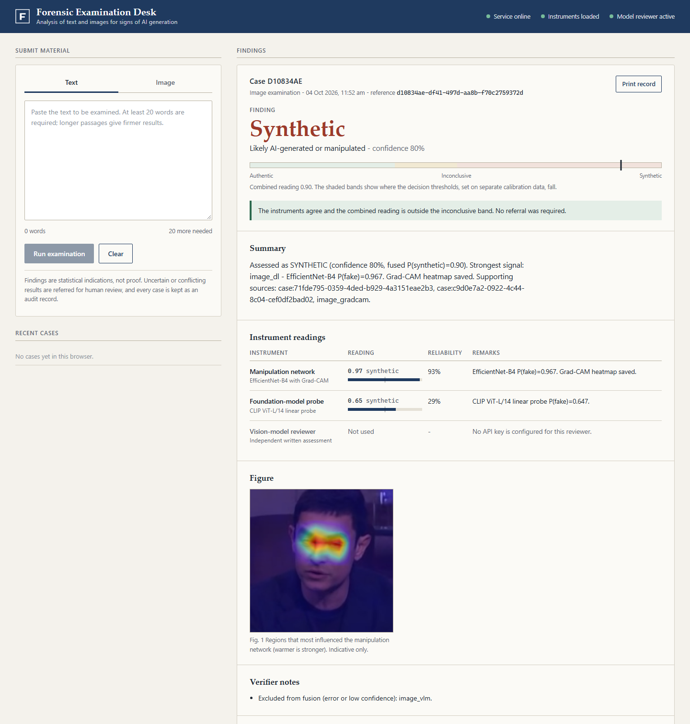
Figure 4.1: Web interface showing a deepfake image case with instrument readings and the Grad-CAM figure.

RESULTS & EVALUATION
All results below are measured on held-out data with thresholds frozen from a separate calibration split. Text sets contain 1,000 samples and image sets 1,500 images each. “Escalated” is the share of cases referred to a human; “accuracy when decided” is measured on the remaining cases.

5.1 Text Detection Results
Test set | DeBERTa  AUROC | Binoculars  AUROC | Full system  AUROC [95% CI] | TPR at  1% FPR | ECE | Escalated | Acc. when  decided
HC3 (in-domain) | 1.000 | 0.961 | 0.998 [0.994-1.000] | 1.00 | 0.014 | 33% | 0.996
MAGE | 0.967 | 0.628 | 0.961 [0.947-0.971] | 0.58 | 0.065 | 52% | 0.958
RAID, all | 0.986 | 0.718 | 0.985 [0.978-0.990] | 0.81 | 0.042 | 30% | 0.966
RAID, unseen generator | 0.957 | 0.923 | 0.957 [0.946-0.969] | 0.60 | 0.043 | 43% | 0.933
RAID, unseen attacks | 0.968 | 0.621 | 0.962 [0.949-0.972] | 0.61 | 0.068 | 36% | 0.920

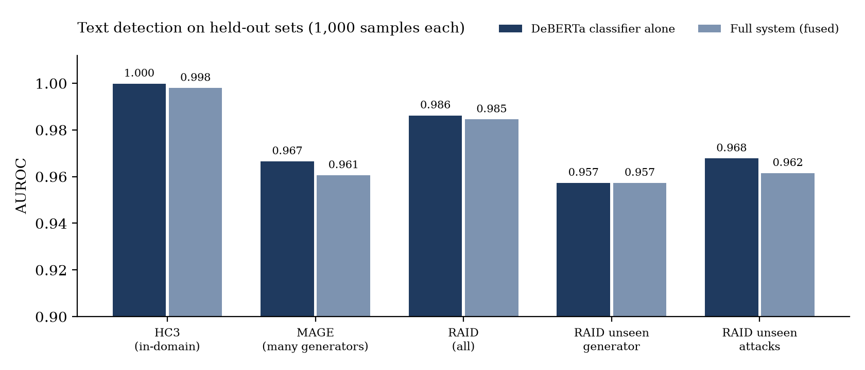
Figure 5.1: Text AUROC by held-out set, classifier alone versus the full system.
The classifier carries the text result. Fusing in Binoculars changes AUROC by −0.001 to −0.006, so the probe is retained only as a low-weight second opinion. At a strict 1 percent false-positive budget the system detects 58 to 61 percent of AI text on the hardest sets (MAGE and unseen attacks) and 81 to 100 percent on easier ones.

5.2 Image Detection Results
Test set | EfficientNet  AUROC | CLIP probe  AUROC | Fused AUROC  [95% CI] | TPR at  1% FPR | ECE | Escalated | Acc. when  decided
WildDeepfake test | 0.973 | 0.914 | 0.977 [0.968-0.984] | 0.67 | 0.052 | 29% | 0.977
FF++, seen methods | 0.980 | 0.809 | 0.976 [0.970-0.982] | 0.70 | 0.054 | 39% | 0.954
Celeb-DF test | 0.999 | 0.901 | 0.999 [0.997-1.000] | 0.99 | 0.078 | 29% | 0.995
FF++, unseen methods | 0.753 | 0.699 | 0.794 [0.771-0.816] | 0.13 | 0.185 | 53% | 0.759

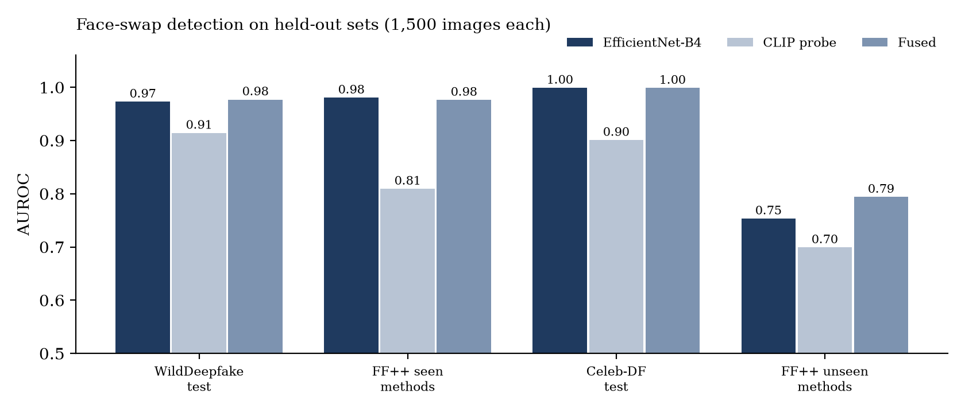
Figure 5.2: Image AUROC by held-out set for each tool and for the fused result.
A model trained only on WildDeepfake scored 0.52 on FaceForensics++ and 0.69 on Celeb-DF. The cause was a preprocessing mismatch (full video frames versus face crops) combined with single-source training; cropping faces and training on three sources raised these to 0.98 and 0.999. Celeb-DF and FaceForensics++ were part of the training mix (with video-disjoint test sets), so those scores are per-dataset. The only true zero-shot test is Face2Face and FaceShifter, where the system reaches 0.794 AUROC and catches only 13 percent of fakes at 1 percent false positives. Adding self-blended images, adding one extra manipulation method, and a CLIP-only probe each failed to close this gap.
AI-synthesised faces and non-face images are handled by the CLIP probes. In an offline check on 120 held-out images per class, weighted fusion of the two face tools caught 63 percent of synthetic faces at a 7 percent false-alarm rate, compared with 21 percent for the face-swap network alone. A maximum rule caught 96 percent but wrongly flagged 20 percent of real faces and was rejected.

5.3 Robustness to Re-uploaded Images
To approximate social-media handling, 300 images per set were degraded and re-scored with thresholds unchanged.
Degradation | Celeb-DF  AUROC / false alarms | WildDeepfake  AUROC / false alarms | FF++ seen  AUROC / false alarms
Original | 0.999 / 3% | 0.977 / 7% | 0.967 / 15%
JPEG quality 50 | 0.992 / 5% | 0.975 / 9% | 0.921 / 22%
Downscale to half size | 0.997 / 13% | 0.980 / 11% | 0.897 / 32%
Screenshot-like (downscale + JPEG 60) | 0.991 / 9% | 0.984 / 17% | 0.899 / 49%

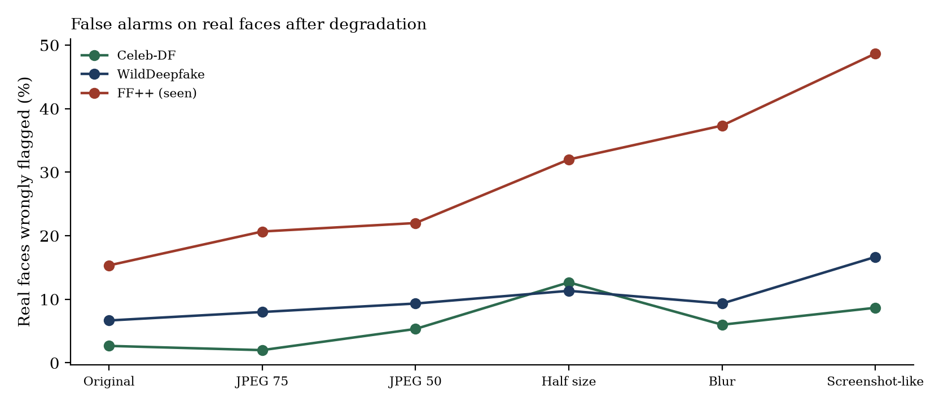
Figure 5.3: Share of real faces wrongly flagged after each degradation.
Ranking quality survives on Celeb-DF and WildDeepfake, but the false-alarm rate on real faces rises with degradation and is worst on FaceForensics++. Material that has been re-uploaded or screenshotted therefore needs a human check; a threshold tuned on degraded images is planned.

5.4 Findings Against the Research Questions
Research question (synopsis) | Finding so far
1. Does combining signals beat the best single detector? | Partly. For images, fusion raised unseen-method AUROC from 0.753 to 0.794 at almost no cost on seen sets. For text, fusion was equal to the classifier alone (within 0.006).
2. Does agentic routing beat a fixed tool sequence? | Yes for scope: the scope guard fixed an AI illustration being labelled authentic. A measured comparison with Reflexion needs the judges.
3. Does RAG improve support and auditability? | Every report cites retrieved sources or states that none were found; scores are unchanged by design. Support quality has not been scored by humans.
4. Does the verifier find uncertain cases better than a fixed threshold? | Accuracy on decided cases is 92 to 99.6 percent against 90 to 96 percent overall (for example MAGE 0.924 overall, 0.958 when decided), at the cost of referring 30 to 52 percent of cases.
5. What latency does each layer add? | About 4 to 6 seconds per examination once models are loaded on an RTX 5080; the first request after start-up is slower while models load.

5.5 Problems Found and Fixed
Problem | Cause | Fix | Effect
Text collapsed on MAGE (AUROC 0.66) | Training on one corpus | Mixed HC3 + MAGE + RAID, held-out generators and attacks | 0.97
Images at chance on FF++ (0.52) | Full frames versus face crops; single source | Face crops, three-dataset mix, augmentation | 0.98
Homoglyph attack broke the text model | Look-alike characters shatter the tokenizer | Input normalisation | 0.72 → 0.99
AI illustration called authentic | No tool covered non-face images | Scope guard and general probe | 39 of 40 art images correct
75% of MAGE cases referred | Weak probe triggered the disagreement rule | Low-weight tools made advisory | 52% (30-43% elsewhere)
Image calibration out of date | Fitted to a replaced CLIP probe | Re-scored, refit, reran all image benchmarks | Benchmarks above
Docker image would fail on images | scikit-learn and joblib missing from requirements | Requirements fixed; CI builds and imports the image | CI green
Slow requests after judge quota ran out | Retries with back-off on a daily limit | Fail fast and pause calls | No added delay

5.6 Limitations
- Unseen manipulation methods reach only 0.794 AUROC; the system should not be relied on for new face-swap techniques.
- Re-uploaded images raise false alarms on real faces (up to 49 percent on FaceForensics++ with screenshot-like damage).
- Language-model judges are not benchmarked. The Gemini judges ran on the four demo inputs and returned valid verdicts, but the vision judge scored the demo deepfake 0.05 with 85 percent confidence, missing it. The free-tier key allows 20 requests per day per model, so judge calibration and ablation were not possible; judge weights are set conservatively (0.3, not fitted).
- Writing styles absent from training data, such as non-native English, were not measured because no such dataset was available.
- AI-synthesised faces are only partly detected, and the art result (AUROC 0.999) is in-domain for that dataset.
- Detection is probabilistic, not proof, and degrades under compression and adversarial edits.

CONCLUSION & FUTURE SCOPE

6.1 Conclusion
The project has progressed from a planned architecture to a working, tested system. Detection is treated as a multi-step evidence analysis: independent tools score each input, calibrated scores are fused, cited reference material is retrieved, and cases the tools cannot settle are referred to a person. Six of the seven sub-objectives are complete (three with modifications), and the seventh, evaluation, is complete for the local tools.
The main finding so far is methodological. In-domain scores of 0.97 to 1.00 concealed collapses to 0.66 (text) and 0.52 (images) on data from other sources, and diagnosing and fixing these gaps took more effort than building the models. With separated calibration data, held-out generators and datasets, and frozen thresholds, the current system reaches AUROC 0.957 to 0.998 on text and 0.976 to 0.999 on seen image datasets, while being clear about where it fails: unseen manipulation methods, degraded re-uploads and the not-yet-benchmarked judges.

6.2 Plan for the End-Semester Stage
- Calibrate and benchmark the language-model judges on 400 samples per modality, then fill the judge ablation rows and measure Reflexion (needs a billing-enabled API key or the daily quota to reset).
- Tune an image threshold on degraded (re-uploaded) calibration images to reduce false alarms on screenshots and social-media copies.
- Add a second unseen synthetic-face generator set for a zero-shot test, and a non-native-English human text set for a text false-positive audit.
- Retrain the face-swap network with synthetic faces included instead of relying on fusion alone, and test frequency or residual evidence as a further tool.
- Finalise the project report and the demonstration; optional server-side PDF export of a case record.

6.3 Future Scope
- Video deepfake detection using temporal consistency and frame-level artefacts.
- A separate video agent that reuses the team's earlier work on spatio-temporal video models.
- Provenance checks and invisible watermarks for media from trusted pipelines.
- Tracing and continuous evaluation of the models and the retrieval step.
- Signed evidence logs and a stronger chain of custody.
- On-premise or edge deployment where evidence cannot be sent to a cloud service.
- A larger knowledge base fed by verified cases and analyst feedback.

REFERENCES
[1] L. Dugan, A. Hwang, F. Trhlík, A. Zhu, J. M. Ludan, H. Xu, D. Ippolito, and C. Callison-Burch, “RAID: A Shared Benchmark for Robust Evaluation of Machine-Generated Text Detectors,” in Proceedings of the 62nd Annual Meeting of the Association for Computational Linguistics, pp. 12463-12492, 2024.
[2] E. Mitchell, Y. Lee, A. Khazatsky, C. D. Manning, and C. Finn, “DetectGPT: Zero-Shot Machine-Generated Text Detection using Probability Curvature,” in Proceedings of the 40th International Conference on Machine Learning, PMLR 202, pp. 24950-24962, 2023.
[3] A. Hans, A. Schwarzschild, V. Cherepanova, H. Kazemi, A. Saha, M. Goldblum, J. Geiping, and T. Goldstein, “Spotting LLMs With Binoculars: Zero-Shot Detection of Machine-Generated Text,” in Proceedings of the 41st International Conference on Machine Learning, PMLR 235, pp. 17519-17537, 2024.
[4] A. Rössler, D. Cozzolino, L. Verdoliva, C. Riess, J. Thies, and M. Nießner, “FaceForensics++: Learning to Detect Manipulated Facial Images,” in Proceedings of the IEEE/CVF International Conference on Computer Vision, pp. 1-11, 2019.
[5] B. Zi, M. Chang, J. Chen, X. Ma, and Y.-G. Jiang, “WildDeepfake: A Challenging Real-World Dataset for Deepfake Detection,” in Proceedings of the 28th ACM International Conference on Multimedia, pp. 2382-2390, 2020.
[6] P. Lewis et al., “Retrieval-Augmented Generation for Knowledge-Intensive NLP Tasks,” in Advances in Neural Information Processing Systems, vol. 33, 2020.
[7] F. Zhang et al., “Code-in-the-Loop Forensics: Agentic Tool Use for Image Forgery Detection,” arXiv:2512.16300, 2026.
[8] C. Wang, Y. Wang, Y. Cao, C. Xiao, and F. Shen, “LaP-Forensics: Latent-Pixel Consistency Guided Multimodal Reasoning for Deepfake Detection,” arXiv:2607.25962, 2026.
[9] R. R. Selvaraju, M. Cogswell, A. Das, R. Vedantam, D. Parikh, and D. Batra, “Grad-CAM: Visual Explanations from Deep Networks via Gradient-Based Localization,” in Proceedings of the IEEE International Conference on Computer Vision, pp. 618-626, 2017.
[10] M. Tan and Q. V. Le, “EfficientNet: Rethinking Model Scaling for Convolutional Neural Networks,” in Proceedings of the 36th International Conference on Machine Learning, PMLR 97, pp. 6105-6114, 2019.
[11] Y. Li, X. Yang, P. Sun, H. Qi, and S. Lyu, “Celeb-DF: A Large-Scale Challenging Dataset for DeepFake Forensics,” in Proceedings of the IEEE/CVF Conference on Computer Vision and Pattern Recognition, pp. 3207-3216, 2020.
[12] P. He, X. Liu, J. Gao, and W. Chen, “DeBERTa: Decoding-enhanced BERT with Disentangled Attention,” in International Conference on Learning Representations, 2021.
[13] A. Radford et al., “Learning Transferable Visual Models From Natural Language Supervision,” in Proceedings of the 38th International Conference on Machine Learning, PMLR 139, pp. 8748-8763, 2021.
[14] N. Shinn, F. Cassano, A. Gopinath, K. Narasimhan, and S. Yao, “Reflexion: Language Agents with Verbal Reinforcement Learning,” in Advances in Neural Information Processing Systems, vol. 36, 2023.
[15] Y. Li et al., “MAGE: Machine-generated Text Detection in the Wild,” in Proceedings of the 62nd Annual Meeting of the Association for Computational Linguistics, 2024.
[16] S.-Q. Yan, J.-C. Gu, Y. Zhu, and Z.-H. Ling, “Corrective Retrieval Augmented Generation,” arXiv:2401.15884, 2024.
[17] B. Guo et al., “How Close is ChatGPT to Human Experts? Comparison Corpus, Evaluation, and Detection,” arXiv:2301.07597, 2023.

