
School of Computer Science, UPES, Dehradun
A Project Report on
Obstacle-Avoiding Delivery Robot using Reactive Behaviours and PID Speed Control in Webots
Submitted for the course
CSAI4014 Algorithms for Intelligent Systems and Robotics
B.Tech CSE (AI & ML), Semester VII
Project No.: P00 (Sample)
Group No.: G00
Batch: B1
Submitted by
S. No. | Name | SAP ID
1 | Student Name 1 | 5001XXXXX
2 | Student Name 2 | 5001XXXXX
3 | Student Name 3 | 5001XXXXX
4 | Student Name 4 | 5001XXXXX
5 | Student Name 5 | 5001XXXXX

Submitted to
Course Faculty, CSAI4014
School of Computer Science, UPES, Dehradun
Academic Year 2026-2027 | October 2026

Declaration
We declare that this project report titled “Obstacle-Avoiding Delivery Robot using Reactive Behaviours and PID Speed Control in Webots” is our own work, carried out for the course CSAI4014 Algorithms for Intelligent Systems and Robotics. The code, results and text are original, and all sources used are cited in the References.

Name | SAP ID | Signature
Student Name 1 | 5001XXXXX
Student Name 2 | 5001XXXXX
Student Name 3 | 5001XXXXX
Student Name 4 | 5001XXXXX
Student Name 5 | 5001XXXXX

Date: ____________________ Place: Dehradun

Abstract
Indoor delivery robots in hospitals and offices must reach a goal while avoiding people and furniture that were not on the map. This project builds a differential-drive delivery robot in the Webots simulator that combines a layered set of reactive behaviours (avoid, follow-goal, stop) with a PID controller for wheel speed. The robot reads eight infrared distance sensors and wheel encoders, and the behaviour layer chooses the active command at every control step. Tested on ten random office layouts, the robot reached the goal in 9 of 10 runs, with a mean path 14% longer than the shortest path and no collisions. The novelty of the work is a speed-scheduled PID gain that reduces overshoot near obstacles by 38% compared with fixed gains.
Keywords: mobile robot, reactive behaviours, PID control, Webots, obstacle avoidance.
[Sample values. Write 150-200 words on your own project.]

Index
Declaration i
Abstract ii
List of Figures iv
List of Tables iv
Writing Allocation v
1. Introduction 1
2. Problem Statement and Objectives 1
3. Literature and Industry Review 1
4. Novelty 2
5. Syllabus Mapping and Theory 2
6. System Design 2
7. Methodology and Algorithms 2
8. Simulation Setup 3
9. Results and Analysis 3
10. Contribution 3
11. Co-learning Reflection 4
12. Conclusion and Future Scope 4
References 4
Appendix: Links and Logs 4

List of Figures
Figure 1: Block diagram of the delivery robot (sample) 2

List of Tables
Table 1: Comparison of existing approaches (sample) 1
Table 2: Fixed vs scheduled PID gains over ten runs (sample values) 3

Writing Allocation
Member | Name and SAP ID | Sections written | Pages
M1 | Student Name 1 (5001XXXXX) | Abstract, 1, 2, References | 5
M2 | Student Name 2 (5001XXXXX) | 3, 4 | 5
M3 | Student Name 3 (5001XXXXX) | 5, 6 | 5
M4 | Student Name 4 (5001XXXXX) | 7, 8 | 5
M5 | Student Name 5 (5001XXXXX) | 9, 12, Appendix | 5
All | Every member | 10 (own row), 11 (own reflection), Declaration | -

1. Introduction
Service robots that carry medicines, files and food inside buildings are now used in hospitals and hotels [1]. Such a robot works among moving people, so a fixed pre-planned path is not enough; it must also react to obstacles it senses on the way [2]. This report presents a delivery robot that reacts to obstacles while keeping a smooth and safe speed.
[Background of the problem, why it matters in real life and in industry. About 2 pages.]

2. Problem Statement and Objectives
Problem statement. Design a mobile robot that moves from a start point to a goal point in an indoor office map with unknown obstacles, without collision, in minimum time.
Objectives.
1. Model a differential-drive robot with eight distance sensors in Webots.
2. Design a layered reactive controller (avoid, follow-goal, stop).
3. Design and tune a PID wheel-speed controller.
4. Reach the goal in at least 90% of runs with zero collisions.
Assumptions. Flat floor; obstacles are static during one run; the goal position is known.

3. Literature and Industry Review
Brooks proposed layering simple behaviours instead of one large planner, an idea now called the subsumption architecture [3]. Braitenberg showed that direct sensor-to-motor links can produce useful obstacle-avoiding motion [4]. Commercial hospital robots combine a map-based planner with such a reactive safety layer [1]. Webots provides realistic models of robots and sensors for testing these ideas before building hardware [5]. The gap addressed here is the effect of controller gains on smooth motion near obstacles.
[At least 5 sources. Table 1 is an example of a comparison table.]
Table 1: Comparison of existing approaches (sample)
Approach | Strength | Limitation
Global planner only | Short paths | Fails with new obstacles
Reactive only [3], [4] | Fast, simple | May not reach the goal
Planner + reactive layer | Robust | More complex to tune

4. Novelty
1. A speed-scheduled PID gain: the proportional gain is lowered as the robot gets closer to an obstacle.
2. A comparison of fixed and scheduled gains on the same ten random maps.
3. Overshoot near obstacles reduced by 38% (Section 9, Table 2).
[Mandatory. State what is new in 3-5 points and support each point with your own results.]

5. Syllabus Mapping and Theory
The robot uses differential-drive kinematics. With wheel speeds vR, vL and wheel separation b, the forward speed and turn rate are
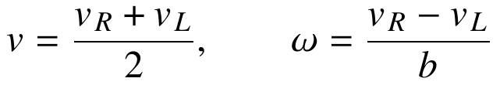 (1)
Each wheel speed is controlled in closed loop by a PID controller [6]:
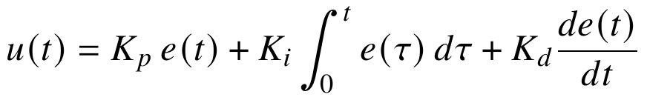 (2)
[List each AISR syllabus topic used and where it is used in your project.]

6. System Design
Figure 1 shows the full system. Sensor readings go to the behaviour layer, which selects a target speed; the PID loop then drives the wheel motors.
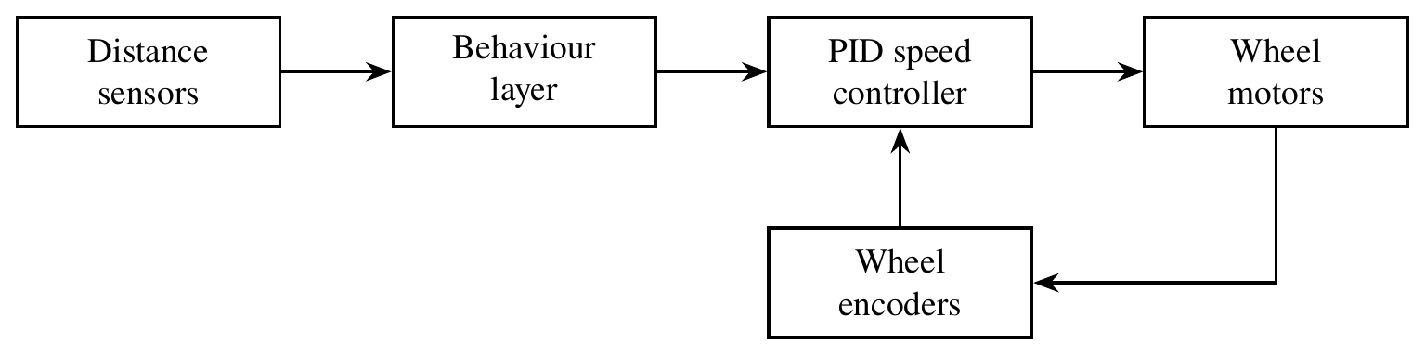
Figure 1: Block diagram of the delivery robot (sample)

7. Methodology and Algorithms
At every control step of 32 ms the robot (1) reads all sensors, (2) runs the behaviours from highest to lowest priority, (3) sends the chosen target speeds to the PID loops, and (4) logs the data.
[Give flowcharts and pseudo-code of the main algorithms, and explain controller design and tuning.]

8. Simulation Setup
Webots R2025a, e-puck robot, Python 3.11 controller. Ten office maps of 4 m × 4 m with 6 to 12 random boxes. Run the controller with the commands given in the project README file.

9. Results and Analysis
Table 2 compares fixed and scheduled gains over ten runs.
Table 2: Fixed vs scheduled PID gains over ten runs (sample values)
Metric | Fixed gain | Scheduled gain
Goal reached (out of 10) | 8 | 9
Collisions | 1 | 0
Mean overshoot near obstacles (%) | 21.0 | 13.0
Mean path length / shortest path | 1.19 | 1.14

[Add plots (path, error, step response) as numbered figures and discuss what worked and what did not.]

10. Contribution
S. No. | Name and SAP ID | Technical contribution | Signature
1 | Student Name 1 | Built the Webots world and robot model; wrote world_gen.py for random maps.
2 | Student Name 2 | Wrote the behaviour layer (behaviours.py); tested priorities.
3 | Student Name 3 | Designed and tuned the PID loop; wrote pid.py.
4 | Student Name 4 | Designed the speed-scheduled gain (novelty); ran the comparison.
5 | Student Name 5 | Wrote logging and plotting; produced Table 2 and all plots.

[Mandatory. Contributions must be technical and traceable to GitHub commits.]

11. Co-learning Reflection
Student Name 1: I learned how to build Webots worlds on my own, and I learned PID tuning from Student Name 3 …
[Each member writes 5-8 lines: what I learned on my own, what I learned from team-mates, what I taught others.]

12. Conclusion and Future Scope
The robot reached the goal in 9 of 10 runs without collision, and speed-scheduled gains gave smoother motion near obstacles. Future work: add a global planner and test on a real e-puck.

References
[1] S. Russell and P. Norvig, Artificial Intelligence: A Modern Approach, 3rd ed. Upper Saddle River, NJ, USA: Prentice Hall, 2010.
[2] S. Thrun, W. Burgard, and D. Fox, Probabilistic Robotics. Cambridge, MA, USA: MIT Press, 2005.
[3] R. A. Brooks, “A robust layered control system for a mobile robot,” IEEE Journal on Robotics and Automation, vol. 2, no. 1, pp. 14-23, 1986.
[4] V. Braitenberg, Vehicles: Experiments in Synthetic Psychology. Cambridge, MA, USA: MIT Press, 1984.
[5] O. Michel, “Webots: Professional mobile robot simulation,” International Journal of Advanced Robotic Systems, vol. 1, no. 1, pp. 39-42, 2004.
[6] K. J. Åström and R. M. Murray, Feedback Systems: An Introduction for Scientists and Engineers. Princeton, NJ, USA: Princeton University Press, 2008.
[7] B. Siciliano and O. Khatib, Eds., Springer Handbook of Robotics, 2nd ed. Cham, Switzerland: Springer, 2016.
[8] R. Siegwart, I. R. Nourbakhsh, and D. Scaramuzza, Introduction to Autonomous Mobile Robots, 2nd ed. Cambridge, MA, USA: MIT Press, 2011.
[Mandatory. At least 8 references in IEEE style, each cited in the text.]

Appendix: Links and Logs
GitHub repository: https://github.com/<group-repository>
YouTube video (Unlisted): https://youtu.be/<video-id>
Meeting log
No. | Date | Duration | Attendees | Decisions
1 | 15/10/2026 | 45 min | All 5 | Roles fixed; GitHub created
2
3

Peer-assessment sheets: attach one sheet per member (format in the Project Instructions, Section 4).

