Start Date :...................... Date of Completion:.......................

Group A Assignment No: 1(A)

**Title of the Assignment:** Design and implement Parallel Breadth First Search based on existing algorithms using OpenMP. Use a Tree or an undirected graph for BFS

**Objective of the Assignment:** Students should be able to perform Parallel Breadth First Search based on existing algorithms using OpenMP

**Prerequisite:**

1. Basic of programming language
2. Concept of BFS
3. Concept of Parallelism

**---------------------------------------------------------------------------------------------------------------**

**Contents for Theory:**

1. **What is BFS?**
2. **Example of BFS**
3. **Concept of OpenMP**
4. **How Parallel BFS Work**
5. **Code Explanation with Output**

**---------------------------------------------------------------------------------------------------------------**

**What is BFS?**

BFS stands for Breadth-First Search. It is a graph traversal algorithm used to explore all the nodes of a graph or tree systematically, starting from the root node or a specified starting point, and visiting all the neighboring nodes at the current depth level before moving on to the next depth level.

The algorithm uses a queue data structure to keep track of the nodes that need to be visited, and marks each visited node to avoid processing it again. The basic idea of the BFS algorithm is to visit all the nodes at a given level before moving on to the next level, which ensures that all the nodes are visited in breadth-first order.

BFS is commonly used in many applications, such as finding the shortest path between two nodes, solving puzzles, and searching through a tree or graph.

**Example of BFS**

Now let’s take a look at the steps involved in traversing a graph by using Breadth-First Search:

**Step 1:** Take an Empty Queue.

**Step 2:** Select a starting node (visiting a node) and insert it into the Queue.

**Step 3:** Provided that the Queue is not empty, extract the node from the Queue and insert its child nodes (exploring a node) into the Queue.

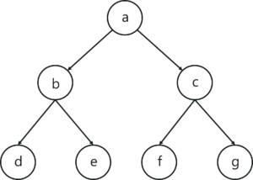**Step 4:** Print the extracted node.

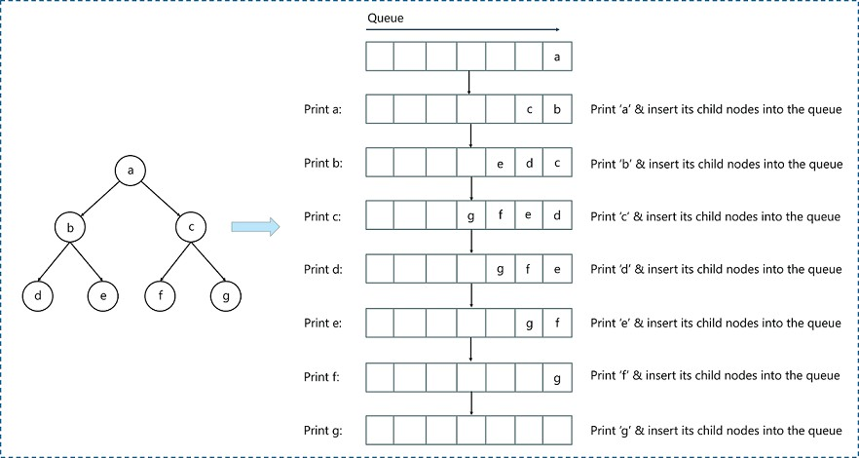

**Concept of OpenMP**

* OpenMP (Open Multi-Processing) is an application programming interface (API) that supports shared-memory parallel programming in C, C++, and Fortran. It is used to write parallel programs that can run on multicore processors, multiprocessor systems, and parallel computing clusters.
* OpenMP provides a set of directives and functions that can be inserted into the source code of a program to parallelize its execution. These directives are simple and easy to use, and they can be applied to loops, sections, functions, and other program constructs. The compiler then generates parallel code that can run on multiple processors concurrently.
* OpenMP programs are designed to take advantage of the shared-memory architecture of modern processors, where multiple processor cores can access the same memory. OpenMP uses a fork-join model of parallel execution, where a master thread forks multiple worker threads to execute a parallel region of the code, and then waits for all threads to complete before continuing with the sequential part of the code.
* OpenMP is widely used in scientific computing, engineering, and other fields that require high-performance computing. It is supported by most modern compilers and is available on a wide range of platforms, including desktops, servers, and supercomputers.

**How Parallel BFS Work**

* Parallel BFS (Breadth-First Search) is an algorithm used to explore all the nodes of a graph or tree

systematically in parallel. It is a popular parallel algorithm used for graph traversal in distributed computing, shared-memory systems, and parallel clusters.

* The parallel BFS algorithm starts by selecting a root node or a specified starting point, and then assigning it to a thread or processor in the system. Each thread maintains a local queue of nodes to be visited and marks each visited node to avoid processing it again.
* The algorithm then proceeds in levels, where each level represents a set of nodes that are at a certain distance from the root node. Each thread processes the nodes in its local queue at the current level, and then exchanges the nodes that are adjacent to the current level with other threads or processors. This is done to ensure that the nodes at the next level are visited by the next iteration of the algorithm.
* The parallel BFS algorithm uses two phases: the computation phase and the communication phase. In the computation phase, each thread processes the nodes in its local queue, while in the communication phase, the threads exchange the nodes that are adjacent to the current level with other threads or processors.
* The parallel BFS algorithm terminates when all nodes have been visited or when a specified node has been found. The result of the algorithm is the set of visited nodes or the shortest path from the root node to the target node.
* Parallel BFS can be implemented using different parallel programming models, such as OpenMP, MPI, CUDA, and others. The performance of the algorithm depends on the number of threads or processors used, the size of the graph, and the communication overhead between the threads or processors.

**Conclusion**- In this way we can achieve parallelism while implementing BFS

**Assignment Question**

1. **What if BFS?**
2. **What is OpenMP?What is its significance in parallel programming?**
3. **Write down applications of Parallel BFS**
4. **How can BFS be parallelized using OpenMP? Describe the parallel BFS algorithm using OpenMP.**
5. **Write Down Commands used in OpenMP?**

**Reference link**

* https://[www.edureka.co/blog/breadth-first-search-algorithm/](http://www.edureka.co/blog/breadth-first-search-algorithm/)