**Understanding and the Applications of Random Walks**

**Introduction**

Random walks are a fundamental concept in understanding various stochastic processes across multiple fields, including mathematics, physics, computer science, and finance. They model paths consisting of a series of random steps, providing insights into seemingly unpredictable systems. This blog post explores the types, mathematical properties, applications, and advanced topics related to random walks.

**Types of Random Walks**

There are three main types of random walks, simple, symmetric, and biased.

1. Simple Random Walk

In a simple random walk, the walker takes steps of fixed length in random directions. For a one-dimensional simple random walk, each step is either to the left or the right with equal probability. This process is described by:

$$X_{n+1}=X_{n}+ζ_{n+1}$$

Where $ζ_{n+1}$ are independent random variables taking either +1 or -1 with equal probability, ½.

2. Symmetric Random Walk

Symmetric random walks generalize the simple random walk to higher dimensions. In the $Z^{d}$ space, the walker moves to any of the 2 * d neighboring sites with equal probability.

3. Biased Random Walk

The biased random walk is a case of the simple random walk, but rather than the equal probabilities between +1 and -1, the probabilities may not be the same. For example, the probability of stepping to the right may be higher than stepping to the left.

**Mathematical Properties of Random Walks**

Random walks exhibit several interesting properties:

* Expectation and Variance: For a simple symmetric random walk, the expectation $E\left[X_{n}\right]=0$ and the variance $Var\left(X_{n}\right)=n$.
* Central Limit Theorem: As n becomes large, the distribution of $X_{n}$ approaches a normal distribution with mean 0 and variance n.

**Applications of Random Walks**

Random walks can be observed in several different ways in numerous fields. For example:

1. Physics: Brownian Motion

Brownian motion, the random movement of particles suspended in a fluid, is modeled using random walks. Einstein’s theory quantitatively describes how the mean squared displacement of particles is proportional to time: $$〈x^{2}(t)〉=2Dt$$  
where $〈x^{2}(t)〉$ is the mean squared displacement, D is the diffusion coefficient, and t is time.

2. Finance: Stock Market Modeling

Random walks are integral in financial modeling, particularly in the context of stock prices:

* Efficient Market Hypothesis: Stock prices follow a random walk, implying future price movements are independent of past movements.
* Geometric Brownian Motion: Used to describe the stochastic behavior of stock prices, incorporating drift and volatility: $dS_{t}=μS_{t}dt+σS_{t}dW_{t}$ 
     
  ​where $S_{t}$ is the stock price, μ is the drift rate, σ is the volatility, and $W_{t}$ is a Wiener process.

3. Biology: Animal Movement Patterns

Random walks help model the movement patterns of animals:

* Foraging Behavior: Animals searching for food exhibit random walk patterns.

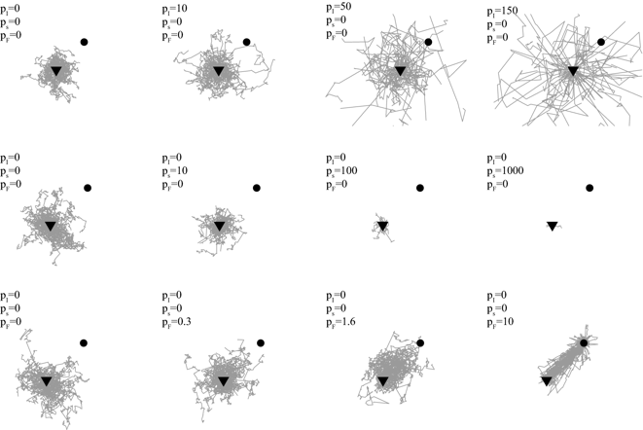

Figure 1: Simulated random walk model that accounts for space occupation and movements of a large herbivore for 50 trials of n = 100 steps. The herbivore is represented by the black triangle, and the attractor is the black dot.[6]

* Levy Flights: Some animals follow Levy flights, characterized by many short moves with occasional long jumps.

4. Computer Science: Algorithms and Network Analysis

Random walks are used in various algorithms and network-related applications:

* Monte Carlo Methods: Rely on random sampling to approximate complex integrals and probabilistic models.
* PageRank Algorithm: Google’s PageRank algorithm is based on a random walk model where a random surfer clicks on links at random: $$PR\left(P_{i}\right)=\frac{1-d}{N}+d\sum_{P_{j}∈M\left(P_{i}\right)}{\frac{PR\left(P_{j}\right)}{L\left(P_{j}\right)}}$$ 
  ​ where $PR\left(P_{i}\right)$ is the PageRank of page $P_{i}$, d is the damping factor, N is the total number of pages, $M\left(P_{i}\right)$ is the set of pages linking to $P_{i}$ ​, and ${L(P}_{j})$ is the number of outbound links on page $P_{j}$ ​.

**Practical Example**

To clarify the concept of the random walk algorithm in a more concrete way, here’s some simple Julia code to demonstrate a one-dimensional simple random walk:

using Plots

function simple_random_walk(n_steps)

steps = rand([-1, 1], n_steps)

position = cumsum(steps)

return position

end

# Simulate a random walk with 10 steps

n_steps = 10

random_walk = simple_random_walk(n_steps)

# Plot the random walk

plot(random_walk, label="Random Walk", title="1D Simple Random Walk", xlabel="Step", ylabel="Position")

Figure 2: Simple Julia code to demonstrate a Random walk for n=10 steps.

When executed, this results in a graph that looks like this. We see that the position starts at -1 at n=1 steps and progresses from there. Each step is either +1 or -1 vertically, in accordance with a simple random walk.

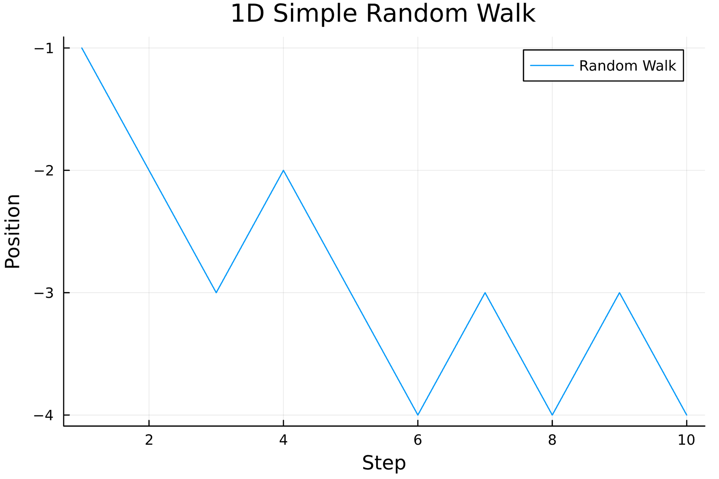

Figure 3: Graphical representation of a one-dimensional random walk of 10 steps.

**Advanced Topics**

Markov Chains: Random walks can be generalized to Markov chains, where the probability of each step depends only on the current state.

Random Walks on Graphs: In graph theory, random walks model processes that traverse the edges of a graph, crucial for network analysis and search algorithms.

**Conclusions**

Random walks offer a versatile framework for modeling and analyzing various stochastic processes. Their simplicity and profound mathematical properties make them indispensable in both theoretical studies and practical applications. Understanding random walks provides insights into the nature of randomness and its implications across multiple domains.

**References**

[1] R. Durrett, "Probability: Theory and Examples," 5th ed., Cambridge University Press, 2019.

[2] S. P. Meyn and R. L. Tweedie, "Markov Chains and Stochastic Stability," 2nd ed., Cambridge University Press, 2009.

[3] J. Norris, "Markov Chains," Cambridge University Press, 1998.

[4] A. Bovier, "Markov Processes and Applications: Algorithms, Networks, Genome and Finance," Springer, 2006.

[5] Y. M. Ermoliev and V. I. Norkin, "Monte Carlo Methods and Optimization," Springer, 2013.

[6] G. Berthelot, S. Said, and V. Bansaye. “A random walk model that accounts for space occupation and movements of a large herbivore,” *Sci Rep*, vol. 11, no. 14061, July 2021, 10.1038/s41598-021-93387-2. [Online]. Available: [www.nature.com/articles/s41598-021-93387-2](https://www.nature.com/articles/s41598-021-93387-2).