**Group 6 report**

1. **Compiler Flags**

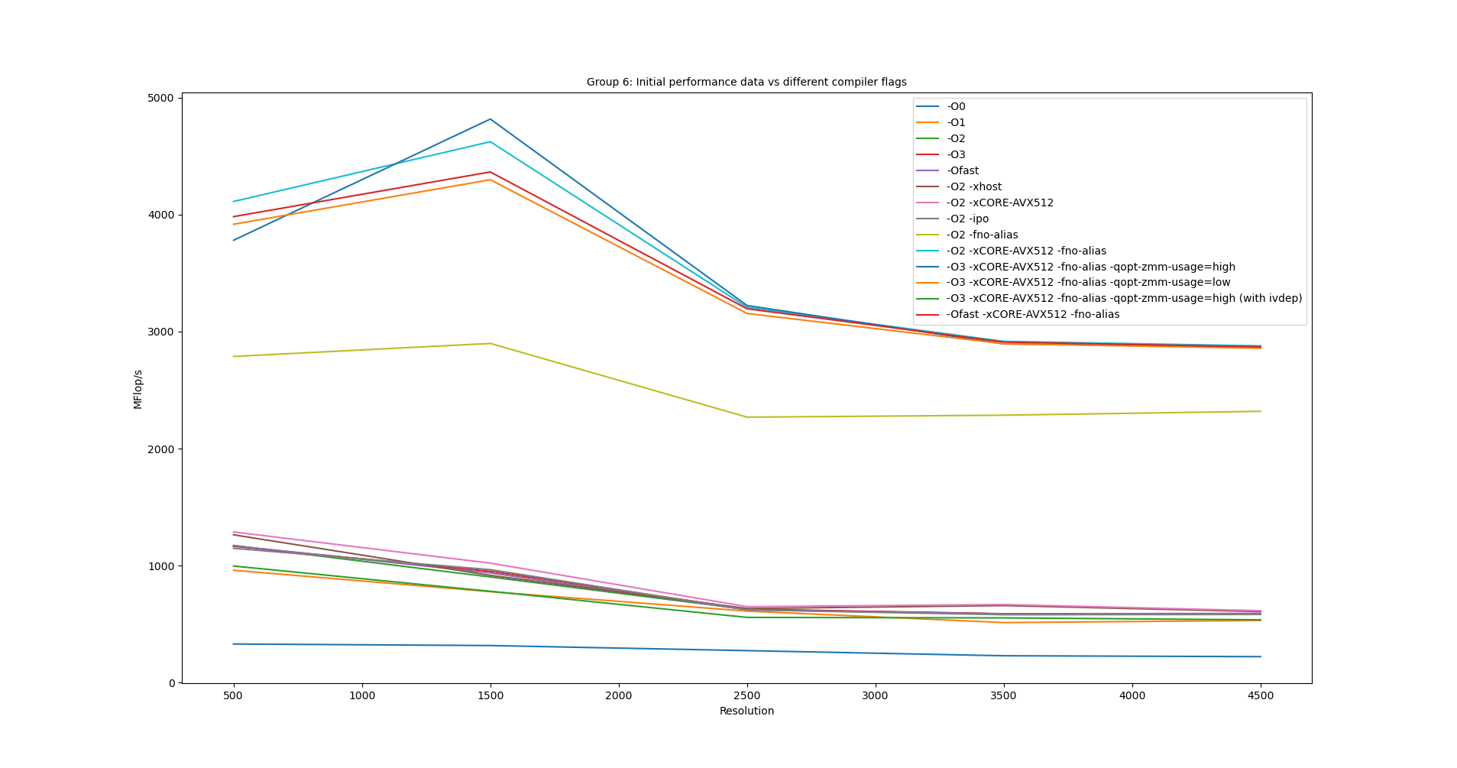

We obtained three categories/clusters of graphs, each with varying MFlop/s. The lowest values are obtained for the compiler flags “**-O1**” to “**-Ofast**” (with increasing performance in that order). A slight performance gain is observed when these optimizations are clubbed with “**-xhost**” and “**-xCORE-AVX512**”. These compiler flags add extra optimizations as per the corresponding host architecture.

The next big speedup is obtained by adding “**-fno-aliasing**” to the compiler flags “**-O1**” to “**-Ofast**” (with increasing performance in that order). By specifying “**-fno-aliasing**”, we ask the compiler not to assume aliasing in the program and do possible optimizations. Specifically, this results in loop interchange and other loop optimizations in “**relax_jacobi.c**” and wherever possible.

Finally, the third and highest category of speedups is obtained by combinations “**-O2/O3/Ofast -xCORE-AVX512 -fno-alias -qopt-zmm-usage=high**”. Their speed was quite similar, especially in the higher resolutions. Overall, the combination: “**O3 -xCORE-AVX512 -fno-alias -qopt-zmm-usage=high**” performs best.

1. **Profiling**

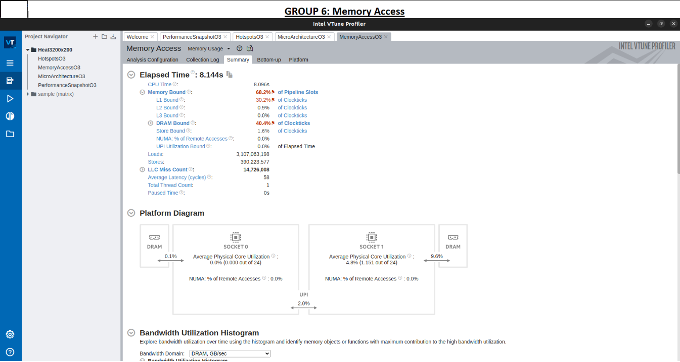

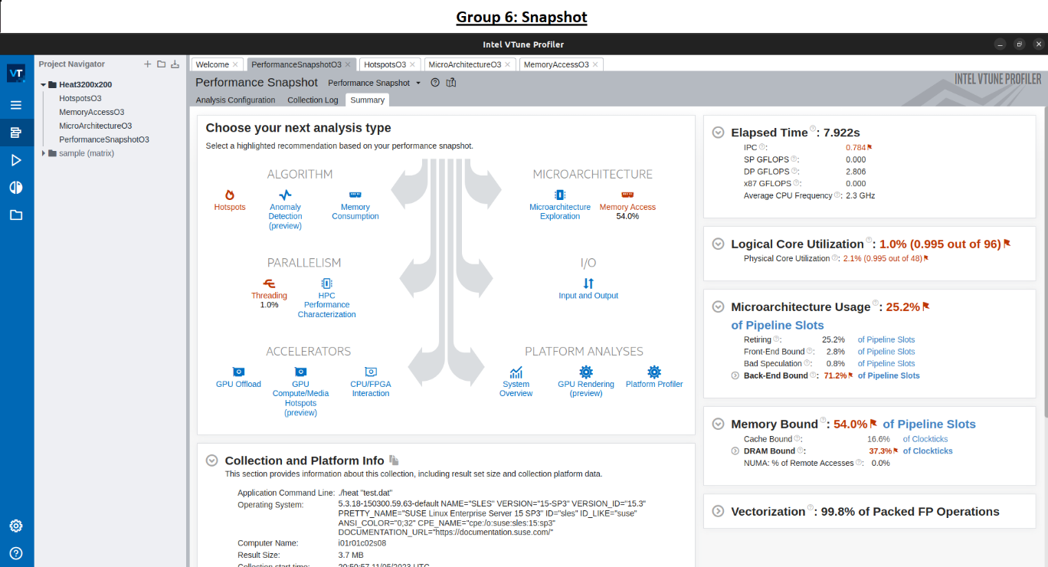

1. **Sequential Optimization**

**Have to re-run.**

1. **OpenMP**

1. **MPI parallelization**
2. **Hybrid parallelization vs pure MPI parallelization**