## **INFO 5100 Application Engineering and Development**

# **Final Project Proposal**

**Project Title : MediLink**

Group Number : 21

| S. No. | NAME | NUID |
| --- | --- | --- |
| 1. | Aditya Sudhakar Pimpalkar | 002060468 |
| 2. | Diksha Sahare | 002479925 |
| 3. | Komal Pravinkumar Khairnar | 002472617 |

**MediLink***Seamlessly Connecting Healthcare Services Through a Unified Digital Ecosystem*

### **Problem Statement**

The healthcare ecosystem faces numerous challenges that hinder efficiency, coordination, and service quality for patients, providers, and administrators:

#### **For Patients**

* **Fragmented Access**: Patients struggle to connect with the right services, such as ambulances, diagnostic labs, and pharmacies.
* **Inefficient Communication**: Multiple disconnected platforms lead to delays in receiving timely care.
* **Lack of Transparency**: Patients face uncertainty about service availability, costs, and timelines.

#### **For Healthcare Enterprises**

* **Resource Management Bottlenecks**: Assigning personnel and managing inventory across organizations is cumbersome.
* **Operational Gaps**: Enterprises lack visibility into system-wide operations, affecting efficiency and accountability.
* **Inconsistent Interactions**: Communication between enterprises, such as hospitals and pharmacies, is often manual and error-prone.

These issues collectively impact the quality of care delivery, resulting in delays, inefficiencies, and reduced patient satisfaction.

### 

### **Solution**

**MediLink** is a robust, role-based healthcare ecosystem designed to streamline operations, improve patient experiences, and foster seamless collaboration between healthcare providers, diagnostics, emergency services, and pharmaceuticals.

#### **Core Features**

* **Centralized Platform**: A single interface connects all healthcare stakeholders for real-time communication and collaboration.
* **Role-Specific Dashboards**: Tailored interfaces for administrators, technicians, and service providers ensure focused workflows.
* **Efficient Resource Allocation**: Automated processes for assigning ambulances, diagnostic tests, and pharmacy orders.
* **Transparency and Trust**: Patients gain visibility into services, costs, and timelines, ensuring informed decisions.
* **Scalable Infrastructure**: Designed to grow with expanding healthcare needs, supporting additional roles and organizations seamlessly.

### 

**High Level Component Diagram:**

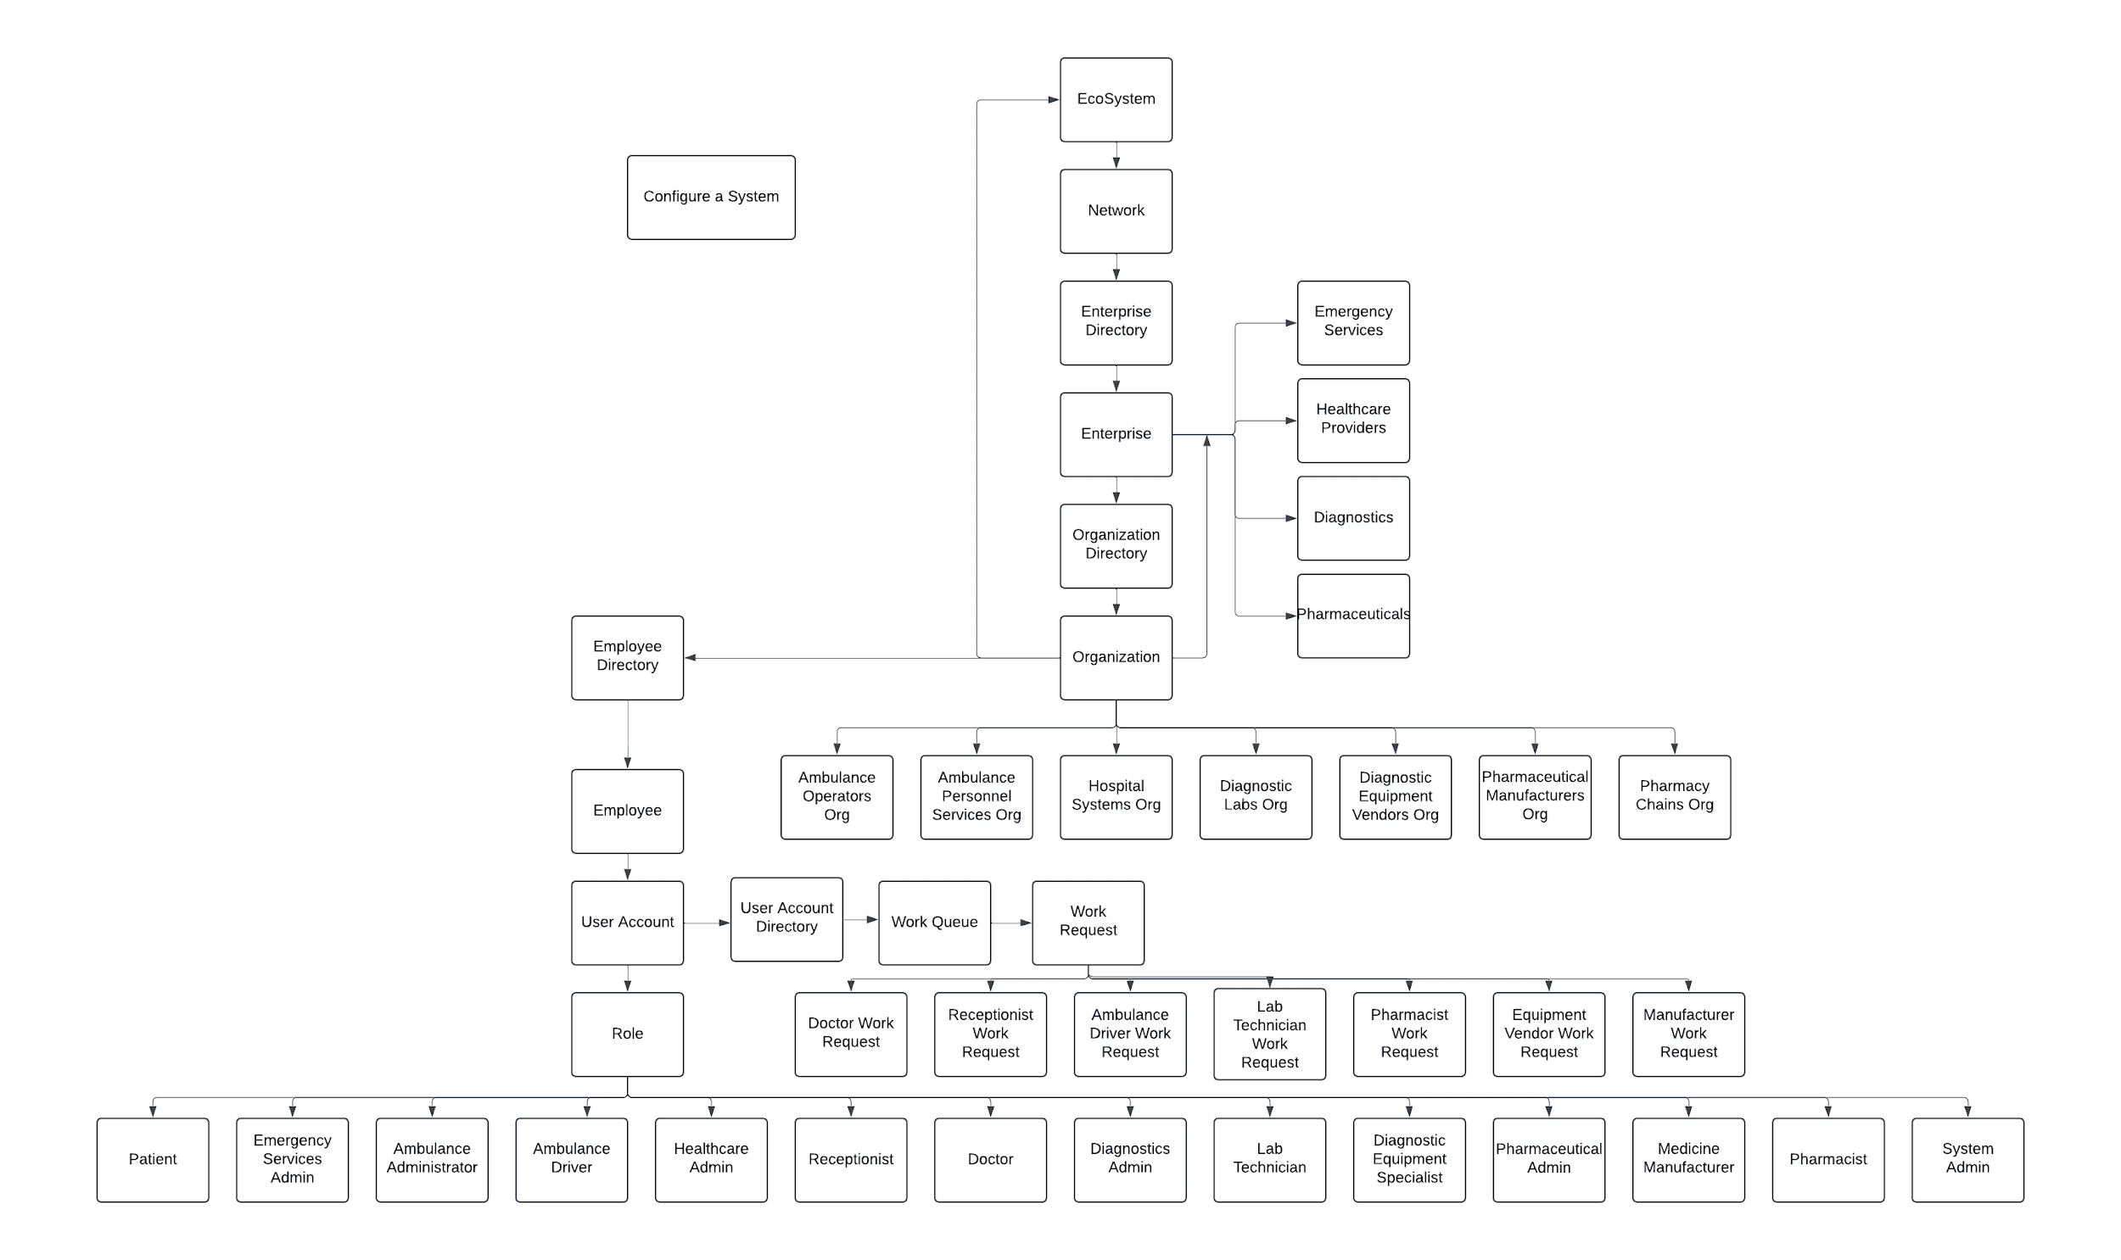

### **High-Level Ecosystem Structure**

#### **Enterprises** ( 4 total )

1. **Emergency Services** – Manages ambulance services and emergency response.
2. **Healthcare Providers** – Oversees hospitals, clinics, and primary care.
3. **Diagnostics** – Handles medical testing and analysis.
4. **Pharmaceuticals** – Manages medicine manufacturing and distribution.

#### **Organizations** ( 7 total )

1. **Ambulance Operators** – Manages ambulance vehicles and emergency response teams.
2. **Ambulance Personnel Services** – Oversees ambulance driver recruitment and training.
3. **Hospital Systems** – Manages patient care, hospital resources, and appointments.
4. **Diagnostic Labs** – Conducts tests and generates patient reports.
5. **Diagnostic Equipment Vendors** – Supplies and maintains laboratory equipment.
6. **Pharmaceutical Manufacturers** – Produces medicines for distribution.
7. **Pharmacy Chains** – Dispenses medications to patients.

#### **Roles** ( 14 total )

1. **Emergency Services Admin** – Manages emergency operations and personnel.
2. **Ambulance Administrator** – Allocates ambulances and handles patient transport requests.
3. **Ambulance Driver** – Transports patients safely.
4. **Healthcare Admin** – Oversees hospital operations and personnel.
5. **Receptionist** – Manages appointments and room assignments.
6. **Doctor** – Diagnoses and treats patients (Consultant/Specialist).
7. **Diagnostics Admin** – Manages lab operations and personnel.
8. **Lab Technician** – Processes and tests medical samples.
9. **Diagnostic Equipment Specialist** – Vendor representative for lab equipment.
10. **Pharmaceutical Admin** – Oversees pharmaceutical operations and personnel.
11. **Medicine Manufacturer** – Produces and tests medicines.
12. **Pharmacist** – Dispenses medicines and advises patients.
13. **System Admin** – Manages IT systems across the ecosystem.
14. **Patient** – Receives healthcare services.

### **Ecosystem Use Cases**

#### **Patient Journey**

1. A **Patient** requests an ambulance via the **Emergency Services** platform.
2. An **Ambulance Administrator** assigns the nearest ambulance, and an **Ambulance Driver** transports the patient to the hospital.
3. The **Receptionist** checks patient details, assigns a room if required, and schedules a consultation with a **Doctor**.
4. The **Doctor** diagnoses the patient and either refers them to a **Specialist** or prescribes medication.
5. If lab testing is needed, the **Receptionist** schedules an appointment with the **Diagnostic Labs**, where a **Lab Technician** performs tests and delivers reports.
6. The **Doctor** reviews the results and adjusts the treatment plan.
7. If medicines are required, the **Pharmacist** dispenses the medication prescribed by the doctor.

#### **Enterprise Interactions**

* The **Diagnostics Admin** coordinates with **Diagnostic Equipment Vendors** for lab device maintenance and procurement.
* The **Pharmaceutical Admin** ensures medicine availability by liaising with **Pharmaceutical Manufacturers**.
* The **System Admin** ensures seamless data exchange and platform security across enterprises.

### **System Flow Example**

1. **Step 1**: A patient logs into the MediLink platform and requests an ambulance.
2. **Step 2**: The ambulance service assigns a driver who picks up the patient and drops them at the hospital.
3. **Step 3**: The receptionist registers the patient, books an appointment, and assigns a room.
4. **Step 4**: The doctor conducts a diagnosis and refers the patient for further testing or treatment.
5. **Step 5**: Diagnostic labs perform tests and share reports.
6. **Step 6**: The doctor reviews the results and prescribes medicines, which the patient collects from a pharmacy.

### **Conclusion**

**MediLink** bridges the gaps in healthcare delivery by connecting patients, providers, and enterprises into a cohesive, efficient ecosystem. It ensures faster, transparent, and scalable solutions to healthcare challenges while delivering a superior patient experience.

Approved Uday Kiran Dasari