R Notebook

loading required library and data

library(tibble)  
library(readr)  
library(keras)  
jena_climate_2009_2016 <- read_csv("jena_climate_2009_2016.csv")

## Parsed with column specification:  
## cols(  
## `Date Time` = col_character(),  
## `p (mbar)` = col_double(),  
## `T (degC)` = col_double(),  
## `Tpot (K)` = col_double(),  
## `Tdew (degC)` = col_double(),  
## `rh (%)` = col_double(),  
## `VPmax (mbar)` = col_double(),  
## `VPact (mbar)` = col_double(),  
## `VPdef (mbar)` = col_double(),  
## `sh (g/kg)` = col_double(),  
## `H2OC (mmol/mol)` = col_double(),  
## `rho (g/m**3)` = col_double(),  
## `wv (m/s)` = col_double(),  
## `max. wv (m/s)` = col_double(),  
## `wd (deg)` = col_double()  
## )

# as data is large we willuse only small portion of data  
data <- jena_climate_2009_2016[1:20000,]  
data <- data.matrix(data[,-1])  
  
  
# creating training data for 15000 observation  
  
train_data <- data[1:15000,]  
  
# scaling data on mean and std. dev.  
mean <- apply(train_data, 2, mean)  
std <- apply(train_data, 2, sd)  
  
data <- scale(data, center = mean, scale = std)

Generator yielding timeseries samples and their targets

generator <- function(data, lookback, delay, min_index, max_index,  
 shuffle = FALSE, batch_size = 128, step = 6) {  
 if (is.null(max_index))  
 max_index <- nrow(data) - delay - 1  
 i <- min_index + lookback  
 function() {  
 if (shuffle) {  
 rows <- sample(c((min_index+lookback):max_index), size = batch_size)  
 } else {  
 if (i + batch_size >= max_index)  
 i <<- min_index + lookback  
 rows <- c(i:min(i+batch_size, max_index))  
 i <<- i + length(rows)  
 }  
 samples <- array(0, dim = c(length(rows),  
 lookback / step,  
 dim(data)[[-1]]))  
 targets <- array(0, dim = c(length(rows)))  
 for (j in 1:length(rows)) {  
 indices <- seq(rows[[j]] - lookback, rows[[j]],  
 length.out = dim(samples)[[2]])  
 samples[j,,] <- data[indices,]  
 targets[[j]] <- data[rows[[j]] + delay,2]  
 }  
 list(samples, targets)  
 }  
}

Preparing the training, validation, and test generators

lookback <- 1440  
step <- 6  
delay <- 144  
batch_size <- 128  
train_gen <- generator(  
 data,  
 lookback = lookback,  
 delay = delay,  
 min_index = 1,  
 max_index = 15000,  
 shuffle = TRUE,  
 step = step,  
 batch_size = batch_size  
)  
val_gen = generator(  
 data,  
 lookback = lookback,  
 delay = delay,  
 min_index = 15001,  
 max_index = 17000,  
 step = step,  
 batch_size = batch_size  
)  
test_gen <- generator(  
 data,  
 lookback = lookback,  
 delay = delay,  
 min_index = 17001,  
 max_index = 19000,  
 step = step,  
 batch_size = batch_size  
)  
  
# to check how many steps to draw from val_gen in order to see the entire validation set  
  
val_steps <- (17000 - 15001 - lookback) / batch_size  
  
# to check howmany steps to draw from test_gen in order to see the entire test set  
test_steps <- (19000 - 17001 - lookback) / batch_size

Computing the common-sense baseline MAE

evaluate_naive_method <- function() {  
 batch_maes <- c()  
 for (step in 1:val_steps) {  
 c(samples, targets) %<-% val_gen()  
 preds <- samples[,dim(samples)[[2]],2]  
 mae <- mean(abs(preds - targets))  
 batch_maes <- c(batch_maes, mae)  
 }  
 print(mean(batch_maes))  
}  
(evaluate_naive_method())

## [1] 0.4259496

## [1] 0.4259496

Training and evaluating a densely connected model

model <- keras_model_sequential() %>%  
 layer_flatten(input_shape = c(lookback / step, dim(data)[-1])) %>%  
 layer_dense(units = 32, activation = "relu") %>%  
 layer_dense(units = 1)  
  
model %>% compile(  
 optimizer = optimizer_rmsprop(),  
 loss = "mae"  
)  
  
history <- model %>% fit_generator(  
 train_gen,  
 steps_per_epoch = 500,  
 epochs = 20,  
 validation_data = val_gen,  
 validation_steps = val_steps  
)  
  
plot(history)

## `geom_smooth()` using formula 'y ~ x'

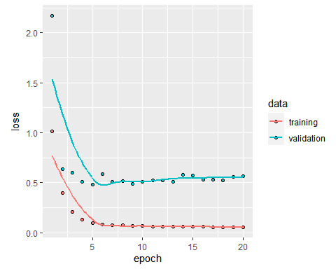

Training and evaluating a model with layer_gru by chnaging numer of units

model <- keras_model_sequential() %>%   
 layer_gru(units = 64,   
 dropout = 0.1,   
 recurrent_dropout = 0.5,  
 return_sequences = TRUE,  
 input_shape = list(NULL, dim(data)[[-1]])) %>%   
 layer_gru(units = 128, activation = "relu",  
 dropout = 0.1,  
 recurrent_dropout = 0.5) %>%   
 layer_dense(units = 1)  
model %>% compile(  
 optimizer = optimizer_rmsprop(),  
 loss = "mae"  
)  
history <- model %>% fit_generator(  
 train_gen,  
 steps_per_epoch = 50,  
 epochs = 5,  
 validation_data = val_gen,  
 validation_steps = val_steps  
)  
  
plot(history)

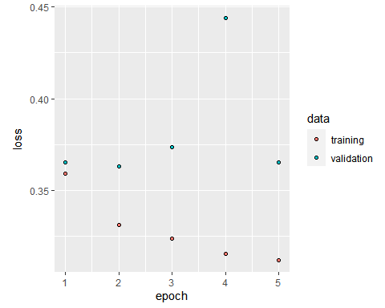

model %>% fit_generator(  
 test_gen,  
 steps_per_epoch = 50,  
 epochs = 5,  
 validation_steps = test_steps  
)

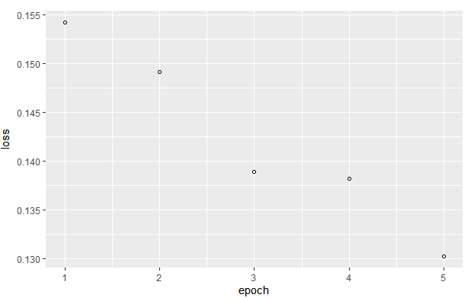

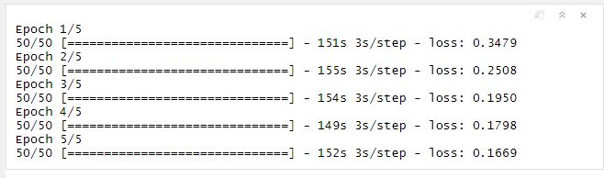

From test result we see loss on test is .1669 which is less than baseline MAE of .45 which shows GRU model was able to reduce loss on partial data