1. **(Computer Center Staffing)** You are the Director of the Computer Center for Gaillard College and responsible for scheduling the staffing of the center. It is open from 8 am until midnight. You have monitored the usage of the center at various times of the day and determined that the following numbers of computer consultants are required.

|  |  |
| --- | --- |
| Time of day | Minimum number of consultants required to be on duty |
| 8 am–noon | 4 |
| Noon–4 pm | 8 |
| 4 am–8 pm | 10 |
| 8 am–midnight | 6 |

Two types of computer consultants can be hired: full-time and part-time. The full-time consultants work for eight consecutive hours in any of the following shifts: morning (8 am – 4 pm), afternoon (noon – 8 pm), and evening (4 pm – midnight). Full-time consult- ants are paid $14 per hour.

Part-time consultants can be hired to work any of the four shifts listed in the table. Part-time consultants are paid $12 per hour. An additional requirement is that during every time period, at least one full-time consultant must be on duty for every part-time consultant on duty.

1. Determine a minimum-cost staffing plan for the center. In your solution, how many consultants will be paid to work full time and how many will be paid to work part xtime? What is the minimum cost?
2. After thinking about this problem for a while, you have decided to recognize meal breaks explicitly in the scheduling of full-time consultants. In particular, full-time consultants are entitled to a one-hour lunch break during their eight-hour shift. In addition, employment rules specify that the lunch break can start after three hours of work or after four hours of work, but those are the only alternatives. Part-time consultants do not receive a meal break. Under these conditions, find a minimum-cost staffing plan. What is the minimum cost?

a). xi =no of consultant working fulltime (i=1,2,3)

yj = no of consultant working part time (j=1,2,3,4)

Fulltime are paid $14 per hrs = 14*8 =112

Parttime are paid $12 per hrs = 12*4 = 48

Zmin= 112(x1 + x2+ x3) + 48(y1 + y2+ y3+ y4 )

Subject to

x1 + y1 >= 4

x1 + x2+ y2 >= 8

x1 + x2+ x3+ y3 >= 10

x3 + y4 >= 6 and xi , yj >0

b.)

x1+x2+x7>=4

x1+x2+x3+x4+x8>+8

x3+x4+x5+x6+x9>=10

x5+x6+x10>=10

Zmin= 112(x1 + x2+ x3+x4) + 48(x7+x8+x9+x10 )

1. Back Savers is a company that produces backpacks primarily for students. They are considering offering some combination of two different models—the Collegiate and the Mini. Both are made out of the same rip-resistant nylon fabric. Back Savers has a long-term contract with a supplier of the nylon and receives a 5000 square-foot shipment of the material each week. Each Collegiate requires 3 square feet while each Mini requires 2 square feet. The sales forecasts indicate that at most 1000 Collegiate and 1200 Minis can be sold per week. Each Collegiate requires 45 minutes of labor to produce and generates a unit profit of $32. Each Mini requires 40 minutes of labor and generates a unit profit of $24. Back Savers has 35 laborers that each provides 40 hours of labor per week. Management wishes to know what quantity of each type of backpack to produce per week.
   1. Clearly define the decision variables
   2. What is the objective function?
   3. What are the constraints?
   4. Write down the full mathematical formulation for this LP problem.
2. Define the decision variable

Let x be no. of Collegiate

Let y be no of Minis

**B. Objective function**

To maximize total no. Of Collegiate and Minis

Profit per collegiate is$32

Profit per Minis is$ 24

Z = 32x+24y

**C. Constraints**

**Nylon:** 5000 sq ft per week

Collegiate = 3sq ft

Minis = 2sq ft

* Nylon : 3x+2y <= 5000

**Time**

Collegiate require 45 min. = 0.75 hrs.

Minis require 40 min = 0.66

Each labor works for 40 hr/week = 2400min

We have 35 labor so total min = 2400*35 84000= 1400/hrs.

* Time : 0.75 x+ 0.66y<= 1400

**Sales Forecast**

Collegiate forecast indicates 1000

Minis forecast 1200

* x<= 1000
* y <= 1200

**Mathematical formulation**

Z = 32x+24y

Nylon: 3x+2y <= 5000

Time: 0.75 x+ 0.66y<= 1400

* x<= 1000
* y <= 1200

x>= 0, y >=0

**Nylon:** 3x+2y <= 5000

Consider x=0 then y=2500 => (0, 2500)

Consider y =0 then x= 1666.6 => (1666.6, 0)

**Time:** 0.75 x+ 0.66y<= 1400

Consider x=0 then y= 2121.2 => (0, 2121.2)

Consider y =0 then x= 1860.6 => (1860.6, 0)

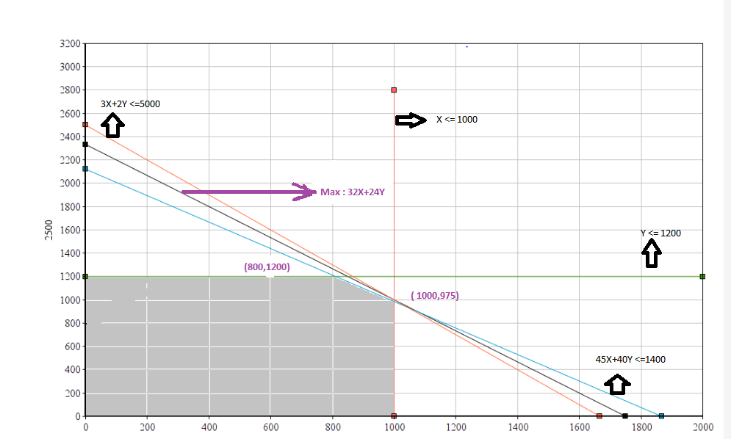

1. **(Weigelt Production)** The Weigelt Corporation has three branch plants with excess production capacity. Fortunately, the corporation has a new product ready to begin production, and all three plants have this capability, so some of the excess capacity can be used in this way. This product can be made in three sizes--large, medium, and small--that yield a net unit profit of $420, $360, and $300, respectively. Plants 1, 2, and 3 have the excess capacity to produce 750, 900, and 450 units per day of this product, respectively, regardless of the size or combination of sizes involved.  
    The amount of available in-process storage space also imposes a limitation on the production rates of the new product. Plants 1, 2, and 3 have 13,000, 12,000, and 5,000 square feet, respectively, of in-process storage space available for a day's production of this product. Each unit of the large, medium, and small sizes produced per day requires 20, 15, and 12 square feet, respectively.  
    Sales forecasts indicate that if available, 900, 1,200, and 750 units of the large, medium, and small sizes, respectively, would be sold per day.  
    At each plant, some employees will need to be laid off unless most of the plant’s excess production capacity can be used to produce the new product. To avoid layoffs if possible, management has decided that the plants should use the same percentage of their excess capacity to produce the new product.  
    Management wishes to know how much of each of the sizes should be produced by each of the plants to maximize profit.
   1. Define the decision variables
   2. Formulate a linear programming model for this problem.
   3. Solve the problem using *lpsolve*, or any other equivalent library in R.

**Solution :**

1. **Decision variables**

Let xij be the number of units of size j product ( j = Large(L), Medium(m),Small(s)) produced at plant i ( i=1,2,3)

1. **Linear programming model**

**Objective function** Z = 420 (x1L+ x2L+ x3L) + 360(x1m+ x2m+ x3m) + 300 (x1s+ x2s+ x3s)

**Constraints**

Capacity Constraints: x1L+ x1m + x1s <= 750

x2L+ x2m + x2s <= 900

x3L+ x3m + x3s <= 450

Storage Space: 20x1L+ 15x1m +12 x1s <=13000

20x2L+15 x2m +12x2s <= 12000

20x3L+15 x3m +12 x3s <= 5000

Sales forecast: x1L+ x2L+ x3L <=900

x1m + x2m+ x3m <=1200

x1s + x2s+ x3s <=750 All xij > 0

900(x1L+ x1m + x1s )- 750 (x2L+ x2m + x2s ) =0

450(x1L+ x1m + x1s ) -750( x3L+ x3m + x3s ) =0