**Dr. AMBEDKAR INSTITUTE OF TECHNOLOGY**

Near Jnana Bharathi Campus, Bengaluru-560056.

(An Autonomous Institution, Aided by Government of Karnataka)

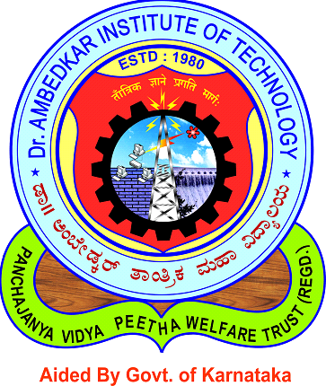

**DB Project Report on:**

**LIBRARY MANAGEMENT SYSTEM**

**Submitted By:**

**ABYAKTA KOIRALA ADITYA ROUNIYAR**

**[1DA17CS005] [1DA17CS006]**

**Under the guidance of:**

**MRS. RASHMI N MRS. LAVANYA SANTHOSH**

**Assistant Professor Assistant Professor**

**Dept. of CSE Dept. of CSE**

**Department of Computer Science & Engineering**

**2019**

**Dr. AMBEDKAR INSTITUTE OF TECHNOLOGY**

Near Jnana Bharathi Campus, Bengalooru-560 056.

(An Autonomous Institution, Aided by Government of Karnataka)

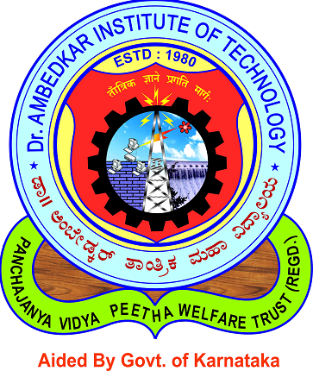

**CERTIFICATE**

This is to certify that the project entitled “**LIBRARY MANAGEMENT SYSTEM**” submitted in the partial fulfillment of the requirement of the 5th semester Database Laboratory curriculum during the year 2019-20 is a result of bonafide work carried out by

**ABYAKTA KOIRALA ADITYA ROUNIYAR**

**[1DA17CS005] [1DA17CS006]**

**Signature of the guide:**

**_____________________** _____**_________________**

**MRS. RASHMI N MRS. LAVANYA SANTHOSH**

**Asst. Prof., Dept. of CSE Asst. Prof., Dept. of CSE**

**Dr. AIT Dr. AIT**

1. Internal Examiner ______________

2. External Examiner _____________

___________________

**Dr. SIDDARAJU**

**Head of Department**

**Computer Science,**

**Dr. AIT**