**ANNAPURNA CIRCUIT**

Trek around the Annapurnas “one of the best trekking trails in the world”

# ANNAPURNA CIRCUIT

Trek in the beautiful and diverse landscape around the Annapurnas, one of the best trekking trails in the world.

Trek around the beautiful and diverse landscape of the [Annapurna,](http://welcomenepal.com/places-to-see/annapurna.html)one of the best trekking trails in the world. Watch the dramatic change in terrain from lush green forests to arid rocky landscape on the other side of the Himalayas.

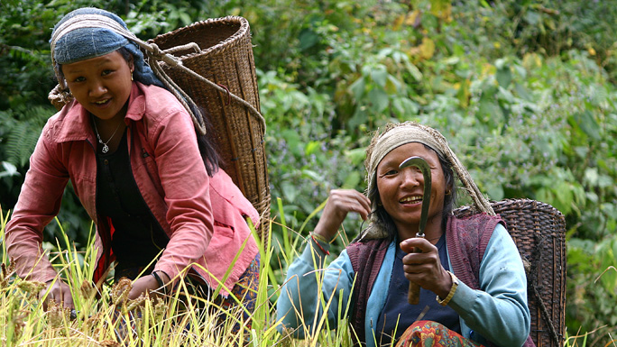

[Meet the Gurung and Thakali people](https://www.welcomenepal.com/things-to-do/meet-the-people.html), spend time with them to know more about their simple world, try their local recipes, and enjoy the spectacular views.

The classic trek in the Annapurna region is the **Annapurna Circuit**. The trek encircles the famous Annapurna massif passing through sub-tropical plains in the Himalayan foothills, trans-Himalayan Manang and then the dry, rain shadow region of [Mustang](http://welcomenepal.com/places-to-see/upper-mustang.html). The highest elevation is reached at Thorang La (pass at 5,416m) before the trail follows the Kali Gandaki River that flows through the deepest gorge on earth between two giant peaks. 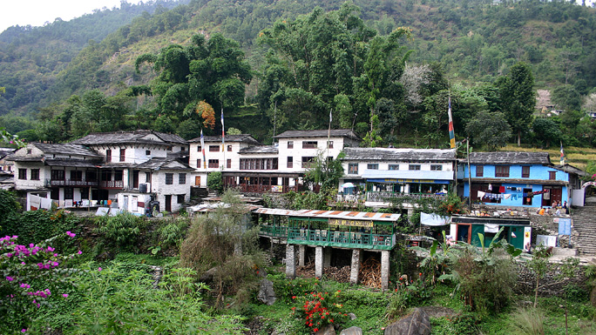

The trek may last 15 to 22 days, starting with a drive to Besisahar from Kathmandu and ending in Pokhara. All trekkers must carry an entry permit for ACAP (Annapurna Conservation Area Project) which can be obtained in Kathmandu. Most trekkers take a bus ride from [Kathmandu](https://www.welcomenepal.com/places-to-see/kathmandu.html) to Besisahar (6-8 hours) from where the trek begins. The trek follows the road as far as the small market town of Khudi.

The first few days of the trek goes along the Marsyangdi River, walking through lush green valleys, an area inhabited by Gurung people along with a large number of other ethnic groups. The trail then goes through Chame (2,685m) and Pisang (3,200m) before reaching Manang. Climbing up to the Braga Hill one gets amazing panoramic views of the Annnapurna range of mountains before reaching Manang (3,535m).

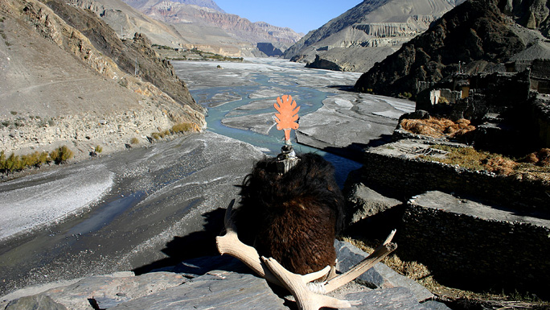

Countless tall waterfalls cascading down into the main river are encountered along the way while the skyline is dominated by the Annapurna and [Manaslu](https://www.welcomenepal.com/places-to-see/manaslu.html) ranges. From Manang, the trail goes uphill through high alpine pastures until the small teahouses at Thorang Phedi are reached. From here on one has to be careful about acclimatization as there is a risk of high altitude sickness. Spending a day in Manang is advised where a side trip to a glacial lake fed by the icefall from Gangapurna is possible.

The following day, the trail goes through the highest point, Thorang La, after which there is a long descent to Muktinath. During the descent, the summit of Dhaulagiri (8,167m) becomes visible on the southern horizon. Muktinath is a popular pilgrimage site for both Hindus and Buddhists and gets plenty of visitors. From [Muktinath](http://welcomenepal.com/places-to-see/jomsom-muktinath.html)look to the west to enjoy a grand view of the Dhaulagiri massif while to the north can be seen the arid hills of Upper Mustang. There are no accommodations near this famous temple so you carry on to Ranipauwa (3710m) where there are many lodges.

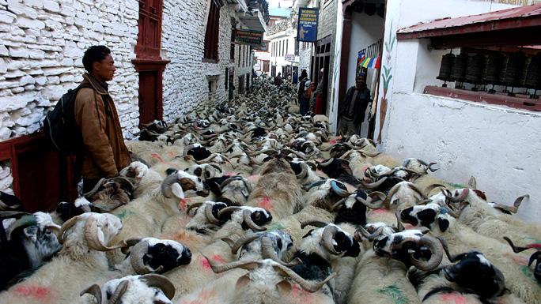

From Ranipauwa, walk down to Kagbeni. The trail then leads down through Marpha (2680m) known for its unique alcoholic drinks made from apples, apricot or peach. Head on to the village of Jharkot and Eklebhati inhabited by people of Tibetan stock. Walking along the river, the well-known settlement of Jomsom (2,713m) is reached. The next interesting destination is Ghorepani which is reached via Tatopani which gets its name from the hot springs nearby. An overnight halt at Ghorepani is rewarded with an excursion to see a spectacular sunrise view of the Dhaulagiri massif and other mountains like Annapurna I and Annapurna South at dawn from Poon Hill (3,030m).

After breakfast the rest of the trek is downhill via Tirkhedhunga and Birethanti by the river Bhurungdi. A short distance away is Nayapul where the trek ends and you catch a ride to Pokhara town. From Pokhara, fly back to Kathmandu or catch a bus.