**BARDIYA**

Ride through the silent jungle catching wildlife by surprise in the largest national park of Nepal.

# BARDIYA NATIONAL PARK

Ride through the silent Bardiya jungle catching wildlife by surprise in the largest [national park of Nepal](https://www.welcomenepal.com/places-to-see/must-see-national-parks-of-nepal.html). Take nature walks with experienced naturalists with years of experience in the region.

Go for [white-water rafting](https://www.welcomenepal.com/things-to-do/rafting.html) on the Karnali, the longest river in Nepal, where you can watch the Gangetic dolphins surface or gharials lazing in the sun. Meet the charming Rana Tharu and Dangora people of southern Nepal and learn about their colorful culture.

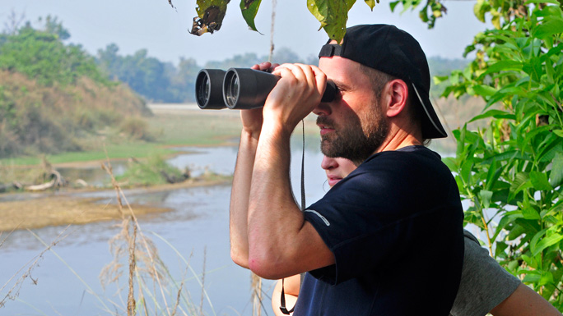

An hour-long flight from Kathmandu and a few hours on the road brings you to the jungles of  Bardiya in west Nepal. Safari in the pristine jungles of Bardiya is an unforgettable experience that will remain with you for a lifetime. The national park is home to countless species of mammals, reptiles and birds, some of which like the Bluebull are not found in Chitwan.

Bardiya National Park is one of the most pristine conservation areas in the Tarai and is home to the endangered Royal Bengal tiger and Nepal's famous One-horned rhinoceros besides countless other mammals and reptiles. The park located in the far western district of Bardiya, is bordered by the Karnali River in the west, the Churia range in the north, while the Babai River flows right through it.

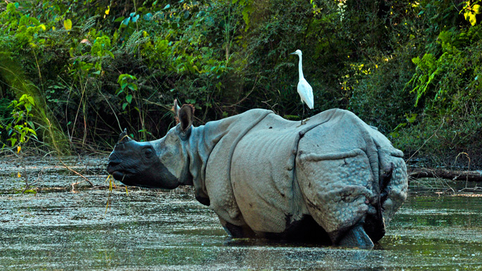

The national park is covered in vast Sal and riverine forests and tall elephant grass, making it an ideal habitat for many kinds of animals that roam freely. The park hosts 30 species of mammals, more than 250 species of birds, and several varieties of reptiles. There are more sightings of tigers here than in other national parks which attracts visitors who come repeatedly to catch a glimpse of the elusive cat.

Some of the other animals found here are elephants, swamp deer, blackbuck, gharials and marsh-muggers. The exotic Gangetic dolphin is also sometimes seen along the surface of the Karnali. Birds found here include endangered species like the Bengal florican, lesser florican, silver-eared mesia and the sarus crane.

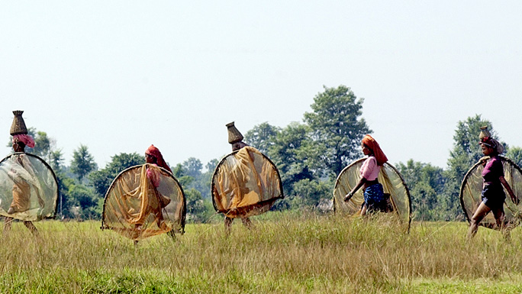

The park offers opportunities for sport fishing at the Karnali and Babai rivers. The best time to visit is autumn, winter and early summer when the weather is warm and dry, but not too hot.  Activities in the park include elephant rides, jeep safari, rafting, sport fishing and bird watching accompanied by a naturalist.

There are more than a dozen safari lodges in Bardiya that provide excellent accommodations and facilities for guests to enjoy wildlife activities. The Park headquarters in Thakurdwara is approximately an hour's drive away from the Nepalgunj-Surkhet road. Bardiya can also be reached by road, passing through Nepalgunj from where the national park is only a two hour drive away.