**EVEREST**

Climb Everest if you want to stand on top of the world, or do the extremely popular Everest Base Camp Trek to enter a strange world of ice and snow.

# EVEREST REGION

Reach the highest point on earth or choose to live out your dream by standing at the foot of Mt. Everest (8,848 m).

The **Everest region in Nepal** is more than just climbing and trekking, it is a life changing experience and some see it as a journey close to achieving Nirvana. Located in the north eastern province of Nepal, this region is in a world of its own with vast glaciers, icefalls, the highest mountains, deep valleys, precarious settlements, and hardy people challenging the harshest conditions thrown at them by nature in the thin air of high altitude.

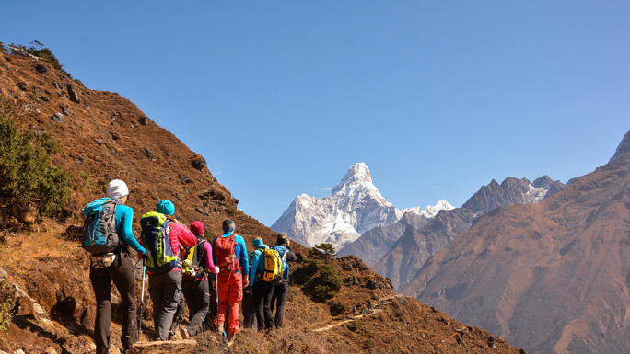

Passing through legendary Sherpa villages, the trek is a mix of deeply cultural and spiritual experiences and physical challenges that test your strength and endurance. Buddhist lamas, monks and nuns led by Rinpoches (reincarnate at mas) serve the predominantly Sherpa communities from their gompas (monasteries).

The journey to Everest or [Everest Base Camp](https://www.welcomenepal.com/places-to-see/everest-base-camp.html), begins with a dramatic flight from Kathmandu to Lukla, after which you hike up the Everest region to reach your destination in the Himalayas. However, for die-hard lovers of trekking, there is another switchback starting from Jiri through the mid-hills of Solu, an ethnically diverse section of the trek rich in flora.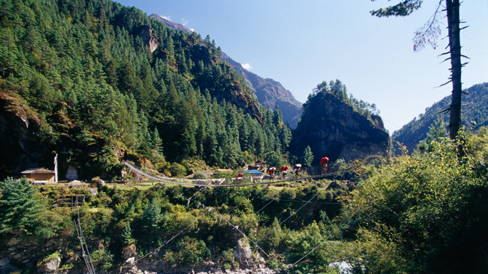

Taking a flight is a time-saver, while trekking from Jiri gives you the opportunity to follow in the footsteps of Tenzing and Hillary before their conquest of Everest. With more time to interact with the charming people along the route, you get to see the rich flora and fauna on the long trail. You get the added benefit of natural acclimatization as you go up and down the cliffs and valleys.

The option from Jiri will roughly add 10 days to your trip to the famous Sherpa village, [Namche Bazaar](https://www.welcomenepal.com/places-to-see/namche-bazaar.html) (3,500m). The **Sagarmatha National Park** in which Mt. Everest lies is one of the few places on earth with the rarest bio-diversity and the highest mountains in the world.

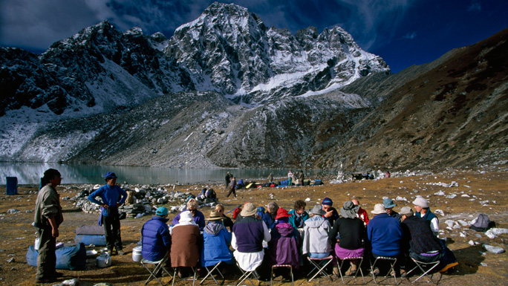

For those with sufficient time, a 10-12 day trek through Solu to the Khumbu and the [Sagarmatha National Park](https://www.welcomenepal.com/places-to-see/sagarmatha-national-park.html) is an excellent itinerary both in terms of acclimatization and to observe the changing customs, traditions, and lifestyles as you go from the lower altitude settlements to those in the higher altitudes.

A part of the Himalayan ecological zone, the park was added to the list of UNESCO Natural World Heritage Sites in 1979. The park has three of the world's highest mountains: Everest, Lhotse, and Cho Oyu besides countless other peaks that rise above 6,000 meters from sea level.

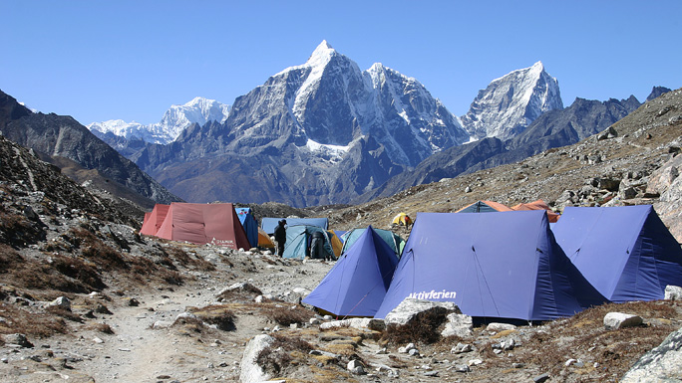

Climbers and trekkers continue to trek to Everest Base Camp and not surprisingly the "Roof of the World" continues to be the world' top attraction for hardened mountaineers, a haven for alpine enthusiasts and is in the bucket list of adventurers from around the world.

**The Everest region** has been valued as the key to evolutionary history of the Earth, and is also a habitat for some rare and endangered species like the snow leopard, red panda, Himalayan black bear, musk deer and Himalayan wolves.