**GOKYO VALLEY**

**Take the alternative route to the serene & rocky Gokyo valley with pristine glacial lakes.**

# GOKYO VALLEY

One of the most picturesque valleys in Nepal, the**Gokyo valley** lies towards the west of the more famous Khumbu region of the Himalaya. The serene valley boasts extensive pastures for yaks to graze during summer and the pristine turquoise lakes are simply breathtaking. Gokyo can be visited after trekking up to [Everest Base Camp](https://www.welcomenepal.com/places-to-see/everest-base-camp.html) by adding another five days to the itinerary.

If Gokyo is your main destination, then the trek goes up the Everest trail only as far as the teahouses at Kenjoma (where the trail from Khumjung joins the main trail). From this point on, the trail leads up towards Mong La pass before dropping steeply back down to the banks of the Dudh Koshi River. The trail then goes past rhododendron and oak forests and waterfalls which are often frozen. A couple of hours on this enchanting trail and you arrive in Dole, where you spend the night in a teahouse.

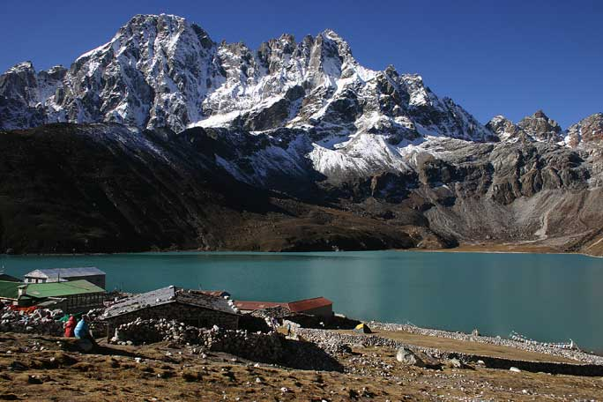

From Dole, it is only four hours to Machherma. The valley that leads west above Machherma is worth a visit, and can be done in the afternoon. The valley is dominated by the unclimbed Mt. Kyojo Ri. The final trail up to Gokyo goes past teahouses at Pangkha and up the terminal moraine of the Ngozumpa glacier, which is the largest glacier in the country. Finally, just above the moraine, you will see the crystal clear lakes.

One of the eight-thousanders, Cho Oyu (8,153m) is seen towards the north from Gokyo. There are many great views all around the valley. The most popular among them is seen by ascending a ridge for 2-3 hours to the north-west to reach a small summit. Enjoy a spectacular panoramic view extending from Cho Oyu and Everest, to Lhotse all the way to Makalu. This view is arguably better than what one sees above Gorak Shep.

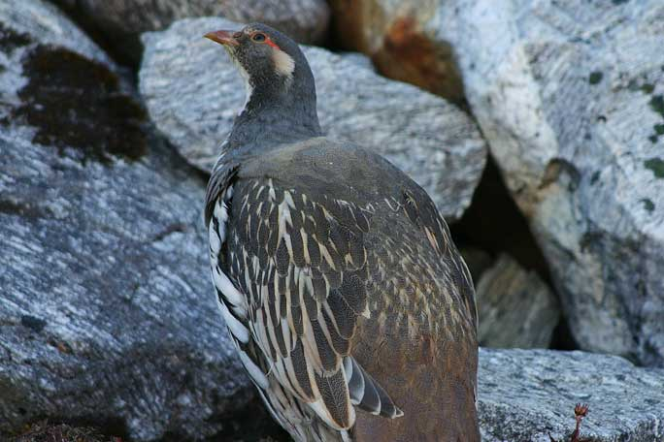

There are two high passes leading out of the **Gokyo valley**, the Cho La pass being the most traveled, which leads on to the Khumbu valley near Lobuche while the other is Renjo La pass that joins the trail between Thame and Nangpa La pass. Following the Everest trek route, one takes the alternative exit route as far as Phortse.

From here you walk along the eastern side of the valley through the village of Konar. There are no facilities available on this side of the valley until the small teahouses at Nah, a six hour trek from Phortse. Nah is a good place for camping, but for proper accommodations, one has to walk another four hours to reach Pangkha. From here follow the route described previously.