## ILAM

#### Walk through the tea gardens, enjoy sightseeing, take short hikes or head for the nearby woods.

# ILAM

A brisk walk in a tea garden, picnic in the peaceful setting and sightseeing stops, short hikes along gentle hills, or explore the nearby woods – enjoy all this and more in the greenery of Ilam.

An excellent getaway from city life, Ilam is famous for its tea. It is a district largely covered in tea bushes with a hill town right beside a plantation enjoying views of pristine landscapes made up of sloping tea gardens, mountain streams, dense natural forests, holy sites and a [unique culture](https://www.welcomenepal.com/things-to-do/cultural-tours.html). Using Ilam Bazaar as a base you can take excursions for a day or more. There are many hotels in the town and a few resorts a short distance away in the tea gardens.

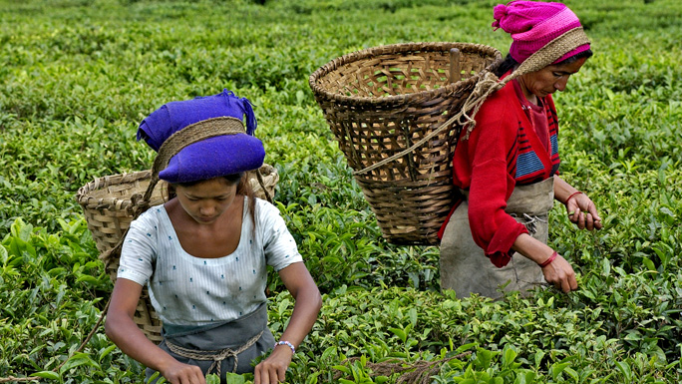

While [the subtropical climate](https://www.welcomenepal.com/plan-your-trip/climate.html)of Ilam ensures good weather most of the year, except during the monsoon when heavy rains engulf most of Nepal, the best time to visit is between October to December or from February to April.

Ilam district is in far eastern Nepal, north of Jhapa and has West Bengal (India) in the east. Ilam town is a quiet little hill town and interesting places to visit are the viewing tower not far from the town and Mai Pokhari which is an hour’s drive away. Diverse species of fish are found in the small lake. Local visitors go to Kanyam Tea Estate for horse riding, hikes and picnics.

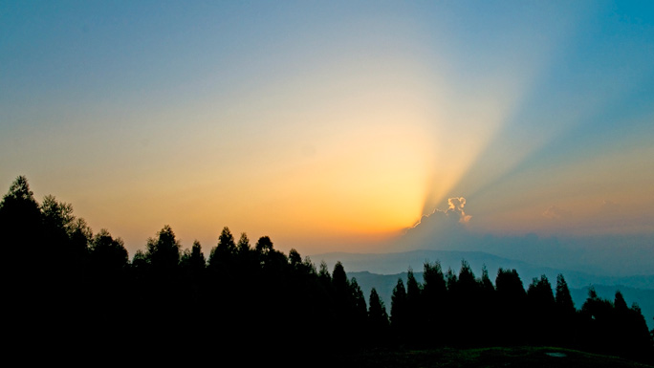

Elevations in Ilam district range between 140 m to 3,636 m above sea level. Ilam is sometimes called Charkhol (**area of four rivers**) because of the four main rivers - the Jogmai, Puwamai, Mai, and Deaumai in the district.

Ilam is one of the richest districts in Nepal when it comes to cultural diversity, natural landscape, and a flourishing cash crop industry. Potato, cardamom, ginger, red round chilly, milk, and broom grass are the major cash crops, with tea being the biggest industry. Scholars visit Ilam for botanical and anthropological research.

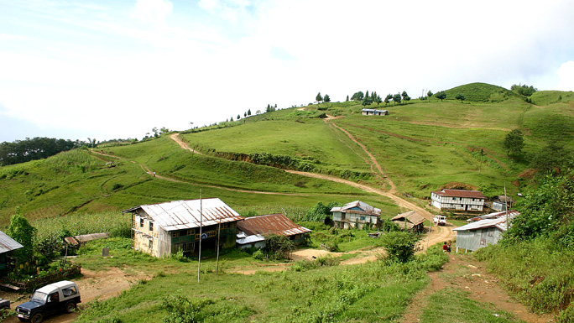Lepchas were once the predominant ethnic group in this region. A Lepcha museum is being built at Antu and there are plans to make it extensive. Ilam reflects the rich social and cultural heritage of people living in harmony. The major ethnic groups living in Ilam are Brahmins and Chettris, Magars, Gurungs, Rais, Limbus, and Sherpas. Most of the land is covered in tea bushes and the tea industry is growing at a rapid pace with exports reaching many countries in Europe and the U.S.