## KHAPTAD

#### Trek up in the rolling hills of Khaptad through lush forests of pine, fir, hemlock, oak & rhododendron.

**KHAPTAD NATIONAL PARK**

Trek up in the rolling hills of the Khaptad National Park (about 3000m) through subtropical forest of Chir pine at lower altitudes, and sub alpine forests of fir, hemlock, oak and rhododendron in the higher regions. The national park is described as a living garden of herbs and a museum of natural history for its 224 species of medicinal herbs. It reportedly harbors 567 species which accounts for 11 percent of all the flowering plants of Nepal.

The park offers excellent bird-watching opportunities, with 270 species of birds, the common ones being: Impheyan pheasant, partridges, flycatchers, bulbuls, cuckoos and eagles. Khaptad National Park is also home to a rich variety of wild animals, such as barking deer, wild dog, wild boar, ghoral, Himalayan black bear, yellow-throated marten, rhesus macaque and langur monkey.

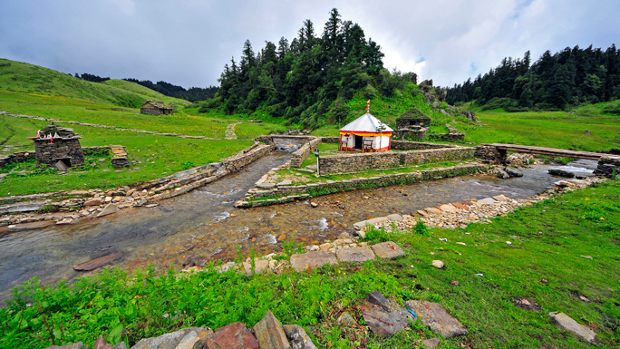

Other areas of interest in the national park are Khaptad Daha, Nag Dhunga and Upper Tribeni. This national park also offers religious sightseeing.

**ASHRAM OF KHAPTAD BABA**

The *Ashram* (hermitage) of Khaptad Baba as the name proclaims is the area where the famous Khaptad Baba (Late Swami Sachchidananda) resided. The *Ashram* located at Tribeni is an important destination for pilgrims and tourists visiting Khaptad. The meditation area includes temples of lower Tribeni. There are no restrictions for visitors. In the core zone, however, grazing animals, cutting firewood and activities like drinking alcohol, smoking and slaughtering animals are prohibited.

**SAILESWORI**

Saileswori is one of the most famous religious stops on the way to Khaptad from Attariya Chowk, Kailali. The temple of Goddess Saileswori in Sigarhi, Doti, is comprised of temples dedicated to Ganesh and Masto. Silgarhi Bazaar*,* which is a historic town, is the main business center for far west Nepal.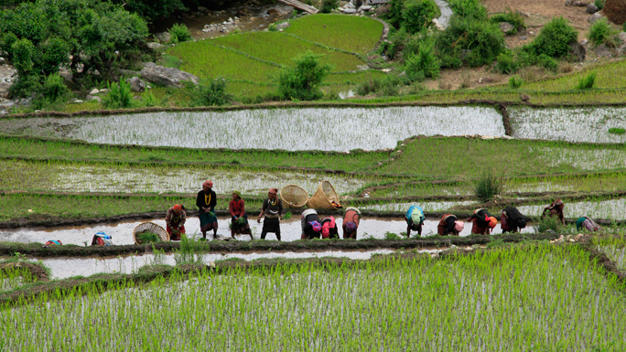

**RAMAROSHAN**

Ramaroshan in Achham district is also called *Pancha Pura*(five cities) in Hindu scriptures and is attached to the stories of *Pauranic* Age. The site is famous for the five historical cities connected to stories of Goddess Parvati. There are 12 lakes in Khaptad National Park that are good bird watching sites. There are also ruins of old historical buildings that make this region important from an archeological point of view.

**Badimallika**

From Badimallika, there are enchanting views of the Himalayas and the ideal time to visit is from April to October. One can reach the area from Khaptad National Park by trekking for 8 to 10 days through remarkable landscapes of verdant forests and pastures. Badmallika houses the temple of Mallika Devi (4,153m) in Bajura district. It is believed that Goddess Sati, Shiva's consort was reborn as Parvati in this holy site.

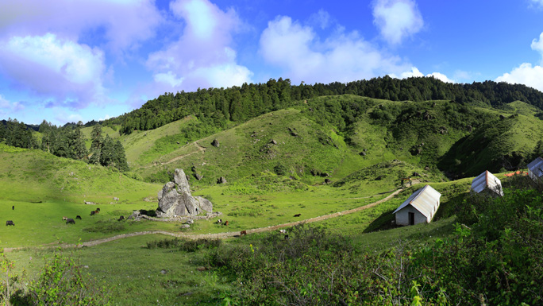

**GETTING THERE**

Khaptad National Park is in Seti zone and is surrounded by Doti, Bajura, Bajhang and Achham districts.

The gateway to Khaptad is Silgarhi Bazaar in Doti district, from where the park headquarters is 50 km and almost a 2-day trek. The best way to reach Silgarhi is via Attariya Chowk in Kailali district. Silgarhi Bazaar is a 9-hour drive from Attariya Chowk. Buses to Attariya Chowki, Kailali, are available at the Central Bus Station, Gongabu, in Kathmandu and transportation to Silgarhi is available from Attariya Chowk. Another option is to catch a flight to Dhangadi from where one can drive on to Silgarhi Bazaar*.*

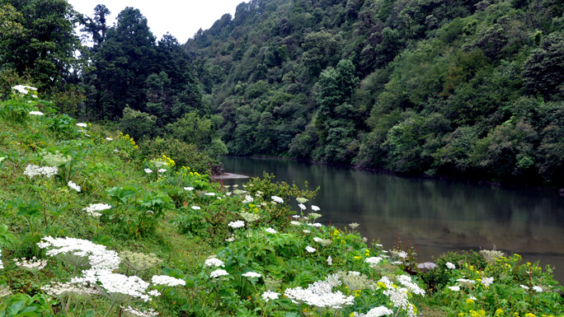

Khaptad National Park can also be reached quite easily from the western entry point to Nepal from India at Gadda Chowki, Mahendranagar. Silgarhi Bazaar is approximately a 10-hour drive  from Mahendranagar, while Mahendranagar is only a 30-minute drive from the Indian border town of Banbasa, from where buses depart for Delhi every hour of the day.