**LANGTANG**

**Trek to Langtang if you want a relatively short itinerary with all excitement of the Himalayas.**

Langtang

Langtang is a region in the north-central Himalayas of the Bagmati province of Nepal. Situated 51 kilometres north of the Kathmandu Valley, the region is renowned for hosting the Langtang national park which eventually constitutes the border with the Tibet autonomous region of China.

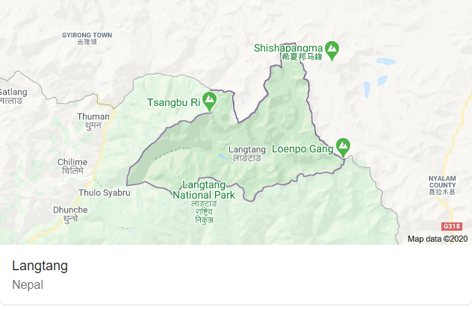

About 4,500 people reside inside the park (with [Tamang](https://en.wikipedia.org/wiki/Tamang_people" \o "Tamang people) as majority), and many more depend on it for timber and firewood.

The park contains a wide variety of climatic zones, from subtropical to alpine.[[1]](https://en.wikipedia.org/wiki/Langtang#cite_note-1) Approximately 25% of the park is forested. Trees include the deciduous [oak](https://en.wikipedia.org/wiki/Oak) and maple, evergreens like [pine](https://en.wikipedia.org/wiki/Pine), and various types of rhododendron. Animal life includes the Himalayan black bear, the goat-like Himalayan tahr, Assam macaque and [red pandas](https://en.wikipedia.org/wiki/Red_panda) [[2]](https://en.wikipedia.org/wiki/Langtang#cite_note-2). There are also stories of [Yeti](https://en.wikipedia.org/wiki/Yeti) sightings.

Langtang has over 70 glaciers of varying sizes, the Langtang and Ganesh Himal mountain ranges, and high-altitude lakes including Gosainkunda, Parvatikunda, Bhairavkunda, and Dudhkunda.

The people in this place are mostly of Tamang and Tibetan origin, whose culture goes back to hundreds of years. The craftsmanship, dress, traditionally-built stone houses, and the beautifully carved wooden porches reflect their rich Himalayan heritage.

Partly protected as Langtang National Park, visit to the area gives Himalayan nature experience and an insight into the lifestyle and culture of the Tamangs who are predominant inhabitants of the region.

They are mainly sheep and yak herders, but grow some hardy grains and vegetables. The daily life of the villagers includes raising livestock, agriculture, and trade with Kerung in Tibet. Wheat, maize, potato, soyabean, and millet are their staple food.

 Tourist facilities are available in Dhunche and Syabru. Established accommodation facilities are available in Langtang route and Gosainkunda route. Trained guides and porters are also available in the villages.