**MANASLU**

A pristine trekking circuit which allows you to circle Mt. Manaslu, the world's 8th highest peak.

# MANASLU CONSERVATION AREA

[A pristine trekking circuit](https://www.welcomenepal.com/things-to-do/trekking.html), this trek allows you to circle around Mt. Manaslu, the world's eighth highest peak. Trek along the less travelled trails through rural Nepal with epic views that have to be seen in all their glory. With few visitors encountered along the way, this region offers a very different experience from treks in the Everest and Annapurna regions which receive the largest number of trekkers.

Manaslu (8,152m) is an opportunity to enjoy a quiet time trekking in pure bliss away from the noisy trappings of the modern world.

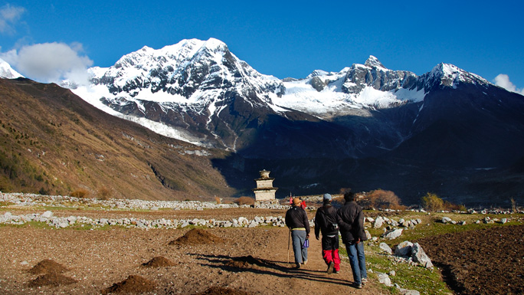

The trek on an ancient trail along which you [enjoy authentic Nepali culture and hospitality,](https://www.welcomenepal.com/things-to-do/culture.html)promises breathtaking views of Manaslu and other Himalayan peaks always on the background. You get to witness ancient cultures and the almost medieval lifestyle of the people as you trek up north towards the peaks.

Shielded from modernization and commercialization, the local people’s lifestyle has changed little over the centuries, thus retaining their purity. So your trek to Manaslu will be akin to time-travel. going back in time. The trail has teahouses along the way for a night halt, but one could opt for a camping trek and sleep under the stars.

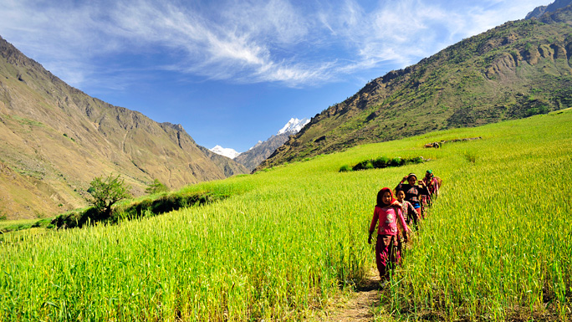

There is internet access, and phones as well as other electronic devices can be charged at the teahouses along the trail. The trek makes for a great photo opportunity so you will have something to take back home to reminisce about. All you need is a decent camera.

Manaslu shares much of its culture and history with its neighboring territory, Tibet. Buddhism is the major religion here as showcased by the Buddhist monasteries, the architecture and traditions all the way.

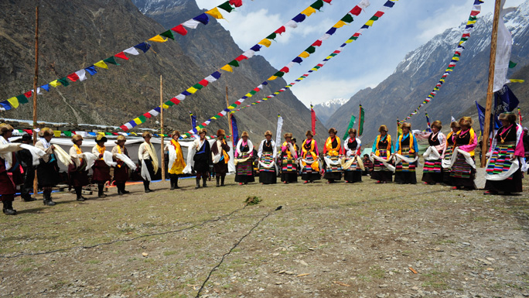

The region, which was officially opened to foreign tourists only in 1991, falls in the Restricted zone and [tourists must acquire a Trekking Permit from the Department of Immigration](https://www.welcomenepal.com/plan-your-trip/trekking-permit.html)in addition to the TIMS card to enter this region