**SHOPPING**

Shopping in Nepal is not your usual shopping for branded goods. Here you search for exotic stuff like Thangkas, pashmina, incense, etc.

# SHOPPING IN NEPAL

Exquisite handicrafts of brilliant workmanship are sold in the markets .Many of these carry religious significance. Artistic works of stone and metal, silver and gold trinkets, and incredible wood carvings are readily available.

Other kinds of souvenirs include Nepali tea, the famous Gurkha knife or Khukuri, prayer wheels, stone carvings, singing bowls, papier–maché masks, thangkas and pauvas, pashmina, carpets, jewelry etc. Souvenir items are available in tourist areas like [Thamel](https://www.welcomenepal.com/places-to-see/Thamel.html" \o "Thamel | Naturally Nepal | Once is not enough), New Road, Basantapur, Asan, [Patan](https://www.welcomenepal.com/places-to-see/patan.html" \o "Patan Handicraft City Of Kathmandu Valley Nepal | Naturally Nepal | Once is not enough), [Bhaktapur](https://www.welcomenepal.com/places-to-see/bhaktapur.html" \o "Bhaktapur | Naturally Nepal | Once is not enough) and around major hotels. But remember anything older than a 100 years old cannot be taken out of the country.

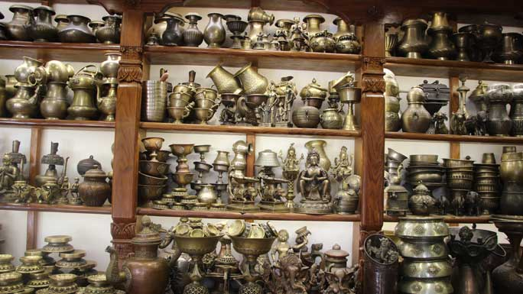

Shopping malls and departmental stores sell branded items and accessories like cell phones, i-pads and laptops to electronic appliances, cameras, music systems, kitchenware, garments, jewelry, perfumes, watches, toys, fitness equipment and a multitude of household items.

Popular shopping malls in [Kathmandu Valley](https://www.welcomenepal.com/places-to-see/kathmandu-valley.html) are: Bhatbhateni chain of stores, Saleways chain of stores, City Center in Kamal Pokhari, Civil Mall in Sundhara, Kathmandu Mall in Sundhara, Labim Mall in Pulchowk, Salesberry in Satdobato.

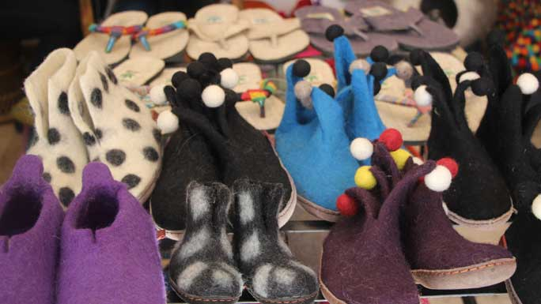

Shopping areas in the valley are around New Road, Putali Sadak, Kumaripati, Bhatbhateni, Lazimpat, Sundhara, Tripureshwor, Lagankhel and Jawalakhel. In [Pokhara](https://www.welcomenepal.com/places-to-see/pokhara.html" \o "Pokhara in Nepal - Leisure and Adventure in Annapurna | Naturally Nepal | Once is not enough), the major shopping areas are Lakeside and Mahendrapul Bazaar.