Sentiment Analysis to Classify Amazon Product Reviews Using Supervised Classification Algorithms
In this project we are using Amazon reviews dataset to predict RATINGS from new user’s reviews and to predict ratings we have used various machine learning algorithms such as SVM, KNN, Random Forest and Decision Tree.
To train and predict ratings we have designed following modules
- Train ML Algorithms: using this module we will read dataset and then preprocess dataset to remove all stop words and special symbols and then extract features by using TFIDF vector. TFIDF will replace each word in reviews by its average frequency occurrence. Extracted features will be into Machine Learning algorithm to train prediction model.
- SubmitReview: New user’s may submit reviews and then ML will predict gender and ratings from that reviews
- Retailer Signup: using this module retailer can signup with application
- Retailer Login: using this module retailer will login to application
- View Reviews Classification Result: using this module retailer can view all reviews and predicted ratings (positive, negative or neutral) and gender in tabular and graphical format.
Below is the AMAZON dataset used to train above ML algorithms
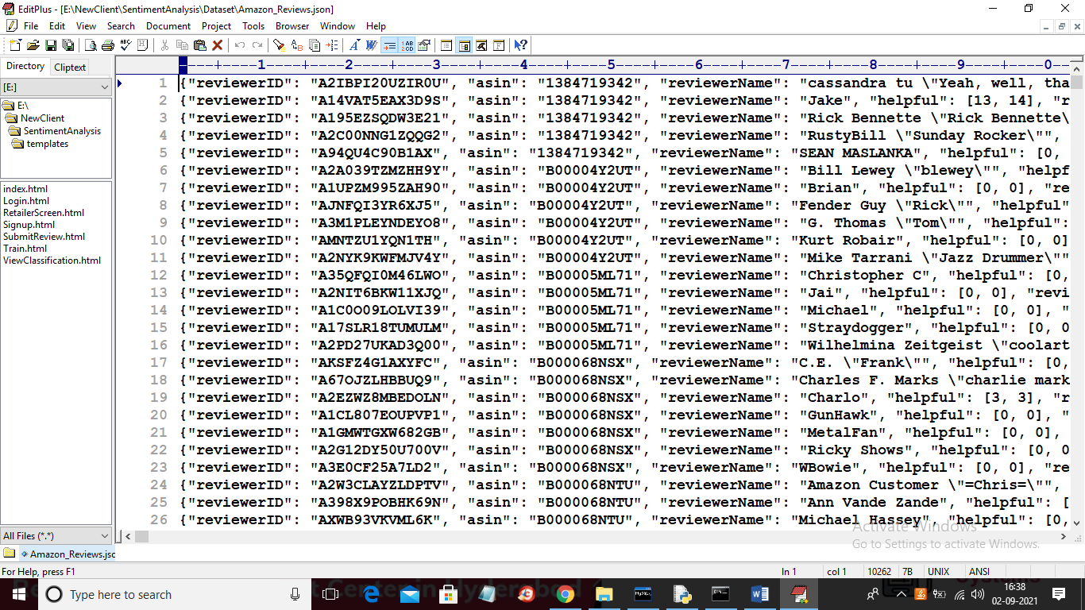
In above dataset you can see review id, reviewer name, review text and overall ratings.
SCREEN SHOTS
To run project double click on ‘run.bat’ file and then open browser and enter URL as ‘http://localhost:999/index’ and press enter key to get below screen
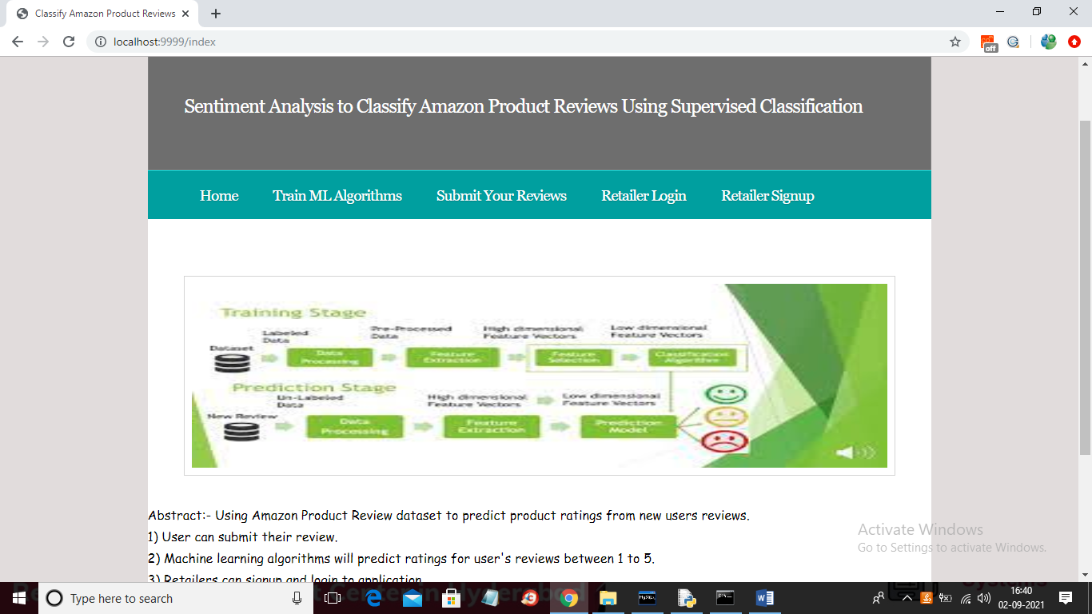
In above screen click on ‘Train ML Algorithms’ link to read dataset and then use this dataset features to train ML algorithms and to get below output
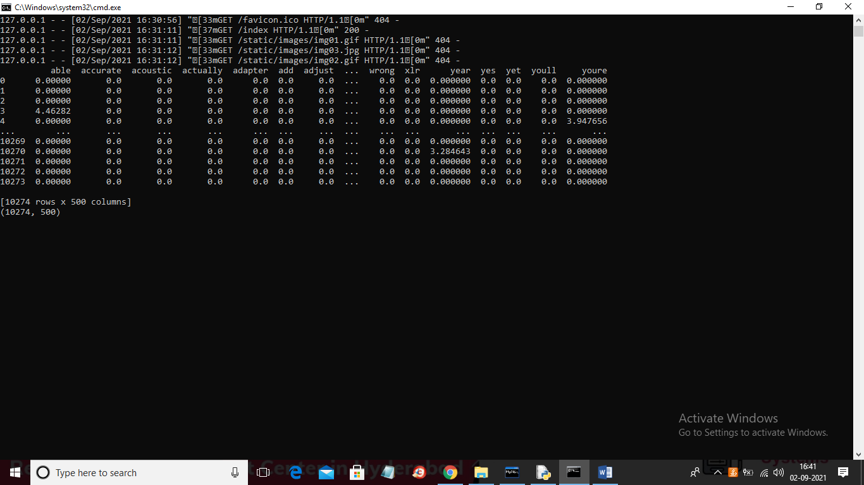
In above screen we can see application extracted all words and features and then put all words in first rows and in remaining rows we can see average occurrence of those words and if word not appear in that row review then 0 will be put and after extracting this features ML algorithms will be trained to get below prediction output
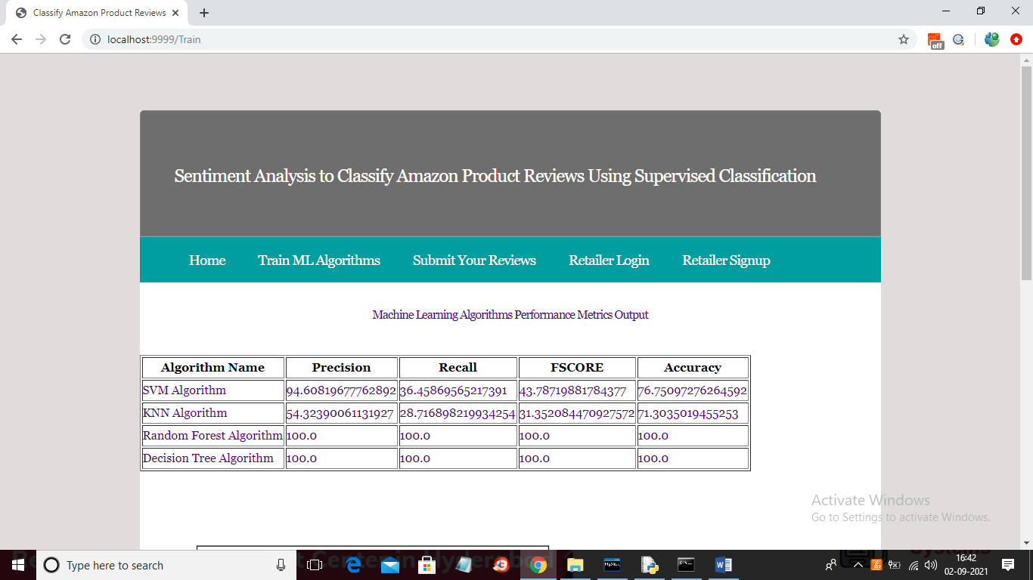
In above screen we can see precision, recall, FSCORE and accuracy of each algorithm and in all algorithms decision tree and random forest is giving better results. Every time this results may vary little as application choose test data for prediction randomly. Now scroll down above screen to get below graph
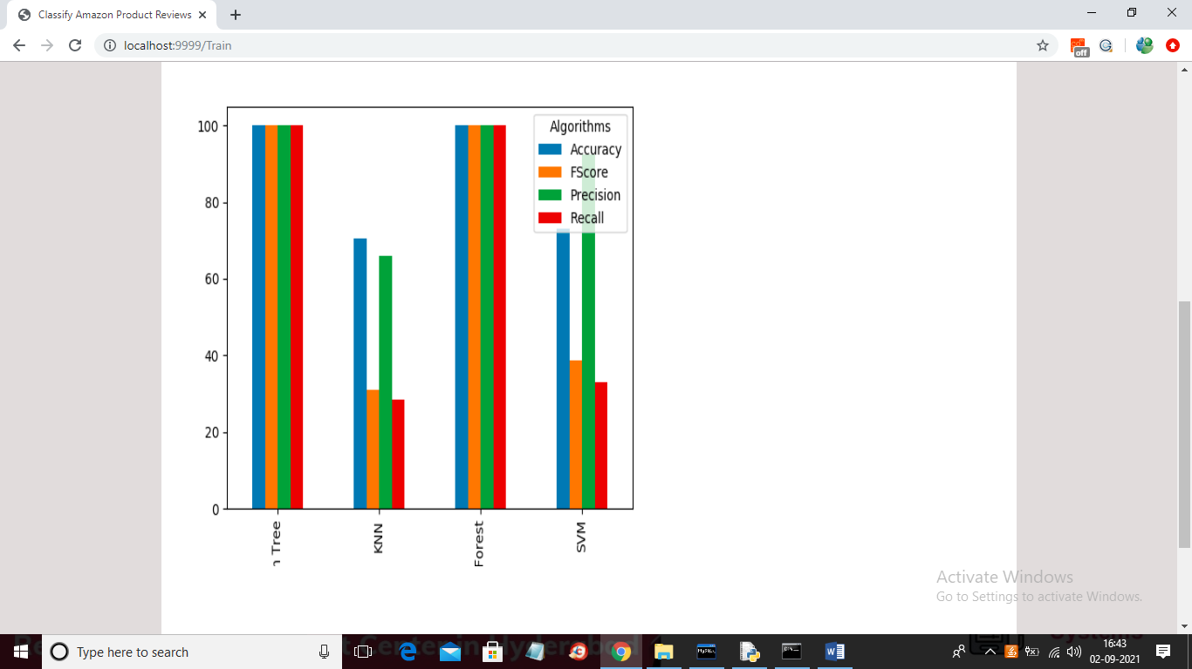
In above graph x-axis represents decision tree, KNN, Random Forest and SVM algorithm and each different colour bar represents different metrics such as precision, recall, FSCORE and accuracy and in above graph we can see decision tree and random forest gave better result and now ML models are ready and now click on ‘Submit Your Reviews’ link to get below screen
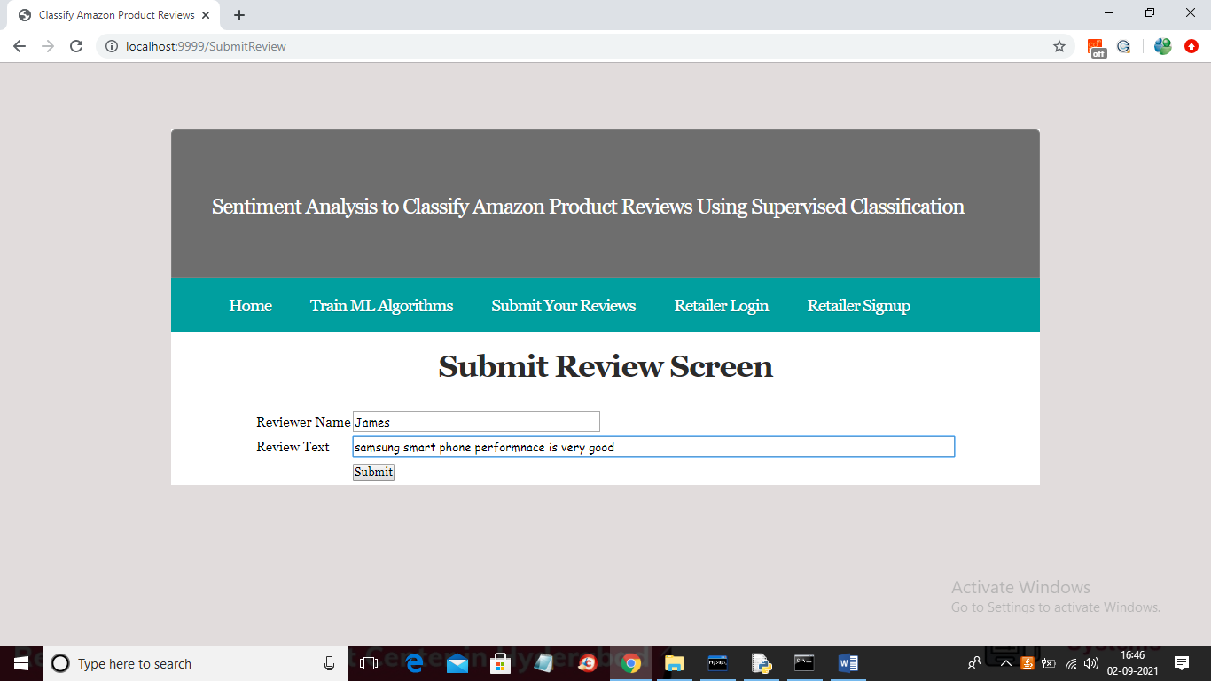
In above screen I wrote reviewer name and review text and then click on ‘Submit’ button to submit reviews and this reviews ratings will be predicted by ML and can view by retailer user.
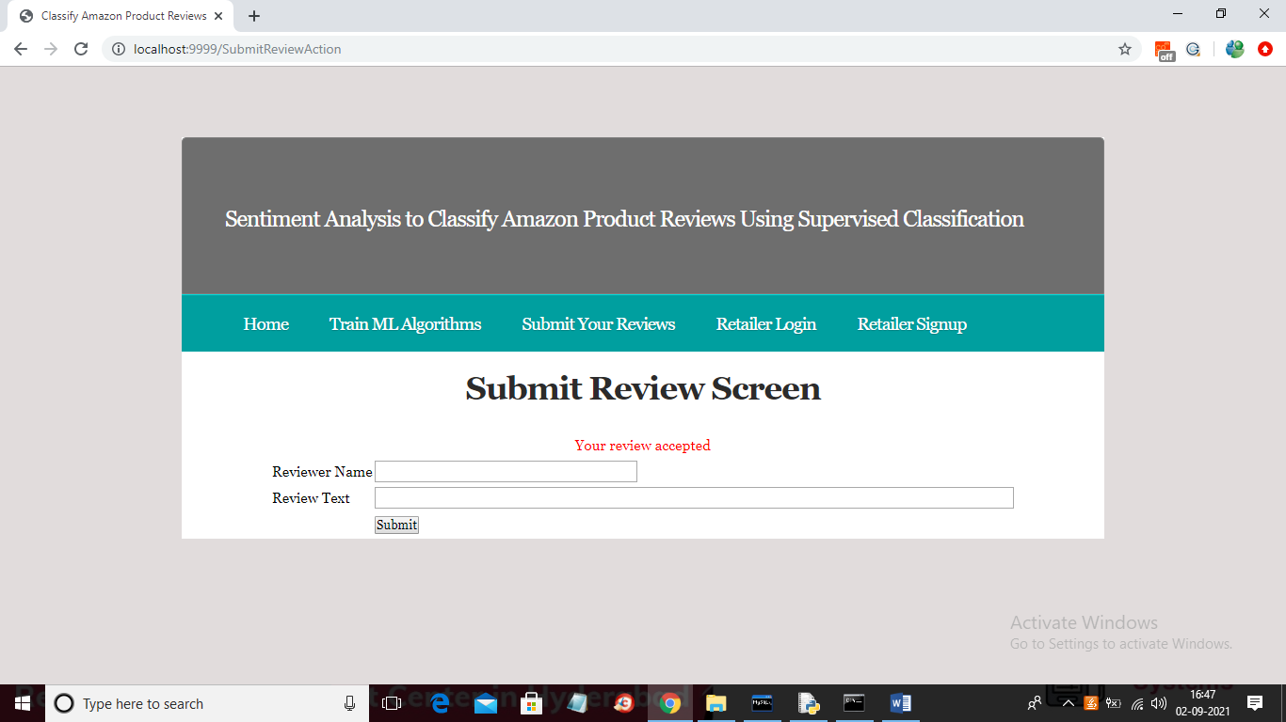
In above screen review is submitted and now click on ‘Retailer Signup’ link to get below screen to register new retailer
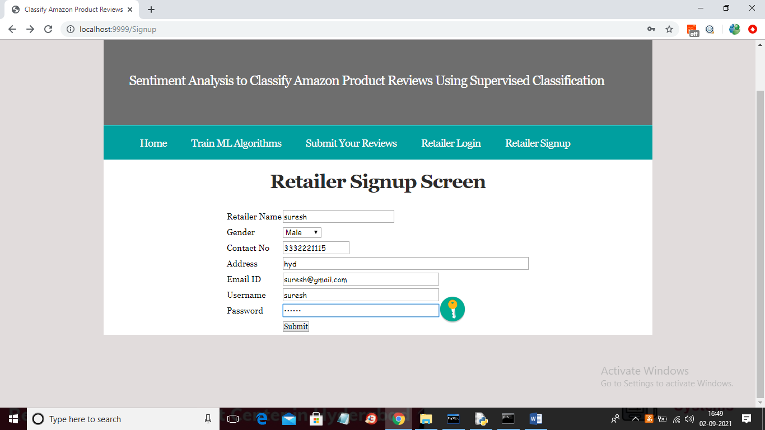
In above screen retailer is signing up with application and then click on ‘Submit’ button to get below screen
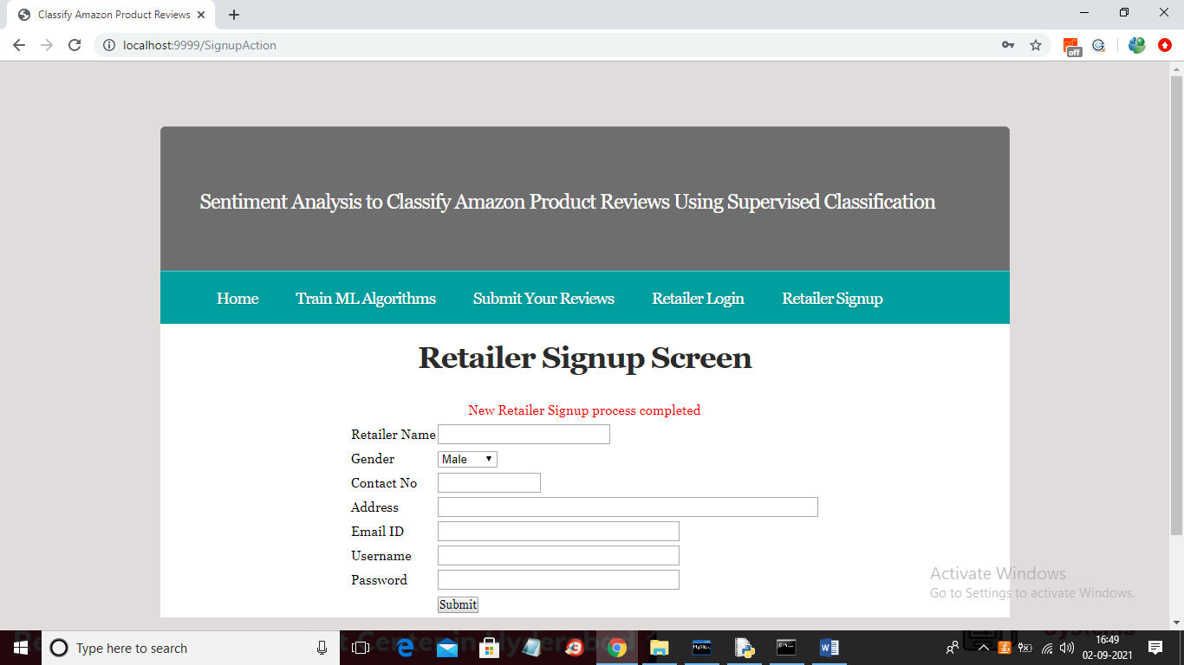
In above screen retailer signup process completed and now click on ‘Retailer Login’ to get below screen
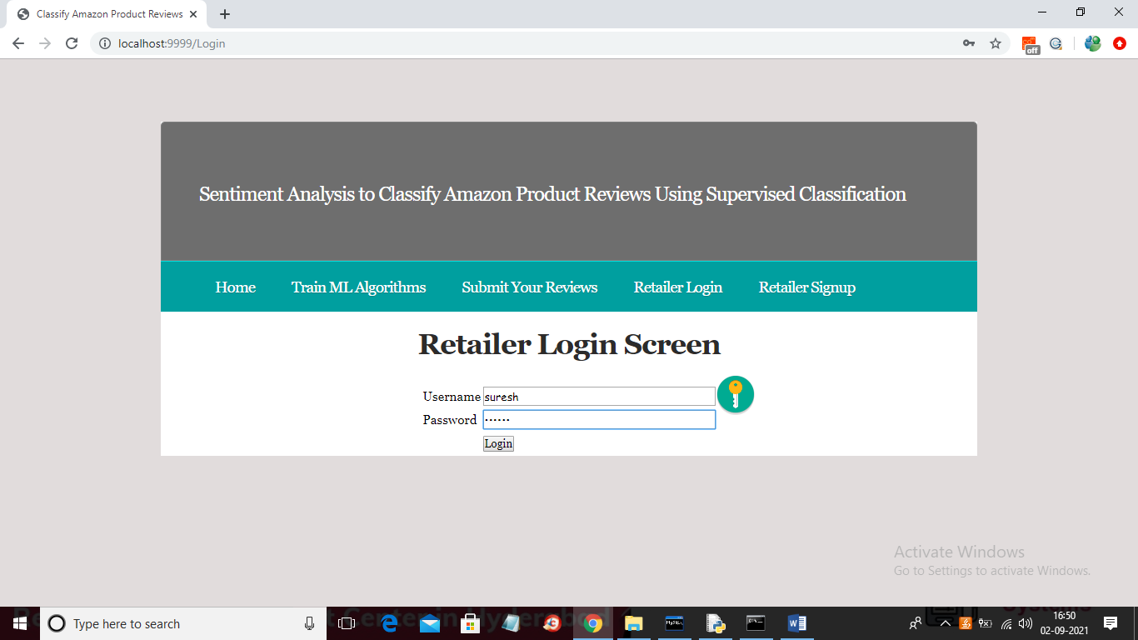
In above screen Retailer user is logged in and after login will get below screen
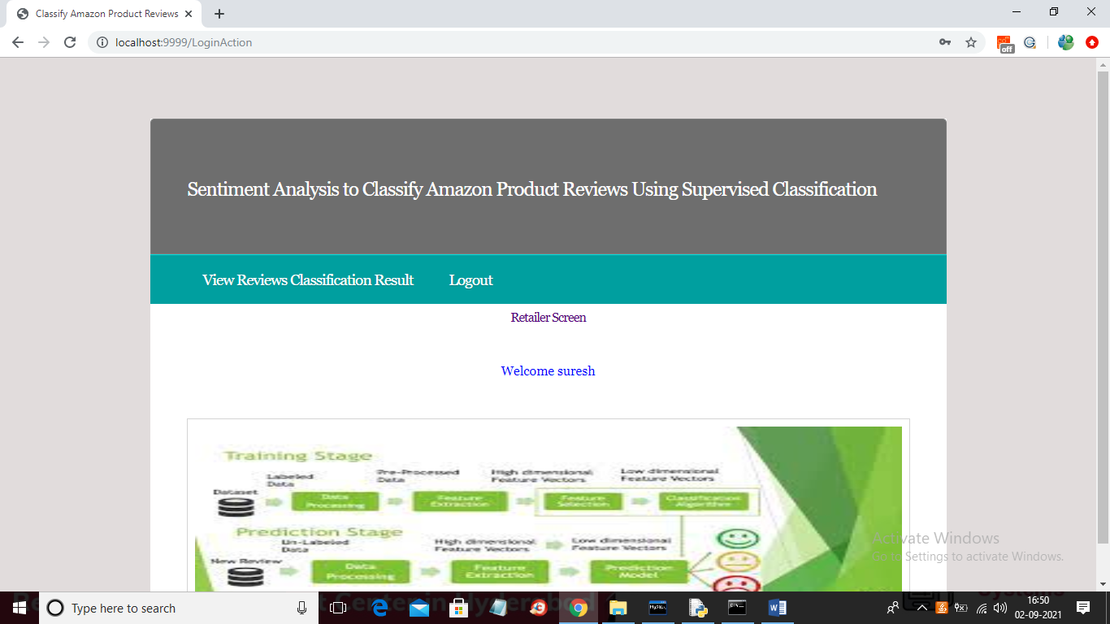
In above screen retailer can click on ‘View Reviews Classification Result’ link to view all user’s reviews ratings and their predicted gender. See below screen
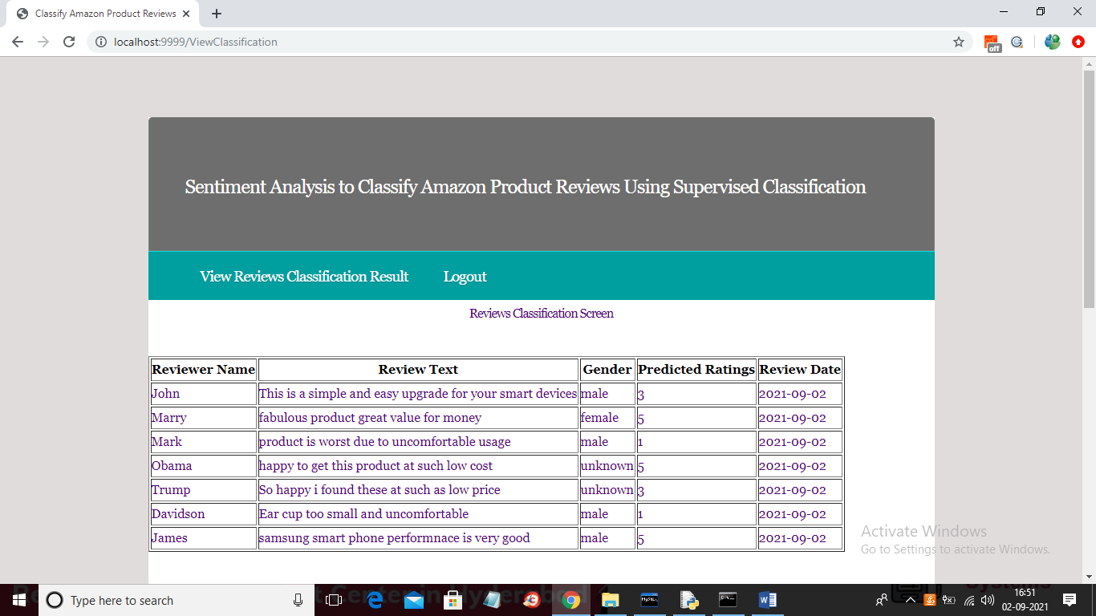
In above screen we can see gender and ratings are predicted by ML automatically and if sometime gender cannot be predicted then will get predicted value as ‘unknown’ and now scroll down above screen to get below comparison graph
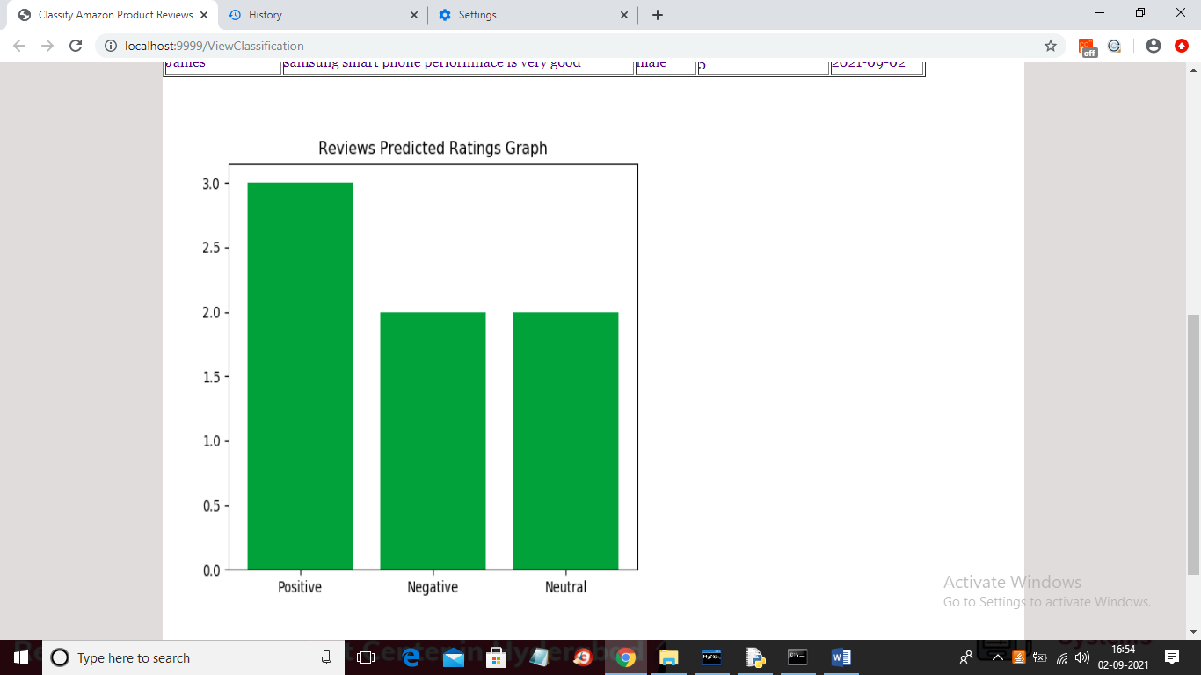
In above graph we can see total positive, negative and neutral ratings/sentiments predicted from test data. In above screen we calculate sentiments based on ratings. If ratings 5 or 4 then positive and if 3 then neutral and if 1 or 2 then negative.
Note: if u don’t get updated graph then clear you browser history and re click on link to get updated result. This is an ML based application so will predict ratings based on words available in dataset and if we give words outside of dataset then we may get wrong prediction.

