A Hybrid Fuzzy Logic-based Deep Learning Approach for Fake Review Detection and Sentiment Classification of Amazon Food Reviews

In this project as per you request we have modified algorithms with Deep Learning CNN and LSTM to build Hybrid Fuzzy Logic where CNN will used to predict sentiments and LSTM will used to predict where review is FAKE OR GENUINE. To implement this project we have used same AMAZON food reviews dataset given by you. Below screen shot showing food review dataset from AMAZON
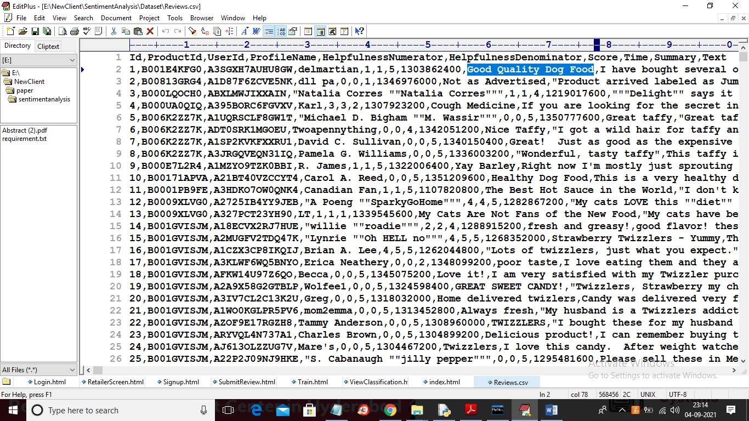
In above reviews dataset first row contains dataset column names and remaining rows contains dataset values. In below screen you can see training above dataset with CNN and LSTM
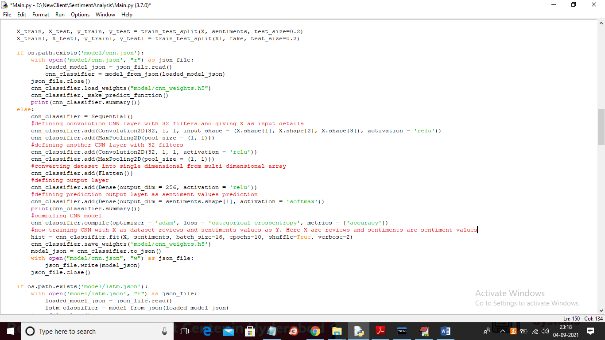
In above screen read red colour comments to know about CNN implementation and below screen shots showing LSTM training with FAKE and genuine data
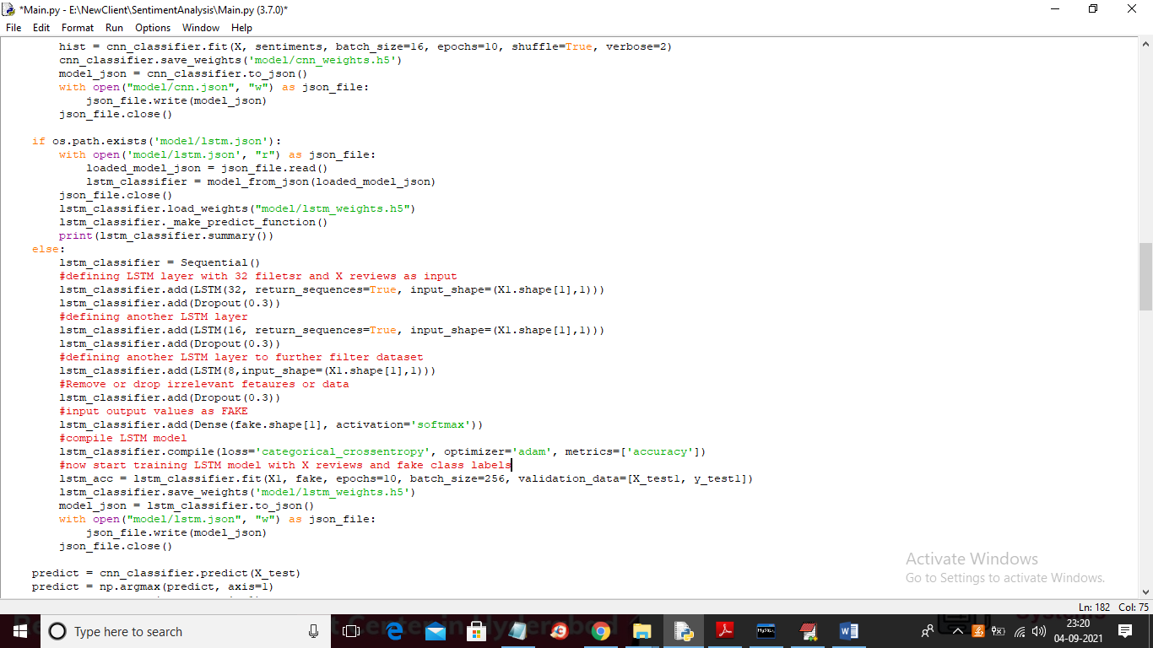
In above screen read red colour comments to know about LSTM implementation
SCREEN SHOTS
Output is same as previous screens just algorithms are changed
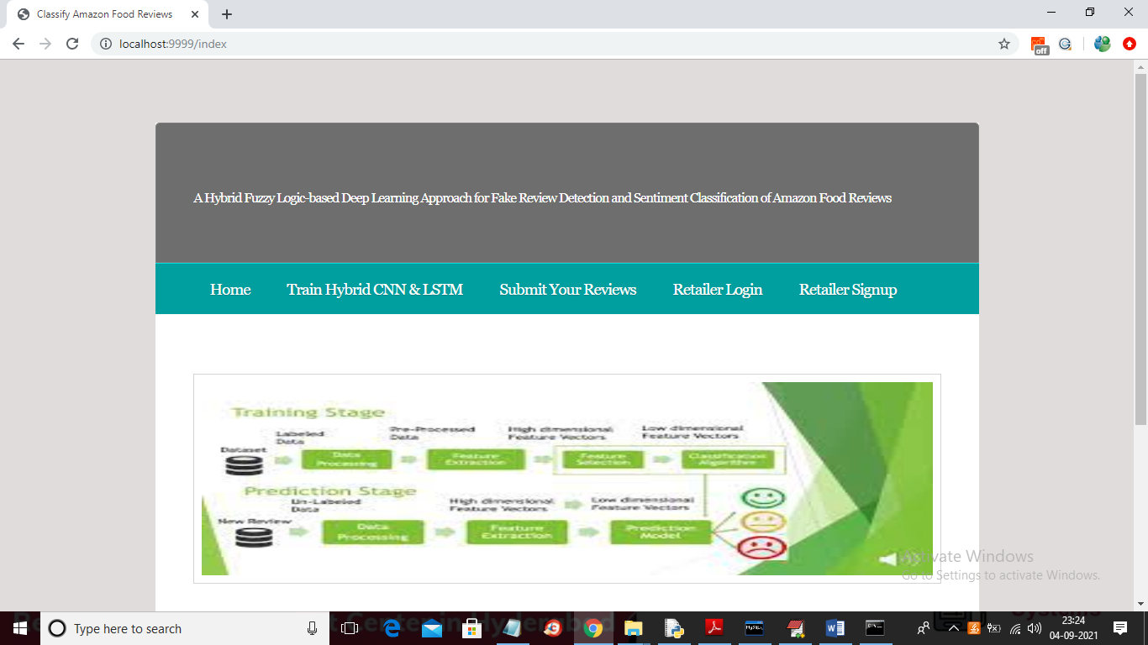
In above screen click on ‘Train Hybrid CNN & LSTM’ link to train both algorithms on ‘Amazon Food reviews’ dataset and to get below output
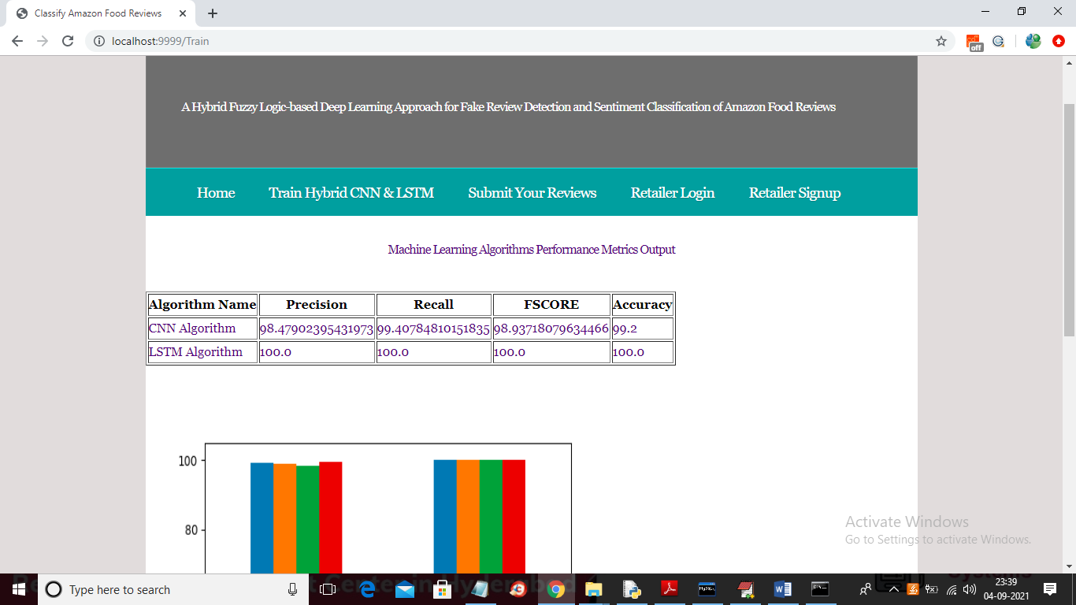
In above screen both algorithms are trained and its performance values in terms of accuracy, precision are calculated and below is the comparison graph
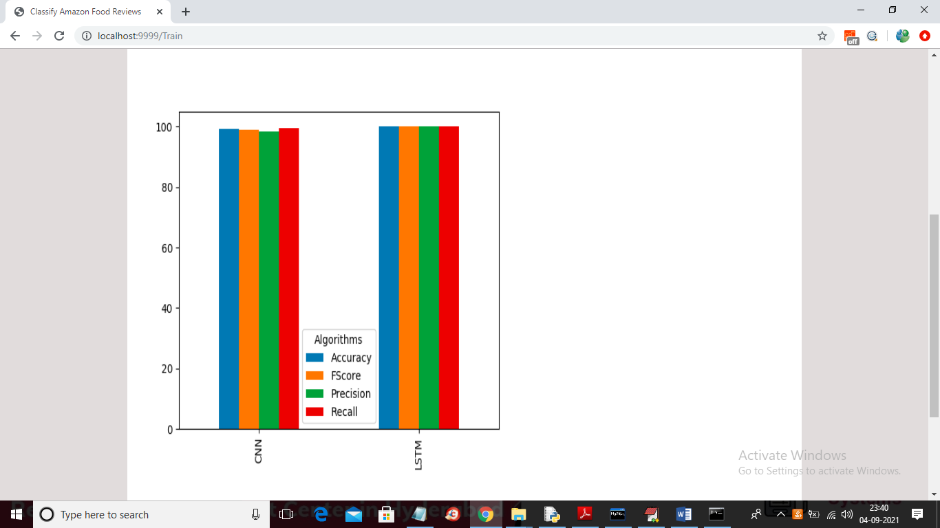
Now click on ‘Submit Your Reviews’ link to submit reviews
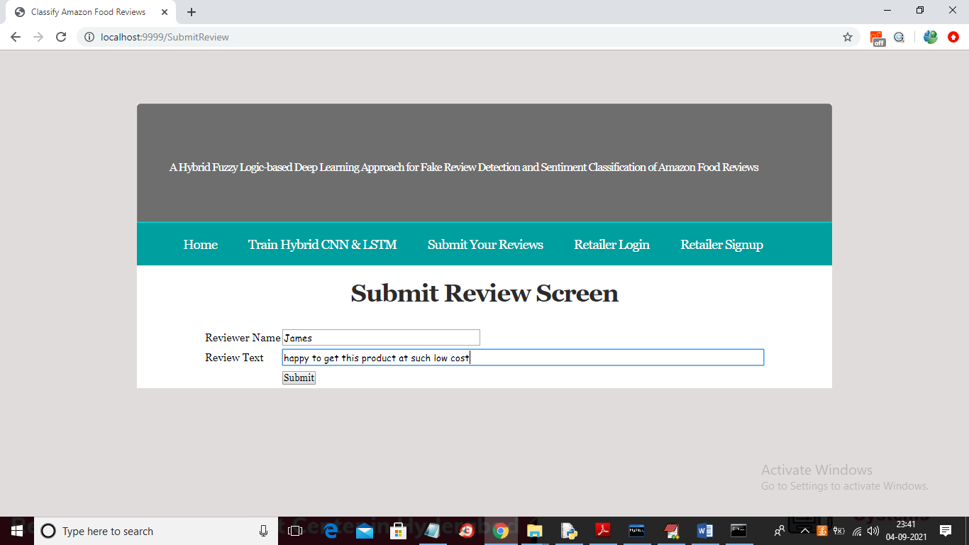
In above screen I entered some review and now click on ‘Submit’ button to get below prediction result
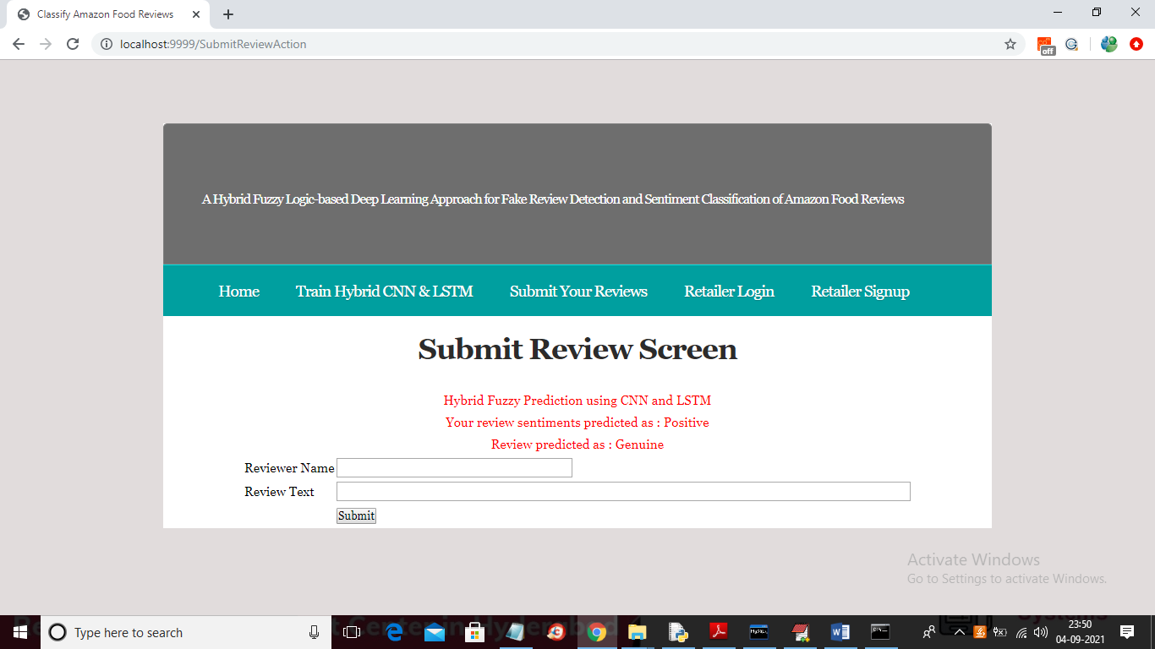
In above screen you can see given review is predicted as ‘POSITIVE’ and ‘GENUINE’ and similarly you can try other reviews and now test other review
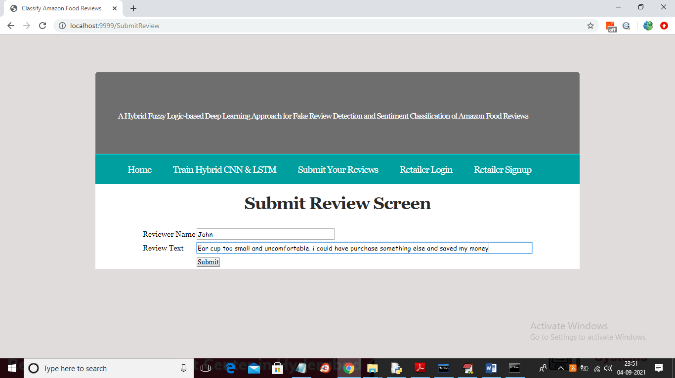
For above review below is the result
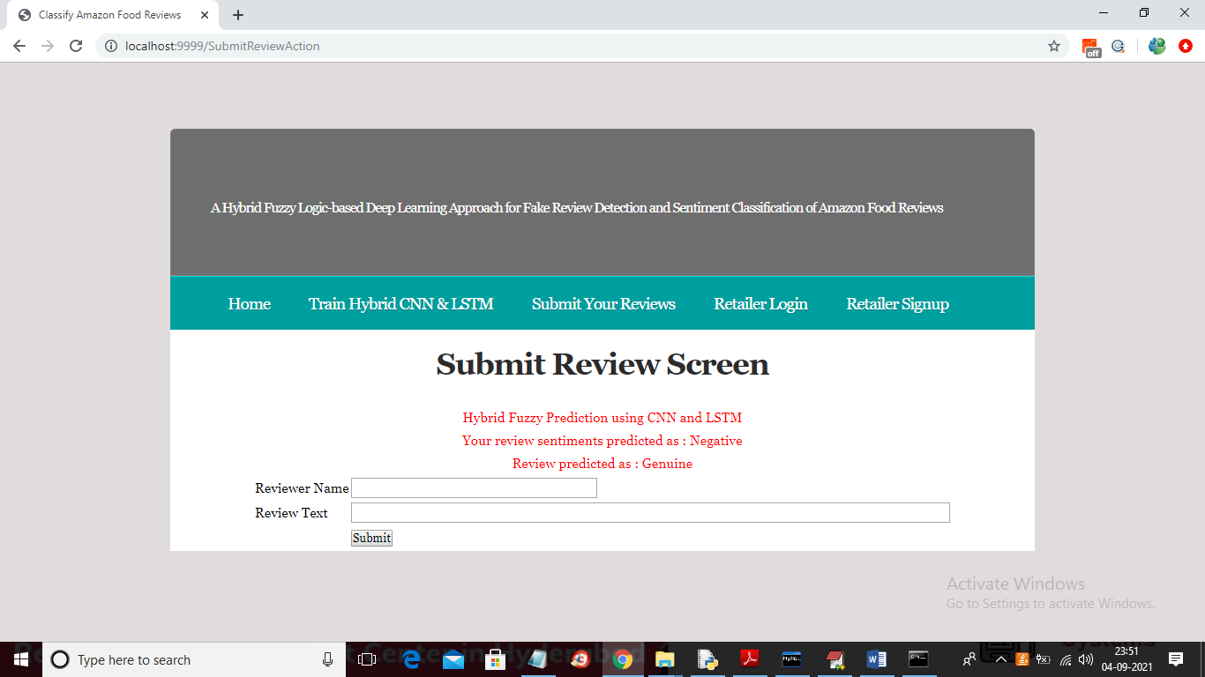
Now click on ‘Retailer Login’ and see all reviews details. In below screen retailer is login
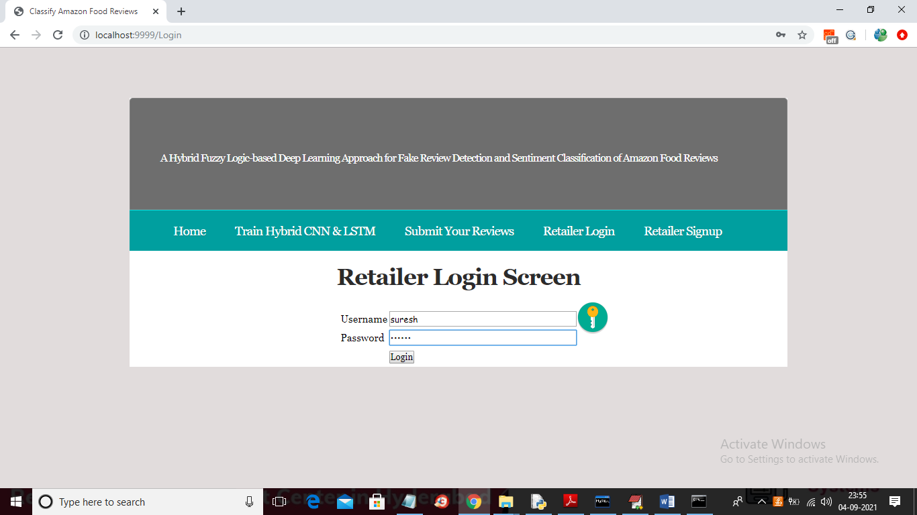
In above screen click on Login button to get below screen
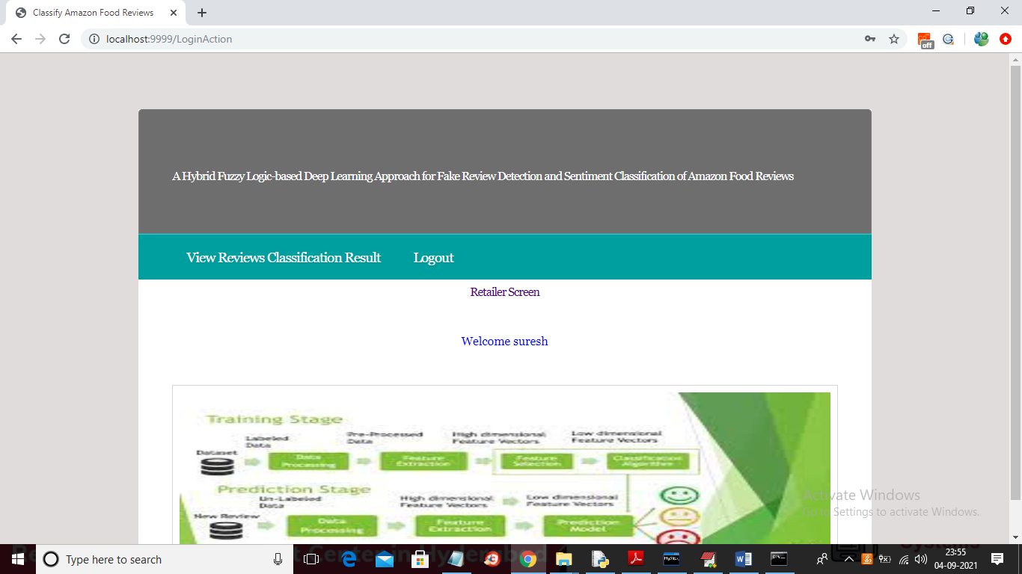
In above screen retailer can click on ‘View Reviews Classification Result’ link to get below output
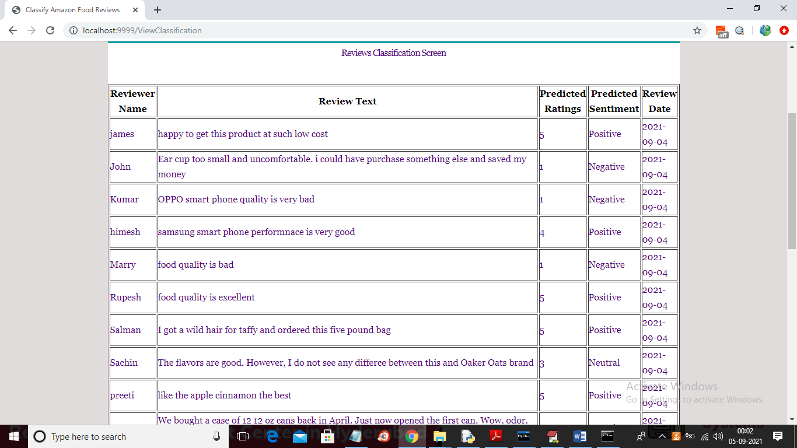
In above screen retailer can view all reviews and its sentiments and below is the sentiment graph
