**GraphQL**

**Aim:-** LearningGraphQL .

**Objective:** Query language for API.

GraphQL is a query language for APIs and a runtime for fulfilling those queries with our existing data. GraphQL provides a complete and understandable description of the data in our API, gives clients the power to ask for exactly what they need and nothing more, makes it easier to evolve APIs over time, and enables powerful developer tools.

**Key important** – schema creation, schema execution with query, response

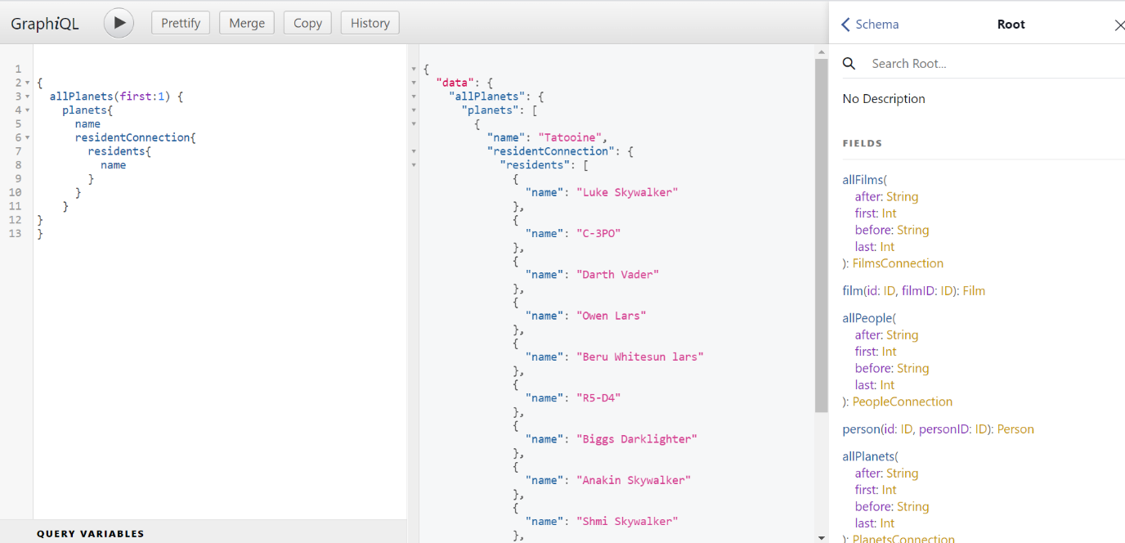

**(GraphQL query execution)**

**Case 1: -Graphql code to perform query and provide a response**

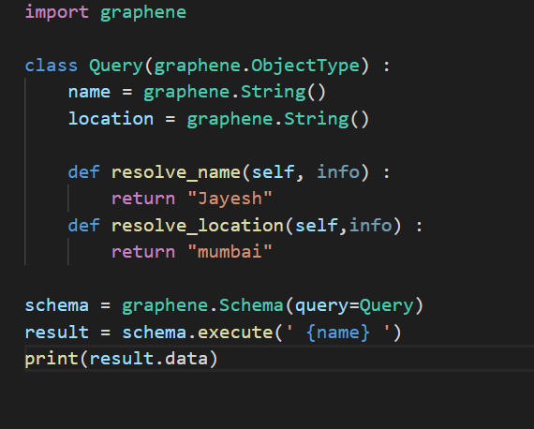

**Case 2: Passing Arguments in name field**

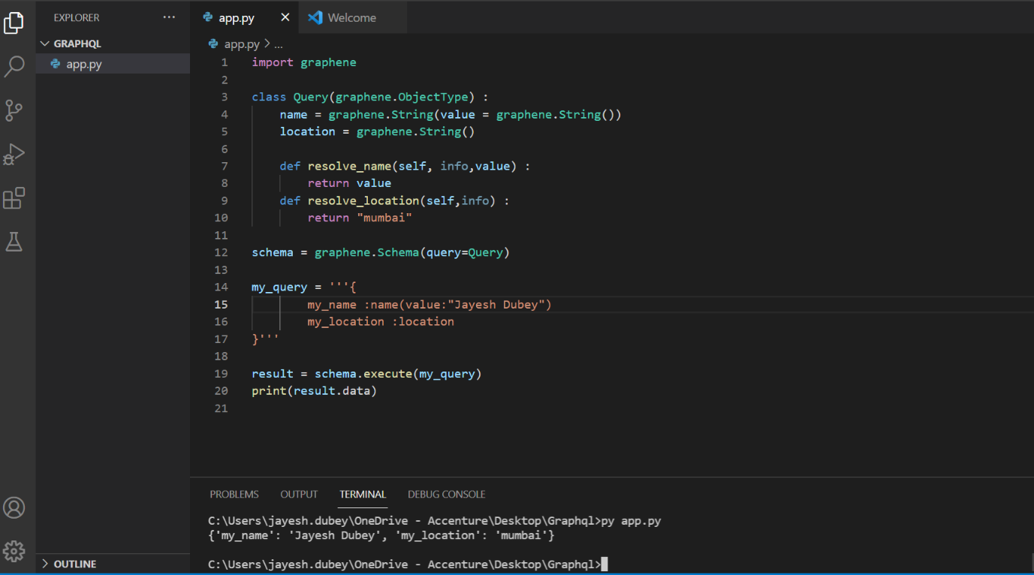

**Case 3: Using arrays.**



