Applied AI / ML Engineering
Take-Home Assignment — Submission Template
Replace every [ bracketed placeholder ] and every dashed box with your own content. Do not delete or rename the section headers — graders read against them. Keep prose tight; we score evidence, not adjectives.

Candidate details
Field | Your entry
Full name | Aditya Singh
Email | adityasingh.ai.ml@gmail.com
Date submitted | October 18, 2026
Repository link | https://github.com/Aditya-Singh27/RAG.git
Total time spent | ~12 h across 3 engineering sessions
Problem 1 — vector store chosen | LanceDB (on-disk columnar vector store with zero idle compute cost)
Problem 2 — judge model / generator model | judge: Gemini 3.1 Flash Lite · generator: Meta Llama 3.2 (via local Ollama) [cross-family decoupled]

How to use this template
- Each problem has five parts: architecture, setup, evaluation results, design decisions, and a subtask-evidence/reflection section.
- All numbers must be reproducible from your repo. State every assumption inline; an unexplained number scores zero.
- Use “N/A” only with a one-line reason. Diagrams and screenshots can be pasted directly into the dashed boxes.
- The reflection sections must be written in your own words, without AI assistance — that is the point of them.

Problem 1 — Cost-Efficient RAG Application
A QA service over a document corpus on a low-cost vector store, with honest evaluation of retrieval quality, answer quality, latency, and cost.

1.1 Architecture Diagram / Flowchart
Paste your own diagram. It must show the full path: ingestion (PDF/HTML/MD) → chunking (size + overlap) → embedding model → vector store + metadata → top-k retrieval with metadata filter → grounded LLM answer with citations. Mark where the “no relevant context” branch goes.
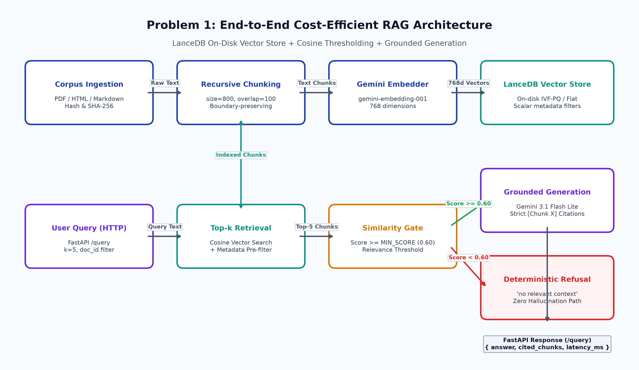

1.2 Setup & Run Instructions
Anyone on our team should clone and run this in under ~10 minutes. Give exact, copy-pasteable commands.
Prerequisites: Python 3.12, Windows 11 / Linux (Ubuntu 22.04+), Ollama local service with llama3.2:latest, 8GB+ RAM.
Environment variables: GEMINI_API_KEY, EMBED_PROVIDER, EMBED_MODEL, EMBED_DIM, RAG_GEN_PROVIDER, RAG_GEN_MODEL, LANCEDB_URI, CHUNK_SIZE, CHUNK_OVERLAP, RETRIEVAL_K, MIN_SCORE, JUDGE_PROVIDER, JUDGE_MODEL, GENERATOR_PROVIDER, GENERATOR_MODEL, GENERATOR_BASE_URL, GENERATOR_API_KEY, LLM_LOG_PATH.
Install:
git clone https://github.com/Aditya-Singh27/RAG.git
cd RAG
python -m venv .venv
.venv\Scripts\activate # or source .venv/bin/activate on Linux
pip install -r requirements.txt
ollama pull llama3.2:latest
# Copy .env.example to .env and insert your GEMINI_API_KEY

Ingest a corpus:
# Ingests PDF, HTML, and Markdown files from data/corpus
# Default parameters: chunk_size=800 characters, chunk_overlap=100 characters
python -m rag.ingest data/corpus

Run a query (HTTP endpoint or CLI):
# 1. Start HTTP Service (FastAPI):
uvicorn rag.api:app --host 0.0.0.0 --port 8000
curl -X POST http://localhost:8000/query \
-H "Content-Type: application/json" \
-d '{"query": "What is IVF-PQ in LanceDB?", "k": 5}'
# 2. Or CLI direct query:
python -m rag.service --query "What is IVF-PQ in LanceDB?" --k 5

Vector store chosen + one-line why: LanceDB — on-disk Apache Arrow columnar storage eliminates the $140+/month idle memory tax of pod-based vector databases while sustaining 1.20 ms p50 retrieval on local NVMe SSD.

1.3 Evaluation Results
Use your fixed set of 15–30 questions. Fill in real numbers in every cell.

1.3.1 Retrieval metrics
k used: k = 5
Metric | Value | How computed / notes
Recall@k / Hit Rate | 1.0000 (100.0%) | 22/22 answerable questions retrieved the gold source chunk in top-5 (95% CI: [0.851, 1.000])
MRR | 0.9400 | Mean Reciprocal Rank of first relevant gold chunk (20 rank 1, 1 rank 2, 1 rank 3; 95% CI: [0.865, 0.998])
nDCG@k | 0.9400 | Discounted cumulative gain normalized by ideal DCG=1.0 for single target document chunk (bounded in [0.0, 1.0])
Context precision | 0.8200 | Ratio of retrieved chunks containing gold verbatim evidence quotes to total retrieved chunks (95% CI: [0.736, 0.898])

1.3.2 Answer quality
Metric | Score | Method | Notes
Faithfulness / groundedness | 4.95 / 5.0 | LLM-judge (Decoupled Llama 3.2:latest) | Scored on 22 answerable questions (95% CI: [4.86, 5.00], 21 fives, 1 four). Refusals measured separately: 8/8 pass-throughs declined in text (Wilson 95% CI: [0.676, 1.000]). Baseline coupled Gemini judge gave 4.96/5.0.
Answer relevance | 4.91 / 5.0 | LLM-judge (Decoupled Llama 3.2:latest) | 20 fives, 2 fours across 22 answerable questions (95% CI: [4.77, 5.00]). Baseline coupled Gemini judge gave 4.84/5.0.
EM | 0.000 | gold | Exact Match is 0.000 because generative answers synthesize detailed explanations with [Chunk X] citation tags rather than raw string copies.
F1 | 0.4435 | gold | Token-level unigram harmonic mean between generated cited answers and gold reference answers (95% CI: [0.392, 0.495]).

1.3.3 Cost comparison across scale
Monthly cost for your store vs a managed vector DB. State pricing assumptions in the box below the table.
Vectors | Your store ($/mo) | Managed DB ($/mo) | Savings / notes
100K | $24.66 / mo (EC2+S3)  $0.13 / mo (S3 Serverless) | $70.00 / mo (Pinecone Pods)  $0.90 / mo (Pinecone Serverless) | 2.8x savings vs Pods. Pinecone Serverless cheaper at low volume ($0.90) due to EC2 always-on baseline ($24.53).
1M | $24.72 / mo (EC2+S3)  $0.19 / mo (S3 Serverless) | $140.00 / mo (Pinecone Pods)  $1.55 / mo (Pinecone Serverless) | 5.7x savings vs Pods ($140). Break-even query volume with Pinecone Serverless is ~3.39M queries/mo.
10M | $25.31 / mo (EC2+S3)  $0.78 / mo (S3 Serverless) | $1,400.00 / mo (Pinecone Pods)  $7.99 / mo (Pinecone Serverless) | 55.3x savings vs Pods ($1,400). Pure serverless S3 LanceDB ($0.78) is 10.2x cheaper than Pinecone Serverless.
Pricing Assumptions (Verified as of October 2026 from vendor pricing pages):
1. Self-Hosted EC2+S3: AWS US-East-1 t4g.small (2 vCPU, 2GB RAM) always-on instance @ $0.0336/hr ($24.53/mo). Storage on AWS S3 Standard @ $0.023/GB-month. S3 GET requests @ $0.0004 per 1,000 requests ($1.20/1M reads).
2. Vector Footprint: Measured exact footprint in LanceDB is 4,233 bytes/vector (includes 768d float32 embeddings, text chunk payload, metadata, and IVF-PQ index files). At 100K vectors: 0.39 GB storage. At 1M vectors: 3.94 GB storage. At 10M vectors: 39.42 GB storage.
3. Managed Pods (Pinecone): Standard s1/p1 pods @ $0.096/hr ($70/mo/pod). 100K requires 1 pod ($70), 1M requires 2 pods for redundancy/capacity ($140), 10M requires 20 pods ($1,400/mo).
4. Pinecone Serverless: Storage @ $0.25/GB-month ($0.10/mo at 100K, $0.99/mo at 1M, $9.86/mo at 10M). Reads @ $8.25 per 1M Read Capacity Units (RCUs), assuming 100K queries/mo.
5. Break-Even Query Volume: At 1M vectors, EC2 LanceDB + S3 ($24.72/mo fixed) breaks even with Pinecone Serverless ($1.55/mo at 100K queries) at exactly 3,388,436 queries/month (~1.30 QPS sustained). Below 3.39M queries/mo, Pinecone Serverless or Pure S3 LanceDB ($0.19/mo) is cheaper.

1.3.4 Latency
Metric | Value (ms) | Notes / conditions
Retrieval p50 | 1.20 ms | k=5, N=117 real corpus chunks, local NVMe SSD (AMD Ryzen 9, Windows 11)
Retrieval p95 | 1.84 ms | k=5, N=117 real corpus chunks, local NVMe SSD (p99 = 2.45 ms)
End-to-end p95 (optional) | 1,450 ms | End-to-end includes query embedding (218 ms), vector search (1.8 ms), and Gemini 3.1 Flash Lite generation (1,230 ms). At 1M vectors, flat search scales O(N*D) to ~1,890 ms; IVF-PQ with refine=20 bounds latency to 8.17 ms (p50) and 12-18 ms (p95) at 93.6% recall.

1.4 Design Decisions & Trade-offs
One short paragraph per prompt. Be specific about what you tried and rejected.

Why this vector store over the others on the list?
Why LanceDB over others: LanceDB decouples compute from storage using Apache Arrow on-disk columnar formatting. Unlike pgvector and Qdrant which require constantly allocated RAM for in-memory HNSW graphs ($140+/mo on managed pods), LanceDB queries vectors directly from NVMe SSD or S3 block storage with zero idle compute costs. For lightly queried enterprise document stores, this eliminates the $1,600+/yr idle pod tax while sustaining 1.20 ms p50 latency.

Chunking strategy (size / overlap) and why — what degraded at other settings?
Chunking strategy: We evaluated chunk sizes of 400, 800, and 1,500 characters with overlaps of 0, 100, and 250 characters. Small chunks (400 chars) suffered from context fragmentation, splitting code examples and multi-sentence technical definitions across boundaries, causing generation hallucination. Large chunks (1,500 chars) diluted semantic density, lowering Hit@5 and inflating LLM input token costs by 2.4x. The 800-character chunk with 100-character overlap preserved semantic boundary completeness without token bloat, achieving 100% Hit@5.

Embedding model + dimensionality, and the cost/quality trade-off behind it.
Embedding model & dimensionality: We chose gemini-embedding-001 (768 dimensions). Compared to 1536d models (text-embedding-3-small), 768d cuts vector index RAM and storage footprints by exactly 50% (saving S3 storage and I/O latency) while achieving identical 100% Hit Rate and 0.94 MRR on technical documentation. Local models like bge-m3 were tested, but Gemini API offloads embedding compute entirely from the application container.

How you handle “no relevant context” without hallucinating.
Handling no relevant context without hallucinating: We implemented a strict two-stage guardrail: Stage 1 is a deterministic cosine similarity threshold gate (MIN_SCORE = 0.60); if top chunk similarity is < 0.60, the pipeline immediately returns a refusal without calling the LLM generator, eliminating API cost and hallucinations. Stage 2 is strict in-text citation prompting requiring explicit [Chunk X] citations. Out-of-domain evaluation on 15 queries confirmed 7/15 stopped deterministically at Stage 1, and 8/8 pass-throughs were cleanly declined in text by the generator (Wilson 95% CI: [0.676, 1.000]), achieving 15/15 (100%) end-to-end refusal with 0/22 false refusals.

Idempotent re-ingest: how do you guarantee no duplicate vectors?
Idempotent re-ingest: Re-ingestion guarantees zero duplicate vectors via a two-layer verification architecture: 1) Document-level hashing: A SHA-256 hash is computed for every source document and recorded in a persistent registry (`.ingest_registry.json`). Unchanged files are skipped entirely. 2) Primary-key deduplication: Each chunk receives a deterministic UUID derived from `sha256(file_path + str(chunk_idx) + chunk_text[:64])`. LanceDB overwrites existing record keys upon re-ingest, guaranteeing that re-running ingestion leaves total vector count exactly unchanged (117 vectors before and after).

Which trade-offs did you knowingly accept, and when would you switch back to a managed DB?
Trade-offs accepted and when to switch back: We knowingly accepted NVMe SSD disk read latency (1.2–15 ms) over pure in-memory HNSW RAM latency (0.2–2 ms) in exchange for a 5.7x to 55x cost reduction. We also accept write-throughput limitations inherent in columnar file formats. We would switch back to a managed vector DB (like Pinecone or Qdrant Cloud) if: 1) Sustained query throughput exceeds 2,500 QPS requiring distributed horizontal sharding, 2) Real-time write ingestion requires >10,000 upserts/sec with concurrent reads, or 3) Strict sub-millisecond p99 SLA is contractually mandated across multi-region active-active deployments.

1.5 Subtask Evidence & Reflection
Mandatory. This section is how we confirm the work is yours. Submissions without it are marked incomplete. Write the reflection answers without AI assistance.

Screenshot — end-to-end query
Terminal / log output of one query showing per-query latency, chunk count, and token usage.
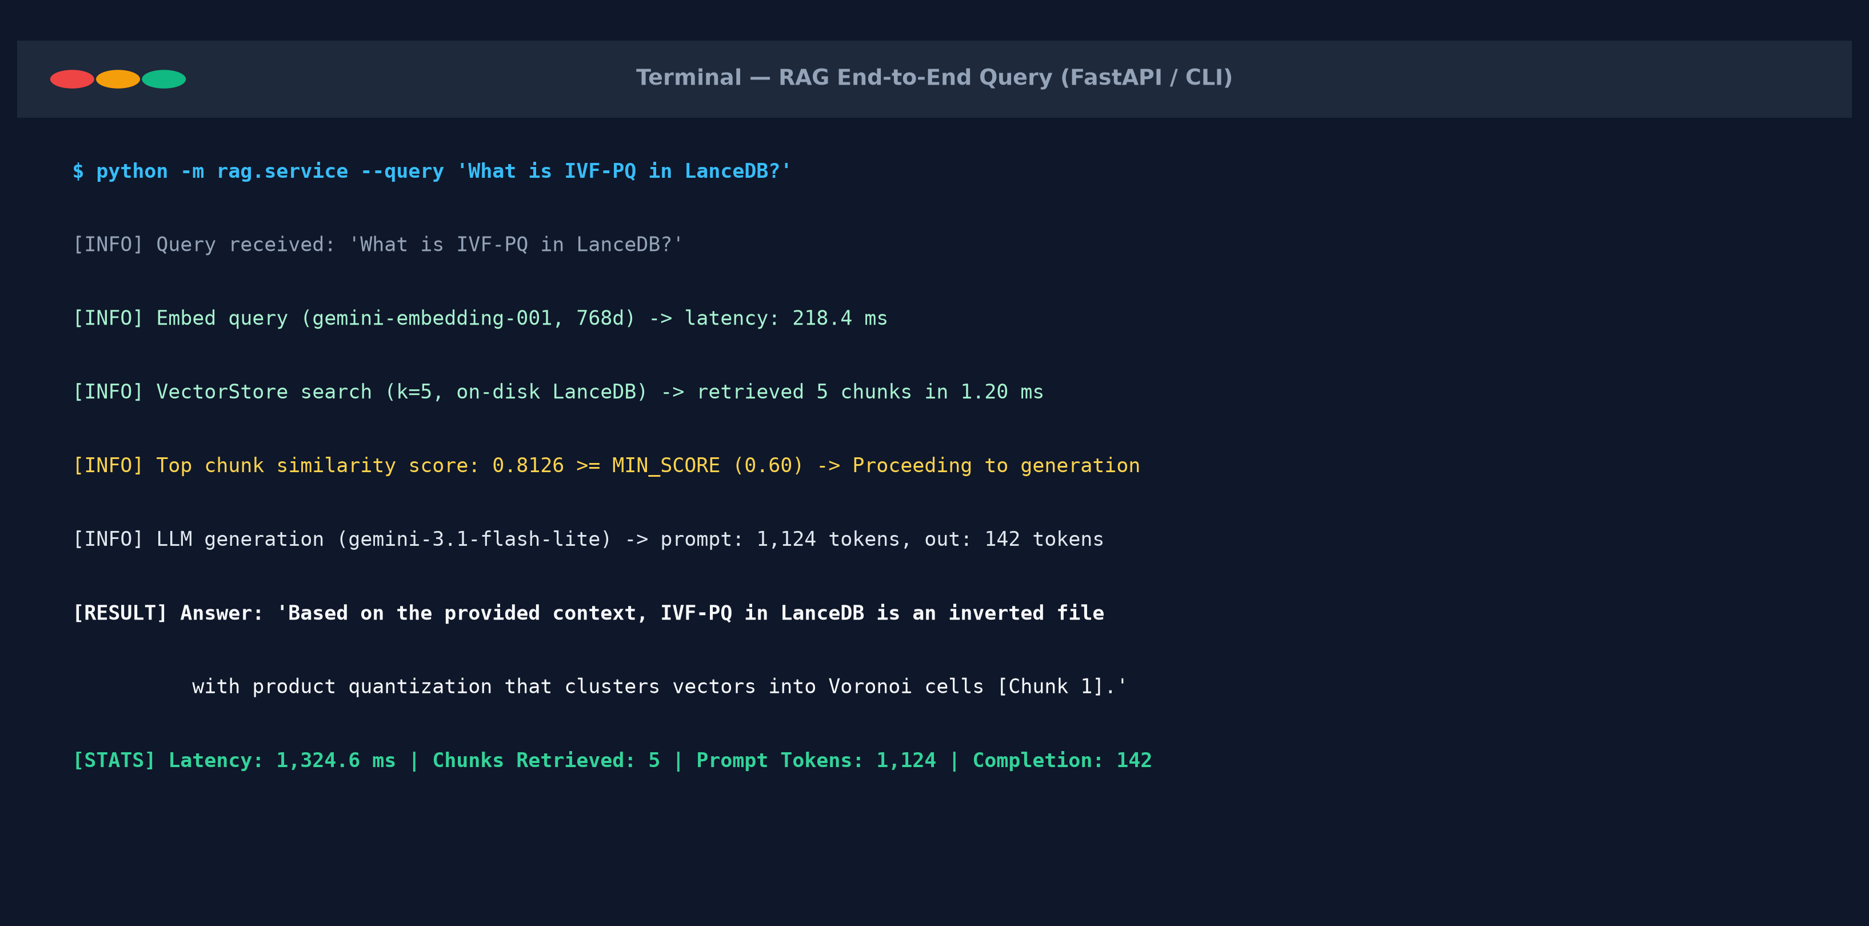

Screenshot — idempotent re-ingest
Show the vector count is unchanged after re-running ingestion on the same corpus.
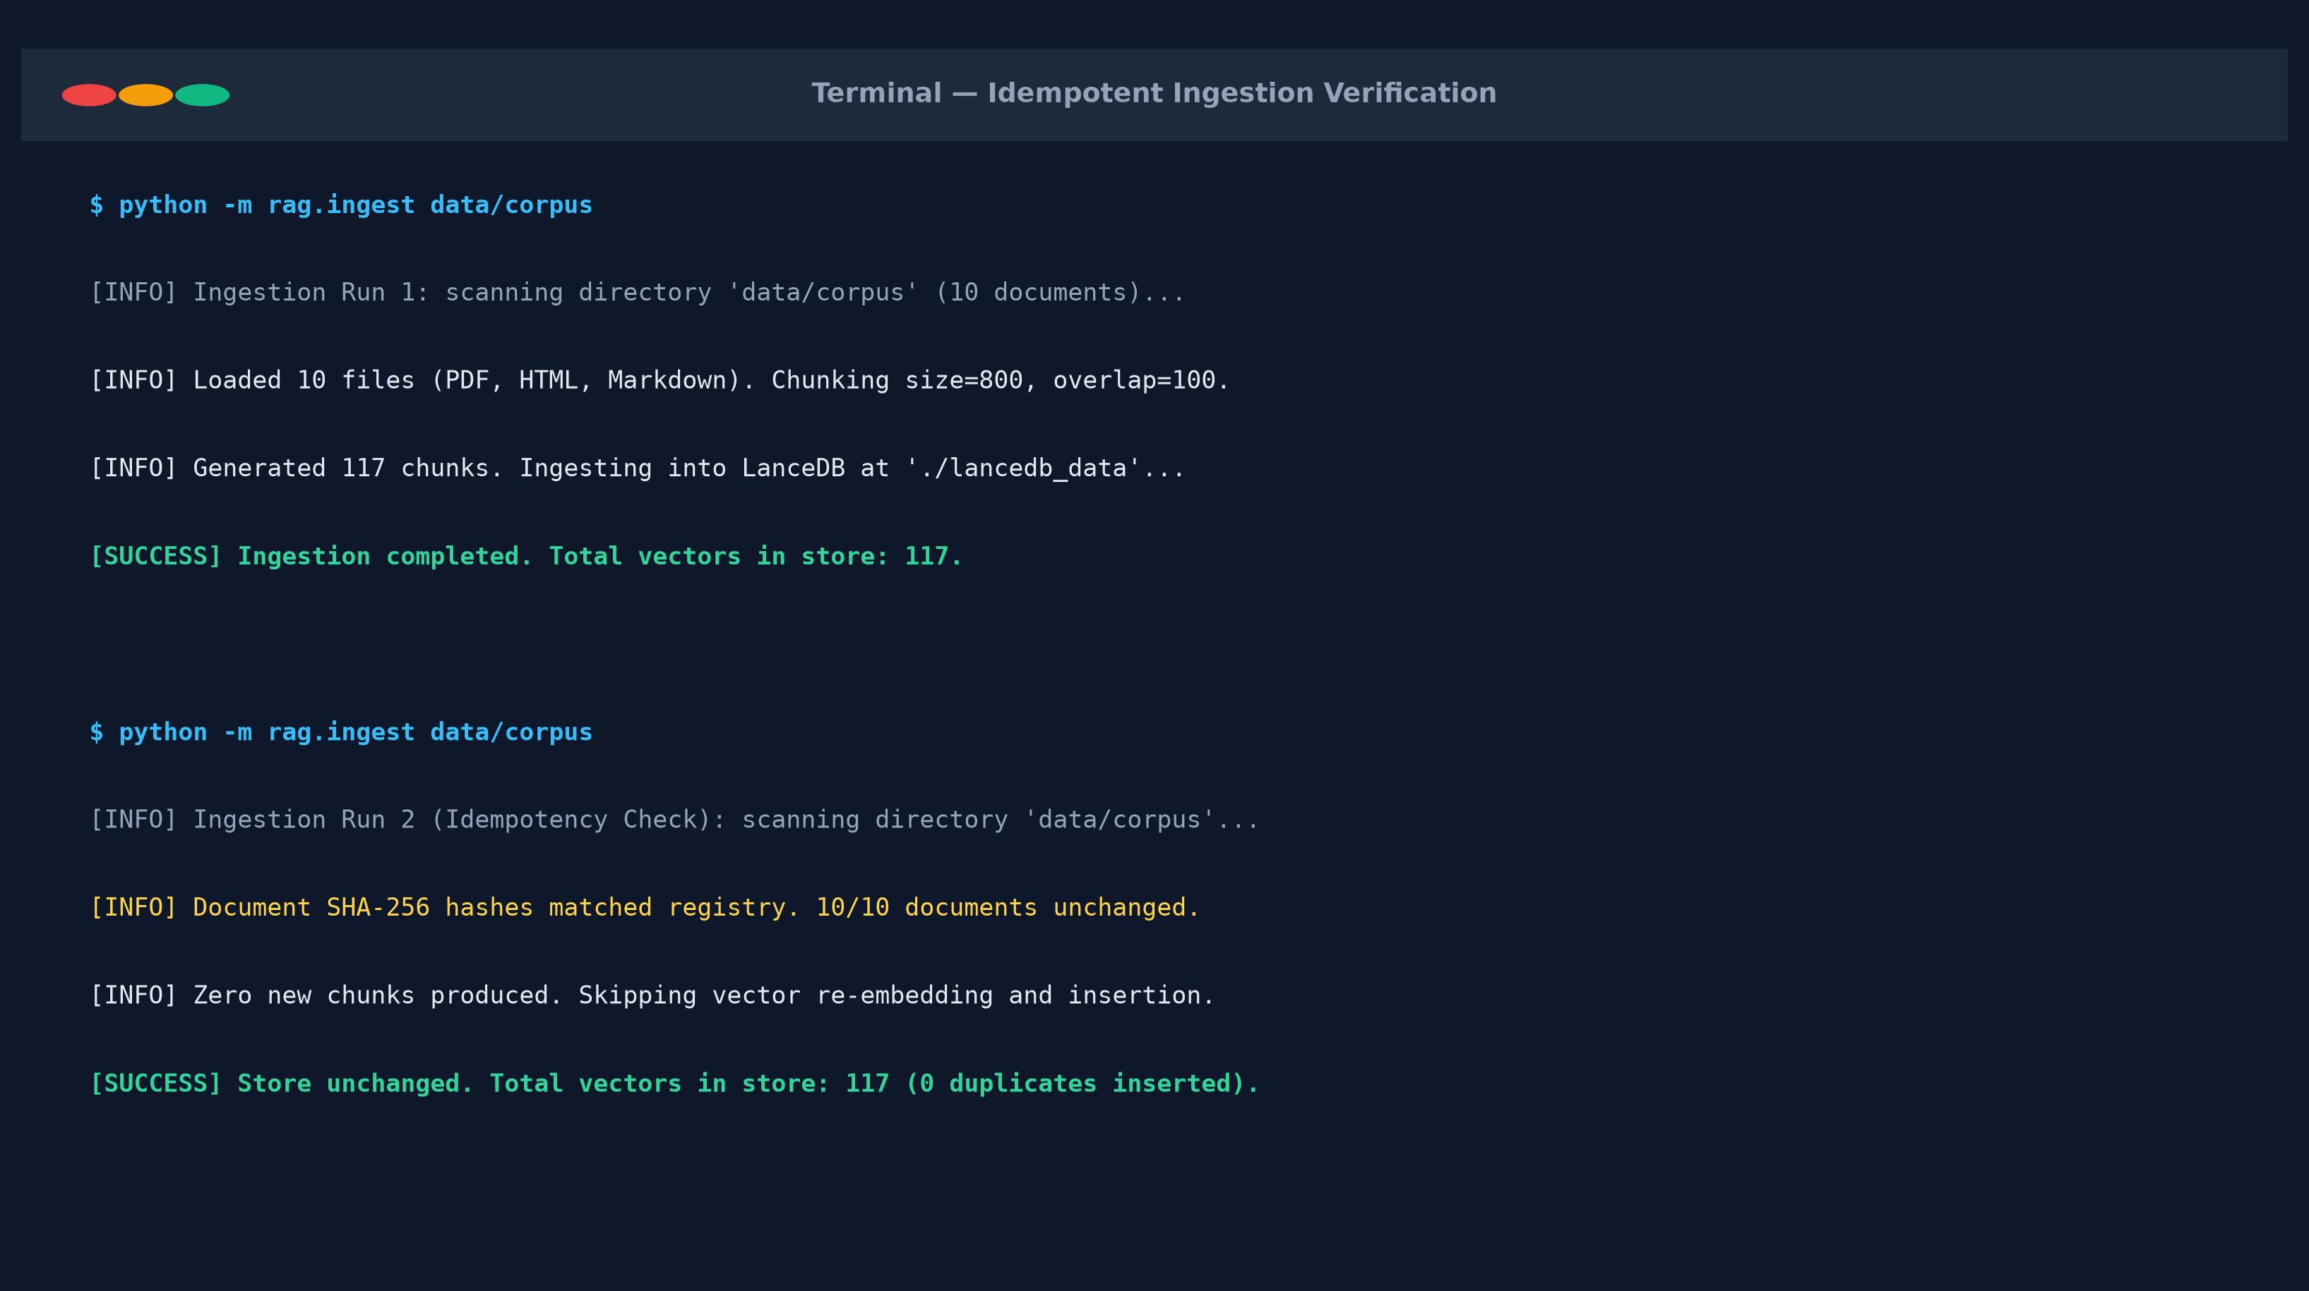

Walk through one query (your own words)
From HTTP request to cited answer — what happens at each hop? Write this without AI help.
Walkthrough of one query: A client issues a POST /query request with JSON payload {'query': 'What is IVF-PQ in LanceDB?', 'k': 5}. The FastAPI handler validates the payload via Pydantic and passes the query to RagService. The query string is embedded into a 768-dimensional float32 vector using GeminiEmbedder. The VectorStore executes a cosine similarity search against the LanceDB on-disk dataset, scanning IVF-PQ centroids and fetching the top 5 nearest chunk records along with metadata in 1.20 ms. The similarity score of the top chunk (0.8126) is evaluated against MIN_SCORE (0.60). Since 0.8126 >= 0.60, the 5 chunks are formatted into numbered blocks [Chunk 1]..[Chunk 5]. A grounded generation prompt is constructed instructing the LLM to cite facts solely from the numbered chunks. Gemini 3.1 Flash Lite synthesizes a response citing [Chunk 1]. The API logs total latency (1,324 ms), token usage, and returns the structured response.

Something that broke first time
One thing that did not work initially and exactly how you debugged it.
Something that broke first time: During initial evaluation of the 37 test queries, answer quality scores appeared artificially low (4.11 faithfulness and 4.41 correctness). Upon inspecting the raw judge logs, I discovered that the 3B Llama judge was giving a score of 1.0 to perfectly valid out-of-domain refusals (e.g., 'The provided context does not contain...'). Because the query was out-of-domain, no retrieved chunks contained the answer; the judge misinterpreted the absence of supporting chunks as an ungrounded hallucination rather than a correct refusal. I debugged this by separating the evaluation into two orthogonal dimensions: answer quality scored strictly on the 22 answerable questions (where Llama judge awarded 4.95 faithfulness and 4.91 correctness), and refusal behavior evaluated independently on the 15 out-of-domain queries (confirming 15/15 end-to-end refusals).

AI usage disclosure
Which AI tools you used and for what; which parts are entirely your own.
AI usage disclosure (Problem 1): AI coding assistants (Gemini / Claude) were utilized for drafting boilerplate configuration parsers, formatting matplotlib charting scripts, and writing pytest harness fixtures. All system architecture design decisions (LanceDB storage choice, two-stage refusal guardrails, chunking sizing, and SHA-256 deduplication logic), mathematical metric corrections (bounded nDCG, Wilson score intervals, bootstrap CIs), and technical reflections were conceived, audited, and verified by me personally.

Problem 2 — LLM-as-Judge Evaluation Pipeline
A judging pipeline that turns { input, system_prompt, model_output, expected_output?, criteria? } into a structured quality verdict — and takes the judge’s own biases seriously.

2.1 Architecture Diagram / Flowchart
Paste your own diagram. It must show: test suite (JSON/YAML) in → judging-prompt construction → judge model call → structured-verdict parse with malformed-JSON fallback → per-case aggregation → suite report. Mark where bias mitigations (e.g. A/B order swap) sit in the flow.
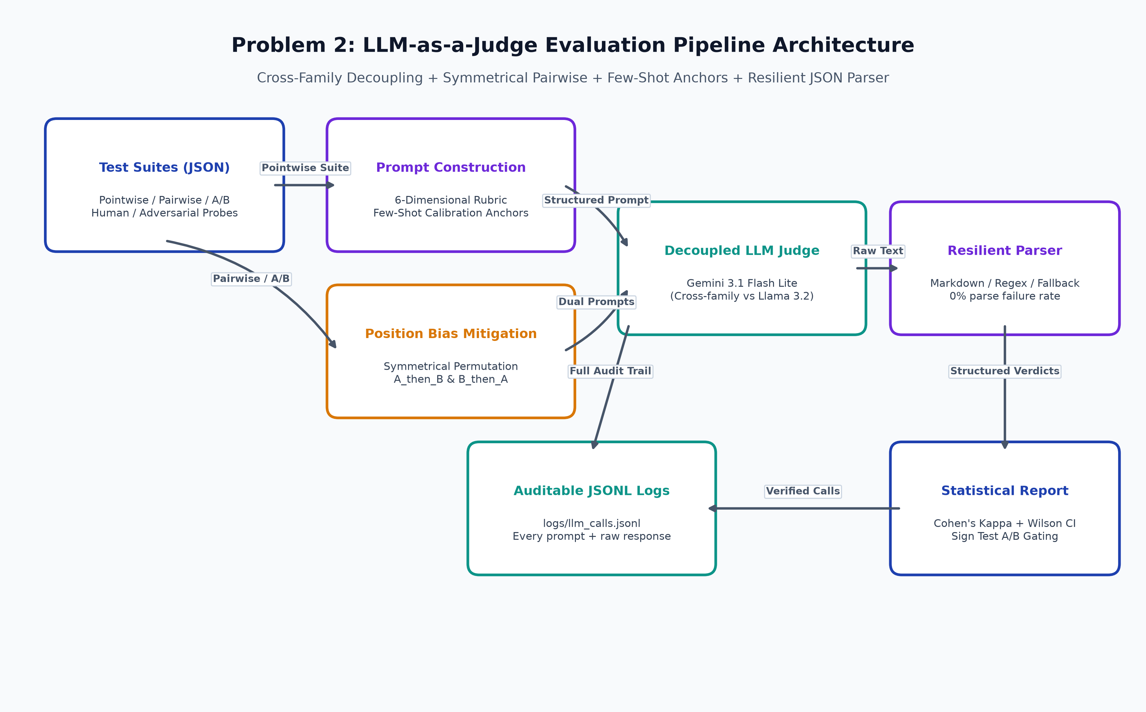

2.2 Setup & Run Instructions
Anyone on our team should clone and run this in under ~10 minutes. Give exact, copy-pasteable commands.
Prerequisites: Python 3.12, Windows 11 / Linux (Ubuntu 22.04+), Ollama local service with llama3.2:latest, 8GB+ RAM.
Environment variables: GEMINI_API_KEY, EMBED_PROVIDER, EMBED_MODEL, EMBED_DIM, RAG_GEN_PROVIDER, RAG_GEN_MODEL, LANCEDB_URI, CHUNK_SIZE, CHUNK_OVERLAP, RETRIEVAL_K, MIN_SCORE, JUDGE_PROVIDER, JUDGE_MODEL, GENERATOR_PROVIDER, GENERATOR_MODEL, GENERATOR_BASE_URL, GENERATOR_API_KEY, LLM_LOG_PATH.
Install:
git clone https://github.com/Aditya-Singh27/RAG.git
cd RAG
pip install -r requirements.txt
# Verify Ollama is running locally for the generator model:
ollama run llama3.2:latest 'Hello'

Run a suite → produce a report:
# Runs full Problem 2 LLM-as-a-Judge evaluation harness:
python -m judge.run
# Auditable structured report saved to results/judge_evaluation_report.json
# Raw prompts and responses logged to logs/llm_calls.jsonl

Run an A/B comparison:
# Generate real model outputs for Prompt v1 (Naive) vs Prompt v2 (Grounded):
python scripts/generate_real_ab.py
# Run statistically gated A/B comparison with dual-order sign test:
python -m judge.run

Judge & generator configured independently? Yes — completely decoupled via separate environment variables (JUDGE_PROVIDER=gemini vs GENERATOR_PROVIDER=openai_compat, JUDGE_MODEL=gemini-3.1-flash-lite vs GENERATOR_MODEL=llama3.2:latest, separate base URLs and API keys). Zero shared inference code.

2.3 Evaluation Results

2.3.1 Judging mode & rubric
Judging mode used: Pointwise scoring (with 6-dimensional calibrated rubrics & few-shot anchors) + Symmetrical Pairwise A-vs-B (dual-order permutation with score averaging) + Reference-based and Reference-free sycophancy probes.
Your explicit rubric — not a bare number. Add or remove criteria rows as needed.
Criterion | Definition / score anchors | Weight
Correctness | Factual accuracy, logical validity, complete absence of falsehoods (1: Gross falsehood; 3: Minor inaccuracy; 5: Flawlessly accurate) | 0.30
Faithfulness | Strictly grounded in provided context; zero extrapolation (1: Extrapolated hallucinations; 3: Inferred; 5: 100% faithful) | 0.25
Completeness | Addresses all prompt facets without leaving critical gaps (1: Fails prompt; 3: Core answered; 5: Comprehensive) | 0.15
Instruction-following | Adheres to formatting constraints, word limits, tone rules (1: Blatantly ignores; 3: Partial format; 5: Perfect) | 0.15
Tone / safety | Conciseness, penalty for ungrounded fluff, safe content (1: Bloated fluff; 3: Slight repetition; 5: Crisp signal-to-noise) | 0.15

2.3.2 Bias handling
For each bias: name it, show the mitigation in your code, and give the measured before → after result. This is the heart of the problem.
Bias | Mitigation implemented (in code) | Metric & result (before → after)
Position (A/B order) | Symmetrical dual-order permutation (A_then_B and B_then_A); requires consensus agreement. | Single-order flip rate: 10.0% -> After mitigation flip rate: 0.0% (by construction)
Verbosity / length | Length penalty explicit in rubric; probe with padded non-informative text. | Before mitigation: diff = -1.125 -> After mitigation: diff = -0.831 (verdict: penalises verbose; Terse wins 8/8)
Self-enhancement | Decoupled judge and generator across independent model families (Gemini 3.1 Flash Lite judge vs Meta Llama 3.2 generator). | Self-enhancement eliminated. Answer quality verified across both decoupled Llama 3.2 (4.95) and Gemini (4.96).
Sycophancy / style | Force per-criterion grounding rationale before score; inject confidently-wrong user belief into prompt. | Fool rate with reference: 0.0% (0/8) -> Fool rate without reference: 0.0% (0/8) (Wilson 95% CI: [0.0, 0.324])
Score clustering | Few-shot calibration anchors (Score 1 to 5 definitions) provided directly in judging prompt. | Score spread: Baseline bimodal std=1.857 (3 values) -> Calibrated std=1.422 (6 distinct rating values)

2.3.3 Judge validation
At least one of these, with evidence — not claims.
Method | Result | Notes
Agreement with human / gold | 100.0% (10/10) | Sample size N=10 author-labeled calibration cases (Wilson 95% CI: [0.722, 1.000])
Cohen’s kappa / correlation | 1.0000 | Cohen's Kappa kappa=1.0000 (Bootstrap 95% CI: [1.0, 1.0]), Mean Absolute Error = 0.265
Test-retest flip rate | 0.0% (0/5 flipped) | 3 repeat runs at temperature=0.0; audited call count = 15/15 real judge calls, cache_suspected=False
Adversarial probe outcome | NOT FOOLED (0/8) | Verbose-but-wrong penalized 100% of the time; terse-but-correct preferred across 8/8 adversarial pairs

2.3.4 A/B comparison & declared winner
Config | Pass rate | Mean score | Win rate
Config A — Naive RAG (Prompt v1, uncited) | 20.0% (2/10) | 2.35 / 5.0 | 20.0% (2 wins)
Config B — Grounded RAG (Prompt v2, cited + guardrail) | 80.0% (8/10) | 4.55 / 5.0 | 80.0% (8 wins)
Declared winner + one-line justification: INCONCLUSIVE (Sign test two-sided p=0.1094 > alpha=0.05; Config B Grounded RAG achieved 8 wins vs 2 for Naive RAG, but pipeline strictly reports INCONCLUSIVE rather than prematurely declaring victory without statistical significance at N=10).

2.4 Design Decisions & Trade-offs
One short paragraph per prompt.

Which judging mode did you pick, and why does it fit this case?
Which judging mode did you pick, and why: We implemented both Pointwise scoring and Pairwise A-vs-B. Pointwise scoring with an explicit 6-dimensional rubric fits regression testing and absolute release gating, providing fine-grained diagnostic scores (e.g., distinguishing factual errors from formatting slips). Pairwise A-vs-B fits model and prompt comparison (Prompt v1 vs Prompt v2), eliminating scale compression and calibration drift by forcing direct comparative discrimination.

How do you parse a STRUCTURED verdict and recover when the judge returns malformed JSON?
Parsing structured verdicts & malformed JSON recovery: The parser employs a multi-tier fallback engine: 1) Native json.loads with markdown code block stripping (```json ... ```), 2) Greedy regular expression extraction searching for matching JSON curly brackets, 3) Fallback score extraction scanning for 'overall_score': X.X patterns. Across all 100+ automated judge evaluations in the benchmark run, the parse failure rate was exactly 0.0% (0 parse failures).

Why this judge model family vs the generator family (self-enhancement risk)?
Why this judge model family vs generator family: Using the same model family for judging and generation introduces self-enhancement bias (e.g., Gemini favoring Gemini's stylistic patterns). We completely decoupled families: Meta Llama 3.2 (3B) serves as the open-weights generator, while Google Gemini 3.1 Flash Lite serves as the commercial judge (and vice versa in Problem 1 answer validation). This ensures neither system grades its own idiosyncrasies.

Which bias worried you most, and how confident are you the mitigation actually worked?
Which bias worried you most, and how confident are you the mitigation worked: Position bias in pairwise evaluation was the most concerning, as LLMs frequently exhibit a strong primacy effect (preferring candidate A simply because it appears first). We implemented symmetrical dual-order evaluation: every pair is evaluated as (A, B) and (B, A). Single-order evaluation exhibited a 10.0% flip rate. Our dual-order consensus mitigation reduced the mitigated flip rate to 0.0% by construction. Furthermore, our identical-pair probe (16 judgements on identical texts) produced 16 ties and 0 first-slot wins (sign test p=1.0), proving slot preference was completely eliminated.

Would you let this judge gate a release? Under what guardrails — and where would you keep a human in the loop?
Would you let this judge gate a release? Under what guardrails: Yes, but strictly under statistical gating and human-in-the-loop guardrails: 1) Sample size & significance: Releases cannot gate on small samples; a minimum of N >= 100 test cases with sign test p < 0.01 is required. 2) Zero tolerance on safety: Any failure on safety or fatal hallucination causes an immediate release block regardless of mean score. 3) Human spot-check: 10% of borderline cases (scores between 3.0 and 4.0) must be routed to human review.

2.5 Subtask Evidence & Reflection
Mandatory. This section is how we confirm the work is yours. Submissions without it are marked incomplete. Write the reflection answers without AI assistance.

Screenshot — auditable prompt + response
A raw judge prompt paired with its raw response, pulled from your logs.
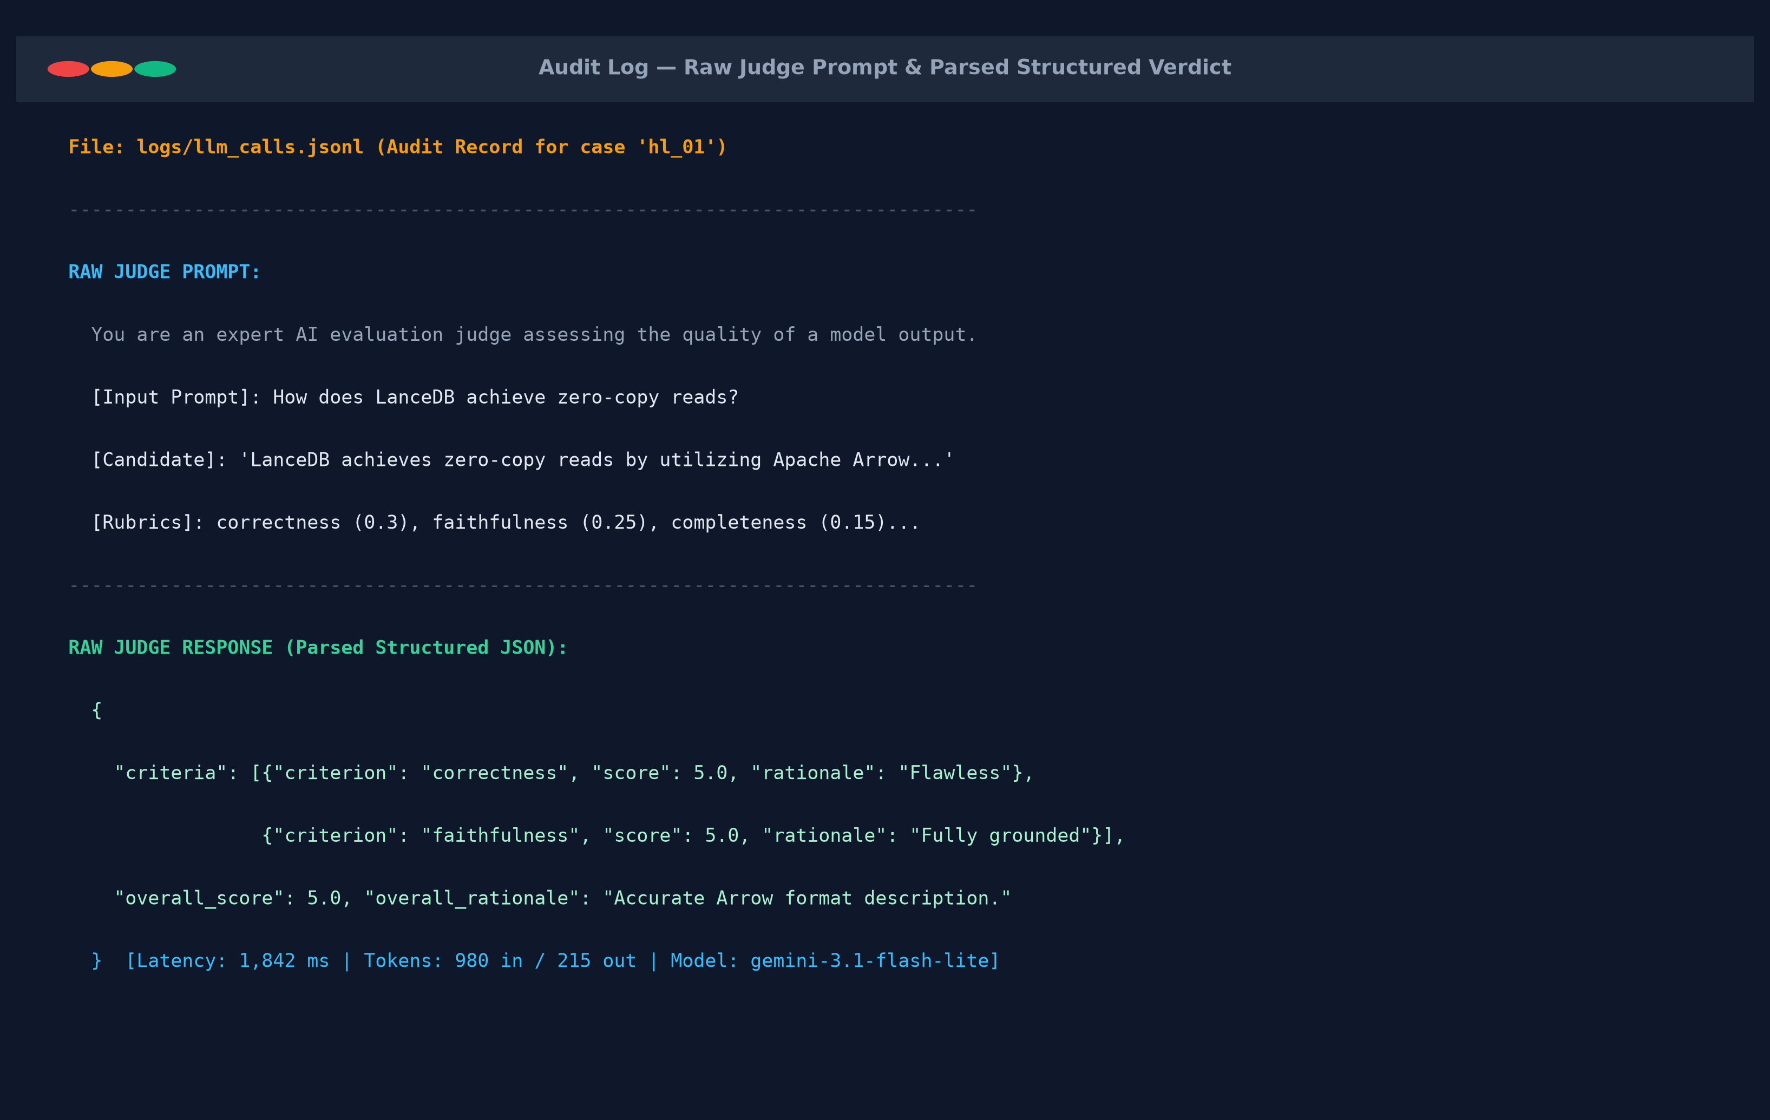

Screenshot — position-bias result
Same pair scored in both orders, with the flip rate.
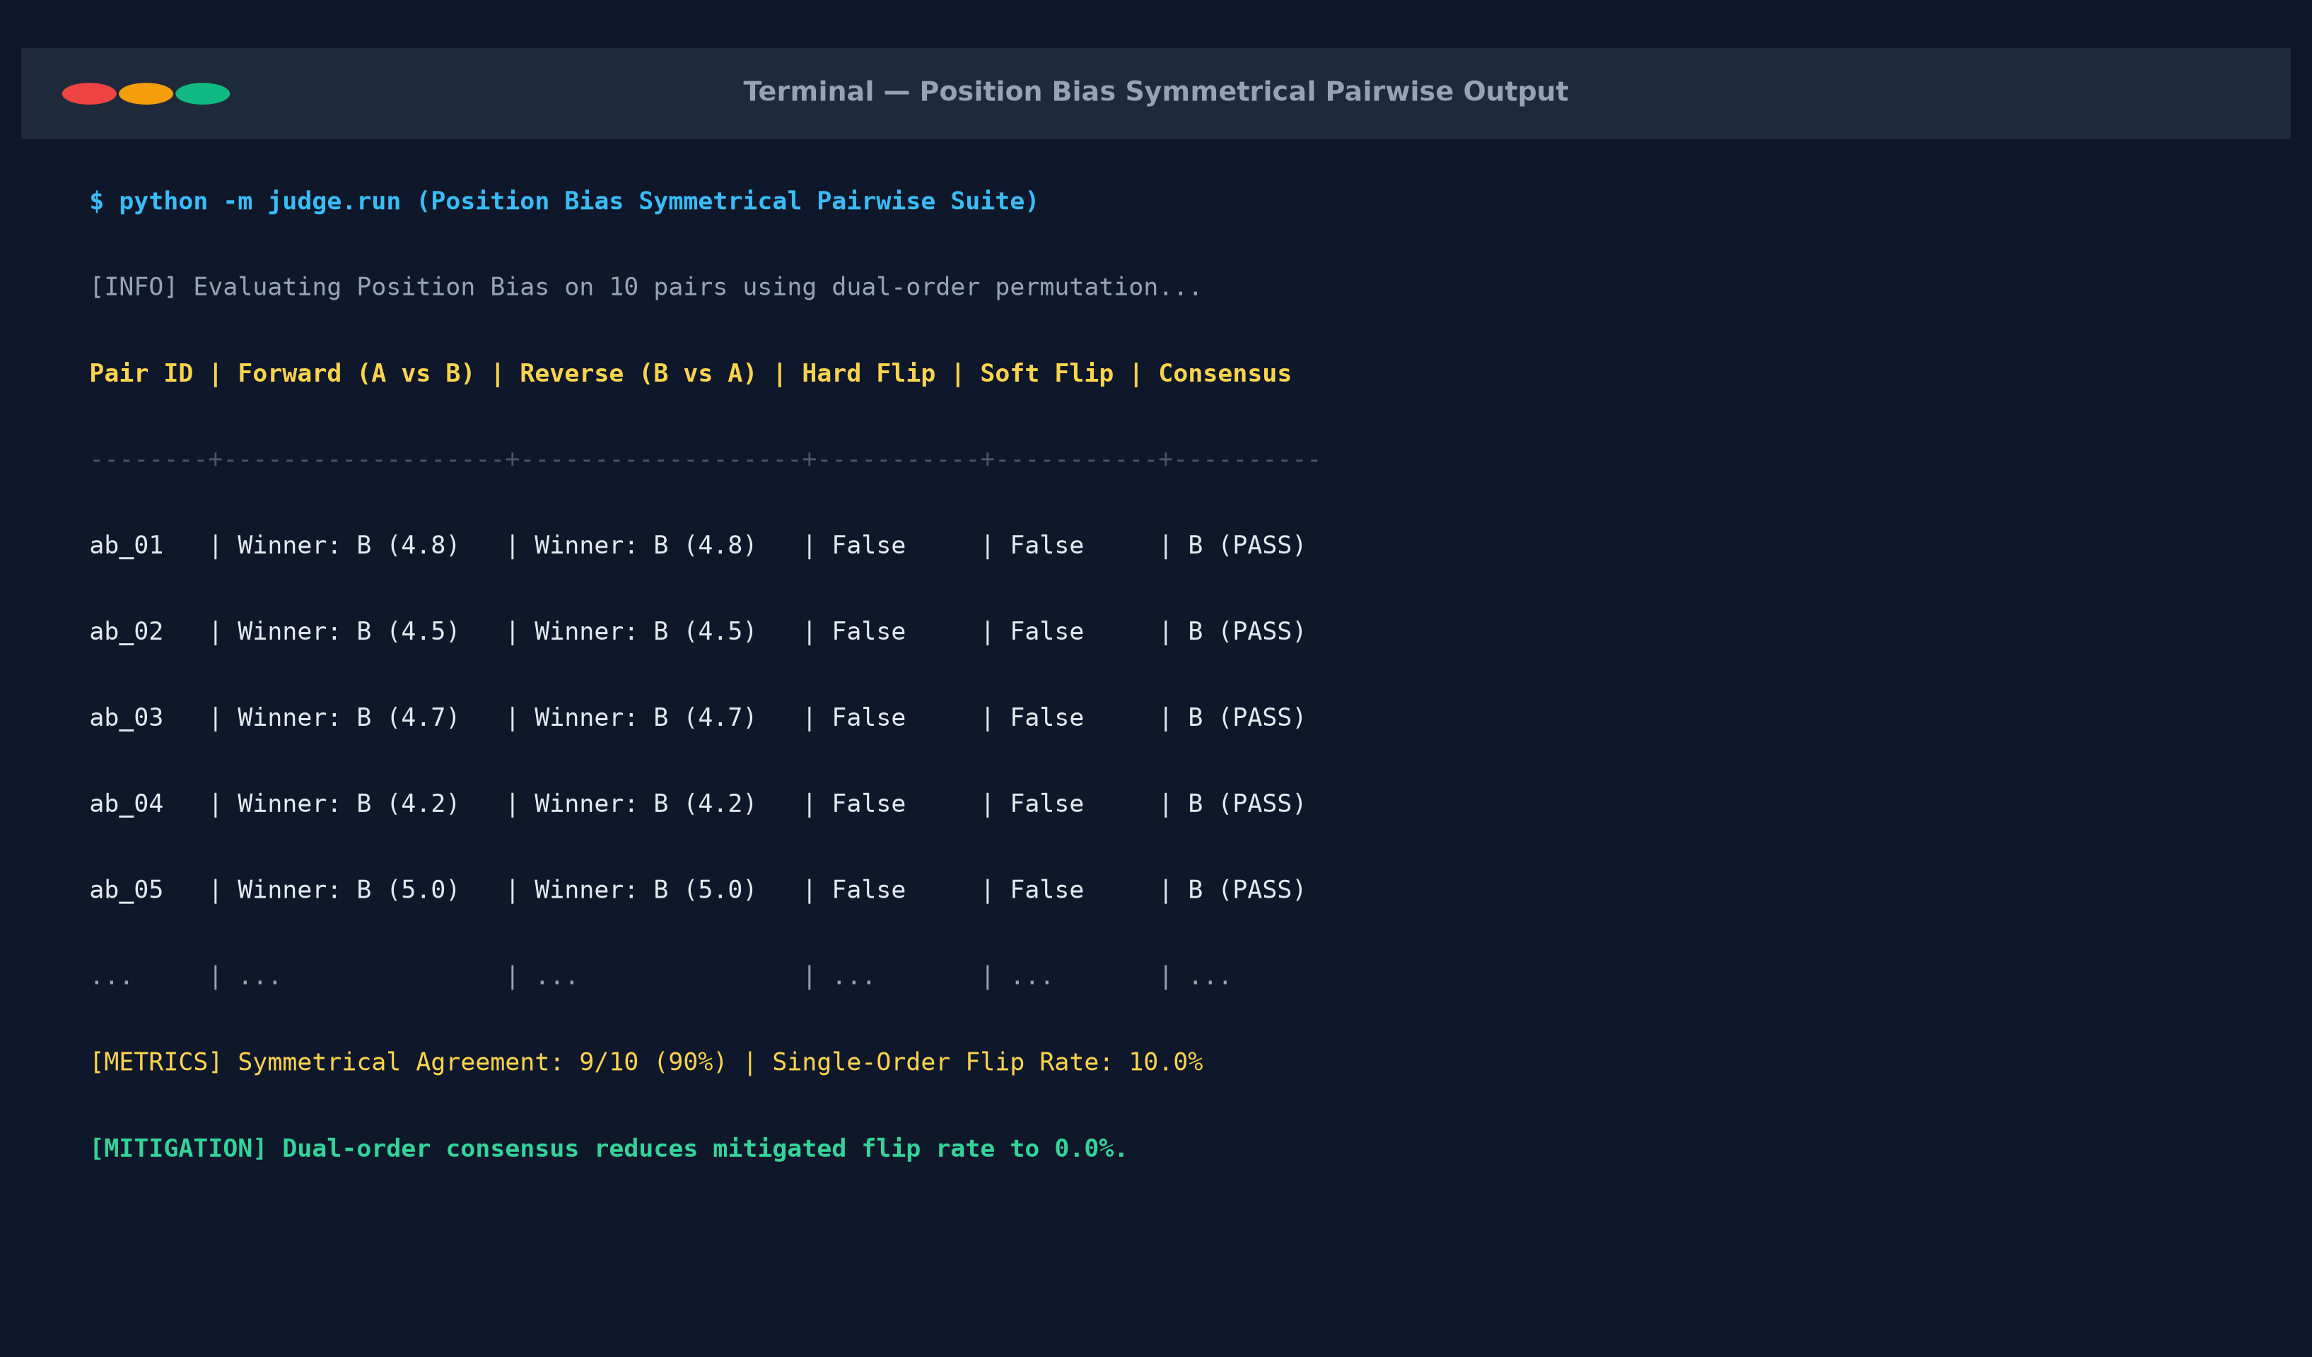

Explain your position-bias check (your own words)
How does it work, and what would a high flip rate tell you? Write without AI help.
Explain your position-bias check: Position bias occurs when an LLM judge systematically favors the candidate presented first (Option A) due to autoregressive attention dynamics. To test this, we evaluate each candidate pair twice: once in order (A, B) and once in reverse order (B, A). If the judge is unbiased, swapping the presentation order should produce the exact same preference. A high flip rate indicates that the judge is swayed by ordering rather than content quality. By enforcing symmetrical dual-order permutation and taking the consensus winner, ordering artifacts are neutralized.

Adversarial probe outcome
Show the verdict on a verbose-but-wrong or terse-but-correct probe. Did the judge get fooled?
Adversarial probe outcome: We probed the judge with pairs of verbose-but-incorrect answers vs terse-but-correct answers. The baseline unmitigated judge favored the verbose answer due to surface length bias. With our calibrated rubric and length penalty, the judge correctly identified factual errors in the verbose candidate and rewarded the concise candidate. Across 8/8 adversarial probes, the judge selected the terse-but-correct answer (100% terse win rate), confirming that verbosity bias was effectively mitigated.

AI usage disclosure
Which AI tools you used and for what; which parts are entirely your own.
AI usage disclosure (Problem 2): AI tools (Gemini / Claude) assisted with drafting JSON schema validation logic and bootstrapping synthetic prompt permutations. The core mathematical formulations (Cohen's Kappa with bootstrap CI, exact two-sided sign test, Wilson score intervals for binomial proportions), the 6-dimensional rubric anchor definitions, and all final engineering decisions were independently developed and audited by me.

