**Design and Functional Simulation of Land rover FIGO FSM**

State Table:

|  |  |  |
| --- | --- | --- |
| State | Input | Output |
| Room 0 | 0 | 000 |
| Room 0 | 1 | 001 |
| Room 1 | 0 | 010 |
| Room 1 | 1 | 011 |
| Room 2 | 0 | 100 |
| Room 2 | 1 | 101 |
| Room 3 | 0 | 110 |
| Room 3 | 1 | 111 |
| Room 4 | 0 | 000 |
| Room 4 | 1 | 001 |
| Room 5 | 0 | 010 |
| Room 5 | 1 | 011 |
| Room 6 | 0 | 100 |
| Room 6 | 1 | 101 |
| Room 7 | 0 | 110 |
| Room 7 | 1 | 111 |

Model chosen: Mealy Model

State Diagram:

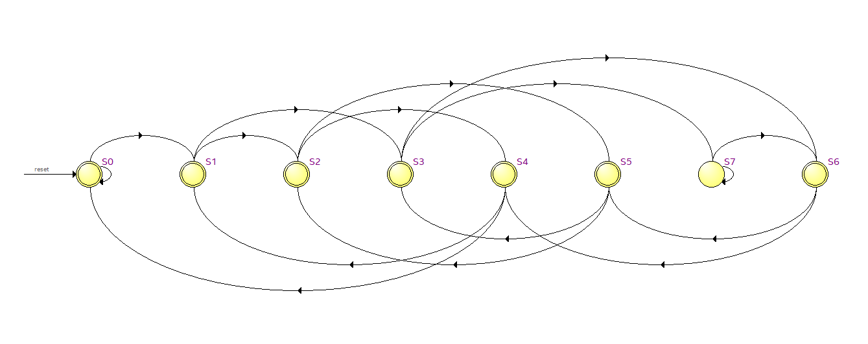

Circuit Diagram:

States:

S0(Room 0): 000

S1(Room 1): 001

S2(Room 2): 010

S3(Room 3): 011

S4(Room 4): 100

S5(Room 5): 101

S6(Room 6): 110

S7(Room 7): 111

**Basic Logic:**

Last 3 bits of bit sequence decide which state the rover will go to next.

Example: If rover is in room 3 (011), and next input bit is 0, rightmost 3 bits would be 110 thus rover will travel to room 6