**Product Recommendation System**

***Abstract*— The paper focuses on the research of Recommendation Systems and describes the current generation of recommendation systems. A collection of information filtering systems known as a recommendation system or a recommender system. There are also a variety of tools, approaches, and software that provide consumers with suggestions based on their preferences. Personal, recommended, and local data from sources such as the Internet are used by recommendation systems. The purpose of this study is to discuss different obstacles, limits, and benefits of recommendation methods.**

**Keywords: - Recommendation system, collaborative filtering, content filtering, hybrid filtering, recommendations.**

I.Introduction

Since its introduction in the first publication on Collaborative filtering in the mid-1990s, the recommendation system has grown in popularity as a study topic. Many websites have been employing the Recommender system in recent years. While surfing websites such as Amazon, Flipkart, Facebook, or another website, everyone has seen suggestions such as "other goods you may like," "customers who purchased this item also bought," "you may like this," and so on. As a result of the rivalry between different websites, businesses are attempting to make suggestions based on filtering the vast array of possibilities available to them.. Because of the fast expansion in data and information alternatives available on websites, as well as the dependability and convenience of use, new E-business services (buying and selling items, production comparison, and so on) are quickly introduced, causing consumers to make incorrect decisions. They aim to make Recommendations on their answers because of the large range of commodities such as services and products on websites.

*A. Recommender System Background*

Recommender Systems are a collection of tools and strategies for retrieving and filtering information with the goal of providing relevant and effective item suggestions to the active user [2]. From the birth of computing, the notion of compelling computers to propose the best product for the consumer had been floated. The RSs idea was initially implemented in 1979 in the GRUNDY system, which was a computer-based librarian that could provide recommendations to the users about what books to read. After then, in late 1990, Amazon cooperative Filtering, one of the most well-known Recommender system Technologies, was implemented.

II. Literature Review

The use of recommender systems has increased. RSs are frequently used and put to use in many different contexts. Based on how users engage with the system, RSs offer recommendations. Content-based, collaborative, and hybrid recommendations strategies are common. All of these methods have advantages and drawbacks, as can be seen from an overview. For the CF system to be machine-recognizable, there is no requirement for content information about the things and users. The CF technique solely uses ratings; no extra user or item information is required. To enhance the effectiveness of collaborative filters, a model-based technique was devised, although it had the drawback of a cold start. Hybrid Recommender Systems were developed as a consequence of substantial study to address the issue of cold start. Accuracy, precision, and recall matrices are noticeably improved by hybrid systems. [2]

With the development of wearable sensor technologies and the use of various types of sensors, performance can be enhanced. For failure management, using many sensors may be helpful. Future work will take into account various sensor combinations that address wearable sensor failures as well as the use of additional sensors to boost performance. The study's findings can improve the user experience of multimedia tools and music recommendation services.

Multimedia recommendation engines can gain from physiological computing systems because there is a strong association between physiological GSR and PPG data and an individual's affective state and cognitive state. [9]

Today, recommender systems research is a crucial area. Big data analysis tools like Spark, Map-Reduce, Apache Hadoop, etc. are rapidly growing in popularity as data size, such as the number of things and users on websites, increases. The user is given recommendations for products based on their interests and the items they have previously rated. In this paper, we analyze four recommender system strategies and identify their benefits and drawbacks for everyone. Discusses problems with recommender systems such as cold start, scalability, privacy, gray sheep, Shilling attack, novelty, sparsity, diversity, and over specialization. Discusses many research issues as well as obstacles, solutions, and benefits. Consider employing a big data algorithm like map reduce to improve recommender system efficiency in your future work.[10]

In this study, They extended the current collaborative filtering method to represent the features of fashion products, and they offered a new method of recommending fashion products to clients. In order to provide recommendations, they first took into account the fact that fashion products are sold both online and offline, and that preferences for them may be seen both there and elsewhere. Second, the popularity of fashion products among consumers normally tends to decline over time. They have presented a decay function that lowers the intensity of preference over to account for this aspect in the recommendation technique. [11]

II.Collaborative Filtering

GOLDBERG et al. proposed the notion of Collaborative Filtering in 1992, stating that when humans are involved, information filtering becomes more effective and productive. [1]. In collaborative filtering approaches, suggestions or recommendations are generated for each user by comparing replies from other users who have indirectly chosen goods in the same way as the active user.

*A. Neighborhood Based Method*

Neighborhood-based filtering algorithms, also known as memory-based algorithms, were among the first collaborative filtering algorithms devised. These algorithms were developed to support the idea that comparable people have similar rating habits and that similar objects obtain similar ratings. Neighborhood-based algorithms are divided into two types.

Algorithms for users Consider the ratings for the item by another user when evaluating the interest of a user 'u' for an item 'i'. This method predicts the rating of an item I of a user 'u' based on the rating of 'u' for items comparable to I. In a similar way, the similarity between two things is determined using the ratings supplied by other users of the system.

The Accuracy of the model is used to assess the recommendation technique's performance. Typically, the rating set R is divided into two parts: a training set Rtr for learning f and a test set Rte for evaluating prediction accuracy. Two of the most often used measures for measuring live accuracy are Mean Absolute Error (MAE) and Root Mean Squared Error (RMSE). [2].

Product (L) = |L(u)| /L(u)

Recall (L) = |L(u)| /L(u)

1. ***Item-based CRS:***

We'll look at the relationship between the two things in this section (the user who bought Y, also bought Z). We locate the missing rating by using the ratings assigned to the other items by the user.

The first step is to construct the model by determining how similar all of the item pairings are. Similarity between item pairs may be discovered in a variety of ways. The usage of cosine similarity is one of the most prevalent ways.

Cosine similarity is a metric that may be used to determine how similar data items are regardless of their size. In R, we may use Cosine Similarity to determine how similar two phrases are. The data objects in a dataset are handled as a vector in cosine similarity. To find the cosine similarity between two vectors, use the formula

Formula for Cosine Similarity:

similarity(x,y)=cos($θ$)=x $⋅$ y|x||y|

1. ***User-based CRS*:**

User-Based Collaborative Filtering is a technique for predicting which products a user would enjoy based on the ratings provided to that item by other users with similar tastes to the target user.

The system selects the X most similar users to you in a fixed-size neighborhood and uses them as a recommendation basis. All users who fall inside the threshold, i.e. are similar enough, are utilized to generate suggestions in a threshold-based neighborhood. This report will employ a threshold-based neighborhood since it makes more sense to use data that is comparable enough, rather than making poor suggestions to specific people merely because their nearest neighbor is too far away.This will result in some people receiving better suggestions than others (since the algorithm will have more comparable users to deal with), but it will at the very least not provide terrible recommendations where none were desired. It will not ignore comparable people just because some are even more similar, and it makes sense to use all of the useful data we have[7].

*B. Model-Based Recommendation Method*

Model-based techniques employ these ratings to collect data and train a predictive model, whereas neighborhood-based approaches use them to learn a predictive model. Model-based systems use the notion of imitating and modeling the interactions of user-items with variables indicating the hidden features of users and also the objects inside the system, such as user preference class and item class category. The model is then trained with the available data (train dataset), and the trained model is then used to predict user ratings for new goods. For the purpose of item recommendation, there are several Model Based techniques. Techniques like Singular Value Decomposition [6], Latent Semantic Analysis [4], and Support Vector Machines [5] and Bayesian Clustering [3] are among them.

III. Pre-Processing Dataset

We used a dataset named as (OnlineRetail) for our project. We need to handle **NA values** in the CustomerID column to build a proper recommendation system.We need to build **a customer-to-item matrix** which is tabular data where each column represents each product, each row represents a customer, and values in each cell represent whether a customer purchased the given product or not. The customer-item matrix that was constructed in the previous step. It indicates if the buyer purchased the product (1) or not(0). Now we need to use the coop library to compute cosine similarity between customers.

The closer the cosine similarity between two customers to 1, the more likely those customers buy similar products.

IV. Algorithm

I. User-based approach

Pick a customer as an example.

**Step 1**

Rank the most similar customers to our

customer with ID.

**Step 2**

Find what the customer A bought.

**Step 3**

Find what bought the B customer.

**Step 4**

Find the items that the customer B didn't buy so we can recommend these items to buy for B

**Step 5**

Find the descriptions of these items

**Step 6**

The list of the item descriptions as a

recommendation to B.

However, there is a drawback to this strategy. We are able to provide only product recommendations based on a customer's previous purchases. As a result, we are unable to use this approach for new clients. Due to that reason We can utilize item-based collaborative filtering to solve problems.

II. Item-based approach

Assume we have a new customer who just bought a product with **StockCode A**

**Step 1**

item-to-item similarity matrix.

**Step 2**

find top10 most similar products to the

product with StockCode A.

**Step 3**

get descriptions.

**Step 4**

The list of the item descriptions as a

recommendation to StockCode A.

The first product is the 1 that the target customer recently purchased. The remaining 10 products are frequently purchased by consumers who have previously purchased the first product.

So we can use these items to recommend to our new customer. You can make product recommendations for new and existing consumers utilizing an item-based collaborative filtering algorithm.

V. Results

I. User-based approach Result: -

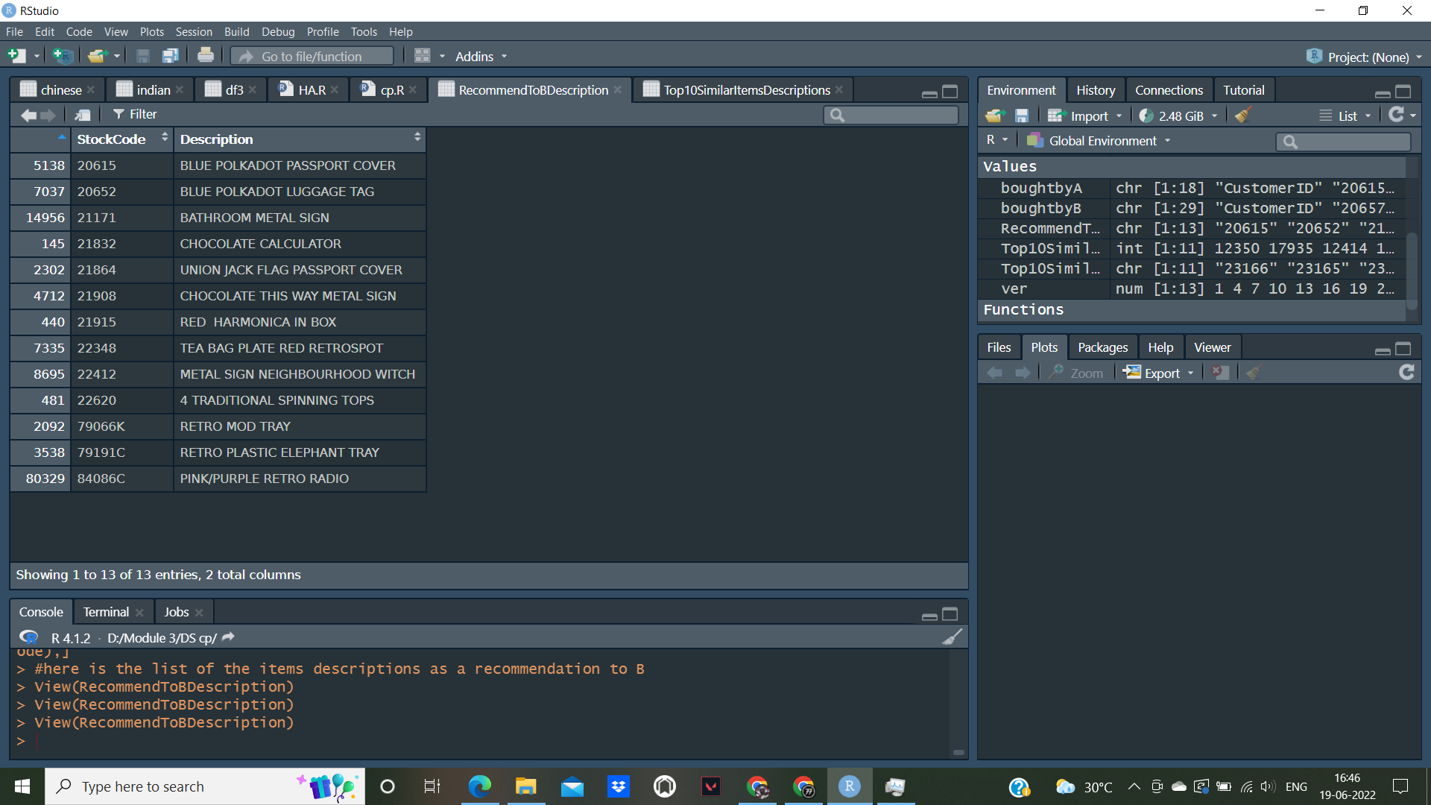

II. Item-based approach Result: -

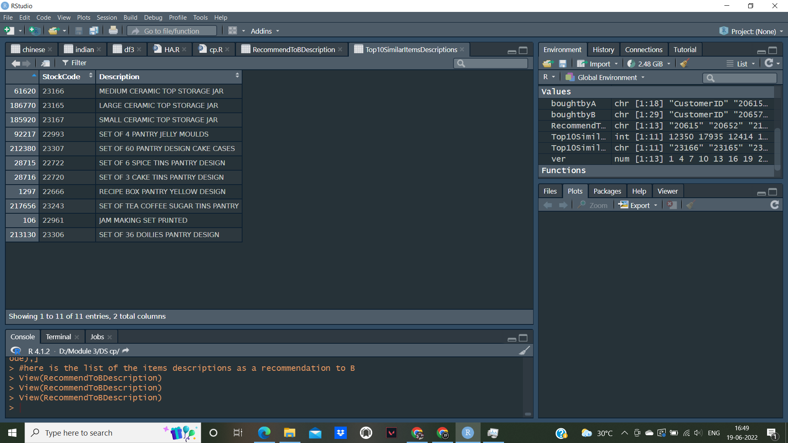

IV. Conclusion

We learnt the fundamentals of collaborative filtering as well as two forms of collaborative filtering. Item-item based filtering and user-user based filtering are both beneficial in this case, but item-item based filtering is the most useful since user interests fluctuate over time, while item reviews do not, thus we usually utilize item-item based filtering.

By using Dataset we learnt how to build a similarity matrix and how to propose new items in the Collaborative Filtering article.

By the help of 2 algorithms (user based Collaborative filtering and Item based Collaborative filtering) we successfully build our recommendation system on Dataset (OnlineRetail).

In conclusion, the study reveals that in all of the evaluated situations, user-based collaborative filtering is superior on datasets big enough to see practical application. Larger amounts of training data produce better outcomes, while the amount of testing data does not need to be very huge to produce a satisfactory result.

V. References

[1] A Case-Based Recommendation Approach for Market Basket Data Anna Gatzioura and Miquel Snchez-Marr IEEE INTELLIGENT SYSTEMS 2015.

[2] Recommender Systems: An overview of different approaches to recommendations.

Kunal Shah , Akshaykumar Salunke, Saurabh Dongare, Kisandas Antala

[3] Empirical Analysis of Predictive Algorithms for Collaborative Filtering.

John S. Breese, David Heckerman, Carl Kadie

[4] Collaborative Filtering via Gaussian Probabilistic Latent Semantic Analysis.

Thomas Hofmann

[5] kNN Versus SVM in the Collaborative Filtering Framework.

Miha Grˇcar, Blaˇz Fortuna, Dunja Mladeniˇc, and Marko Grobelnik

[6] Modeling Relationships at Multiple Scales to Improve Accuracy of Large Recommender Systems.

Robert M. Bell, Yehuda Koren and Chris Volinsky

[7] Comparison of User Based and Item Based Collaborative Filtering Recommendation Services

PETER BOSTRÖM and MELKER FILIPSSON

[8] Content-Based Movie Recommendation System Using Genre Correlation

SRS Reddy, Sravani Nalluri, Subramanyam Kunisetti, S. Ashok and B. Venkatesh

[9] Emotion Based Music Recommendation System Using Wearable Physiological Sensors

Deger Ayata, Yusuf Yaslan and Mustafa E.Kamasak

[10] Recommender Systems Challenges and Solutions Survey

Marwa Hussien Mohamed, Mohamed Helmy Khafagy and Mohamed Hasan Ibrahim

[11] Recommendation system development for fashion retail e-commerce

Hyunwoo Hwangbo, Yang Sok Kim , Kyung Jin Cha