TASK -4
NAME:GURRAM BHASKER JAI RAJ
ROLL NO:2420030414
Step 1: Create the Physical Topology
- Place 2 switches (Switch0 & Switch1)
- Connect 4 PCs to each switch
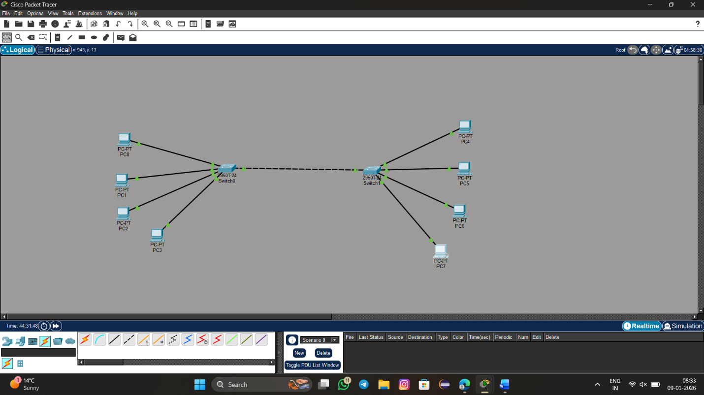
- Connect switches using FastEthernet ports

Example Port Connections
Switch | Port | Connected To
Switch0 | Fa0/1 – PC0 | VLAN 10
Switch0 | Fa0/2 – PC1 | VLAN 10
Switch0 | Fa0/3 – PC2 | VLAN 20
Switch0 | Fa0/4 – PC3 | VLAN 20
Switch1 | Fa0/1 – PC4 | VLAN 10
Switch1 | Fa0/2 – PC5 | VLAN 10
Switch1 | Fa0/3 – PC6 | VLAN 20
Switch1 | Fa0/4 – PC7 | VLAN 20
Switch0 | Fa0/24 | Trunk
Switch1 | Fa0/24 | Trunk
Step 2: Configure IP Addresses on PCs
VLAN 10 PCs
PC | IP Address | Subnet
PC0 | 192.168.10.1 | 255.255.255.0
PC1 | 192.168.10.2 | 255.255.255.0
PC4 | 192.168.10.3 | 255.255.255.0
PC5 | 192.168.10.4 | 255.255.255.0
VLAN 20 PCs
PC | IP Address | Subnet
PC2 | 192.168.20.1 | 255.255.255.0
PC3 | 192.168.20.2 | 255.255.255.0
PC6 | 192.168.20.3 | 255.255.255.0
PC7 | 192.168.20.4 | 255.255.255.0
