T. Aditya Varun
21011102102
IoT B

Why use C?
- I am using C programming language as am more familiar and comforatble with it.
- It feels faster and easier to work with.
- Array implementation is easier in this language.
- I am personally more familiar with C for Data Structures implementation

Comparison of the three algorithms:

Prims:
- works for both directed and undirected graphs
- works with negative values
- cost is caluculated from each and every node
- O ( ( V + E ) l o g V )
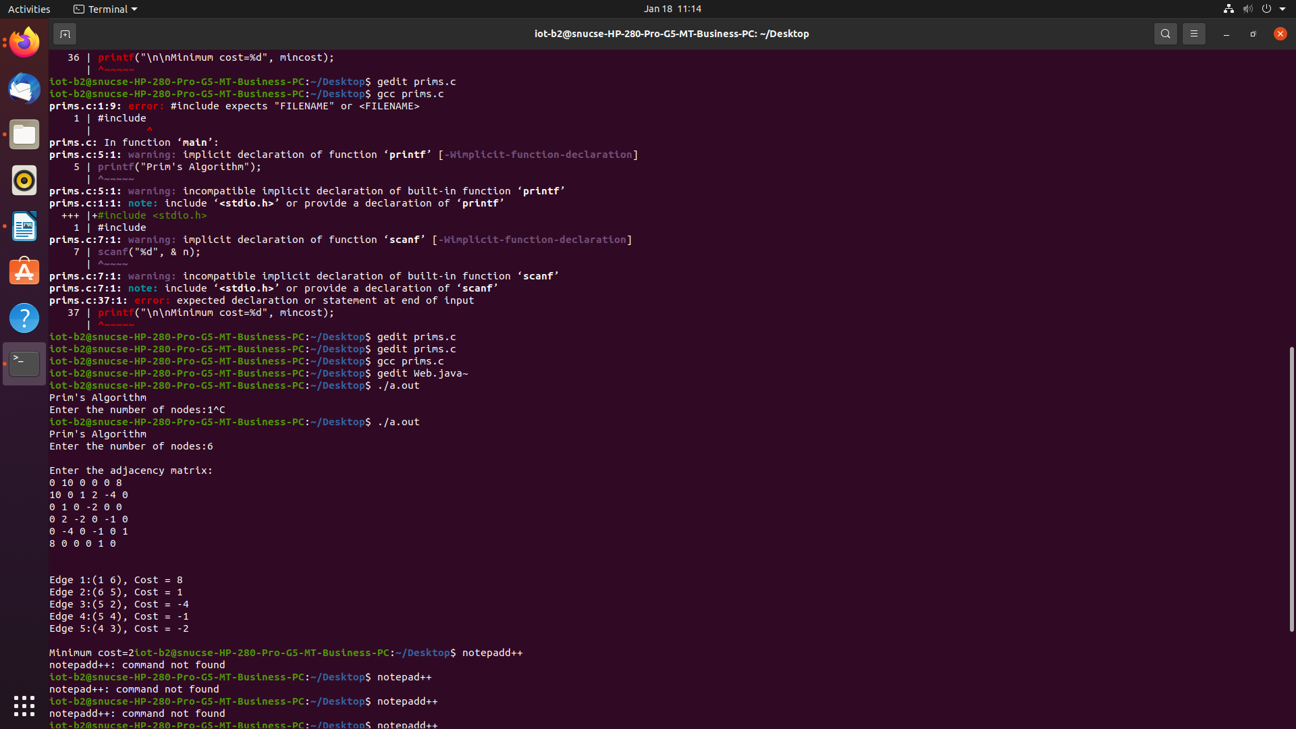

Krushkals:
- works for both directed and undirected graph
- works with negative values
- if cycle is formed the algorithm breaks
- O(E logE)
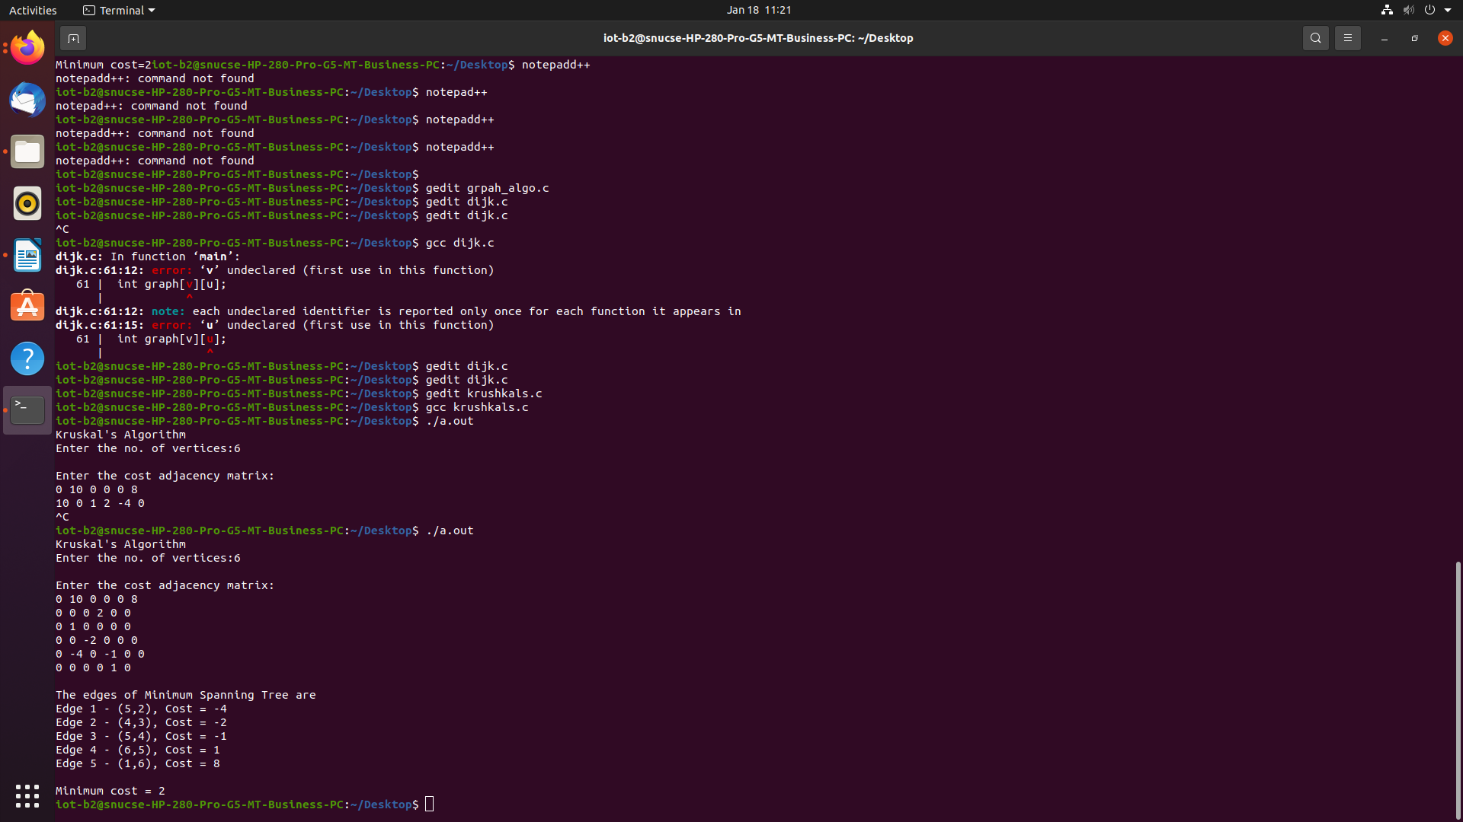

Dijkstra:
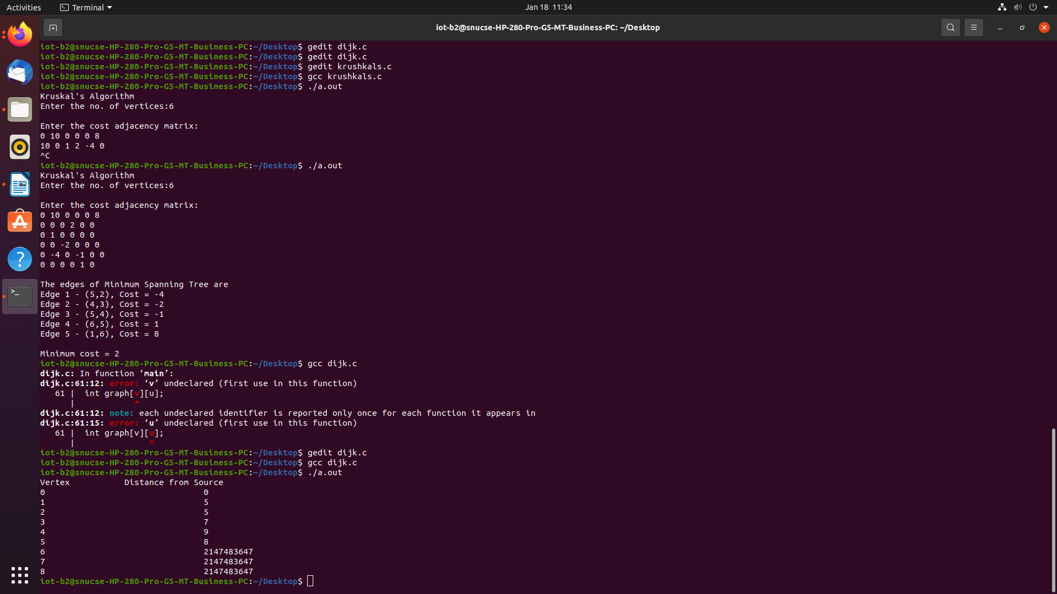
- undirected graphs wont work
- negative wieghts in the graph wont work
- if there is a cycle present as well it wont work
- O(V+E log V)- multi queue
- O(V^2)

